DBSCAN run on for different values of minPts

|  |  |  |
| --- | --- | --- |
| MinPts | Radius | No. of Clusters |
| 3 | 4.5 | 6 |
| 4 | 4.8 | 4 |
| 5 | 6.2 | 2 |
| 6 | 7.1 | 2 |
| 7 | 7.9 | 2 |
| 8 | 8.5 | 2 |

Here are the elbow method plots and cluster plots for all these observations

1. MinPts = 3

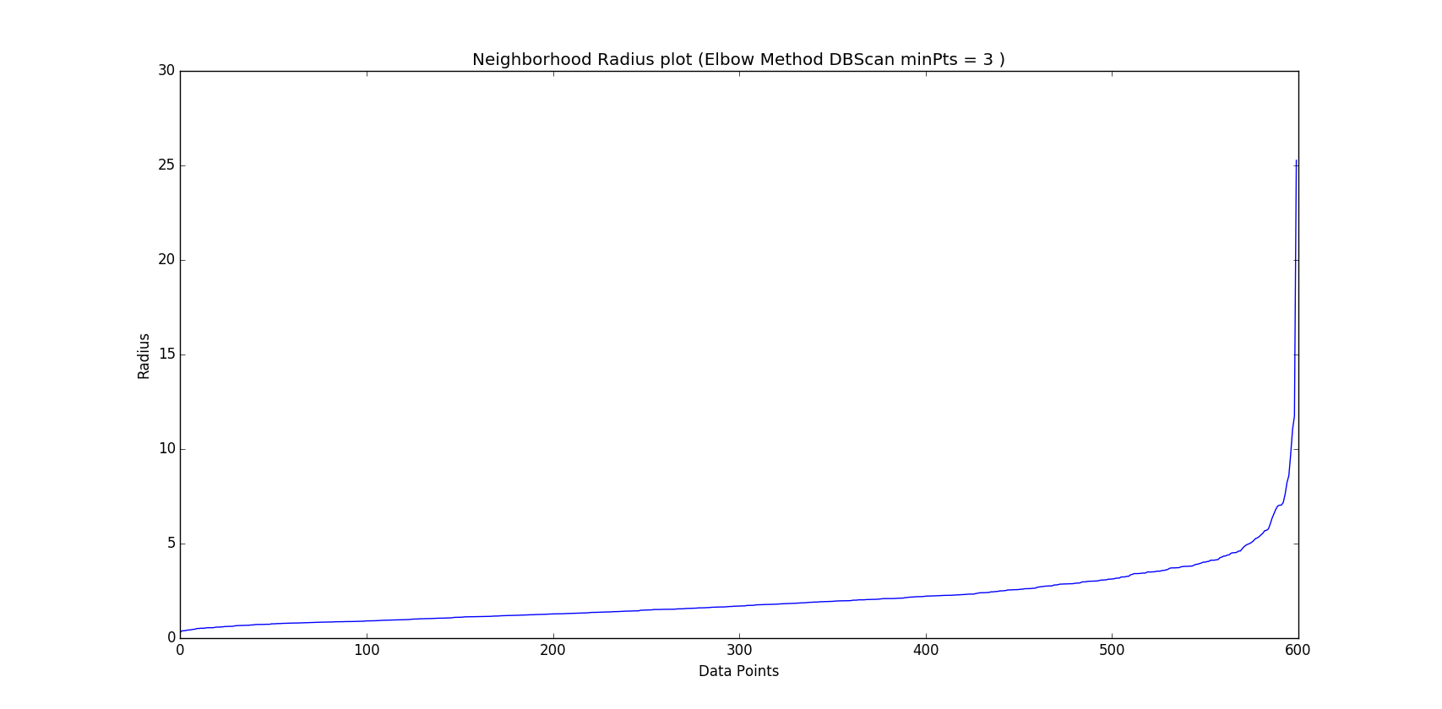

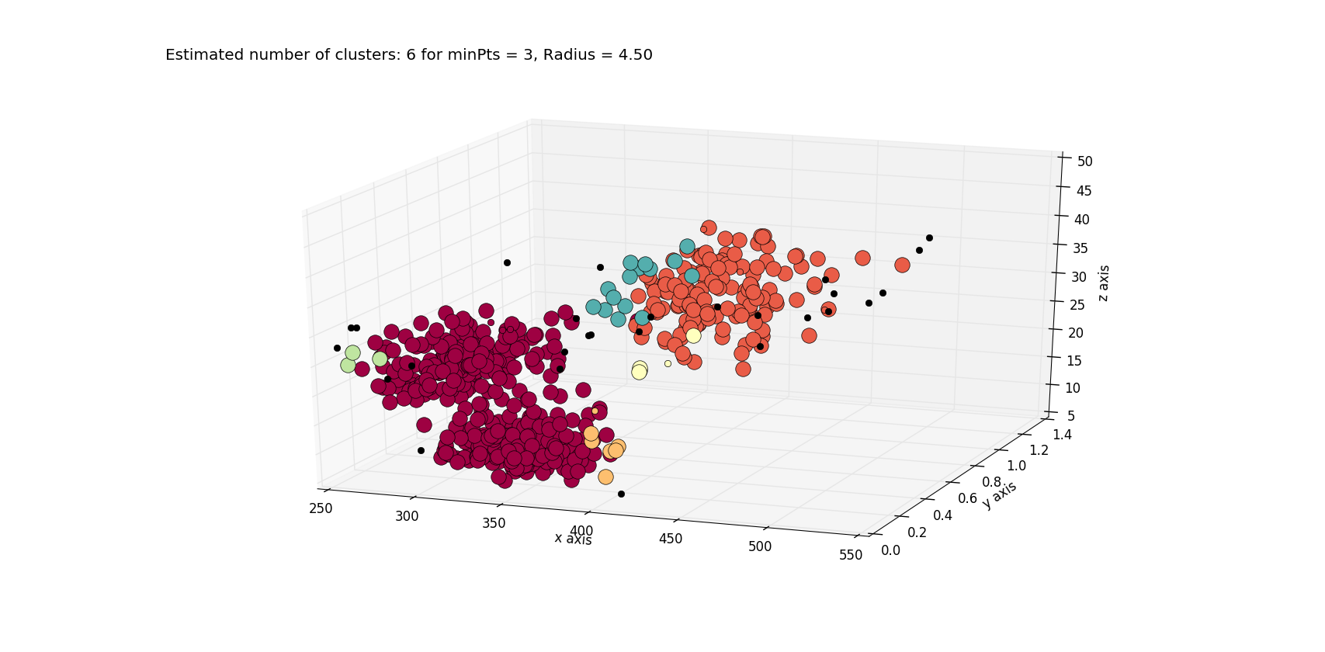

1. Minpts = 4

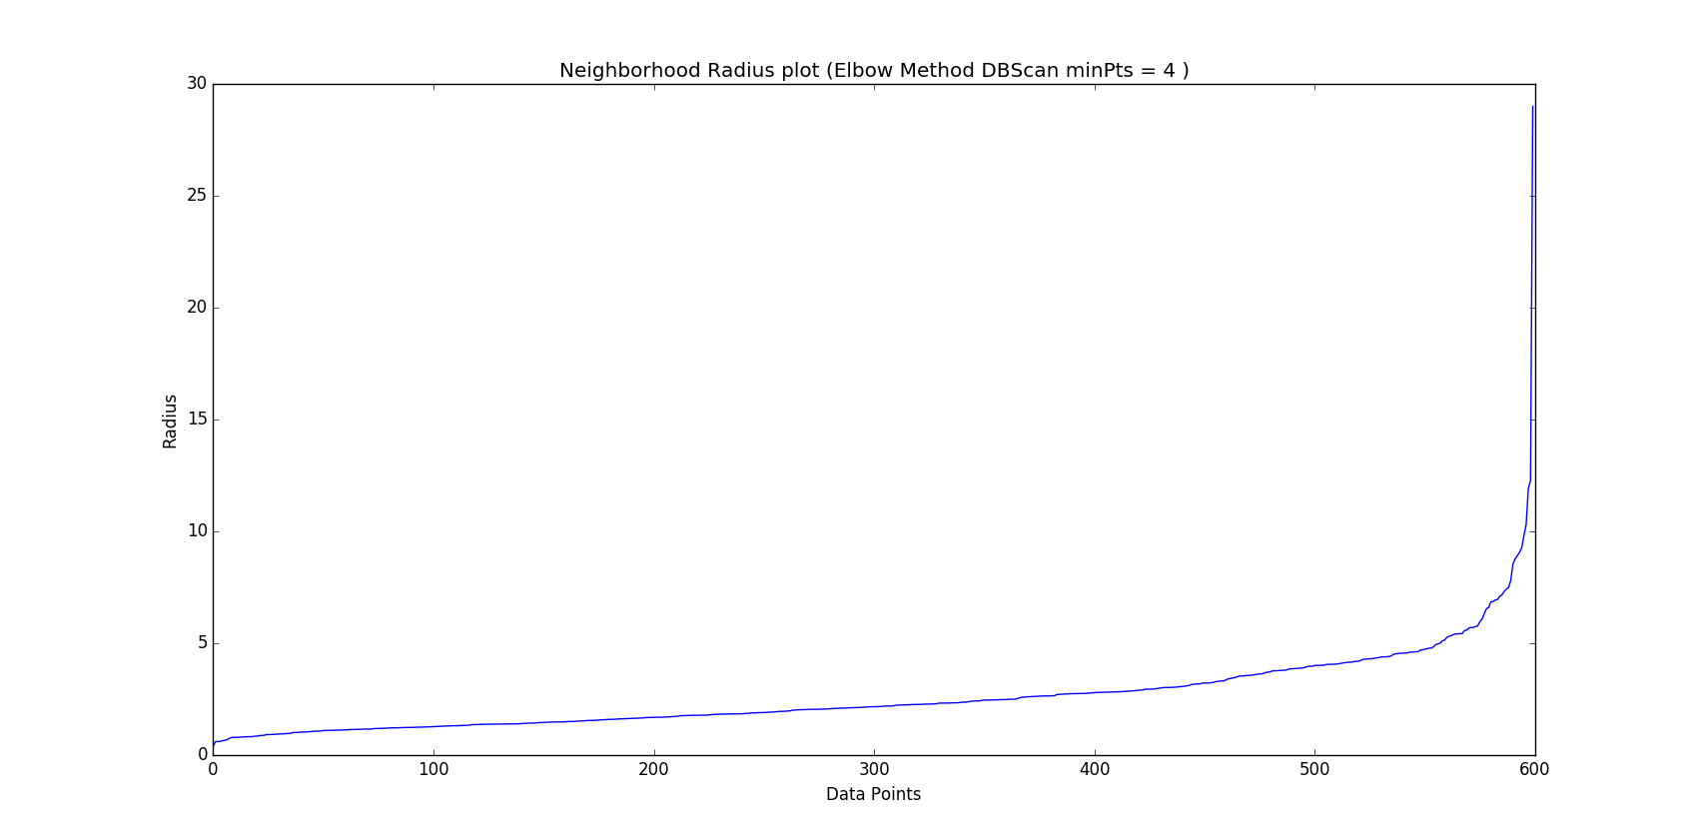

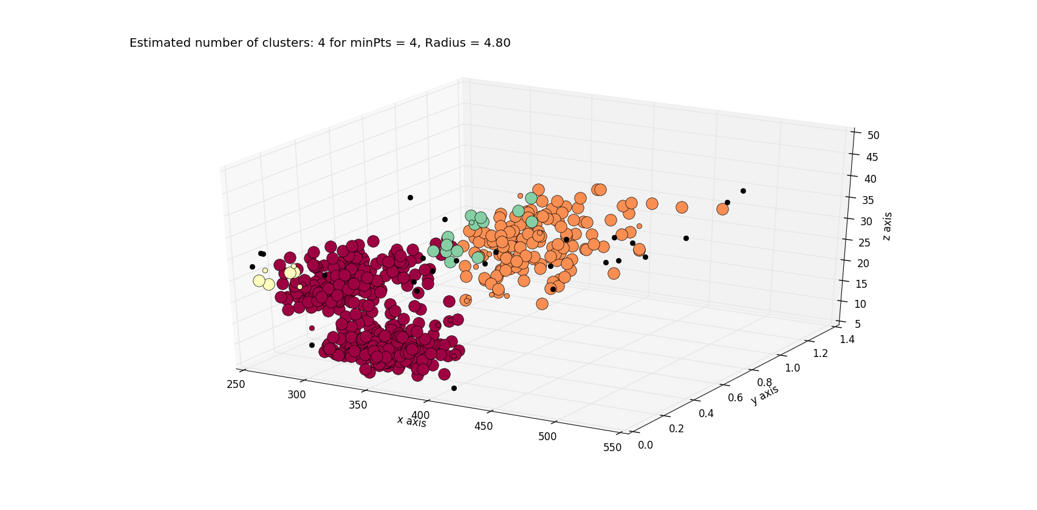

1. Minpts = 5

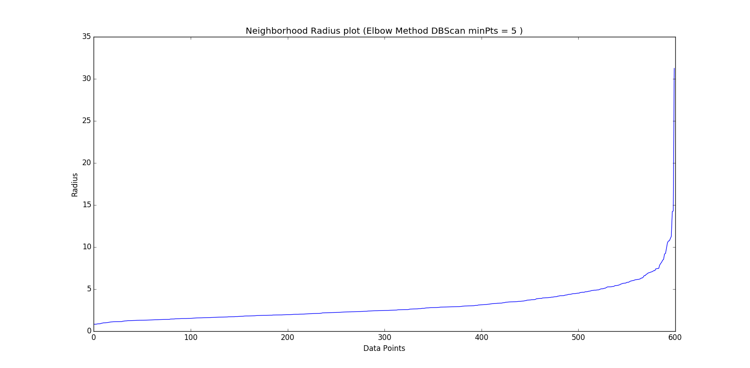

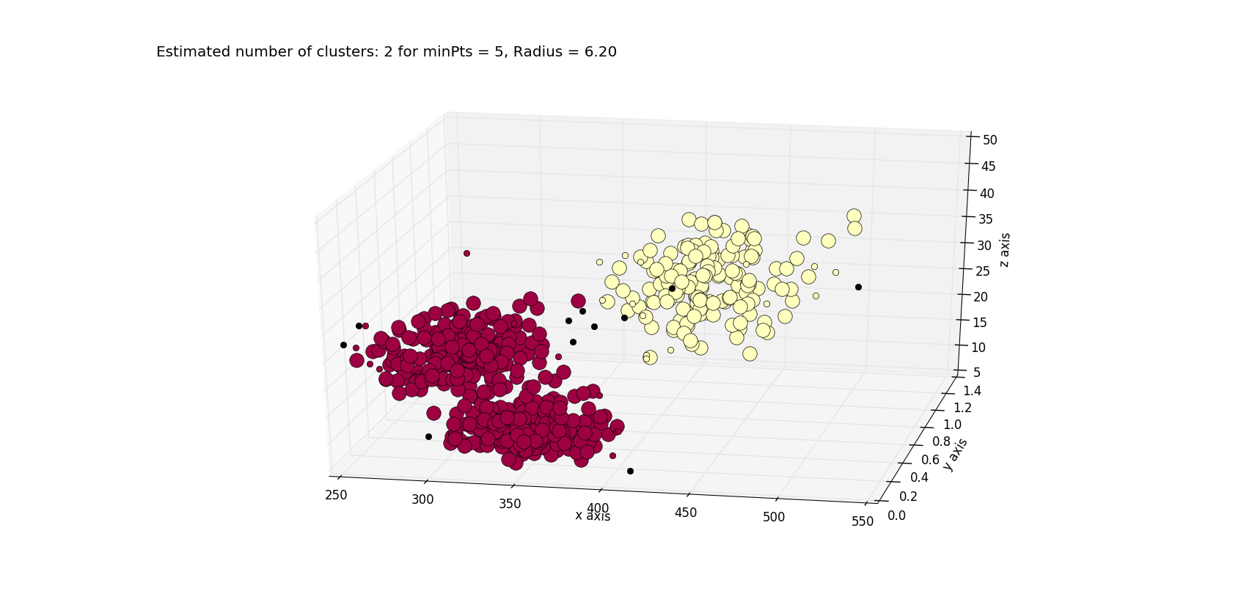

1. Minpts = 6

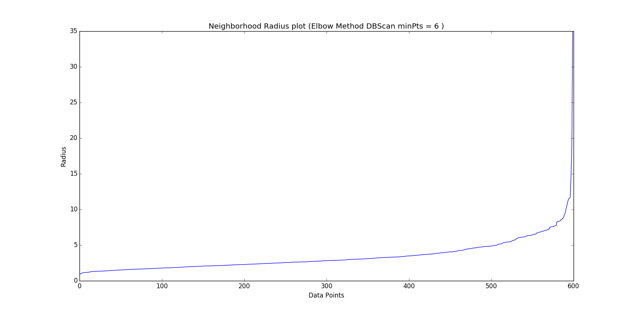

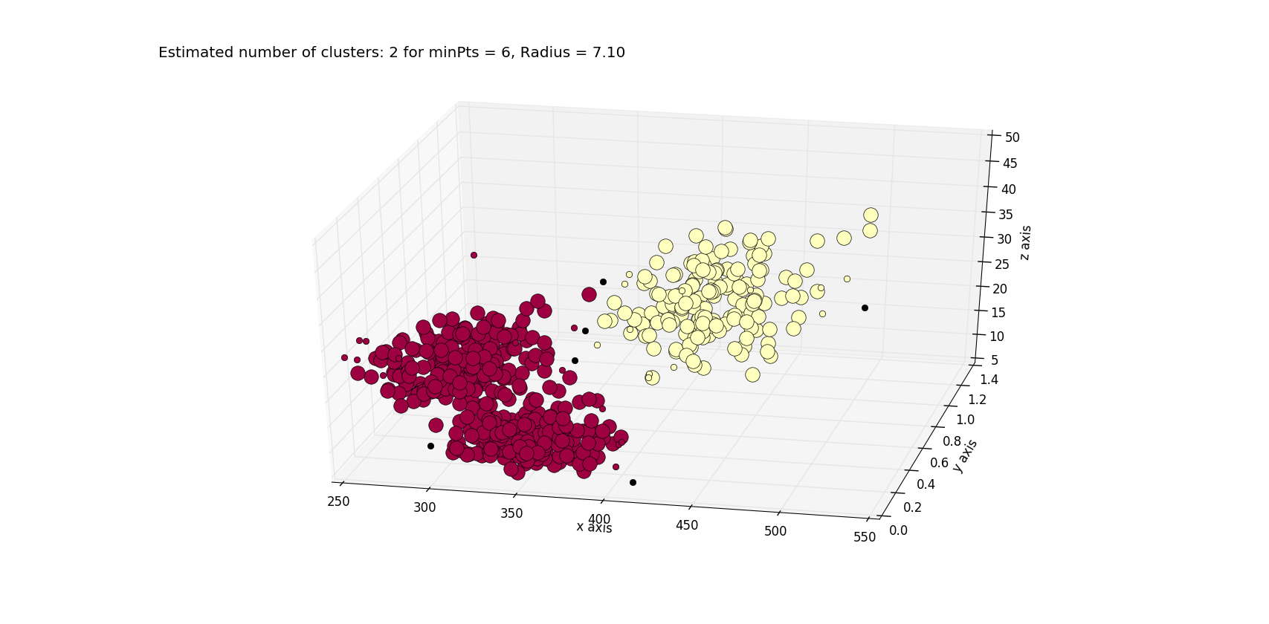

1. Minpts =7

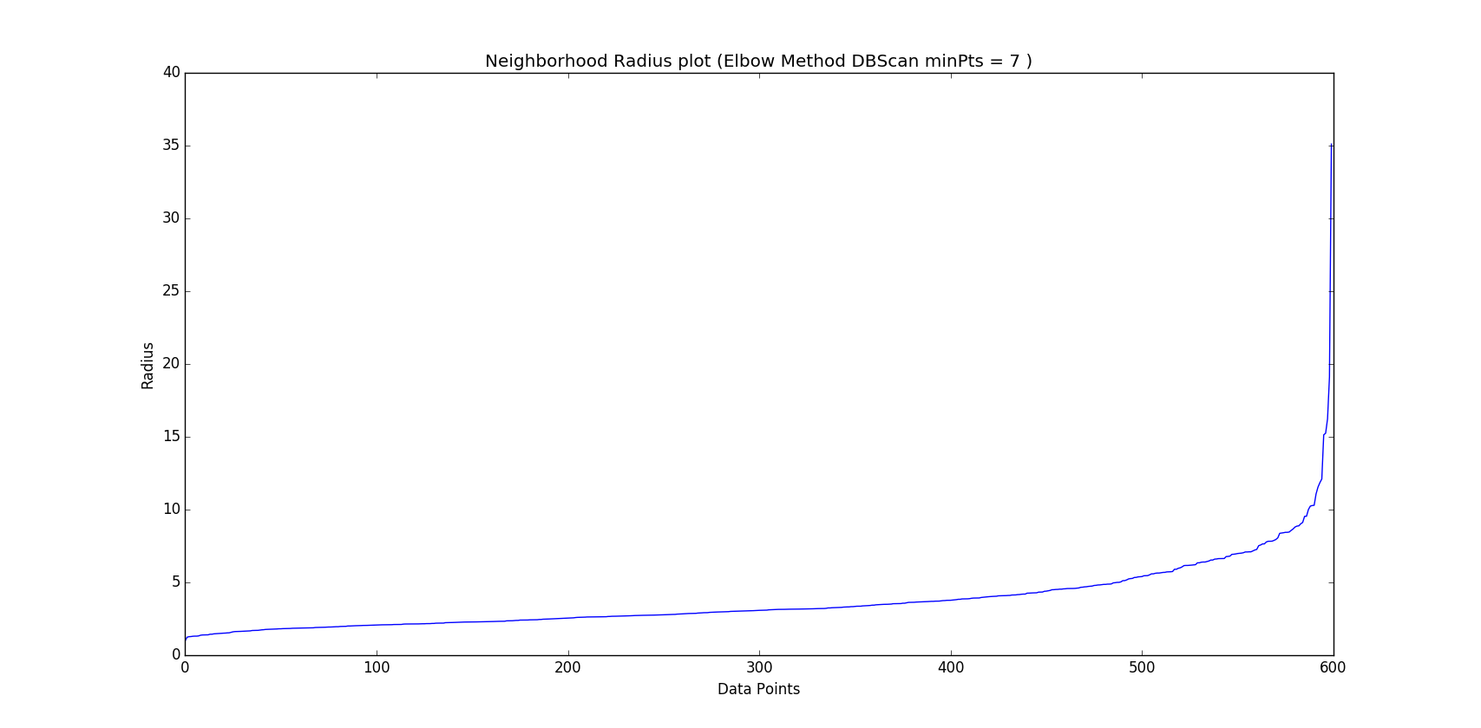

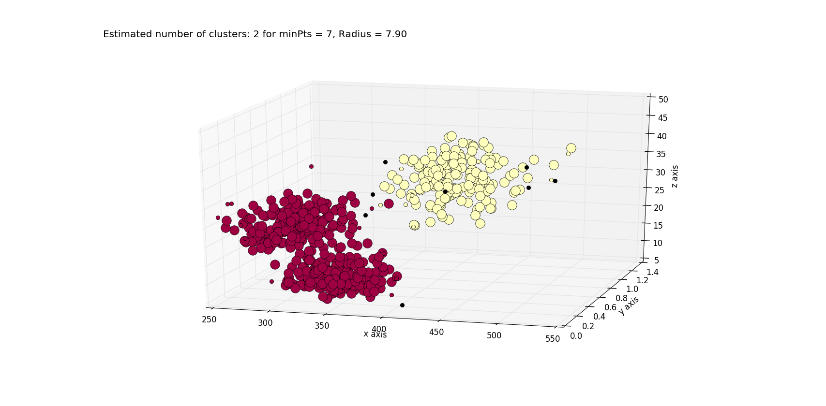

1. Minpts = 8

