**Answer Task 1**

**All time values are in seconds.**

**Part 1) Mean and 95th percentile and their confidence interval of T**

**(Answer)**

Answers are written in form of (S=11, S=12, S=13, S=14,S=15, S=16, S=17)

|  |  |  |  |  |  |  |  |
| --- | --- | --- | --- | --- | --- | --- | --- |
| Service Time-> | 11 | 12 | 13 | 14 | 15 | 16 | 17 |
| T Mean | 19.44 | 24.06 | 29.86 | 38.64 | 50.54 | 77.73 | 141.08 |
| T 95th Percentile | 42.22 | 53.05 | 67.11 | 89.12 | 126.87 | 215.57 | 420.24 |
| Confidence Intervals | (19.12, 19.77) | (23.56, 24.55) | (29.09, 30.62) | (37.37, 39.92) | (48.01, 53.07) | (70.86, 84.59) | (126.52, 155.65) |

**T Mean**

19.44, 24.06, 29.86, 38.64, 50.54, 77.73, 141.08

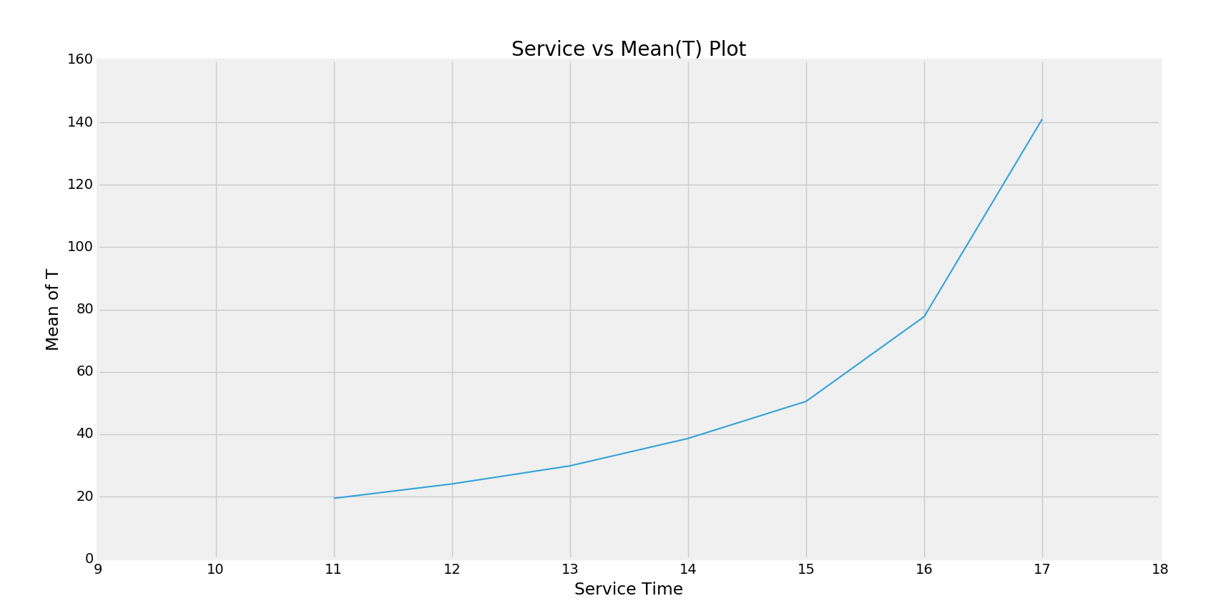

**T 95th Percentile**

42.22, 53.05, 67.11, 89.12, 126.87, 215.57, 420.23

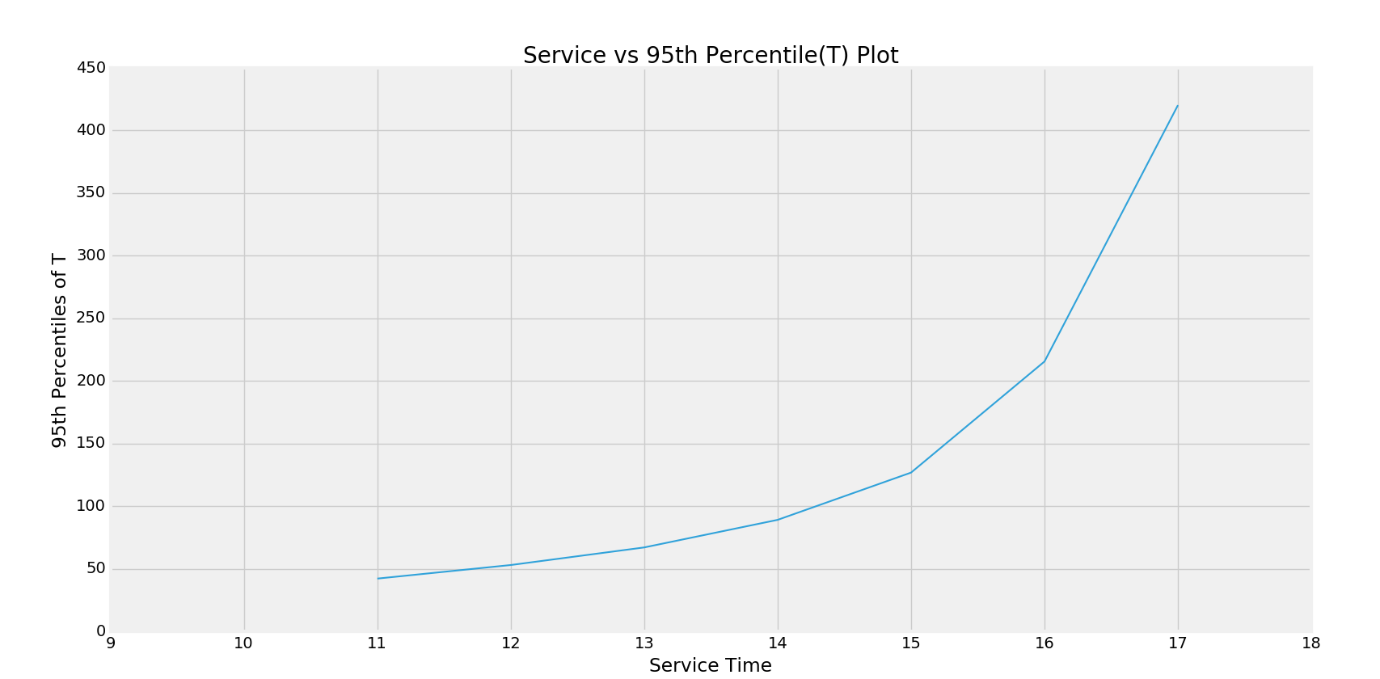

**Confidence Interval of T**

(19.12, 19.77), (23.56, 24.55), (29.09, 30.62), (37.37, 39.92), (48.01, 53.07), (70.86, 84.59), (126.52, 155.65)

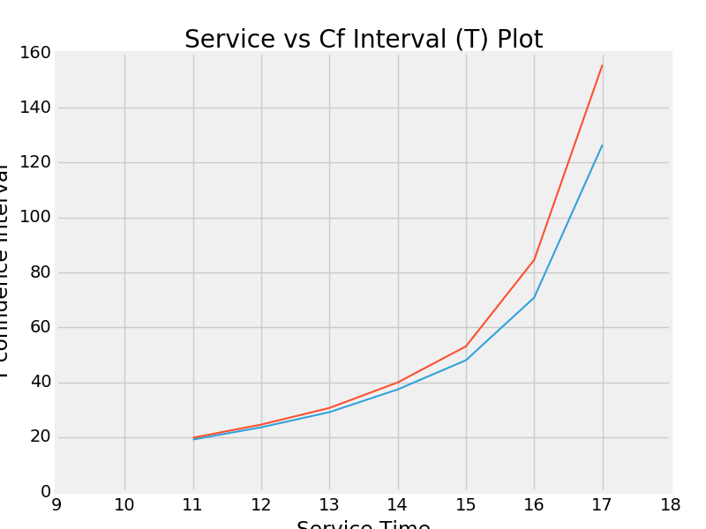

**Comments:** With increasing Service time, the mean value of T value increases because the device lives in the system for a longer duration. The 95th percentile value and confidence interval also increase with increasing value of service time. As the service time increases, we see that the mean time a device stays in the system is increasing but as shown below the total time remains almost same. It implies the standard deviation of the values with increased service time will be more and hence its confidence interval (and 95th percentile value) also grows.

------------------------------------------------------------------------------------------------------------------------------------------

**Part 2) Mean and 95th percentile and their confidence interval of D**

**(Answer)**

|  |  |  |  |  |  |  |  |
| --- | --- | --- | --- | --- | --- | --- | --- |
| Service Time-> | 11 | 12 | 13 | 14 | 15 | 16 | 17 |
| D Mean | 19.57 | 24.15 | 32.07 | 38.32 | 50.97 | 74.73 | 130.60 |
| D 95th Percentile | 36.48 | 56.21 | 89.74 | 113.80 | 162.94 | 247.52 | 440.08 |
| Confidence Intervals | (17.42, 21.73) | (21.93, 26.38) | (28.14, 36.00) | (35.73, 40.91) | (46.73, 55.22) | (66.13, 83.34) | (116.25, 144.95) |

**D Mean**

19.57, 24.15, 32.07, 38.32, 50.97, 74.73, 130.60

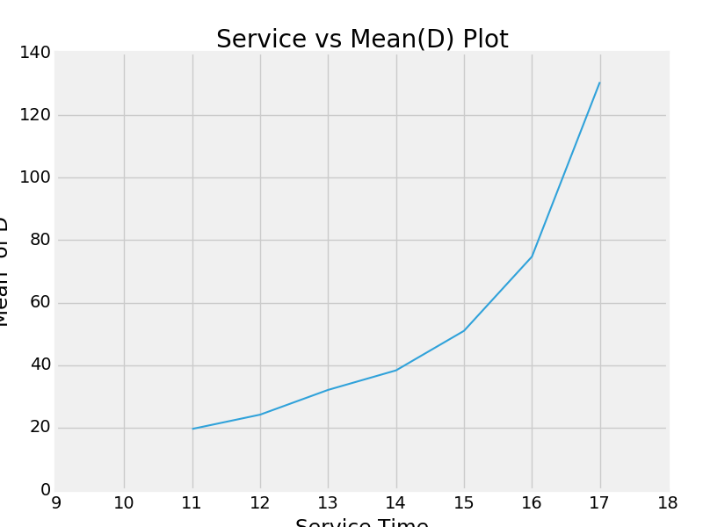

**D 95th Percentile**

36.48, 56.21, 89.74, 113.80, 162.93, 247.52, 440.08

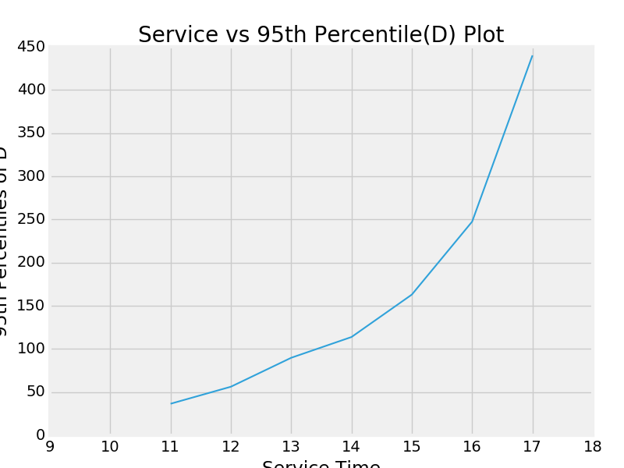

**Confidence Interval of D**

(17.42, 21.73), (21.93, 26.38), (28.14, 36.00), (35.73, 40.91), (46.73, 55.22), (66.13, 83.34), (116.25, 144.95)

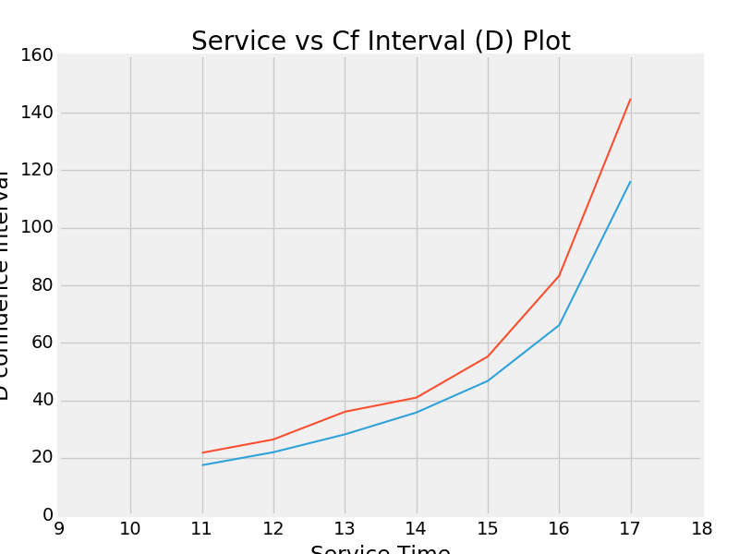

**Comments:** With increasing Service time, the mean value of D increases because with increasing service time, the device has a higher probability of getting rejected from entering the service buffer on arrival. The confidence interval and 95th percentile also increases with increasing value of service time. Since the mean is increased but as shown below, the total time it takes for 1000 device certifications remains almost same and hence the variance (thus, standard deviation) also increases. So the confidence interval also grows.

------------------------------------------------------------------------------------------------------------------------------------------

**Part 3) Mean and confidence interval of P**

**(Answer)**

|  |  |  |  |  |  |  |  |
| --- | --- | --- | --- | --- | --- | --- | --- |
| Service Time-> | 11 | 12 | 13 | 14 | 15 | 16 | 17 |
| P Mean | 18056.23 | 17934.83 | 18060.59 | 17999.19 | 18128.20 | 18049.80 | 18086.33 |
| Confidence Intervals | (17887.36, 18225.10) | (17786.20, 18083.46) | (17929.95, 18191.23) | (17842.54, 18155.84) | (17973.68, 18282.72) | (17889.96, 18209.64) | (17947.80, 18224.85) |

**Total_Time** **(P)**

18056.23, 17934.83, 18060.59, 17999.19, 18128.20, 18049.80, 18086.33

**Confidence Interval of P**

(17887.36, 18225.10), (17786.20, 18083.46), (17929.95, 18191.23), (17842.54, 18155.84), (17973.68, 18282.72), (17889.96, 18209.63), (17947.80, 18224.85)

**Comments**: Total Time however, does not change much with increasing the service time (for service values 11-17 s). It almost has the same value.

-----------------------------------------------------------------------------------------------------------------------------------------

------------------------------------------------------------------------------------------------------------------------------------------

**Task 2**

**Investigate the effect of varying B on all the above statistics for s =16. Provide numerical results in tables and/or curves and comments on your findings.**

**(Answer)**

**The buffer size is varied from 5 to 200 at an interval of 5 and the plots for the statistics value is presented here**

1. **T – mean**

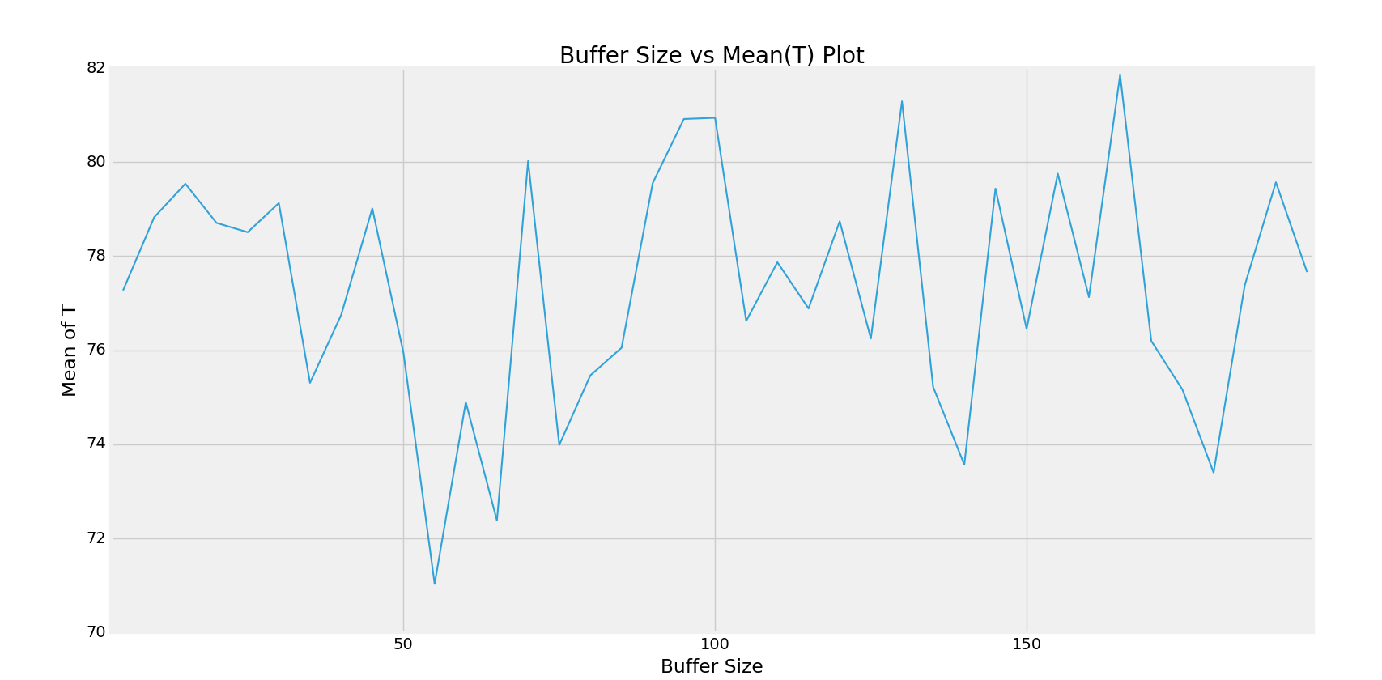

**Comments: With increasing buffer size, the mean time for T does not change significantly. It shoes T mean values are independent of buffer size**

**Value of T mean for 39 observations (Buffer size = 5, 10, 15, …, 195)**

77.27039240000005, 78.82693140000008, 79.53955279999997, 78.70644040000003, 78.50846520000007, 79.12801300000007, 75.30656839999999, 76.7492170000001, 79.01480019999987, 75.94008719999967, 71.03101640000001, 74.89547379999998, 72.37851100000006, 80.02217940000008, 73.98503459999995, 75.46642559999995, 76.05227619999998, 79.55458919999975, 80.91615639999993, 80.94189359999993, 76.62259360000012, 77.86981859999999, 76.88664639999969, 78.74144219999985, 76.24768959999986, 81.29118500000014, 75.2185096, 73.56626260000009, 79.43589680000018, 76.45258579999994, 79.75474479999983, 77.12906040000011, 81.85251920000002, 76.19826800000021, 75.16240399999994, 73.39763060000017, 77.3788082000001, 79.57021419999982, 77.6610075999998

1. **T – 95 percentile**

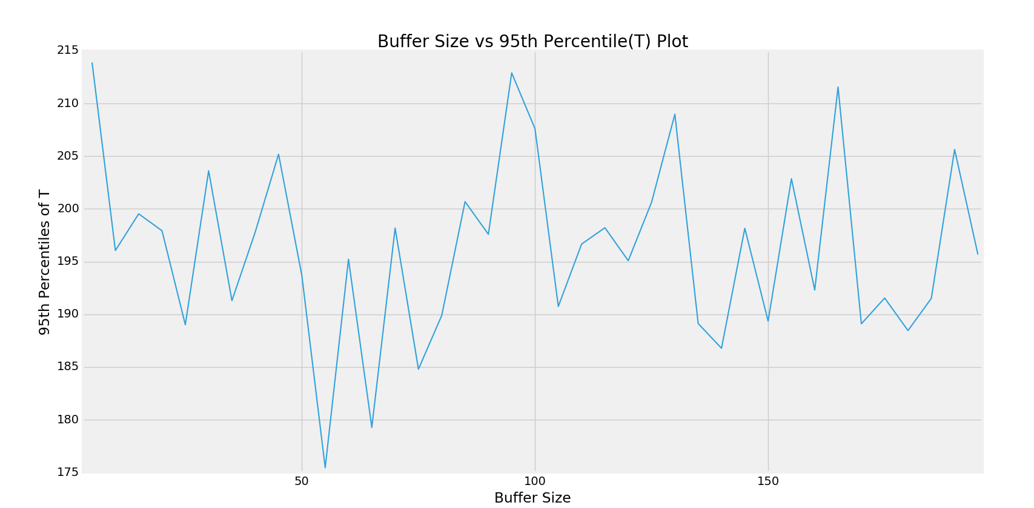

**Comments: With increasing buffer size, the 95th Percentile for T does not change significantly. It shows T 95th percentile value is independent of buffer size**

**Value of T 95th Percentile for 39 observations (Buffer = 5, 10, 15, …195)**

213.89799999999991, 196.05719999999982, 199.53319999999971, 197.93059999999994, 189.01219999999944, 203.61740000000037, 191.30160000000041, 197.81119999999984, 205.18819999999906, 193.66879999999946, 175.4466000000001, 195.22280000000021, 179.27320000000043, 198.18179999999924, 184.79639999999964, 189.89620000000005, 200.68979999999905, 197.59339999999949, 212.90559999999942, 207.60739999999845, 190.75280000000097, 196.66739999999922, 198.21479999999858, 195.08660000000006, 200.62580000000031, 208.98520000000076, 189.12460000000092, 186.78280000000061, 198.15860000000131, 189.3581999999997, 202.86579999999984, 192.30499999999975, 211.55940000000061, 189.10380000000055, 191.5437999999991, 188.46000000000095, 191.51080000000024, 205.64299999999986, 195.67180000000016

1. **T – Confidence Interval**

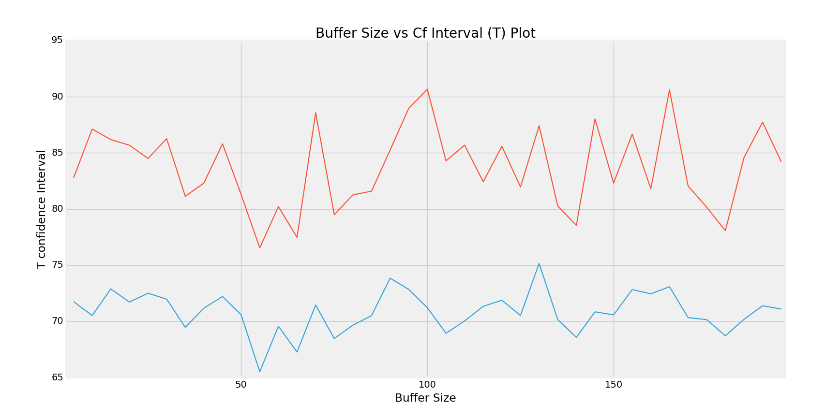

**Comments: With increasing buffer size, the CFI for T does not change significantly.**

**Value of T CFI for 39 observations (Buffer = 5, 10, 15, …195)**

(71.761558521144977, 82.77922627885512), (70.529347734574003, 87.124515065426152), (72.892299581533521, 86.186806018466413), (71.723464488689544, 85.689416311310524), (72.511249990199417, 84.505680409800732), (71.981977531791983, 86.27404846820815), (69.472625725784738, 81.14051107421524), (71.183017778751662, 82.31541622124854), (72.21473055564401, 85.814869844355727), (70.59032325164344, 81.289851148355893), (65.517277636634461, 76.544755163365565), (69.570198581400021, 80.220749018599932), (67.276778242606099, 77.480243757394021), (71.461219832212805, 88.583138967787363), (68.4760045518927, 79.494064648107198), (69.666668685275624, 81.266182514724278), (70.508731195068364, 81.595821204931596), (73.851407593392167, 85.25777080660734), (72.850373944470888, 88.981938855528981), (71.218408171978353, 90.665379028021505), (68.946960054609676, 84.298227145390555), (70.048633396395047, 85.691003803604929), (71.342009741575907, 82.431283058423475), (71.891043032486408, 85.591841367513297), (70.529817625036031, 81.965561574963687), (75.162268132501552, 87.42010186749873), (70.163038001511765, 80.273981198488244), (68.579678584121808, 78.552846615878366), (70.852101077020194, 88.019692522980165), (70.5862830295804, 82.318888570419475), (72.830928911876725, 86.678560688122928), (72.456570599340651, 81.801550200659577), (73.090448825116013, 90.614589574884022), (70.338563587219596, 82.057972412780828), (70.156496720560995, 80.168311279438882), (68.719528306470437, 78.075732893529903), (70.179784167019719, 84.577832232980469), (71.396594284368334, 87.743834115631316), (71.102722180128765, 84.219293019870847)

1. **D – mean**

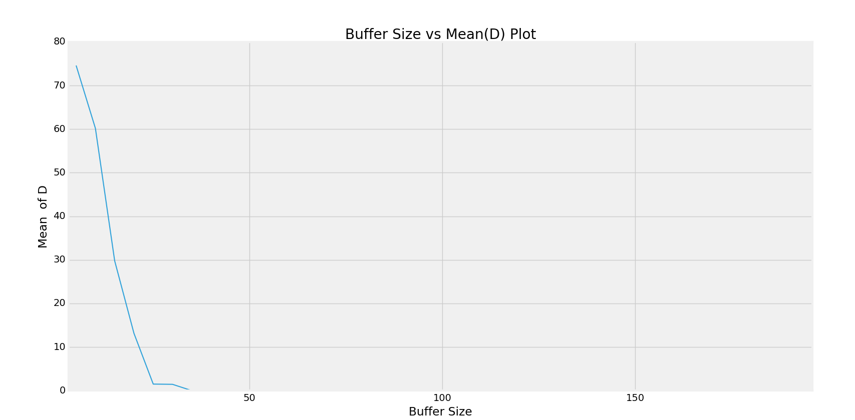

**Comments: With increasing buffer size, the mean for D gradually comes down to zero because when the buffer size is more, the devices start getting in the buffer rather than getting rejected and hence, the d values comes to zero**

**Value of D mean for 39 observations (Buffer = 5, 10, 15, …195)**

74.61219726753892, 60.18670013429085, 29.77118593362781, 13.140273820408138, 1.4958533333333306, 1.4404158730158343, 0.0, 0.0, 0.0, 0.0, 0.0, 0.0, 0.0, 0.0, 0.0, 0.0, 0.0, 0.0, 0.0, 0.0, 0.0, 0.0, 0.0, 0.0, 0.0, 0.0, 0.0, 0.0, 0.0, 0.0, 0.0, 0.0, 0.0, 0.0, 0.0, 0.0, 0.0, 0.0, 0.0

1. **D – 95 percentile**

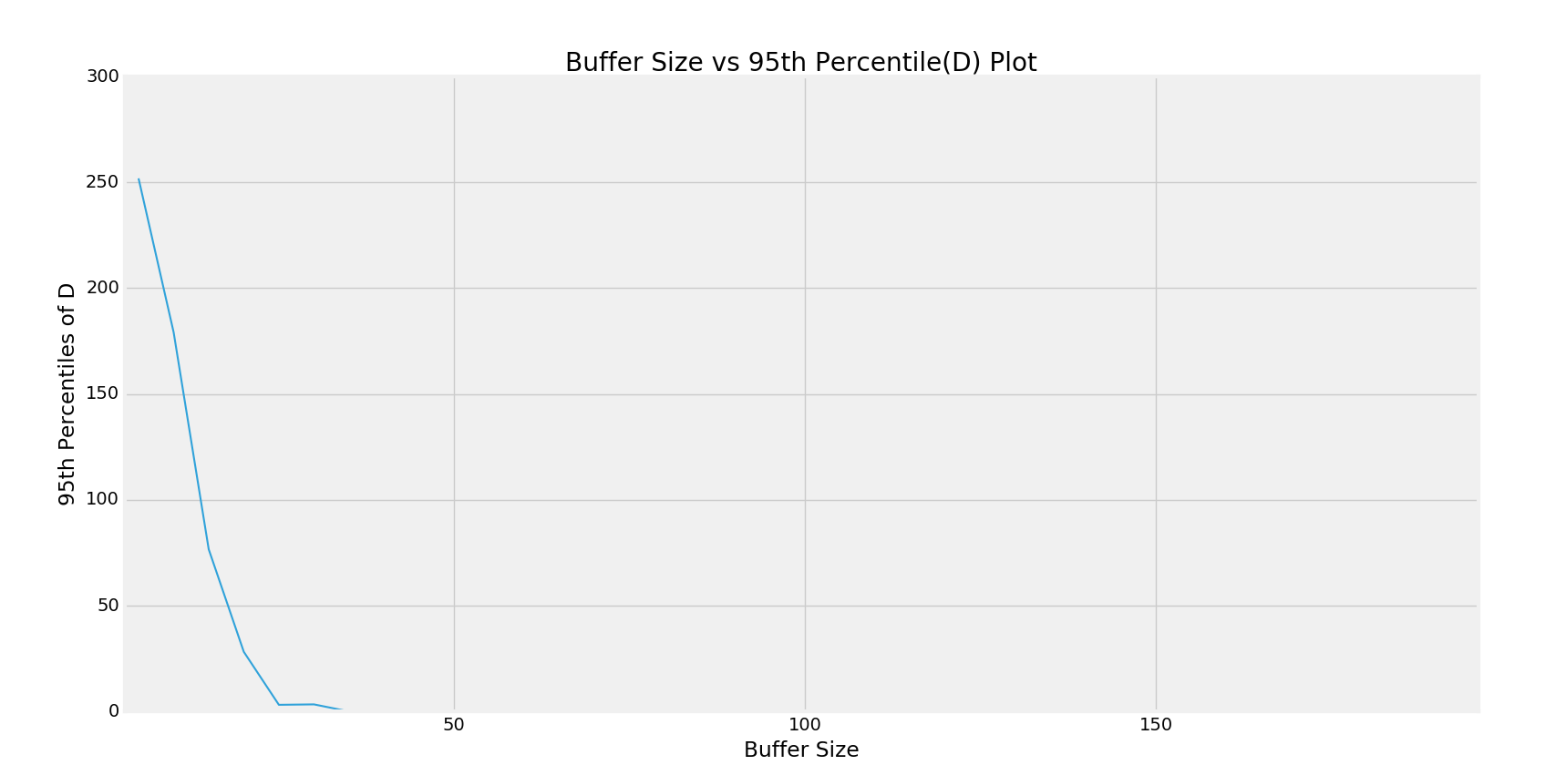

**Comments: With increasing buffer size, the 95th Percentile for D comes down to zero as with increased buffer size, the retransmissions count decreases**

**Value of D 95th Percentile for 39 observations (Buffer =5, 10, 15, … 195)**

251.87740000000053, 179.16700000000009, 76.622799999999913, 28.1796000000002, 3.141800000000003, 3.3423999999999796, 0.0, 0.0, 0.0, 0.0, 0.0, 0.0, 0.0, 0.0, 0.0, 0.0, 0.0, 0.0, 0.0, 0.0, 0.0, 0.0, 0.0, 0.0, 0.0, 0.0, 0.0, 0.0, 0.0, 0.0, 0.0, 0.0, 0.0, 0.0, 0.0, 0.0, 0.0, 0.0, 0.0

1. **D – Confidence Interval**

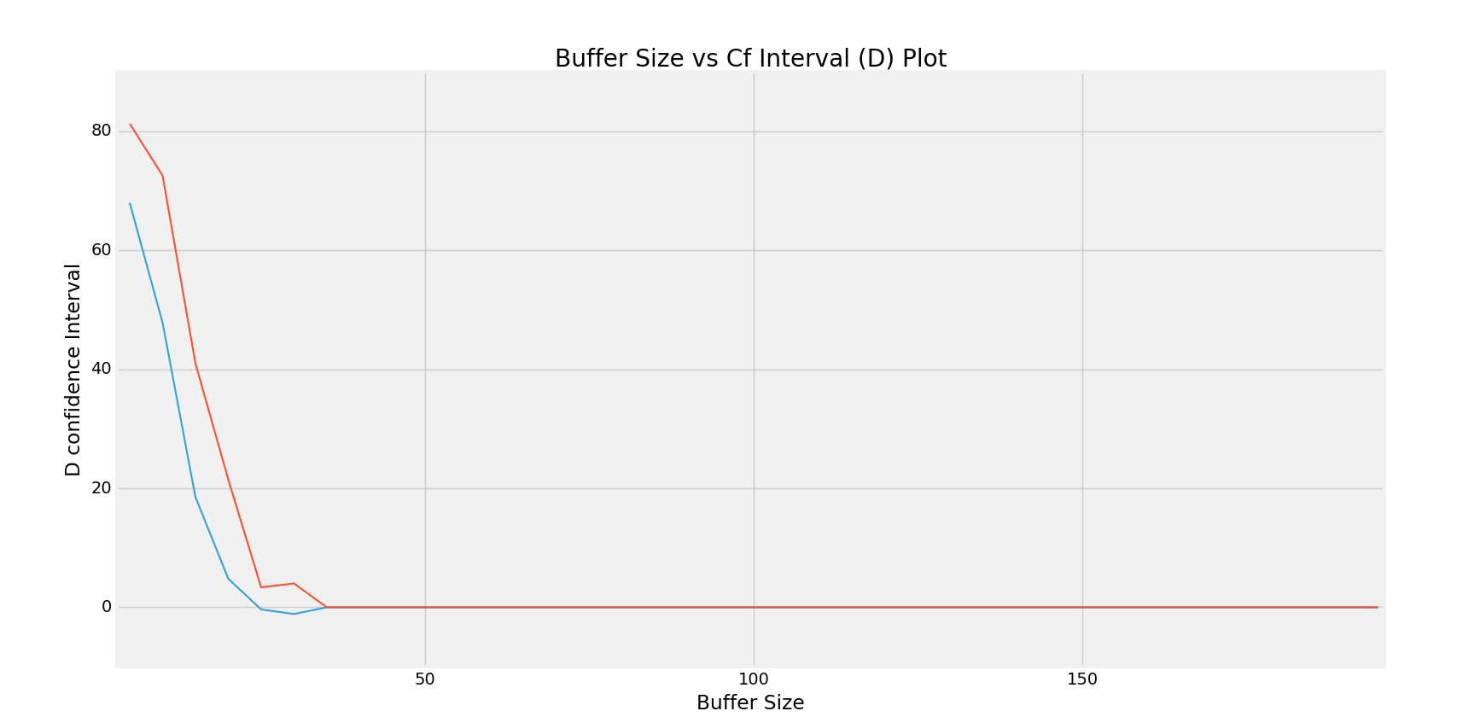

**Comments: With increasing buffer size, the CFI for D comes down to zero as retransmissions keep decreasing as buffer size increases**

**Value of D CFI for 39 observations (Buffer = 5, 10, 15, …195)**

(67.965327105676707, 81.259067429401128), (47.818089074701803, 72.555311193879902), (18.538465167261272, 41.003906699994346), (4.80079403341907, 21.479753607397207), (-0.35613878329196558, 3.3478454499586268), (-1.1245389407542652, 4.005370686785934), (0.0, 0.0), (0.0, 0.0), (0.0, 0.0), (0.0, 0.0), (0.0, 0.0), (0.0, 0.0), (0.0, 0.0), (0.0, 0.0), (0.0, 0.0), (0.0, 0.0), (0.0, 0.0), (0.0, 0.0), (0.0, 0.0), (0.0, 0.0), (0.0, 0.0), (0.0, 0.0), (0.0, 0.0), (0.0, 0.0), (0.0, 0.0), (0.0, 0.0), (0.0, 0.0), (0.0, 0.0), (0.0, 0.0), (0.0, 0.0), (0.0, 0.0), (0.0, 0.0), (0.0, 0.0), (0.0, 0.0), (0.0, 0.0), (0.0, 0.0), (0.0, 0.0), (0.0, 0.0), (0.0, 0.0)

1. **Mean value of P**

18016.468400000002, 18106.546399999999, 18105.130400000002, 18109.334199999998, 17992.02, 18145.009599999998, 18031.493599999998, 18136.654000000002, 18089.762000000002, 18127.941200000005, 18136.809600000001, 18197.622599999999, 18115.695199999998, 17937.665799999995, 18169.5524, 18122.443800000008, 18130.250199999999, 18000.936800000003, 17979.152600000001, 18116.810600000001, 18102.728600000002, 18043.852599999998, 18037.525000000001, 18078.376199999999, 18033.911000000004, 18018.147199999999, 18142.346600000001, 18137.618999999999, 18128.656000000003, 18046.065199999997, 18029.406199999998, 17958.254400000002, 18055.0798, 17995.206200000001, 18064.909800000001, 18120.074000000001, 18053.861000000004, 17997.7212, 18076.992200000001

**Mean value of P remains almost unchanged**

**Values for confidence interval of P**

(17875.162023648929, 18157.774776351074), (17942.17664593158, 18270.916154068418), (17957.693744621029, 18252.567055378975), (17968.155080873184, 18250.513319126811), (17854.504565322615, 18129.535434677386), (17994.463532293528, 18295.555667706467), (17889.634511573648, 18173.352688426348), (18005.62515977646, 18267.682840223544), (17953.591505196546, 18225.932494803459), (17968.664300271856, 18287.218099728154), (18004.459549067458, 18269.159650932543), (18065.715082938113, 18329.530117061884), (17988.072198276615, 18243.318201723381), (17760.378714898026, 18114.952885101964), (18019.493823456669, 18319.610976543332), (17962.369826623948, 18282.517773376068), (17978.425168896585, 18282.075231103412), (17858.409637229775, 18143.463962770231), (17863.164308987412, 18095.14089101259), (17964.667224043675, 18268.953975956327), (17942.109703034042, 18263.347496965962), (17903.419872323626, 18184.285327676371), (17893.009428478847, 18182.040571521156), (17935.961441296855, 18220.790958703143), (17905.744502312707, 18162.0774976873), (17857.545707147165, 18178.748692852834), (18013.759378409766, 18270.933821590235), (17999.89165202836, 18275.346347971637), (17952.058007320793, 18305.253992679212), (17858.065559057559, 18234.064840942436), (17866.554323373046, 18192.258076626949), (17810.673266326401, 18105.835533673602), (17899.116817217498, 18211.042782782501), (17848.66708698907, 18141.745313010932), (17925.078064146059, 18204.741535853944), (17961.880232286421, 18278.26776771358), (17914.066920128225, 18193.655079871784), (17851.11107873288, 18144.33132126712), (17908.436098153888, 18245.548301846113)

**Comments: Confidence interval of P is on an average not changing with increased buffer size**