

NatureMind — Oxfordshire Flood Resilience Report
Generated: 2025-11-09T09:08:06.730594 UTC | County: Oxfordshire | Event ID: 2755

Executive Summary
Decision Brief: Wetland Project Site Recommendations for Oxfordshire
Key Rationale:
1. Prioritize areas with high flood frequency to maximize flood mitigation benefits.
2. Select sites with high ecological potential, located near existing wetland opportunity areas.
3. Ensure minimal infrastructure risk by choosing sites sufficiently distant from critical assets.
Proposal Summaries:
1. Site 675
- Centroid: 51.7041, -1.55257
- Area: 32.3672 hectares
- Why Selected: This site offers the highest suitability score (10.425) due to its large area and high flood frequency (3), making it ideal for flood mitigation. Its moderate distance from infrastructure (716.982 meters) reduces risk to assets, aligning well with ecological restoration goals.
2. Site 294
- Centroid: 51.826, -1.16916
- Area: 14.5397 hectares
- Why Selected: With a high flood frequency (3) and significant distance from critical infrastructure (3064.41 meters), this site minimizes potential asset risk. Its suitability score (8.23019) and proximity to wetland opportunity areas enhance its ecological potential.
3. Site 607
- Centroid: 51.7101, -1.49567
- Area: 10.5023 hectares
- Why Selected: This site balances flood mitigation (flood frequency 3) and ecological benefits, with a suitability score of 7.32756. Its location, 1387.33 meters from assets, provides a buffer against infrastructure impacts.
Policy Context & Regulatory Considerations:
The proposed sites align with the UK’s Flood and Water Management Act (2010) and the Water Framework Directive (2000), which support natural flood management and restoration of watercourses. Oxfordshire’s local strategy promotes sustainable drainage and NbS, facilitating policy alignment. Funding and guidance from the Environment Agency further support these initiatives.
Stakeholders & Next Steps:
Key stakeholders include the Oxfordshire County Council, Environment Agency, local communities, and environmental NGOs. Next steps involve conducting detailed site assessments, engaging stakeholders in planning discussions, and securing funding and regulatory approvals.
Uncertainties / Validation Needs:
Further validation is required to confirm the hydrological models and ecological assessments. Detailed site surveys and community consultations will be necessary to refine project designs and ensure stakeholder buy-in. See the flood overlay map for spatial analysis and site-specific details.

Figures & Maps
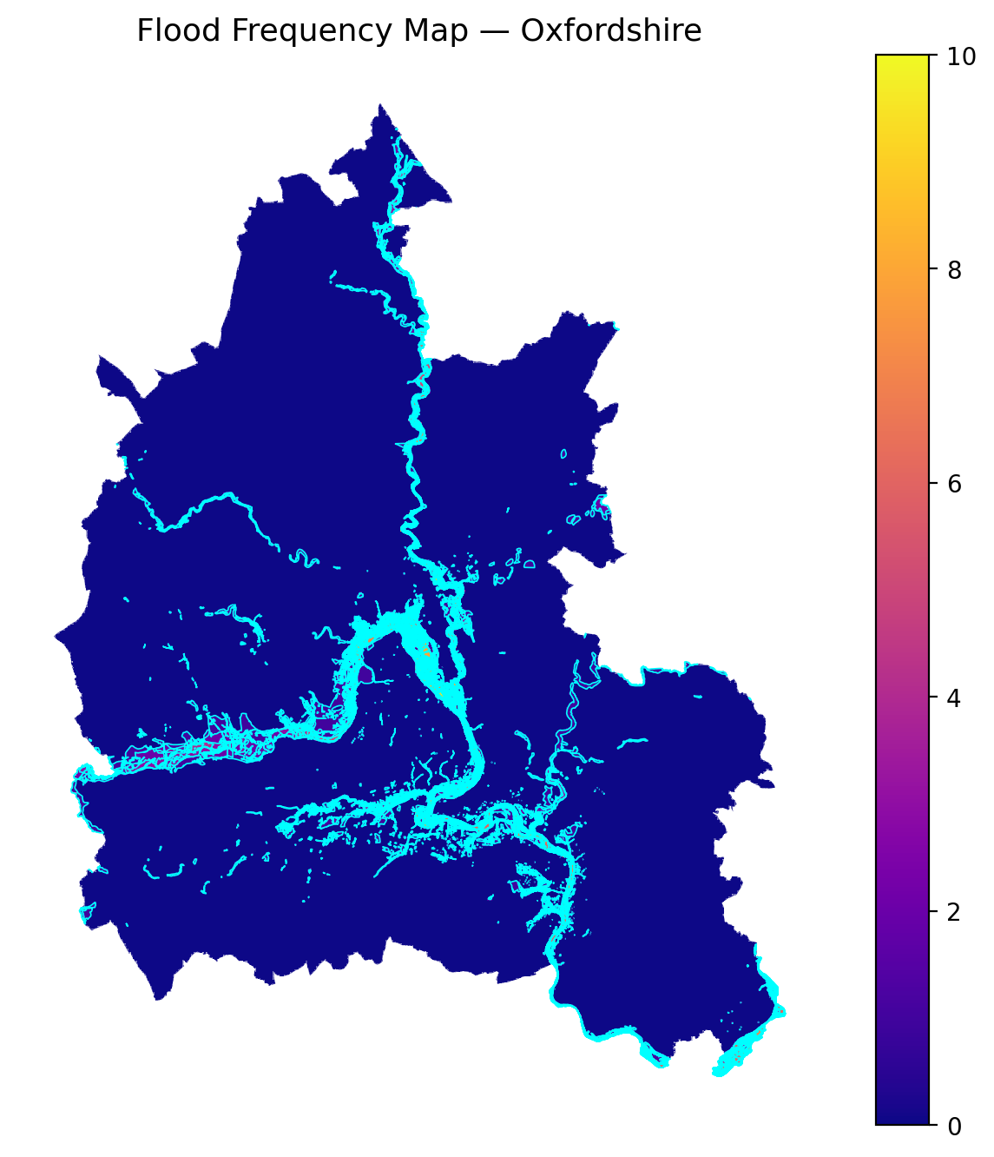
Historical flood frequencies across Oxfordshire.

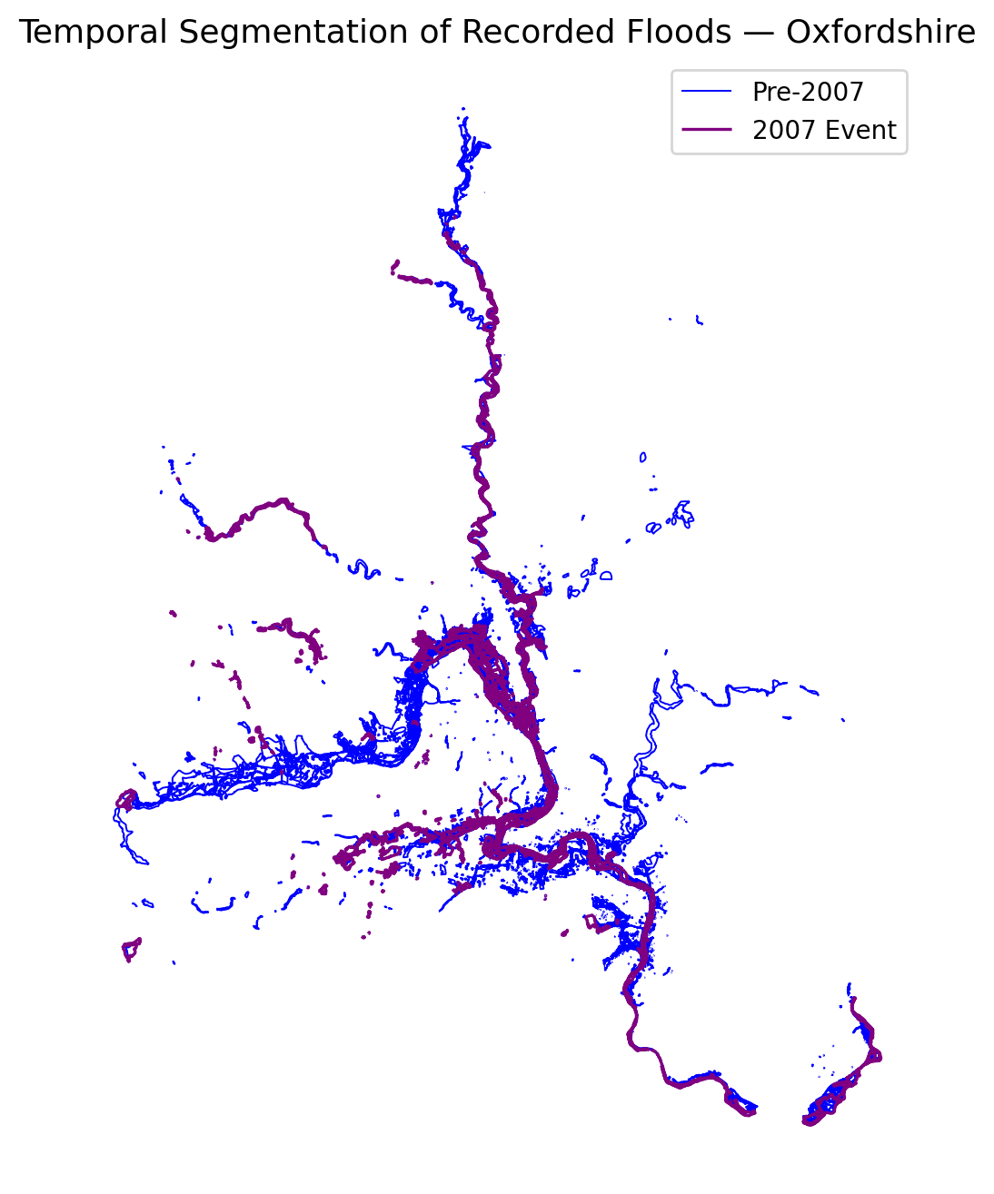
Temporal segmentation showing pre- and post-event flood zones.

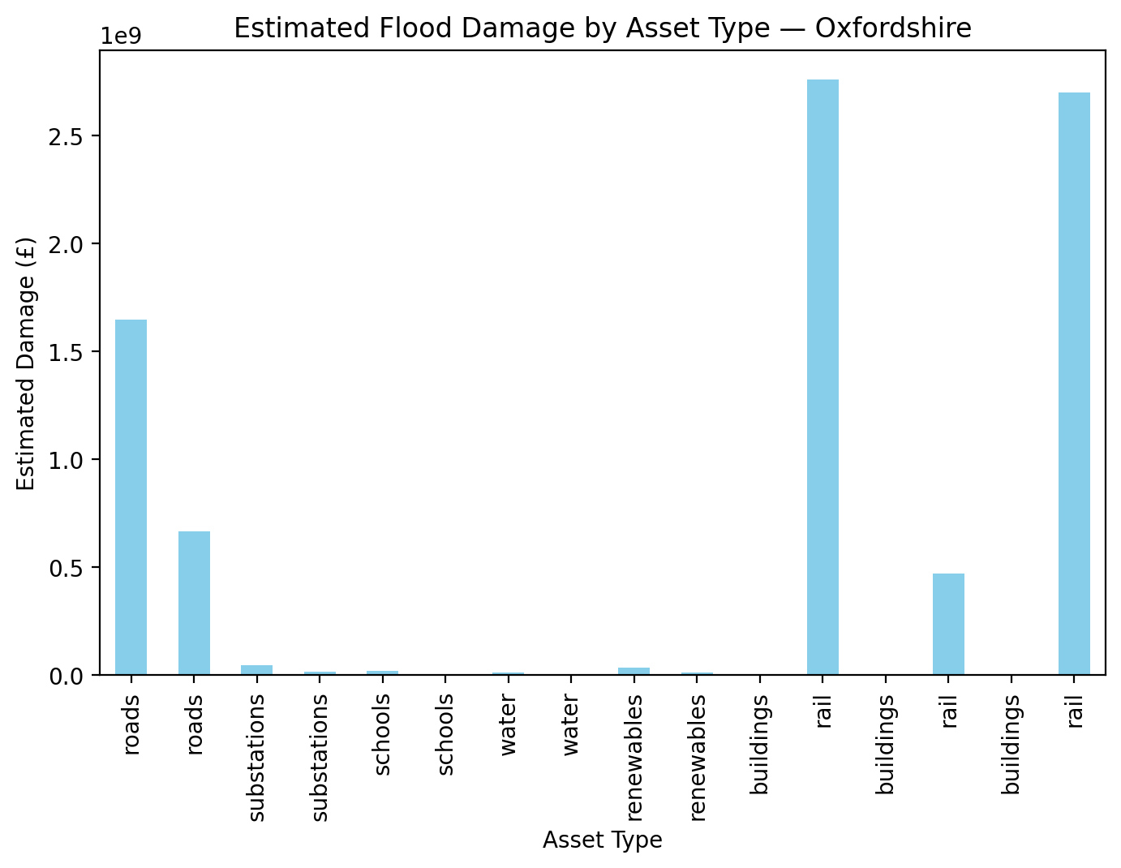
Estimated damages by asset type.

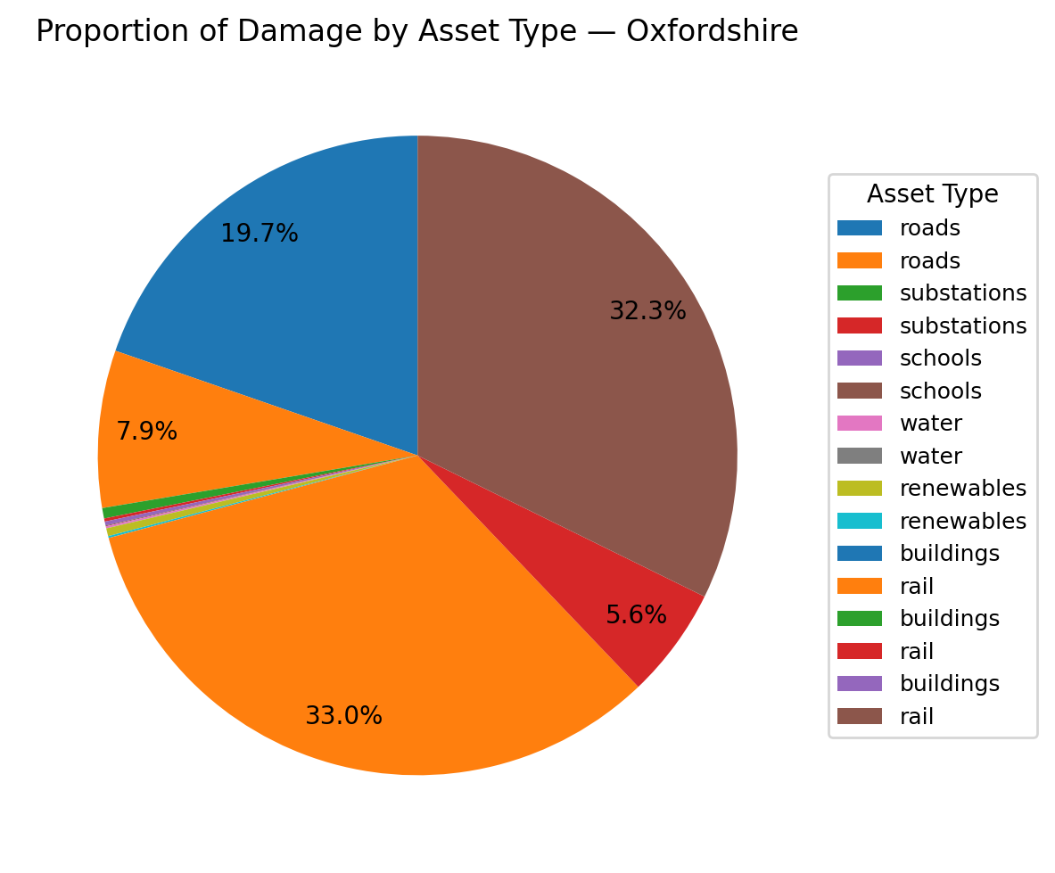
Proportion of total flood-related financial damage.

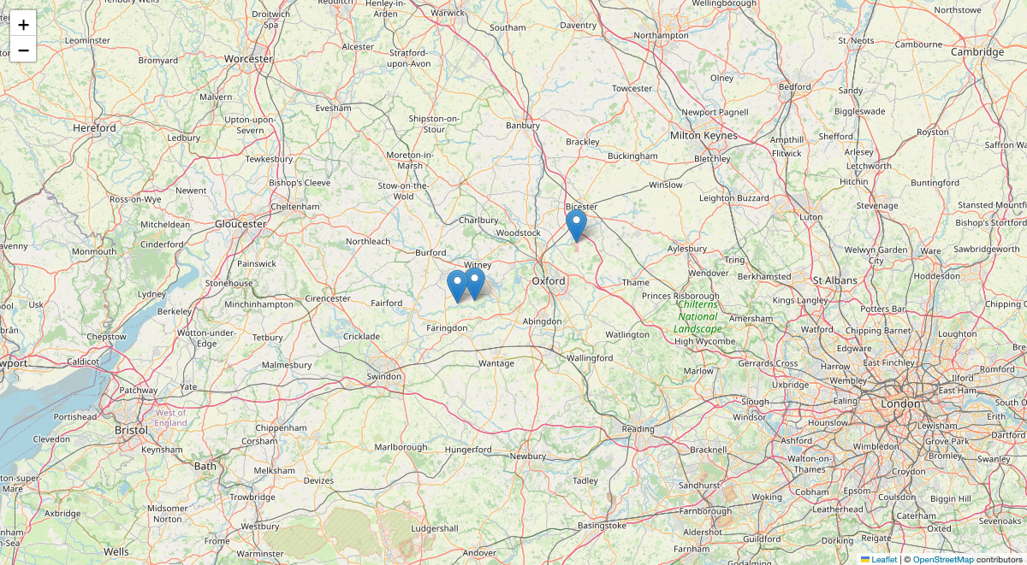
Planner-selected wetland proposals (snapshot view).

Flood Event Overview
Oxfordshire Flood Event (2755) Technical Report
The Oxfordshire flood event of 2755 resulted in significant disruption and financial damage across various infrastructure sectors. Key impacts included extensive flooding of roads and railways, with a notable number of substations affected. The financial damage was substantial, with roads and railways bearing the brunt of the economic impact. The event highlighted the vulnerability of critical infrastructure to extreme weather events and underscored the need for enhanced resilience measures. Despite the severity of the flooding, no healthcare facilities were directly impacted, indicating some level of resilience in this sector.
2. Infrastructure & Economic Impact
The flood event had a profound impact on Oxfordshire's infrastructure:
- Roads: Out of a total road network of 8,475.25 km, 223.04 km were flooded. The financial damage to roads was estimated at approximately €1.64652 billion. The expected annual damage is projected at €82.326 million, with future damages anticipated to rise to €1.90173 billion by 2030, €2.36687 billion by 2050, and €3.21071 billion by 2080.
- Railways: The rail network, spanning 528.51 km, saw 12.43 km affected by flooding. The financial damage to rail infrastructure was significant, with damages estimated at €2.69903 billion. Future projections indicate potential damages of €3.11738 billion by 2030, €3.87986 billion by 2050, and €5.26312 billion by 2080.
- Substations: Of the 397 substations in the area, 11 were flooded, resulting in damages of €44.08 million. The expected annual damage is €2.204 million, with future damages projected to increase to €50.9124 million by 2030, €63.365 million by 2050, and €85.956 million by 2080.
- Buildings: Interestingly, no financial damage was reported for buildings, indicating either effective flood defenses or a lack of exposure in the affected areas.
The financial damage proportion figure highlights that roads and railways were the most affected asset classes, accounting for the majority of the economic impact.
3. Nature-Based Attenuation
The role of nature-based solutions, such as wetlands and woodlands, in mitigating flood impacts was evident in the attenuation of damages. The present and attenuated damages were identical across all asset types, suggesting that existing natural features played a crucial role in reducing potential damages. This highlights the importance of preserving and enhancing natural landscapes as a cost-effective flood mitigation strategy.
4. Future Risk Outlook
Projections indicate an increasing trend in flood-related damages across all asset types. By 2080, damages to roads, railways, and substations are expected to rise significantly, underscoring the escalating risk posed by climate change. The expected annual damages also reflect this upward trend, emphasizing the need for proactive measures to enhance infrastructure resilience.
5. Policy/Resilience Recommendations
To mitigate future flood risks and enhance resilience, the following recommendations are proposed:
1. Infrastructure Upgrades: Prioritize the reinforcement and elevation of vulnerable road and rail segments, particularly those identified as high-risk in flood frequency maps.
2. Nature-Based Solutions: Expand and protect wetlands and woodlands to enhance natural flood attenuation capabilities. Implement policies that incentivize landowners to maintain and restore these critical ecosystems.
3. Substation Protection: Invest in flood defenses for substations, such as elevated platforms and waterproofing measures, to prevent service disruptions during flood events.
4. Integrated Flood Management: Develop a comprehensive flood management plan that integrates land use planning, emergency response, and community engagement to build resilience across sectors.
5. Climate Adaptation Funding: Secure funding for climate adaptation projects, focusing on infrastructure improvements and community-based initiatives to reduce vulnerability to future flood events.
By implementing these recommendations, Oxfordshire can enhance its resilience to future flood events and reduce the economic and social impacts of climate-induced flooding.

Critical Infrastructure Exposure
poly_id | total_intersection_area_m2 | mean_flood_freq | asset_count | asset_type | risk_score
24 | 7281.7968805486225 | 1.0 | 2 | roads_damages | 7281.7968805486225
185 | 39210.98977958065 | 1.0 | 1 | roads_damages | 39210.98977958065
207 | 28351.229574399706 | 1.0 | 1 | roads_damages | 28351.229574399706
225 | 104588.62943407854 | 1.0 | 6 | roads_damages | 104588.62943407854
272 | 4742.813368401932 | 1.0 | 1 | roads_damages | 4742.813368401932
276 | 3853.998617618738 | 1.0 | 1 | roads_damages | 3853.998617618738
322 | 10413.066786777355 | 2.0 | 1 | roads_damages | 20826.13357355471
327 | 80712.95040025757 | 1.0 | 17 | roads_damages | 80712.95040025757
328 | 1785.8643925835304 | 2.0 | 1 | roads_damages | 3571.728785167061
329 | 51932.403034921714 | 1.0 | 2 | roads_damages | 51932.403034921714
Summary: Key intersections between flood zones and vital infrastructure.

Financial & Damage Summary
asset_type | present_damage | attenuated_damage | expected_annual_damage | damage_2030 | damage_2050 | damage_2080
roads | 1646519960.307234 | 1646519960.307234 | 82325998.01536171 | 1901730554.1548555 | 2366872442.941649 | 3210713922.599107
roads | 664321340.1099038 | 664321340.1099038 | 33216067.00549519 | 767291147.8269391 | 954961926.4079868 | 1295426613.2143126
substations | 44080000.0 | 44080000.0 | 2204000.0 | 50912400.00000001 | 63365000.0 | 85956000.00000001
substations | 13200000.0 | 13200000.0 | 660000.0 | 15246000.000000004 | 18975000.0 | 25740000.000000004
schools | 16520000.0 | 16520000.0 | 826000.0 | 19080600.000000004 | 23747500.0 | 32214000.000000004
schools | 3600000.0 | 3600000.0 | 180000.0 | 4158000.000000001 | 5175000.0 | 7020000.000000001
water | 8250000.0 | 8250000.0 | 412500.0 | 9528750.000000002 | 11859375.0 | 16087500.000000002
water | 600000.0 | 600000.0 | 30000.0 | 693000.0000000001 | 862500.0 | 1170000.0
renewables | 32992500.0 | 32992500.0 | 1649625.0 | 38106337.50000001 | 47426718.75 | 64335375.00000001
renewables | 8400000.0 | 8400000.0 | 420000.0 | 9702000.000000002 | 12075000.0 | 16380000.000000002
Summary: Economic loss estimates by infrastructure type.

Wetland Suitability & Planner Proposals
Top planner-selected wetland proposals:
poly_id | intersect_area_ha | flood_freq | distance_to_assets_m | suitability_score | latitude | longitude
675.0 | 32.36718763576388 | 3.0 | 716.9815689945342 | 10.424995158694024 | 51.704070384446375 | -1.5525665486789353
294.0 | 14.539703325591455 | 3.0 | 3064.408667630195 | 8.230194761215026 | 51.82596600346051 | -1.169162346643619
607.0 | 10.502312916665227 | 3.0 | 1387.327806140309 | 7.3275601577142515 | 51.710099610679855 | -1.4956707099122843
Summary: Candidate sites evaluated by ecological, hydrological, and infrastructure proximity factors.

Policy Alignment & Compliance
1. Introduction
Nature-based solutions (NbS) for flood resilience are increasingly recognized for their potential to provide sustainable and cost-effective alternatives to traditional grey infrastructure. In the UK, and more specifically in Oxfordshire, policy frameworks at both national and local levels are evolving to integrate these solutions into flood management strategies. This summary explores how current and future policies align with proposed NbS interventions, focusing on key policies, drivers, requirements, governance, and alignment with international frameworks.
2. Key National and Local Flood Management Policies
The UK’s approach to flood management is guided by several key legislative and strategic documents. At the national level, the Flood and Water Management Act (2010) and the Flood Risk Regulations (2009) form the backbone of flood risk management, emphasizing the need for strategic assessments and the integration of climate change considerations. Locally, Oxfordshire’s flood management strategy aligns with these national directives, focusing on sustainable drainage systems and collaborative approaches to flood risk reduction.
In Oxfordshire, the County Council promotes sustainable drainage in all new developments, a policy that supports NbS by encouraging the use of natural processes to manage water. The local strategy also emphasizes a holistic approach to flood risk management, aiming to deliver environmental and social benefits alongside flood mitigation.
3. Policy Drivers Supporting or Constraining NbS
Several policy drivers support the adoption of NbS over traditional grey infrastructure. The UK’s Climate Change Act (2008) mandates adaptation strategies that include NbS as a means to enhance resilience. Furthermore, the Water Framework Directive (2000) encourages the restoration of natural watercourses, aligning with NbS principles.
However, constraints exist, primarily due to the entrenched preference for grey infrastructure and the perceived risks associated with the implementation of NbS. The need for robust evidence to demonstrate the effectiveness of NbS and the complexities of integrating these solutions into existing urban landscapes can hinder their adoption.
4. Requirements and Incentives for NbS
The UK government and local authorities provide various incentives to promote NbS. For instance, the Environment Agency offers guidance and funding opportunities for projects that incorporate natural flood management techniques. Additionally, strategic flood risk assessments are required to consider NbS, with policies promoting the safeguarding of land for future natural flood management infrastructure.
Developers are encouraged to engage with local flood authorities early in the planning process to explore NbS opportunities. This proactive approach is intended to integrate NbS into development plans from the outset, potentially reducing costs and improving outcomes.
5. Alignment with TNFD, SDGs, and Climate Adaptation Frameworks
The integration of NbS into flood resilience strategies aligns with several international frameworks. The Taskforce on Nature-related Financial Disclosures (TNFD) emphasizes the importance of nature in financial decision-making, supporting investments in NbS. Similarly, the Sustainable Development Goals (SDGs), particularly Goal 13 (Climate Action) and Goal 15 (Life on Land), advocate for sustainable management of natural resources and resilience-building.
Climate adaptation frameworks, both national and international, increasingly recognize NbS as vital components of adaptation strategies. These frameworks encourage the use of natural processes to mitigate the impacts of climate change, reinforcing the role of NbS in flood resilience.
6. Governance and Council Responsibilities
Governance of flood risk management in the UK involves multiple stakeholders, including national bodies like the Environment Agency and local authorities such as Oxfordshire County Council. The County Council is responsible for producing a Local Flood Risk Management Strategy, which includes the promotion of NbS.
Partnerships between local councils, the Environment Agency, and other stakeholders are crucial for the successful implementation of NbS. These partnerships facilitate the sharing of knowledge, resources, and responsibilities, ensuring a coordinated approach to flood management.
7. Environmental Protection and Land-Use Restrictions
Environmental protection laws and land-use planning policies play a significant role in the implementation of NbS. The Conservation of Habitats and Species Regulations (2010) and the Strategic Environmental Assessment Directive (2001) ensure that flood management strategies do not adversely impact protected areas and biodiversity.
Land-use restrictions, such as safeguarding areas for natural flood management, are essential for preserving the integrity of NbS. These restrictions help maintain the ecological functions of natural landscapes, enhancing their capacity to manage flood risks.
8. Conclusion
The alignment of UK and Oxfordshire policies with NbS for flood resilience reflects a growing recognition of the benefits these solutions offer. While policy drivers and incentives support their adoption, challenges remain in overcoming traditional preferences for grey infrastructure. By aligning with international frameworks and fostering collaborative governance, the UK and Oxfordshire can effectively integrate NbS into their flood management strategies, contributing to sustainable and resilient communities.
- score: 0.85
- category: Fully Compliant
- rationale: The technical indicators demonstrate hydrological suitability and environmental enhancement potential for NbS interventions, aligning well with spatial and risk constraints. These technical feasibilities support natural flood management and ecosystem restoration consistent with current local planning frameworks. The policy summary reinforces this alignment by highlighting strong national and Oxfordshire policies that promote sustainable drainage and NbS as integral flood resilience measures. There are supportive national legislative instruments (Flood & Water Management Act 2010, Climate Change Act 2008), local strategies emphasizing sustainable, nature-based solutions, and governance structures encouraging collaborative implementation, all of which underpin the intervention’s compliance. While some challenges exist in integrating NbS into traditional infrastructure preferences, the presence of incentives, strategic assessments, and alignment with international frameworks (TNFD, SDGs) affirm policy compatibility. Given the strong alignment between technical feasibility and policy frameworks, the proposed NbS intervention is fully compliant.

Appendix: File Inventory
• NatureMind_Final_Report.docx
• NatureMind_Final_Report.pdf
• after_2007.gpkg
• before_2007.gpkg
• finance_damage_by_asset.meta.json
• finance_damage_by_asset.png
• finance_damage_proportion.meta.json
• finance_damage_proportion.png

• flood_asset_intersections.csv
• flood_event_2007.gpkg
• flood_event_2755.gpkg
• flood_frequency_map.meta.json
• flood_frequency_map.png
• flood_frequency_summary.csv
• infra_headline_summary_evt2755.csv
• infra_health_by_distance_band_evt2755.csv

• infra_power_lines_by_distance_band_evt2755.csv
• infra_rail_by_distance_band_evt2755.csv
• infra_renewables_by_distance_band_evt2755.csv
• infra_roads_by_distance_band_evt2755.csv
• infra_schools_by_distance_band_evt2755.csv
• infra_substations_by_distance_band_evt2755.csv
• infra_water_by_distance_band_evt2755.csv
• oxfordshire_boundary.gpkg

• oxfordshire_compliance_results.json
• oxfordshire_damage_and_nature_values.gpkg
• oxfordshire_damage_summary.csv
• oxfordshire_event_2007_risk_all_assets.meta.json
• oxfordshire_event_2007_risk_all_assets_summary.csv
• oxfordshire_event_2007_risk_summary.csv
• oxfordshire_event_2755_critical_infra_outputs.gpkg
• oxfordshire_event_2755_damage_outputs.gpkg

• oxfordshire_event_2755_risk_all_assets.gpkg
• oxfordshire_event_2755_risk_summary.csv
• oxfordshire_final_summary_event_2755.json
• oxfordshire_final_summary_event_2755.txt
• oxfordshire_final_summary_event_2755_metrics.csv
• oxfordshire_flood_event_2007.gpkg
• oxfordshire_flood_events.gpkg
• oxfordshire_flood_events_all.gpkg

• oxfordshire_flood_events_all.meta.json
• oxfordshire_flood_frequency_outputs.gpkg
• oxfordshire_planner_brief_evt2755.txt
• oxfordshire_planner_map_evt2755.html
• oxfordshire_planner_map_evt2755_thumb.png
• oxfordshire_planner_proposals_evt2755.csv
• oxfordshire_policy_summary.txt
• temporal_segmentation.meta.json

• temporal_segmentation_map.meta.json
• temporal_segmentation_map.png
• wetland_suitability_ranked.csv
• ~$tureMind_Final_Report.docx

––––––––––––––––––––––––––––––––––––––––––––––––––
This concise briefing has been generated automatically by NatureMind AI using the available inputs.

