**Application Structure.**

There are two layers in the Application

* EmployeeDataAccess - This is used for the database connection using EntityFramework.
* EmployeeService – This is the API service which does all the insert, update, create and delete functionality in the database.

1.Create a table using the script provided below:

CREATE TABLE ContactInfo (

Id int IDENTITY(1,1) PRIMARY KEY,

FirstName varchar(255) NOT NULL,

LastName varchar(255),

Email varchar(255),

PhoneNumber int,

ContactStatus varchar(255)

);

2.Change the connection string in Web.Config File.

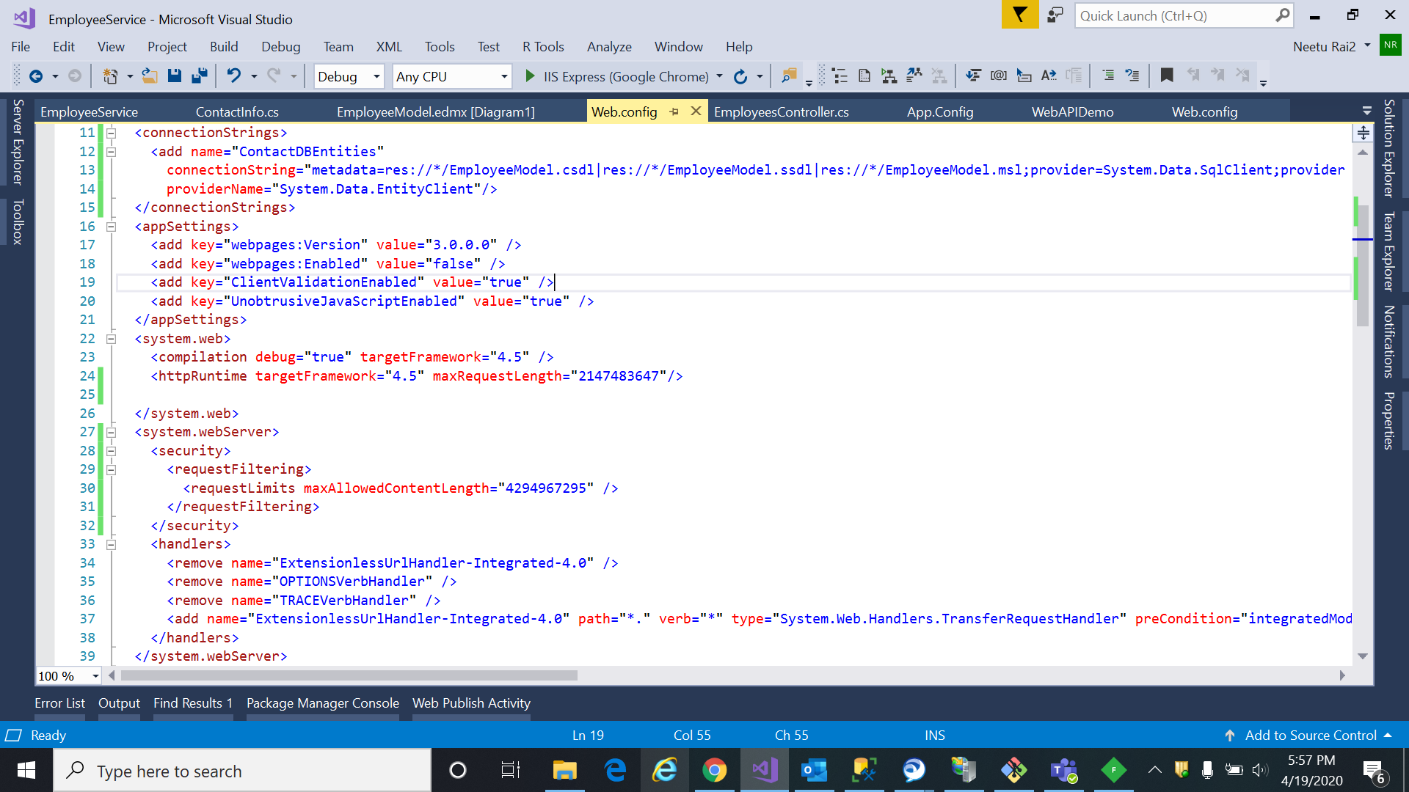

Make Sure the Entity Framework is installed along with the .net Framework to get connected with the database.

Use a 3rd Party Tool to test the API . I have used Fiddler and attached the unit test result.