Question 3

1. Git clone <https://github.com/Neetz78/DATA541_gitversion.git>

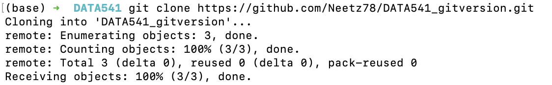

1. cd DATA541gitversion
2. git checkout -b Markdown

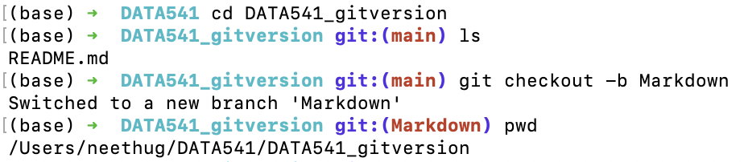

1. git status

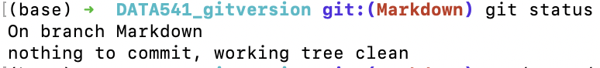

1. cp /Users/neethug/DATA541/DATA541_Lab3/lab3_q1.md lab3_q1.md

cp /Users/neethug/DATA541/DATA541_Lab3/lab3_q2.md lab3_q2.md

git and -A

git commit -m “Adding lab Question 1 & 2”

git push -u origin Markdown

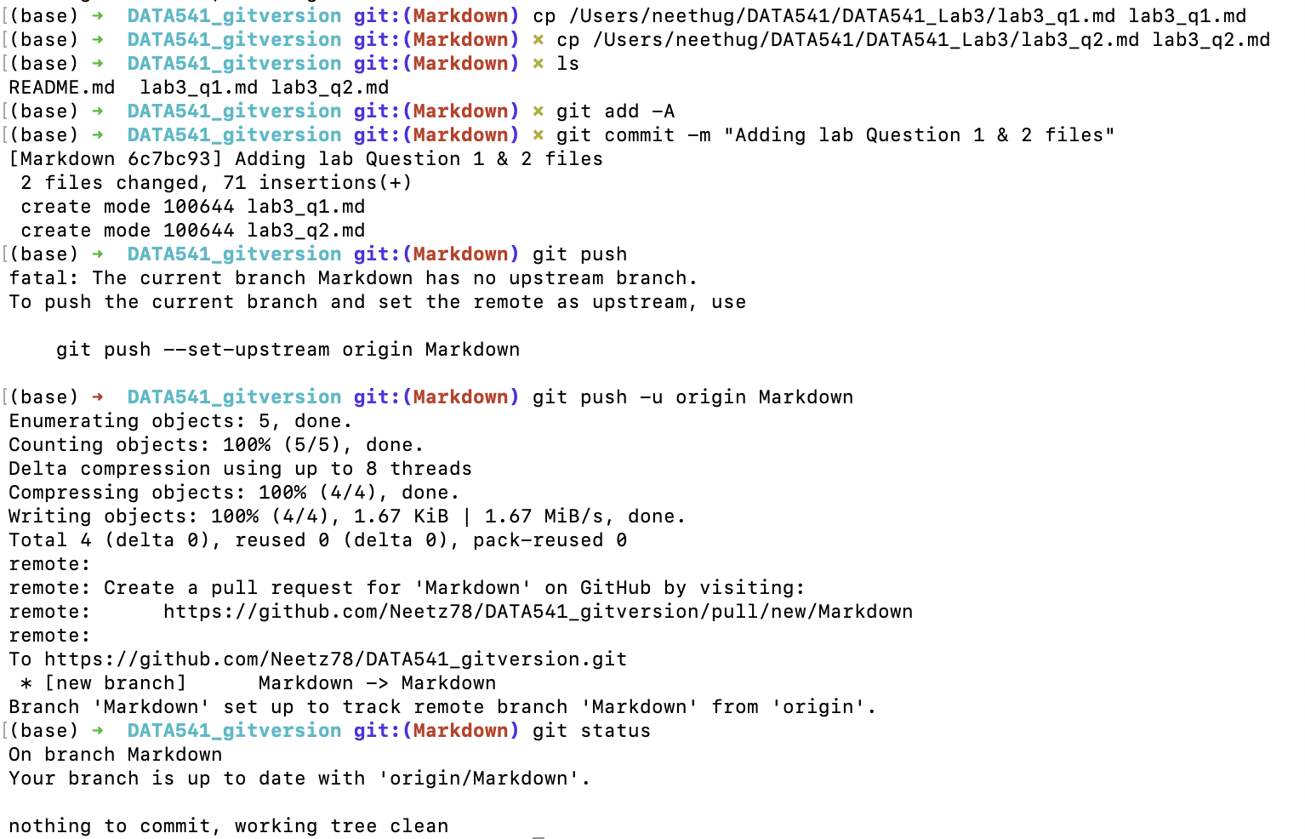

1. Mardown branch created in git.

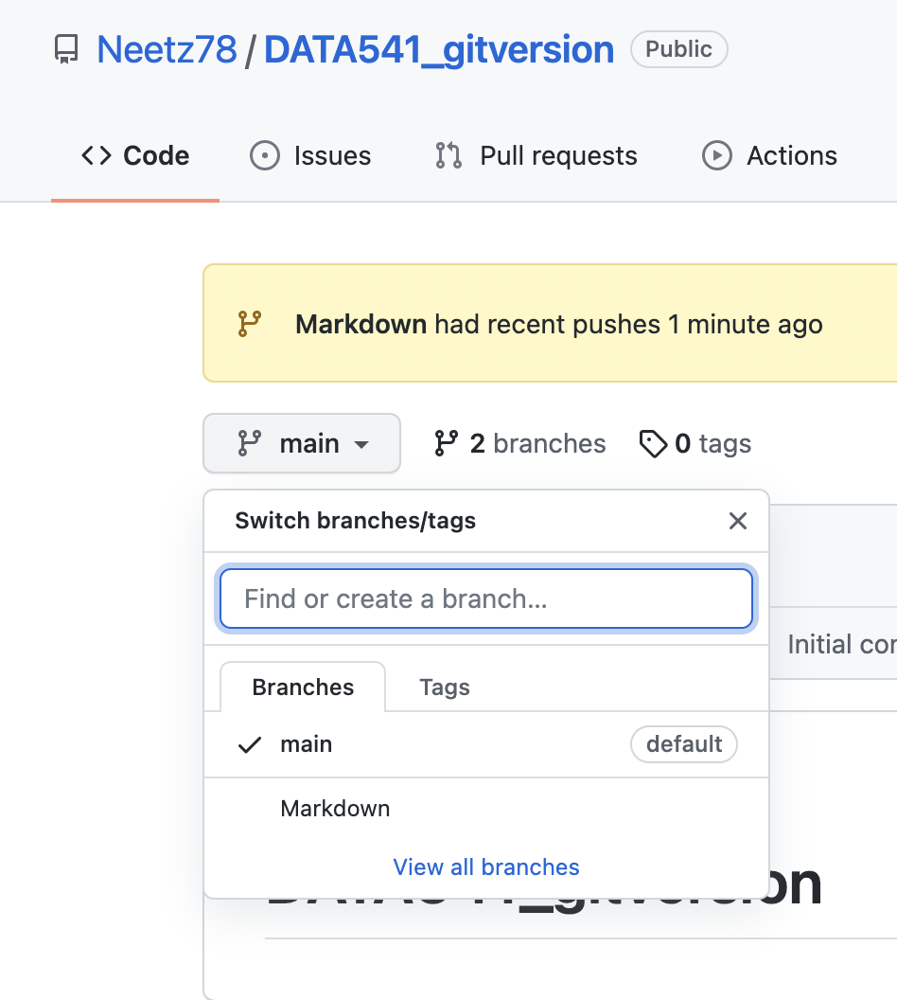

Question 4

1. Git checkout main
2. Git merge –allow-unrelated-histories Markdown
3. Git add -A
4. Git commit -m “Pushing files to git after merge”
5. Git push

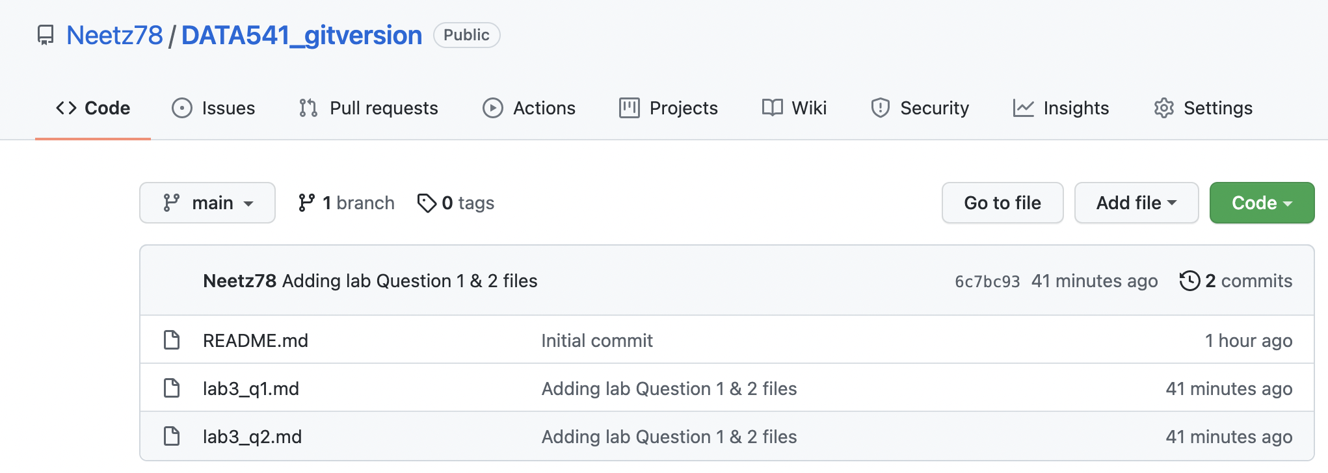

1. Git branch -d Markdown
2. Git log –pretty=oneline

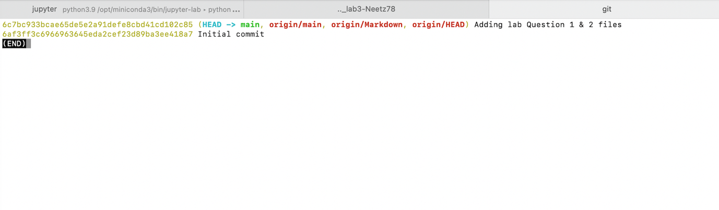

1. Git push origin –delete Markdown

