
Course Name: | Web Development Laboratory (316U01L306) | Semester: | III
Date of Performance: | 15 / 07 / 2026 | DIV / Batch No: | B - 3
Student Name: | Pranav Mendon | Roll No: | 16010125138

Experiment No: 1
Title: Design and Development of an AI-based Smart Irrigation Advisory Web Portal Front-End using HTML5

Aim of the Experiment: To design and develop a multi-page, use-case-based web portal front-end using HTML5 for an AI-based Smart Irrigation Advisory System for sugarcane crops (KJS-AGR-01), incorporating semantic structure, lists, text formatting, multimedia, interactive client-side image maps, responsive tables, and forms.

Objectives of the Experiment:
• 1. To develop structured and semantic HTML5 web pages for an AI-enabled smart irrigation advisory system.
• 2. To create interactive web pages for farmer registration, irrigation recommendations, and weather forecast display.
• 3. To apply real-world agricultural IoT use case telemetry as the core theme across all modular pages.
• 4. To implement HTML5 lists, tables, image maps, forms, and multimedia elements without external libraries.
• 5. To build a robust, accessible foundation ready for subsequent CSS3 styling and JavaScript validation layers.

COs to be achieved: CO1: Developing webpages using HTML and CSS.

Books / Journals / Websites references:
• 1. MDN Web Docs – HTML: HyperText Markup Language, Mozilla Developer Network, 2026. https://developer.mozilla.org/en-US/docs/Web/HTML
• 2. W3Schools – HTML5 Tutorial and Semantic Web Guide, Refsnes Data, 2026. https://www.w3schools.com/html/
• 3. J. Duckett, HTML and CSS: Design and Build Websites, 1st ed., Indianapolis, IN: John Wiley & Sons, 2011.

Theory / Relevant Concepts: HyperText Markup Language 5 (HTML5) is the core standard for structuring and presenting content on the World Wide Web [1]. HTML5 introduces semantic tags that provide explicit meaning to both browsers and search engines, superseding legacy generic '<div>' elements.
Key HTML5 Modules Used in This Portal:
1. Semantic Structural Elements: Elements including '<header>', '<nav>', '<main>', '<section>', '<article>', '<aside>', and '<footer>' delineate the layout hierarchy and ensure accessibility.
2. Information Representation via Lists: Ordered lists ('<ol>'), unordered lists ('<ul>'), nested lists, and description lists ('<dl>') organize sensor telemetry collection sequences, agricultural parameters, and domain abbreviations.
3. Tabular Data Structures: Complex tables utilizing '<thead>', '<tbody>', '<tfoot>', '<th>', '<caption>', along with 'rowspan' and 'colspan' attributes present multi-zone sugarcane soil moisture thresholds, irrigation schedules, and weather dependencies.
4. Client-Side Image Maps: The '<map>' and '<area>' tags enable coordinates-based interactive navigation on aerial farm plot imagery.
5. Comprehensive HTML5 Forms: Semantic input controls ('text', 'tel', 'email', 'number', 'date', 'select', 'textarea') enclosed within '<fieldset>' and '<legend>' containers enable structured data acquisition.
6. Embedded Media & Iframes: Native '<audio>' and '<video>' elements deliver farmer training media without third-party plugins, while '<iframe>' embeds georeferenced GIS telemetry radar.

Step by Step Implementation / Procedure: 1. Define the website wireframe and modular multi-page hierarchy for the Sugarcane Advisory System (KJS-AGR-01).
2. Task 1: Construct the primary portal layout in 'index.html' using semantic tags (<header>, <nav>, <main>, <aside>, <footer>).
3. Task 2: Create 'farm-information.html' to present telemetry workflows and abbreviations using ordered, unordered, and definition lists.
4. Task 3: Build 'irrigation-advisory.html' employing HTML formatting tags (<strong>, <em>, <mark>, <abbr>, <sub>, <sup>).
5. Task 4: Construct the precision agriculture gallery in 'index.html' using semantic <figure>, <img>, and <figcaption> tags.
6. Task 5: Implement 'farm-map.html' with a client-side <map> and rectangular/polygonal <area> coordinates linking to plot advisories.
7. Task 6: Build 'recommendation.html' with structured <table>, <thead>, <tbody>, <tfoot>, rowspan, and colspan attributes.
8. Task 7: Design the farmer registration form in 'registration.html' with required fieldsets, inputs, and validation attributes.
9. Task 8: Embed an OpenStreetMap GIS radar iframe into 'media.html' for live field coordinates tracking.
10. Task 9: Embed awareness video and audio broadcasting elements in 'media.html' using native HTML5 media tags.

HTML5 Source Code Snippets:
Task 1: Semantic Homepage Structure (index.html)
<!-- index.html excerpt -->
<header class="layout-header">
<p class="org-name"><img class="logo" src="./images/image.png" alt="org logo"> Agricultural Advisory Organization</p>
<h1 class="page-name">Smart Irrigation Advisory System</h1>
</header>
<nav class="site-nav">
<ul class="nav-menu">
<li><a href="index.html">Home</a></li>
<li><a href="irrigation-advisory.html">Irrigation Advisory</a></li>
<li><a href="farm-information.html">Farm Information</a></li>
<li><a href="farm-map.html">Interactive Map</a></li>
<li><a href="recommendation.html">Recommendations</a></li>
<li><a href="registration.html">Farmer Registration</a></li>
<li><a href="media.html">Media & Awareness</a></li>
</ul>
</nav>
Task 2: Agricultural Lists Implementation (farm-information.html)
<!-- farm-information.html excerpt -->
<ol>
<li>Collect farm profile and sugarcane crop stage details.</li>
<li>Read telemetry from IoT soil moisture sensors.</li>
<li>Analyze soil moisture deficit against crop evapotranspiration coefficients.</li>
<li>Generate plot-specific irrigation dosage and run-time recommendations.</li>
</ol>
<dl>
<dt>AI</dt><dd>Artificial Intelligence — Computational models simulating agronomic decisions.</dd>
<dt>IoT</dt><dd>Internet of Things — Network of physical FDR probes collecting moisture telemetry.</dd>
</dl>
Task 5 & 6: Image Map and Tabular Data Structures
<!-- Farm Map Image Map (farm-map.html) -->
<img src="./images/farm_map.jpg" alt="Sugarcane farm map" usemap="#farmMap">
<map name="farmMap">
<area shape="rect" coords="20,20,280,180" href="irrigation-advisory.html#plot-a" alt="Plot A note">
<area shape="rect" coords="300,20,580,180" href="irrigation-advisory.html#plot-b" alt="Plot B note">
<area shape="rect" coords="20,200,580,380" href="irrigation-advisory.html#plot-c" alt="Plot C note">
</map>
<!-- Table with rowspan and colspan (recommendation.html) -->
<table class="data-table">
<thead>
<tr><th>Plot ID</th><th>Farmer Name</th><th>Stage</th><th>Moisture</th><th>Duration</th></tr>
</thead>
<tbody>
<tr><td rowspan="2">Plot A</td><td>Ravi Patil</td><td>Tillering</td><td>28%</td><td>35 min</td></tr>
<tr><td>Ravi Patil</td><td colspan="3">Young crop requiring low moisture threshold</td></tr>
</tbody>
</table>

Expected Output / Screenshots (Task-Wise):
Task 1: Semantic Homepage Portal Structure (index.html)
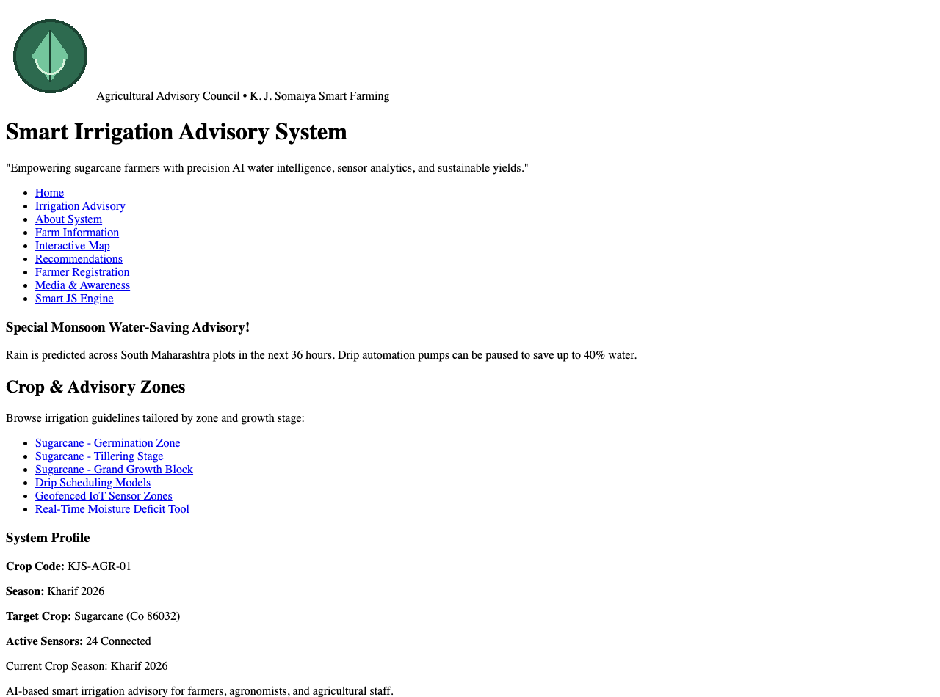
Task 2: Farm Information Displayed using Ordered, Unordered & Definition Lists
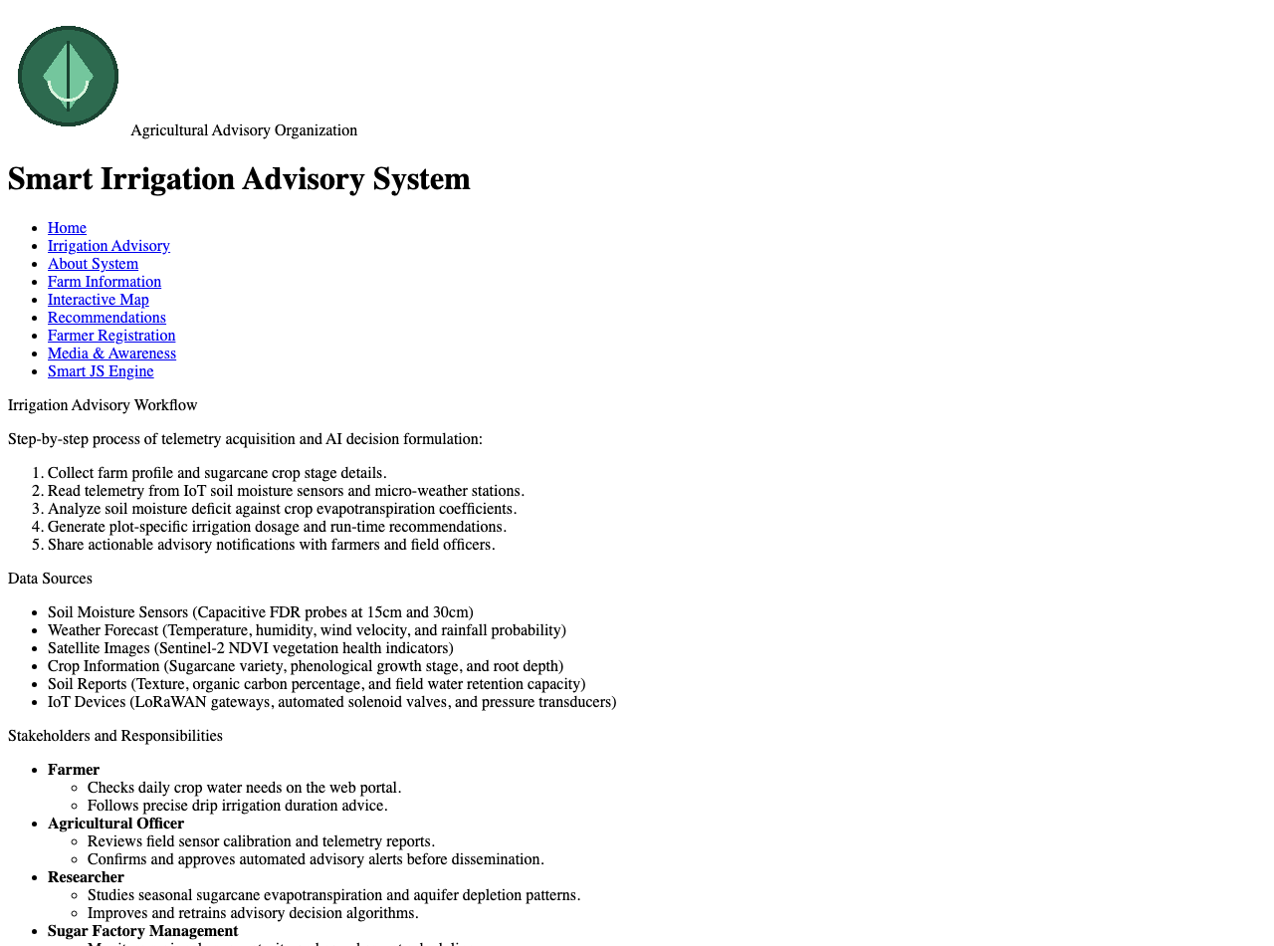
Task 3: Irrigation Advisory Page using HTML Formatting & Abbreviation Tags
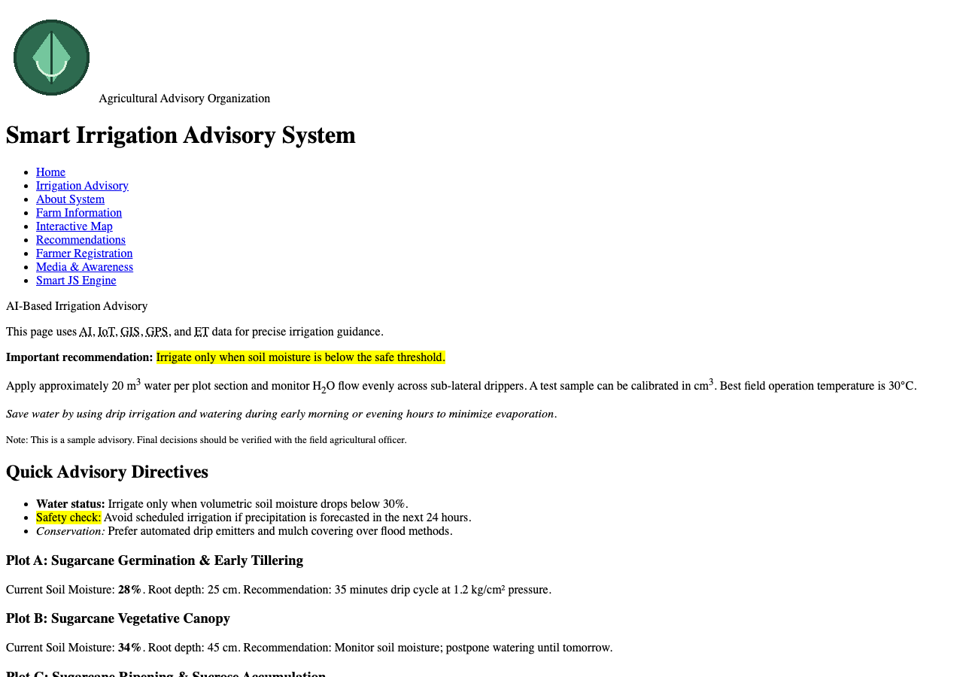
Task 4: Farm Gallery using Semantic Figure, Image & Figcaption Elements
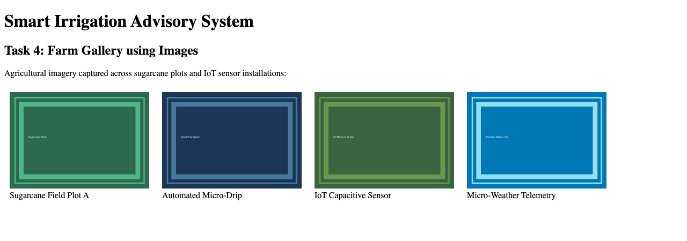
Task 5: Interactive Farm Plot Navigation using Client-Side Image Map (<map> & <area>)
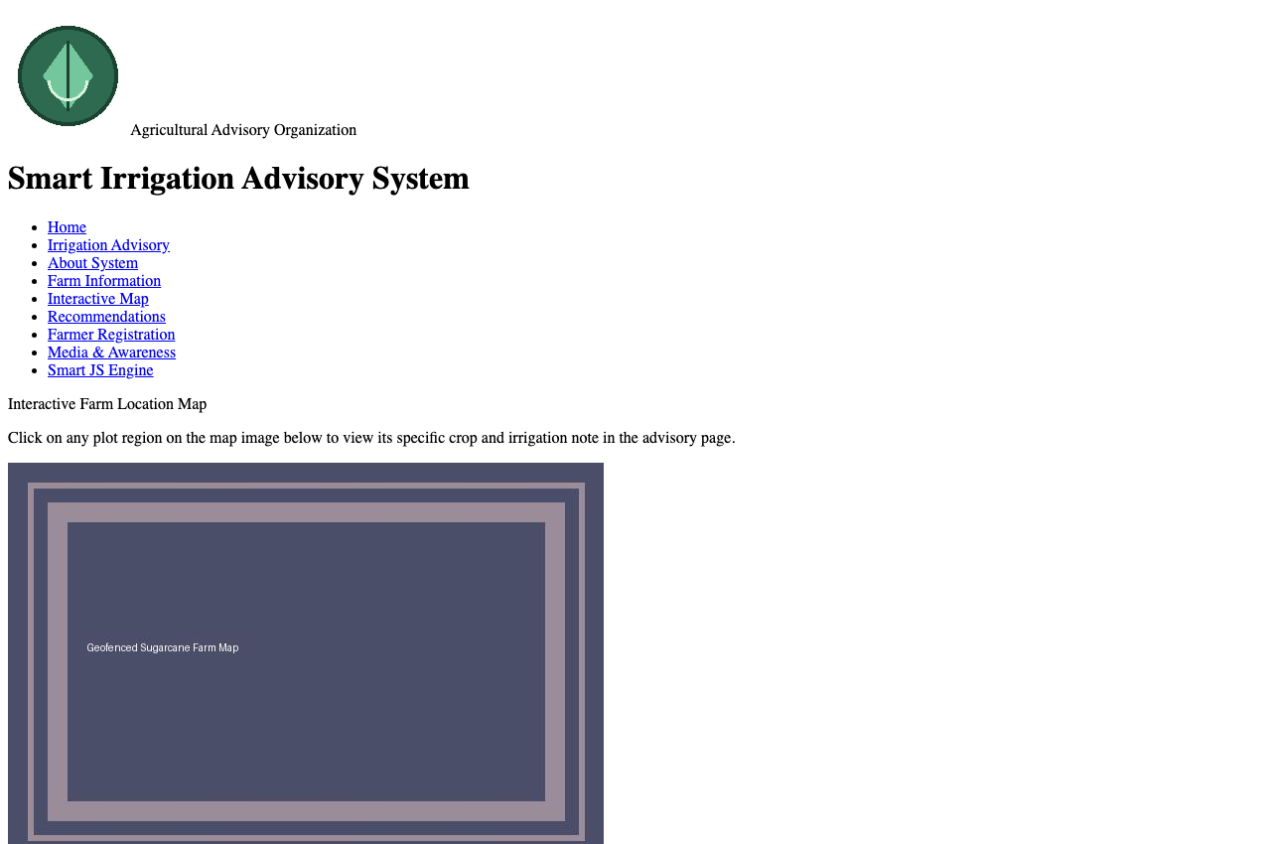
Task 6: Soil Moisture & Irrigation Quota Table (Thead, Tbody, Rowspan & Colspan)
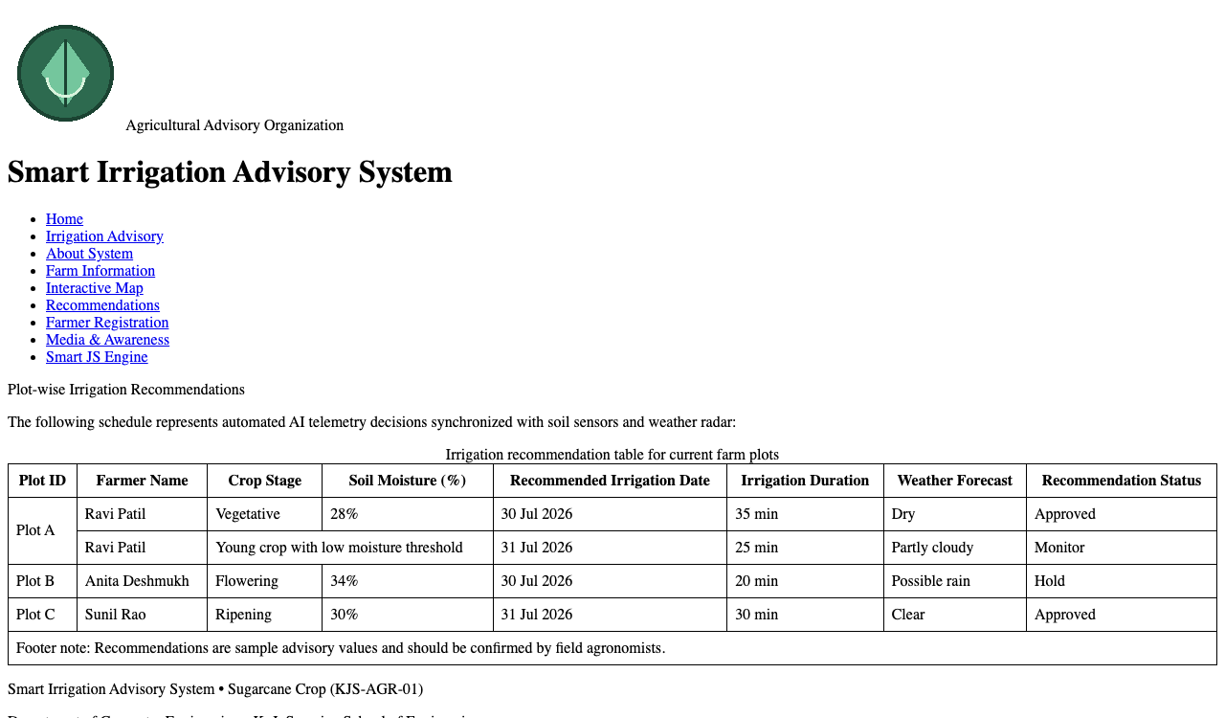
Task 7: Farmer Registration Form with Semantic Controls & Fieldsets
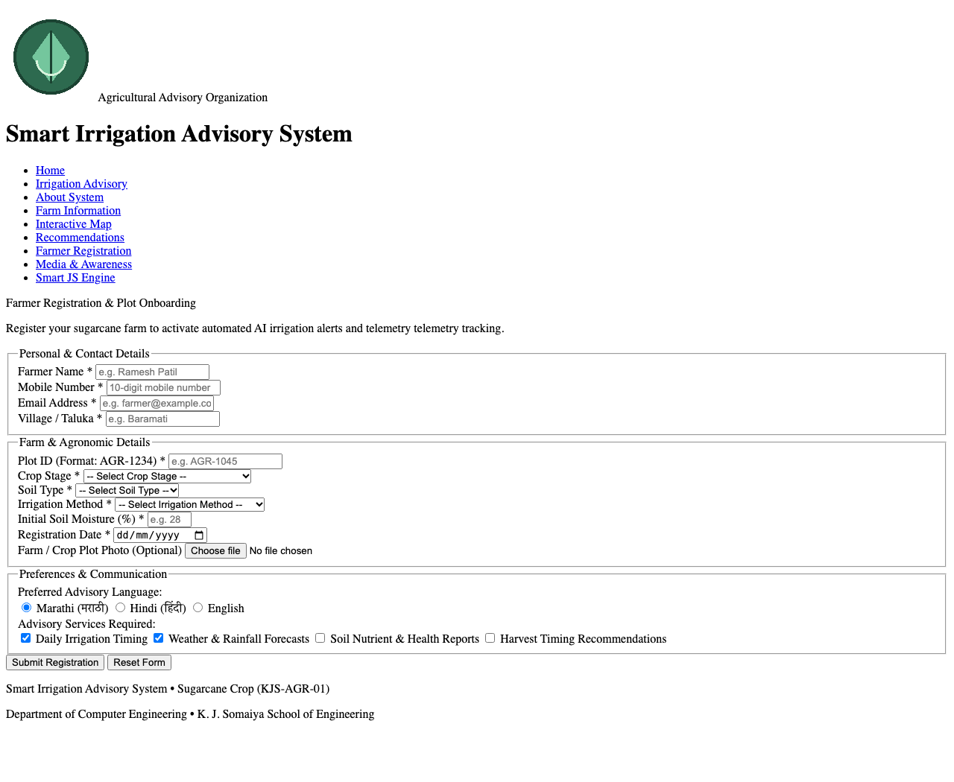
Task 8: Display Weather Forecast & Georeferenced Radar using IFrame
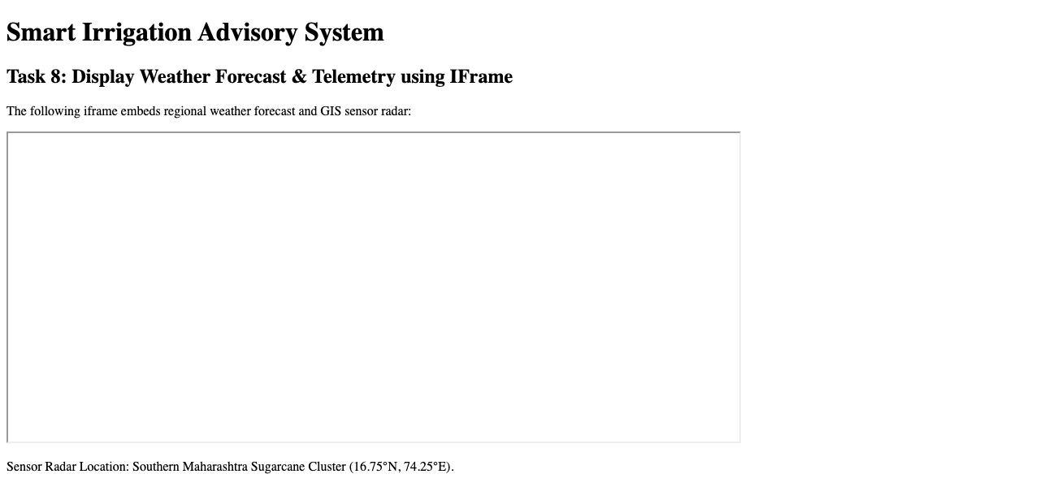
Task 9: Multimedia & Executable Awareness Content (Native HTML5 Audio & Video)
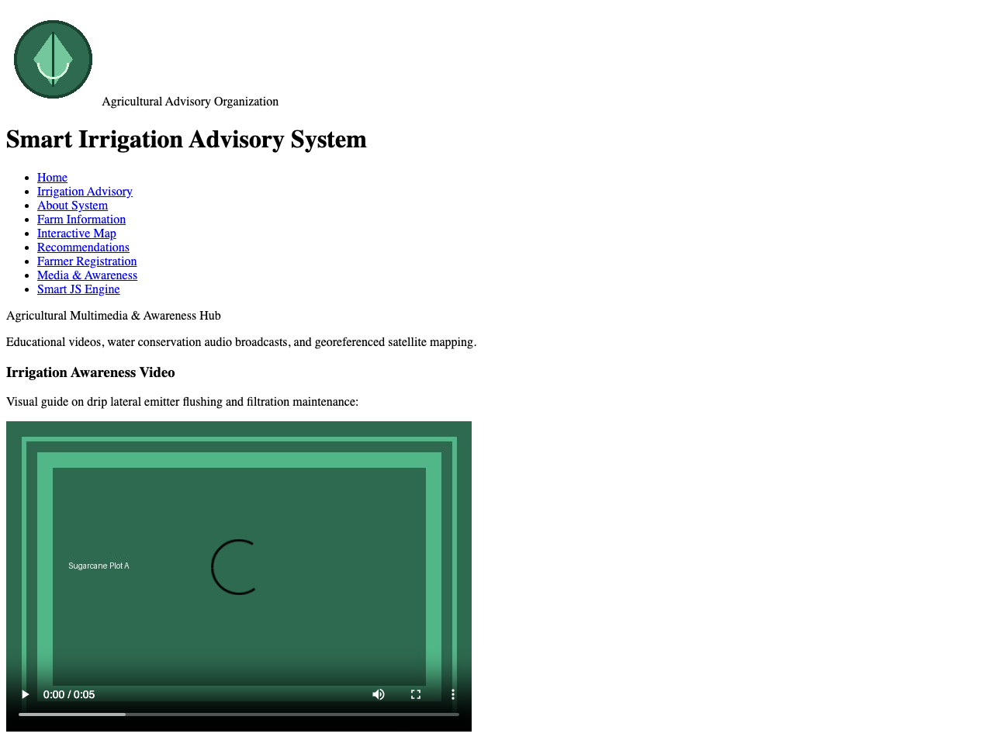

Post Lab Subjective/Objective type Questions: Question 1: Explain the importance of semantic elements in HTML5 compared to traditional div tags.
Answer:
Semantic HTML tags (such as <header>, <nav>, <article>, <section>, and <footer>) describe their meaning to both the browser and developer. Traditional <div> tags are generic block containers that convey no structural context. The advantages of semantic elements include:
1. Accessibility (a11y): Screen readers navigate landmarks directly, allowing visually impaired users to jump across navigation and main content.
2. Search Engine Optimization (SEO): Search web crawlers accurately index content priority, distinguishing headlines from auxiliary sidebars.
3. Maintainability: Codebases are self-documenting and easier for distributed engineering teams to read and debug.
Question 2: How does a client-side image map function?
Answer:
An HTML client-side image map utilizes the '<img>' tag paired with 'usemap="#mapName"'. The companion '<map name="mapName">' element contains one or more '<area>' tags defining geometric shapes ('rect', 'circle', 'poly') and pixel coordinates ('coords="x1,y1,x2,y2"'). When a user clicks within these geometric bounds, the browser routes them to the associated hyperlink without requiring server coordinate processing.

Conclusion and Discussion: Conclusion:
Experiment 1 successfully established the front-end foundation for the AI-based Smart Irrigation Advisory System (KJS-AGR-01) using pure HTML5. A multi-page website was implemented incorporating semantic page structuring, comprehensive lists, formatted agronomic text directives, client-side clickable image maps for farm plots, structured tables with cell spans, interactive forms, and native multimedia awareness components.
Discussion:
Developing the portal emphasized strict structural hierarchy before applying CSS styles. Semantic elements made document navigation clean and logical. The client-side image map proved highly practical for rural agricultural use, enabling farmers to tap directly on visual plot zones to retrieve plot-specific irrigation advice.

