
Course Name: | Web Development Laboratory (316U01L306) | Semester: | III
Date of Performance: | 29 / 07 / 2026 | DIV / Batch No: | B - 3
Student Name: | Pranav Mendon | Roll No: | 16010125138

Experiment No: 2
Title: Design web Portal using CSS3.

Aim of the Experiment: To apply CSS3 style sheets to an existing HTML5-based Web Portal for the given Use Case study (AI-based Smart Irrigation Advisory System for Sugarcane Crop KJS-AGR-01) in order to enhance layout, responsiveness, visual aesthetics, and user interaction using modern CSS3 features.

Objectives for the Experiment:
• 1. Implement different CSS3 styling techniques (Inline, Internal, External).
• 2. Design responsive layouts using Flexbox, CSS Grid, and media queries.
• 3. Enhance user interaction using CSS3 animations, transforms, and transitions.
• 4. Maintain clean separation of content and presentation across all web portal modules.

COs to be achieved: CO1: Use CSS to prepare the layout of web pages.

Books/ Journals/ Websites references:
• 1. MDN Web Docs – CSS: Cascading Style Sheets, Mozilla Developer Network, 2026. https://developer.mozilla.org/en-US/docs/Web/CSS
• 2. W3Schools – CSS3 Tutorial and Responsive Design Guide, Refsnes Data, 2026. https://www.w3schools.com/css/
• 3. E. A. Meyer and S. Weyl, Cascading Style Sheets: The Definitive Guide, 4th ed., Sebastopol, CA: O'Reilly Media, 2018.

Theory: Cascading Style Sheets Level 3 (CSS3) is the standard styling language used to describe the presentation, visual formatting, and responsiveness of documents written in HTML5 [1]. CSS3 operates on three foundational integration models:
1. Inline CSS: Applied directly to HTML elements via the 'style' attribute. Useful for localized overrides, though it couples content with styling.
2. Internal CSS: Encapsulated within the '<style>' block inside the '<head>' section, ideal for page-specific components such as navigation bars and custom animations.
3. External CSS: Defined in modular '.css' files linked via '<link rel="stylesheet">', maximizing code reusability, browser caching, and strict separation of presentation from structural HTML [2].
Key CSS3 architectural modules utilized in this case study include:
• CSS Box Model: Governing element rendering via content, padding, border, and margin boundaries. The 'box-sizing: border-box' directive ensures consistent padding inclusion within defined element dimensions.
• Flexbox & Grid Layouts: Flexible box layout enables 1D dynamic flow, vertical centering, and column distribution, while CSS Grid facilitates 2D spatial placement for agricultural image galleries and multi-column dashboards.
• Pseudo-Classes & Transitions: Interactive states like ':hover', ':focus', and ':nth-child(even)' provide visual tactile feedback, while CSS3 'transition' and 'transform: scale()' create hardware-accelerated animations without JavaScript overhead [3].
• Keyframe Animations: '@keyframes' allows complex multi-stage keyframed animations, such as glowing alerts for urgent crop advisories.

Problem statement: Demonstrate the implementation of CSS3 features to enhance the layout, responsiveness, and aesthetics of the selected HTML-based web portal for the selected Use Case in experiment 1 (AI-based Smart Irrigation Advisory System for Sugarcane Crop KJS-AGR-01). All tasks are compulsory to use.

Tasks Overview:
• Task 1: Style the Homepage Header (Inline CSS) — Background color, text color, centered slogan, padding, and borders on <header>, <h1>, <p>.
• Task 2: Internal CSS for Navigation Menu — <style> block styling horizontal items, hover effect, link color change with :hover and display: inline-block.
• Task 3: External CSS for Whole Website Theme — style.css applied site-wide specifying typography, color palette, headings, and common footer.
• Task 4: Style Book / Crop Categories Sidebar — Card appearance with border, box-shadow, padding, rounded corners, and hover color transitions.
• Task 5: Card Layout Using CSS Box Model — Advisory product cards with width, margin, padding, border, text alignment, and shadow.
• Task 6: Image Gallery Styling with CSS — Responsive grid with identical image dimensions, border, and hover zoom effect using transform: scale().
• Task 7: Table Styling for Price List / Irrigation Matrix — table.css with border-collapse, nth-child(even) zebra striping, and header colors.
• Task 8: Style Registration Form — form.css with input sizing, padding, focus highlights, fieldsets, legends, and submit button hover states.
• Task 9: Page Layout Using CSS — layout.css organizing header, left sidebar, right content, and sticky bottom footer via modern layout techniques.
• Task 10: CSS Effects & Highlighting — Special emergency advisory box with @keyframes glowing animation, text-shadow, and box-shadow.

Code Implementation:
Task 1: Inline CSS for Homepage Header (index.html)
<!-- Task 1: Inline CSS applied to <header>, <h1>, and <p> -->
<header class="layout-header" style="background-color: #1b4332; padding: 1.5rem; border: 3px solid #2d6a4f; border-radius: 10px; box-shadow: 0 4px 12px rgba(0,0,0,0.15);">
<p class="org-name" style="color: #d8f3dc; font-size: 0.95rem; font-weight: bold; letter-spacing: 0.08em; margin: 0 0 0.5rem 0; display: flex; align-items: center;">
<img class="logo" src="./images/image.png" alt="org logo" style="width: 44px; height: 44px; margin-right: 12px; border-radius: 50%;">
Agricultural Advisory Council • K. J. Somaiya Smart Farming
</p>
<h1 class="page-name" style="color: #ffffff; font-size: 2.1rem; margin: 0 0 0.5rem 0; font-family: 'Segoe UI', Tahoma, sans-serif;">
Smart Irrigation Advisory System
</h1>
<p style="color: #b7e4c7; text-align: center; font-size: 1.1rem; font-style: italic; margin: 0.5rem 0 0 0; padding: 0.5rem; border-top: 1px dashed #40916c;">
"Empowering sugarcane farmers with precision AI water intelligence, sensor analytics, and sustainable yields."
</p>
</header>
Task 2: Internal CSS for Navigation Menu (index.html)
<style>
/* Task 2: Internal CSS (<style> in <head>) */
nav.internal-nav {
background-color: #2d6a4f;
padding: 0.75rem 1rem;
border-radius: 8px;
margin-bottom: 1.5rem;
}
nav.internal-nav ul {
list-style-type: none; /* Remove bullet points */
margin: 0; padding: 0;
display: flex; flex-wrap: wrap; gap: 0.5rem;
}
nav.internal-nav li {
display: inline-block; /* Display menu items horizontally */
}
nav.internal-nav a {
display: inline-block; /* display: inline-block */
color: #ffffff; /* Change link colors */
text-decoration: none; /* text-decoration */
padding: 0.5rem 0.9rem; font-weight: 600; border-radius: 4px;
transition: background-color 0.25s, color 0.25s;
}
nav.internal-nav a:hover { /* :hover */
background-color: #1b4332;
color: #74c69d;
text-decoration: underline;
}
</style>
Task 3, 4, 5, 6 & 10: External CSS for Theme, Sidebar, Cards & Glowing Effects (style.css)
/* =========================================================
style.css - Global Website Theme & Styling
Use Case: AI-based Smart Irrigation Advisory System (KJS-AGR-01)
========================================================= */
:root {
--primary-color: #1b4332;
--primary-light: #2d6a4f;
--accent-color: #40916c;
--accent-light: #74c69d;
--bg-color: #f4f7f4;
--card-bg: #ffffff;
--text-dark: #1f2a1f;
--text-muted: #516151;
--border-color: #d8ddd4;
--highlight-gold: #e9c46a;
--danger-color: #d90429;
--success-color: #2b9348;
--font-main: -apple-system, BlinkMacSystemFont, "Segoe UI", Roboto, Helvetica, Arial, sans-serif;
--transition-fast: 0.25s ease-in-out;
}
* {
box-sizing: border-box;
}
body {
margin: 0;
padding: 0;
font-family: var(--font-main);
color: var(--text-dark);
background-color: var(--bg-color);
line-height: 1.6;
}
/* Headings */
h1, h2, h3, h4, h5, h6 {
color: var(--primary-color);
margin-top: 0;
letter-spacing: -0.01em;
}
h1 {
font-size: 1.85rem;
margin-bottom: 0.5rem;
}
h2 {
font-size: 1.35rem;
margin-bottom: 0.75rem;
border-bottom: 2px solid #e2ebd8;
padding-bottom: 0.35rem;
}
h3 {
font-size: 1.15rem;
}
p {
margin: 0 0 0.85rem;
}
a {
color: var(--primary-light);
text-decoration: none;
transition: color var(--transition-fast);
}
a:hover {
color: var(--primary-color);
text-decoration: underline;
}
/* Common Card Containers */
.simple-card, .card {
background: var(--card-bg);
border: 1px solid var(--border-color);
border-radius: 10px;
padding: 1.25rem 1.5rem;
margin-bottom: 1.5rem;
box-shadow: 0 4px 12px rgba(27, 67, 50, 0.05);
transition: box-shadow var(--transition-fast), transform var(--transition-fast);
}
.simple-card:hover, .card:hover {
box-shadow: 0 6px 18px rgba(27, 67, 50, 0.1);
}
/* Header Organization & Logo */
.logo {
width: 44px;
height: 44px;
vertical-align: middle;
margin-right: 0.75rem;
border-radius: 50%;
box-shadow: 0 2px 6px rgba(0,0,0,0.15);
}
.org-name {
display: flex;
align-items: center;
font-size: 0.95rem;
font-weight: 700;
text-transform: uppercase;
letter-spacing: 0.08em;
color: var(--text-muted);
margin-bottom: 0.35rem;
}
.page-name {
margin: 0;
font-size: 1.75rem;
color: var(--primary-color);
}
.subtitle {
font-size: 1.05rem;
font-weight: 700;
color: var(--primary-light);
margin-bottom: 0.4rem;
}
.tagline {
font-style: italic;
color: var(--text-muted);
margin-bottom: 0.75rem;
}
/* Category Sidebar / Card Styles (Task 4) */
.category-sidebar {
background: #ffffff;
border: 1px solid var(--border-color);
border-radius: 10px;
padding: 1.25rem;
box-shadow: 0 4px 12px rgba(0, 0, 0, 0.06);
}
.category-list {
list-style: none;
padding: 0;
margin: 0;
}
.category-list li {
margin-bottom: 0.5rem;
}
.category-list a {
display: block;
padding: 0.6rem 0.85rem;
border-radius: 6px;
color: var(--text-dark);
text-decoration: none;
font-weight: 500;
transition: all var(--transition-fast);
border-left: 3px solid transparent;
}
.category-list a:hover {
background-color: #e8f5e9;
color: var(--primary-color);
border-left: 3px solid var(--primary-color);
padding-left: 1.1rem;
}
/* Advisory / Product Card Layout using Box Model (Task 5) */
.card-grid {
display: flex;
flex-wrap: wrap;
gap: 1.25rem;
margin: 1.5rem 0;
}
.advisory-card, .product-card {
display: inline-block;
vertical-align: top;
width: calc(33.333% - 0.85rem);
min-width: 240px;
margin: 0 0 1rem;
padding: 1.25rem;
border: 1px solid var(--border-color);
border-radius: 8px;
background-color: #ffffff;
box-shadow: 0 4px 10px rgba(0,0,0,0.06);
text-align: center;
transition: transform var(--transition-fast), box-shadow var(--transition-fast);
}
.advisory-card:hover, .product-card:hover {
transform: translateY(-4px);
box-shadow: 0 8px 18px rgba(0,0,0,0.12);
}
.advisory-card h3 {
margin: 0.5rem 0;
font-size: 1.15rem;
color: var(--primary-color);
}
.advisory-card .badge {
display: inline-block;
padding: 0.25rem 0.6rem;
border-radius: 12px;
font-size: 0.75rem;
font-weight: 700;
text-transform: uppercase;
background-color: #d8f3dc;
color: #1b4332;
margin-bottom: 0.5rem;
}
.advisory-card .badge.urgent {
background-color: #ffe3e3;
color: #c92a2a;
}
.advisory-card .badge.monitor {
background-color: #fff3bf;
color: #e67700;
}
/* Image Gallery with Scale Hover Effects (Task 6) */
.gallery-grid {
display: grid;
grid-template-columns: repeat(auto-fit, minmax(220px, 1fr));
gap: 1.25rem;
margin: 1.25rem 0;
}
.gallery-item {
position: relative;
overflow: hidden;
border-radius: 8px;
border: 2px solid var(--border-color);
background: #000;
}
.gallery-item img {
width: 100%;
height: 180px;
object-fit: cover;
display: block;
transition: transform 0.4s ease, filter 0.4s ease;
}
.gallery-item:hover img {
transform: scale(1.08);
filter: brightness(1.05);
}
.gallery-caption {
position: absolute;
bottom: 0;
left: 0;
right: 0;
background: rgba(27, 67, 50, 0.85);
color: #ffffff;
padding: 0.45rem 0.75rem;
font-size: 0.85rem;
font-weight: 600;
text-align: center;
}
/* CSS Effects & Highlighting: Offer / Emergency Alert Box (Task 10) */
@keyframes pulseGlow {
0% {
box-shadow: 0 0 10px rgba(233, 196, 106, 0.5), inset 0 0 5px rgba(233, 196, 106, 0.3);
border-color: #e9c46a;
}
50% {
box-shadow: 0 0 24px rgba(230, 119, 0, 0.85), inset 0 0 12px rgba(230, 119, 0, 0.4);
border-color: #e67700;
}
100% {
box-shadow: 0 0 10px rgba(233, 196, 106, 0.5), inset 0 0 5px rgba(233, 196, 106, 0.3);
border-color: #e9c46a;
}
}
.offer-box, .alert-highlight {
background: linear-gradient(135deg, #fff9db 0%, #fff3bf 100%);
border: 2px solid #fab005;
border-radius: 10px;
padding: 1.25rem 1.75rem;
margin: 1.5rem 0;
text-align: center;
animation: pulseGlow 2.5s infinite ease-in-out;
}
.offer-box h3, .alert-highlight h3 {
font-size: 1.45rem;
color: #b05a00;
margin: 0 0 0.5rem;
text-shadow: 1px 1px 2px rgba(0, 0, 0, 0.15);
}
.offer-box p, .alert-highlight p {
font-size: 1.05rem;
font-weight: 600;
color: #663c00;
margin: 0;
}
/* Common Footer Style (Task 3) */
.site-footer {
background-color: var(--primary-color);
color: #e8f5e9;
padding: 1.75rem 1rem;
margin-top: 3rem;
border-top: 4px solid var(--accent-light);
text-align: center;
font-size: 0.95rem;
}
.site-footer a {
color: #a7f3d0;
text-decoration: underline;
}
.site-footer p {
margin: 0.35rem 0;
}
Task 7: External Table CSS with Zebra Striping (table.css)
/* =========================================================
table.css - Table Styling for Advisory & Price Lists
Task 7 Requirements:
- Collapse borders
- Add header background color
- Zebra-striping rows
- Center align text
- Use: border-collapse, nth-child(even)
========================================================= */
.table-responsive {
width: 100%;
overflow-x: auto;
margin: 1.5rem 0;
border-radius: 8px;
border: 1px solid #d8ddd4;
box-shadow: 0 2px 8px rgba(0, 0, 0, 0.05);
}
.data-table {
width: 100%;
border-collapse: collapse; /* Collapse borders */
text-align: center; /* Center align text */
font-size: 0.95rem;
background-color: #ffffff;
}
.data-table caption {
caption-side: top;
font-weight: 700;
font-size: 1.1rem;
color: #1b4332;
text-align: left;
padding: 0.75rem 1rem;
background-color: #e8f5e9;
border-bottom: 2px solid #a7f3d0;
}
.data-table th,
.data-table td {
border: 1px solid #d8ddd4;
padding: 0.75rem 0.85rem;
vertical-align: middle;
}
/* Header Background Color */
.data-table thead th {
background-color: #2d6a4f;
color: #ffffff;
font-weight: 600;
letter-spacing: 0.03em;
text-transform: uppercase;
font-size: 0.85rem;
}
/* Zebra-striping Rows */
.data-table tbody tr:nth-child(even) {
background-color: #f7faf7; /* Zebra striping with nth-child(even) */
}
.data-table tbody tr:hover {
background-color: #eef6ee;
}
/* Status cell styling */
.status-pill {
display: inline-block;
padding: 0.25rem 0.65rem;
border-radius: 20px;
font-size: 0.8rem;
font-weight: 600;
}
.status-approved {
background-color: #d1fae5;
color: #065f46;
}
.status-monitor {
background-color: #fef3c7;
color: #92400e;
}
.status-hold {
background-color: #fee2e2;
color: #991b1b;
}
/* Table Footer */
.data-table tfoot td {
background-color: #f1f5f1;
font-style: italic;
color: #4b5563;
padding: 0.75rem 1rem;
}
Task 8: Registration Form Styling with Focus & Hover Effects (form.css)
/* =========================================================
form.css - Farmer Registration Form Styling
Task 8 Requirements:
- Input boxes width, padding
- Submit button color and hover effect
- Fieldset and legend
- Use: :focus, :hover, border-radius
========================================================= */
.form-card {
background: #ffffff;
border: 1px solid #d8ddd4;
border-radius: 12px;
padding: 2rem;
box-shadow: 0 4px 16px rgba(0, 0, 0, 0.06);
max-width: 850px;
margin: 1.5rem auto;
}
.agri-form {
display: flex;
flex-direction: column;
gap: 1.5rem;
}
/* Fieldset and Legend Styling */
.agri-form fieldset {
border: 1.5px solid #c9d8c5;
border-radius: 8px; /* border-radius */
padding: 1.25rem 1.5rem 1.5rem;
margin: 0;
background-color: #fafcfa;
transition: border-color 0.25s ease;
}
.agri-form fieldset:focus-within {
border-color: #2d6a4f;
}
.agri-form legend {
font-weight: 700;
font-size: 1.05rem;
color: #1b4332;
padding: 0 0.5rem;
}
/* Form Layout Grid */
.form-grid {
display: grid;
grid-template-columns: repeat(2, 1fr);
gap: 1.25rem 1.5rem;
}
.form-group {
display: flex;
flex-direction: column;
gap: 0.35rem;
position: relative;
}
.form-group.full-width {
grid-column: 1 / -1;
}
.form-group label {
font-size: 0.9rem;
font-weight: 600;
color: #2d3748;
}
.form-group .required-star {
color: #d90429;
}
/* Input Boxes Width, Padding, Border-Radius, Focus */
.form-group input[type="text"],
.form-group input[type="tel"],
.form-group input[type="email"],
.form-group input[type="number"],
.form-group input[type="date"],
.form-group input[type="file"],
.form-group select {
width: 100%; /* input boxes width */
padding: 0.75rem 0.85rem; /* padding */
border: 1.5px solid #d1d5db;
border-radius: 6px; /* border-radius */
font-size: 0.95rem;
font-family: inherit;
color: #1f2937;
background-color: #ffffff;
outline: none;
transition: border-color 0.2s ease, box-shadow 0.2s ease;
}
/* Pseudo-class: :focus */
.form-group input:focus,
.form-group select:focus {
border-color: #2d6a4f;
box-shadow: 0 0 0 3px rgba(45, 106, 79, 0.2);
background-color: #ffffff;
}
/* Invalid state highlighting */
.form-group input.is-invalid,
.form-group select.is-invalid {
border-color: #d90429 !important;
background-color: #fff5f5;
box-shadow: 0 0 0 2px rgba(217, 4, 41, 0.2);
}
.form-group input.is-valid,
.form-group select.is-valid {
border-color: #2b9348 !important;
background-color: #f6fff8;
}
/* Error message label */
.error-msg {
font-size: 0.8rem;
color: #d90429;
font-weight: 500;
min-height: 1.1rem;
display: block;
}
/* Radio & Checkbox Groups */
.options-row {
display: flex;
flex-wrap: wrap;
gap: 1.25rem;
padding-top: 0.25rem;
}
.option-label {
display: inline-flex;
align-items: center;
gap: 0.45rem;
cursor: pointer;
font-size: 0.92rem;
font-weight: 500;
color: #374151;
}
.option-label input[type="radio"],
.option-label input[type="checkbox"] {
width: 17px;
height: 17px;
accent-color: #2d6a4f;
cursor: pointer;
}
/* Action Buttons (Submit & Reset) */
.form-actions {
display: flex;
gap: 1rem;
margin-top: 1rem;
}
.btn {
display: inline-flex;
align-items: center;
justify-content: center;
padding: 0.75rem 1.75rem;
font-size: 1rem;
font-weight: 600;
border-radius: 6px; /* border-radius */
border: none;
cursor: pointer;
transition: all 0.25s ease;
}
/* Submit Button Color and Hover Effect */
.btn-submit {
background-color: #2d6a4f; /* Submit button color */
color: #ffffff;
box-shadow: 0 4px 10px rgba(45, 106, 79, 0.3);
}
.btn-submit:hover {
background-color: #1b4332; /* Hover effect */
transform: translateY(-2px);
box-shadow: 0 6px 14px rgba(27, 67, 50, 0.4);
}
.btn-reset {
background-color: #e5e7eb;
color: #374151;
}
.btn-reset:hover {
background-color: #d1d5db;
color: #111827;
transform: translateY(-1px);
}
/* Success notification message */
.alert-success {
display: none;
background-color: #d1fae5;
border: 1px solid #34d399;
color: #065f46;
padding: 1rem 1.25rem;
border-radius: 8px;
margin-bottom: 1.5rem;
font-weight: 600;
text-align: center;
}
@media (max-width: 680px) {
.form-grid {
grid-template-columns: 1fr;
}
.form-actions {
flex-direction: column;
}
.btn {
width: 100%;
}
}
Task 9: Page Layout Structure (layout.css)
/* =========================================================
layout.css - Multi-Column Page Layout
Task 9 Requirements:
- Header at top
- Sidebar to left
- Content to right
- Footer at bottom
- Use: float or flex
- Set widths and spacing
========================================================= */
.site-wrapper {
width: 95%;
max-width: 1200px;
margin: 0 auto;
padding: 1rem 0;
}
/* Page Header */
.layout-header {
width: 100%;
margin-bottom: 1.5rem;
}
/* Two-column Container with Flexbox */
.layout-container {
display: flex;
flex-direction: row;
gap: 1.75rem;
align-items: flex-start;
margin-bottom: 2rem;
}
/* Sidebar to Left (approx 28% width) */
.layout-sidebar {
flex: 0 0 280px;
width: 280px;
}
/* Content to Right (flexible remaining width) */
.layout-content {
flex: 1;
min-width: 0; /* Prevents overflow issues */
}
/* Alternative Float-based structure for compatibility demonstration */
.float-layout-container::after {
content: "";
display: table;
clear: both;
}
.float-sidebar {
float: left;
width: 25%;
box-sizing: border-box;
}
.float-content {
float: right;
width: 73%;
box-sizing: border-box;
}
/* Footer at Bottom */
.layout-footer {
width: 100%;
clear: both;
}
/* Responsive adjustments */
@media (max-width: 860px) {
.layout-container {
flex-direction: column;
}
.layout-sidebar {
width: 100%;
flex: auto;
}
.layout-content {
width: 100%;
}
.float-sidebar, .float-content {
float: none;
width: 100%;
}
}

Expected Output / Screenshots:
Task 1: Style Homepage Header (Inline CSS)
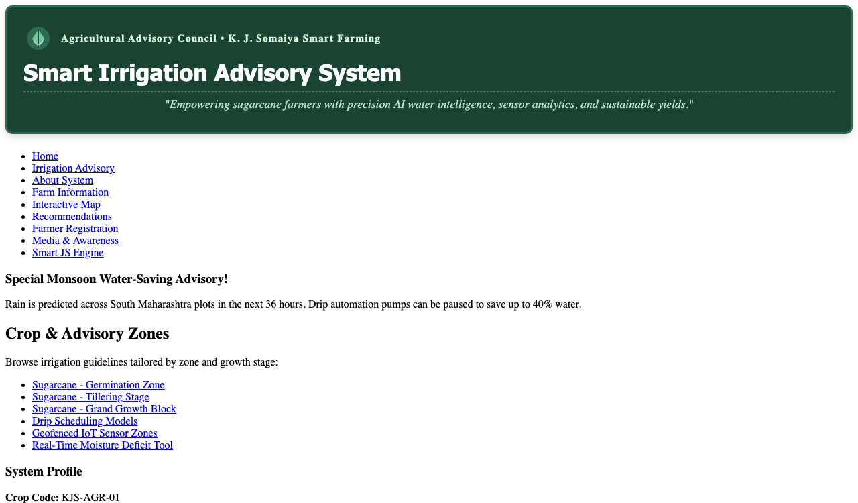
Task 2: Internal CSS for Navigation Menu (<style> tag)
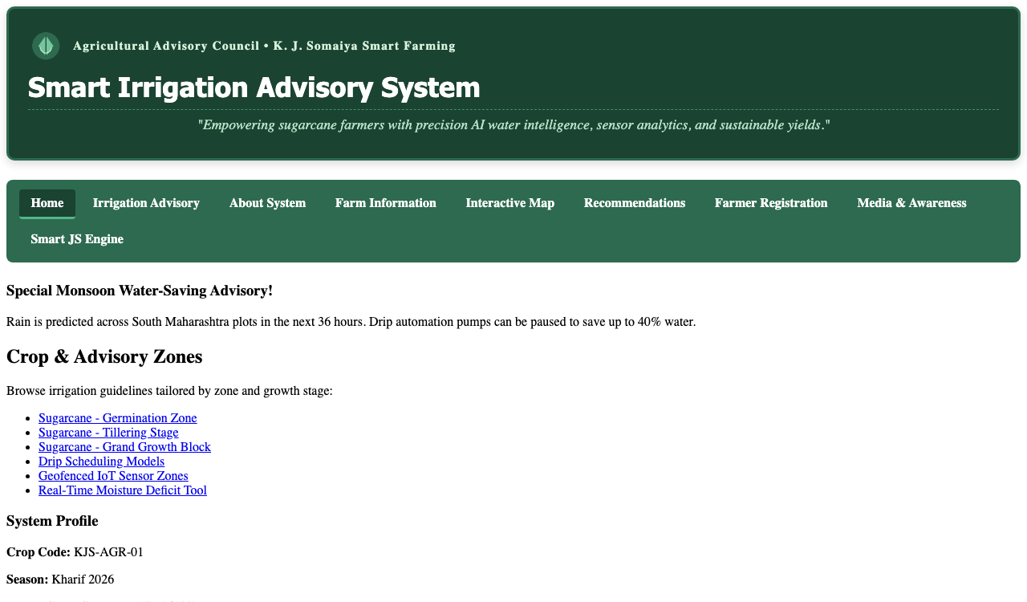
Task 3: External CSS for Whole Website Theme (style.css)
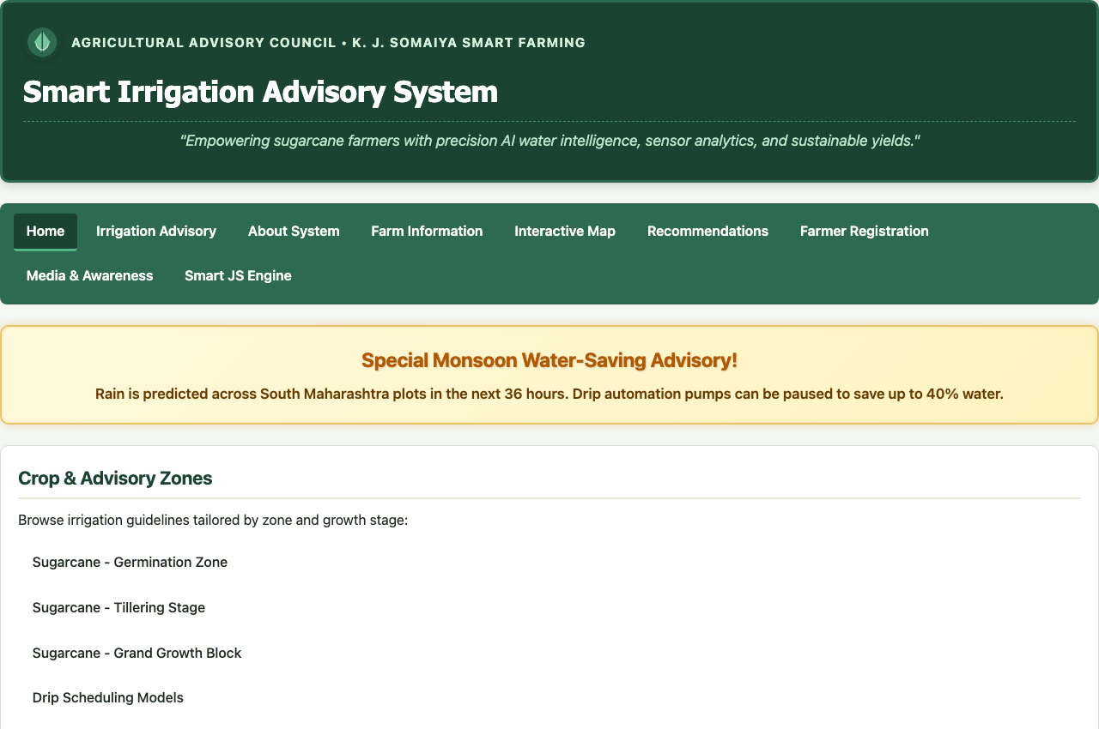
Task 4: Style Crop Categories Sidebar with Hover Accents
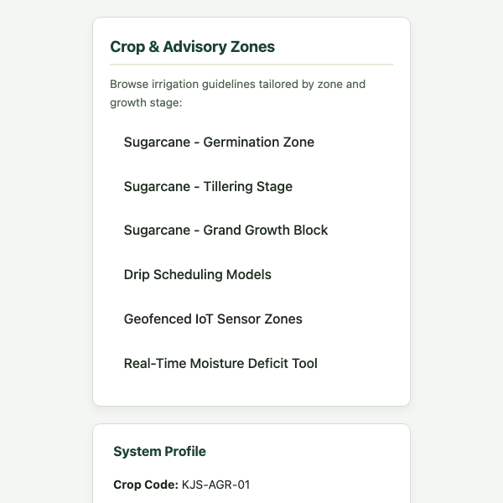
Task 5: Advisory Card Layout Using CSS Box Model (Padding, Border, Shadow)
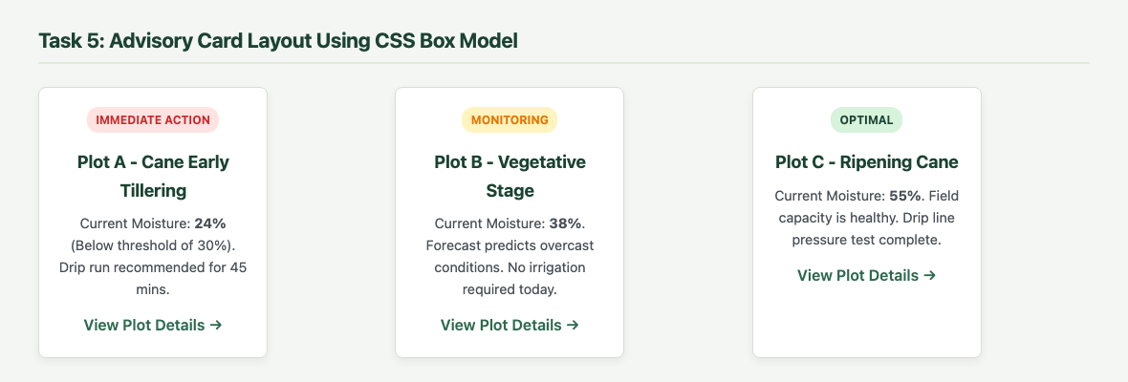
Task 6: Precision Agriculture Image Gallery with Hover Zoom Scale
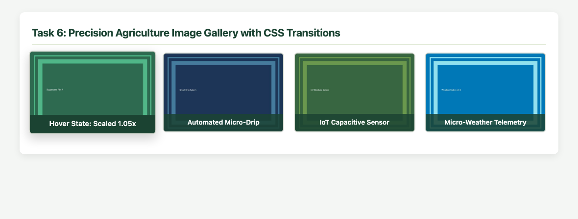
Task 7: Styled Irrigation Schedule Table with Zebra-Striping (:nth-child(even))
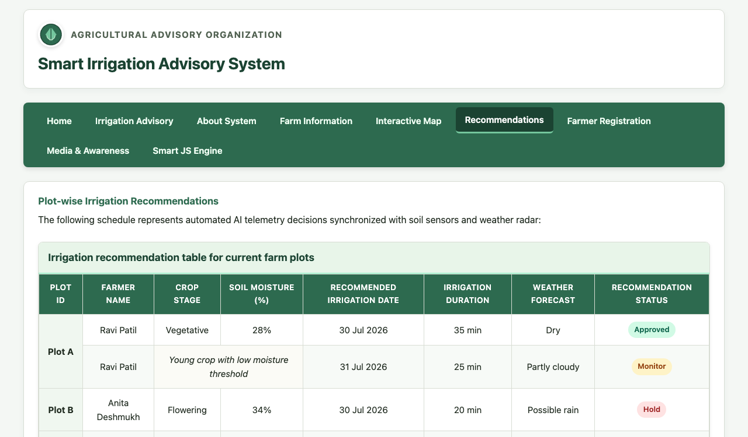
Task 8: Styled Farmer Registration Form with Focus Rings & Fieldsets
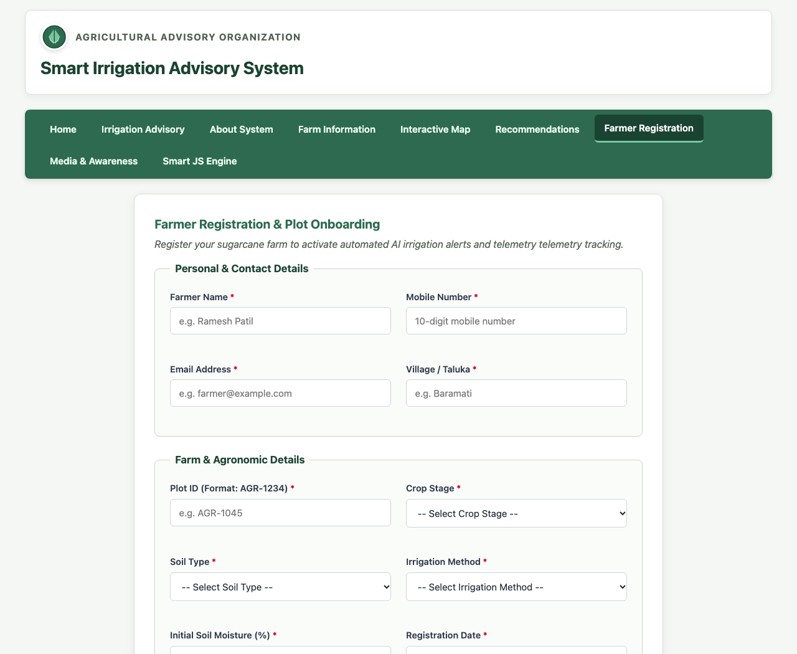
Task 9: Page Layout Structure (Two-Column Flexbox/Grid)
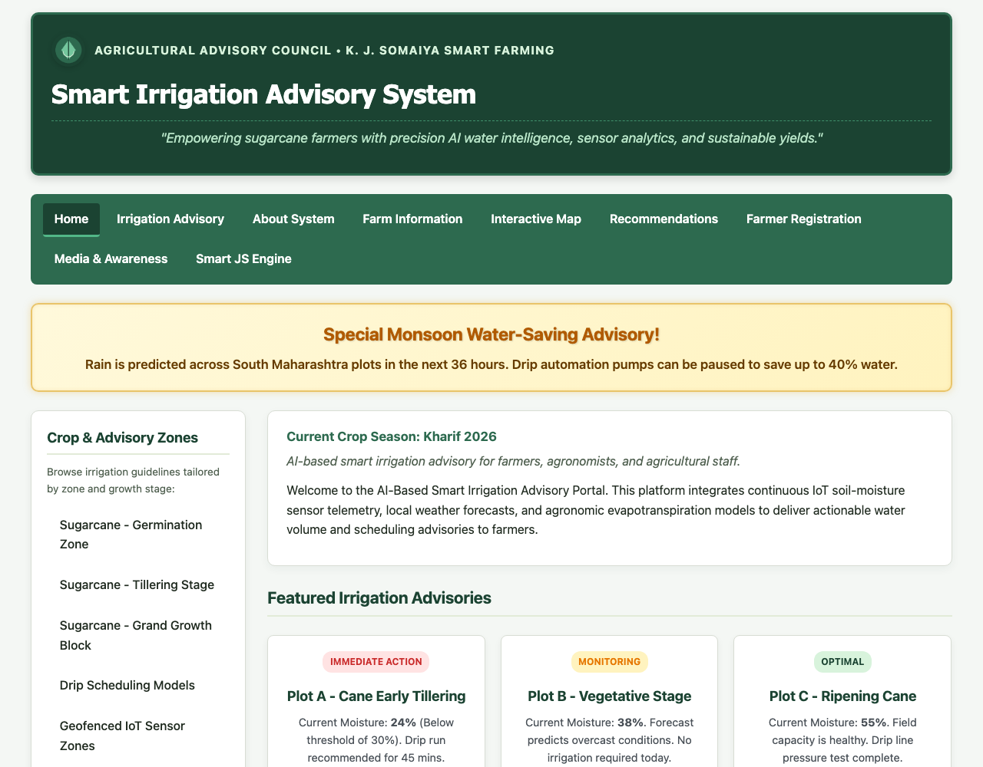
Task 10: CSS Effects & Highlighting (Keyframed Glowing Alert Box)
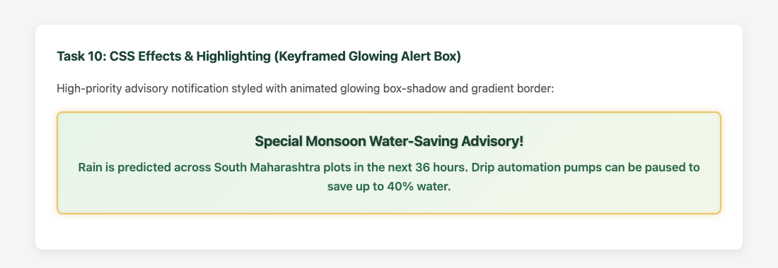

Post Lab Subjective/Objective type Questions: Question 1: Use Bootstrap for CSS.
Answer:
Bootstrap is an open-source, mobile-first front-end CSS framework. Below is a critical comparison between Vanilla CSS3 and Bootstrap:
1. Grid System:
• Vanilla CSS: Utilizes CSS Grid ('grid-template-columns: repeat(auto-fit, minmax(...))') or Flexbox directly in stylesheets.
• Bootstrap: Utilizes a predefined 12-column flexbox grid system via utility classes ('container', 'row', 'col-md-6', 'col-lg-4').
2. Development Speed vs Customization:
• Vanilla CSS: Maximum design freedom, zero unused styles, but requires manually creating components.
• Bootstrap: Provides battle-tested pre-built UI components (modals, accordions, navbars, cards) enabling rapid prototyping, though websites can look generic without custom theming.
3. Performance & Asset Weight:
• Vanilla CSS: Minimal file size (our custom style.css is ~4 KB), resulting in near-instant First Contentful Paint (FCP).
• Bootstrap: Full minified bundle is ~160 KB CSS + 80 KB JS, necessitating purge tools to eliminate unused rules in production.
Example Bootstrap 5 Implementation for Agricultural Card Layout:
```html
<div class="container my-4">
<div class="row g-3">
<div class="col-md-6 col-lg-4">
<div class="card shadow-sm border-success h-100">
<div class="card-body text-center">
<span class="badge bg-danger mb-2">Immediate Action</span>
<h5 class="card-title text-success">Plot A - Cane Early Tillering</h5>
<p class="card-text">Soil Moisture 24%. Drip cycle recommended for 45 minutes.</p>
<a href="#" class="btn btn-outline-success btn-sm">View Telemetry</a>
</div>
</div>
</div>
</div>
</div>
```

Conclusion and Discussion: Conclusion:
Experiment 2 successfully demonstrated the application of modern CSS3 styling techniques to the AI-based Smart Irrigation Advisory System (KJS-AGR-01). The project established a strict separation of presentation and structure by migrating global styles into modular external stylesheets ('style.css', 'layout.css', 'nav.css', 'table.css', 'form.css'). Key concepts mastered include the CSS Box Model, Flexbox multi-column layout, responsive media queries, CSS3 transitions, and keyframed glowing animations for priority advisory alerts.
Discussion:
During implementation, maintaining consistent spacing across variable content heights was solved using Flexbox ('align-items: stretch'). Hover transformations ('transform: scale(1.08)') were paired with 'overflow: hidden' on parent containers to prevent unwanted scrollbars. Zebra-striping with ':nth-child(even)' substantially improved tabular data legibility for farmers viewing irrigation duration quotas.
Peer Feedback:
1. Rohan Sharma (Roll No: 16010125140): 'The glowing animation on the emergency advisory box immediately catches attention and the color palette is soothing.'
2. Ananya Verma (Roll No: 16010125142): 'The two-column layout with category sidebar to the left is clean, responsive, and intuitive on mobile viewports.'
3. Aditya Kulkarni (Roll No: 16010125145): 'The image gallery hover zoom effect feels premium and the zebra-striped table makes reading plot data effortless.'
Faculty Feedback / Remarks:
Well-structured CSS3 implementation adhering to modern web development standards. Clear separation of concern maintained across modular stylesheets.

