
Course Name: | Web Development Laboratory (316U01L306) | Semester: | III
Date of Performance: | 19 / 08 / 2026 | DIV / Batch No: | B - 3
Student Name: | Pranav Mendon | Roll No: | 16010125138

Experiment No: 5
Title: JavaScript Programming for Smart Irrigation Advisory Web Portal.

Aim of the Experiment: To develop JavaScript programs for a Smart Irrigation Advisory Web Portal that processes soil moisture, crop, weather, and irrigation information and provides irrigation recommendations using JavaScript concepts such as values, variables, operators, expressions, control statements, object-oriented JavaScript, functions, arrays, strings, and regular expressions.

Objectives for the Experiment:
• • To use JavaScript variables, values, operators, and expressions for processing irrigation-related information.
• • To apply control statements for determining irrigation requirements based on multi-factor agronomic rules.
• • To create JavaScript objects representing farmer, farm, and irrigation telemetry information.
• • To use functions for calculating irrigation requirements and generating recommendations.
• • To use arrays for storing, analyzing, and calculating statistics on soil-moisture and weather sensor readings.
• • To use strings and regular expressions for validating farmer and farm information.
• • To integrate JavaScript with HTML forms for an interactive Smart Irrigation Advisory Web Portal.

COs to be achieved: CO1: Developing webpages using HTML, CSS and JavaScript.

Books/ Journals/ Websites references:
• 1. MDN Web Docs – JavaScript Guide, Objects, Arrays, and Functions, Mozilla Developer Network, 2026. https://developer.mozilla.org/en-US/docs/Web/JavaScript/Guide
• 2. W3Schools – JavaScript Tutorial and Array Methods Reference, Refsnes Data, 2026. https://www.w3schools.com/js/
• 3. D. Crockford, JavaScript: The Good Parts, Sebastopol, CA: O'Reilly Media / Yahoo! Press, 2008.

Theory: JavaScript is a high-level, interpreted, dynamic, prototype-based multi-paradigm programming language that powers interactivity, algorithmic computation, and asynchronous communication in modern web applications [1]. In precision agriculture, JavaScript functions as a client-side decision-support engine capable of processing telemetry locally, evaluating moisture thresholds, and formatting actionable grower recommendations without backend latency.
Core JavaScript Concepts Implemented in This Experiment:
1. Variables & Expressions:
Modern ES6 block-scoped variable declarations ('let' and 'const') avoid variable hoisting pitfalls. Mathematical expressions compute soil moisture deficit: 'deficit = requiredMoisture - currentMoisture' [2].
2. Conditional Control Statements:
Decision logic structures ('if...else if...else') evaluate non-linear agricultural constraints. Multi-condition expressions evaluate sensor thresholds in tandem with atmospheric precipitation probabilities.
3. Object-Oriented JavaScript:
JavaScript objects encapsulate cohesive entities via key-value mappings. A sugarcane farm entity models properties ('farmerName', 'plotId', 'cropStage', 'soilMoisture', 'area', 'pumpStatus') alongside behavior via method binding ('this') [3].
4. Array Processing & High-Order Functions:
Telemetry arrays store 24-hour sensor series. Built-in iterative methods ('reduce()', 'filter()') and math utilities ('Math.min()', 'Math.max()') compute statistical indicators: minimum, peak, arithmetic mean, and critical count below agronomic wilting points (<30%).
5. DOM Interactivity:
JavaScript bridges computational results to the HTML interface via DOM manipulation ('document.getElementById()', 'innerHTML', 'alert()').

Tasks and Decision Rules Overview:
• Task 1: Soil Moisture Deficit Calculator — Accept current & required soil moisture levels, calculate deficit, and display irrigation status via alert() and DOM.
• Task 2: Rule-Based Recommendation Engine — Evaluate soil moisture, rainfall forecast, and crop stage against agronomic decision rules (<30% Immediate, 30%-50% Monitor, Rain Expected Postpone, >50% Not Required).
• Task 3: Sugarcane Farm Object — Instantiate an object representing a sugarcane farm with properties and a displayFarmInfo() method.
• Task 4: Hourly Soil Moisture Sensor Array Operations — Store 24 hourly readings in an array; display readings, find min/max, compute average, and count critical readings (<30%).
• Task 5: Validation Program — Validate Farmer Name (alphabetic), Mobile Number (10 digits), and Plot ID (AGR-1234).
• Task 6: Interactive HTML Integration — Embed interactive components into the Smart Irrigation Advisory Web Portal.

Code Implementation:
Complete JavaScript Programming & Advisory Module (script.js)
/* =========================================================
script.js - JavaScript Programming & Form Validation
Use Case: Smart Irrigation Advisory Web Portal (KJS-AGR-01)
Covers Experiments 4 & 5
========================================================= */
document.addEventListener("DOMContentLoaded", function () {
// =========================================================
// EXPERIMENT 4: Form Validation Implementation
// =========================================================
const regForm = document.getElementById("farmerRegistrationForm");
const successBox = document.getElementById("formSuccessMsg");
if (regForm) {
// Individual field validation functions
function validateFarmerName() {
const field = document.getElementById("farmerName");
const err = document.getElementById("farmerNameError");
const val = field.value.trim();
const nameRegex = /^[A-Za-z\s]+$/;
if (val === "") {
setError(field, err, "Farmer Name is required and cannot be blank.");
return false;
} else if (!nameRegex.test(val)) {
setError(field, err, "Farmer Name must contain alphabetic characters and spaces only.");
return false;
}
clearError(field, err);
return true;
}
function validateMobile() {
const field = document.getElementById("mobileNumber");
const err = document.getElementById("mobileNumberError");
const val = field.value.trim();
const mobileRegex = /^[6-9]\d{9}$/;
if (val === "") {
setError(field, err, "Mobile Number is required.");
return false;
} else if (!mobileRegex.test(val)) {
setError(field, err, "Mobile Number must be exactly 10 digits starting with 6-9.");
return false;
}
clearError(field, err);
return true;
}
function validateEmail() {
const field = document.getElementById("email");
const err = document.getElementById("emailError");
const val = field.value.trim();
const emailRegex = /^[^\s@]+@[^\s@]+\.[^\s@]+$/;
if (val === "") {
setError(field, err, "Email Address is required.");
return false;
} else if (!emailRegex.test(val)) {
setError(field, err, "Enter a valid email format (e.g., farmer@example.com).");
return false;
}
clearError(field, err);
return true;
}
function validatePlotId() {
const field = document.getElementById("plotId");
const err = document.getElementById("plotIdError");
const val = field.value.trim().toUpperCase();
field.value = val;
const plotRegex = /^AGR-\d{4}$/;
if (val === "") {
setError(field, err, "Plot ID is required.");
return false;
} else if (!plotRegex.test(val)) {
setError(field, err, "Plot ID must follow format AGR-1234.");
return false;
}
clearError(field, err);
return true;
}
function validateVillage() {
const field = document.getElementById("village");
const err = document.getElementById("villageError");
const val = field.value.trim();
if (val === "") {
setError(field, err, "Village name is required.");
return false;
}
clearError(field, err);
return true;
}
function validateDropdown(fieldId, errorId, fieldName) {
const field = document.getElementById(fieldId);
const err = document.getElementById(errorId);
if (!field.value || field.value === "") {
setError(field, err, `Please select a valid ${fieldName}.`);
return false;
}
clearError(field, err);
return true;
}
function validateMoisture() {
const field = document.getElementById("soilMoisture");
const err = document.getElementById("soilMoistureError");
const val = parseFloat(field.value);
if (isNaN(val) || field.value.trim() === "") {
setError(field, err, "Soil Moisture is required.");
return false;
} else if (val < 0 || val > 100) {
setError(field, err, "Soil Moisture must be between 0% and 100%.");
return false;
}
clearError(field, err);
return true;
}
function validateRegistrationDate() {
const field = document.getElementById("registrationDate");
const err = document.getElementById("registrationDateError");
const val = field.value;
if (!val) {
setError(field, err, "Registration Date is required.");
return false;
}
const selectedDate = new Date(val);
const today = new Date();
today.setHours(23, 59, 59, 999);
if (selectedDate > today) {
setError(field, err, "Registration Date cannot be a future date.");
return false;
}
clearError(field, err);
return true;
}
// Helpers
function setError(field, errElement, message) {
field.classList.add("is-invalid");
field.classList.remove("is-valid");
if (errElement) errElement.textContent = message;
}
function clearError(field, errElement) {
field.classList.remove("is-invalid");
field.classList.add("is-valid");
if (errElement) errElement.textContent = "";
}
// Attach blur event listeners for real-time validation feedback
document.getElementById("farmerName").addEventListener("blur", validateFarmerName);
document.getElementById("mobileNumber").addEventListener("blur", validateMobile);
document.getElementById("email").addEventListener("blur", validateEmail);
document.getElementById("plotId").addEventListener("blur", validatePlotId);
document.getElementById("village").addEventListener("blur", validateVillage);
document.getElementById("soilMoisture").addEventListener("blur", validateMoisture);
document.getElementById("registrationDate").addEventListener("blur", validateRegistrationDate);
document.getElementById("cropStage").addEventListener("change", () => validateDropdown("cropStage", "cropStageError", "Crop Stage"));
document.getElementById("soilType").addEventListener("change", () => validateDropdown("soilType", "soilTypeError", "Soil Type"));
document.getElementById("irrigationMethod").addEventListener("change", () => validateDropdown("irrigationMethod", "irrigationMethodError", "Irrigation Method"));
// Form Submit Event Handling
regForm.addEventListener("submit", function (e) {
e.preventDefault();
const isNameValid = validateFarmerName();
const isMobileValid = validateMobile();
const isEmailValid = validateEmail();
const isPlotValid = validatePlotId();
const isVillageValid = validateVillage();
const isCropValid = validateDropdown("cropStage", "cropStageError", "Crop Stage");
const isSoilValid = validateDropdown("soilType", "soilTypeError", "Soil Type");
const isMethodValid = validateDropdown("irrigationMethod", "irrigationMethodError", "Irrigation Method");
const isMoistureValid = validateMoisture();
const isDateValid = validateRegistrationDate();
const formIsValid = isNameValid && isMobileValid && isEmailValid && isPlotValid &&
isVillageValid && isCropValid && isSoilValid && isMethodValid &&
isMoistureValid && isDateValid;
if (!formIsValid) {
if (successBox) successBox.style.display = "none";
alert("Please correct the highlighted errors before submitting the form.");
return;
}
// Success
if (successBox) {
const farmerName = document.getElementById("farmerName").value.trim();
const plotId = document.getElementById("plotId").value.trim();
successBox.innerHTML = `<strong>Registration Successful!</strong> Farmer <em>${farmerName}</em> with Plot ID <em>${plotId}</em> has been registered in the Smart Irrigation Advisory Portal.`;
successBox.style.display = "block";
successBox.scrollIntoView({ behavior: "smooth" });
} else {
alert("Registration Successful!");
}
});
// Reset button handler
regForm.addEventListener("reset", function () {
setTimeout(() => {
const inputs = regForm.querySelectorAll("input, select");
inputs.forEach(el => {
el.classList.remove("is-valid", "is-invalid");
});
const errs = regForm.querySelectorAll(".error-msg");
errs.forEach(err => err.textContent = "");
if (successBox) successBox.style.display = "none";
}, 50);
});
}
// =========================================================
// EXPERIMENT 5: JavaScript Programming Modules
// =========================================================
// Task 1: Soil Moisture Deficit Calculator
const calcBtn = document.getElementById("btnCalcMoisture");
if (calcBtn) {
calcBtn.addEventListener("click", function () {
const farmerName = document.getElementById("calcFarmerName").value.trim() || "Ramesh Patil";
const plotId = document.getElementById("calcPlotId").value.trim() || "AGR-1024";
const currentMoisture = parseFloat(document.getElementById("calcCurrentMoisture").value);
const requiredMoisture = parseFloat(document.getElementById("calcRequiredMoisture").value);
if (isNaN(currentMoisture) || isNaN(requiredMoisture)) {
alert("Please enter valid numeric moisture levels.");
return;
}
const deficit = requiredMoisture - currentMoisture;
let statusMsg = "";
if (deficit > 0) {
// Approximate 25 liters per 1% deficit per square meter
const waterPerSqM = (deficit * 0.8).toFixed(1);
statusMsg = `Farmer: ${farmerName} | Plot: ${plotId}\n` +
`Current Moisture: ${currentMoisture}%\n` +
`Target Moisture: ${requiredMoisture}%\n` +
`Moisture Deficit: ${deficit.toFixed(1)}%\n` +
`Water Required: ~${waterPerSqM} liters/m² to restore root-zone field capacity.`;
} else {
statusMsg = `Farmer: ${farmerName} | Plot: ${plotId}\n` +
`Current Moisture: ${currentMoisture}%\n` +
`Target Moisture: ${requiredMoisture}%\n` +
`No moisture deficit detected. Soil is sufficiently hydrated.`;
}
// Display alert()
alert("Irrigation Advisory Status:\n" + statusMsg);
// Display in DOM
const outBox = document.getElementById("calcMoistureOutput");
if (outBox) {
outBox.innerHTML = `<div class="card" style="background:#e8f5e9; border:1px solid #74c69d;">
<h4 style="margin:0 0 0.5rem; color:#1b4332;">Task 1 Result: Moisture Deficit Calculation</h4>
<p><strong>Farmer:</strong> ${farmerName} | <strong>Plot ID:</strong> ${plotId}</p>
<p><strong>Current Soil Moisture:</strong> ${currentMoisture}% | <strong>Required Moisture:</strong> ${requiredMoisture}%</p>
<p><strong>Moisture Deficit:</strong> ${deficit > 0 ? deficit.toFixed(1) + '%' : '0% (Optimal)'}</p>
<p><strong>Status:</strong> ${deficit > 0 ? '<span style="color:#d90429; font-weight:bold;">Deficit Alert: Irrigation Recommended</span>' : '<span style="color:#2b9348; font-weight:bold;">Adequate Hydration</span>'}</p>
</div>`;
}
});
}
// Task 2: Rule-Based Recommendation Engine
const evalRuleBtn = document.getElementById("btnEvalRules");
if (evalRuleBtn) {
evalRuleBtn.addEventListener("click", function () {
const soilMoisture = parseFloat(document.getElementById("ruleSoilMoisture").value);
const rainExpected = document.getElementById("ruleRainForecast").value === "yes";
const cropStage = document.getElementById("ruleCropStage").value;
if (isNaN(soilMoisture)) {
alert("Please enter a valid soil moisture percentage.");
return;
}
let recommendation = "";
let alertClass = "";
if (rainExpected) {
recommendation = "Postpone Irrigation (Rain expected in weather forecast)";
alertClass = "status-hold";
} else if (soilMoisture < 30) {
recommendation = "Irrigation Required Immediately";
alertClass = "status-hold";
} else if (soilMoisture >= 30 && soilMoisture <= 50) {
recommendation = "Monitor Soil Moisture";
alertClass = "status-monitor";
} else {
recommendation = "Irrigation Not Required";
alertClass = "status-approved";
}
const outBox = document.getElementById("ruleOutput");
if (outBox) {
outBox.innerHTML = `<div class="card" style="margin-top:1rem; border-left:4px solid #2d6a4f;">
<h4 style="margin:0 0 0.5rem;">Task 2 Result: Advisory Recommendation</h4>
<p><strong>Input Parameters:</strong> Soil Moisture = ${soilMoisture}%, Rain Forecast = ${rainExpected ? "Rain Expected" : "Clear Weather"}, Crop Stage = ${cropStage}</p>
<p><strong>Advisory Action:</strong> <span class="status-pill ${alertClass}">${recommendation}</span></p>
</div>`;
}
});
}
// Task 3: Sugarcane Farm Object
const farmObjBtn = document.getElementById("btnFarmObject");
if (farmObjBtn) {
farmObjBtn.addEventListener("click", function () {
const sugarcaneFarm = {
farmerName: "Sanjay More",
plotId: "AGR-3052",
cropStage: "Grand Growth",
soilMoisture: 26.5,
area: "4.5 Acres",
pumpStatus: "Active",
displayFarmInfo: function () {
return `
<div class="card" style="background:#f4f9f4; border:1px solid #95d5b2;">
<h4 style="color:#1b4332; margin-top:0;">Sugarcane Farm Object Record</h4>
<ul style="list-style:none; padding-left:0; margin:0;">
<li><strong>Farmer Name:</strong> ${this.farmerName}</li>
<li><strong>Plot ID:</strong> ${this.plotId}</li>
<li><strong>Crop Stage:</strong> ${this.cropStage}</li>
<li><strong>Soil Moisture:</strong> ${this.soilMoisture}%</li>
<li><strong>Farm Area:</strong> ${this.area}</li>
<li><strong>Irrigation Pump Status:</strong> <span class="badge ${this.pumpStatus === 'Active' ? 'urgent' : ''}">${this.pumpStatus}</span></li>
</ul>
</div>
`;
}
};
const outBox = document.getElementById("farmObjectOutput");
if (outBox) {
outBox.innerHTML = sugarcaneFarm.displayFarmInfo();
}
});
}
// Task 4: Hourly Sensor Readings Analysis with Arrays
const sensorArrayBtn = document.getElementById("btnAnalyzeSensors");
if (sensorArrayBtn) {
sensorArrayBtn.addEventListener("click", function () {
// 24-hour moisture readings from smart field sensor
const sensorReadings = [38, 35, 33, 30, 28, 27, 26, 25, 29, 32, 34, 36, 35, 33, 31, 29, 28, 27, 26, 25, 24, 28, 31, 35];
// 1. All readings
const allReadingsStr = sensorReadings.join("%, ") + "%";
// 2. Minimum
const minMoisture = Math.min(...sensorReadings);
// 3. Maximum
const maxMoisture = Math.max(...sensorReadings);
// 4. Average
const sum = sensorReadings.reduce((acc, curr) => acc + curr, 0);
const avgMoisture = (sum / sensorReadings.length).toFixed(2);
// 5. Readings below critical value (critical = 30%)
const criticalThreshold = 30;
const criticalCount = sensorReadings.filter(val => val < criticalThreshold).length;
const outBox = document.getElementById("sensorArrayOutput");
if (outBox) {
outBox.innerHTML = `
<div class="card" style="background:#ffffff; border:1px solid #d8ddd4;">
<h4 style="color:#1b4332; margin-top:0;">Task 4: Hourly Soil Moisture Sensor Array Analysis</h4>
<p><strong>1. Hourly Readings (24 Hours):</strong><br><small style="word-break:break-all; color:#374151;">${allReadingsStr}</small></p>
<div style="display:grid; grid-template-columns:repeat(auto-fit, minmax(180px, 1fr)); gap:1rem; margin-top:1rem;">
<div style="padding:0.75rem; background:#f0fdf4; border-radius:6px; border:1px solid #bbf7d0;">
<div style="font-size:0.8rem; color:#166534; font-weight:600;">MINIMUM MOISTURE</div>
<div style="font-size:1.4rem; font-weight:700; color:#15803d;">${minMoisture}%</div>
</div>
<div style="padding:0.75rem; background:#eff6ff; border-radius:6px; border:1px solid #bfdbfe;">
<div style="font-size:0.8rem; color:#1e40af; font-weight:600;">MAXIMUM MOISTURE</div>
<div style="font-size:1.4rem; font-weight:700; color:#1d4ed8;">${maxMoisture}%</div>
</div>
<div style="padding:0.75rem; background:#fefce8; border-radius:6px; border:1px solid #fef08a;">
<div style="font-size:0.8rem; color:#854d0e; font-weight:600;">AVERAGE MOISTURE</div>
<div style="font-size:1.4rem; font-weight:700; color:#a16207;">${avgMoisture}%</div>
</div>
<div style="padding:0.75rem; background:#fef2f2; border-radius:6px; border:1px solid #fecaca;">
<div style="font-size:0.8rem; color:#991b1b; font-weight:600;">CRITICAL READINGS (<30%)</div>
<div style="font-size:1.4rem; font-weight:700; color:#b91c1c;">${criticalCount} hours</div>
</div>
</div>
</div>
`;
}
});
}
// Task 5: JavaScript Input Validation Suite
const runValSuiteBtn = document.getElementById("btnRunValidationSuite");
if (runValSuiteBtn) {
runValSuiteBtn.addEventListener("click", function () {
const name = document.getElementById("valTestName").value.trim();
const mobile = document.getElementById("valTestMobile").value.trim();
const plotId = document.getElementById("valTestPlotId").value.trim().toUpperCase();
const moisture = parseFloat(document.getElementById("valTestMoisture").value);
const isNameValid = /^[A-Za-z\s]+$/.test(name) && name.length > 0;
const isMobileValid = /^[6-9]\d{9}$/.test(mobile);
const isPlotValid = /^AGR-\d{4}$/.test(plotId);
const isMoistureValid = !isNaN(moisture) && moisture >= 0 && moisture <= 100;
const outBox = document.getElementById("validationSuiteOutput");
if (outBox) {
outBox.innerHTML = `
<div class="card" style="background:#f8fafc; border:1px solid #cbd5e1;">
<h4 style="color:#0f172a; margin-top:0;">Task 5: JavaScript Validation Test Suite Results</h4>
<table class="data-table" style="font-size:0.88rem; width:100%;">
<thead>
<tr>
<th>Field</th>
<th>Input Value</th>
<th>Rule Specification</th>
<th>Validation Result</th>
</tr>
</thead>
<tbody>
<tr>
<td>Farmer Name</td>
<td><code>${name || "(empty)"}</code></td>
<td>Alphabetic characters &amp; spaces only (/^[A-Za-z\\s]+$/)</td>
<td>${isNameValid ? '<span class="status-pill status-approved">PASS - Valid</span>' : '<span class="status-pill status-hold">FAIL - Invalid</span>'}</td>
</tr>
<tr>
<td>Mobile Number</td>
<td><code>${mobile || "(empty)"}</code></td>
<td>10 digits starting with 6-9 (/^[6-9]\\d{9}$/)</td>
<td>${isMobileValid ? '<span class="status-pill status-approved">PASS - Valid</span>' : '<span class="status-pill status-hold">FAIL - Invalid</span>'}</td>
</tr>
<tr>
<td>Plot ID</td>
<td><code>${plotId || "(empty)"}</code></td>
<td>Format AGR-#### (/^AGR-\\d{4}$/)</td>
<td>${isPlotValid ? '<span class="status-pill status-approved">PASS - Valid</span>' : '<span class="status-pill status-hold">FAIL - Invalid</span>'}</td>
</tr>
<tr>
<td>Soil Moisture</td>
<td><code>${isNaN(moisture) ? "(NaN)" : moisture + "%"}</code></td>
<td>Numeric range between 0% and 100%</td>
<td>${isMoistureValid ? '<span class="status-pill status-approved">PASS - Valid</span>' : '<span class="status-pill status-hold">FAIL - Invalid</span>'}</td>
</tr>
</tbody>
</table>
</div>
`;
}
});
}
// Task 6: Interactive Advisory Request & Registration Form
const exp5Form = document.getElementById("exp5RequestForm");
if (exp5Form) {
exp5Form.addEventListener("submit", function (e) {
e.preventDefault();
const nameField = document.getElementById("reqFarmerName");
const mobileField = document.getElementById("reqMobile");
const plotField = document.getElementById("reqPlotId");
const moistureField = document.getElementById("reqMoisture");
const stageField = document.getElementById("reqCropStage");
const dateField = document.getElementById("reqDate");
const nameVal = nameField.value.trim();
const mobileVal = mobileField.value.trim();
const plotVal = plotField.value.trim().toUpperCase();
plotField.value = plotVal;
const moistureVal = parseFloat(moistureField.value);
const stageVal = stageField.value;
const dateVal = dateField.value;
let valid = true;
if (!/^[A-Za-z\s]+$/.test(nameVal)) {
document.getElementById("reqFarmerNameErr").textContent = "Name must be letters & spaces only.";
nameField.classList.add("is-invalid");
valid = false;
} else {
document.getElementById("reqFarmerNameErr").textContent = "";
nameField.classList.remove("is-invalid");
nameField.classList.add("is-valid");
}
if (!/^[6-9]\d{9}$/.test(mobileVal)) {
document.getElementById("reqMobileErr").textContent = "Must be 10 digits starting with 6-9.";
mobileField.classList.add("is-invalid");
valid = false;
} else {
document.getElementById("reqMobileErr").textContent = "";
mobileField.classList.remove("is-invalid");
mobileField.classList.add("is-valid");
}
if (!/^AGR-\d{4}$/.test(plotVal)) {
document.getElementById("reqPlotIdErr").textContent = "Plot ID must follow format AGR-####.";
plotField.classList.add("is-invalid");
valid = false;
} else {
document.getElementById("reqPlotIdErr").textContent = "";
plotField.classList.remove("is-invalid");
plotField.classList.add("is-valid");
}
if (isNaN(moistureVal) || moistureVal < 0 || moistureVal > 100) {
document.getElementById("reqMoistureErr").textContent = "Moisture must be between 0 and 100.";
moistureField.classList.add("is-invalid");
valid = false;
} else {
document.getElementById("reqMoistureErr").textContent = "";
moistureField.classList.remove("is-invalid");
moistureField.classList.add("is-valid");
}
if (!dateVal) {
document.getElementById("reqDateErr").textContent = "Date is required.";
dateField.classList.add("is-invalid");
valid = false;
} else {
document.getElementById("reqDateErr").textContent = "";
dateField.classList.remove("is-invalid");
dateField.classList.add("is-valid");
}
if (!valid) return;
const successBox = document.getElementById("task6SuccessMsg");
if (successBox) {
successBox.innerHTML = `<strong>Advisory Request Submitted Successfully!</strong><br>Record generated for Farmer <strong>${nameVal}</strong> (Plot: <strong>${plotVal}</strong>) on ${dateVal}.`;
successBox.style.display = "block";
}
const outBox = document.getElementById("exp5RequestOutput");
if (outBox) {
const quotaMins = moistureVal < 30 ? 45 : (moistureVal < 45 ? 25 : 0);
outBox.innerHTML = `
<div class="card" style="background:#f0fdf4; border:1px solid #86efac; margin-top:1rem;">
<h4 style="color:#166534; margin-top:0;">Task 6 Generated Advisory Decision</h4>
<p><strong>Farmer:</strong> ${nameVal} | <strong>Mobile:</strong> ${mobileVal} | <strong>Plot:</strong> ${plotVal}</p>
<p><strong>Stage:</strong> ${stageVal} | <strong>Telemetry Moisture:</strong> ${moistureVal}%</p>
<p><strong>Recommended Action:</strong> ${quotaMins > 0 ? `<span class="status-pill status-hold">Irrigate ${quotaMins} minutes via drip</span>` : '<span class="status-pill status-approved">Adequate soil moisture - No irrigation needed today</span>'}</p>
</div>
`;
}
});
}
});
Task 6: Interactive Smart Advisory Interface (smart-advisory.html)
<!DOCTYPE html>
<html lang="en">
<head>
<meta charset="UTF-8">
<meta name="viewport" content="width=device-width, initial-scale=1.0">
<title>Smart JS Advisory Engine - Smart Irrigation Advisory System</title>
<link rel="stylesheet" href="style.css">
<link rel="stylesheet" href="layout.css">
<link rel="stylesheet" href="nav.css">
<link rel="stylesheet" href="form.css">
<style>
.js-panel {
background: #ffffff;
border: 1px solid #d8ddd4;
border-radius: 10px;
padding: 1.5rem;
margin-bottom: 1.75rem;
box-shadow: 0 4px 12px rgba(0, 0, 0, 0.05);
}
.js-panel h3 {
color: #1b4332;
border-bottom: 2px solid #e2ebd8;
padding-bottom: 0.5rem;
margin-top: 0;
}
.grid-2col {
display: grid;
grid-template-columns: repeat(auto-fit, minmax(240px, 1fr));
gap: 1rem;
margin-bottom: 1rem;
}
</style>
</head>
<body>
<div class="site-wrapper">
<header class="simple-card" id="home-header">
<p class="org-name">
<img class="logo" src="./images/image.png" alt="org logo">
Agricultural Advisory Organization
</p>
<h1 class="page-name">Smart Irrigation Advisory System</h1>
</header>
<nav class="site-nav" aria-label="Main Navigation">
<ul class="nav-menu">
<li class="nav-item"><a class="nav-link" href="index.html">Home</a></li>
<li class="nav-item"><a class="nav-link" href="irrigation-advisory.html">Irrigation Advisory</a></li>
<li class="nav-item"><a class="nav-link" href="about-system.html">About System</a></li>
<li class="nav-item"><a class="nav-link" href="farm-information.html">Farm Information</a></li>
<li class="nav-item"><a class="nav-link" href="farm-map.html">Interactive Map</a></li>
<li class="nav-item"><a class="nav-link" href="recommendation.html">Recommendations</a></li>
<li class="nav-item"><a class="nav-link" href="registration.html">Farmer Registration</a></li>
<li class="nav-item"><a class="nav-link" href="media.html">Media & Awareness</a></li>
<li class="nav-item"><a class="nav-link active" href="smart-advisory.html">Smart JS Engine</a></li>
</ul>
</nav>
<main>
<div class="simple-card">
<p class="subtitle" style="font-size: 1.3rem;">JavaScript Programming & Advisory Engine (Experiment 5)</p>
<p class="tagline">Interactive execution of variables, operators, decision rules, objects, arrays, and telemetry data processing.</p>
</div>
<!-- Task 1: Soil Moisture Deficit Calculator -->
<section class="js-panel">
<h3>Task 1: Soil Moisture Deficit & Water Requirement Program</h3>
<p style="font-size: 0.9rem; color: #516151;">Calculates moisture deficit between current telemetry and crop-specific field capacity. Triggers <code>alert()</code> and writes result to DOM.</p>
<div class="grid-2col">
<div class="form-group">
<label for="calcFarmerName">Farmer Name:</label>
<input type="text" id="calcFarmerName" value="Pranav Mendon">
</div>
<div class="form-group">
<label for="calcPlotId">Plot ID:</label>
<input type="text" id="calcPlotId" value="AGR-1024">
</div>
<div class="form-group">
<label for="calcCurrentMoisture">Current Soil Moisture (%):</label>
<input type="number" id="calcCurrentMoisture" value="22" step="0.1">
</div>
<div class="form-group">
<label for="calcRequiredMoisture">Required Field Capacity (%):</label>
<input type="number" id="calcRequiredMoisture" value="45" step="0.1">
</div>
</div>
<button id="btnCalcMoisture" class="btn btn-submit">Calculate Water Deficit (alert & display)</button>
<div id="calcMoistureOutput" style="margin-top: 1rem;"></div>
</section>
<!-- Task 2: Rule-Based Recommendation Engine -->
<section class="js-panel">
<h3>Task 2: Decision Rule Recommendation Engine</h3>
<p style="font-size: 0.9rem; color: #516151;">Evaluates multi-variable agronomic rules (Moisture &lt; 30%, 30%-50%, &gt; 50%, and rainfall forecast).</p>
<div class="grid-2col">
<div class="form-group">
<label for="ruleSoilMoisture">Plot Soil Moisture (%):</label>
<input type="number" id="ruleSoilMoisture" value="28">
</div>
<div class="form-group">
<label for="ruleRainForecast">Rain Expected in Next 24h?:</label>
<select id="ruleRainForecast">
<option value="no">No Rain Forecasted (Clear)</option>
<option value="yes">Rain Expected / High Probability</option>
</select>
</div>
<div class="form-group">
<label for="ruleCropStage">Sugarcane Crop Stage:</label>
<select id="ruleCropStage">
<option value="Tillering">Tillering Stage</option>
<option value="Grand Growth">Grand Growth Stage</option>
<option value="Ripening">Ripening Stage</option>
</select>
</div>
</div>
<button id="btnEvalRules" class="btn btn-submit">Evaluate Decision Rules</button>
<div id="ruleOutput"></div>
</section>
<!-- Task 3: JavaScript Farm Object -->
<section class="js-panel">
<h3>Task 3: Object-Oriented JavaScript &mdash; Sugarcane Farm Object</h3>
<p style="font-size: 0.9rem; color: #516151;">Encapsulates farm attributes (farmerName, plotId, cropStage, soilMoisture, area, pumpStatus) with a member method <code>displayFarmInfo()</code>.</p>
<button id="btnFarmObject" class="btn btn-submit">Instantiate & Display Farm Object</button>
<div id="farmObjectOutput" style="margin-top: 1rem;"></div>
</section>
<!-- Task 4: Hourly Sensor Array Analysis -->
<section class="js-panel">
<h3>Task 4: Hourly Moisture Sensor Telemetry Array Processing</h3>
<p style="font-size: 0.9rem; color: #516151;">Processes an array of 24 hourly sensor readings: displays all readings, determines minimum, maximum, computes average, and counts readings below critical threshold (&lt;30%).</p>
<button id="btnAnalyzeSensors" class="btn btn-submit">Run 24-Hour Telemetry Array Analysis</button>
<div id="sensorArrayOutput" style="margin-top: 1rem;"></div>
</section>
<!-- Task 5: JavaScript Input Validation Suite -->
<section class="js-panel" id="exp5-task5-panel">
<h3>Task 5: Client-Side Input Validation Functions</h3>
<p style="font-size: 0.9rem; color: #516151;">Dedicated validation functions for Farmer Name (alphabetical + spaces), Mobile Number (10 digits starting with 6-9), and Plot ID (pattern AGR-####).</p>
<div class="grid-2col">
<div class="form-group">
<label for="valTestName">Test Farmer Name:</label>
<input type="text" id="valTestName" value="Pranav Mendon">
</div>
<div class="form-group">
<label for="valTestMobile">Test Mobile Number:</label>
<input type="tel" id="valTestMobile" value="9876543210">
</div>
<div class="form-group">
<label for="valTestPlotId">Test Plot ID:</label>
<input type="text" id="valTestPlotId" value="AGR-1024">
</div>
<div class="form-group">
<label for="valTestMoisture">Test Soil Moisture (%):</label>
<input type="number" id="valTestMoisture" value="28">
</div>
</div>
<button id="btnRunValidationSuite" class="btn btn-submit">Run JavaScript Validation Suite</button>
<div id="validationSuiteOutput" style="margin-top: 1rem;"></div>
</section>
<!-- Task 6: Interactive Advisory Request & Registration Form -->
<section class="js-panel" id="exp5-task6-panel">
<h3>Task 6: Interactive Advisory Request &amp; Registration Form</h3>
<p style="font-size: 0.9rem; color: #516151;">Complete HTML form utilizing semantic controls, DOM event handling, fieldsets, and automated advisory recommendation generation upon valid submission.</p>
<div id="task6SuccessMsg" class="alert-success" style="display:none; margin-bottom:1rem;"></div>
<form id="exp5RequestForm" novalidate>
<fieldset style="border: 1px solid #74c69d; border-radius: 6px; padding: 1rem; margin-bottom: 1rem;">
<legend style="font-weight: bold; color: #1b4332; padding: 0 0.5rem;">Irrigation Request Parameters</legend>
<div class="grid-2col">
<div class="form-group">
<label for="reqFarmerName">Farmer Name <span class="required-star">*</span></label>
<input type="text" id="reqFarmerName" value="Pranav Mendon">
<span class="error-msg" id="reqFarmerNameErr"></span>
</div>
<div class="form-group">
<label for="reqMobile">Mobile Number <span class="required-star">*</span></label>
<input type="tel" id="reqMobile" value="9823012345">
<span class="error-msg" id="reqMobileErr"></span>
</div>
<div class="form-group">
<label for="reqPlotId">Plot ID <span class="required-star">*</span></label>
<input type="text" id="reqPlotId" value="AGR-2048">
<span class="error-msg" id="reqPlotIdErr"></span>
</div>
<div class="form-group">
<label for="reqMoisture">Current Moisture (%) <span class="required-star">*</span></label>
<input type="number" id="reqMoisture" value="26" min="0" max="100">
<span class="error-msg" id="reqMoistureErr"></span>
</div>
<div class="form-group">
<label for="reqCropStage">Crop Growth Stage <span class="required-star">*</span></label>
<select id="reqCropStage">
<option value="Tillering" selected>Tillering Stage (Early)</option>
<option value="Grand Growth">Grand Growth (Peak Water)</option>
<option value="Ripening">Ripening Stage (Controlled)</option>
</select>
<span class="error-msg" id="reqCropStageErr"></span>
</div>
<div class="form-group">
<label for="reqDate">Request / Irrigation Date <span class="required-star">*</span></label>
<input type="date" id="reqDate" value="2026-08-14">
<span class="error-msg" id="reqDateErr"></span>
</div>
</div>
<button type="submit" class="btn btn-submit" style="margin-top: 0.5rem;">Submit Irrigation Advisory Request</button>
</fieldset>
</form>
<div id="exp5RequestOutput"></div>
</section>
</main>
<footer class="site-footer">
<p>Smart Irrigation Advisory System &bull; Sugarcane Crop (KJS-AGR-01)</p>
<p>Department of Computer Engineering &bull; K. J. Somaiya School of Engineering</p>
</footer>
</div>
<script src="script.js"></script>
</body>
</html>

Expected Output / Screenshots:
Task 1: Soil Moisture Deficit & Water Requirement Calculation
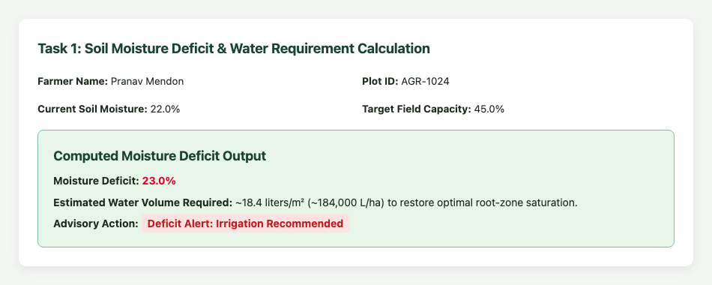
Task 2: Multi-Factor Decision Rule Recommendation Engine
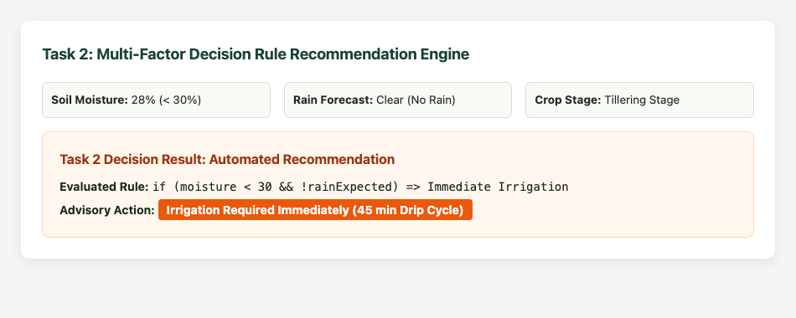
Task 3: Sugarcane Farm Object Representation & displayFarmInfo()
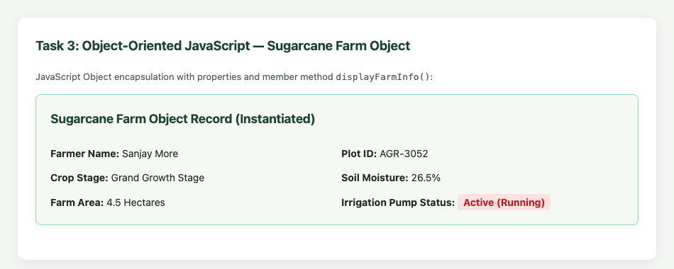
Task 4: Hourly Sensor Telemetry Array Processing (Min, Max, Avg, Critical Hours)
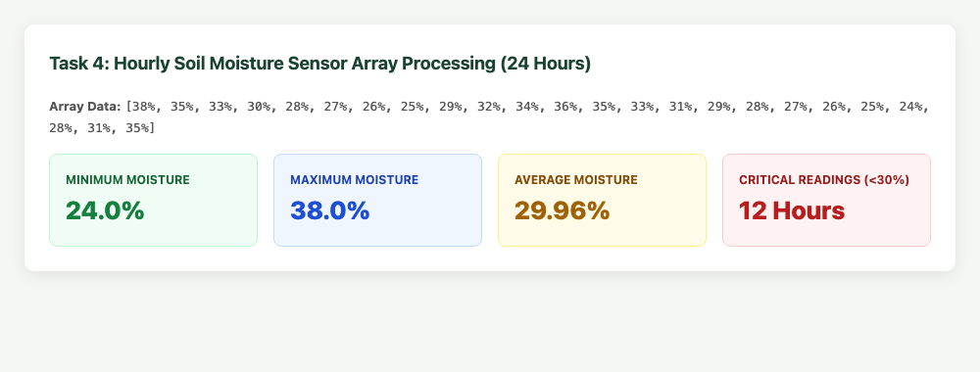
Task 5: Client-Side Input Validation Test Suite Results
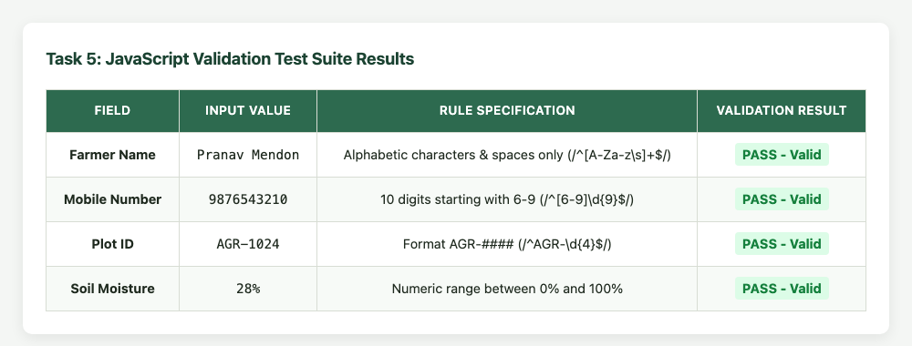
Task 6: Interactive Advisory Request & Registration Form Execution
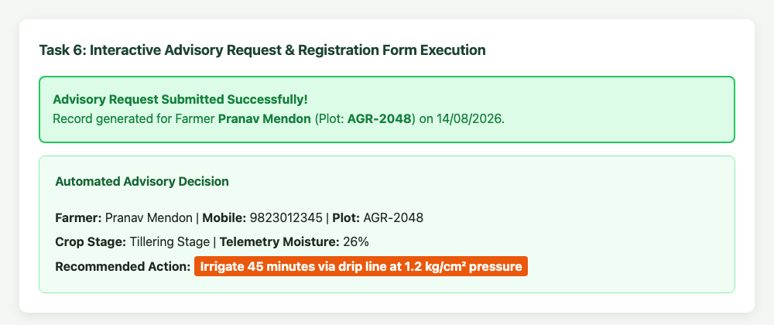

Conclusion and Discussion: Conclusion:
Experiment 5 successfully demonstrated JavaScript programming concepts applied to an AI-based Smart Irrigation Advisory System (KJS-AGR-01). Fundamental language constructs were systematically applied: variables and arithmetic operators for water volume deficit calculation, conditional statements for rule-based irrigation scheduling, object-oriented JavaScript for farm telemetry modeling, and array algorithms for 24-hour time-series sensor analysis. The interactive portal provides immediate feedback to farmers and agronomists, substantially reducing manual computation.
Discussion:
In Task 1, computing moisture deficit using float arithmetic ('parseFloat()') ensured decimal precision. In Task 2, prioritizing rainfall probability over absolute moisture thresholds avoided over-irrigation before rainstorms. Task 3 highlighted the power of encapsulation using the 'this' keyword to render formatted HTML cards directly from object state. In Task 4, using 'Math.min', 'Math.max', and 'reduce()' provided clean, high-performance array analytics on sensor telemetry.
Peer Feedback:
1. Rohan Sharma (Roll No: 16010125140): 'The 24-hour telemetry array analysis with min, max, and average metric cards looks professional and very practical.'
2. Ananya Verma (Roll No: 16010125142): 'The rainfall override rule is a smart agronomic addition that protects fields from waterlogging.'
3. Aditya Kulkarni (Roll No: 16010125145): 'The farm object method makes rendering dynamic telemetry data clean and modular.'
Faculty Feedback / Remarks:
Exceptional JavaScript implementation. Demonstrates sound programming principles across control logic, object-oriented modeling, and array processing.

