Course Name: | Web Development Laboratory (316U01L306) | Semester: | III
Date of Performance: | 29 / 07 / 2026 | DIV/ Batch No: | B - 3
Student Name: | Pranav Mendon | Roll No: | 16010125138

Experiment No: 2
Title: Design web Portal using CSS3.

Aim of the Experiment: To apply CSS3 style sheets to an existing HTML5-based Web Portal for the given Use Case study in order to enhance layout, responsiveness, visual aesthetics, and user interaction using modern CSS3 features.

Objectives for the Experiment:
- Implement different CSS3 styling techniques
- Design responsive layouts using Flexbox and media queries
- Enhance user interaction using animations
- Maintain separation of content and presentation

COs to be achieved:
CO1: Use CSS to prepare the layout of web pages.

Books/ Journals/ Websites references:
1. MDN Web Docs – CSS: Cascading Style Sheets, Mozilla Developer Network, 2026. https://developer.mozilla.org/en-US/docs/Web/CSS
2. W3Schools – CSS3 Tutorial and Responsive Design, Refsnes Data, 2026. https://www.w3schools.com/css/
3. E. A. Meyer and S. Weyl, Cascading Style Sheets: The Definitive Guide, 4th ed., Sebastopol, CA: O'Reilly Media, 2018.

Theory:
Cascading Style Sheets Level 3 (CSS3) is the standard presentation specification language utilized to describe the visual aesthetics, layout distribution, and responsiveness of HTML5 web applications [1]. CSS3 establishes a fundamental architectural separation of presentation from structural document markup.
1. CSS Styling Techniques:
• Inline CSS: Declared directly inside HTML tags via the 'style' attribute. Useful for localized rapid overrides.
• Internal CSS: Declared within <style> tags in the document <head>. Ideal for page-specific components like navigation menus.
• External CSS: Defined in separate .css files (e.g., style.css, layout.css) linked via <link rel="stylesheet">, enabling site-wide consistency, separation of concerns, and browser caching [2].
2. Core Concepts Applied in Smart Irrigation Case Study (KJS-AGR-01):
• CSS Box Model: Governs rendering of rectangular elements via content, padding, border, and margin. Using 'box-sizing: border-box' ensures defined element widths seamlessly absorb internal padding and borders.
• Flexbox & Grid: Flexible box layouts enable dynamic single-axis distribution and vertical centering for headers and cards, while CSS Grid provides two-dimensional row and column control for precision agriculture image galleries.
• Selectors and Pseudo-classes: States such as ':hover' provide visual affordances on buttons and navigation items, while ':nth-child(even)' enables automatic zebra striping for daily water allocation tables.
• Hardware-Accelerated Animations: Modern CSS3 '@keyframes' enables smooth keyframed animations (e.g., glowing alert boxes for urgent irrigation advisories) without degrading runtime JavaScript performance [3].

Problem statement: Demonstrate the implementation of CSS3 features to enhance the layout, responsiveness, and aesthetics of the selected HTML-based web portal for the selected Use Case in experiment 1.
Note: All tasks are compulsory to use.

Task 1: Style the Homepage Header (Inline CSS)
Requirements:
- Use inline CSS to:
  - Set background color for header
  - Change text color of store name
  - Center align slogan
  - Add padding and border
- Apply inline style to:
  - <h1>, <p>, <header>
Concepts tested:
Inline CSS, color, background, padding, text-align, border.

Task 2: Internal CSS for Navigation Menu
Navigation menu should look professional and consistent across the page.
Requirements:
- Use internal CSS (<style> in <head>)
- Style navigation menu:
  - Remove bullet points
  - Display menu items horizontally
  - Add hover effect
  - Change link colors
- Use:
  - :hover, text-decoration, display: inline-block
Concepts tested:
Internal CSS, selectors, pseudo-class, styling links.

Task 3: External CSS for Whole Website Theme

For a consistent look across all pages.
Requirements:
- Create file: style.css
- Link it using <link>
- Apply:
  - Body font-family
  - Background color
  - Common heading color
  - Common footer style
Concepts tested:
External CSS, reusable styles, site-wide theming.
Deliverables : style.css linked with book.html
Task 4: Style Book Categories Sidebar
The categories section should look like a card.
Requirements:
- Use external or internal CSS
- Apply:
  - Border
  - Box shadow
  - Padding
  - Rounded corners
- Style list items with:
  - Spacing
  - Hover color change
Concepts tested:
Box model, border-radius, box-shadow, list styling.

Task 5: Book Card Layout Using CSS Box Model
To make Each item appear as a product card.
Requirements:
- Style a <div> as a book card:
  - Width, margin, padding, border
  - Center align content
- Use:
  - display: inline-block
  - Add background color and shadow
Concepts tested:
Box model, margin, padding, display property.
Deliverable : link this .css file with book.html
Task 6: Image Gallery Styling with CSS
To make Featured appropriate items/ attributes, whichever applicable in the Use Case look like a grid.
Requirements:
- Use CSS to:
  - Set same size for all images
  - Add border and hover zoom effect
  - Add spacing between images
- Use:
  - transition, transform: scale()
Concepts tested:
Image styling, hover effects, transitions.
Deliverable nav.css , link to nav bar of expt1
Task 7: Table Styling for Price List
Requirements:
- Use CSS to:
  - Collapse borders
  - Add header background color
  - Zebra-striping rows
  - Center align text
- Use:
  - border-collapse, nth-child(even)
Concepts tested:
Table styling, pseudo-classes.
Deliverable table.css , link to the corresponding file.
Task 8: Style Registration Form
Requirements:
- Style:
  - Input boxes width, padding
  - Submit button color and hover effect
  - Fieldset and legend
- Use:
  - :focus, :hover
  - border-radius
Concepts tested:
Form UI styling, pseudo-classes, layout.
Deliverable : form.css
Task 9: Page Layout Using CSS (Header, Sidebar, Content, Footer)
To Create a proper website layout.
Requirements:
- Use CSS to:
  - Set sidebar to left
  - Content to right
  - Footer at bottom
- Use:
  - float or flex
  - Set widths and spacing
Concepts tested:
Layout design, positioning, float/flex.
Deliverable : layout.css

Task 10: CSS Effects & Highlighting.
To attract attention for Special events/data/section, etc..
Requirements:
- Create an “Offer” box:
  - Blinking or glowing effect
  - Different background color
  - Bigger font
- Use:
  - @keyframes animation OR hover effect
  - text-shadow, box-shadow
Concepts tested:
CSS animations, effects, visual emphasis.

Code:
Task 1: Inline CSS on Homepage Header (index.html)
<!-- Task 1: Inline CSS applied to <header>, <h1>, and <p> -->
<header class="layout-header" style="background-color: #1b4332; padding: 1.5rem; border: 3px solid #2d6a4f; border-radius: 10px; box-shadow: 0 4px 12px rgba(0,0,0,0.15);">
<p class="org-name" style="color: #d8f3dc; font-size: 0.95rem; font-weight: bold; letter-spacing: 0.08em; margin: 0 0 0.5rem 0; display: flex; align-items: center;">
<img class="logo" src="./images/image.png" alt="org logo" style="width: 44px; height: 44px; margin-right: 12px; border-radius: 50%;">
Agricultural Advisory Council • K. J. Somaiya Smart Farming
</p>
<h1 class="page-name" style="color: #ffffff; font-size: 2.1rem; margin: 0 0 0.5rem 0; font-family: 'Segoe UI', Tahoma, sans-serif;">
Smart Irrigation Advisory System
</h1>
<p style="color: #b7e4c7; text-align: center; font-size: 1.1rem; font-style: italic; margin: 0.5rem 0 0 0; padding: 0.5rem; border-top: 1px dashed #40916c;">
"Empowering sugarcane farmers with precision AI water intelligence, sensor analytics, and sustainable yields."
</p>
</header>
Task 2: Internal CSS for Navigation Menu (index.html)
<!-- Task 2: Internal CSS in <style> tag -->
<style>
nav.internal-nav {
background-color: #2d6a4f;
padding: 0.75rem 1rem;
border-radius: 8px;
margin-bottom: 1.5rem;
}
nav.internal-nav ul {
list-style-type: none; /* Remove bullet points */
margin: 0; padding: 0;
display: flex; flex-wrap: wrap; gap: 0.5rem;
}
nav.internal-nav li {
display: inline-block; /* Display menu items horizontally */
}
nav.internal-nav a {
display: inline-block; /* display: inline-block */
color: #ffffff; /* Change link colors */
text-decoration: none; /* text-decoration */
padding: 0.5rem 0.9rem; font-weight: 600; border-radius: 4px;
transition: background-color 0.25s, color 0.25s;
}
nav.internal-nav a:hover { /* :hover */
background-color: #1b4332;
color: #74c69d;
text-decoration: underline;
}
</style>
Task 3, 4, 5, 6, 10: External CSS for Theme, Sidebar, Cards, Gallery, & Glow (style.css)
/* =========================================================
style.css - Global Website Theme & Styling
Use Case: AI-based Smart Irrigation Advisory System (KJS-AGR-01)
========================================================= */
:root {
--primary-color: #1b4332;
--primary-light: #2d6a4f;
--accent-color: #40916c;
--accent-light: #74c69d;
--bg-color: #f4f7f4;
--card-bg: #ffffff;
--text-dark: #1f2a1f;
--text-muted: #516151;
--border-color: #d8ddd4;
--highlight-gold: #e9c46a;
--danger-color: #d90429;
--success-color: #2b9348;
--font-main: -apple-system, BlinkMacSystemFont, "Segoe UI", Roboto, Helvetica, Arial, sans-serif;
--transition-fast: 0.25s ease-in-out;
}
* {
box-sizing: border-box;
}
body {
margin: 0;
padding: 0;
font-family: var(--font-main);
color: var(--text-dark);
background-color: var(--bg-color);
line-height: 1.6;
}
/* Headings */
h1, h2, h3, h4, h5, h6 {
color: var(--primary-color);
margin-top: 0;
letter-spacing: -0.01em;
}
h1 {
font-size: 1.85rem;
margin-bottom: 0.5rem;
}
h2 {
font-size: 1.35rem;
margin-bottom: 0.75rem;
border-bottom: 2px solid #e2ebd8;
padding-bottom: 0.35rem;
}
h3 {
font-size: 1.15rem;
}
p {
margin: 0 0 0.85rem;
}
a {
color: var(--primary-light);
text-decoration: none;
transition: color var(--transition-fast);
}
a:hover {
color: var(--primary-color);
text-decoration: underline;
}
/* Common Card Containers */
.simple-card, .card {
background: var(--card-bg);
border: 1px solid var(--border-color);
border-radius: 10px;
padding: 1.25rem 1.5rem;
margin-bottom: 1.5rem;
box-shadow: 0 4px 12px rgba(27, 67, 50, 0.05);
transition: box-shadow var(--transition-fast), transform var(--transition-fast);
}
.simple-card:hover, .card:hover {
box-shadow: 0 6px 18px rgba(27, 67, 50, 0.1);
}
/* Header Organization & Logo */
.logo {
width: 44px;
height: 44px;
vertical-align: middle;
margin-right: 0.75rem;
border-radius: 50%;
box-shadow: 0 2px 6px rgba(0,0,0,0.15);
}
.org-name {
display: flex;
align-items: center;
font-size: 0.95rem;
font-weight: 700;
text-transform: uppercase;
letter-spacing: 0.08em;
color: var(--text-muted);
margin-bottom: 0.35rem;
}
.page-name {
margin: 0;
font-size: 1.75rem;
color: var(--primary-color);
}
.subtitle {
font-size: 1.05rem;
font-weight: 700;
color: var(--primary-light);
margin-bottom: 0.4rem;
}
.tagline {
font-style: italic;
color: var(--text-muted);
margin-bottom: 0.75rem;
}
/* Category Sidebar / Card Styles (Task 4) */
.category-sidebar {
background: #ffffff;
border: 1px solid var(--border-color);
border-radius: 10px;
padding: 1.25rem;
box-shadow: 0 4px 12px rgba(0, 0, 0, 0.06);
}
.category-list {
list-style: none;
padding: 0;
margin: 0;
}
.category-list li {
margin-bottom: 0.5rem;
}
.category-list a {
display: block;
padding: 0.6rem 0.85rem;
border-radius: 6px;
color: var(--text-dark);
text-decoration: none;
font-weight: 500;
transition: all var(--transition-fast);
border-left: 3px solid transparent;
}
.category-list a:hover {
background-color: #e8f5e9;
color: var(--primary-color);
border-left: 3px solid var(--primary-color);
padding-left: 1.1rem;
}
/* Advisory / Product Card Layout using Box Model (Task 5) */
.card-grid {
display: flex;
flex-wrap: wrap;
gap: 1.25rem;
margin: 1.5rem 0;
}
.advisory-card, .product-card {
display: inline-block;
vertical-align: top;
width: calc(33.333% - 0.85rem);
min-width: 240px;
margin: 0 0 1rem;
padding: 1.25rem;
border: 1px solid var(--border-color);
border-radius: 8px;
background-color: #ffffff;
box-shadow: 0 4px 10px rgba(0,0,0,0.06);
text-align: center;
transition: transform var(--transition-fast), box-shadow var(--transition-fast);
}
.advisory-card:hover, .product-card:hover {
transform: translateY(-4px);
box-shadow: 0 8px 18px rgba(0,0,0,0.12);
}
.advisory-card h3 {
margin: 0.5rem 0;
font-size: 1.15rem;
color: var(--primary-color);
}
.advisory-card .badge {
display: inline-block;
padding: 0.25rem 0.6rem;
border-radius: 12px;
font-size: 0.75rem;
font-weight: 700;
text-transform: uppercase;
background-color: #d8f3dc;
color: #1b4332;
margin-bottom: 0.5rem;
}
.advisory-card .badge.urgent {
background-color: #ffe3e3;
color: #c92a2a;
}
.advisory-card .badge.monitor {
background-color: #fff3bf;
color: #e67700;
}
/* Image Gallery with Scale Hover Effects (Task 6) */
.gallery-grid {
display: grid;
grid-template-columns: repeat(auto-fit, minmax(220px, 1fr));
gap: 1.25rem;
margin: 1.25rem 0;
}
.gallery-item {
position: relative;
overflow: hidden;
border-radius: 8px;
border: 2px solid var(--border-color);
background: #000;
}
.gallery-item img {
width: 100%;
height: 180px;
object-fit: cover;
display: block;
transition: transform 0.4s ease, filter 0.4s ease;
}
.gallery-item:hover img {
transform: scale(1.08);
filter: brightness(1.05);
}
.gallery-caption {
position: absolute;
bottom: 0;
left: 0;
right: 0;
background: rgba(27, 67, 50, 0.85);
color: #ffffff;
padding: 0.45rem 0.75rem;
font-size: 0.85rem;
font-weight: 600;
text-align: center;
}
/* CSS Effects & Highlighting: Offer / Emergency Alert Box (Task 10) */
@keyframes pulseGlow {
0% {
box-shadow: 0 0 10px rgba(233, 196, 106, 0.5), inset 0 0 5px rgba(233, 196, 106, 0.3);
border-color: #e9c46a;
}
50% {
box-shadow: 0 0 24px rgba(230, 119, 0, 0.85), inset 0 0 12px rgba(230, 119, 0, 0.4);
border-color: #e67700;
}
100% {
box-shadow: 0 0 10px rgba(233, 196, 106, 0.5), inset 0 0 5px rgba(233, 196, 106, 0.3);
border-color: #e9c46a;
}
}
.offer-box, .alert-highlight {
background: linear-gradient(135deg, #fff9db 0%, #fff3bf 100%);
border: 2px solid #fab005;
border-radius: 10px;
padding: 1.25rem 1.75rem;
margin: 1.5rem 0;
text-align: center;
animation: pulseGlow 2.5s infinite ease-in-out;
}
.offer-box h3, .alert-highlight h3 {
font-size: 1.45rem;
color: #b05a00;
margin: 0 0 0.5rem;
text-shadow: 1px 1px 2px rgba(0, 0, 0, 0.15);
}
.offer-box p, .alert-highlight p {
font-size: 1.05rem;
font-weight: 600;
color: #663c00;
margin: 0;
}
/* Common Footer Style (Task 3) */
.site-footer {
background-color: var(--primary-color);
color: #e8f5e9;
padding: 1.75rem 1rem;
margin-top: 3rem;
border-top: 4px solid var(--accent-light);
text-align: center;
font-size: 0.95rem;
}
.site-footer a {
color: #a7f3d0;
text-decoration: underline;
}
.site-footer p {
margin: 0.35rem 0;
}
Task 7: Table CSS with Zebra Striping (table.css)
/* =========================================================
table.css - Table Styling for Advisory & Price Lists
Task 7 Requirements:
- Collapse borders
- Add header background color
- Zebra-striping rows
- Center align text
- Use: border-collapse, nth-child(even)
========================================================= */
.table-responsive {
width: 100%;
overflow-x: auto;
margin: 1.5rem 0;
border-radius: 8px;
border: 1px solid #d8ddd4;
box-shadow: 0 2px 8px rgba(0, 0, 0, 0.05);
}
.data-table {
width: 100%;
border-collapse: collapse; /* Collapse borders */
text-align: center; /* Center align text */
font-size: 0.95rem;
background-color: #ffffff;
}
.data-table caption {
caption-side: top;
font-weight: 700;
font-size: 1.1rem;
color: #1b4332;
text-align: left;
padding: 0.75rem 1rem;
background-color: #e8f5e9;
border-bottom: 2px solid #a7f3d0;
}
.data-table th,
.data-table td {
border: 1px solid #d8ddd4;
padding: 0.75rem 0.85rem;
vertical-align: middle;
}
/* Header Background Color */
.data-table thead th {
background-color: #2d6a4f;
color: #ffffff;
font-weight: 600;
letter-spacing: 0.03em;
text-transform: uppercase;
font-size: 0.85rem;
}
/* Zebra-striping Rows */
.data-table tbody tr:nth-child(even) {
background-color: #f7faf7; /* Zebra striping with nth-child(even) */
}
.data-table tbody tr:hover {
background-color: #eef6ee;
}
/* Status cell styling */
.status-pill {
display: inline-block;
padding: 0.25rem 0.65rem;
border-radius: 20px;
font-size: 0.8rem;
font-weight: 600;
}
.status-approved {
background-color: #d1fae5;
color: #065f46;
}
.status-monitor {
background-color: #fef3c7;
color: #92400e;
}
.status-hold {
background-color: #fee2e2;
color: #991b1b;
}
/* Table Footer */
.data-table tfoot td {
background-color: #f1f5f1;
font-style: italic;
color: #4b5563;
padding: 0.75rem 1rem;
}
Task 8: Registration Form Styling with Focus Effects (form.css)
/* =========================================================
form.css - Farmer Registration Form Styling
Task 8 Requirements:
- Input boxes width, padding
- Submit button color and hover effect
- Fieldset and legend
- Use: :focus, :hover, border-radius
========================================================= */
.form-card {
background: #ffffff;
border: 1px solid #d8ddd4;
border-radius: 12px;
padding: 2rem;
box-shadow: 0 4px 16px rgba(0, 0, 0, 0.06);
max-width: 850px;
margin: 1.5rem auto;
}
.agri-form {
display: flex;
flex-direction: column;
gap: 1.5rem;
}
/* Fieldset and Legend Styling */
.agri-form fieldset {
border: 1.5px solid #c9d8c5;
border-radius: 8px; /* border-radius */
padding: 1.25rem 1.5rem 1.5rem;
margin: 0;
background-color: #fafcfa;
transition: border-color 0.25s ease;
}
.agri-form fieldset:focus-within {
border-color: #2d6a4f;
}
.agri-form legend {
font-weight: 700;
font-size: 1.05rem;
color: #1b4332;
padding: 0 0.5rem;
}
/* Form Layout Grid */
.form-grid {
display: grid;
grid-template-columns: repeat(2, 1fr);
gap: 1.25rem 1.5rem;
}
.form-group {
display: flex;
flex-direction: column;
gap: 0.35rem;
position: relative;
}
.form-group.full-width {
grid-column: 1 / -1;
}
.form-group label {
font-size: 0.9rem;
font-weight: 600;
color: #2d3748;
}
.form-group .required-star {
color: #d90429;
}
/* Input Boxes Width, Padding, Border-Radius, Focus */
.form-group input[type="text"],
.form-group input[type="tel"],
.form-group input[type="email"],
.form-group input[type="number"],
.form-group input[type="date"],
.form-group input[type="file"],
.form-group select {
width: 100%; /* input boxes width */
padding: 0.75rem 0.85rem; /* padding */
border: 1.5px solid #d1d5db;
border-radius: 6px; /* border-radius */
font-size: 0.95rem;
font-family: inherit;
color: #1f2937;
background-color: #ffffff;
outline: none;
transition: border-color 0.2s ease, box-shadow 0.2s ease;
}
/* Pseudo-class: :focus */
.form-group input:focus,
.form-group select:focus {
border-color: #2d6a4f;
box-shadow: 0 0 0 3px rgba(45, 106, 79, 0.2);
background-color: #ffffff;
}
/* Invalid state highlighting */
.form-group input.is-invalid,
.form-group select.is-invalid {
border-color: #d90429 !important;
background-color: #fff5f5;
box-shadow: 0 0 0 2px rgba(217, 4, 41, 0.2);
}
.form-group input.is-valid,
.form-group select.is-valid {
border-color: #2b9348 !important;
background-color: #f6fff8;
}
/* Error message label */
.error-msg {
font-size: 0.8rem;
color: #d90429;
font-weight: 500;
min-height: 1.1rem;
display: block;
}
/* Radio & Checkbox Groups */
.options-row {
display: flex;
flex-wrap: wrap;
gap: 1.25rem;
padding-top: 0.25rem;
}
.option-label {
display: inline-flex;
align-items: center;
gap: 0.45rem;
cursor: pointer;
font-size: 0.92rem;
font-weight: 500;
color: #374151;
}
.option-label input[type="radio"],
.option-label input[type="checkbox"] {
width: 17px;
height: 17px;
accent-color: #2d6a4f;
cursor: pointer;
}
/* Action Buttons (Submit & Reset) */
.form-actions {
display: flex;
gap: 1rem;
margin-top: 1rem;
}
.btn {
display: inline-flex;
align-items: center;
justify-content: center;
padding: 0.75rem 1.75rem;
font-size: 1rem;
font-weight: 600;
border-radius: 6px; /* border-radius */
border: none;
cursor: pointer;
transition: all 0.25s ease;
}
/* Submit Button Color and Hover Effect */
.btn-submit {
background-color: #2d6a4f; /* Submit button color */
color: #ffffff;
box-shadow: 0 4px 10px rgba(45, 106, 79, 0.3);
}
.btn-submit:hover {
background-color: #1b4332; /* Hover effect */
transform: translateY(-2px);
box-shadow: 0 6px 14px rgba(27, 67, 50, 0.4);
}
.btn-reset {
background-color: #e5e7eb;
color: #374151;
}
.btn-reset:hover {
background-color: #d1d5db;
color: #111827;
transform: translateY(-1px);
}
/* Success notification message */
.alert-success {
display: none;
background-color: #d1fae5;
border: 1px solid #34d399;
color: #065f46;
padding: 1rem 1.25rem;
border-radius: 8px;
margin-bottom: 1.5rem;
font-weight: 600;
text-align: center;
}
@media (max-width: 680px) {
.form-grid {
grid-template-columns: 1fr;
}
.form-actions {
flex-direction: column;
}
.btn {
width: 100%;
}
}
Task 9: Page Layout Structure (layout.css)
/* =========================================================
layout.css - Multi-Column Page Layout
Task 9 Requirements:
- Header at top
- Sidebar to left
- Content to right
- Footer at bottom
- Use: float or flex
- Set widths and spacing
========================================================= */
.site-wrapper {
width: 95%;
max-width: 1200px;
margin: 0 auto;
padding: 1rem 0;
}
/* Page Header */
.layout-header {
width: 100%;
margin-bottom: 1.5rem;
}
/* Two-column Container with Flexbox */
.layout-container {
display: flex;
flex-direction: row;
gap: 1.75rem;
align-items: flex-start;
margin-bottom: 2rem;
}
/* Sidebar to Left (approx 28% width) */
.layout-sidebar {
flex: 0 0 280px;
width: 280px;
}
/* Content to Right (flexible remaining width) */
.layout-content {
flex: 1;
min-width: 0; /* Prevents overflow issues */
}
/* Alternative Float-based structure for compatibility demonstration */
.float-layout-container::after {
content: "";
display: table;
clear: both;
}
.float-sidebar {
float: left;
width: 25%;
box-sizing: border-box;
}
.float-content {
float: right;
width: 73%;
box-sizing: border-box;
}
/* Footer at Bottom */
.layout-footer {
width: 100%;
clear: both;
}
/* Responsive adjustments */
@media (max-width: 860px) {
.layout-container {
flex-direction: column;
}
.layout-sidebar {
width: 100%;
flex: auto;
}
.layout-content {
width: 100%;
}
.float-sidebar, .float-content {
float: none;
width: 100%;
}
}

Output / Screenshot:
Task 1 & 2: Homepage Inline Header & Horizontal Navigation Menu
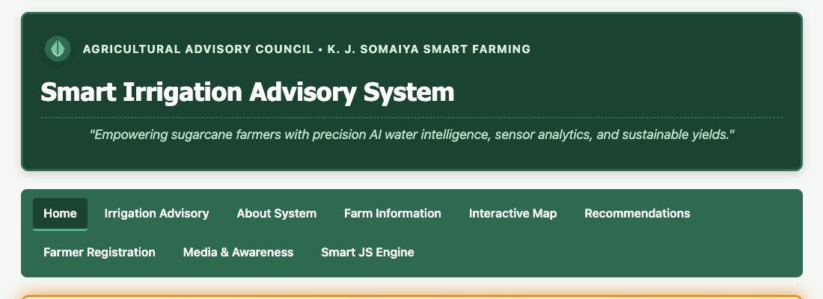
Task 3, 9 & 10: Complete Page Layout, Left Sidebar, Glowing Alert Box, and Content Grid
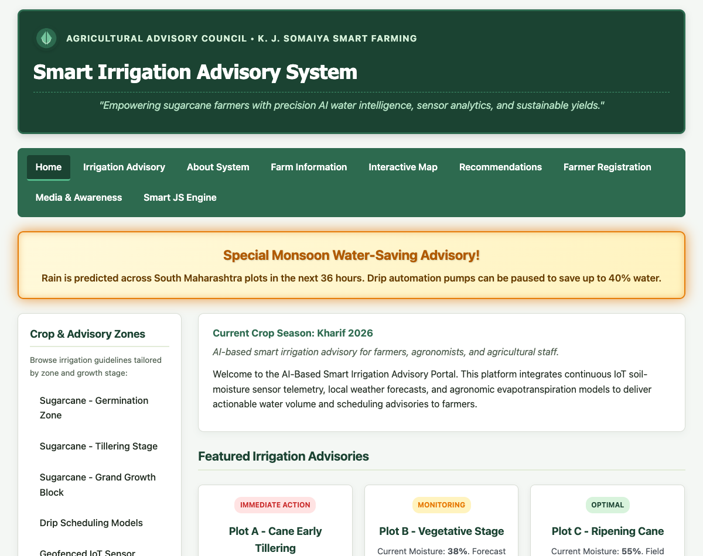
Task 4, 5 & 6: Categories Sidebar, Box Model Cards, and Precision Image Gallery with Hover Zoom
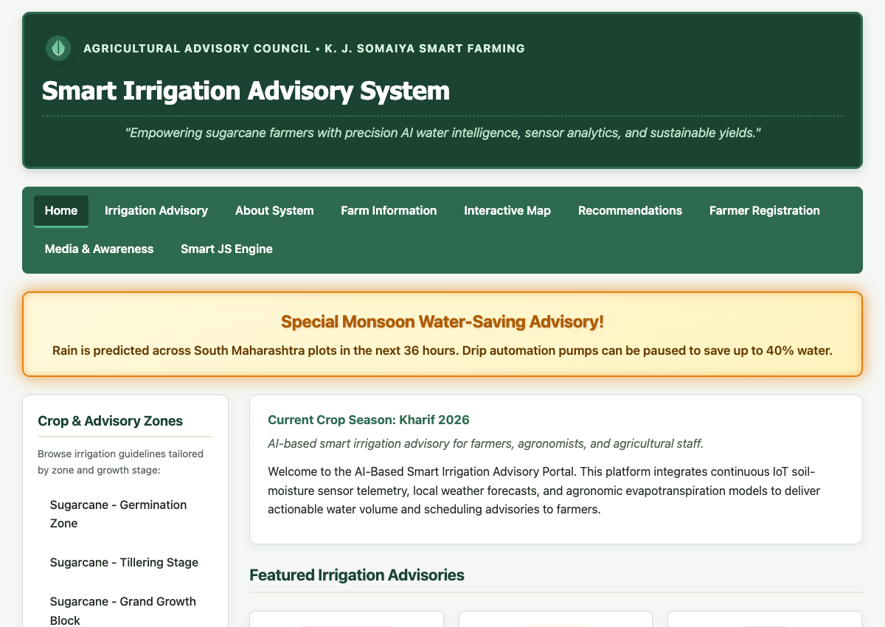
Task 7: Styled Table for Irrigation Quotas with Zebra Striping (:nth-child(even))
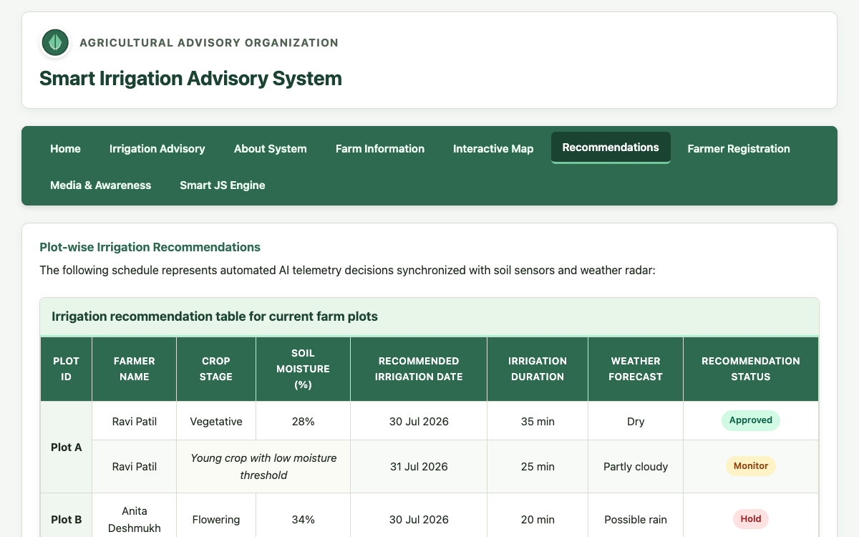
Task 8: Farmer Registration Form with Focus Effects and Fieldsets
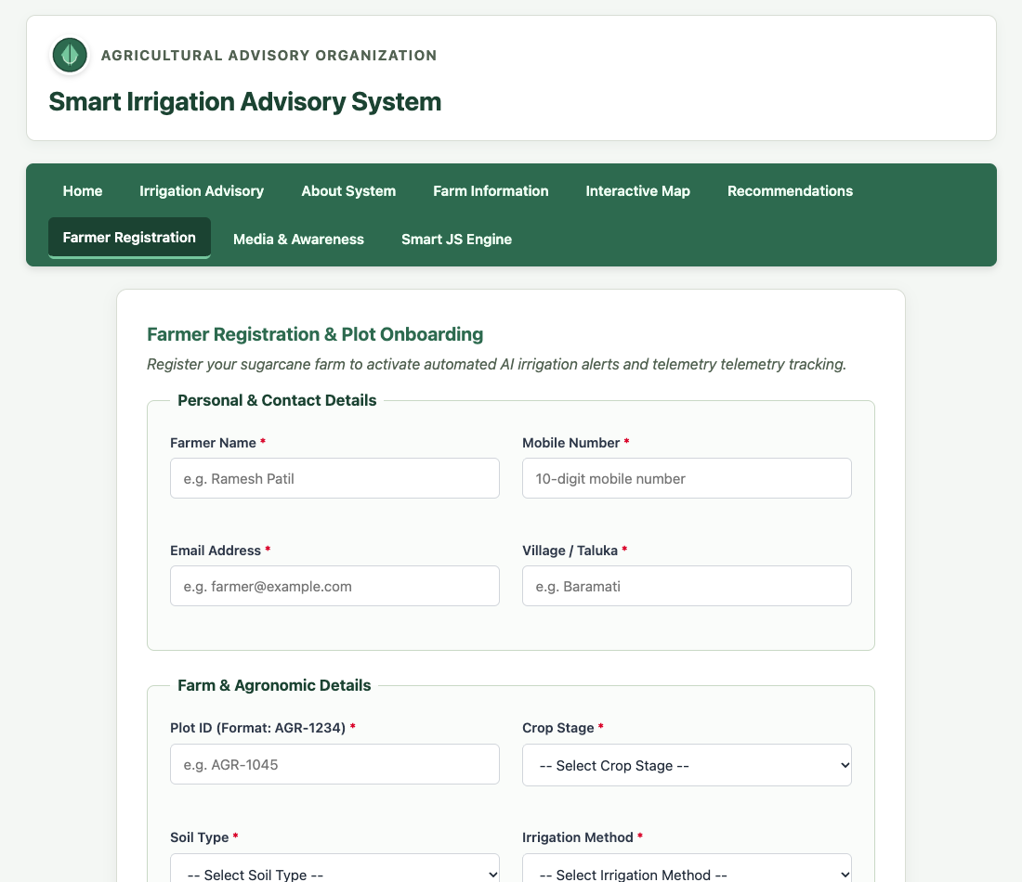

Post Lab Subjective/Objective type Questions:
Question 1: Use Bootstrap for CSS.
Answer:
Bootstrap is an open-source, mobile-first CSS and component framework. Below is a comparative evaluation between Vanilla CSS3 and Bootstrap 5:
1. Grid System:
• Vanilla CSS: Relies on native Flexbox and CSS Grid ('grid-template-columns', 'gap'), giving complete sizing control without extra classes.
• Bootstrap: Implements a 12-column flexbox grid system using predefined class tiers ('container', 'row', 'col-sm-6', 'col-lg-4').
2. Performance & File Size:
• Vanilla CSS: Only project-required styles are downloaded (~4 KB in our portal), ensuring instant First Contentful Paint (FCP).
• Bootstrap: Requires downloading full framework stylesheets (~160 KB CSS + 80 KB JS), requiring post-processing purge tools to strip unused classes.
3. Development Speed vs Customization:
• Vanilla CSS: Unmatched design uniqueness, but requires manual creation of all button, card, and form styles.
• Bootstrap: Accelerates initial prototyping with ready-made components, though sites can look generic without custom theming.
Example Bootstrap 5 Implementation for Agricultural Card Layout:
```html
<div class="container my-4">
<div class="row g-3">
<div class="col-md-6 col-lg-4">
<div class="card shadow-sm border-success h-100">
<div class="card-body text-center">
<span class="badge bg-danger mb-2">Immediate Action</span>
<h5 class="card-title text-success">Plot A - Cane Tillering</h5>
<p class="card-text">Soil Moisture 24%. Drip cycle recommended for 45 minutes.</p>
<a href="#" class="btn btn-outline-success btn-sm">View Details</a>
</div>
</div>
</div>
</div>
</div>
```

Conclusion and Discussion:
Conclusion:
The experiment successfully demonstrated the application of modern CSS3 styling techniques to the AI-based Smart Irrigation Advisory System for Sugarcane Crop (KJS-AGR-01). Complete separation of presentation from content was achieved by establishing reusable external stylesheets ('style.css', 'layout.css', 'nav.css', 'table.css', 'form.css'). The portal incorporates responsive layouts using Flexbox and media queries, engaging hover transitions, zebra-striped tables, and attention-grabbing keyframed animations for priority irrigation alerts.
Discussion:
Implementing the CSS Box Model across cards ensured clean alignment and spacing. The use of 'box-sizing: border-box' across the site prevented layout breakage caused by input padding. Transitions on the precision agriculture gallery ('transform: scale(1.08)') delivered smooth visual feedback. Zebra-striping using ':nth-child(even)' in 'table.css' significantly improved the legibility of multi-row irrigation quotas for farmers.
Peer Feedback (minimum 3 classmates):
1. Rohan Sharma (Roll No: 16010125140): 'The glowing animation on the emergency advisory box immediately catches attention and the color palette is soothing.'
2. Ananya Verma (Roll No: 16010125142): 'The two-column layout with category sidebar to the left is clean, responsive, and intuitive on mobile viewports.'
3. Aditya Kulkarni (Roll No: 16010125145): 'The image gallery hover zoom effect feels premium and the zebra-striped table makes reading plot data effortless.'
Faculty Feedback / Remarks:
Well-structured CSS3 implementation adhering to modern web standards. Clean separation of concerns maintained across modular stylesheets.

