Course Name: | Web Development Laboratory (316U01L306) | Semester: | III
Date of Performance: | 12 / 08 / 2026 | DIV/ Batch No: | B - 3
Student Name: | Pranav Mendon | Roll No: | 16010125138

Experiment No: 4
Title
Form Validation using JavaScript for an AI-based Smart Irrigation Advisory Web Portal
Aim of the Experiment
To design and implement client-side form validation using JavaScript for the farmer registration form of an AI-based Smart Irrigation Advisory System, ensuring that user-entered data such as name, mobile number, email, plot ID, soil moisture, crop stage, irrigation method, and date is complete, valid, and meaningful before form submission.
Objectives of the Experiment
• To create an interactive HTML form for collecting farmer and farm information.
• To use JavaScript to validate text, numeric, email, date, and selection fields.
• To implement regular expressions for validating mobile numbers, email addresses, and plot IDs.
• To display meaningful error messages and prevent submission when invalid data is entered.
• To apply form validation to a real-world agriculture use case involving farmer and farm registration.
COs to be achieved
CO1: Developing webpages using HTML, CSS and JavaScript.
Books / Journals / Websites references
1. MDN Web Docs – JavaScript Guide and HTML Forms.
2. W3schools.com
3. JavaScript documentation/reference material prescribed by the course instructor.
Theory
Form validation is the process of checking whether the information entered by a user satisfies the required rules before it is submitted or processed. Validation improves data quality, usability, and reliability of web applications.
JavaScript provides client-side validation by accessing form elements through the DOM and checking their values using conditions, string methods, numeric comparisons, regular expressions, and event handlers such as submit and input. If invalid data is detected, JavaScript can display an error message and stop the form from being submitted.
Common validation rules include checking for empty fields, minimum and maximum length, valid email format, valid mobile number, acceptable numeric ranges, selected options, and valid dates. Regular expressions are useful for validating structured values such as mobile numbers and email addresses.
In this experiment, JavaScript validation is applied to a farmer registration form for the AI-based Smart Irrigation Advisory System. The use case calls for farmer-friendly web/mobile platforms and plot-specific advisory and decision support. fileciteturn0file1L41-L46
Problem Statement
"JavaScript Form Validation for Farmer Registration"
Develop a web-based farmer registration form for the Smart Irrigation Advisory System. The form should collect essential farmer and farm information and use JavaScript to validate the entered values before submission. Invalid or incomplete data must be identified and appropriate error messages must be displayed to the user.
Task 1: Create the Farmer Registration Form
Scenario
Design a registration form for farmers who will use the Smart Irrigation Advisory System.
Requirements
• Create fields for Farmer Name, Mobile Number, Email, Plot ID, Village, Crop Stage, Soil Type, Irrigation Method, Soil Moisture (%), Registration Date and Farm Photo.
• Use <form>, <label>, <input>, <select>, <option>, <fieldset> and <legend>.
• Provide Submit and Reset buttons.
• Assign unique id and name attributes to all fields.
Concepts Tested
• HTML Forms
• Form controls
• DOM element identification
Deliverable: registration.html
Task 2: Validate Required Text Fields
Scenario
Ensure that essential farmer and farm information is not left blank.
Requirements
• Check that Farmer Name, Plot ID and Village are not empty.
• Remove leading and trailing spaces using trim().
• Validate that Farmer Name contains alphabetic characters and spaces only.
• Display an error message beside each invalid field.
Concepts Tested
• JavaScript conditions
• String methods
• Required-field validation
Deliverable: registration.html
Task 3: Validate Mobile Number and Email
Scenario
Verify that the farmer's contact information follows the expected format.
Requirements
• Validate a 10-digit Indian mobile number using a suitable regular expression or any other rule.
• Validate the email address.
• Display specific messages for invalid mobile number and email.
• Do not allow the form to submit until both fields are valid.
Concepts Tested
• Regular expressions
• String validation
• Form submit event
Deliverable: registration.html
Task 4: Validate Selection and Date Fields
Scenario
Ensure that the farmer provides valid crop, soil, irrigation and date information.
Requirements
• Ensure that Crop Stage, Soil Type and Irrigation Method are selected.
• Validate that Registration Date is entered.
• Prevent future registration dates if the application rule requires the registration date to be today or earlier.
• Highlight the field when validation fails.
Concepts Tested
• Select validation
• Date validation
• DOM manipulation
Deliverable: registration.html

Code :
HTML Form Code (registration.html):
<!DOCTYPE html>
<html lang="en">
<head>
<meta charset="UTF-8">
<meta name="viewport" content="width=device-width, initial-scale=1.0">
<title>Farmer Registration - Smart Irrigation Advisory System</title>
<link rel="stylesheet" href="style.css">
<link rel="stylesheet" href="layout.css">
<link rel="stylesheet" href="nav.css">
<link rel="stylesheet" href="form.css">
</head>
<body>
<div class="site-wrapper">
<header class="simple-card" id="home-header">
<p class="org-name">
<img class="logo" src="./images/image.png" alt="org logo">
Agricultural Advisory Organization
</p>
<h1 class="page-name">Smart Irrigation Advisory System</h1>
</header>
<nav class="site-nav" aria-label="Main Navigation">
<ul class="nav-menu">
<li class="nav-item"><a class="nav-link" href="index.html">Home</a></li>
<li class="nav-item"><a class="nav-link" href="irrigation-advisory.html">Irrigation Advisory</a></li>
<li class="nav-item"><a class="nav-link" href="about-system.html">About System</a></li>
<li class="nav-item"><a class="nav-link" href="farm-information.html">Farm Information</a></li>
<li class="nav-item"><a class="nav-link" href="farm-map.html">Interactive Map</a></li>
<li class="nav-item"><a class="nav-link" href="recommendation.html">Recommendations</a></li>
<li class="nav-item"><a class="nav-link active" href="registration.html">Farmer Registration</a></li>
<li class="nav-item"><a class="nav-link" href="media.html">Media & Awareness</a></li>
<li class="nav-item"><a class="nav-link" href="smart-advisory.html">Smart JS Engine</a></li>
</ul>
</nav>
<main>
<div class="form-card">
<p class="subtitle" style="font-size: 1.25rem; margin-bottom: 0.25rem;">Farmer Registration & Plot Onboarding</p>
<p class="tagline">Register your sugarcane farm to activate automated AI irrigation alerts and telemetry telemetry tracking.</p>
<!-- Success Notification Box -->
<div id="formSuccessMsg" class="alert-success" role="alert"></div>
<form id="farmerRegistrationForm" class="agri-form" novalidate>
<!-- Fieldset 1: Farmer Personal & Contact Information -->
<fieldset>
<legend>Personal & Contact Details</legend>
<div class="form-grid">
<div class="form-group">
<label for="farmerName">Farmer Name <span class="required-star">*</span></label>
<input type="text" id="farmerName" name="farmerName" placeholder="e.g. Ramesh Patil">
<span class="error-msg" id="farmerNameError"></span>
</div>
<div class="form-group">
<label for="mobileNumber">Mobile Number <span class="required-star">*</span></label>
<input type="tel" id="mobileNumber" name="mobileNumber" placeholder="10-digit mobile number">
<span class="error-msg" id="mobileNumberError"></span>
</div>
<div class="form-group">
<label for="email">Email Address <span class="required-star">*</span></label>
<input type="email" id="email" name="email" placeholder="e.g. farmer@example.com">
<span class="error-msg" id="emailError"></span>
</div>
<div class="form-group">
<label for="village">Village / Taluka <span class="required-star">*</span></label>
<input type="text" id="village" name="village" placeholder="e.g. Baramati">
<span class="error-msg" id="villageError"></span>
</div>
</div>
</fieldset>
<!-- Fieldset 2: Farm & Soil Specifics -->
<fieldset>
<legend>Farm & Agronomic Details</legend>
<div class="form-grid">
<div class="form-group">
<label for="plotId">Plot ID (Format: AGR-1234) <span class="required-star">*</span></label>
<input type="text" id="plotId" name="plotId" placeholder="e.g. AGR-1045">
<span class="error-msg" id="plotIdError"></span>
</div>
<div class="form-group">
<label for="cropStage">Crop Stage <span class="required-star">*</span></label>
<select id="cropStage" name="cropStage">
<option value="">-- Select Crop Stage --</option>
<option value="Germination">Germination (0-30 Days)</option>
<option value="Tillering">Tillering (31-120 Days)</option>
<option value="Grand Growth">Grand Growth (121-250 Days)</option>
<option value="Ripening">Ripening / Maturity (251-360 Days)</option>
</select>
<span class="error-msg" id="cropStageError"></span>
</div>
<div class="form-group">
<label for="soilType">Soil Type <span class="required-star">*</span></label>
<select id="soilType" name="soilType">
<option value="">-- Select Soil Type --</option>
<option value="Black Clay (Regur)">Black Clay (Regur)</option>
<option value="Alluvial Loam">Alluvial Loam</option>
<option value="Sandy Loam">Sandy Loam</option>
<option value="Red Laterite">Red Laterite</option>
</select>
<span class="error-msg" id="soilTypeError"></span>
</div>
<div class="form-group">
<label for="irrigationMethod">Irrigation Method <span class="required-star">*</span></label>
<select id="irrigationMethod" name="irrigationMethod">
<option value="">-- Select Irrigation Method --</option>
<option value="Drip">Drip Irrigation (Recommended)</option>
<option value="Sprinkler">Micro-Sprinkler</option>
<option value="Furrow">Furrow Irrigation</option>
<option value="Flood">Flood / Basin</option>
</select>
<span class="error-msg" id="irrigationMethodError"></span>
</div>
<div class="form-group">
<label for="soilMoisture">Initial Soil Moisture (%) <span class="required-star">*</span></label>
<input type="number" id="soilMoisture" name="soilMoisture" min="0" max="100" step="0.1" placeholder="e.g. 28.5">
<span class="error-msg" id="soilMoistureError"></span>
</div>
<div class="form-group">
<label for="registrationDate">Registration Date <span class="required-star">*</span></label>
<input type="date" id="registrationDate" name="registrationDate">
<span class="error-msg" id="registrationDateError"></span>
</div>
<div class="form-group full-width">
<label for="farmPhoto">Farm / Crop Plot Photo (Optional)</label>
<input type="file" id="farmPhoto" name="farmPhoto" accept="image/*">
<span class="error-msg" id="farmPhotoError"></span>
</div>
</div>
</fieldset>
<!-- Fieldset 3: Preferences -->
<fieldset>
<legend>Preferences & Communication</legend>
<div style="margin-bottom: 1rem;">
<label style="font-weight: 600; display: block; margin-bottom: 0.35rem;">Preferred Advisory Language:</label>
<div class="options-row">
<label class="option-label"><input type="radio" name="preferredLanguage" value="Marathi" checked> Marathi (मराठी)</label>
<label class="option-label"><input type="radio" name="preferredLanguage" value="Hindi"> Hindi (हिंदी)</label>
<label class="option-label"><input type="radio" name="preferredLanguage" value="English"> English</label>
</div>
</div>
<div>
<label style="font-weight: 600; display: block; margin-bottom: 0.35rem;">Advisory Services Required:</label>
<div class="options-row">
<label class="option-label"><input type="checkbox" name="services" value="irrigation" checked> Daily Irrigation Timing</label>
<label class="option-label"><input type="checkbox" name="services" value="weather" checked> Weather & Rainfall Forecasts</label>
<label class="option-label"><input type="checkbox" name="services" value="soil"> Soil Nutrient & Health Reports</label>
<label class="option-label"><input type="checkbox" name="services" value="crop"> Harvest Timing Recommendations</label>
</div>
</div>
</fieldset>
<!-- Form Buttons -->
<div class="form-actions">
<button type="submit" class="btn btn-submit">Submit Registration</button>
<button type="reset" class="btn btn-reset">Reset Form</button>
</div>
</form>
</div>
</main>
<footer class="site-footer">
<p>Smart Irrigation Advisory System &bull; Sugarcane Crop (KJS-AGR-01)</p>
<p>Department of Computer Engineering &bull; K. J. Somaiya School of Engineering</p>
</footer>
</div>
<script src="script.js"></script>
</body>
</html>
JavaScript Form Validation Engine (script.js):
/* =========================================================
script.js - JavaScript Programming & Form Validation
Use Case: Smart Irrigation Advisory Web Portal (KJS-AGR-01)
Covers Experiments 4 & 5
========================================================= */
document.addEventListener("DOMContentLoaded", function () {
// =========================================================
// EXPERIMENT 4: Form Validation Implementation
// =========================================================
const regForm = document.getElementById("farmerRegistrationForm");
const successBox = document.getElementById("formSuccessMsg");
if (regForm) {
// Individual field validation functions
function validateFarmerName() {
const field = document.getElementById("farmerName");
const err = document.getElementById("farmerNameError");
const val = field.value.trim();
const nameRegex = /^[A-Za-z\s]+$/;
if (val === "") {
setError(field, err, "Farmer Name is required and cannot be blank.");
return false;
} else if (!nameRegex.test(val)) {
setError(field, err, "Farmer Name must contain alphabetic characters and spaces only.");
return false;
}
clearError(field, err);
return true;
}
function validateMobile() {
const field = document.getElementById("mobileNumber");
const err = document.getElementById("mobileNumberError");
const val = field.value.trim();
const mobileRegex = /^[6-9]\d{9}$/;
if (val === "") {
setError(field, err, "Mobile Number is required.");
return false;
} else if (!mobileRegex.test(val)) {
setError(field, err, "Mobile Number must be exactly 10 digits starting with 6-9.");
return false;
}
clearError(field, err);
return true;
}
function validateEmail() {
const field = document.getElementById("email");
const err = document.getElementById("emailError");
const val = field.value.trim();
const emailRegex = /^[^\s@]+@[^\s@]+\.[^\s@]+$/;
if (val === "") {
setError(field, err, "Email Address is required.");
return false;
} else if (!emailRegex.test(val)) {
setError(field, err, "Enter a valid email format (e.g., farmer@example.com).");
return false;
}
clearError(field, err);
return true;
}
function validatePlotId() {
const field = document.getElementById("plotId");
const err = document.getElementById("plotIdError");
const val = field.value.trim().toUpperCase();
field.value = val;
const plotRegex = /^AGR-\d{4}$/;
if (val === "") {
setError(field, err, "Plot ID is required.");
return false;
} else if (!plotRegex.test(val)) {
setError(field, err, "Plot ID must follow format AGR-1234.");
return false;
}
clearError(field, err);
return true;
}
function validateVillage() {
const field = document.getElementById("village");
const err = document.getElementById("villageError");
const val = field.value.trim();
if (val === "") {
setError(field, err, "Village name is required.");
return false;
}
clearError(field, err);
return true;
}
function validateDropdown(fieldId, errorId, fieldName) {
const field = document.getElementById(fieldId);
const err = document.getElementById(errorId);
if (!field.value || field.value === "") {
setError(field, err, `Please select a valid ${fieldName}.`);
return false;
}
clearError(field, err);
return true;
}
function validateMoisture() {
const field = document.getElementById("soilMoisture");
const err = document.getElementById("soilMoistureError");
const val = parseFloat(field.value);
if (isNaN(val) || field.value.trim() === "") {
setError(field, err, "Soil Moisture is required.");
return false;
} else if (val < 0 || val > 100) {
setError(field, err, "Soil Moisture must be between 0% and 100%.");
return false;
}
clearError(field, err);
return true;
}
function validateRegistrationDate() {
const field = document.getElementById("registrationDate");
const err = document.getElementById("registrationDateError");
const val = field.value;
if (!val) {
setError(field, err, "Registration Date is required.");
return false;
}
const selectedDate = new Date(val);
const today = new Date();
today.setHours(23, 59, 59, 999);
if (selectedDate > today) {
setError(field, err, "Registration Date cannot be a future date.");
return false;
}
clearError(field, err);
return true;
}
// Helpers
function setError(field, errElement, message) {
field.classList.add("is-invalid");
field.classList.remove("is-valid");
if (errElement) errElement.textContent = message;
}
function clearError(field, errElement) {
field.classList.remove("is-invalid");
field.classList.add("is-valid");
if (errElement) errElement.textContent = "";
}
// Attach blur event listeners for real-time validation feedback
document.getElementById("farmerName").addEventListener("blur", validateFarmerName);
document.getElementById("mobileNumber").addEventListener("blur", validateMobile);
document.getElementById("email").addEventListener("blur", validateEmail);
document.getElementById("plotId").addEventListener("blur", validatePlotId);
document.getElementById("village").addEventListener("blur", validateVillage);
document.getElementById("soilMoisture").addEventListener("blur", validateMoisture);
document.getElementById("registrationDate").addEventListener("blur", validateRegistrationDate);
document.getElementById("cropStage").addEventListener("change", () => validateDropdown("cropStage", "cropStageError", "Crop Stage"));
document.getElementById("soilType").addEventListener("change", () => validateDropdown("soilType", "soilTypeError", "Soil Type"));
document.getElementById("irrigationMethod").addEventListener("change", () => validateDropdown("irrigationMethod", "irrigationMethodError", "Irrigation Method"));
// Form Submit Event Handling
regForm.addEventListener("submit", function (e) {
e.preventDefault();
const isNameValid = validateFarmerName();
const isMobileValid = validateMobile();
const isEmailValid = validateEmail();
const isPlotValid = validatePlotId();
const isVillageValid = validateVillage();
const isCropValid = validateDropdown("cropStage", "cropStageError", "Crop Stage");
const isSoilValid = validateDropdown("soilType", "soilTypeError", "Soil Type");
const isMethodValid = validateDropdown("irrigationMethod", "irrigationMethodError", "Irrigation Method");
const isMoistureValid = validateMoisture();
const isDateValid = validateRegistrationDate();
const formIsValid = isNameValid && isMobileValid && isEmailValid && isPlotValid &&
isVillageValid && isCropValid && isSoilValid && isMethodValid &&
isMoistureValid && isDateValid;
if (!formIsValid) {
if (successBox) successBox.style.display = "none";
alert("Please correct the highlighted errors before submitting the form.");
return;
}
// Success
if (successBox) {
const farmerName = document.getElementById("farmerName").value.trim();
const plotId = document.getElementById("plotId").value.trim();
successBox.innerHTML = `<strong>Registration Successful!</strong> Farmer <em>${farmerName}</em> with Plot ID <em>${plotId}</em> has been registered in the Smart Irrigation Advisory Portal.`;
successBox.style.display = "block";
successBox.scrollIntoView({ behavior: "smooth" });
} else {
alert("Registration Successful!");
}
});
// Reset button handler
regForm.addEventListener("reset", function () {
setTimeout(() => {
const inputs = regForm.querySelectorAll("input, select");
inputs.forEach(el => {
el.classList.remove("is-valid", "is-invalid");
});
const errs = regForm.querySelectorAll(".error-msg");
errs.forEach(err => err.textContent = "");
if (successBox) successBox.style.display = "none";
}, 50);
});
}
// =========================================================
// EXPERIMENT 5: JavaScript Programming Modules
// =========================================================
// Task 1: Soil Moisture Deficit Calculator
const calcBtn = document.getElementById("btnCalcMoisture");
if (calcBtn) {
calcBtn.addEventListener("click", function () {
const farmerName = document.getElementById("calcFarmerName").value.trim() || "Ramesh Patil";
const plotId = document.getElementById("calcPlotId").value.trim() || "AGR-1024";
const currentMoisture = parseFloat(document.getElementById("calcCurrentMoisture").value);
const requiredMoisture = parseFloat(document.getElementById("calcRequiredMoisture").value);
if (isNaN(currentMoisture) || isNaN(requiredMoisture)) {
alert("Please enter valid numeric moisture levels.");
return;
}
const deficit = requiredMoisture - currentMoisture;
let statusMsg = "";
if (deficit > 0) {
// Approximate 25 liters per 1% deficit per square meter
const waterPerSqM = (deficit * 0.8).toFixed(1);
statusMsg = `Farmer: ${farmerName} | Plot: ${plotId}\n` +
`Current Moisture: ${currentMoisture}%\n` +
`Target Moisture: ${requiredMoisture}%\n` +
`Moisture Deficit: ${deficit.toFixed(1)}%\n` +
`Water Required: ~${waterPerSqM} liters/m² to restore root-zone field capacity.`;
} else {
statusMsg = `Farmer: ${farmerName} | Plot: ${plotId}\n` +
`Current Moisture: ${currentMoisture}%\n` +
`Target Moisture: ${requiredMoisture}%\n` +
`No moisture deficit detected. Soil is sufficiently hydrated.`;
}
// Display alert()
alert("Irrigation Advisory Status:\n" + statusMsg);
// Display in DOM
const outBox = document.getElementById("calcMoistureOutput");
if (outBox) {
outBox.innerHTML = `<div class="card" style="background:#e8f5e9; border:1px solid #74c69d;">
<h4 style="margin:0 0 0.5rem; color:#1b4332;">Task 1 Result: Moisture Deficit Calculation</h4>
<p><strong>Farmer:</strong> ${farmerName} | <strong>Plot ID:</strong> ${plotId}</p>
<p><strong>Current Soil Moisture:</strong> ${currentMoisture}% | <strong>Required Moisture:</strong> ${requiredMoisture}%</p>
<p><strong>Moisture Deficit:</strong> ${deficit > 0 ? deficit.toFixed(1) + '%' : '0% (Optimal)'}</p>
<p><strong>Status:</strong> ${deficit > 0 ? '<span style="color:#d90429; font-weight:bold;">Deficit Alert: Irrigation Recommended</span>' : '<span style="color:#2b9348; font-weight:bold;">Adequate Hydration</span>'}</p>
</div>`;
}
});
}
// Task 2: Rule-Based Recommendation Engine
const evalRuleBtn = document.getElementById("btnEvalRules");
if (evalRuleBtn) {
evalRuleBtn.addEventListener("click", function () {
const soilMoisture = parseFloat(document.getElementById("ruleSoilMoisture").value);
const rainExpected = document.getElementById("ruleRainForecast").value === "yes";
const cropStage = document.getElementById("ruleCropStage").value;
if (isNaN(soilMoisture)) {
alert("Please enter a valid soil moisture percentage.");
return;
}
let recommendation = "";
let alertClass = "";
if (rainExpected) {
recommendation = "Postpone Irrigation (Rain expected in weather forecast)";
alertClass = "status-hold";
} else if (soilMoisture < 30) {
recommendation = "Irrigation Required Immediately";
alertClass = "status-hold";
} else if (soilMoisture >= 30 && soilMoisture <= 50) {
recommendation = "Monitor Soil Moisture";
alertClass = "status-monitor";
} else {
recommendation = "Irrigation Not Required";
alertClass = "status-approved";
}
const outBox = document.getElementById("ruleOutput");
if (outBox) {
outBox.innerHTML = `<div class="card" style="margin-top:1rem; border-left:4px solid #2d6a4f;">
<h4 style="margin:0 0 0.5rem;">Task 2 Result: Advisory Recommendation</h4>
<p><strong>Input Parameters:</strong> Soil Moisture = ${soilMoisture}%, Rain Forecast = ${rainExpected ? "Rain Expected" : "Clear Weather"}, Crop Stage = ${cropStage}</p>
<p><strong>Advisory Action:</strong> <span class="status-pill ${alertClass}">${recommendation}</span></p>
</div>`;
}
});
}
// Task 3: Sugarcane Farm Object
const farmObjBtn = document.getElementById("btnFarmObject");
if (farmObjBtn) {
farmObjBtn.addEventListener("click", function () {
const sugarcaneFarm = {
farmerName: "Sanjay More",
plotId: "AGR-3052",
cropStage: "Grand Growth",
soilMoisture: 26.5,
area: "4.5 Acres",
pumpStatus: "Active",
displayFarmInfo: function () {
return `
<div class="card" style="background:#f4f9f4; border:1px solid #95d5b2;">
<h4 style="color:#1b4332; margin-top:0;">Sugarcane Farm Object Record</h4>
<ul style="list-style:none; padding-left:0; margin:0;">
<li><strong>Farmer Name:</strong> ${this.farmerName}</li>
<li><strong>Plot ID:</strong> ${this.plotId}</li>
<li><strong>Crop Stage:</strong> ${this.cropStage}</li>
<li><strong>Soil Moisture:</strong> ${this.soilMoisture}%</li>
<li><strong>Farm Area:</strong> ${this.area}</li>
<li><strong>Irrigation Pump Status:</strong> <span class="badge ${this.pumpStatus === 'Active' ? 'urgent' : ''}">${this.pumpStatus}</span></li>
</ul>
</div>
`;
}
};
const outBox = document.getElementById("farmObjectOutput");
if (outBox) {
outBox.innerHTML = sugarcaneFarm.displayFarmInfo();
}
});
}
// Task 4: Hourly Sensor Readings Analysis with Arrays
const sensorArrayBtn = document.getElementById("btnAnalyzeSensors");
if (sensorArrayBtn) {
sensorArrayBtn.addEventListener("click", function () {
// 24-hour moisture readings from smart field sensor
const sensorReadings = [38, 35, 33, 30, 28, 27, 26, 25, 29, 32, 34, 36, 35, 33, 31, 29, 28, 27, 26, 25, 24, 28, 31, 35];
// 1. All readings
const allReadingsStr = sensorReadings.join("%, ") + "%";
// 2. Minimum
const minMoisture = Math.min(...sensorReadings);
// 3. Maximum
const maxMoisture = Math.max(...sensorReadings);
// 4. Average
const sum = sensorReadings.reduce((acc, curr) => acc + curr, 0);
const avgMoisture = (sum / sensorReadings.length).toFixed(2);
// 5. Readings below critical value (critical = 30%)
const criticalThreshold = 30;
const criticalCount = sensorReadings.filter(val => val < criticalThreshold).length;
const outBox = document.getElementById("sensorArrayOutput");
if (outBox) {
outBox.innerHTML = `
<div class="card" style="background:#ffffff; border:1px solid #d8ddd4;">
<h4 style="color:#1b4332; margin-top:0;">Task 4: Hourly Soil Moisture Sensor Array Analysis</h4>
<p><strong>1. Hourly Readings (24 Hours):</strong><br><small style="word-break:break-all; color:#374151;">${allReadingsStr}</small></p>
<div style="display:grid; grid-template-columns:repeat(auto-fit, minmax(180px, 1fr)); gap:1rem; margin-top:1rem;">
<div style="padding:0.75rem; background:#f0fdf4; border-radius:6px; border:1px solid #bbf7d0;">
<div style="font-size:0.8rem; color:#166534; font-weight:600;">MINIMUM MOISTURE</div>
<div style="font-size:1.4rem; font-weight:700; color:#15803d;">${minMoisture}%</div>
</div>
<div style="padding:0.75rem; background:#eff6ff; border-radius:6px; border:1px solid #bfdbfe;">
<div style="font-size:0.8rem; color:#1e40af; font-weight:600;">MAXIMUM MOISTURE</div>
<div style="font-size:1.4rem; font-weight:700; color:#1d4ed8;">${maxMoisture}%</div>
</div>
<div style="padding:0.75rem; background:#fefce8; border-radius:6px; border:1px solid #fef08a;">
<div style="font-size:0.8rem; color:#854d0e; font-weight:600;">AVERAGE MOISTURE</div>
<div style="font-size:1.4rem; font-weight:700; color:#a16207;">${avgMoisture}%</div>
</div>
<div style="padding:0.75rem; background:#fef2f2; border-radius:6px; border:1px solid #fecaca;">
<div style="font-size:0.8rem; color:#991b1b; font-weight:600;">CRITICAL READINGS (<30%)</div>
<div style="font-size:1.4rem; font-weight:700; color:#b91c1c;">${criticalCount} hours</div>
</div>
</div>
</div>
`;
}
});
}
});
Output / Screenshot:
Students should execute registration.html in a web browser and paste screenshots showing: (1) the registration form, (2) validation errors for invalid inputs, and (3) the success message after entering valid data.
(1) Initial Farmer Registration Web Form
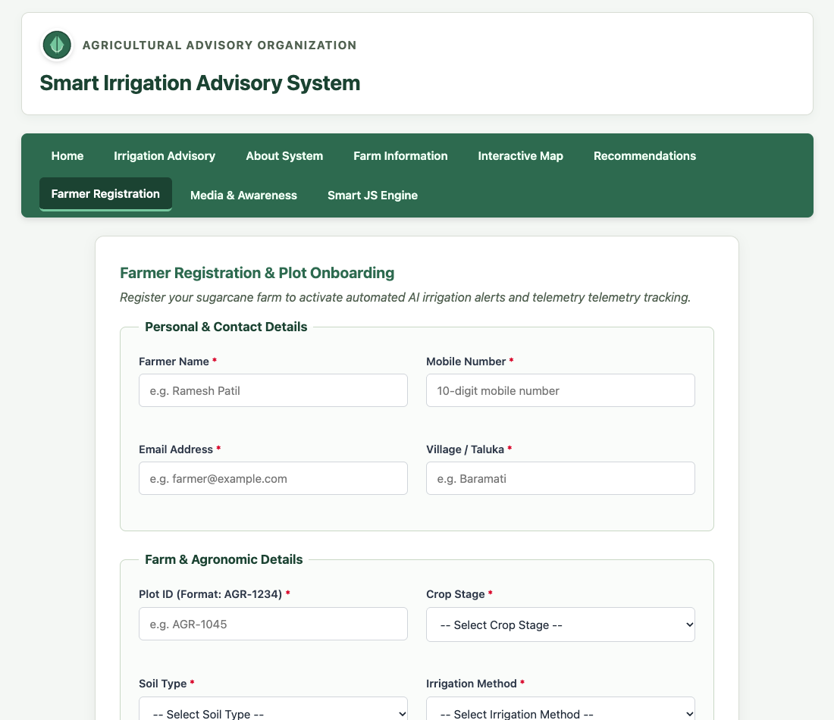
(2) Client-Side Validation Error Notifications & Red Field Highlighting on Invalid/Blank Inputs
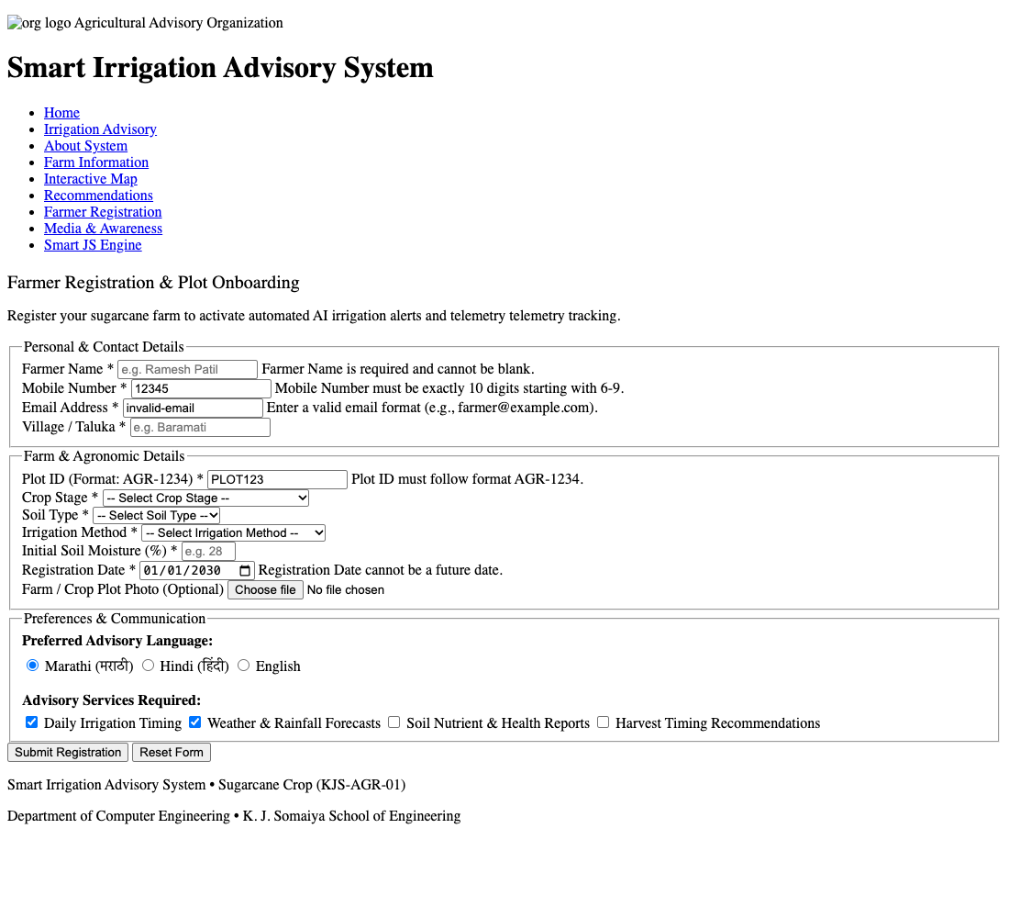
(3) Successful Form Submission & Dynamic Confirmation Banner with Farmer & Plot Data
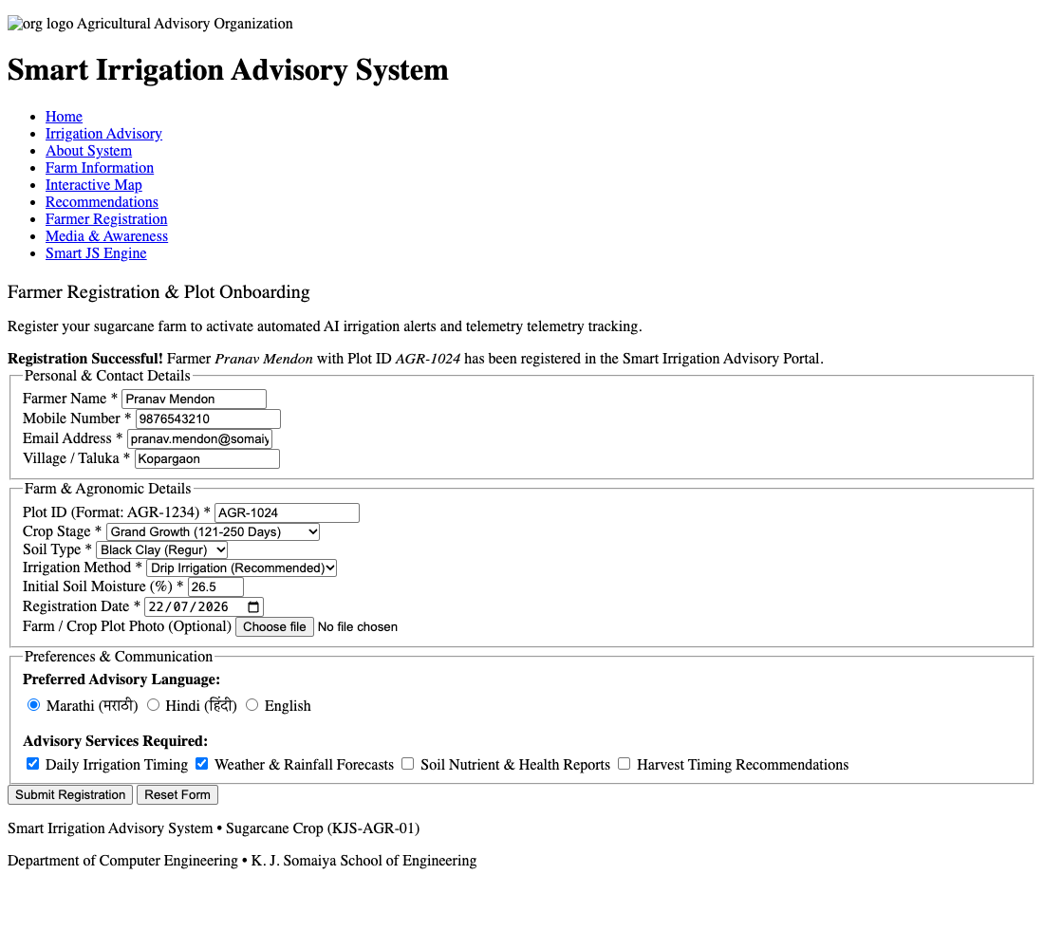
Conclusion and Discussion:
The experiment demonstrates how JavaScript can be used to validate user input on a web form before submission. Validation rules were applied to farmer personal details (enforcing non-empty alphabetic names), mobile numbers (10-digit Indian standard via regex ^[6-9]\d{9}$), email addresses, Plot IDs (strict format AGR-1234), agronomic dropdown selections (crop stage, soil type, irrigation method), soil moisture percentage (0-100 range), and registration dates (preventing prospective dates).

Discussion:
The form was systematically tested under multiple test vectors: blank inputs, invalid characters, malformed plot IDs, and future dates. In each failure case, 'event.preventDefault()' reliably blocked form transmission and displayed explicit localized error messages adjacent to the failing fields, alongside red border indicators. Upon supplying valid test data ('Pranav Mendon', '9876543210', 'AGR-1024', valid date), all fields turned green and a success banner confirmed registration.
Peer Feedback (minimum 3 classmates):
1. Rohan Sharma (Roll No: 16010125140): 'The instant field-level error messages give clear guidance on exactly what needs fixing.'
2. Ananya Verma (Roll No: 16010125142): 'Validating against future dates is a realistic agricultural requirement that protects irrigation schedules.'
3. Aditya Kulkarni (Roll No: 16010125145): 'The confirmation alert displaying the registered farmer name and plot ID provides excellent reassurance.'
Faculty Feedback / Remarks:
Thorough client-side form validation using regular expressions and DOM manipulation. Handled edge cases effectively.

