-init

--• Initializes a new Git repository in the current directory, creating a .git subdirectory. This is the first step in setting up a new repository.

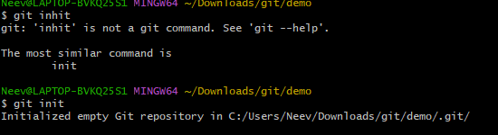

-diff

Shows the differences between the working directory and the staging area, or between commits. It helps in reviewing changes before committing.

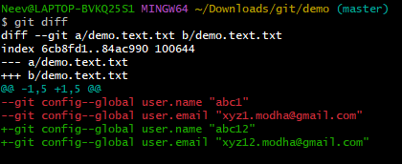

-log

Shows the commit history of the repository, displaying a list of past commits along with their metadata (author, date, and message).

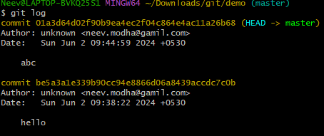

Status

Displays the state of the working directory and staging area, showing which changes have been staged, which haven't, and which files aren't being tracked by Git.

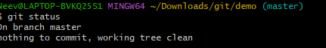

Add

Adds changes in the working directory to the staging area, preparing them for the next commit. This includes new files and modifications.



Conifg

• Configures Git settings, such as user name and email, which are used for commits. It can be scoped globally or per repository.

