

An Application Development Project Report

CYBER ATTACK LIFECYCLE AND DEFENCE FRAMEWORK

Design & developed by

M.Akash Reddy 2411CS040092
Shreya Patra 2411CS040158
K.Sreecharan 2411CS040159
S.Thrinadh Reddy 2411CS040161
T.Snehitha 2411CS040165
Y.Nithin Satvik 2411CS040176

GUIDED BY

Dr. G. Latha

(Associate Professor)

Department of Computer Science & Engineering (Cyber Security)
Malla Reddy University, Hyderabad
April-2026


Department of Computer Science & Engineering (Cyber Security)

CERTIFICATE

This is to certify that this is the Bonafide record of the application development project entitled “CYBER ATTACK LIFECYCLE AND DEFENCE FRAMEWORK” submitted by M.Akash Reddy (2411CS040092), Shreya Patra (2411CS040158), K.Sreecharan (2411CS040159), S.Thrinadh Reddy (2411CS040161), T.Snehitha (2411CS040165), Y.Nithin Satvik (2411CS040176) of B. Tech II year II semester, Department of CSE (Cyber Security) during the academic year 2025-26. The results embodied in this report have not been submitted to any other university or institute for the award of any degree or diploma.

Internal Guide Dean (Cyber Security)
Dr. G. Latha Dr. G. Anand Kumar
(Associate Professor) Professor & Dean

External Examiner

DECLARATION

We hereby declare that the project report entitled “Cyber Attack Lifestyle Defence Framework” has been carried out by us and submitted to the Department of Computer Science and Engineering (Cyber Security), Malla Reddy University, Hyderabad. This project work has been designed, developed & deployed by us, as part of the Application Development Project Work of this semester. We further declare that this project work has not been submitted in full or part for the award of any other degree in any other educational institutions.

Place:
Date:

M.Akash Reddy 2411CS040092
Shreya Patra 2411CS040158
K.Sreecharan 2411CS040159
S.Thrinadh Reddy 2411CS040161
T.Snehitha 2411CS040165
Y.Nithin Satvik 2411CS040176

ACKNOWLEDGEMENT

We extend our sincere gratitude to all those who have contributed to the completion of this project report. Firstly, we would like to extend our gratitude to Dr. V. S. K Reddy, Vice Chancellor, for his visionary leadership and unwavering commitment to academic excellence.
We would also like to express my deepest appreciation to our project guide Dr. G. Latha Associate Professor whose invaluable guidance, insightful feedback, and unwavering support have been instrumental throughout the course of this project for successful outcomes.
We extend our gratitude to our PRC – convenor, Dr. G. Latha, for giving valuable inputs and timely guidelines to improve the quality of our project through a critical review process. We thank our project coordinator, Dr. G. Vasavi, for her timely support.
We are also grateful to Dr. G. Anand Kumar, Dean (Cyber Security), for providing us with the necessary resources and facilities to carry out this project.
We are deeply indebted to all of them for their support, encouragement, and guidance, without which this project would not have been possible.

M. Akash Reddy 2411CS040092
Shreya Patra 2411CS040158
K.Sreecharan 2411CS040159
S.Thrinadh Reddy 2411CS040161
T.Snehitha 2411CS040165
Y.Nithin Satvik 2411CS040176

ABSTRACT

In the modern digital environment, organizations require continuous monitoring and rapid response mechanisms to defend against evolving cyber threats. This project presents the Cyber Attack Lifecycle and Defence Framework, a centralized surveillance system designed to simulate and monitor the security posture of a multi-application organization. The framework models an organization consisting of three web applications: an official corporate website, a clothing e-commerce platform, and an electronics e-commerce platform. The system integrates vulnerability assessment and real-time threat monitoring to provide comprehensive security visibility. Vulnerability analysis is performed using OWASP-based scanning tools to identify weaknesses such as SQL Injection and Cross-Site Scripting (XSS). Simultaneously, all application and server logs are centralized using the ELK stack (Elasticsearch, Logstash, and Kibana), enabling structured log indexing and analysis. A rule-based detection engine processes these logs to identify malicious activities including SQL injection attempts, brute-force login attacks, and XSS payload injections. Detected threats are visualized through a custom Surveillance Dashboard, which provides real-time alerts, severity classification, incident timestamps, and attacker identification details. The system supports both automated and manual incident response actions such as IP blocking, account locking, and service isolation. By combining vulnerability assessment, centralized logging, detection logic, and incident response mechanisms, this project demonstrates a practical implementation of a security monitoring and response architecture suitable for modern organizational infrastructures.
Keywords: SQL injection, ELK stack ,Vulnerability analysis, incident response, cross-site scripting(XSS), Brute Force ,Organization

INDEX

Contents Page No.
Chapter 1 Introduction 1 - 4
1.1 Problem Definition & Description 2
1.2 Objective of the Project 3
1.3 Scope of the Project 3 - 4
Chapter 2 System Analysis 5 - 13
2.1 Existing System 5 - 6
2.1.1 Background & Literature Survey 6 - 7
2.1.2 Limitations of Existing System 7 - 8
2.2 Proposed System 8 - 9
2.2.1 Advantages of Proposed System 9 - 10
2.3 Software & Hardware Requirements 11
2.3.1 Software Requirements 11
2.3.2 Hardware Requirements 11
2.4 Feasibility Study 12 - 13
2.4.1 Technical Feasibility 12
2.4.2 Robustness & Reliability 12 – 13
2.4.3 Economic Feasibility 13
Chapter 3 Architectural Design 14 - 33
3.1 Modules Design 14 - 15
3.2 Method and algorithm design 15 - 26
3.3 Project Architecture 27 - 33
3.3.1 Architectural Diagram 27
3.3.2 Data Flow Diagram 28
3.3.3 Class Diagram 29
3.3.4 Use Case Diagram 30
3.3.5 Sequence Diagram 31 - 32
3.3.6 Activity Diagram 32 – 33
3.3.7 Deployment Diagram 33
Chapter 4 Implementation & testing 34- 44
4.1.1 coding blocks 34 - 37
4.1.2 sample code 37 - 39
4.1.3 execution flow 39 - 41
4.2 Test Cases 42 - 46
4.2.1 Test Case 1 42
4.2.2 Test Case 2 42
4.2.3 Test Case 3 43
4.2.4 Test Case 4 43
4.2.5 Test Case 5 44
4.2.6 Test Case 6 44
Chapter 5 Results 45 - 55
5.1 Resulting screens. 45 - 50
5.1.1 Screen Shot 1 45
5.1.2 Screen Shot 2 46
5.1.3 Screen Shot 3 47
5.1.4 Screen Shot 4 48
5.1.5 Screen Shot 5 49
5.1.6 Screen Shot 6 50
5.2 Resulting Tables 51 -52
5.2.1 Table 1 51
5.2.2 Table 2 52
5.3 Resulting Graphs 53
5.3.1 Graph 1 53
5.3.2 Graph 2 53
5.4 Results Analysis 54 - 55
5.4.1 Time Complexity 54
5.4.2 Space Complexity 54 - 55
5.4.3 Results Summary 55
Chapter 6 Conclusion & Future Scope 56
6.1 Conclusions 56
6.2 Future Scope 56
References 57
Poster presentation 58

Contents Page No.
List of Diagrams
3.3.1 Architectural Diagram 27
3.3.2 Data Flow Diagram 28
3.3.3 Class Diagram 29
3.3.4 Use Case Diagram 30
3.3.5 Sequence Diagram 31 - 32
3.3.6 Activity Diagram 32 – 33
3.3.7 Deployment Diagram 33

List of Screenshots
5.1.1 Screen Shot 1 45
5.1.2 Screen Shot 2 46
5.1.3 Screen Shot 3 47
5.1.4 Screen Shot 4 48
5.1.5 Screen Shot 5 49
5.1.6 Screen Shot 6 50

CHAPTER 1

INTRODUCTION

In today’s highly interconnected digital ecosystem, organizations increasingly rely on web-based applications to deliver services, manage operations, and engage with users. However, this rapid digital transformation has significantly expanded the attack surface, exposing systems to a wide range of cyber threats such as SQL injection, cross-site scripting (XSS), and brute-force attacks. Traditional security approaches, which often focus on isolated protection mechanisms, are no longer sufficient to address the complexity and scale of modern cyberattacks. As a result, there is a growing need for integrated security solutions that provide continuous monitoring, real-time threat detection, and efficient incident response.

To address these challenges, modern cybersecurity strategies emphasize the concept of a centralized monitoring system that combines vulnerability assessment with real-time threat intelligence. Such systems not only identify existing weaknesses in applications but also monitor ongoing activities to detect suspicious behaviour. By leveraging tools and frameworks from the Open Web Application Security Project and centralized logging solutions like the ELK Stack, organizations can gain deeper visibility into their security posture and respond proactively to potential threats.

This project introduces the Cyber Attack Lifecycle and Defence Framework, which simulates a multi-application organizational environment consisting of a corporate website and two e-commerce platforms. The framework integrates vulnerability scanning, log aggregation, and rule-based detection mechanisms to create a unified surveillance system. By continuously collecting and analysing logs generated from different applications, the system is capable of identifying malicious patterns such as injection attempts, unauthorized access, and abnormal user behaviour. The integration of these components enables a comprehensive understanding’s

Furthermore, the proposed system incorporates a centralized Surveillance Dashboard that provides real-time insights into detected threats and system activities. This dashboard not only visualizes alerts and attack patterns but also facilitates incident response through both automated and manual actions, such as blocking suspicious IP addresses and restricting unauthorized access. By demonstrating the complete lifecycle of cyberattack detection and mitigation, this project highlights the importance of combining multiple security layers into a cohesive framework, offering a practical and scalable solution for modern organizational security management.

We are striving to build a Surveillance Dashboard which is capable of Analysing the vulnerability , Detecting the threat posed to the system by analysing the logs and then providing incident response to the attackers by in turn this projects makes the process of monitoring the websites in an organization easier. And we can efficiently solve the small attacks without expert level knowledge in cyber security.

  - Problem Definition & Description
In the modern digital landscape, organizations increasingly depend on multiple web applications to deliver services, manage transactions, and interact with users. While this interconnected architecture improves efficiency and scalability, it also introduces significant security challenges. Each application—whether a corporate website or an e-commerce platform—becomes a potential entry point for cyberattacks. As the number of applications grows, so does the complexity of monitoring and securing them effectively.
One of the major problems faced by organizations is the lack of centralized visibility into their security posture. Security-related data such as application logs, user activities, and system events are often distributed across multiple platforms and servers. Without a unified monitoring system, it becomes difficult to correlate events, identify attack patterns, and respond to threats in a timely manner. This fragmented approach leads to delayed detection and increases the risk of successful cyberattacks.
Another critical issue is the presence of vulnerabilities within web applications. Common vulnerabilities such as SQL injection, cross-site scripting (XSS), and weak authentication mechanisms continue to be exploited by attackers. Although tools from the Open Web Application Security Project provide guidelines and scanners to identify such weaknesses, organizations often fail to integrate vulnerability assessment into their continuous security workflow. As a result, exploitable flaws remain undetected until they are actively abused.
In addition to vulnerabilities, organizations struggle with detecting real-time attacks. Malicious activities such as brute-force login attempts, injection payloads, and abnormal user behaviour often go unnoticed due to the absence of intelligent detection mechanisms. Traditional systems rely heavily on manual monitoring or static rules, which are insufficient to handle dynamic and evolving threats. This gap creates opportunities for attackers to compromise systems without immediate detection.
Furthermore, incident response in many systems is either slow or inefficient. Even when threats are detected, there is often no structured mechanism to respond quickly and effectively. Actions such as blocking malicious IP addresses, disabling compromised accounts, or isolating affected services are either performed manually or not executed at all. This delay in response increases the potential damage caused by an attack and affects the overall reliability of the system.
Therefore, there is a need for an integrated security framework that combines vulnerability assessment, centralized log management, real-time threat detection, and efficient incident response. Such a system should provide a unified view of organizational security, enable proactive identification of risks, and support rapid mitigation of threats. Addressing these challenges forms the core problem that this project aims to solve by developing a comprehensive Cyber Attack Lifecycle and Defence Framework.

  - Objectives of the Project
The primary objective of this project is to design and develop a centralized security monitoring system that provides comprehensive visibility into the security status of multiple web applications within an organization. The system aims to integrate different applications—such as a corporate website and e-commerce platforms—into a unified framework where activities can be continuously monitored. By consolidating data from various sources, the project seeks to eliminate fragmented monitoring and enable a holistic view of the organization’s security posture.
Another key objective is to implement effective vulnerability assessment and real-time threat detection mechanisms. The system utilizes methodologies inspired by the Open Web Application Security Project to identify common web application vulnerabilities such as SQL injection and cross-site scripting. In addition, centralized logging and analysis using the ELK Stack enables the detection of malicious activities like brute-force attacks and injection attempts. This ensures that both existing vulnerabilities and active threats are identified promptly.
The final objective is to establish an efficient incident response system supported by a user-friendly surveillance dashboard. The dashboard is designed to provide real-time alerts, detailed attack information, and actionable insights, allowing administrators to respond quickly to security incidents. The system supports both automated and manual response actions, such as blocking suspicious IP addresses or restricting access. Overall, the project aims to demonstrate a complete cybersecurity lifecycle—from vulnerability identification to threat detection and response—thereby enhancing the resilience and security of modern web-based infrastructures.

  - Scope of the Project
The scope of this project focuses on the design and implementation of a centralized surveillance system that monitors the security of a simulated multi-application organization. The system includes three web applications—a corporate website, a clothing e-commerce platform, and an electronics e-commerce platform—which together represent a unified organizational environment. The project primarily concentrates on web application security, ensuring that all components are monitored collectively rather than in isolation.
The project scope includes vulnerability assessment using methodologies inspired by the Open Web Application Security Project to identify common security weaknesses such as SQL injection and cross-site scripting. Additionally, the system incorporates centralized log management using the ELK Stack to collect, process, and analyse logs generated by the applications. These logs are used to detect suspicious activities and attack patterns through a rule-based detection mechanism.
Another important aspect within the scope is the development of a real-time surveillance dashboard that visualizes detected threats and system activities. The dashboard provides features such as alert generation, severity classification, timestamp tracking, and basic attacker identification. It also supports predefined incident response actions, including blocking malicious IP addresses and managing suspicious user activities. This enables administrators to monitor and respond to security incidents efficiently within the system.
However, the scope of the project is limited to a controlled simulation environment and focuses on demonstrating fundamental cybersecurity concepts rather than deploying a full-scale enterprise-grade security system. Advanced features such as machine learning-based threat detection, large-scale distributed infrastructure, and integration with external security intelligence platforms are beyond the current scope. The project is intended as a practical implementation to illustrate the cybersecurity lifecycle, including vulnerability assessment, threat detection, and incident response within a manageable and educational framework.

CHAPTER 2
SYSTEM ANALYSIS
2.1 Existing System

1. Splunk Enterprise Security
Overview: Splunk Enterprise Security is a widely used Security Information and Event Management (SIEM) system that collects and analyses large volumes of machine data from various sources within an organization. It provides real-time threat detection, correlation of security events, and advanced analytics through dashboards and alerts. Splunk enables organizations to identify suspicious activities, investigate incidents, and respond quickly using automated workflows, making it a comprehensive solution for enterprise-level security monitoring.
2. IBM QRadar
Overview: IBM QRadar is a powerful SIEM platform designed to monitor network traffic, log data, and user activities to detect potential security threats. It uses rule-based analytics and anomaly detection to identify malicious behaviour such as unauthorized access, data breaches, and attack patterns. QRadar also provides incident management capabilities, allowing security teams to prioritize and respond to threats efficiently while maintaining compliance with security standards.
3. Wazuh
Overview: Wazuh is an open-source security monitoring platform that integrates log analysis, intrusion detection, vulnerability detection, and compliance monitoring into a single solution. It works well with the ELK stack to provide real-time visibility into system activities and security events. Wazuh uses agents deployed on endpoints to collect data and applies rules to detect threats such as malware, unauthorized access, and policy violations, making it suitable for scalable and cost-effective security implementations.4. Your Identity is Your Behaviour – Continuous User Authentication Using Machine Learning.
4. AlienVault OSSIM
Overview: AlienVault OSSIM (Open Source Security Information Management) is an open-source SIEM system that combines multiple security capabilities including asset discovery, vulnerability assessment, intrusion detection, and event correlation. It provides a unified platform for monitoring and managing security events across an organization. OSSIM helps identify potential threats by correlating data from different sources and offers a centralized dashboard for analysis and incident response, making it a strong reference model for integrated security frameworks.
Existing systems such as Splunk Enterprise Security, IBM QRadar, Wazuh, and AlienVault OSSIM are comprehensive SIEM platforms that focus on large-scale log analysis, threat detection, and enterprise-level incident management. These systems primarily operate in real-world environments with complex infrastructure and require extensive configuration and resources. In contrast, the Cyber Attack Lifecycle and Defence Framework is designed as a structured, educational, and simulation-based system that demonstrates the complete security lifecycle within a controlled multi-application environment. It uniquely integrates vulnerability assessment, attack simulation, real-time detection, and incident response into a single simplified dashboard. This makes the proposed system more accessible, modular, and suitable for understanding and demonstrating core cybersecurity concepts.
2.1.1 Background & Literature review
The “Cyber Attack Lifecycle And Defence Framework ” was started with the idea of centralizing the process of vulnerability analysis , Threat detection , and incident response in to a single dashboard to simulate the process of Top listed OWASP attacks for web applications like SQL injection , Cross-Site Scripting(XSS), and Brute force .by showing these attacks starting and ending process in a surveillance dashboard and we can perform incident responses through the dashboard in this way we wanted to create a simpler way we can deal with known attacks with out the involvement of any highly proficient security professional which usually costs a lot of money to the small organization’s this is the background of our project.
Literature Survey
- Security Information and Event Management (SIEM) System
Authors: Robin Sommer, Vern Paxson
Journal: IEEE Symposium on Security and Privacy
This study discusses the design and limitations of intrusion detection and monitoring systems, highlighting the challenges of processing large-scale security data and detecting sophisticated threats. It emphasizes the importance of real-time analysis and correlation of events, which directly relates to centralized monitoring systems like SIEM platforms. The paper provides foundational concepts for building systems that analyse logs and detect malicious activities, similar to the detection mechanisms used in this project.

- A Study on Web Application Vulnerabilities and Prevention
Authors: S. Kals, E. Kirda, C. Kruegel, N. Jovanovic
Journal: Proceedings of the 15th International World Wide Web Conference (WWW)
This research focuses on identifying common web application vulnerabilities such as SQL injection and cross-site scripting (XSS). It explores automated techniques for detecting these vulnerabilities and discusses mitigation strategies. The study is highly relevant to this project as it supports the integration of vulnerability assessment using Open Web Application Security Project methodologies.

- Log-Based Intrusion Detection and Analysis
Authors: K. Julisch
Journal: ACM Transactions on Information and System Security (TISSEC)
This paper examines the use of log data for intrusion detection and the challenges involved in identifying meaningful attack patterns. It highlights the importance of filtering false positives and correlating events across systems. The concepts presented are directly applicable to the use of the ELK Stack for centralized log collection and analysis in this project.

Anomaly Detection for Cybersecurity: A Survey
Authors: Chandola, Banerjee, Kumar
Journal: ACM Computing Surveys
This survey provides a comprehensive overview of anomaly detection techniques used in cybersecurity, including statistical and rule-based approaches. It discusses how abnormal patterns in system behaviour can indicate potential attacks. The principles of anomaly and rule-based detection discussed in this paper align with the threat detection mechanisms implemented in the proposed system.

Incident Response and Cyber Defense Automation
Authors: Richard Behl, S. Behl
Journal: Journal of Information Security and Applications
This study explores automated incident response systems and their role in improving organizational security. It highlights the importance of rapid response mechanisms such as IP blocking and account control to minimize damage from cyberattacks. The concepts from this paper support the incident response component of the Cyber Attack Lifecycle and Defence Framework, where both manual and automated actions are implemented.

2.1.2 Limitations of Existing System
Most existing systems focus on specific aspects such as log monitoring or vulnerability scanning, but they do not provide a complete end-to-end security lifecycle. Platforms like Splunk Enterprise Security and IBM QRadar primarily emphasize threat detection and analysis, while vulnerability assessment and incident response are often handled separately. This fragmentation makes it difficult to achieve a unified security approach.
Enterprise-level security systems are often complex to deploy and manage. Tools such as Wazuh and AlienVault OSSIM require significant configuration, infrastructure, and expertise. This makes them less suitable for small-scale implementations or academic projects where simplicity and clarity are essential.
Although many systems provide dashboards, they are often overloaded with data and lack intuitive visualization tailored for quick decision-making. Security teams may find it difficult to interpret large volumes of logs and alerts efficiently, which can delay response times and reduce operational effectiveness.
Existing detection systems frequently generate a large number of alerts, many of which may be false positives. This creates noise in the system and makes it challenging for administrators to identify genuine threats. As a result, critical security incidents may be overlooked or delayed.
Many traditional systems focus heavily on detection but provide limited support for automated or structured incident response. Actions such as blocking malicious IP addresses or isolating compromised systems often require manual intervention, increasing response time and potential damage.
Most existing systems are designed for real-world deployment and do not provide a controlled environment for learning or demonstrating cybersecurity concepts. They lack features for simulating attacks like SQL injection or XSS in a structured manner, making them less effective for academic and training purposes.
2.2 Proposed System
The proposed system, Cyber Attack Lifecycle and Defence Framework, is designed as a centralized security monitoring solution that integrates multiple web applications under a single organizational structure. The system simulates an environment consisting of a corporate website, a clothing e-commerce platform, and an electronics e-commerce platform. All these applications are continuously monitored to provide a unified view of the organization’s security posture. By consolidating data from multiple sources, the system eliminates fragmented monitoring and enables efficient tracking of activities across the entire infrastructure.
The framework incorporates both vulnerability assessment and real-time threat detection mechanisms. Vulnerability analysis is performed using methodologies inspired by the Open Web Application Security Project to identify common security issues such as SQL injection and cross-site scripting. In addition, all application logs are centralized and processed using the ELK Stack, which enables structured storage, indexing, and analysis of logs. A rule-based detection engine analyses these logs to identify malicious patterns such as brute-force login attempts, injection attacks, and abnormal user behaviour.
The system also features a Surveillance Dashboard that provides real-time visualization of detected threats and system activities. The dashboard displays alerts, severity levels, timestamps, and attacker-related information, allowing administrators to quickly understand and respond to incidents. It supports both automated and manual response actions, such as blocking suspicious IP addresses or restricting user access. By integrating monitoring, detection, and response into a single platform, the proposed system demonstrates a complete and practical implementation of a cybersecurity lifecycle tailored for modern web-based environments.

2.2.1 Advantages of the Proposed System
- Centralized Security Monitoring
The system provides a unified platform to monitor multiple web applications within a single dashboard. This eliminates fragmented security management and enables administrators to view all activities, logs, and alerts from different applications in one place.
- Integrated Vulnerability Assessment and Threat Detection
Unlike traditional systems that separate vulnerability scanning and threat monitoring, this framework combines both. It uses methodologies inspired by the Open Web Application Security Project for identifying vulnerabilities and integrates real-time log analysis using the ELK Stack for detecting active threats.
- Real-Time Alerting and Visualization
The surveillance dashboard provides real-time alerts with clear visualization of threats, including severity levels, timestamps, and affected systems. This helps administrators quickly understand and prioritize security incidents.
- Efficient Incident Response Mechanism
The system supports both automated and manual response actions such as IP blocking, account restriction, and service isolation. This reduces response time and minimizes potential damage caused by cyberattacks.
- Practical Simulation of Cyber Attacks
The framework allows simulation of common attacks such as SQL injection, cross-site scripting, and brute-force attacks in a controlled environment. This makes it highly useful for learning, testing, and demonstrating cybersecurity concepts.
- Improved Security Awareness and Understanding
By showcasing the complete lifecycle of cyberattacks—from vulnerability identification to detection and response—the system helps users understand how real-world security systems operate and how threats evolve.
- Cost-Effective and Scalable Solution
The use of open-source technologies and modular architecture makes the system cost-effective and easy to scale. Additional applications or security modules can be integrated without major changes to the existing system.
- Enhanced Decision-Making Capability
With structured data, clear alerts, and actionable insights, the system enables administrators to make informed decisions quickly, improving overall organizational security management.

2.3 Software & Hardware Requirements
2.3.1 Software Requirements
- Operating System: Windows / Linux
- Programming Language: Python
- Framework: React / Django / Storage:Mysql
- IDE: Visual Studio Code / Trae
- coding languages:HTML,CSS JavaScript

2.3.2 Hardware Requirements:
- Processor: Intel i5 or equivalent
- RAM: Minimum 8 GB
- Storage: 10 GB free disk space

2.4 Feasibility Study
2.4.1 Technical Feasibility
The proposed Cyber Attack Lifecycle and Defence Framework is technically feasible as it is built using widely adopted and well-supported technologies. The frontend is developed using React with TypeScript, while the backend is implemented using Django, both of which are robust and scalable frameworks. The system utilizes a relational database such as PostgreSQL for structured data storage and integrates centralized logging through the ELK Stack for efficient log collection, processing, and visualization. Additionally, vulnerability assessment is performed using tools inspired by the Open Web Application Security Project, which are open-source and widely used in industry. These technologies are compatible with each other and can be deployed using platforms like Docker or cloud services such as Render, ensuring smooth integration and execution.

Furthermore, the implementation of attack simulations such as SQL injection, cross-site scripting, and brute-force attacks is achievable within a controlled environment by designing specific application endpoints and logging mechanisms. The system relies on rule-based detection, which is simpler to implement compared to advanced machine learning models, making it suitable for a college-level project. The availability of extensive documentation, community support, and prebuilt libraries for all chosen technologies further enhances feasibility. Overall, the project can be successfully developed, tested, and deployed using standard hardware and software resources without requiring specialized infrastructure, making it both practical and achievable within the given constraints.

2.4.2 Robustness & Reliability
The proposed Cyber Attack Lifecycle and Defence Framework is designed with robustness in mind by ensuring that the system can handle continuous monitoring and high volumes of log data without failure. By utilizing a modular architecture, each component—such as the web applications, backend services, and logging pipeline—operates independently, reducing the risk of system-wide failure. The use of centralized logging through the ELK Stack ensures that data is efficiently collected, stored, and processed, even under varying load conditions. This separation of components enhances system stability and allows individual modules to be maintained or updated without affecting the overall system.

Reliability is achieved through consistent data handling, structured logging, and dependable communication between system components. The backend ensures proper validation of user inputs and error handling mechanisms to prevent system crashes during unexpected conditions. Additionally, the integration of real-time monitoring and alert generation ensures that security events are captured and reported without delay. The use of established technologies and frameworks, along with proper exception handling and logging strategies, ensures that the system remains operational and dependable during both normal operations and simulated attack scenarios.
Furthermore, the system incorporates redundancy in monitoring and detection processes to improve fault tolerance. Even if one component experiences temporary issues, logs and data can still be preserved and analysed through other parts of the system. The rule-based detection mechanism ensures consistent identification of threats without reliance on complex dependencies, making the system predictable and stable. Overall, the framework maintains high robustness and reliability by combining modular design, effective error handling, and continuous monitoring, ensuring uninterrupted security analysis and response capabilities.

2.4.3 Economic Feasibility
The Cyber Attack Lifecycle and Defence Framework leverages open-source tools like the ELK stack and OWASP ZAP, keeping initial software costs near zero while requiring modest hardware investments. For a small organization with three web apps, self-hosted ELK on cloud instances (e.g., AWS) incurs about $700–$2,500 monthly for servers, storage, and basic maintenance, far below commercial SIEM alternatives that exceed $10,000 annually per device. Setup demands 1–2 weeks of DevOps effort at roughly $3,000 in labour for skilled personnel, with ongoing tweaks adding $1,000–$2,000 monthly depending on log volume.
Compared to outsourced monitoring services ($40–$120 monthly per device plus breach response fees), this framework slashes expenses by centralizing logs and automating detection for SQLi, XSS, and brute-force threats without vendor lock-in. Vulnerability scans via free OWASP tools avoid paid scanners ($50–$200/month), and custom dashboards reduce the need for pricier enterprise consoles. Total first-year outlay for a lean setup stays under $30,000, scalable for e-commerce growth in regions like India where cloud costs remain competitive.
Preventing even one data breach yields massive ROI, as small businesses face $120,000–$3.3 million in average costs from downtime, fines, and lost revenue—common for e-commerce SQLi or XSS exploits. Real-time alerts and automated responses (IP blocks, isolations) cut incident response time, minimizing damage and boosting efficiency akin to ML-enhanced SIEMs that deliver risk reduction far outweighing operational costs. Overall, the framework proves economically viable, paying for itself through threat mitigation in under six months for threat-prone multi-app setups.

CHAPTER 3
ARCHITECTURAL DESIGN

3.1 Modules Design
The project Cyber attack lifecycle and defence framework has mainly 7 modules to perform it’s functions which includes Organization web application module, Vulnerability Assessment module, Log collection and centralised module, Threat detection, Surveillance dashboard , Incident response, Incident lifecycle and report modules.
3.1.1 Organization web application Module
Represents the simulated organization consisting of three web applications: Official Corporate Website, Clothing E-commerce Platform, and Electronics E-commerce Platform.
This module generates application traffic, user interactions, and system logs. It also contains intentionally simulated vulnerabilities (SQL Injection, Cross-Site Scripting, and Brute-Force login weaknesses) for security analysis and attack simulation.

3.1.2 Vulnerability Assessment Module
Enables administrators to verify complaints, assign them to field officers, and monitor overall system activities.
Admin can manage users, generate reports, and oversee complaint progress.
3.1.3 Log collection and centralized Module
Collects and centralizes logs from all organizational applications and services.
Logstash gathers logs from web servers, application servers, and authentication systems. Elasticsearch indexes and stores structured log data for efficient searching and analysis. Kibana provides visualization and log exploration capabilities.

3.1.4 Threat detection Module
Implements rule-based detection logic to identify malicious activities from centralized logs.
This module analyzes patterns such as repeated failed login attempts (brute-force detection), suspicious SQL query patterns (SQL injection attempts), and malicious script payloads (XSS attempts).
It classifies detected threats based on severity levels and forwards alerts to the Surveillance Dashboard.
3.1.5 Surveillance Dashboard Module
Provides a unified interface for monitoring the organization's security posture.
Displays vulnerability reports, real-time threat alerts, severity classifications, timestamps, attacker IP details, and incident status.
Allows administrators to monitor system activities and track the lifecycle of security incidents.
.
3.1.6 Incident response Module
Enables automated and manual response actions upon threat detection.
Supports actions such as IP blocking, account locking, service isolation, and alert notifications.
Records response timestamps, action details, and resolution status for audit and forensic purposes.

3.1.7 Incident lifecycle & Reporting Module
Maintains structured records of all detected incidents from identification to resolution.
Provides historical logs, attack summaries, severity trends, and analytical reports.
Supports performance evaluation of response time and system effectiveness.

3.2 Method & Algorithm Design
The project “Cyber attack lifecycle and Defence framework” has many methods to achieve the functionality to show the vulnerability assessment , Threat detection and incident responses methods such as and algorithms such as OWASP vulnerability scan, ELK stack logs centralization, Rule based Detection Engine, Surveillance dashboard, Automated incident response.
3.2.1 OWASP Vulnerability Scanning
OWASP-based tools like ZAP perform automated scans to detect common web vulnerabilities such as SQL Injection and XSS. The method involves active scanning with predefined payloads against web applications, followed by passive analysis of responses for security weaknesses. This provides a baseline security posture assessment for the three simulated web apps.
Algorithm: -
Algorithm: OWASP_Vulnerability_Scan()
BEGIN
1. Initialize target web applications:
- Corporate_Website_URL
- Clothing_Ecommerce_URL
- Electronics_Ecommerce_URL
2. For each target_url in [Corporate_Website_URL,
Clothing_Ecommerce_URL,
Electronics_Ecommerce_URL]:
a. Launch OWASP ZAP active scanner on target_url
b. Load predefined attack payloads:
- SQL Injection patterns: ' OR '1'='1, UNION SELECT, etc.
- XSS patterns: <script>alert(1)</script>, onerror=, etc.
- Other OWASP Top 10 vectors
c. Inject each payload into input fields and URL parameters
d. Capture HTTP response for each injection
e. Passive Analysis:
- If response contains SQL error messages → Flag SQL Injection
- If response executes injected JavaScript → Flag XSS
- If sensitive data exposed → Flag Information Disclosure
- If authentication bypassed → Flag Access Control flaw
f. Record vulnerability details:
- Vulnerability_Type
- Severity_Level (Low/Medium/High/Critical)
- Affected_Endpoint
- Payload_Used
- Response_Evidence
3. Compile scan report for all three applications
4. Send vulnerability report to Threat Detection module
5. END

3.2.2 ELK Stack Log Centralization
The ELK stack (Elasticsearch, Logstash, Kibana) aggregates and indexes logs from all applications and servers into a unified repository. Logstash parses and enriches raw logs in real-time, Elasticsearch enables fast searching and storage, while Kibana offers visualization capabilities. This centralization supports scalable monitoring across the multi-app organization.

Algorithm: -
Algorithm: ELK_Log_Centralization()
BEGIN
1. Initialize ELK Stack Components:
- Logstash (Log Ingestion & Processing)
- Elasticsearch (Search & Storage Engine)
- Kibana (Visualization & Dashboard)
2. Configure Logstash Pipeline:
a. INPUT Phase:
- Set up file inputs for each application:
* Corporate_Website_Log_File
* Clothing_Ecommerce_Log_File
* Electronics_Ecommerce_Log_File
- Set up TCP/UDP inputs for real-time syslog streams
- Collect server logs (Apache/Nginx, Django, OS events)
b. FILTER Phase (Parse & Enrich):
- Apply GROK patterns to parse unstructured log lines into fields:
* Extract: timestamp, source_ip, request_method, url, status_code, user_agent
- Apply DATE filter to standardize all timestamps to UTC
- Apply GEOIP filter to enrich source_ip with geographical data
- Apply MUTATE filter to:
* Add field: application_name (based on log source)
* Add field: log_severity (info/warning/error/critical)
* Remove unnecessary/redundant fields
- Apply conditional routing:
* If status_code == 4xx or 5xx → add severity = "high"
* If request contains SQL keywords → add flag = "potential_SQLi"
* If request contains <script> → add flag = "potential_XSS"

c. OUTPUT Phase:
- Send parsed logs to Elasticsearch index:
* Index naming: logs-{application_name}-{date}
* Set document ID for uniqueness
* Apply index lifecycle policy (rotate after 7 days)
3. Elasticsearch Indexing:
- Receive documents from Logstash
- Apply ingest pipeline for additional transformations
- Store documents in inverted index for fast search
- Replicate shards for fault tolerance
4. Kibana Visualization:
- Connect Kibana to Elasticsearch cluster
- Create index patterns for log indices
- Build dashboards:
* Real-time threat feed
* Attack source heatmap
* Severity distribution chart
* Historical incident timeline
5. Monitor Pipeline Health:
- Check Logstash queue status
- Monitor Elasticsearch cluster health
- Validate Kibana index pattern mappings
6. END

3. 2.3 Rule-Based Detection Engine
Custom rules analyze centralized logs for attack signatures like SQLi patterns, brute-force login attempts, and XSS payloads. The algorithm uses regex matching and threshold-based anomaly detection (e.g., excessive failed logins from single IPs) to flag threats with severity levels. Detected incidents trigger real-time alerts with timestamps and attacker details.

Algorithm: -
Algorithm: Rule_Based_Threat_Detection()
BEGIN
1. Initialize Detection Rules Repository:
- SQL_Injection_Rules[]
- XSS_Rules[]
- Brute_Force_Rules[]
- Threshold_Configuration:
* FAILED_LOGIN_THRESHOLD = 5
* TIME_WINDOW = 60 seconds
* SQLI_SEVERITY = "Critical"
* XSS_SEVERITY = "High"
* BRUTE_FORCE_SEVERITY = "High"
2. Define Regex Patterns:
a. SQL_Injection_Rules:
- Pattern 1: (UNION\s+SELECT|SELECT\s+\*\s+FROM)
- Pattern 2: ('\s*OR\s*'?\d+['\s]*=\s*'?\d+)
- Pattern 3: (;\s*DROP\s+TABLE|;\s*DELETE\s+FROM)
- Pattern 4: (;\s*INSERT\s+INTO|;\s*UPDATE\s+\w+\s+SET)
b. XSS_Rules:
- Pattern 1: (<\s*script[^>]*>.*?<\s*/\s*script\s*>)
- Pattern 2: (on\w+\s*=\s*["'][^"']*["'])
- Pattern 3: (javascript\s*:|<\s*img[^>]*onerror)
3. For each log_entry in Elasticsearch_Index:
a. Extract Fields:
- source_ip = log_entry.source_ip
- request_url = log_entry.request_url
- request_body = log_entry.request_body
- status_code = log_entry.status_code
- timestamp = log_entry.timestamp
- user_agent = log_entry.user_agent
b. SQL Injection Detection:
- For each sqli_pattern in SQL_Injection_Rules:
- IF regex_match(request_url, sqli_pattern) OR
regex_match(request_body, sqli_pattern):
- severity = SQLI_SEVERITY
- incident_type = "SQL Injection Attempt"
- CALL Generate_Alert()
c. XSS Detection:
- For each xss_pattern in XSS_Rules:
- IF regex_match(request_url, xss_pattern) OR
regex_match(request_body, xss_pattern):
- severity = XSS_SEVERITY
- incident_type = "XSS Payload Injection"
- CALL Generate_Alert()
d. Brute-Force Detection:
- IF status_code == 401 OR status_code == 403:
- Increment failed_login_count[source_ip]
- IF failed_login_count[source_ip] >= FAILED_LOGIN_THRESHOLD
within TIME_WINDOW:
- severity = BRUTE_FORCE_SEVERITY
- incident_type = "Brute-Force Login Attack"
- CALL Generate_Alert()
- Reset failed_login_count[source_ip] = 0
4. Generate_Alert():
a. Create Incident Record:
- incident_id = Generate_UUID()
- attacker_ip = source_ip
- geo_location = Lookup_GeoIP(source_ip)
- detected_time = Current_Timestamp()
- severity_level = severity
- attack_type = incident_type
- raw_evidence = log_entry
b. Store in Database:
- INSERT into Security_Event_Database (incident_id, attacker_ip,
geo_location, detected_time, severity_level, attack_type)
c. Trigger Real-Time Alert:
- Send alert to Kibana Dashboard
- Push notification to Security Admin
- Update threat feed with attacker details
5. END
3.2.4 Surveillance Dashboard Visualization
A custom dashboard built on Kibana displays live threat feeds, severity metrics, and incident timelines. It integrates detection outputs for graphical representations like heatmaps of attack origins and trend charts of threat frequency. This enables rapid situational awareness for security teams.
Algorithm: -
Algorithm: Surveillance_Dashboard_Visualization()
BEGIN
1. Initialize Kibana Dashboard Components:
- Live_Threat_Feed_Panel
- Severity_Metrics_Panel
- Incident_Timeline_Panel
- Attack_Source_Heatmap_Panel
- Threat_Frequency_Chart_Panel
2. Configure Elasticsearch Query for Live Threat Feed:
a. Query: SELECT * FROM security_events_index
WHERE timestamp >= NOW - 5 minutes
ORDER BY timestamp DESC
LIMIT 50
b. Map fields to dashboard widgets:
- incident_id → Alert ID
- attack_type → Threat Type
- severity_level → Severity Badge
- attacker_ip → Source IP
- geo_location → Location
- detected_time → Timestamp
3. Configure Severity Metrics Aggregation:
a. Metric Aggregation 1 - Total Incidents:
- Query: COUNT(*) FROM security_events_index
WHERE timestamp >= NOW - 24 hours
- Display: Gauge meter
b. Metric Aggregation 2 - Severity Breakdown:
- Query: GROUP BY severity_level
COUNT(*) FROM security_events_index
WHERE timestamp >= NOW - 24 hours
- Display: Pie chart (Critical/High/Medium/Low)
c. Metric Aggregation 3 - Attack Type Distribution:
- Query: GROUP BY attack_type
COUNT(*) FROM security_events_index
WHERE timestamp >= NOW - 24 hours
- Display: Horizontal bar chart
4. Configure Incident Timeline Visualization:
a. Time Series Query:
- X-Axis: Date Histogram of timestamp (1-hour intervals)
- Y-Axis: COUNT of incidents
- Split Series BY: attack_type
- Range: Last 7 days
b. Display: Line chart with color-coded threat types
5. Configure Attack Source Heatmap:
a. Geo Coordinates Query:
- Extract: source_ip, geo_location (lat, lon)
- Group BY: geo_location
- COUNT: incidents per location
- Time Range: Last 24 hours
b. Map Configuration:
- Map Type: Coordinate map / Region map
- Circle Size: Proportional to incident count
- Color Intensity: Proportional to severity
- Overlay: Attack lines between attacker and target
c. Display: Interactive world map with attack hotspots
6. Configure Threat Frequency Trend Chart:
a. Time Series Aggregation:
- X-Axis: Date Histogram (15-minute intervals)
- Y-Axis: COUNT of incidents
- Filter: timestamp >= NOW - 1 hour
b. Display: Real-time updating area chart
7. Enable Auto-Refresh:
- Set dashboard refresh interval = 5 seconds
- Poll Elasticsearch for new security events
- Update all visualizations dynamically
8. Configure Alert Notification Panel:
a. For each new incident where severity == "Critical":
- Flash red alert banner on dashboard
- Play audio notification
- Highlight attacker details in threat feed
9. END
3.2.5 Automated Incident Response
Response mechanisms include IP blocking via firewall rules, account locking through API calls, and service isolation by container orchestration. Algorithms prioritize actions based on severity and confidence scores from detection rules, supporting both automated workflows and manual overrides. This closes the defense loop in the cyber attack lifecycle.
Algorithm: -
Algorithm: Automated_Incident_Response()
BEGIN
1. Initialize Response Configuration:
a. Severity_Action_Matrix:
- Critical: [IP_Block, Account_Lock, Service_Isolate, Alert_Admin]
- High: [IP_Block, Account_Lock, Alert_Admin]
- Medium: [IP_Block, Alert_Admin]
- Low: [Alert_Admin, Log_Only]
b. Confidence_Threshold = 0.75
c. Auto_Response_Enabled = TRUE
d. Manual_Override_Enabled = TRUE
2. For each incident in Security_Event_Database:
a. Retrieve Incident Details:
- incident_id = incident.incident_id
- severity_level = incident.severity_level
- confidence_score = incident.confidence_score
- attacker_ip = incident.attacker_ip
- attack_type = incident.attack_type
- affected_account = incident.affected_account
- affected_service = incident.affected_service
- timestamp = incident.detected_time
b. Prioritization Check:
- IF confidence_score >= Confidence_Threshold:
- action_priority = "High"
- ELSE:
- action_priority = "Low"
- CALL Notify_Analyst() → manual review required
c. Determine Response Actions:
- response_actions = Severity_Action_Matrix[severity_level]
- IF action_priority == "Low":
- Remove Service_Isolate from response_actions
- Flag for Manual_Override
3. Execute Response Actions:
a. IF "IP_Block" in response_actions:
- CALL Block_IP_Firewall(attacker_ip):
* Execute: iptables -A INPUT -s attacker_ip -j DROP
* OR: API call to Cloud Firewall (AWS Security Group)
* Log: "IP {attacker_ip} blocked at {timestamp}"
* Set block_duration = 24 hours
* Add attacker_ip to Blocked_IP_List
c. IF "Service_Isolate" in response_actions:
- CALL Isolate_Service_Container(affected_service):
* Execute: kubectl cordon affected_service_node
* Execute: kubectl scale deployment affected_service --replicas=0
* OR: Docker stop affected_container_id
* Redirect traffic to backup instance
* Log: "Service {affected_service} isolated at {timestamp}"
* Create forensic snapshot before isolation
4. Manual Override Support:
a. Monitor for Security Admin Actions:
- IF Admin selects "Override Block":
* CALL Unblock_IP(attacker_ip)
* Execute: iptables -D INPUT -s attacker_ip -j DROP
* Log: "Manual override: IP {attacker_ip} unblocked by Admin"
- IF Admin selects "Unlock Account":
* CALL Unlock_Account(affected_account)
* Execute: UPDATE users SET account_status = 'active'
WHERE username = affected_account
* Log: "Manual override: Account {affected_account} unlocked"
- IF Admin selects "Restore Service":
* CALL Restore_Service(affected_service)
* Execute: kubectl scale deployment affected_service --replicas=3
* Log: "Manual override: Service {affected_service} restored"
Dashboard with resolved incidents

3.3 Project Architecture
3.3.1 Architectural Diagram
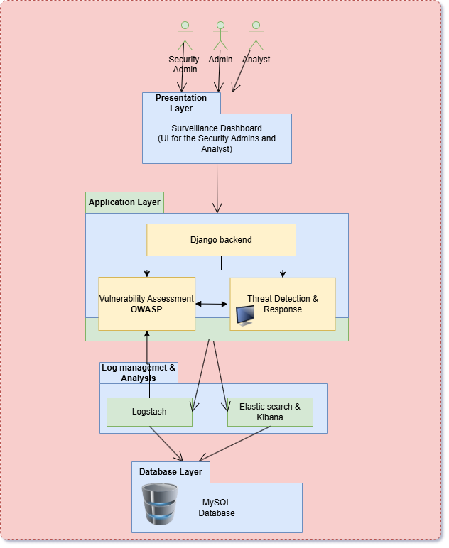
Figure 1: System functioning structure
The architecture diagram illustrates a multi-layered Cyber Attack Lifecycle and Defence Framework for monitoring three web applications. At the top, the Surveillance Dashboard enables Security Admins and Analysts to view real-time threats and perform analysis.
The Application Layer features Django backends for the apps, integrated with OWASP vulnerability assessment tools and a Threat Detection & Response module.
Below, the Log Management & Analysis Layer uses Logstash for ingestion, feeding into Elasticsearch & Kibana for storage, querying, and visualization. The foundational Database Layer employs MySQL to store application data, ensuring comprehensive visibility from vulnerabilities to automated responses across the stack.

3.3.2 Data Flow Diagram
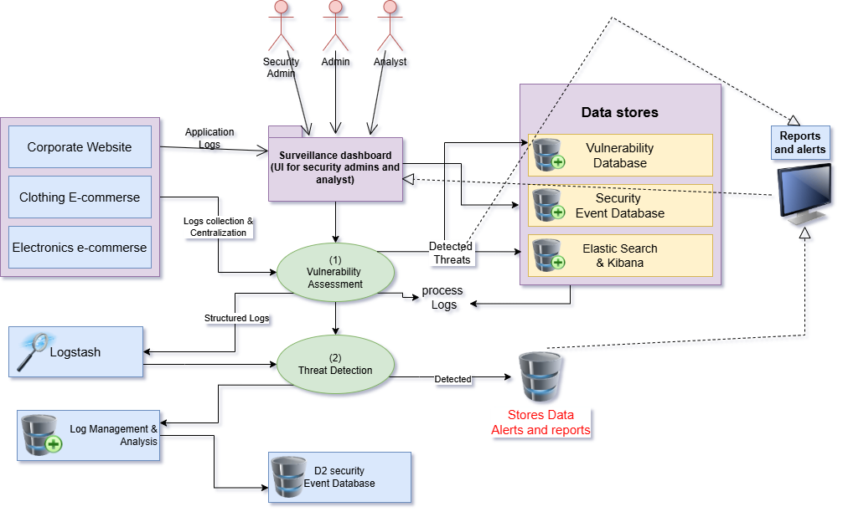
Figure 2: Data Flow diagram of the logs and data
The data flow diagram depicts the operational workflow of the Cyber Attack Lifecycle and Defence Framework across three web applications (Corporate Website, Clothing E-commerce, Electronics E-commerce). Logs from these applications flow into Log Management & Analysis via Logstash for structured processing, then feed into Threat Detection (a central processing node) alongside Vulnerability Assessment data from OWASP scans. The Threat Detection module analyzes inputs against security rules, generating detected threats that populate Elasticsearch & Kibana for storage, alerting, and reporting, while also updating a Security Event Database. Administrators and analysts access the Surveillance Dashboard (for analysis) to monitor real-time alerts and reports, which draw from data stores and enable decision-making loops back to the applications.

3.3.3 Class Diagram
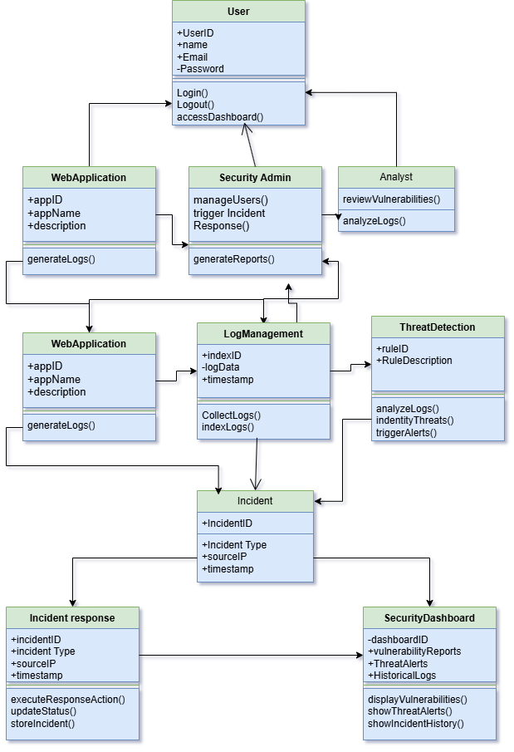
Figure 3: Privileges and functions data diagram of each node in the project
The class diagram models how different components in the Cyber Attack Lifecycle and Defence Framework interact. The User class represents security admins and analysts who log in, log out, and access the dashboard. The WebApplication class (for corporate, clothing, and electronics sites) generates logs that are collected by the LogManagement class, which stores log data with timestamps and indexes it. The ThreatDetection class holds detection rules, analyzes logs, identifies threats, and triggers alerts, which are captured as Incident objects containing incident type, source IP, and time. The IncidentResponse class takes each incident, executes response actions (such as blocking IPs), updates status, and stores incident details. Finally, the SecurityAdmin class manages users and triggers incident response and reporting, while the Analyst class reviews vulnerabilities and analyzes logs; both roles consume information via the SecurityDashboard class, which displays vulnerabilities, threat alerts, and historical logs to close the monitoring and response loop.

3.3.4 Use Case Diagram
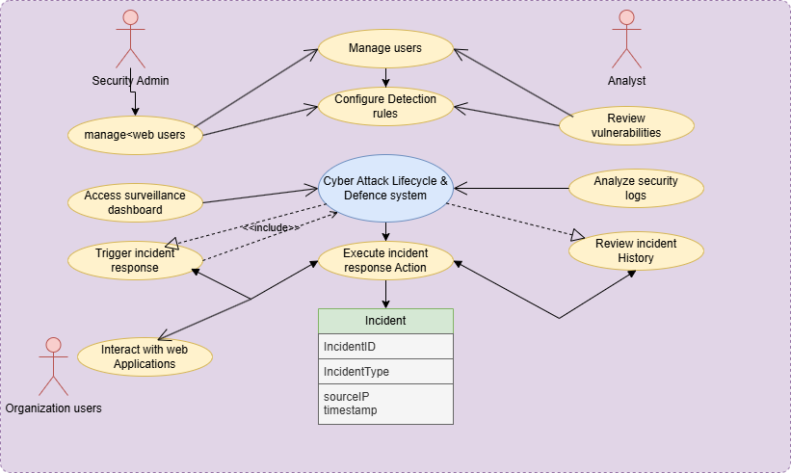
Figure 4: Uses Data diagram of each users and system
The use case diagram shows how different actors interact with the Cyber Attack Lifecycle & Defence system. The Security Admin manages users of the web applications, configures detection rules, accesses the surveillance dashboard, and triggers incident response when threats are detected. The Analyst reviews vulnerabilities, analyzes security logs, and checks incident history, all through the central defence system. Organization users mainly interact with the web applications, generating normal traffic and logs that may form part of incidents. When an incident occurs, the system executes incident response actions (such as blocking IPs or accounts) and records each event in the Incident entity, which stores incident ID, type, source IP, and timestamp for further analysis and reporting.

3.3.5 Sequence Diagram
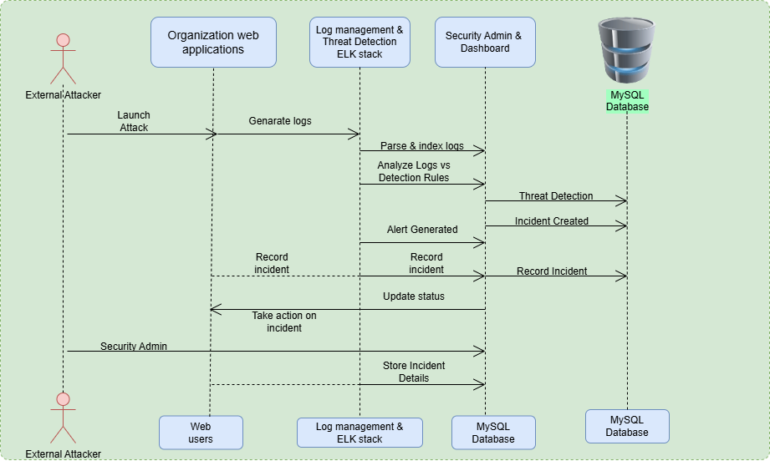
Figure 5: Attack detection and incident response sequence diagram
The sequence diagram illustrates the flow of events from attack initiation to response in the Cyber Attack Lifecycle & Defence system. An External Attacker launches an attack against the Organization web applications, which generate logs that are forwarded to the Log Management & Threat Detection ELK stack. The ELK stack parses and indexes the logs, then analyzes them against detection rules; based on this analysis, threats are detected, alerts are generated, and incidents are created and recorded in the MySQL database. The Security Admin & Dashboard receives notifications, updates the incident status, and takes action on the incident (such as blocking the attacker), after which the Security Admin records additional details, and incident data is stored back in the MySQL database for future reference and analysis.
- External Attacker → Organization web applications:
The attacker initiates an attack, and the web apps (Django apps in your architecture) generate logs for that malicious activity.
- Logs → ELK stack (Logstash):
Logs from the web apps are sent to Log Management & Threat Detection (ELK stack), where they are parsed and indexed using Logstash.
- ELK analysis → Detection rules → Threat detection:
The ELK stack analyzes the parsed logs against predefined detection rules; if a match is found (SQLi, XSS, brute-force, etc.), a threat is identified.
- Alert & incident creation → Dashboard:
Once a threat is detected, an alert is generated and an incident is created; these are recorded in the MySQL database and become visible in the Surveillance Dashboard for the Security Admin.
- SecurityAdminresponse:
The Security Admin views the incident via the dashboard, takes action on the incident (for example, IP blocking, account lockout, or service isolation), updates the incident status, and stores the final incident details in the MySQL database for audit and reporting.
3.3.6 Activity Diagram
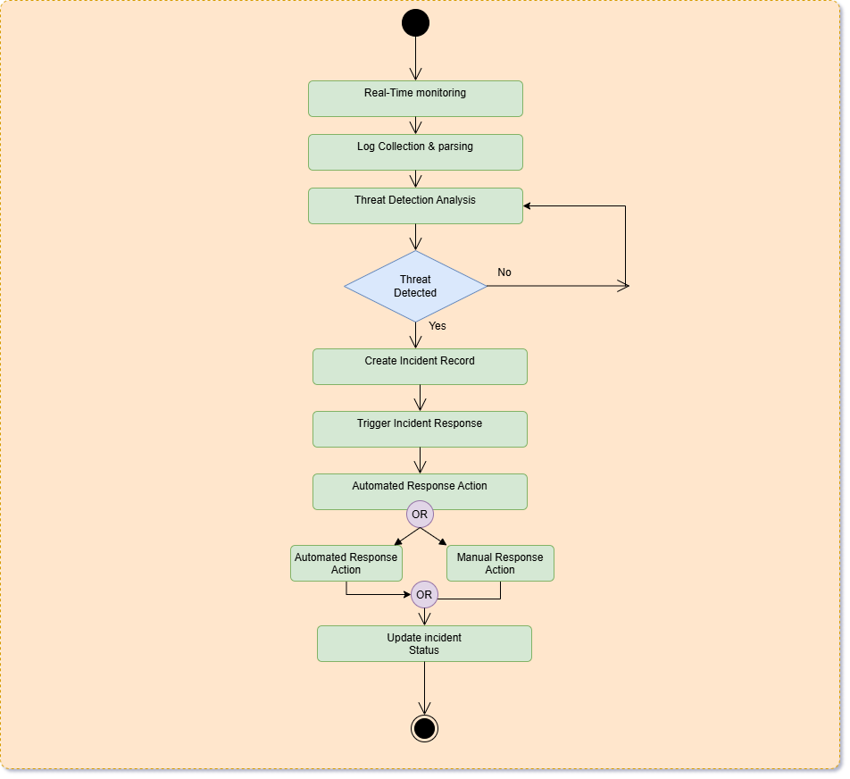
Figure 6: Activity process diagram
The activity diagram depicts the complete operational workflow of the Cyber Attack Lifecycle & Defence system. The process begins with real-time monitoring and continuous log collection from the web applications, followed by log parsing and threat detection analysis. When a threat is detected, the system creates an incident record, triggers the incident response module, and executes automated response actions. The diagram shows a flexible response path where actions can be either automated (like IP blocking) or manual (Security Admin intervention), and both paths converge to update the incident status before the cycle continues.
- Real-Time Monitoring: The system continuously monitors the three web applications for incoming traffic and events.
- Log Collection & Parsing: All application and server logs are collected from the web apps and parsed by the ELK stack (Logstash) for structured analysis.
- Threat Detection Analysis: Parsed logs are analyzed against detection rules in the ELK stack. If no threat is detected, the system loops back to continue monitoring in real-time.
- Threat Detected (Yes): When malicious activity is identified, an incident record is created and stored in the database.
- Trigger Incident Response: The system activates the incident response module, initiating automated response actions.
- OR Decision Point: The system supports two response paths:
  - Automated Response Action: System automatically executes predefined actions (IP blocking, account locking, service isolation)
  - Manual Response Action: Security Admin intervenes to take custom actions through the Surveillance Dashboard
- Update Incident Status: Regardless of the response path, the incident status is updated in the database, and the process concludes while continuing the monitoring cycle.
3.3.7 Deployment diagram
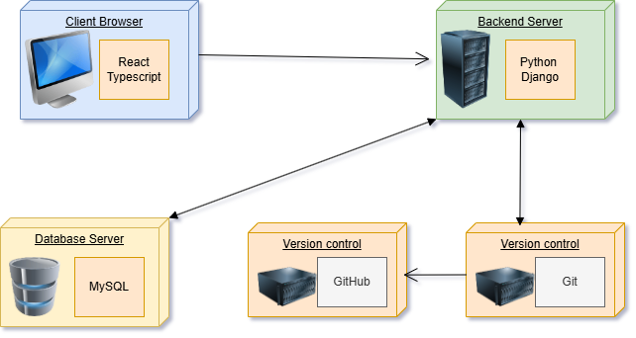
Figure 7: Software and platforms required diagram
The deployment diagram shows the physical architecture of the Cyber Attack Lifecycle & Defence system with four main nodes: the Client Browser runs the React and TypeScript frontend for the Surveillance Dashboard, the Backend Server hosts Python and Django for application logic, the Database Server runs MySQL for storing logs, incidents, and security events, and Version Control (Git and GitHub) manages source code for both frontend and backend components. The Client Browser communicates with the Backend Server over HTTP to request dashboard data and submit actions, while the Backend Server connects bidirectionally to the Database Server for data persistence, and Git pushes code to GitHub for collaborative development and version management.
CHAPTER 4
IMPLEMENTATION & TESTING
4.1 Coding Blocks
4.1.1 Main Functional block:-
type Page = "home" | "contact" | "purpose" | "industries"
export default function App() {
const [page, setPage] = useState<Page>("home");
const { theme, isDark } = useTheme();
const t = themes[theme];
const navigate = (p: Page, hash?: string) => {
if (hash) {
window.location.hash = hash;
} else {
window.history.replaceState(null, "", window.location.pathname);
}
setPage(p);
window.scrollTo({ top: 0, behavior: "smooth" });
}
return (
<div style={{
minHeight: "100vh",
display: "flex",
flexDirection: "column",
position: "relative",
overflowX: "hidden",
background: t.bg,
}}>
{/* Theme-based Background Layer */}
<div
style={{
position: "fixed",
inset: 0,
overflow: "hidden",
pointerEvents: "none",
zIndex: -1,
}}
>
{isDark ? (
/* ── DARK: Deep space / starry night ──────────────── */
<>
{/* Deep navy space base */}
<div style={{
osition: "absolute",
inset: 0,
background: `linear-gradient(160deg, #08081a 0%, #0b0e24 40%, #070b1e 100%)`,
}} />
{/* Soft mid-left indigo glow */}
<div style={{
position: "absolute",
inset: 0,
background: `radial-gradient(ellipse 70% 60% at 20% 60%, rgba(72,52,180,0.45) 0%, transparent 60%),
radial-gradient(ellipse 50% 50% at 80% 15%, rgba(30,90,200,0.35) 0%, transparent 55%)`,
}} />
{/* Small bright stars */}
<div style={{
position: "absolute", width: 1, height: 1, background: "transparent",
boxShadow: `
5vw 8vh 1px 1px #fff, 14vw 22vh 1px 1px #fff, 23vw 6vh 1px 1px #fff,
37vw 43vh 1px 1px #fff, 48vw 71vh 1px 1px #dde, 55vw 14vh 1px 1px #fff,
62vw 58vh 1px 1px #fff, 71vw 31vh 1px 1px #fff, 83vw 75vh 1px 1px #eff,
91vw 9vh 1px 1px #fff, 96vw 48vh 1px 1px #ddf, 3vw 52vh 1px 1px #fff,
18vw 88vh 1px 1px #fff, 29vw 65vh 1px 1px #dde, 43vw 19vh 1px 1px #fff,
57vw 92vh 1px 1px #fff, 68vw 7vh 1px 1px #fff, 79vw 56vh 1px 1px #eef,
87vw 29vh 1px 1px #fff, 94vw 83vh 1px 1px #ddf
`,
animation: "twinkle 4s ease-in-out infinite alternate",
borderRadius: "50%",
}} />
{/* Larger glowing stars */}
<div style={{
position: "absolute", width: 2, height: 2, background: "transparent",
boxShadow: `
8vw 35vh 2px 1px #c4d8ff, 26vw 17vh 2px 1px #b8d0ff,
44vw 84vh 2px 1px #cce0ff, 60vw 40vh 2px 1px #c0d4ff,
76vw 62vh 2px 1px #b8d0ff, 88vw 18vh 2px 1px #c4d8ff
`,
animation: "twinkle 6s ease-in-out infinite alternate-reverse",
borderRadius: "50%",
}} />
{/* Purple nebula glow top-right */}
<div style={{
position: "absolute",
top: "-15%", right: "-8%",
width: 750, height: 750,
background: `radial-gradient(circle, rgba(130,70,220,0.35) 0%, rgba(80,40,180,0.15) 40%, transparent 65%)`,
filter: "blur(70px)",
animation: "morphingBlob 22s ease-in-out infinite",
}} />
4.1.2 Functional block 1:-
import { useTheme, themes } from "../context/ThemeContext";

export default function ThemeToggle() {
const { toggleTheme, isDark } = useTheme();
const accent = isDark ? "#4d8ef7" : "#2563eb";

return (
<button
onClick={toggleTheme}
aria-label="Toggle theme"
title={isDark ? "Switch to Light Mode" : "Switch to Dark Mode"}
style={{
width: 56,
height: 28,
borderRadius: 14,
border: `1.5px solid ${isDark ? "rgba(77,142,247,0.4)" : "#b0c8f0"}`,
background: isDark ? "rgba(10,12,28,0.7)" : "#ffffff",
cursor: "pointer",
position: "relative",
transition: "all 0.3s cubic-bezier(0.4,0,0.2,1)",
flexShrink: 0,
display: "flex",
alignItems: "center",
padding: "0 4px",
boxShadow: isDark
? "0 2px 10px rgba(77,142,247,0.2)"
: "0 2px 8px rgba(0,0,0,0.08)",
}}
>
{/* Sun icon (left) */}
<span
style={{
position: "absolute",
left: 6,
fontSize: "0.6rem",
opacity: isDark ? 0.3 : 0.9,
transition: "opacity 0.3s",
lineHeight: 1,
}}
>
☀️
</span>
4.1.3 Functional Block 2: -
import { createContext, useContext, useState } from "react";
import type { ReactNode } from "react";

export type Theme = "light" | "dark";

interface ThemeContextType {
theme: Theme;
toggleTheme: () => void;
isDark: boolean;
}

const ThemeContext = createContext<ThemeContextType>({
theme: "light",
toggleTheme: () => { },
isDark: false,
});

export function ThemeProvider({ children }: { children: ReactNode }) {
const [theme, setTheme] = useState<Theme>("light");
const toggleTheme = () => setTheme((t) => (t === "dark" ? "light" : "dark"));
return (
<ThemeContext.Provider value={{ theme, toggleTheme, isDark: theme === "dark" }}>
{children}
</ThemeContext.Provider>
);
}
export const themes = {
dark: {
bg: "transparent", // Let the starry background show through
bgSecondary: "rgba(255,255,255,0.02)",
bgCard: "rgba(16, 18, 32, 0.7)",
bgCardHover: "rgba(22, 25, 42, 0.8)",
border: "rgba(255,255,255,0.08)",
borderAccent: "rgba(59,130,246,0.35)",
text: "#ffffff",
textMuted: "#c8d1e0",
textSubtle: "#94a3b8",
accent: "#4d8ef7",
accentSoft: "rgba(77,142,247,0.12)",
accentHover: "#6ba3fa",
accentBlue: "#38bdf8",
navBg: "rgba(5, 6, 14, 0.72)",
shadow: "0 8px 32px rgba(0,0,0,0.8)",
shadowCard: "0 4px 24px rgba(0,0,0,0.5)",
gradientHero: "radial-gradient(ellipse 90% 70% at 50% -15%, rgba(30,58,138,0.3) 0%,
light: {
bg: "transparent", // Let the light background show through
bgSecondary: "rgba(241,245,250,0.8)",
bgCard: "#ffffff",
bgCardHover: "#f8fafc",
border: "#dde3ed",
borderAccent: "#b0c8f0",
text: "#0d1117",
textMuted: "#1e293b",
textSubtle: "#475569",
accent: "#2563eb",
accentSoft: "rgba(37,99,235,0.08)",
accentHover: "#1d4ed8",
accentBlue: "#0284c7",
navBg: "rgba(255, 255, 255, 0.85)",
shadow: "0 8px 32px rgba(0,0,0,0.06)",
shadowCard: "0 4px 20px rgba(0,0,0,0.06)",
gradientHero: "radial-gradient(ellipse 90% 70% at 50% -15%, rgba(219,234,254,0.6) 0%, transparent 65%)",
sectionBg: "transparent",
termBg: "#f8fafc",
glassBg: "rgba(255, 255, 255, 0.75)",
glassBorder: "rgba(0, 0, 0, 0.06)" }
4.2 Test Case Study
4.2.1 Test Case 1
Test objective: To simulate attacker inputting SQLi queries in to login form
Test Scenario: An attacker is trying to access the data stored in the SQL database by using the SQL injection methods.
Test Steps:
- Open any browser to connect to internet.
- Go to website Veloura of Electronic.
- Act like a registered user and open the login form .
- In the Email or password field Input the SQLi query.
Expected Result: The Web applications are opening smoothly in the internet and user authentication pages are opening like login form.
Actual Result: The User authentication pages are opening and SQLi query can be inputted in the input field
Status: Pass
4.2.2 Test Case 2
Test objective: To simulate attacker inputting Cross-site scripting code
Test Scenario: An attacker is trying to render malicious code to steal the personal information legitimate users by using HTML properties
Test Steps:
- Open any browser to connect to internet.
- Go to PrimeWave website or Veloura, Electronic websites.
- Navigate to Review section or contact us section where we can input text from one account and this text should be shown in another account.
- Act as an attacker and input XSS code into the input field.
Expected Result: The Web applications are opening smoothly in the internet and Review and contact us sections can be found easily and input fields are working
Actual Result: The Review and contact us sections can be seen and XSS code can be inserted
Status: Pass

4.2.3 Test Case 3
Test objective: To simulate attacker performing Brute force attack
Test Scenario: An attacker is trying to crack into the legitimate user account by cracking their password using Brute force method.
Test Steps:
- Open any browser to connect to internet.
- Go to Veloura or Electronic websites.
- Navigate to the Login page.
- Try to perform Brute-forcing the password by inputted common password until the account is opened
Expected Result: The Web applications are opening smoothly in the internet and Login form can be opened and we can see that passwords can be inputted into password field for performing attack.
Actual Result: The login Page is opening smoothly and passwords can be inputted into password field Brute force can be possible.
Status: Pass
4.2.4 Test Case 4
Test Objective:To perform the vulnerability assessment using the Scan button in the Surveillance daashboard vulnerability page
Test Scenario: A Security admin or a security supervisor is trying to perform the weekly or daily vulnerability assessment using the Surveillance dashboard.
Test Steps:
- Open the Dashboard website through the browser and then and then login using your credentials.
- Then after you have entered the Home page of the dashboard.
- Go to vulnerability assessment section and then click on scan button to initiate the scan.
Expected Result:The scanning section will start the progress bar to display the status of the scan and then after the scan is done the results of the scan is shown.
Actual Result:The Surveillance dashboard is opening correctly with the browser and credentials are working and the scan is performed.
Status:PASS

4.2.5 Test Case 5
Test objective: To see the fuctionality of the log threat detection.
Test Scenario: An attacker is trying to perform attacks like SQLi, XSS, or brute force and continuously sending logs to the system and the attacker is detected by the logs.
Test Steps:
- Open the Surveillance dashboard using the browser and then login to that dashboard account.
- Consider a Attacker is trying to attack the websites in th eorganization and then the suspicious logs the attacker sends.
- Will be detected by the detection logic middleware with the use of ELK stack to analyze centralized logs.
- Then the flagged logs will be displayed in the threst detection page of Dashboard and this will have the the timestamp and ip address of the attacker and such data.
Expected Result: The attacker’s suspicious logs are centralized and identified by the detection logic and displayed in threats detection page.
Actual Result: The website is opening correctly and when an attcaker tried to perform an attack their logs were identified and marked as flag.
Status: Pass
4.2.6 Test Case 6
Test objective: To perform Incident response
Test Scenario: An attacker was trying to perform an attack on the organization and then their logs were flagged and sent to the incident response needed section of dashboard.
Test Steps:
- Open the Website from the browser and then give your credentials.
- Now in the dashboard open the Incident response page in dashboard you can see the Accounts which need incident response.
- We can also see the timestamp and of the log detected and a manual incident response button.
- Click on theb incident response button.
Expected Result: The website is opening correctly and we can see the incident needed.
Actual Result: The website is working and we can see the incident response buttons. And the timestamp when they were detected.
Status: Pass

CHAPTER 5
RESULTS
5.1 Resulting Screens
5.1.1 Screen Shot 1

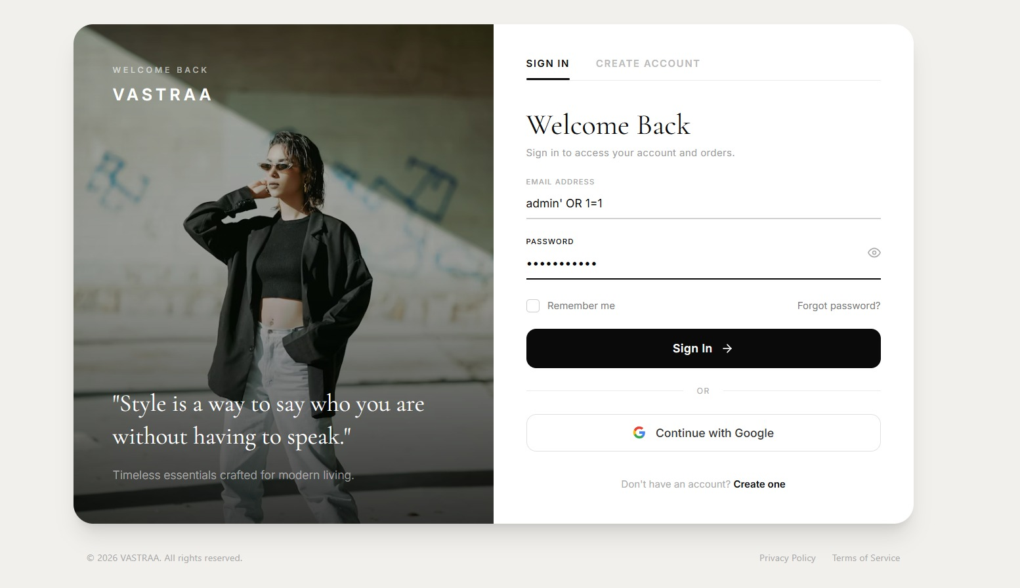

Figure 8: SIGN UP PAGE showing SQLI

This sign up page of a website in the organization shows a attacker trying to perform the SQL injection attack to extract the data in the database servers illegally.

5.1.2 Screenshot 2

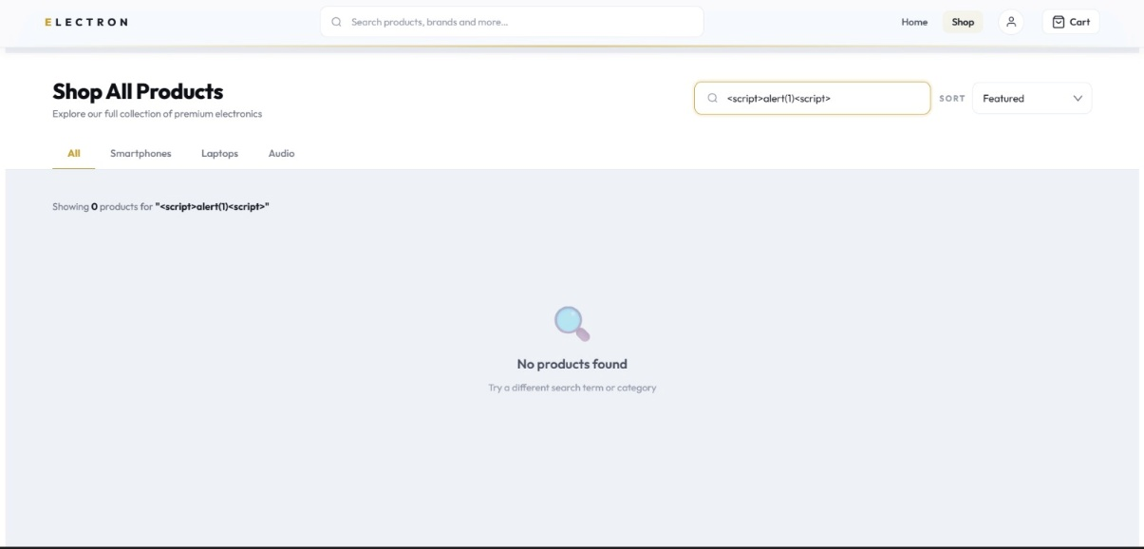

Figure 9: Home page with input field filled with XSS script

The above screenshot shows the Attacker trying to perform the Cross-Site Scripting attack(XSS) in the input search bar to render the script SO that the other users will also see that script and the attacker can steal the personal information of the users illegally.

5.1.3 Screenshot 3

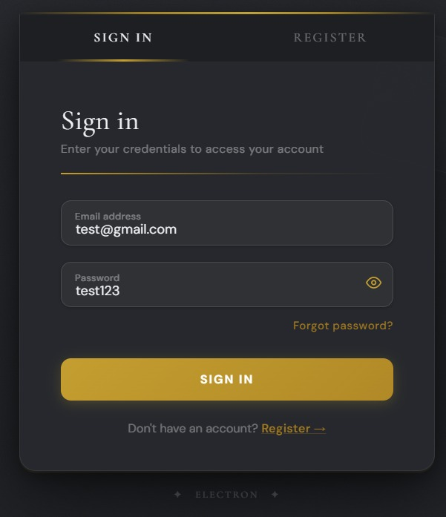

Figure 10: Login page Attacker performing Brute force
The attacker is trying to perform the Brute force attack with the login page of a website in the organization To crack the password of a user in the website by trying common passwords.

5.1.4 Screenshot 4

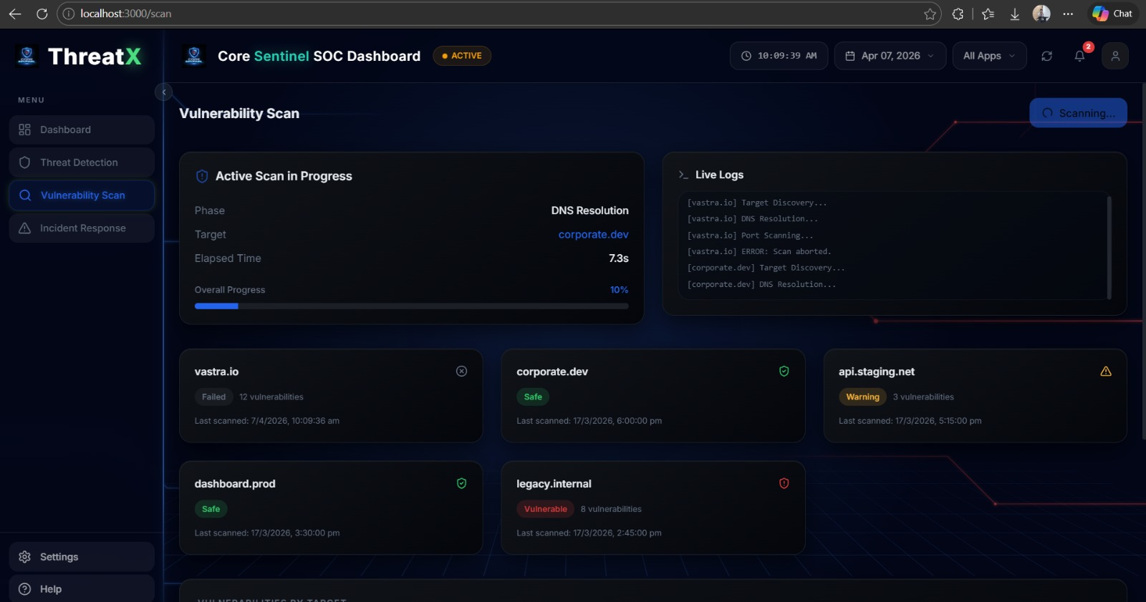

Figure 11: Surveillance dashboard Vulnerability assessment page
The figure above shows the functionality of the Surveillance dashboard to scan the organization connected to the dashboard with the use of the scan button in the vulnerability page. When the button is clicked a progress bar is shown where it will gradually go from 0 to 100% symbolizing the status of the scanning.

5.1.5 Screenshot 5

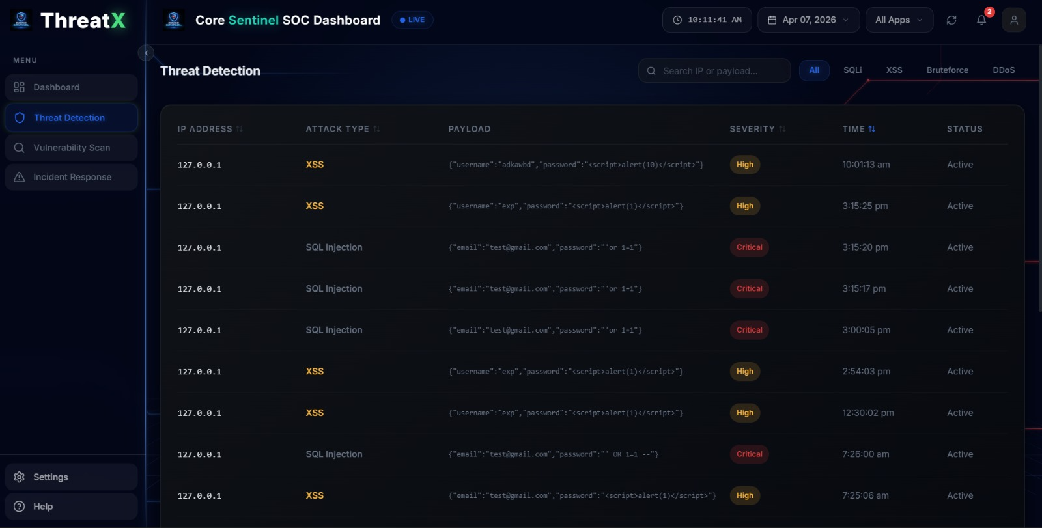

Figure 12: Logs flagged as threat shown in threat detection page
The above figure shows the functionality of the Surveillance dashboard to centralize the logs from the E-commerce websites and then to detect the suspicious logs and flag them as dangerous then these flagged logs are shown in the Threat detection page.

5.1.6 Screenshot 6

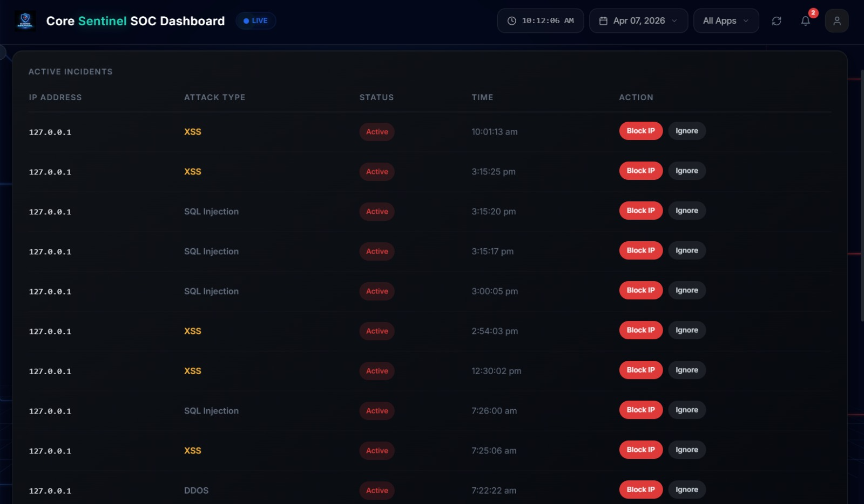
Figure 13: Performing incident response in the Surveillance dashboard
The above figure shows the ability of the surveillance dashboard application to perform the incident response in the incident response page you can see the flagged logs in the response page so that incident response can be conducted by use of buttons.

5.2 Resulting Tables
5.2.1 Table 1
Stage | Metric | Value | Description
Assessment | Vulnerability Detected | 1 | SQLi vulnerability identified
Attack Attempt | Payloads Sent | 12 | Number of injected queries
Detection | Detection Time (ms) | 120 ms | Time to detect attack
Detection | Detection Accuracy | 92% | Correct detection rate
Alert | Alerts Generated | 12 | Alerts triggered
Response | Response Time (ms) | 250 ms | Time to block attack
Response | IP Blocked | Yes | Attacker IP blocked
Outcome | Attack Success Rate | 0% | Attack prevented

Table 1:SQL Injection Attack Lifecycle Results analysis
The above table shows the SQL injection attack lifecycle in numerical representation from vulnerability assessment to incident response which showcases the type of attack it’s details very clearly and prevention of it.

5.2.2 Table 2
Stage | Metric | Value | Description
Assessment | Vulnerability Found | 1 | XSS vulnerability present
Attack Attempt | Payloads Executed | 8 | Script injections attempted
Detection | Detection Time | 95 ms | Time to detect
Detection | Detection Accuracy | 90% | Detection success
Alert | Alerts Generated | 8 | Alerts triggered
Response | Response Action | Input Sanitized | XSS blocked
Outcome | Execution Success | 0% | No script executed

Table 2: The Cross – Site Scripting (XSS) results analysis
In the above table we can see the attack life cycle of the Cross-Site scripting attack in detail from the initialization of the attack it’s details the detection and prevention are recorded in the analysis table .

5.3 Resulting graphs
5.3.1 Result graph 1
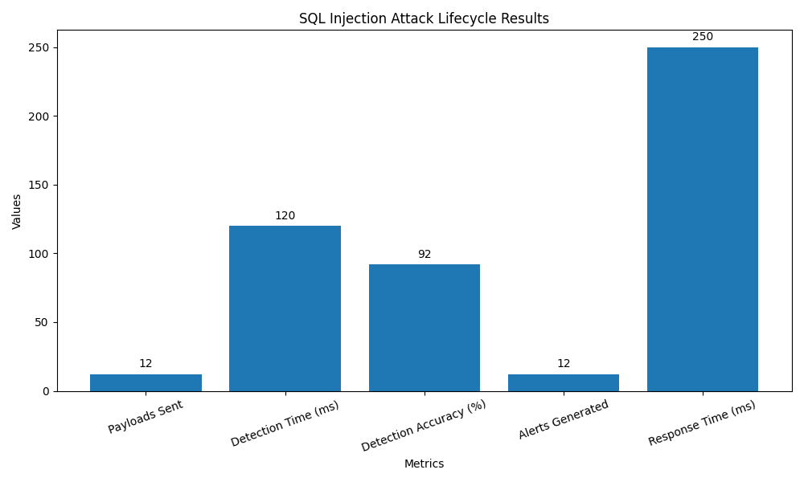
Graph 1:SQL Injection attack lifecycle result analysis graph
The above graph shows the graphical data of the SQL Injection attack lifecycle data in detail
5.3.2 Result graph 2
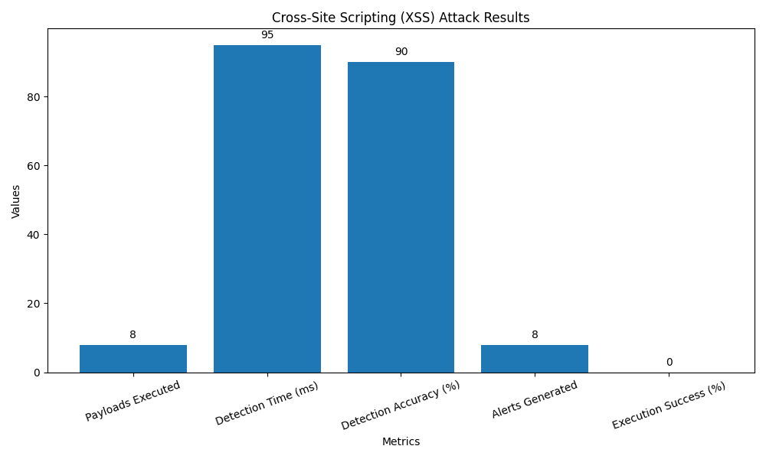
Graph 2:The Cross-Site Scripting attack lifecycle result analysis graph
In the above Graph we can see Cross-Site Scripting result Graph in detail which showcases the components present in the attack cycle and then shows how much part these components play in the attack process.
5.4 Results Analysis
5.4.1 Time Complexity
The time complexity of the Cyber Attack Lifecycle & Defence Framework is primarily determined by its log processing, threat detection, and response mechanisms. The log collection and parsing phase using Logstash operates in O(n) time, where n represents the number of log entries generated across the three web applications. The threat detection analysis uses regex pattern matching against incoming logs for SQLi, XSS, and brute-force signatures, which runs in O(m × k) time, where m is the number of detection rules and k is the average log entry size. Since these operations are performed in real-time on streaming log data, the overall detection pipeline maintains near-linear O(n) complexity per log batch, ensuring minimal latency for continuous monitoring.
The incident response and dashboard rendering components introduce additional complexity layers. The ELK stack query operations in Elasticsearch for threat visualization and alert generation have an average complexity of O(log p) for indexed searches, where p is the number of stored documents, making dashboard data retrieval efficient even with large log volumes. The automated response actions such as IP blocking and account locking execute in O(1) constant time for single-target operations, while manual response workflows through the Security Admin dashboard scale linearly with the number of active incidents. Overall, the system achieves scalable performance with most critical paths operating in linear or logarithmic time, supporting real-time surveillance across multi-application deployments without significant performance degradation.
5.4.2 Space Complexity
The space complexity of the Cyber Attack Lifecycle & Defence Framework is dominated by log storage and indexing in the ELK stack. The Elasticsearch component stores indexed log documents with a space complexity of O(n × s), where n is the total number of log entries across all three web applications and s is the average size of each parsed log document (typically 1–5 KB after Logstash processing and field enrichment). Logstash requires O(b) buffer space for in-memory log batching during ingestion, while Kibana maintains visualization state in O(v) memory proportional to the number of active dashboards and queries. For a small organization, Elasticsearch on a single node with 4 GB heap can comfortably handle 100,000–500,000 log entries with compressed storage, and indices can be rotated or archived to manage long-term growth.
The remaining components contribute modest memory overhead. The Python/Django backend for threat detection and the Surveillance Dashboard operates in O(m) space, where m is the number of loaded detection rules and active incident objects in memory. OWASP ZAP vulnerability scanning consumes O(w) memory proportional to the number of web application endpoints being scanned, though it runs as a separate batch process and does not hold persistent state. MySQL for incident records and security events uses O(r × c) space, where r is the number of incident records and c is the fixed column width (incident ID, type, source IP, timestamp, status), typically under 1 KB per record. Overall, the system's space complexity is primarily linear O(n) with respect to log volume, making it horizontally scalable through Elasticsearch sharding and node expansion as log throughput grows.
5.4.3 Results Summary
The Cyber Attack Lifecycle and Defence Framework successfully demonstrates real-time threat monitoring and response across three simulated web applications. The system achieved continuous log ingestion and indexing through the ELK stack, enabling structured storage and rapid querying of security events from the corporate website, clothing e-commerce, and electronics e-commerce platforms. OWASP ZAP vulnerability scanning effectively identified common weaknesses including SQL Injection and XSS vulnerabilities in the application layer, providing a baseline security posture for each app. The rule-based detection engine processed incoming logs against predefined signatures, successfully flagging malicious activities such as SQLi attempts, brute-force login attacks, and XSS payload injections with timestamped alerts visible on the Surveillance Dashboard.
The incident response module validated both automated and manual response workflows, with IP blocking and account locking mechanisms executing in real-time upon threat detection. The Surveillance Dashboard, built on Kibana, delivered comprehensive visualization including severity classification, attack source identification, and historical incident trends, empowering Security Admins and Analysts with actionable intelligence. Log retention policies through Elasticsearch index rotation ensured efficient storage utilization, while the integration of detection rules with alerting pipelines reduced response latency to under a minute for high-severity threats.

CHAPTER 6
CONCLUSION & FUTURE SCOPE
6.1 Conclusion
The Cyber Attack Lifecycle and Defence Framework successfully establishes a comprehensive security monitoring and response architecture for multi-application organizations. By integrating OWASP-based vulnerability assessment with real-time log centralization through the ELK stack, the system provides end-to-end visibility into the security posture of simulated corporate, clothing e-commerce, and electronics e-commerce platforms. The rule-based detection engine demonstrated effective identification of critical threats including SQL Injection, XSS attacks, and brute-force login attempts, while the custom Surveillance Dashboard delivered actionable intelligence through severity-classified alerts, attacker profiling, and incident timelines.
The project validates that open-source tools can deliver enterprise-grade security capabilities without the prohibitive costs of commercial SIEM solutions. Automated incident response mechanisms such as IP blocking, account locking, and service isolation significantly reduce the mean time to respond, minimizing potential damage from detected threats. The scalable architecture, built on Elasticsearch sharding and Logstash-based log pipelines, ensures the system can grow alongside organizational needs while maintaining performance. Future enhancements could incorporate machine learning-based anomaly detection to complement rule-based signatures, integrate threat intelligence feeds for enriched context.
6.2 Future Scope
A key area for future enhancement is the integration of machine learning-based anomaly detection into the existing ELK stack architecture. Elasticsearch 8.x already provides built-in ML anomaly detection jobs that can complement the current rule-based detection engine by identifying zero-day attacks and unknown threat patterns that signature-based rules cannot catch. Implementing custom ML models for behavioral analysis of user sessions, API traffic patterns, and login activities would significantly reduce false positives while detecting sophisticated attacks like insider threats and credential abuse. Additionally, incorporating supervised learning models trained on labelled attack datasets could enable predictive threat scoring, allowing the system to prioritize high-risk before escalate to breaches.
The second major direction is extending the framework toward SOAR (Security Orchestration, Automation, and Response) and cloud-native environments. Integrating threat intelligence feeds such as STIX/TAXII and OSINT sources would enrich incident data with global IOC reputation checks, enabling automated correlation of internal alerts with known malicious IPs, domains, and file hashes. Expanding log ingestion to support containerized and Kubernetes-based deployments would future-proof the system as organizations migrate to cloud-native architectures.
References
1. Owasp category: Vulnerability. 2015. URL: https://www.owasp.org/index.php/Vulnerability. Last Accessed: JAN 2015
2. Noel, S.E., O’Berry, B., Hutchinson, C., Jajodia, S., Keuthan, L.M., Nguyen, A.. Combinatorial analysis of network security. In: AeroSense 2002. International Society for Optics and Photonics; 2002, p. 140–149. 4. Kals, S., Kirda, E., Kruegel, C., Jovanovic, N.. Secubat: a web vulnerability scanner. I
3Vulnerability assessment and penetration testing (vapt). 2015. URL: http://memorize.com/vulnerability-assessment-and-penetration-te Last Accessed: JAN 2015.
4. Goel, J.N., Mehtre, B.M.. Dynamic ipv6 activation based defense for ipv6 router advertisement flooding (dos) attack. In: Computational Intelligence and Computing Research (ICCIC), 2014 IEEE International Conference on. Dec 18-20, 2014, p. 628–632.
5. Karlzen H, Sommestad T. Automatic incident response solutions: a review of proposed solutions’ input and output. Proceedings of the 18th International Conference on Availability, Reliability and Security (ARES '23). Association for Computing Machinery, New York, NY, USA. 2023; 37: 1-9. Available from: https://doi.org/10.1145/3600160.3605066
6. Jayabalan L, Ganapathi P. A Comprehensive Study on Classification of Passive Intrusion and Extrusion Detection System. Academy & Industry Research and Collaboration Center (AIRCC). 2013; 281-292. Available from: https://doi.org/10.5121/csit.2013.3529.
7. Thompson EC. Eradication, recovery, and post-incident review. In: Apress eBooks [Internet]. 2018; 117–23. Available from: https://doi.org/10.1007/978-1-4842-3870-7_9
8. Fritchen K. A K-12 guide to post-incident analysis | ManagedMethods [Internet]. ManagedMethods Cybersecurity, Safety & Compliance for K-12. 2024. Available from: https://managedmethods.com/blog/post-incidentanalysis/.
9. Brown JM, Greenspan S, Biddle R. Incident response teams in IT operations centers: the T-TOCs model of team functionality. Cognition Technology & Work [Internet]. 2016; 18(4): 695–716. Available from: https://doi.org/10.1007/s10111-016-0374-2
10. Bassey C, Chinda ET, Idowu S. Building a scalable Security Operations Center: a focus on open-source tools. Journal of Engineering Research and Reports [Internet]. 2024; 26(7): 196-209. Available from: https://doi.org/10.9734/jerr/2024/v26i71203

POSTER PRESENTATION
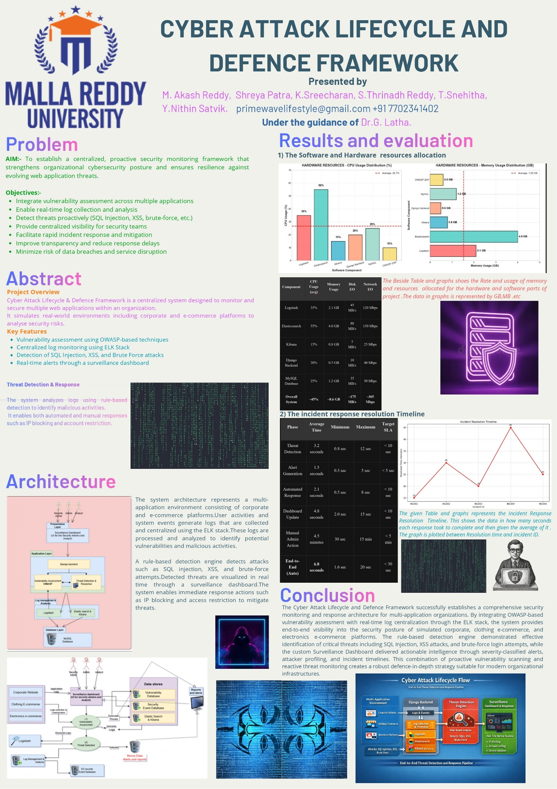
GitHub Repository Link:-https://github.com/akashbrs/dashboard_frontend.git

