

HuisClos method report
Problem, legal frame, pipeline, evaluation, limits and reproducibility

Advanced AI Algorithms, group assignment
Status at the feature freeze of 28 October 2026
All documents, tests and examples mentioned are fictitious.
Word edition of docs/METHOD_REPORT.md in the HuisClos repository. Decision identifiers (D-xx) refer to docs/DECISIONS.md, written in French.

Contents
1. Problem and users 3
2. Legal and ethical framework 3
3. Market and alternatives 4
4. Solution and pipeline 5
5. Evaluation 5
5.1 Corpora and protocol 5
5.2 Development results 6
5.3 Historical test register 7
5.4 Challenge: G7, the G8 failure and the single resume G8R2 7
5.5 C3 French and English blind sets (historical, code e3d13bd) 8
5.6 Limits of the evaluation 8
6. Course concepts applied 8
7. Beyond the course 9
8. Limits and ethics 9
9. Value if widely used 10
10. Reproducibility 10
11. Use of AI tools 10
12. References 11

Course: Advanced AI Algorithms, group assignment, 2026. Status at the feature freeze of 28 October 2026. Every document, test and example mentioned here is fictitious. Figures come from the project files cited under each table; this report runs no new measurement.

1. Problem and users
Lawyers and in-house legal staff want to ask a general-purpose language model to summarise a file, draft a letter or compare two contracts. Pasting the file as it is sends client names, addresses, bank details and case numbers to a third party. For a French lawyer this conflicts with professional secrecy, and for any organisation it is a transfer of personal data that needs a legal basis and safeguards.
HuisClos answers a narrow need: before the text leaves the computer, replace each identifying value with a stable token such as [PERSONNE_1] or [SOCIETE_A], let a human check every replacement, send only the checked text, then put the real values back into the answer. The mapping between tokens and real values stays on the computer.
The primary users are lawyers, legal assistants and lawyers working in companies, who handle French or English documents and have no programming background. The user guide is written for them (USER_GUIDE.md).
A second audience is a hypothesis, not a validated use: human resources teams handle similar documents (employment contracts, disciplinary letters, labelled employee numbers). The detector already recognises labelled internal identifiers such as employee numbers (decision D-S14-1), but no HR user was interviewed and no HR corpus was measured. This report gives no market size, no user count and no adoption figure, because the project holds no sourced data on them.

2. Legal and ethical framework
The references below are those already stated in the application's Method page and in the project documents. They describe the frame the tool was designed for; they are not a legal opinion.
- Professional secrecy. Law no. 71-1130 of 31 December 1971, article 66-5: consultations, correspondence, interview notes and, more generally, every document of the case file are covered by professional secrecy. Penal Code, article 226-13: revealing secret information held through one's profession is a criminal offence. Sending a client file to an external AI service can amount to such a disclosure.
- GDPR, article 4(5). Pseudonymisation means processing personal data so that they can no longer be attributed to a person without additional information, kept separately and protected. In HuisClos, that additional information is the mapping table.
- GDPR, recital 26. Pseudonymised data remain personal data. HuisClos therefore never claims anonymisation: the interface, the README and every export say "Pseudonymization is not anonymization".
- GDPR, article 5(1)(c) and article 32. Data minimisation, and security of processing, which names pseudonymisation among the possible measures. HuisClos sends the minimum (the checked document and the user's instruction) and processes everything else locally.
Primary sources: the GDPR, Regulation (EU) 2016/679, at https://eur-lex.europa.eu/eli/reg/2016/679/oj; the French texts on Legifrance, https://www.legifrance.gouv.fr. These links point to official publication sites. They were not consulted during this session and do not replace a check of the current wording.
Three design rules follow from this frame:
- The mapping table is sensitive. It is never sent to the model, never committed to Git (*.mapping.json is ignored), held in session memory and offered for download only with a red warning (AGENTS.md, principle 5).
- A missed name is a breach; an extra masked word is a nuisance. Recall comes first.
- The human decides. No detection is accepted by default and no alert masks anything.
Missing research. The project holds no research file (docs/RESEARCH.md is absent). The report therefore says nothing about recent guidance of the French bar on artificial intelligence, the final status of European guidelines on pseudonymisation, or how the Court of Justice of the European Union interprets pseudonymised data held by a recipient without the key. These points need a sourced legal review before any professional use.

3. Market and alternatives
This section is a qualitative comparison only. The project collected no market study, price list or competitor documentation, so no commercial product is named and no figure is given.
Approach | What the user does | Main weakness for a lawyer
Send the raw file to a chatbot | Paste and ask | Discloses every identifier to a third party
Manual redaction | Replace names by hand | Slow, inconsistent tokens, no restoration of the answer
Contractual enterprise AI service | Rely on a provider's terms | Data still leave the firm; depends on the contract
Generic open-source PII detection library | Build a pipeline | Mostly English, no French legal identifiers, no review or restoration
HuisClos | Detect, review, tokenise, check, restore locally | Small fictitious validation; human review still required

HuisClos is built on one such library, Microsoft Presidio, and on spaCy models. Its added value lies in the French and English legal rules, the review step, the outbound check and the restoration, not in a new detection model.

4. Solution and pipeline
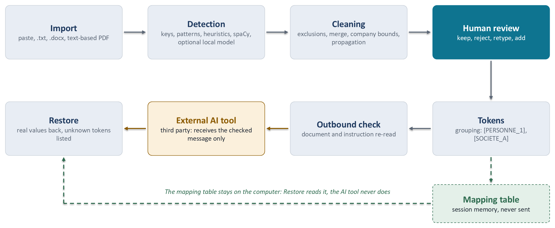
Figure 1. The HuisClos pipeline: detection, human review, tokens and outbound check run locally; only the checked message reaches the AI tool.
Each stage and the decision that justifies it:
- Local reading (D-15, D-AF-B2-1, D-AF-B2-2). Text-based PDF and DOCX are read locally; a PDF without text is refused, because there is no OCR. Doubtful pages raise a warning.
- Rules before statistics (D-03, D-07). Identifiers with a control key (IBAN and NIR by modulo 97, SIREN and SIRET by the Luhn key) score 1.00; emails 0.95; labelled case numbers and birth dates 0.90; spaCy entities a fixed 0.85 (D-S12-1); name heuristics 0.70 to 0.80.
- Threshold 0.30 (D-13). It maximises F2 on the development set, the lowest value at a tie.
- Merge without overlap (D-S13-1, D-AF-A1-1). Overlapping proposals are arbitrated by priority, score and length; a weak candidate below the threshold can no longer remove a stronger protection.
- Span conventions (D-09). Titles and labels stay outside the token (M. [PERSONNE_1]), which keeps grammatical gender for the model; a legal form stays inside a company token.
- Propagation (D-S13-4, D-S14-4). Once "Jean DUPONT" is found, "M. Dupont" and "DUPONT" elsewhere are found too, but "petit" never matches the surname Petit.
- Grouping in doubt (D-S21-1, D-FIX3-1). Two uncertain mentions get two tokens rather than one shared token, because confusing two people is worse than an extra token.
- Exact or tolerant restoration (D-10, D-S22-1). If the received text is the tokenised text, positions restore it exactly; otherwise common token alterations by the model (case, accents, brackets, Markdown escapes) are recognised and unknown tokens are listed.
- Outbound check (D-S24-3, D-AF-A3-3 to D-AF-A3-5). The message is composed once, then both segments, the document and the user's instruction, are re-read for residual values.

5. Evaluation

5.1 Corpora and protocol
All corpora are fictitious, built from annotated Markdown sources by scripts/build_corpus.py, which fills identifiers with valid synthetic keys (D-12).
Set | Documents | Role | Status
French dev | 20 | Tuning and threshold choice | Saturated: rules written next to it
English dev | 8 | English tuning | 136 evaluated entities; not a blind check
Historical test | 6 | Held out, measured once per gate | 93 evaluated entities, measured four times
Challenge | 8 | Written blind after the S14 rule freeze | 190 evaluated entities, now known
C3 French and English | 8 + 8 | Written blind after the A4 freeze | Measured once by G8 on e3d13bd

Sources: D-S14-10, D-G7-1, D-AF-B2-3, D-G8-1.
Eleven types are evaluated: person, company, address, email, phone, IBAN, NIR, SIREN, SIRET, birth date and case number. CUSTOM (labelled identifiers and manual values) and LOCATION are excluded from the main figures and reported separately.
Metrics (POST_G7_PROTOCOL.md, sections 1 and 4):
- Exact and partial matching. A prediction matches a reference of the same type, one to one; exact matching needs the same bounds, partial matching any overlap. A wrong label is never a true positive.
- F2 weighs recall twice as much as precision, mirroring the asymmetric cost.
- Leak rate: reference characters left visible, divided by all reference characters.
- Full coverage: references whose every character is masked, whatever the predicted type; one visible character breaks it.
- Over-masking: masked characters outside any annotation.
- Uncertainty: document bootstrap, 2,000 draws, seed 45, 2.5 and 97.5 percentiles. A difference between two profiles is called significant only if its paired interval, computed on the same draws, excludes zero.
- Engineering criterion for recommending a heavier profile against its reference: lower leakage, higher full coverage, precision loss within 0.02 and extra masking within 0.01.
No measurement simulates a human: every proposal is substituted automatically. The figures describe the tool before review.

5.2 Development results
French dev, threshold 0.30, partial matching, micro averages: Standard (hybrid) reaches precision 0.9904, recall 1.0000, F2 0.9981 and leak rate 0.0000; Enhanced (hybrid_camembert) gives the same figures (source: results/summary.md). Both profiles fully cover 311/311 entities with 7 over-masked characters (D-AF-A4-4). These figures show that the rules fit the documents they were written with; they do not measure generalisation.
English dev: Standard fully covers 124/136 entities and leaks 105/2553 characters; Enhanced (GLiNER, cutoff 0.70) covers 126/136 and leaks 63/2553, with 48 over-masked characters in both. The paired intervals include zero (source: D-AF-A4-4, README).

5.3 Historical test register
Measure | Code | Precision | Recall | F2 | Leak rate
1, G4 | ad978562 | 0.946809 | 0.956989 | 0.954936 | 0.120169
2, G4bis | 9a18fdd | 0.978947 | 1.000000 | 0.995717 | 0.052938
3, G7 | b86a977 | 0.978947 | 1.000000 | 0.995717 | 0.019587
4, G8 | e3d13bd | 0.978947 | 1.000000 | 0.995717 | 0.000000

Source: D-G8-1, historical register (Standard profile, partial matching, threshold 0.30). G4bis was a second measure after rule changes made on dev only (D-S35-3). Each measure is kept in its history; none replaces another. The G8 figures describe code e3d13bd, not the current code.

5.4 Challenge: G7, the G8 failure and the single resume G8R2
At G7, on the challenge written blind after the rule freeze, Standard reached recall 0.8421 and leak rate 0.1283 with 26 entities fully exposed; Enhanced reached recall 0.9211 and leak rate 0.0969 with 12 (source: results/summary.md). These results were much lower than on dev and showed the limits of rules written next to their examples.
At G8, the single authorised challenge run stopped with exit code 2 and no usable report (D-G8-1). FIX2 then ran one diagnostic attempt that exported only the failure location: a RuntimeError in the token assignment when the same name appeared both in the text and inside a file name, such as conclusions_NAME.pdf (D-FIX2-1). FIX3 corrected the token assignment (D-FIX3-1) and FIX4 cleared earlier results before a new attempt (D-FIX4-1). After an independent recheck, G8R2 measured the challenge once more, the fourth historical execution including the diagnostic, on code 930c414, with the plan frozen at G7.
French challenge, G8R2 | Fully covered | Leaked characters | Partial precision | Over-masked characters
Standard | 157/190 | 325/3600 | 0.803922 | 366
Enhanced | 170/190 | 218/3600 | 0.801802 | 379

Source: results/gate8-resume/report.md, D-G8R2-1.
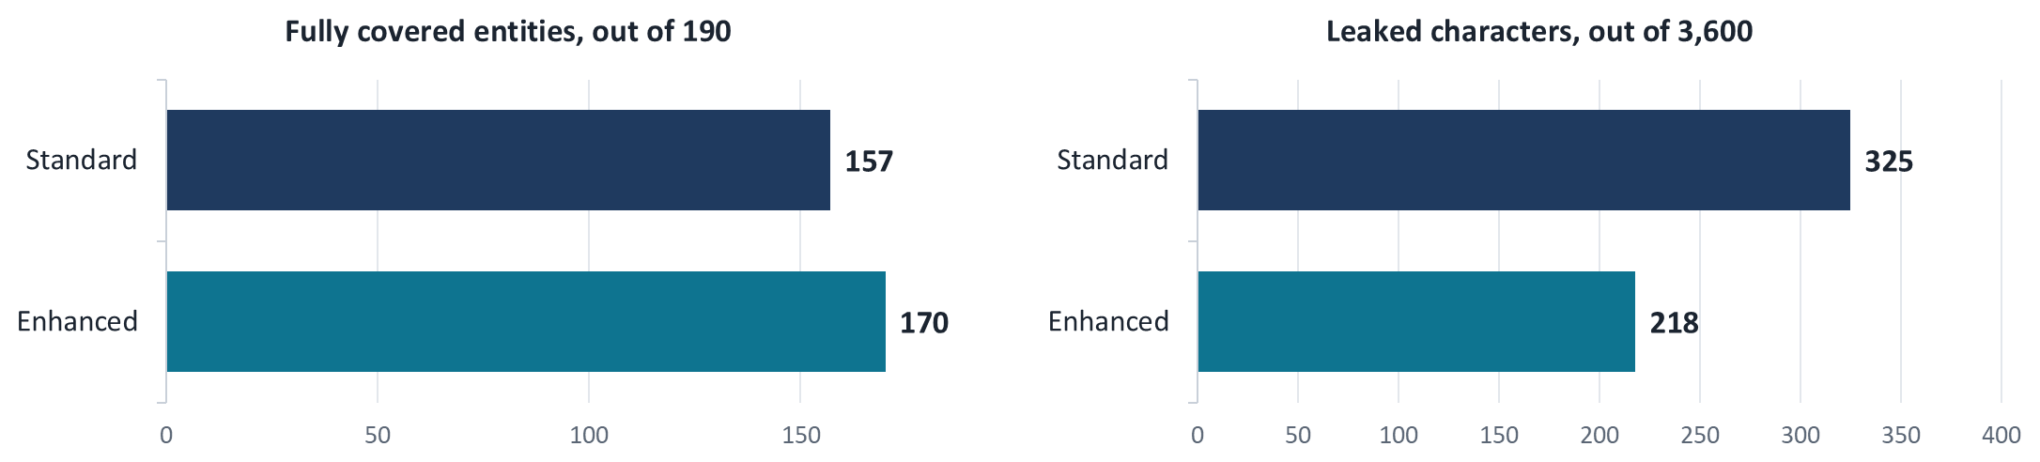
Figure 2. French challenge, G8R2 (code 930c414): fully covered entities and leaked characters before review, Standard and Enhanced.
Enhanced meets the four pre-registered criteria against Standard. The paired leakage difference, -0.029722 [-0.061759; -0.006485], excludes zero on this set. The paired coverage gain, 0.068421 [0.000000; 0.166667], touches zero: no significant coverage gain is claimed. Before review, 33 entities with Standard and 20 with Enhanced remain at least partly exposed. This challenge was already known when G8R2 ran, so it is not a new blind validation.

5.5 C3 French and English blind sets (historical, code e3d13bd)
Language and profile | Partial precision | Fully covered | Leaked characters
French Standard | 0.8922 | 95/105 | 139/2042
French Enhanced | 0.8824 | 96/105 | 130/2042
English Standard | 0.8349 | 78/100 | 235/2285
English Enhanced | 0.7000 | 88/100 | 115/2285

Source: D-G8-1 and results/gate8/report.md.
English Enhanced protects more characters, but its precision loss of 0.1349 exceeds the 0.02 margin: it is experimental and not recommended. English Standard leaves content exposed in all eight documents and remains experimental with strong reservations. No complete bilingual validation exists and no figure guarantees zero leakage.

5.6 Limits of the evaluation
The corpora are small, fictitious and written by few authors, often from the same model family, so styles may be correlated. The intervals are conditional on the corpus and the threshold; they do not measure author bias. Character coverage does not judge re-identification by context. The final-check alerts are reported separately and reduce no leakage unless a human masks the value.

6. Course concepts applied
Concept | How HuisClos applies it | Where it is visible
Asymmetric cost | F2 chooses the threshold; lowest threshold at a tie | Threshold setting, default 0.30; "Low confidence" card in Review
Human in the loop | No proposal accepted by default; keep, reject, retype or add | Review step and its decision table
Hybrid system | Keys and patterns plus statistical models plus heuristics | Source column in Review (checksum, pattern, heuristic, ner_spacy)
Transfer | Published pretrained models reused without project training | Document language and profile settings
Measurement | Held-out sets, ablations, bootstrap intervals | Evaluation page, linked from Method & limits

The ablation shows why the system is hybrid. On the G7 challenge, patterns alone reach recall 0.6947, the spaCy model alone 0.4579, and their combination with propagation 0.8421 (source: results/summary.md).
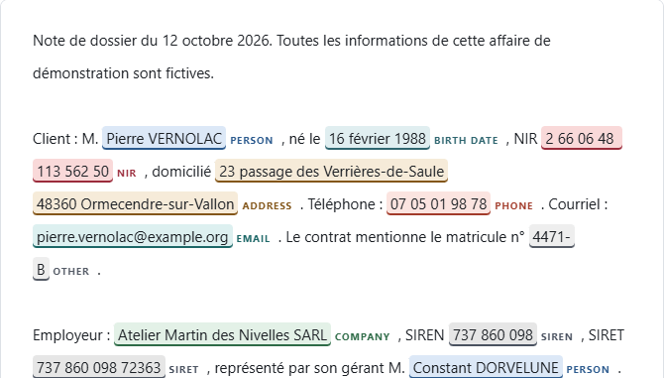
Figure 3. Review step on the fictitious sample case: every value carries a colour and a written type.

7. Beyond the course
- Optional local models. CamemBERT for French and GLiNER for English, pinned to immutable revisions and file hashes, loaded offline from a prepared folder (D-AF-A4-6).
- Overlapping windows. CamemBERT reads 510-token windows with a 64-token overlap, so a mention near a cut is seen whole by one window (D-AF-A1-2); GLiNER uses 256-token windows and checks its full prompt against the native 512 limit after a silent truncation was found (D-AF-A4-7).
- Unicode projection. Invisible characters, ligatures and typographic spaces are normalised in an analysis view; every span is projected back onto the original text, which is never modified (D-AF-A2-5).
- Grouping. Mentions of one entity share a token; in doubt a new group is created.
- Tolerant restoration. Altered tokens are restored without touching ordinary words.
- Case memory. A mapping table from an earlier document keeps tokens stable across a case (D-S24-2), with a known limit when a name also appears in a file name (D-FIX3-2).
- Two-segment check. The exact outgoing string is checked, instruction included.
- Revoked authorisation. Any edit after the check revokes the user's confirmation; the send function recomputes it in Python before sending (D-AF-A3-4).
- Paired bootstrap. Profiles are compared on the same document draws (D-AF-B1-3).
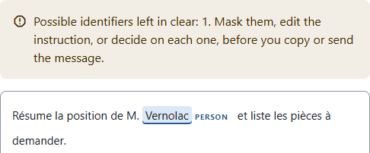
Figure 4. Final check: a surname left in the instruction raises an alert; nothing is masked automatically.

8. Limits and ethics
- Omissions. Values are missed, especially in English and in unusual formats.
- Context. A rare job title, a small town and a date can identify a person.
- File quality. No OCR; mixed PDFs and unsupported DOCX structures can import partially.
- Synthetic bias. Fictitious corpora may be easier than real files.
- False positives. Ordinary words are sometimes masked; the human rejects them.
- The table. Whoever holds the mapping table can re-identify the text.
- Responsibility. The lawyer remains responsible for what is sent.
- English. Standard English carries strong reservations; English Enhanced is not recommended.
- Demo. The public demo runs on the host's server and accepts fictitious data only.
- Token continuity. A person can receive a new token in a later document (D-FIX3-2).

9. Value if widely used
If the tool were widely used, the hypotheses are qualitative: fewer raw files pasted into external services, consistent tokens instead of ad hoc redaction, and a recorded review. Review has a cost: every detection must be read, and the final check can raise false alerts. Whether the net effect saves time is unknown. A timed study with real users on realistic, non-sensitive files is still needed. HuisClos guarantees neither a productivity gain nor legal compliance.

10. Reproducibility
Ordinary local use (from the user guide), Python 3.12 required:
- Windows: python -m venv .venv, then .venv\Scripts\python.exe -m pip install -r requirements.txt, then .venv\Scripts\python.exe -m streamlit run streamlit_app.py --server.address localhost.
- macOS: python3.12 -m venv .venv, then .venv/bin/python -m pip install -r requirements.txt, then .venv/bin/python -m streamlit run streamlit_app.py --server.address localhost.
- Toolkit: START_HERE.md launchers for Windows and macOS.
Optional models are prepared outside the application with scripts/prepare_local_models.py, then HUISCLOS_MODELS_DIR points to that folder; the application never downloads a model (LOCAL_MODELS.md).
Ordinary checks: PY -m pytest -q, PY -m ruff check ., PY -m ruff format --check . and PY scripts/check_style.py, where PY is the environment's Python. Development evaluation: PY scripts/run_evaluation.py --split dev. Reserved evaluation on test, challenge or C3 is a different matter: it requires a gate session and its explicit authorisation, a registration written before the run and a single attempt. These commands are documented here, not run by this session.

11. Use of AI tools
The prompt log PROMPTS.md records every prompt given to an AI tool. Observed uses:
- Claude (claude.ai, Opus 5.5) produced the master plan from the planning prompt.
- Claude Code (Opus 5.5, Sonnet 5.5, Haiku 5.5) and Codex (GPT-6, or model not exposed) ran the development, gate and documentation sessions, each with a verbatim or referenced prompt.
- The same agents wrote the fictitious corpora (prompts in docs/prompts/).
- Humans pasted prompts, reviewed code and took decisions; independent gates used a different model family where possible.
The demonstration video is entrusted to a classmate. It is planned to be produced entirely with AI tools and a synthetic voice (video plan). It is not produced yet; its tools and final result will be credited when it is delivered.

12. References
Project files:
- README.md, USER_GUIDE.md, LOCAL_MODELS.md, ARCHITECTURE.md
- DECISIONS.md, in French: D-07, D-09, D-10, D-12, D-13, D-S24-2, D-S24-3, D-AF-A2-5, D-AF-A3-3 to D-AF-A3-5, D-G7-1, D-G8-1, D-FIX2-1, D-FIX3-1, D-FIX3-2, D-FIX4-1, D-G8R2-1, D-R8-1
- POST_G7_PROTOCOL.md, in French
- results/summary.md, results/challenge_comparison.md
- results/gate8/report.md, results/gate8-recheck/report.md, results/gate8-resume/report.md, results/recette8/report.md
- PROMPTS.md
Primary legal sources:
- Regulation (EU) 2016/679 (GDPR), articles 4(5), 5(1)(c), 32 and recital 26: https://eur-lex.europa.eu/eli/reg/2016/679/oj
- Law no. 71-1130 of 31 December 1971, article 66-5, and French Penal Code, article 226-13: https://www.legifrance.gouv.fr

