“Golden Leaf Spa” is a small luxurious spa with different services: different types of massage, outdoor and indoor pool, jacuzzi, sauna, salt room, floating tub, outdoor area and small caffe.
✅ build an application to manage everything about the spa: bookings, services and guests
✅ build the API using Postgres
👉 need a customer-facing website where guests can learn about the spa, browse all services, reserve a spot, and create and update their profile
👉 Updating data in the internal app should update the website, so we use the same DB and API
👨💼 PROJECT REQUIREMENTS FROM THE BUSINESS UI
👉 Users of the app are potential guests and actual guests
👉 Guests should be able to learn all about Abi spa
👉 Guests should be able to get information about each service and see booked dates 👉 Guests should be able to filter services by their maximum guest capacity
👉 Guests should be able to reserve a cabin for a certain date range
👉 Reservations are not paid online. Payments will be made at the property upon arrival. Therefore, new reservations should be set to “unconfirmed” (booked but not yet checked in)
👉 Guests should be able to view all their past and future reservations
👉 Guests should be able to update or delete a reservation
👉 Guests need to sign up and log in before they can reserve a cabin and perform any operation
👉 On sign up, each guest should get a profile in the DB
👉 Guests should be able to set and update basic data about their profile to make check-in at the hotel faster

PROJECT REQUIREMENTS FROM THE BUSINESS (employee’s dashboard)
👉 Users of the app are spa employees. They need to be logged into the application to perform tasks
👉 New users can only be signed up inside the applications (to guarantee that only actual spa employees can get accounts)
👉 Users should be able to upload an avatar, and change their name and password
👉 App needs a table view with all services, showing the services’ photo, name, capacity, price, and current discount
👉 Users should be able to update or delete a service, and to create new service (including uploading a photo)
👉 App needs a table view with all bookings, showing arrival and departure dates, status, and paid amount, as well as service and spot and guest data
👉 The booking status can be “unconfirmed” (booked but not yet checked in), “checked in”, or “checked out”. The table should be filterable by this important status
👉 Other booking data includes number of guests, number of hours, guest observations, whether they booked services, services’ price
👉 Users should be able to delete, check in, or check out a booking as the guest arrives (no editing necessary for now)
👉 Bookings may not have been paid yet on guest arrival. Therefore, on check in, users need to accept payment (outside the app), and then confirm that payment has been received (inside the app)
👉 On check in, the guest should have the ability to add service for the entire stay, if they hadn’t already
👉 Guest data should contain full name, email, national ID, nationality, and a country flag for easy identification
👉 The initial app screen should be a dashboard, to display important information for the last 7, 30, or 90 days:
👉 A list of guests checking in and out on the current day. Users should be able to perform these tasks from here
👉 Statistics on recent bookings, sales, check ins, and occupancy rate
👉 A chart showing all daily spa sales, showing both “total” sales and “extras” sales
👉 A chart showing statistics on stay durations, as this is an important metric for the spa
👉 Users should be able to define a few application-wide settings: service price, min and max hours/booking, max guests/booking
👉 App needs a dark mode

Technology decisions:
React Router
Styled components
React Query
Content API
React Hook Form
Postgres/ prisma/ express.js
React icons/React hot toast/ Rechart/ date-fns

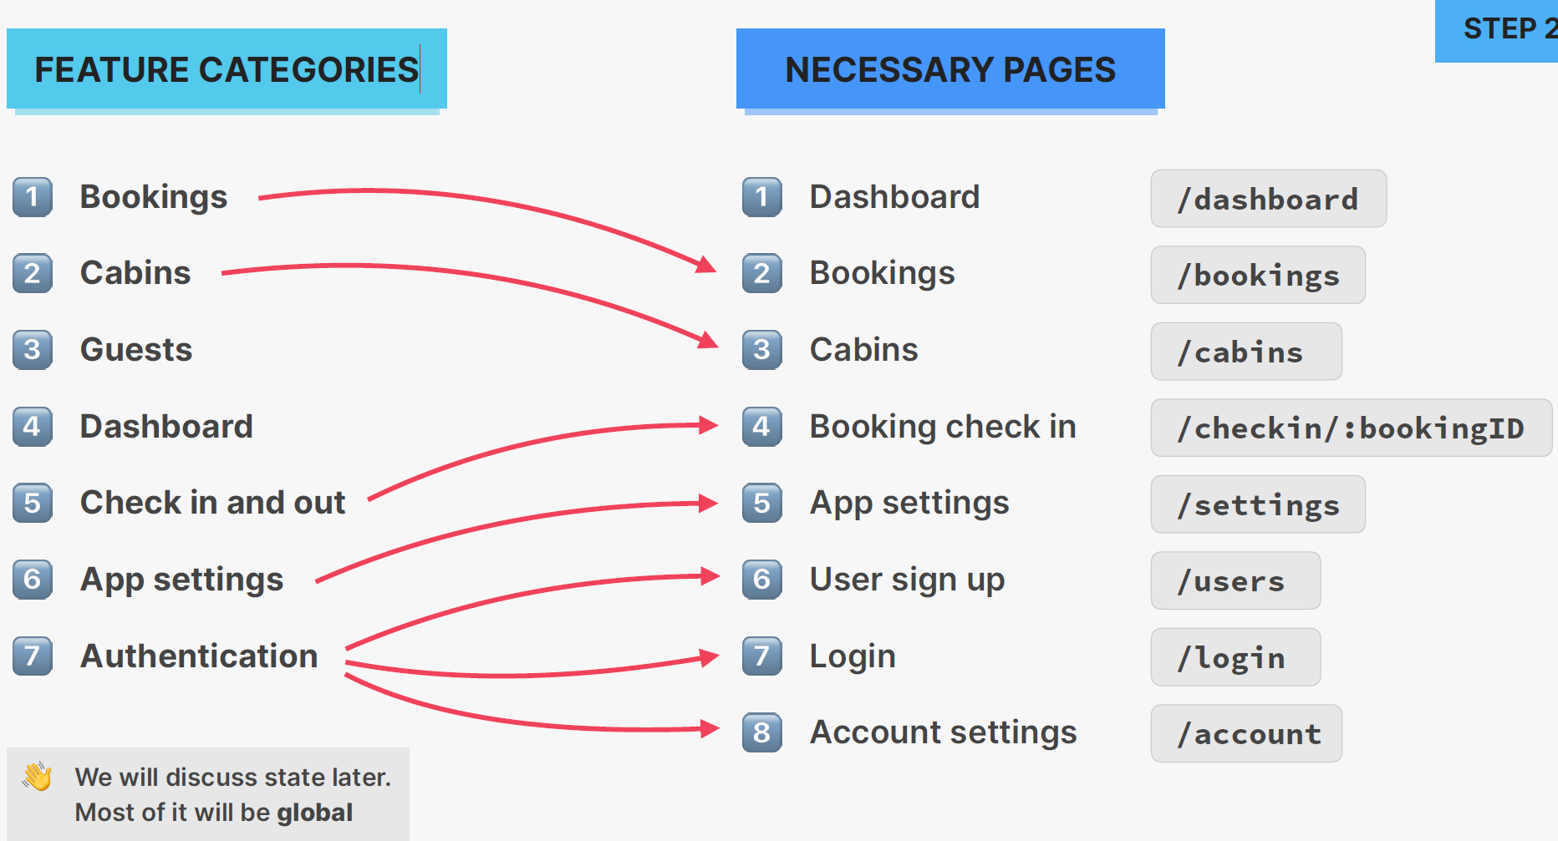
services
/services
services

