Poster Abstracts
9th Annual UW-Madison Postdoctoral Research Symposium
Organized by the UW-Madison Postdoctoral Association
Monday September 16th, 2024

Poster #1
Title: Design and application of small molecules for the interception of quorum sensing in Staphylococcus aureus
Authors: Clay, A.P.; Polaske, T.J.P.; Blackwell, H.E.B.
Presenter: Alyssa Clay; Chemistry
Abstract: Quorum sensing (QS) is the process by which bacteria of the same species coordinate behavior, including virulence, at a high population density. The accessory gene regulator (agr) QS system found in the Gram-positive pathogen Staphylococcus aureus uses agr to regulate an arsenal of toxins and biofilm formation. Small molecules that inhibit agr QS have the potential to be used as therapeutics to combat S. aureus infection. Previous small molecules that have been reported to inhibit agr QS suffer from low potencies, poorly characterized mechanisms of action, and/or associated toxicities that render them impractical for use as chemical probes. We have developed a new class of small molecule agr inhibitors, and are studying their biochemical mechanisms of agr inhibition. I have designed a new synthetic route to the core structure of a best-in-class small molecule inhibitor, which is the most potent small molecule inhibitor of S. aureus agr QS to date. This synthesis enables facile functional group variation for the delineation of structure activity relationship analyses to improve compound potency, membrane permeability, solubility, and stability. Characterization of the mechanism of agr inhibition by this new small molecule scaffold is currently underway. Almost all known agr inhibitors target autoinducer (AIP) binding to the transmembrane histidine kinase AgrC or intracellular response regulator AgrA:DNA binding. Elucidating the mechanisms of agr inhibition by these new small molecules may provide access to chemical probes that target other components of the agr QS system. It has been demonstrated that the best-in-class small molecule inhibitor is a competitive inhibitor of AIP:AgrC binding, although the exact mechanism of inhibition remains unknown.

Poster #2
Title: Effects of Psychosocial Stress on Laryngeal Biology: Implications for how our Voice sounds
Authors: Anumitha Venkatraman, Katelyn Jacobs, John Binns, Susan Thibeault
Presenter: Anumitha Venkatraman; Surgery/Otolaryngology Head and Neck
Abstract: Background: Psychosocial stress and voice production are inextricably linked. Psychosocial stress can change the pitch/intensity of our voice, or cause significant muscle tension in the throat (causing hoarseness). However, the biological relationship between stress and the voice is unknown. Objective: To shed light on the cellular and microbiological mechanisms of stress in the larynx (voice box). Three targeted mechanisms were studied: 1) How stress affects the laryngeal microbiota? Stress is known to play a role in gut dysbiosis, thereby regulating changes in social behavior via the microbial gut-brain axis. If replicated in the larynx, it may provide a biological basis for stress-induced voice changes found in anecdotal evidence. 2) How stress affects vocal fold epithelial integrity? Stress-altered decreases in intestinal epithelial barrier integrity leads to inflammation and increases infection risk. If replicated in the larynx, it could increase susceptibility to environmental (pollutants), or systemic (acid reflux) elements. 3) How stress affects laryngeal sensory mechanisms? Stress is reported in chronic cough. If stress alters laryngeal sensory mechanisms, it could lead to increased laryngeal hypersensitivity associated with chronic cough. Methods: 16S rRNAseq, qPCR, immunofluorescence were employed in stressed and unstressed C56BL/7 mice (N=108 total) Results/Discussion: 1) Stress results in laryngeal dysbiosis (characterized by changes in alpha, beta diversity). Within genera-specific changes, there was an increase in pathogenic-bacteria Streptococcus, decrease in Corynebacterium. 2) Stress results in decreased epithelial barrier integrity; increased gene expression of inflammatory cytokines, decreased protein expression of mucins, tight junctions, indicating stress-induced increase in laryngeal susceptibility to noxious elements. 3) Stress alters gene and protein expression of laryngeal sensory receptors, indicating potential for increased laryngeal hypersensitivity. Takeaways: There is a biological basis for the relationship between stress and voice production via different cellular and microbial mechanisms. Future research can relate stress-related voice symptomology to biological underpinnings in the larynx.
[Graphical Abstract Below]

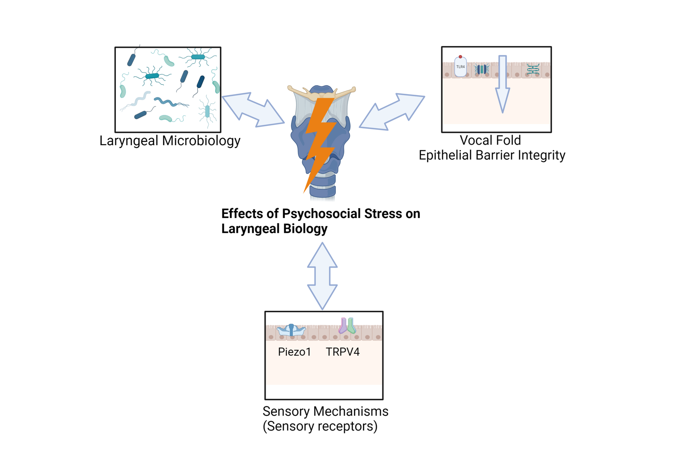

Poster #3
Title: Designing Autonomous, Conversational Robots to Support Remote Space Exploration
Authors: Yaxin Hu, Arissa J. Sato, Jingxin Du, Pragathi Praveena, Bilge Mutlu (*authors of equal contribution)
Presenter: Arissa Sato; Department of Computer Sciences
Abstract: In this work, we explore how AI-enabled conversational capabilities on a mobile robot can facilitate exploration of a remote space. We prototyped a robot system that enables users to navigate, ask questions about, and receive recommendations for ways to experience a remote environment. We deployed our prototype to provide a remote tour of a geology museum and asked 11 remote participants to use the robot. The study uncovered user patterns that point to design considerations for the user’s remote experience with exhibits; their thoughts on the social space provided via the robot; the robot’s ability to suggest and navigate touring routes for users; and suggestions on how to design and convey the robot’s knowledge, manners, and behavior. Our work highlights the potential for autonomous, conversation capabilities to provide users with rich remote experiences and offers design guidelines on these robots.

Poster #4
Title: Assessing Nitrogen Mineralization/Immobilization in Grass and Grass-Legume Pasture Systems
Authors: Beatriz E. Bizzuti; José C.B. Dubeux; Kevin R. Trumpp; Flavia F. Simili; Luana M. D. Queiroz; Martin Ruiz-Moreno; Igor L. Bretas; Javier A. Portuguez; Mario de A. L. Junior; Marta M. Kohmann
Presenter: Beatriz Bizzuti; UW Department of Plant and Agroecosystem Sciences
Abstract: Nitrogen (N) is an important nutrient for biomass production in grass-based pastures, but inadequate management of N-based fertilizer (e.g. excessive use) can lead to soil and water contamination via inorganic N leaching, particularly in sandy soils. Integrating legumes such as rhizome perennial peanut (Arachis glabrata Benth.) into grass-based pastures offers a source of N through biological fixation, reducing the need for N fertilizer application. This study investigates the dynamics of soil inorganic N and N mineralization/immobilization in 8-yr-old pasture systems. The soil at the experimental site was classified as Orangeburg loamy sand, and soil samples were collected (0-10 cm depth) from three grazing systems: ´Argentine´ bahiagrass (Paspalum notatum Flugge) with higher N fertilizer application (224 kg N ha-1 year-1) overseeded in the fall with a mixture of ‘RAM’’ oat (Avena sativa L.) and ‘Prine’ ryegrass (Lolium multiflorum Lam.) (BGN), grass overseeded in the fall with a similar ryegrass-oat mixture described above, combined with a mixture of clovers (Trifolium spp.) plus 34 kg N ha-1 year-1 (BG), and grass/rhizoma peanut mixture overseeded in the fall with the same mixture as BG plus 34 kg N ha-1 year-1 (BGRP). 50 grams of soil were weighed in a container (50 mL capacity), wetted at 50% water-filled pore space, placed in a 1-L canning jar with a water vial to maintain humidity, and incubated for 24 days in a dark room at 25ºC. N stock, inorganic N, mineralization/immobilization, and nitrification were evaluated. BGN had greater N stock compared to BGRP (0.21 and 0.14 Mg ha-1, respectively; p = 0.025). For nitrification and nitrate concentrations BGN also had greater values (59 and 64 mg N Kg-1 soil, respectively) compared to BGRP (39 and 43 mg N Kg-1 soil, respectively). This study demonstrates that over the long term, the bahiagrass/rhizome peanut mixture had lower N stocks compared to bahiagrass with N fertilizer, but achieved an 85% reduction in nitrogen fertilizer use, and had lower chances of nitrate leaching, resulting in a more sustainable option.

Poster #5
Title: Machine Learning for Data Integrity: Validating Rural Property Identities in the Brazilian Amazon to End Deforestation
Authors: Cainã M. Couto-Silva, Matthew Christie, Lisa Rausch, Holly K. Gibbs
Presenter: Cainã Max Couto da Silva; Department of Geography
Abstract: Brazil continues to have the world’s highest rates of deforestation and most efforts aiming to address this focus on individual properties and producers. Over the last 15 years, we have focussed on addressing deforestation in cattle supply chains by collecting and integrating land use, sales, and environmental data about these properties from multiple sources. This is challenging due to the variations in names and attributes for the same rural property across different data sources, which led us to implement a matching algorithm that labels observations referring to the same property, assigning each group a unique property group identifier (PGI). However, given the large amount of data (> 15 million records and >3 million PGIs), there has been no easy way to validate the data integrity of PGIs to date. To address this, we aimed to train a classifier using machine learning to predict whether a PGI is ill-formed or not (i.e., whether or not all properties labeled to the same PGI refer to the exact property unit), enabling us to validate the integrity of PGIs quickly and reliably. Based on domain knowledge and manual inspection, we annotated the labels for 100 representative PGIs using a stratified random sampling approach, stratifying by PGI group size. As part of our data pipeline, we prepared the modeling data by aggregating the property data into a PGI-granularity level, computing custom and descriptive statistics as features for each attribute. Additionally, as part of our feature-engineering process, we’ve applied DBSCAN to calculate the distinct count of property clusters based on geolocation data. We’ve used the annotated labels and prepared features to train rule-based and machine-learning models to predict our target. We validated the model using cross-validation and bootstrapping. We chose a Catboost model tuned to deal with unbalanced targets as our final model since it outperformed our baseline models, reaching an average of 91% accuracy, 83% recall, and 84% precision. We have also developed a web app to inspect raw and aggregated data, red flags, and geolocation maps for each target PGI.

Poster #6
Title: Microbial investigations of coral algal symbionts exposed to stony coral tissue loss disease reveal unseen diversity
Authors: Charlotte E. Ford, Christopher D. Dunn, Caroline Dennison, Andrew Baker, Richard Karp and Tony L. Goldberg
Presenter: Charlotte Ford; Pathbiological sciences
Abstract: Stony coral tissue loss disease (SCTLD) affects scleractinian (stony) corals (order Scleractinia), causing a rapid onset of tissue loss which can result in complete colony mortality over a timescale of months. It is estimated that at least 22 stony coral species are affected by SCTLD. SCTLD was first observed off the coast of Miami, Florida in 2014 and has since spread to reefs in 30 countries/territories across the Caribbean. The etiological agent of SCTLD has not yet been identified but is believed to be infectious. Recent research suggests that algal symbionts may be among the first to show signs of disruption which then leads to rapid degradation of coral tissues. Our aim was to identify an infectious agent(s) which could have a role in the etiology of SCTLD. We investigated the microbial composition of cultured symbiodinium dinoflagellates (family Symbiodiniaceae; n=12) experimentally exposed to SCTLD. Breviolum minitum, Durusdinium trenchii and Cladocopium goreaui were exposed to unfiltered or filtered (0.2ÔÅ≠m) water from a prior SCTLD infection and sampled before exposure, pre-disease and during disease. We performed metagenomic sequencing for virus discovery and 16S ribosomal RNA sequencing (V4 region) for microbiome analysis. Bacterial composition differed significantly between symbiont species (p = 0.0348) but not treatment group. Overall viral diversity was dominated by bacteriophage (72%), with diversity most affected by symbiont species (p = <0.0001) and treatment group (p = 0.01253). We identified 36 novel viruses in this study; 10 were found to be present only in the symbiodinium exposed to SCTLD. No virus or bacteria were found to be significantly enriched in samples exhibiting disease or indeed those exposed to SCTLD. Whilst no single pathogen was associated with SCTLD, novel microbial diversity within coral algal symbionts described in this study will be valuable for future studies.

Poster #7
Title: RNAseq reveals distinct mechanosensitive landscape underlying arrhythmogenicity of the superior vena cava
Authors: Turner DGP, Egorov YuV, Glukhov AV
Presenter: Daniel Turner; Medicine
Abstract: Atrial fibrillation (AF) is the most common heart rhythm disorder and increases the risk of death. AF arises from aberrant ion channel activity, which alters cardiac electrophysiology and induces arrhythmic irregular heartbeats. AF often occurs during hypertension and importantly, arises from discrete vulnerable regions of the atria located near veins where blood enters the heart, including the superior vena cava (SVC). However, the cellular and molecular mechanisms that render these regions more susceptible to arrythmia is poorly understood. To determine molecular mechanisms of region-specific mechanosensitivity and hypertension-induced pathological remodeling, we utilized bulk RNA-sequencing of 12-months-old normotensive (n=4) and spontaneously hypertensive (n=4) rat SVC and RA tissue samples to compare expression of >10,000 mRNAs. Region-specific and hypertension-induced differences were linked to signaling pathways relevant to cardiac electrophysiology, contraction, and mechanosensitivity. First, we found significantly altered expressions of 11 mechanosensitive ion channels in the SVC, some of which are implicated in cardiac arrythmia including KCNMA1 and TRPV4. Secondly, in the SVC we found 22 significantly altered mRNA expressions that may affect cardiac contraction and alter ion channel activity, such as PKA- and SERCA-associated mRNAs. Lastly, we observed that 23 mRNA related to fibrosis were significantly changed in the SVC including various collagen mRNAs. As changes in the extracellular matrix could affect the stiffness and thus mechano-sensitivity of the heart, these fibrotic changes may increase the hypersensitivity of the SVC to mechanical stretch during hypertension as observed in electrophysiological studies. In both hypertensive SVC and RA, we observed changes in mechanosensitive, cytoskeletal, and inflammatory mRNA expression but less than hypothesized. We suspect that altered protein activity and/or post-translational modifications may play a more important role in mediating hypertension-induced arrhythmogenesis in the SVC. In conclusion, our RNA-sequencing data confirms that the SVC has significantly different expressions of various mechano-responsive mRNA, compared to RA, which may underly the hypersensitivity of the SVC to mechanical stretch and arrythmia generation.

Poster #8
Title: Effects of NREM sleep on the cortical synaptic expression of GluA1-containing AMPA receptors
Authors: Fabio Squarcio, Giulio Tononi, Chiara Cirelli
Presenter: Fabio Squarcio; Department of PsychiatryAbstract: A net increase in synaptic strength accrues in many synapses during wakefulness as the inevitable consequence of ongoing learning. However, to avoid saturation and keep energy costs under control, the wake-related synaptic strengthening needs to be corrected via a broad but selective process of synaptic weakening. Sleep seems to promote this net decrease in excitatory synaptic strength. Nonetheless, several outstanding questions about sleep-dependent synaptic weakening remain. A major unresolved question relates to whether non-rapid eye movement (NREM) sleep and rapid eye movement (REM) sleep play specific roles in sleep-dependent synaptic weakening. Another unresolved question is whether a few hours of recovery sleep following acute sleep deprivation are sufficient to bring net synaptic strength back to baseline levels. In order to address these questions, we used two established molecular markers of synaptic strength, the levels of the AMPA (Alpha-Amino-3-Hydroxy-5-Methyl-4-Isoxazole Propionic Acid) receptors containing the GluA1 subunit, and the phosphorylation of GluA1 at serine 845 (p-GluA1(845)). We measured changes of these two markers in synaptosomes of mouse cortex (one hemisphere), using the following 4 experimental conditions (8 C57BL/B6 mice per condition, 14-15 weeks old of both sexes): sleep (5 hours), sleep deprivation (5 hours, with novel objects), recovery sleep (5 hours) after sleep deprivation (5 hours), and REM sleep deprivation (5 hours). Finally, we also tested whether sleep-dependent synaptic weakening is affected by aging. For this experiment we used aged mice (85-86 weeks old) assigned to 3 experimental conditions: sleep, sleep deprivation and recovery sleep after sleep deprivation (4 male mice per condition). We found that the renormalization of GluA1 and p-GluA1(845) expression seems to crucially rely on NREM sleep and can occur in a few hours of sleep after acute sleep deprivation. Moreover, this process seems to be unaffected by aging.

Poster #9
Title: Analysis of Swallowing Dysfunction: Insights from Ts65Dn and Df(17)2 Mouse Models of Down Syndrome
Authors: Gaurav Singhal, Erin H Fisher, Tiffany J Glass, Nadine Connor, Department of Surgery, Division of Otolaryngology - Head & Neck Surgery, University of Wisconsin, Madison, USA
Presenter: Gaurav Singhal; Surgery
Abstract: Introduction: Down syndrome (DS) is characterized by significant swallowing challenges1, 2. We investigate swallowing dysfunctions using Videofluoroscopic Swallow Study (VFSS) in Ts65Dn and Df(17)2 mice3. Ts65Dn mice, with partial trisomy comprising portions of mouse chromosomes 16 and 17, are commonly used in DS research and exhibit significant swallowing phenotypes. The Df(17)2 model, with a specific deletion on chromosome 17, helps isolate genetic regions implicated in Ts65Dn phenotypes. Slow weight gain is frequently regarded clinically as symptom of feeding difficulties in children with DS4, and therefore early postnatal body weights can be used as a measure to evaluate mouse models for the presence of developmental feeding disorders. Here, we hypothesized that the Df(17)2 deletion would impair feeding ability leading to lower body weights compared to euploid controls at an early age. Methods: We conducted the preliminary analysis of postnatal body weights (grams) at 21 days (P21) and 22 days (P22) in Df(17)2 (n=8) and euploid (n=5) male mice to assess growth patterns. T-tests were used to identify statistically significant differences at &lt;0.05. Results: Body weights were not significantly different between P21 and P22 for both euploid and Df(17)2 mice. However, significant differences in body weights were observed between euploid and Df(17)2 mice at both P21 (p=0.0043) and P22 (p=0.0061). Conclusion: Df(17)2 deletion significantly impacted growth, potentially also affecting oral motor function and dysphagia that we plan to investigate using VFSS, with analyses of swallow rate (SR), interswallow interval (ISI), jaw excursion rate (JER), and jaw swallow cycle ratio (JSCR). Our previous research demonstrated that Ts65Dn mice exhibited significantly slower SR, longer ISI and more JER, which are all indicative of swallowing difficulties2, 5. Analyzing Df(17)2 mice for these measures will deepen our understanding of how specific genetic alterations influence swallowing dysfunctions. Acknowledgement: This work is supported by NIDCD R01DC019735, NICHD R01HD104640. References: 1 Zalzal, HG, et al., 2023 2 Glass, TJ, et al., 2024 3 Xing, Z, et al., 2016 4 Bull, MJ, et al., 2022 5 Glass, TJ, et al., 2019

Poster #10
Title: A cross-system functional comparison of primary succession in bacteria
Authors: Cagle, Grace A.; Bernardin, Jessica; Baiser, Benjamin; Bittleston, Leonora; Young, Erica; Gray, Sarah M.; Freedman, Zachary B.
Presenter: Grace Cagle; Soil and Environmental Sciences
Abstract: Primary succession is a dramatic example of functional change over time. Theory developed from plant ecology predicts that interspecific competition drives the replacement of weedy, fast-growing colonizers with slower-growing species, promoting the accumulation of carbon and nutrients often observed in mature ecosystems. But does primary succession in bacterial communities follow a similar trajectory? Identifying generalizable principles to describe microbial community function during primary succession will facilitate the development of a more holistic theory of ecological succession. We classified bacterial communities into trait-based groups and then determined how the abundances of these groups changed during primary succession. We hypothesized that three groups would best fit the data and that the groups’ abundances would change over time according to the availability of carbon, nutrient supplies, and accumulation of metabolic byproducts in the system. Data were obtained via a systematic review of metagenomics-based studies on primary succession in bacteria following the PRISMA protocol. The studies were screened for inclusion, and the functional potential of each metagenome was estimated from normalized gene copy numbers. Functional genes were selected a priori to represent each trait-based group. Additionally, we evaluated which traits contributed to sample groups classified using an unsupervised topic modeling approach on the full suite of functional genes. To determine how the abundances of the trait-based groups changed over time and across systems, their temporal trajectories were mapped on ternary plots and evaluated using random forest analysis. Initial results showed a consistent pattern in functional primary succession in systems with limited organic carbon, supporting the hypothesis that carbon availability is a predictive factor. These initial findings indicate bacterial life-history strategies change during primary succession and are associated with physiological trade-offs. Forthcoming results will reveal how the trajectories of ecological groups, and the traits that define them, differ across systems.

Poster #11
Title: Improved Monitoring of Alfalfa Yield and Quality from Multisource Optical and SAR Satellite Data: Ensuring the Security of Dairy Products
Authors: Jiang Chen, Zhou Zhang
Presenter: Jiang Chen; Department of Biological Systems Engineering
Abstract: Precision agriculture management and practices using satellite remote sensing images play an important role for monitoring crop growth under the context of climate change. Alfalfa is a vital forage crop for various livestock and widely distributed around the world. Satellite remote sensing has been broadly employed to monitor corn and soybean. However, unlike corn and soybean, alfalfa is usually monthly harvested and has a rapid regrowth stage, and thus its growth is difficult to describe using a traditional phenological curve. Limited by the availability of high spatio-temporal resolution images from single satellite, few studies devoted to monitoring fine-scale (e.g., <= 30-m) alfalfa growth using satellite images. Fusion of Landsat/Sentinel-2 optical and Sentinel-1 SAR images can enhance the resolution of satellite data. To form a unified optical and SAR image from multisource satellites, there are still four specific issues during satellite image fusion: (1) Landsat has no red edge band; (2) the effects of solar angles on optical data fusion have not been evaluated and corrected; (3) climate data have not been used for generating more accurate optical vegetation indices (VIs) from SAR data; (4) the feasibility of optical-based SAR fusion has not been explored. To address these issues, this study proposes a new multisource optical and SAR data fusion framework with Landsat-7/8, Sentinel-2, and Sentinel-1 satellites for monitoring fine-scale alfalfa growth. The data fusion framework includes three models, i.e., Landsat2Sentinel-2, SAR2Optical, and Optical2SAR. Using random forest (RF) algorithm and the known spectral bands, the Landsat2Sentinel-2 model improves Landsat-based red edge reflectance fusion (RMSE reduced 28.22-31.16%) compared to multiple linear regression (MLR). Furthermore, RMSE was reduced by 22.61-23.58% if considering solar angles in the fusion model. Compared to the traditional linear regression model, Landsat2Sentinel-2 model more accurately fuses Landsat and Sentinel-2 derived four surface VIs. The SAR2Optical model improves VIs fusion (RMSE reduced 32.18-34.59%) since climate data were considered. The Optical2SAR fusion model can accurately produce optical-based SAR data, demonstrating that optical and SAR satellite data can be reciprocally fused. Moreover, the developed data fusion models present improved performance for fusing optical data at both surface and top-of-atmosphere levels. On the other hand, the new methodological framework can be employed to develop a unified data fusion model across different crop types. Overall, this study proposes a new multisource optical and SAR data fusion framework which has great implications for ensuring the security of dairy products.

Poster #12
Title: Computational Discovery of Fast Interstitial Oxygen Conductors
Authors: Jun Meng, Md Sariful Sheikh, Ryan Jacobs, Jian Liu, William O. Nachlas, Xiangguo Li, Dane Morgan
Presenter: Jun Meng; Materials Science and Engineering
Abstract: Oxygen-active materials are crucial for a variety of applications such as solid-oxide fuel cells, gas sensors, catalysts, and oxygen separation membranes. Currently, the predominant families of oxygen-active materials used in commercial devices often diffuse oxygen via a vacancy mechanism (such as perovskites and fluorites), and only have adequate oxygen diffusivity and surface exchange at high temperatures (e.g., ~800 ˚C for fuel cells), resulting in high system cost and materials degradation. Interstitial oxygen conductors generally have lower migration barriers compared to vacancy conductors, which, in turn, can provide orders of magnitude kinetic enhancement at lower temperatures. In this work, we combined physically-motivated structure and property descriptors, ab initio simulations, and experiments to demonstrate an approach to discover new fast interstitial oxygen conductors.[1] We identified multiple new promising structural classes, and demonstrated the exceptional performance of one example material, La4Mn5Si4O22+𝜹 (LMS) with experimental validation. Experimental studies uncovered an interstitial oxygen content of δ=0.42 in as-synthesized LMS, as determined by electron probe micro-analyzer (EPMA) analysis. Ionic conductivity measurements demonstrate that LMS exhibits considerably higher conductivity than widely used commercial materials such as LSCF and YSZ, and comparable or improved conductivity compared to other known interstitial oxygen conductors. The fast oxygen ion conduction is attributed to the simultaneously active interstitial and interstitialcy diffusion pathways revealed by ab initio studies. Electrical conductivity relaxation (ECR) studies have shown that LMS has among the highest k_chem values at low temperatures of any known material, suggesting LMS has the potential to facilitate fast oxygen reduction kinetics, for example, by reducing area specific resistance in the air electrode of solid oxide cells for electricity or hydrogen production. LMS is just one member of multiple new families of promising fast interstitial oxygen conductors identified in this work, suggesting that many more materials exhibiting fast interstitial oxygen kinetics remain to be found. We show that all known interstitial oxygen conductors have two enabling features in common: (i) availability of electrons for oxygen reduction and (ii) structural flexibility enabling sufficient accessible volume. We propose that these are two essential features to effectively incorporate and diffuse interstitial oxygen, which provides guidance for future discovery and analysis of interstitial oxygen diffusing materials. [1] Meng, J., Sheikh, M.S., Jacobs, R. et al. Computational discovery of fast interstitial oxygen conductors. Nat. Mater. (2024). https://doi.org/10.1038/s41563-024-01919-8

Poster #13
Title: Discriminating Polar Ice Features: An Object-Based Classification Approach
Authors: Kavita Mitkari
Presenter: Kavita Mitkari; Space Science and Engineering Center
Abstract: Ice feature discrimination is an important component of the cryosphere studies. The ice type classification is needed for the scientific expedition for selecting the safer ship navigation route which provide least resistance. In this work, the effectiveness of object-based classification for discriminating various polar ice features using Landsat 8 Operational Land Imager (OLI) and Thermal Infrared Sensor (TIRS) data has been examined. The features considered are sea-ice, land-ice, open ocean, icebergs and exposed rocks in and around Indian Antarctic research station Bharati. Classification of various polar ice features using pixel-based classification from optical data faces challenges due to spectral similarity among polar ice features. To deal with this challenge, an object-based classification algorithm which takes into consideration spatial properties along with spectral properties has been developed. Due to non-availability of in-situ data, validation of results has been carried out by creating reference dataset using on-screen digitization.

Poster #14
Title: 2D IR of voltage gating in potassium ion channels
Authors: Kiera B Wilhelm, Matthew J Ryan, Kyle R Billings, Lujia Gao, Francis I Valiyaveetil, Alexei A Kananenka, Martin T Zanni
Presenter: Kiera Wilhelm; Chemistry
Abstract: Membrane proteins respond to the potential across cell membranes to regulate many basic cellular functions. One quintessential class of these proteins, voltage-gated potassium ion channels (Kv), regulates potassium ion efflux to reestablish the resting potential of cells after membrane depolarization. Kv channels contain a voltage-sensing domain (VSD) that senses local membrane potential and drives a conformational change to regulate opening and closing of the pore domain. While there exist many high-resolution structures of Kv channels in depolarized states, new methods are needed to experimentally probe Kv structure under applied potentials and to map the mechanism of voltage gating. We have recently developed a new means of investigating structural dynamics of membrane proteins under an electric field using surface-enhanced two-dimensional infrared (2D IR) spectroscopy. Using residue-specific, environmentally-sensitive cyano-tags, we probe voltage-dependent structural changes between the hyperpolarized and depolarized states of the VSD of the model archaeal channel KvAP. Steered molecular dynamics simulations of membrane-embedded KvAP VSD under a series of transmembrane potentials, using the crystal structure of KvAP VSD in its depolarized state as the starting structure, are used to interpret spectral features. Further work developing transient 2D IR to time-resolve the gating motion in response to a rapid voltage pulse will be discussed. By investigating protein structural dynamics under the influence of an electric field, our 2D IR measurements connect classical electrophysiology techniques that measure current with structural biology techniques that provide structure. This method can be extended to broadly study protein structure and dynamics at cellular resting potentials.

Poster #15
Title: Strategies and Challenges For Engaging Latine Older Adults in Physical Activity in Wisconsin
Authors: Laura Prieto, Kristen Pickett, Luis Columna
Presenter: Laura Prieto; Kinesiology/ Family Medicine & Community Health
Abstract: Participation in physical activity (PA) can reduce the risk of disability, maintain quality of life, and promote independence for older adults. Facilitators to PA participation for older adults include having community leaders facilitate evidence-based programming at senior centers and health care professionals recommending PA. Yet, racial and ethnic disparities still persist with Latine older adults reporting lower levels of PA than white older adults. Thus, the purpose of this descriptive qualitative study was to describe the experiences of senior center staff, program instructors, community health workers, and health care professionals in engaging Latine older adults in PA. Senior center staff and community health workers (n = 11) and health care professionals ( n = 6 ) working in the state of Wisconsin were purposively recruited for this study. Data were collected using demographic questionnaires and semi-structured interviews, which were transcribed and analyzed using thematic line-by-line analysis (Braun & Clarke, 2021). Three themes were constructed from the data, (a) Creando Confianza (Creating Trust), (b) Meeting Latino Older Adults Where They Are, and (c) Make it or Break it: The Contrasting Levels of Institutional Support. Facilitators to PA included connecting with the Latine members outside of community programs, hosting PA programs at familiar geographical locations, and progressing PA based on health needs. Barriers to PA included not knowing how to individualize PA recommendations, lack of administrative support, and lack of adequate transportation. Findings inform strategies to improve reach and adoption of a future PA intervention for Latine older adults.

Poster #16
Title: AI-based cattle detection tracing illegal ranching activities in the Amazon
Authors: Leonie Hodel, Amintas Brandão, Matt Christie, Jacob Munger, Lisa Rausch, Holly Gibbs,
Presenter: Leonie Hodel; Nelson Institute for Environmental Studies, SAGE
Abstract: The Brazilian Amazon, the world’s largest rainforest and a vital biodiversity hotspot, is under severe threat from deforestation, fires, and environmental degradation. Protected Areas and Indigenous Lands are essential for both conservation and the sustenance of Indigenous and local communities. In recent years, illegal deforestation within these Protected Areas has surged dramatically. Cattle ranching, a major driver of deforestation in the Amazon, has been challenging to monitor due to difficulties in tracking the precise locations of cattle production. Utilizing recent advances in AI-based image analysis and very high-resolution satellite imagery, we have developed a convolutional neural network model that detects and counts individual cattle from satellite data. This technology offers unprecedented insights into cattle production which has been undocumented in official systems, particularly encroachment processes into Protected Areas. Our analysis reveals a high density of cattle inside Protected Areas near the borders. Through linking those detected cattle herds to adjacent farms and analyzing the cattle sales using the Brazilian cattle transaction database we expose practices of cattle laundering within the beef production system. This research is crucial for identifying hotspots of cattle encroachments and weaknesses in the beef supply chain, thereby aiding efforts to foster sustainable production practices in the region.

Poster #17
Title: Unraveling the mystery of β-1,6-glucan synthesis in Cryptococcus neoformans
Authors: Liza Loza, Thomas Hurtaux, Elizabeth Gaylord, Tamara Doering
Presenter: Liza Loza; Genetics
Abstract: The fungal cell wall (CW) protects the cell from external stressors, including heat, salt, pH changes, and nitrosative and oxidative stress. This complex structure is composed of interconnected glycans including chitin, variably linked glucans, and mannan. In pathogenic fungi, defects in CW synthesis often result in loss of thermotolerance and hence virulence. Echinocandin drugs, which target β-1,3-glucan synthesis, exploit this weakness. Despite the obvious importance of the CW to fungal survival in the host, many basic questions remain about its synthesis. β-1,6-glucan is the predominant glucan species in the CW of the pathogenic yeast Cryptococcus neoformans and is critical for connecting other CW glycans to each other. While some cryptococcal proteins are known to affect β-1,6-glucan abundance, the actual synthet-ic machinery has never been identified. We have identified a candidate gene whose product, a putative in-verting glycosyltransferase, may participate in β-1,6-glucan synthesis. The corresponding deletion mutant is sensitive to temperature and Congo red pigment in vitro. Consistent with a loss of thermotolerance, it is avirulent in a mouse model of infection. Enzymatic analysis of mutant CW material reveals a dramatic reduction in β-1,6-glucan relative to WT, potentially implicating this protein in the synthesis of this im-portant CW component. Experiments to define the purified protein’s enzymatic activity and product are ongoing. We aim to fill gaps in our knowledge of fungal CW synthesis by elucidating the cellular and en-zymatic roles of this glycosyltransferase, which is clearly crucial for CW integrity in C. neoformans.

Poster #18
Title: Density-dependent regulation of secondary metabolite production in Aspergillus flavus
Authors: Mira Syahfriena Amir Rawa, Jin Woo Bok, Benjamin Otoo, Nancy P. Keller
Presenter: Mira Syahfriena Amir Rawa; Medical Microbiology and Immunology
Abstract: Secondary metabolites (SMs) are often critical for fungal survival in their normal environments but identifying how they are regulated remains challenging in laboratory settings. Here, we find that ZfpA, a C2H2 transcription factor, regulates SM production in a density dependent manner in the plant and human pathogen Aspergillus flavus. Metabolomic analysis shows spore density-dependent changes in the production of known A. flavus SMs. Significantly, a specific metabolite group was highly upregulated in the overexpression zfpA strain (OE::zfpA) at high spore densities, where their molecular formula and structure prediction established these SMs as known and putative new aspergillic acid analogs. Aspergillic acid, encoded by the asa genes, is a known siderophore and the OE::zfpA strain demonstrates high siderophore activity. We also find evidence of copper (Cu) chelation in this strain, presumably through aspergillic acid binding to Cu. Current efforts are directed toward comparing metabolite profiles of the ΔasaC strain and double mutant OE::zfpA ΔasaC compared to the WT and OE::zfpA strains to (i) assist in the isolation of new aspergillic acid analogs, (ii) determine the potential of aspergillic acid content to impact regulation of other siderophores in A. flavus and (iii) examine the hypothesis that aspergillic acid impacts sclerotial formation.

Poster #19
Title: Toxicity Evaluations of Botulinum Neurotoxin A1 Mutants Designed to be Atoxic
Authors: Polrit Viravathana, William H. Tepp, Marite Bradshaw, Amanda Przedpelski, Joseph T. Barbieri, and Sabine Pellett
Presenter: Polrit Viravathana; Bacteriology
Abstract: Recombinant mutant holotoxin BoNTs (rBoNTs) are being evaluated as possible vaccines against botulism. Previously, several rBoNTs containing 2-3 amino acid mutations in the light chain (LC) showed significant decreases in toxicity (2.5 - 12.5 million-fold) versus wildtype BoNT/A1, leading to their current exclusion from the Federal Select Agent list. In this study, we added four additional mutations in the receptor binding domain, translocation domain, and in the enzymatic cleft to further decrease toxicity, creating 7M rBoNT/A1. Due to poor expression in E.coli, 7M rBoNT/A1 was produced in an endogenous C. botulinum expression system. This protein had higher residual toxicity (LD50: 280 ng/mouse) than previously reported for the catalytically inactive rBoNT/A1 containing only 3 of the mutations (>10 µg/mouse). To investigate this discrepancy, several additional rBoNT/A1 constructs containing individual sets of amino acid substitutions from 7M rBoNT/A1 and related mutations were also endogenously produced. Similarly to endogenously produced 7M rBoNT/A1, all of the endogenously produced mutants had ~100-1,000-fold greater toxicity than what was reported for their original heterologous host counterparts. Combination of mutations in multiple functional domains resulted in a greater but not multiplicative reduction in toxicity. This report demonstrates the impact of production systems on residual toxicity of genetically inactivated rBoNTs.

Poster #20
Title: Defining the role of Epstein-Barr virus (EBV) in Diffuse Large B-Cell Lymphoma (DLBCL) pathogenesis
Authors: Quincy Rosemarie, Mitch Hayes, Eric Johannsen
Presenter: Quincy Rosemarie; Oncology (McArdle Laboratory for Cancer Research)
Abstract: Diffuse large B-cell lymphoma (DLBCL) is both the most common and aggressive lymphoma. DLBCL is not a single disease, but a group of histologically similar yet genetically distinct cancers with unique prognostic and therapeutic features. The recently defined genetic landscape of DLBCL includes at least seven subtypes, but does not consider Epstein-Barr virus (EBV) status, a human tumor virus, despite up to 14% of DLBCL being EBV-positive and EBV’s known role in B cell lymphomagenesis. We have reanalyzed published DLBCL genetic data and found that ~1/3 of EBV-positive DLBCLs are BN2 subtype (named for frequent BCL6 and Notch2 mutations). The remaining 2/3 of EBV-positive DLBCLs appear to be distinct from currently defined subtypes. Our preliminary findings indicate that: 1) EBV-positive DLBCL, like DLBCL itself, is not a single disease, and 2) EBV-positive and BN2 DLBCLs likely have a shared pathogenesis. Our analyses of mutations in EBV-positive vs EBV-negative DLBCL within the BN2 subtype revealed several genes frequently mutated in EBV-negative BN2 tumors that are not mutated in their EBV-positive counterparts. These genes include subtype-defining features, B cell receptor signaling genes, cell cycle regulators, and genes known to be downstream of EBV, thus supporting the hypothesis that EBV confers oncogenic properties to these tumors by functionally compensating for cellular mutations that drive cancer. We are extending our study to define the genetic landscape of EBV-positive DLBCLs using genomic and transcriptomic analyses, genetically characterize existing cell line models of EBV-positive DLBCL, and perform CRISPR screening to functionally characterize the role of EBV in BN2 DLBCL pathogenesis. Integrating EBV status into the classification and study of DLBCL will enhance our understanding of the biology of this disease, resolve the specific role(s) of EBV in different DLBCL subtypes, and inform the development of DLBCL models and targeted therapies.
[Graphical Abstract Below]
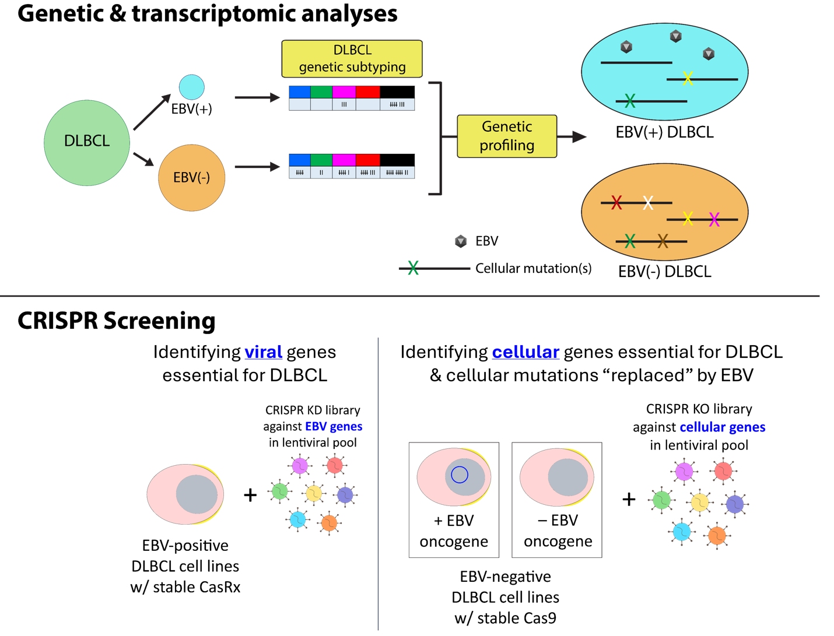

Poster #21
Title: Redefining Lignin Valorization through an Integrated Biomass-to-Bioproduct Pipeline
Authors: Sarada Sripada, Anna Qualls, Maximilliano A. Garcia, Bumkyu Kim, Timothy J. Donohue, Daniel R. Noguera, Steven D. Karlen, Canan Sener*
Presenter: Sarada Sripada; Wisconsin Energy Institute
Abstract: To improve the sustainability and economics of lignocellulosic biorefineries, there has been a growing interest in upgrading lignin into bioproducts and specialty biofuels through integrated chemical and biological processes. We have developed a biomass-to-bioproduct pipeline that involves chemical fractionation and depolymerization of biomass by catalytic hydrogenolysis followed by microbial funneling (using an engineered microbe Novosphingobium aromaticivorans) of depolymerized lignin to produce 2-pyrone-4,6-dicarboxylic acid (PDC), a precursor for bioplastics. In this pipeline reductive catalytic fractionation (RCF) was used to fractionate lignocellulosic biomass and depolymerize lignin into a mixture of monomeric and oligomeric phenolic compounds. RCF uses a solvent such as methanol to fractionate lignin from cellulose and hemicellulose, and a Pd/C catalyst with hydrogen to reductively depolymerize lignin. A solid carbohydrate pulp was obtained, that can be further upgraded into biofuel. The solvent employed in RCF is one of the critical factors driving process safety and economics. Although RCF has been widely studied in methanol owing to its high delignification efficiency, safety and cost issues associated with use of methanol at high pressures have indicated the need for green solvents that can work at lower pressures, thereby reducing reactor cost. In addition, compatibility with biological systems is a prerequisite for integrated chemical and biological processes. In this study, RCF was explored with various solvents including methanol, ethanol, 2-propanol, isobutanol, 1,4-dioxane and ethylene glycol, and aqueous mixtures of these solvents, and the lignin monomer yields per kg of biomass and product distributions were analyzed and compared. Further, microbial funneling of the lignin oil in solvent was performed with the different solvent systems to study the impact of various solvents on PDC production from N. aromaticivorans. This research aimed to identify a solvent system that operates at low pressures, is tolerated by N. aromaticivorans. and generates high RCF monomer and PDC yields.

Poster #22
Title: The role of phenotypic plasticity in the adaptive capacity of fish and wildlife species to climate change in the Midwestern United States
Authors: Sarah Ramirez, Benjamin Zuckerberg, Jake Vander Zanden, and Dan Vimont
Presenter: Sarah Ramirez; Center for Limnology; and, Forest and Wildlife Ecology
Abstract: Many species display unique phenotypes (observable characteristics or traits) that align with specific environmental cues associated with favorable climate conditions. In a rapidly changing climate, however, many organisms face situations where phenotypes no longer align well with novel climatic conditions, resulting in a phenotypic mismatch. Phenotypic mismatches could induce significant demographic costs. For example, snowshoe hares (Lepus americanus) rely on day length to initiate molting to change their coat color from brown to white to match snow cover, but the widespread loss of snow cover is causing a mismatch. Phenotypic plasticity is one pathway by which individuals may adjust their phenotypes by responding to environmental cues that may more accurately predict favorable conditions. For this project, we will synthesize existing literature to identify managerially important species that exhibit climate-sensitive phenotypes to identify potential phenotypic mismatches. Working with a group of federal, tribal, and state partners, we will identify species of management, conservation, or cultural interest to investigate the role of phenotypic variation and plasticity in adaptive capacity of those species to climate change. We will strive to identify potential phenotypic and phenological mismatches during years of extremely variable weather patterns, followed by investigating the role of phenotypic plasticity in minimizing the risks of these mismatches, and determining the mechanisms behind why those mismatches are detrimental to persistence of populations. As climate change progresses, knowledge about the ability of populations to respond and adjust to predicted extreme variability is important for anticipating management actions needed to maintain those populations.

Poster #23
Title: How genetic differences affect soybean protein quality for Better Use in Plant-Based foods
Authors: Shima Momen, Benjamin D. Fallen, Audrey L. Girard
Presenter: Shima Momen; Food Science
Abstract: Soybeans are a key ingredient in many plant-based foods, but the lack of genetic diversity in current commercial crops limits their potential. To explore how naturally diverse soybeans can unlock new possibilities, we studied 20 unique soybean varieties, each with its own natural genetic traits. Our research uncovered that certain soybean varieties, like USDA-N7007 genotype, have proteins that dissolve better and mix more smoothly with other ingredients. This makes them perfect for creating creamier, more consistent plant-based milks and meat substitutes—foods that are becoming increasingly popular among health-conscious consumers. Other varieties, like N16-9124 genotype, are excellent for making foamy products, such as vegan whipped cream or egg-free meringues, offering new options for those with dietary restrictions. By tapping into the natural diversity of soybeans, our work has the potential to improve the taste, texture, and nutritional quality of plant-based foods, making them more appealing to a wider audience. This research is not just about better soybeans; it’s about creating healthier, more sustainable food choices that can support a growing global population while reducing environmental impact.

Poster #24
Title: High-Throughput Probing of Lipid Alterations in Alzheimer’s Disease Progression via Isobaric Labeling and LC-MS/MS Analysis
Authors: Shuling Xu, Zhijun Zhu, Luigi Puglielli, Lingjun Li
Presenter: Shuling Xu; School of Pharmacy
Abstract: Lipids are crucial for cellular homeostasis, with their functions closely linked to their structures and concentrations, their inter- and intracellular spatial and temporal distributions. It is obvious that lipid accurate identification and quantification are essential for investigating their physiological roles in health and disease. However, comprehensive, and high-throughput quantification of lipidome remains challenging due to the diverse lipid structures. In this study, we developed a robust method for sensitive and high-throughput relative quantification of multiple lipid classes using 12-plex isobaric dual-reactive dimethylaminopyridine-activated N,N-dimethyl leucine- (DiLeu-DMAP) tag labeling and nanoLC-MS/MS analysis. DiLeu-DMAP labeling boosts the detection of nonpolar subclasses by up to 200-fold and improves annotation accuracy by providing more structure-informative fragment ions. Moreover, the labeling could reduce the extent of in-source fragmentation of cholesterol. The excellent quantitative performance including labeling efficiency, quantification accuracy, and dynamic range of 12-plex DiLeu tags for lipid analysis has been demonstrated. Utilizing this method, we analyzed brain tissue lipid changes in Alzheimer’s disease mice, a total of 242 lipid species across 11 lipid subclasses could be relatively quantified with high confidence, and the results indicated that some of the quantified lipid species may contribute to entail a valuable step forward in discovering disease biomarkers.

Poster #25
Title: Production of medium chain length oleochemicals from C2 substrates
Authors: Sri Harsha Adusumilli, Paul Perkovich, Shivangi Mishra, Ted Chavkin, and Brian Pfleger
Presenter: Sri Harsha Adusumilli; Chemical and Biological Engineering
Abstract: Medium chain length (MCL) oleochemicals have the potential to serve as renewable sources of fuel owing to their cetane number and low melting point. The sustainable production of MCL oleochemicals is crucial given the current situation of global warming and diminishing natural fuel resources. In this work we have developed a renewable chemical production strategy that uses acetate as the energy carrier to link renewable energy with the synthesis of organic compounds. We demonstrated that acetate can be efficiently converted to MCL oleochemicals in Escherichia coli by the expression of medium chain thioesterase (TE), Acyl-CoA synthase (FadD) and Acyl-CoA reductase (ACR). We integrated the fatty alcohol pathway into E. coli and optimized the copy numbers. E. coli grown on acetate as a substrate has higher energy costs and no yield of reducing equivalents. We therefore chose to cofeed ethanol, a good electron, carbon, or energy source that could provide reducing equivalents when fed with acetate. E. coli is incapable of growing on ethanol; hence we expressed the best performing operon with combination of alcohol assimilating genes, from various sources and combined with improved engineered acetate activation by using an Acetyl CoA Synthetase (ACS) mutant. The engineered strains are then used to develop a fermentation process that yields high titers of oleochemicals from acetate.

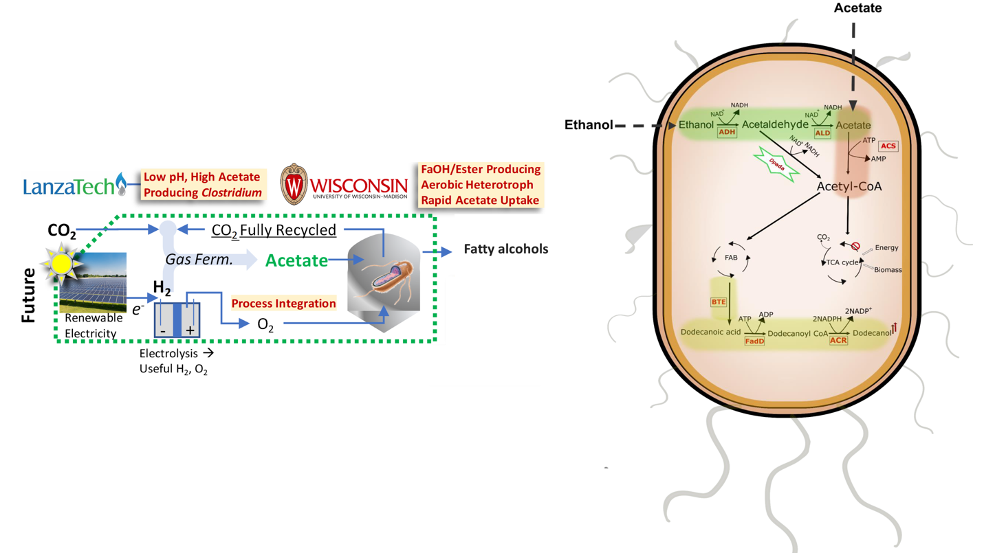

Poster #26
Title: Understanding the Inhibitory role of Frizzled 1 in Melanoma Development and Progression
Authors: Umar Sheikh, Minakshi Nihal and Hao Chang
Presenter: UMAR SHEIKH; Dermatology
Abstract: Melanoma is a highly aggressive cancer of melanin-producing melanocytes, and exposure to solar ultraviolet (UV) radiation is the major contributing factor. Despite recent groundbreaking progress in melanoma therapeutics, including BRAF and MEK inhibitors and monoclonal antibodies against immune checkpoints, the prognosis remains very poor in almost half of the patients due to the development of drug resistance, the rapid distant metastasis, and a variety of autoimmune side effects. A broader understanding of the biology of melanoma is needed for developing novel and effective treatments. The mammalian Frizzled gene family comprises ten 7-transmembrane G-protein coupled receptors (GPCRs)mediating canonical and non-canonical Wnt signaling. They are widely involved in multiple biological processes during normal development and disease, including cancer. Earlier, we showed a pro-metastasis role of FZD6 in melanoma. Here, we focus on FZD1, a homolog of FZD6, in melanoma. We found that FZD1 is highly expressed in multiple melanoma cell lines. To determine the role of FZD1 in melanoma, we knocked down FZD1 using siRNA in multiple melanoma cell lines. In contrast to the reported pro-cancer role of FZD1 in other cancers, we found that FZD1 knockdown in A375, Hs 294T and SK-MEL-28 melanoma cells significantly promotes cell invasion in vitro, suggesting an unexpected anti-cancer role of FZD1 in melanoma. To determine whether FZD1 plays a similar role in melanoma in vivo, we generated Fzd1 knockout YUMM1.7 cell lines. Fzd1 knockout clones also promote melanoma cell invasion in vitro suggesting the novel anti-cancer role of Fzd1 in melanoma. We are planning in vivo syngeneic experiments in mice to further understand the in-vivo role of Fzd1 in melanoma development and metastasis. To determine the potential mechanism of Fzd1 in melanoma growth and invasion, we examined the expression levels of several canonical Wnt signaling, EMT, and MMP signaling pathway genes in YUMM 1.7 cells and identified many significant changes upon Fzd1 knockdown. We are validating these changes in several other human melanoma cell lines and in the in vivo mouse syngeneic model. Furthermore, genetic rescue experiments will be performed using gain- and loss-of-function approaches to determine the involvement of these downstream targets in the Fzd1-induced anti-melanoma phenotype. Our work suggests that FZD1 plays an inhibitory role in melanoma and highlights the distinct roles of Frizzled family receptors in melanoma development and progression.

Poster #27
Title: New insights on locomotion mechanisms in C. elegans : Deciphering Neuropeptide-GPCR interplay.
Authors: Vishnu Raj, Fujia Han, Haania Khan, Han Wang.
Presenter: Vishnu Raj; Integrative Biology
Abstract: The movement of an organism helps to identify its sources of food and avoid potential threats from the environment in which it is residing. The locomotive ability of an organism is intricately influenced by both internal regulatory mechanisms and external interactions, thereby exerting context-dependent control over locomotive responses. Despite extensive studies, precise mechanisms underlying locomotion in animals, specifically the roles of neuropeptides, remain unclear. C. elegans possesses at least 159 genes that encode predicted putative neuropeptides, with at least 31 of these genes producing FMRFamide-related peptides (FLPs). Signals mediated by these peptides influence various behaviors in C. elegans, including locomotion. In this study, we report that the neuropeptide FLP-9 and its G-protein coupled receptor FRPR-21 play a crucial role in the forward locomotion by inhibiting the backward locomotion circuitry. Overexpressing FLP-9 (FLP-9 OE) in C. elegans showed a nearly complete absence of reversal in response to anterior gentle touch stimuli. This result suggests that FLP-9 exerted an inhibitory influence on the reversal movement, thus favoring forward locomotion as the predominant movement pattern. We carried out a suppressor screen to isolate mutants that reverse the phenotype of FLP-9(OE) transgenic worms and identified 5 suppressors. Genetic mapping and complementation tests showed that info-2 and info-7 are new alleles of frpr-21, which encodes a GPCR. Rescue experiments were conducted in FLP-9 OE; frpr-21 mutants under various neuronal-specific promoters showed that expression of frpr-21 cDNA in AVA neuron resulted in a complete absence of reversals. This observation underlines the biological interaction of FLP-9 and FRPR-21 GPCR within the command interneuron AVA in eliciting a backward movement in response to gentle touch stimuli. We will also present the research updates as to the characterization and cloning of the other three suppressors info-1, info-4, and info-5. Ongoing experiments to study these mutants will improve our understanding of how forward locomotion is controlled by a neuropeptide-GPCR interaction in C. elegans. Overall, this study will shed light on how the organism uses a neuropeptide to regulate their locomotion pattern to run away in response to potential dangers in the environment.

Poster #28
Title: For passive radiative cooling, we recommend broadband thermal emitters vs. narrowband ones
Authors: Yeonghoon Jin and Mikhail Kats
Presenter: Yeonghoon Jin; Electrical and Computer Engineering
Abstract: The cooling of surfaces via thermal radiation toward the sky, even when the sun is shining, is a highly active research field and a meaningful component of a strategy of sustainability. The design of such surfaces has tradeoffs, including minimizing solar absorption, implementing the ideal mid-infrared emissivity spectrum, and making large-area surfaces at low cost. We built a sophisticated model for evaluating radiative cooling, accounting for atmospheric transparency at any location and time on Earth, altitude-dependent temperature, and other factors. We found the widely pursued approach of designing selective emitters for the 8-13 µm atmospheric transparency window is usually unnecessary, and this design constraint makes it harder to achieve low solar absorption and low cost, which is considerably more important.

Poster #29
Title: Graph-Theoretic Representations of Process Phenomena: Concepts, Algorithms, and Software Implementation
Authors: Yoel R. Cortes-Pena, Victor Zavala
Presenter: Yoel Cortes-Pena; Department of Chemical and Biological Engineering
Abstract: Rapid and robust simulation of a chemical production process is critical to address core scientific questions related to process design, optimization, and sustainability. However, efficiently solving a chemical process remains a challenge due to their highly coupled and nonlinear nature. In this work, we show that graph representations of the underlying physical phenomena may help identify potential avenues to systematically reformulate the network of equations and enable more robust topology-aware simulation. To this end, we developed graph abstractions of the governing equations of separation equipment. The graph abstraction consists of a mesh of interconnected variable nodes and equation nodes. We show that partitioning the graph into separate mass, energy, and phenomenological subgraphs can help decouple nonlinearities and guide decomposition algorithms. We implemented this new simulation algorithm in BioSTEAM —an open-source process simulation platform implemented in Python— and show how this phenomena-oriented decomposition algorithm enables more rapid and robust simulation than classical sequential modular approaches.
[Graphical Abstract Below]

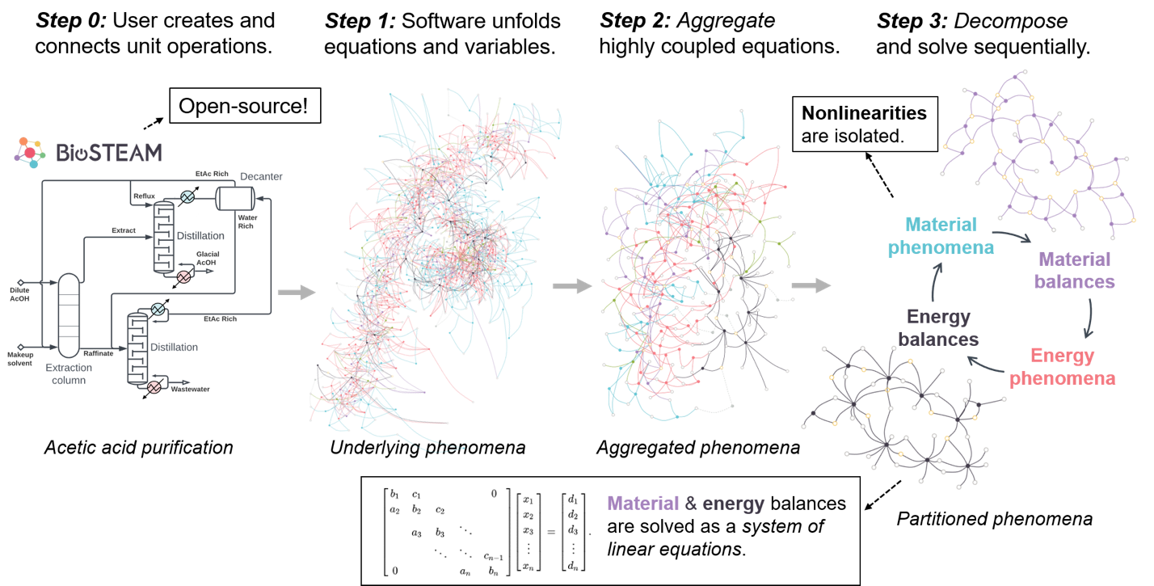

Poster #30
Title: Loss of Candida albicans TLO genes induces genome instability and transcription
Authors: Zinnat Shahina, Matthew Z Anderson
Presenter: Zinnat Shahina; Genetics Biotechnology Center
Abstract: Candida albicans is a commensal and opportunistic fungal pathogen of humans. Within C. albicans, the most expanded gene family is a set of paralogs called the telomere-associated (TLO) genes. Tlo products encode a subunit of the Mediator complex, which regulates transcription across eukaryotes and affects a range of in vitro and in vivo processes. The 14 annotated C. albicans TLO genes can be sub-divided into three clades (Œ±, Œ≤, and Œ≥), based largely on the presence of indels and the alternative splicing of a subset of sequences that contain an intron (Œ≥) in the 3’ end. Importantly, the specific biological and molecular roles for each TLO paralog are not well defined. Investigation into their functions could provide valuable insight and an understanding of regulatory mechanisms in relation to pathogenicity. More specifically, it may reveal how transcriptional plasticity in C. alibcans facilitates adaptation to a broad range of different environmental niches.

Poster #31
Title: Systematic investigation of bile salt hydrolase activity in human gut bacteria reveals production of conjugated secondary bile acids
Authors: Lauren N. Lucas, Mallikarjun Jillella, Bhavana Gangwar, Lea E. Cattaneo, Qijun Zhang, Robert Kerby, David M. Stevenson, Federico E. Rey, and Daniel Amador-Noguez
Presenter: Lauren Lucas; Bacteriology
Abstract: Bile acids (BAs) play a crucial role in human health by facilitating the absorption of lipophilic nutrients from the diet, interacting with hormone receptors to effect host physiology, and modulating gut microbiota composition through antimicrobial activity. We sought to investigate bile salt hydrolase (bsh) activity in diverse human gut bacteria to gain a deeper understanding of its role in diversification of the BA pool. We systematically investigated 77 human gut bacteria for their capacity to transform five prevalent conjugated BAs in humans. All species were grown in monoculture and sampled at stationary phase to assess their BA transformation capabilities. Selected strains were further examined in time-course monoculture and coculture experiments to evaluate sequential BA transformations. Our analyses revealed widespread, yet variable bsh activity in both the amount and type of BAs deconjugated. Surprisingly, we observed activity by hydroxysteroid dehydrogenases (hsd) on conjugated BAs to produce conjugated secondary BAs that have never been reported before. We constructed an Œîhsd in Bacteroides thetaiotaomicron and confirmed that this gene alone was directly responsible for the production of conjugated secondary BAs. This activity contradicts the widely accepted notion that BAs must be deconjugated before they can be transformed. Our results reveal a more complex network of bacterial BA transformations than previously understood, which will stimulate a new suite of hypotheses regarding how bacteria act by themselves or in concert to diversify the BA pool in in vivo systems.

