SUMMER TRAINING REPORT
ON
Study of ADSP-BF609 Processor Architecture, EMIF, and Memory Programming Using CrossCore Embedded Studio

AT


DEFENCE ELECTRONICS APPLICATIONS LABORATORY (DEAL)
DEFENCE RESEARCH & DEVELOPMENT ORGANISATION (DRDO)
MINISTRY OF DEFENCE, GOVERNMENT OF INDIA
DEHRADUN - 248008, INDIA
JULY, 2026

in partial fulfilment of the degree

BACHELOR OF TECHNOLOGY
IN
COMPUTER SCIENCE AND ENGINEERING
Graphic Era Hill University, Dehradun
Submitted By:
RISHAV SINGH NEGI

Under the Guidance of:
Mr. ANKUR AWASTHI
Scientist, DEAL

DECLARATION
I hereby declare that the summer training report entitled Study of ADSP-BF609 Processor Architecture, EMIF, and Memory Programming Using CrossCore Embedded Studio submitted by me at Defence Electronics Applications Laboratory (DEAL), DRDO, Dehradun, is an authentic record of my training work carried out during the period of my internship under the supervision and guidance of Mr. Ankur Awasthi, Scientist, DEAL, DRDO.
Date: July 08, 2026
Place: Dehradun

SIGNATURE

ANKUR AWASTHI
(SCIENTIST DEAL)
ACKNOWLEDGEMENT
I express my deep gratitude and sincere thanks to my project guide, Mr. Ankur Awasthi, Scientist, Defence Electronics Applications Laboratory (DEAL), Dehradun, for his invaluable guidance, support, and mentorship throughout my training. His insights and feedback have been critical to the success of this project.
I would also like to express my sincere appreciation to the Director, DEAL, and the Head of Department/Division for providing me the opportunity to carry out my summer training at this esteemed laboratory and for allowing me to utilize the facilities.
Furthermore, I thank the faculty members of the Department of Computer Science and Engineering, Graphic Era Hill University, Dehradun, for their constant encouragement and academic support.
Finally, I extend my heartfelt thanks to all the scientists, staff members, and my peers at DEAL, DRDO, who helped me directly or indirectly during my internship.
RISHAV SINGH NEGI

ORGANIZATION PORTFOLIO
Defence Electronics Applications Laboratory (DEAL)
Defence Electronics Applications Laboratory (DEAL), Dehradun, is a premier Research and Development laboratory under the Defence Research and Development Organisation (DRDO), Ministry of Defence, Government of India.
Established with the vision of achieving self-reliance in electronic warfare and communication systems, DEAL is mandated to design and develop state-of-the-art technologies in the fields of:
• Satellite Communication Systems (SATCOM)
• Software Defined Radios (SDR) and Cognitive Radios
• Millimetre-Wave and Microwave Communication Links
• Secure Data Links for Unmanned Aerial Vehicles (UAVs)
• Radar Systems and advanced signal processing.
DEAL has made significant contributions to the Indian Armed Forces by delivering robust communication systems that operate under harsh electronic countermeasure environments. The laboratory is equipped with advanced testing facilities, simulation software, and specialized labs to foster cutting-edge research and product development.

TABLE OF CONTENTS
Declaration ii
Acknowledgement iii
Organization Portfolio iv
List of Figures vi
CHAPTER 1: INTRODUCTION 1
CHAPTER 2: LITERATURE SURVEY 8
CHAPTER 3: EXISTING SYSTEM 14
CHAPTER 4: PROPOSED SYSTEM 16
CHAPTER 5: SYSTEM ARCHITECTURE 19
CHAPTER 6: TECHNOLOGY STACK 21
CHAPTER 7: MODULE DESCRIPTION 23
CHAPTER 8: RELIABLE UDP PROTOCOL 27
CHAPTER 9: SLIDING WINDOW FLOW CONTROL 30
CHAPTER 10: TCP RENO INSPIRED CONGESTION CONTROL 31
CHAPTER 11: SECURITY IMPLEMENTATION 32
CHAPTER 12: COMPRESSION MECHANISM 33
CHAPTER 13: DATABASE DESIGN 35
CHAPTER 14: USER INTERFACE 35
CHAPTER 15: TESTING AND RESULTS 39
CHAPTER 16: FUTURE SCOPE 39
CHAPTER 17: CONCLUSION 40
REFERENCES 41

LIST OF FIGURES
Figure 7.1: Peer Discovery Interface 22
Figure 7.2: Secure Pairing Handshake Prompt 24
Figure 7.3: Encrypted Peer-to-Peer Chat Room 25
Figure 7.4: Live File Transfer & Telemetry Analytics 26
Figure 14.1: Local File Transfer Logs & History 38

CHAPTER 1

INTRODUCTION

1.1 Introduction
Embedded systems have become one of the most significant technologies driving modern electronic and computational systems. Unlike general-purpose computers that are designed to perform a wide variety of applications, embedded systems are developed to execute specific tasks with high efficiency, reliability, and deterministic performance. These systems are integrated into larger products and operate with limited computational resources while satisfying strict timing and performance requirements. Embedded processors are therefore designed to provide fast computation, efficient memory utilization, and direct interaction with hardware peripherals.
With the continuous advancement in communication systems, industrial automation, defense electronics, autonomous systems, and multimedia applications, the demand for high-performance embedded processors has increased considerably. Modern embedded applications frequently require real-time execution, simultaneous processing of multiple data streams, and interaction with numerous external devices. To satisfy these requirements, specialized processors with enhanced computational capability and optimized memory architecture have been developed.
The ADSP-BF609 processor, developed by Analog Devices, belongs to the Blackfin® family of embedded processors and represents one such high-performance computing platform. The processor combines the characteristics of a 32-bit Reduced Instruction Set Computer (RISC) architecture with powerful Digital Signal Processing (DSP) capabilities, enabling efficient execution of computationally intensive algorithms while maintaining deterministic real-time performance.
Unlike conventional processors that focus primarily on sequential instruction execution, the ADSP-BF609 has been designed to efficiently process large amounts of data through an optimized memory hierarchy, multiple processing cores, dedicated hardware accelerators, and high-speed communication interfaces. The processor integrates several hardware modules, including Level-1 (L1) memory, Level-2 (L2) SRAM, Direct Memory Access (DMA) controllers, interrupt controllers, timers, communication peripherals, and an External Memory Interface (EMIF), allowing efficient interaction with both internal and external memory devices.
One of the distinguishing features of the ADSP-BF609 processor is its sophisticated memory organization. The processor employs a hierarchical memory architecture that balances speed and storage capacity by utilizing processor registers, L1 instruction and data memory, L2 SRAM, Boot ROM, and external Double Data Rate (DDR) SDRAM. Frequently accessed instructions and data are stored within high-speed internal memory, while larger datasets can be maintained in external DDR memory. This memory hierarchy significantly improves execution efficiency by reducing memory access latency for time-critical operations while providing sufficient storage capacity for large embedded applications.
The processor also supports numerous communication interfaces, including Serial Peripheral Interface (SPI), Universal Asynchronous Receiver-Transmitter (UART), Serial Ports (SPORT), Ethernet, USB, General Purpose Input/Output (GPIO), timers, watchdog timers, and Direct Memory Access (DMA) controllers. These integrated peripherals enable efficient communication with external hardware devices while minimizing processor intervention during data transfer operations.
The practical work carried out during this internship primarily focused on studying the architecture of the ADSP-BF609 processor and understanding its memory subsystem through experimental implementation. Particular emphasis was placed on the External Memory Interface (EMIF), internal L2 SRAM, and external DDR memory. Programs were developed using CrossCore Embedded Studio (CCES) to perform memory access operations, including writing data into different memory locations, reading stored data, and verifying memory contents using debugger tools and memory windows. These experiments provided practical exposure to processor memory organization and embedded programming techniques.

Figure 1.1

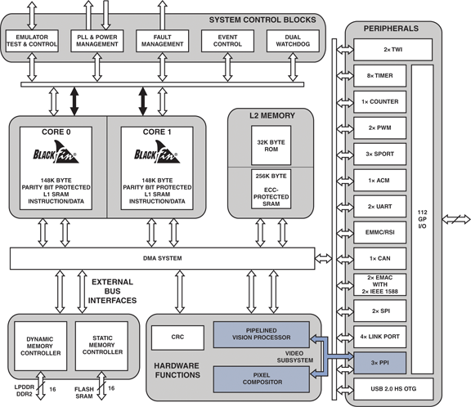

Figure 1.1: Functional Block Diagram of the ADSP-BF609 Processor.

1.2 About the ADSP-BF609 Processor
The ADSP-BF609 is a member of the Blackfin+ family of processors developed specifically for high-performance embedded applications. The processor integrates dual Blackfin+ processing cores, advanced memory architecture, hardware accelerators, and multiple communication peripherals within a single integrated circuit. This level of integration reduces system complexity while improving computational efficiency and reliability.
The processor architecture is optimized for deterministic execution, enabling real-time processing of complex algorithms without compromising system responsiveness. Unlike desktop processors, which are designed primarily for maximum computational throughput, embedded processors such as the ADSP-BF609 emphasize predictable execution timing, efficient memory utilization, and direct interaction with external hardware.
The Blackfin+ architecture combines the simplicity of RISC-based instruction execution with specialized hardware resources that accelerate arithmetic operations commonly required in Digital Signal Processing applications. As a result, the processor is capable of efficiently executing filtering algorithms, image processing operations, communication protocols, mathematical computations, and industrial control applications.
Another important characteristic of the ADSP-BF609 processor is its flexible memory architecture. Internal memories provide extremely low-latency storage for frequently executed instructions and data, while the External Memory Interface enables connection to high-capacity DDR SDRAM for applications requiring larger memory space. The processor automatically manages communication between internal resources and external memory through dedicated memory controllers, ensuring efficient movement of data throughout the system.
The combination of high computational capability, integrated peripherals, scalable memory architecture, and real-time processing makes the ADSP-BF609 suitable for applications in defense electronics, industrial automation, machine vision, communication systems, software-defined radio, medical imaging, surveillance equipment, and multimedia processing.

1.3 Applications of the ADSP-BF609 Processor
The ADSP-BF609 processor is widely used in applications that require continuous processing of large volumes of data while maintaining deterministic execution. Some important application areas include:

Defense Electronics
The processor is extensively employed in radar systems, electronic warfare equipment, secure communication systems, surveillance platforms, and signal intelligence applications. Its high computational performance and deterministic execution make it suitable for mission-critical defense applications where processing delays cannot be tolerated.

Industrial Automation
Industrial control systems require continuous monitoring of sensors, actuators, communication interfaces, and control algorithms. The ADSP-BF609 processor provides sufficient computational capability to execute control algorithms while simultaneously managing communication with industrial peripherals.

Medical Imaging
Medical imaging devices such as ultrasound systems, diagnostic instruments, and patient monitoring equipment require real-time signal acquisition and processing. The processor efficiently executes filtering, image enhancement, and data acquisition algorithms necessary for these applications.

Machine Vision
Image acquisition and processing systems generate enormous quantities of data that must be processed with minimal delay. The processor's architecture supports high-speed image processing through optimized memory organization and computational resources.

Communication Systems
Modern communication equipment requires modulation, demodulation, packet processing, encryption, and protocol handling. The processor supports these functions through its integrated communication peripherals and Digital Signal Processing capabilities.

Multimedia Systems
Applications involving audio processing, video encoding, image compression, and multimedia streaming require efficient mathematical computation and memory management. The ADSP-BF609 processor provides dedicated hardware resources suitable for these tasks.

1.4 Objectives of the Internship Work
The primary objective of this internship was to gain practical understanding of embedded processor architecture and memory programming using the ADSP-BF609 processor. Rather than focusing solely on theoretical concepts, the work emphasized experimental implementation and verification of memory operations using the CrossCore Embedded Studio development environment.
The specific objectives of the work were:
- To study the architecture of the ADSP-BF609 Blackfin processor.
- To understand the organization of processor registers, L1 memory, L2 SRAM, Boot ROM, and external DDR memory.
- To study the External Memory Interface (EMIF) and its role in accessing external DDR SDRAM.
- To understand processor memory mapping and address allocation.
- To develop embedded programs capable of writing data to external DDR memory.
- To implement read operations for verifying stored data within DDR memory.
- To develop programs for storing and retrieving information from internal L2 SRAM.
- To verify successful memory operations using the debugger, memory window, and console output available in CrossCore Embedded Studio.
- To gain practical experience in pointer-based memory access techniques and embedded memory programming.

1.5 Organization of the Report
This report is organized into five technical chapters. Chapter 1 introduces the ADSP-BF609 processor, its applications, and the objectives of the internship work. Chapter 2 presents the processor architecture, including the Blackfin+ core, Harvard architecture, RISC architecture, instruction pipeline, register organization, and integrated peripherals. Chapter 3 discusses the memory hierarchy of the processor, including registers, L1 memory, L2 SRAM, DDR memory, and the External Memory Interface (EMIF). Chapter 4 describes the practical implementation of memory programming, covering the development of programs to write and read data from both L2 SRAM and DDR memory using CrossCore Embedded Studio. Finally, Chapter 5 presents the experimental results, observations, conclusions, and key outcomes of the work carried out during the internship.

CHAPTER 2

ADSP-BF609 PROCESSOR ARCHITECTURE

2.1 Introduction
The architecture of a processor defines the internal organization of its functional units and determines how instructions are executed, how data moves through the system, and how different hardware components interact with each other. Understanding the processor architecture is essential before developing embedded software because every instruction executed by the processor passes through several hardware stages before producing the required output.
The ADSP-BF609 processor belongs to the Blackfin® family of processors developed by Analog Devices and is specifically designed for embedded applications requiring high computational performance, efficient memory management, and deterministic real-time execution. The processor architecture integrates computational cores, memory controllers, communication peripherals, interrupt controllers, timers, Direct Memory Access (DMA) engines, and memory interfaces within a single integrated circuit.
Unlike conventional processors that rely heavily on external hardware resources, the ADSP-BF609 provides an extensive collection of integrated hardware modules capable of independently performing memory transfers, communication operations, and peripheral management. This reduces processor workload and improves execution efficiency.
The processor architecture has been optimized to minimize instruction latency while maximizing data throughput. Multiple hardware techniques including Harvard architecture, pipelined execution, multi-level memory hierarchy, and dedicated DMA controllers work together to achieve high computational performance.
During the internship, understanding these architectural components was necessary before implementing memory access operations involving L2 SRAM and external DDR memory.

Figure 2.1



Figure 2.1: Internal Functional Architecture of the ADSP-BF609 Processor.

2.2 Overall Architecture of ADSP-BF609
The ADSP-BF609 processor integrates several hardware subsystems within a single chip to provide a complete embedded computing platform. At the center of the architecture are two independent Blackfin+ processing cores responsible for executing program instructions. These processing cores communicate with internal memory, peripheral controllers, interrupt systems, and external memory interfaces through an internal high-speed system bus.
The processor architecture can be broadly divided into the following functional blocks:
- Dual Blackfin+ Processing Cores
- Internal Register File
- Arithmetic Logic Unit (ALU)
- Instruction Decoder
- Pipeline Unit
- L1 Instruction and Data Memory
- L2 Shared SRAM
- Dynamic Memory Controller (DMC)
- External Memory Interface (EMIF)
- Direct Memory Access (DMA) Controller
- Interrupt Controller
- Peripheral Interfaces
- System Bus Architecture
Each of these functional blocks performs a dedicated task while continuously interacting with the remaining hardware components. Together they form a complete embedded processing system capable of executing millions of instructions every second.

2.3 Dual Blackfin+ Processing Cores
The ADSP-BF609 incorporates two independent Blackfin+ processor cores. Each processing core operates as a complete processor containing its own execution units, register set, arithmetic logic unit, instruction decoder, and pipeline stages.
The dual-core architecture enables parallel execution of software tasks. Instead of executing every task sequentially on a single processor, different tasks can be distributed between both cores.
For example:
- Core 0 may acquire sensor data from external devices.
- Core 1 may simultaneously process the acquired data.
Because both processors execute independently, the overall computational throughput increases significantly.
The two cores share common memory resources through the processor's internal bus architecture. Shared resources include L2 SRAM, DDR memory, and peripheral interfaces. Hardware arbitration logic ensures simultaneous access without causing data corruption.
The dual-core organization offers several advantages:
- Increased computational performance.
- Parallel execution of multiple applications.
- Reduced processor bottlenecks.
- Better utilization of processor resources.
- Improved responsiveness for real-time applications.

Figure 2.2

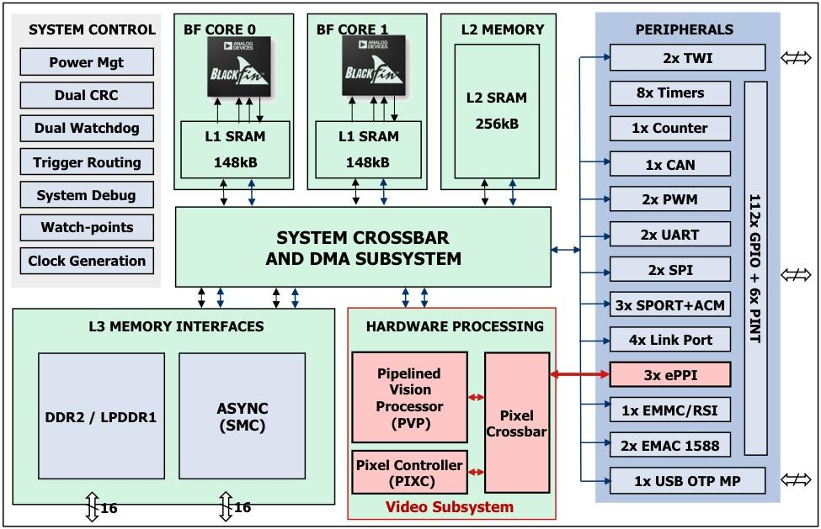
Figure 2.2: Dual-Core Processing Architecture.

2.4 Blackfin+ Core
The Blackfin+ Core is the computational engine of the ADSP-BF609 processor. Every instruction executed by the processor passes through the Blackfin+ core.
Internally, the processing core consists of several specialized functional units.
These include:
- Instruction Fetch Unit
- Instruction Decoder
- Arithmetic Logic Unit (ALU)
- Multiply-Accumulate Unit (MAC)
- Register File
- Branch Unit
- Memory Access Unit
- Pipeline Controller
The instruction fetch unit continuously retrieves instructions from instruction memory.
The instruction decoder interprets the binary instruction and determines the required operation.
The Arithmetic Logic Unit performs arithmetic operations such as
- Addition
- Subtraction
- Logical AND
- Logical OR
- Bit Manipulation
- Comparison
For Digital Signal Processing applications, the Multiply-Accumulate (MAC) unit performs repeated multiplication and accumulation operations at very high speed.
The Memory Access Unit transfers data between processor registers and memory.
The Branch Unit controls program flow whenever loops, conditional statements, or function calls occur.

2.5 Harvard Architecture
One of the defining characteristics of the ADSP-BF609 processor is its Harvard Architecture.
Unlike the traditional Von Neumann architecture, where both instructions and data share the same communication path, Harvard architecture maintains separate buses for program instructions and data.
This means:
Instruction Bus
↓
Program Memory
Data Bus
↓
Data Memory
Since instructions and data travel through different buses, both operations occur simultaneously.
For example,
while one instruction is being fetched,
another piece of data may be read or written at exactly the same time.
This significantly improves processor performance.
The Harvard architecture minimizes memory bottlenecks and allows continuous instruction execution without unnecessary waiting periods.
This architecture is especially useful in Digital Signal Processing applications where continuous streams of data are processed.
Advantages include:
- Higher throughput.
- Reduced instruction latency.
- Simultaneous instruction and data access.
- Better utilization of processor resources.
- Increased execution efficiency.

Figure 2.3
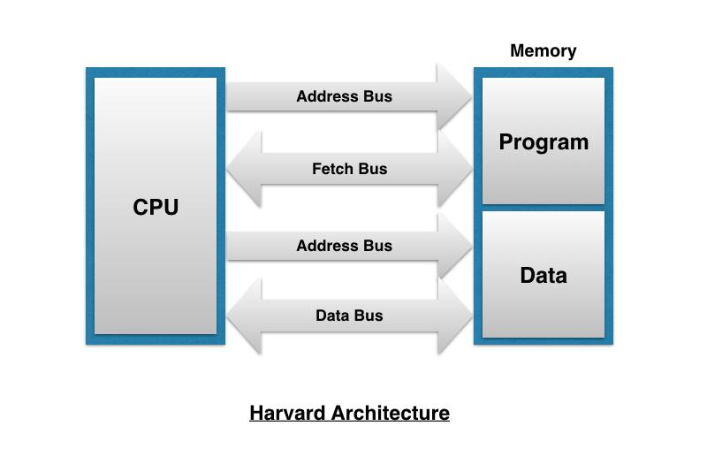
Figure 2.3: Harvard Architecture Used in the ADSP-BF609 Processor.

2.6 RISC Architecture
The ADSP-BF609 follows the Reduced Instruction Set Computer (RISC) architecture.
RISC processors simplify hardware implementation by using a relatively small collection of instructions that execute quickly.
Unlike Complex Instruction Set Computer (CISC) processors, which contain hundreds of specialized instructions, RISC processors rely on a smaller number of optimized instructions.
Complex operations are performed by combining several simple instructions.
The advantages include:
- Faster instruction execution.
- Simpler instruction decoding.
- Lower power consumption.
- Higher clock frequencies.
- Better pipeline efficiency.
- Predictable execution timing.
The ADSP-BF609 uses a 32-bit instruction set optimized for embedded applications and Digital Signal Processing.

2.7 Processor Pipeline
Modern processors execute instructions using pipelining.
Without pipelining,
Instruction 1 would complete first.
Then Instruction 2 would start.
Then Instruction 3.
Most processor hardware would remain idle while waiting.
The ADSP-BF609 eliminates this problem through pipeline execution.
Instruction execution is divided into several stages.
Typical stages include:
- Instruction Fetch
- Instruction Decode
- Operand Read
- Execute
- Memory Access
- Write Back
While one instruction is executing,
another instruction is decoding,
and a third instruction is already being fetched.
Multiple instructions therefore remain active simultaneously.
This dramatically increases processor throughput.

Figure 2.4
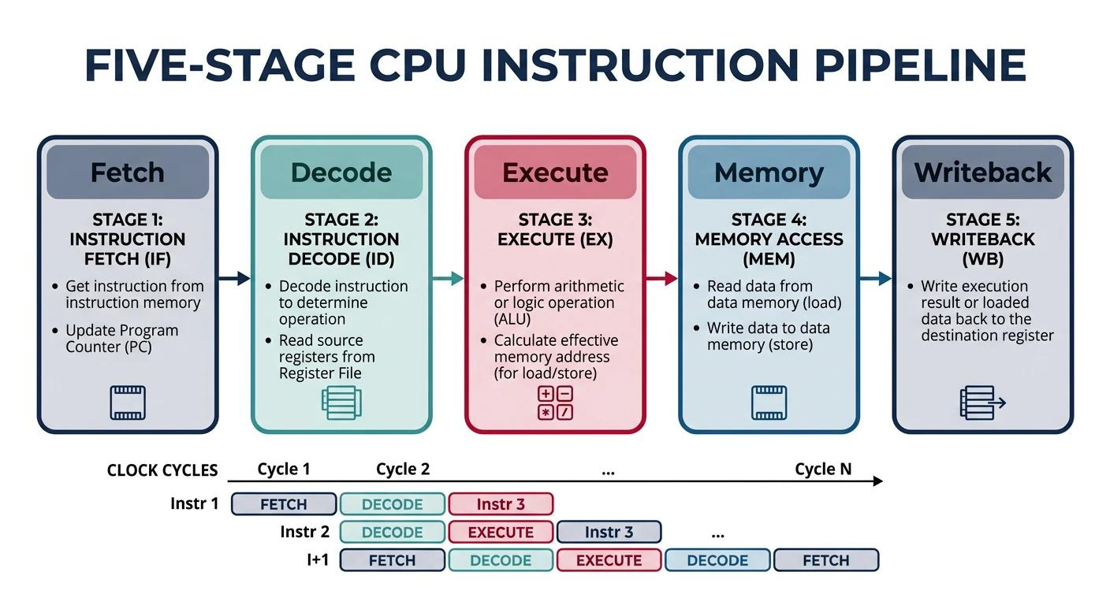
Figure 2.4: Pipeline Stages of Instruction Execution.

2.8 Register Organization
Registers represent the fastest storage elements inside the processor.
Unlike RAM,
registers are located directly inside the processor core.
Every arithmetic operation first moves operands into registers.
The processor performs calculations using register values.
The result is finally stored back into memory.
The ADSP-BF609 contains multiple categories of registers.
These include:
- General Purpose Registers
- Data Registers
- Pointer Registers
- Stack Pointer
- Frame Pointer
- Program Counter
- Status Registers
- Loop Registers
Registers provide:
- Extremely low access latency.
- High-speed temporary storage.
- Efficient arithmetic processing.
- Faster instruction execution.
Because register access requires very few processor cycles, effective utilization of registers significantly improves application performance.

2.9 System Bus Architecture
The various functional units of the ADSP-BF609 processor must continuously exchange instructions, data, addresses, and control information during program execution. This communication is achieved through an internal System Bus Architecture, which acts as the backbone of the processor by interconnecting the processing cores, memory modules, DMA controllers, and peripheral interfaces.
Rather than relying on a single communication path, the ADSP-BF609 employs multiple dedicated buses to improve bandwidth and reduce communication bottlenecks. Separate buses allow instruction fetching, data transfer, and peripheral communication to occur simultaneously, thereby increasing the overall execution efficiency.
The primary buses present within the processor include:
- Instruction Bus: Transfers program instructions from instruction memory to the processor core.
- Data Bus: Transfers data between processor registers, memories, and peripherals.
- Address Bus: Carries memory addresses generated by the processor during read and write operations.
- Control Bus: Carries control signals such as Read Enable, Write Enable, Interrupt Requests, Reset, and Clock Synchronization.
When the processor executes an instruction requiring data from memory, the Address Bus first specifies the required memory location. The Control Bus then indicates whether the operation is a read or write transaction. Finally, the Data Bus transfers the required information between memory and the processor.
This separation of communication channels significantly improves data throughput by allowing multiple operations to occur concurrently.

Figure 2.5
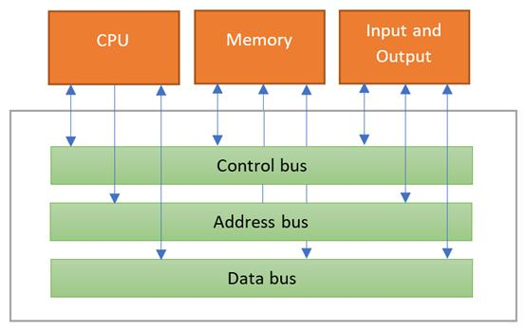

Figure 2.5: Internal System Bus Organization.

2.10 Clock Generation and Synchronization
Every operation performed by the processor is synchronized using a system clock. The clock provides periodic timing pulses that coordinate instruction execution, memory access, peripheral communication, and interrupt handling.
The ADSP-BF609 processor contains an internal clock generation unit capable of producing multiple clock domains from a single external crystal oscillator. Phase-Locked Loops (PLLs) multiply the input clock frequency to generate the operating frequencies required by different hardware modules.
Separate clock domains are provided for:
- Processor Core
- System Bus
- DDR Memory Controller
- Peripheral Interfaces
- DMA Controller
Using independent clock domains enables each subsystem to operate at an optimal frequency without affecting the operation of other hardware modules.
Proper clock synchronization is particularly important during communication with external DDR memory because both the processor and DDR memory must operate in precise timing coordination.

Figure 2.6
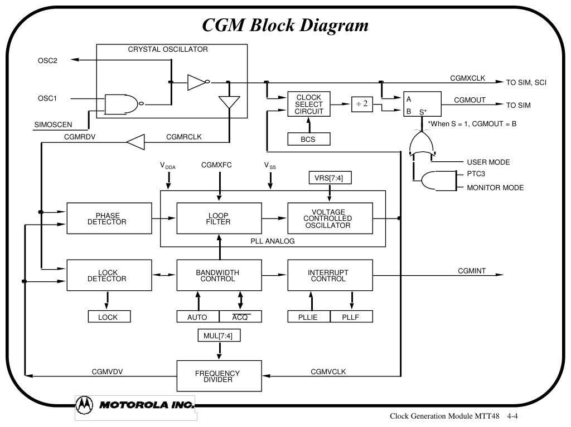
Figure 2.6: Clock Generation and Distribution.

2.11 Direct Memory Access (DMA) Controller
One of the most powerful hardware modules integrated within the ADSP-BF609 processor is the Direct Memory Access (DMA) Controller.
Normally, whenever data needs to be transferred between memory and a peripheral, the processor must execute several instructions to perform the transfer. During this time, the processor cannot perform other computational tasks efficiently.
The DMA controller eliminates this limitation.
Instead of requiring continuous processor intervention, the DMA controller independently transfers data between memory locations and peripheral devices. The processor simply configures the DMA channel by specifying:
- Source Address
- Destination Address
- Number of Bytes
- Transfer Mode
Once configured, the DMA controller performs the entire transfer autonomously.
During DMA operation:
- The processor initializes the DMA controller.
- DMA requests access to the system bus.
- Data is transferred directly between source and destination.
- Upon completion, DMA generates an interrupt notifying the processor.
This significantly reduces CPU workload while increasing overall system performance.
DMA is commonly used for:
- Audio streaming
- Video processing
- Ethernet communication
- SPI communication
- UART communication
- Memory-to-memory transfer
- DDR memory transfer
During high-speed embedded applications, DMA allows the processor to continue executing application code while data transfers occur in the background.

Figure 2.7

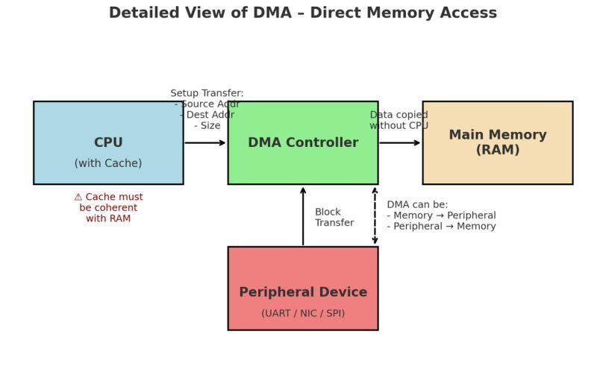

Figure 2.7: Direct Memory Access Operation.

2.12 Interrupt Controller
Embedded systems frequently interact with external devices that generate asynchronous events. Such events include receiving serial data, timer expiration, completion of DMA transfers, and external hardware signals.
Instead of continuously checking the status of every peripheral, the ADSP-BF609 processor employs an Interrupt Controller.
Whenever an important event occurs, the corresponding peripheral generates an interrupt request. The interrupt controller temporarily suspends the currently executing program, saves the processor context, and transfers program execution to the appropriate Interrupt Service Routine (ISR).
After servicing the interrupt, normal program execution resumes from the exact instruction where it was interrupted.
The interrupt controller provides:
- Fast response to external events.
- Reduced processor overhead.
- Efficient peripheral communication.
- Support for multiple interrupt priority levels.
- Improved real-time system performance.
Examples of interrupt sources include:
- DMA Completion
- UART Reception
- SPI Transfer Completion
- GPIO Events
- Timer Overflow
- External Hardware Signals

Figure 2.8
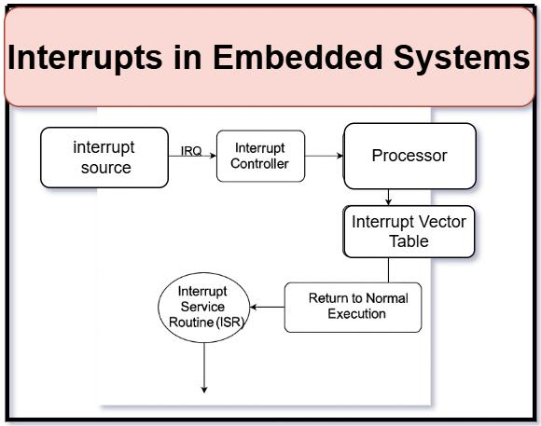
Figure 2.8: Interrupt Handling Mechanism.

2.13 Integrated Peripheral Interfaces
The ADSP-BF609 processor integrates numerous communication peripherals, enabling direct interaction with external hardware devices without requiring additional interface controllers.

General Purpose Input/Output (GPIO)
GPIO pins provide programmable digital input and output functionality. They allow the processor to communicate directly with LEDs, switches, sensors, relays, and other digital devices. Each GPIO pin can be individually configured as either an input or an output depending on application requirements.

Universal Asynchronous Receiver-Transmitter (UART)
UART enables serial communication between the processor and external devices such as personal computers, development boards, GPS modules, and wireless communication modules.
Communication occurs asynchronously using two primary signals:
- Transmit (TX)
- Receive (RX)
UART is commonly used for debugging, console communication, and configuration interfaces.

Serial Peripheral Interface (SPI)
SPI is a synchronous serial communication protocol designed for high-speed communication between the processor and external devices.
SPI consists of four primary signals:
- MOSI (Master Out Slave In)
- MISO (Master In Slave Out)
- Serial Clock (SCLK)
- Chip Select (CS)
Typical SPI devices include:
- Flash Memory
- EEPROM
- Sensors
- ADCs
- DACs
- Display Controllers

Serial Ports (SPORT)
SPORT interfaces are optimized for Digital Signal Processing applications.
They support continuous high-speed streaming of digital audio, communication signals, and sensor data.
SPORT interfaces are extensively used in:
- Audio Codecs
- Digital Microphones
- Communication Systems
- Radar Signal Processing

Timers
Programmable timers generate periodic events required for scheduling, delay generation, pulse-width modulation (PWM), watchdog functionality, and real-time operating systems.
Timers operate independently of processor execution, providing accurate timing even during intensive computational tasks.

Ethernet Controller
The integrated Ethernet Media Access Controller (MAC) enables high-speed network communication over Ethernet. Combined with an external PHY device, the processor can participate in Local Area Networks (LANs), industrial Ethernet systems, and embedded communication platforms.

USB Interface
The USB interface supports communication with USB-compatible devices, enabling data transfer, debugging, firmware updates, and peripheral connectivity.

CAN Controller
The Controller Area Network (CAN) interface provides reliable communication in automotive, industrial automation, and distributed embedded control systems.
CAN supports:
- Multi-node communication
- Error detection
- Automatic retransmission
- High reliability

2.14 Summary
The ADSP-BF609 processor combines a powerful dual-core Blackfin+ architecture with a rich set of integrated hardware resources to provide an efficient platform for real-time embedded applications. Features such as the Harvard architecture, RISC instruction set, pipelined execution, DMA controller, interrupt management, and high-speed peripheral interfaces work together to deliver high computational performance while maintaining deterministic execution.
An equally important aspect of the processor is its advanced memory subsystem. The execution speed of any embedded application depends not only on processor performance but also on how efficiently instructions and data are stored and accessed. Therefore, a detailed understanding of the processor's memory hierarchy is essential before implementing practical memory operations.

CHAPTER 3

MEMORY ARCHITECTURE OF ADSP-BF609

3.1 Introduction
Memory plays a crucial role in determining the performance of an embedded processor. The ADSP-BF609 employs a hierarchical memory architecture that balances speed and storage capacity by utilizing different types of memory for different purposes. Fast internal memories are used to store frequently accessed instructions and data, while larger external memories accommodate applications requiring greater storage capacity.
The processor integrates multiple memory levels, including processor registers, L1 memory, L2 SRAM, Boot ROM, and external DDR SDRAM. Efficient utilization of these memory resources is essential for achieving high execution speed and reliable real-time performance.

3.2 Memory Hierarchy
The memory hierarchy of the ADSP-BF609 is designed to provide both high-speed access and sufficient storage capacity.
- Registers provide the fastest storage for temporary data during instruction execution.
- L1 Memory stores frequently executed instructions and critical data requiring low-latency access.
- L2 SRAM provides larger on-chip storage for program code, buffers, and variables.
- DDR SDRAM serves as high-capacity external memory for large datasets.
- Boot ROM stores the processor boot code required during system startup.
As memory capacity increases, access speed generally decreases. Therefore, frequently accessed data is kept in internal memory, while larger data structures are stored in external DDR memory.

3.3 Processor Registers
Registers are the fastest storage elements within the processor and are located inside the CPU core. They temporarily store operands, addresses, and intermediate results during program execution.
Common register types include:
- General Purpose Registers
- Pointer Registers
- Program Counter (PC)
- Stack Pointer (SP)
- Status Registers
Almost every instruction executed by the processor uses registers before accessing memory, making them essential for high-speed processing.

3.4 L1 Memory
L1 memory is the fastest on-chip memory after the processor registers. It is divided into instruction memory and data memory, allowing simultaneous instruction fetching and data access.
L1 memory is primarily used for:
- Frequently executed program code
- Interrupt Service Routines (ISRs)
- Critical variables
- Real-time processing routines
Because of its low latency, placing performance-critical code in L1 memory improves execution speed.

3.5 L2 SRAM
L2 SRAM is a larger internal memory that provides a balance between storage capacity and performance. Unlike L1 memory, L2 SRAM can accommodate larger data structures and application code while still offering faster access than external memory.
During this internship, L2 SRAM was used to store and retrieve data through embedded C programs developed in CrossCore Embedded Studio. The stored data was verified using the Memory Window and debugger.
Applications of L2 SRAM include:
- Program code
- Communication buffers
- Lookup tables
- Stack and heap memory
- User-defined variables

3.6 External DDR Memory
The ADSP-BF609 supports external DDR SDRAM to provide additional storage beyond the available internal memory. DDR memory offers high storage capacity and is commonly used to store large datasets, image buffers, communication packets, and multimedia data.
Although DDR memory is slower than internal SRAM due to external access delays, it is essential for applications requiring memory sizes beyond the processor's internal capacity.
During the internship, programs were developed to write data to DDR memory and read it back to verify successful storage.

3.7 Dynamic Memory Controller (DMC)
The Dynamic Memory Controller (DMC) manages communication between the processor and external DDR memory. It generates the timing, control, and refresh signals required for proper DDR operation.
The DMC automatically handles memory initialization and refresh operations, allowing application software to access DDR memory using standard memory addresses without manually controlling the hardware.

3.8 External Memory Interface (EMIF)
The External Memory Interface (EMIF) provides the hardware connection between the processor and external memory devices. It transfers addresses, data, and control signals between the processor and DDR memory.
During memory access:
- The processor generates the target memory address.
- The EMIF forwards the address to the DDR memory.
- The DMC controls the timing of the transaction.
- Data is either written to or read from DDR memory.
- The processor receives the requested data.
Understanding the operation of the EMIF was one of the primary objectives of this internship, as it forms the basis for external memory programming.

Figure 3.2
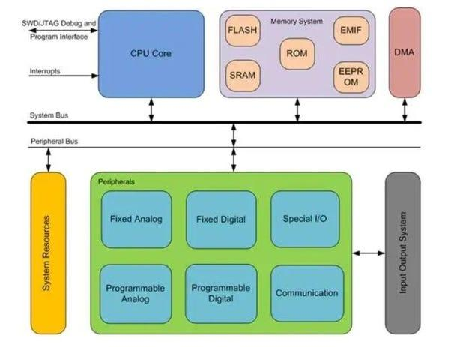
Figure 3.2: Communication Between the Processor and DDR Memory Through EMIF.

3.9 Summary
The ADSP-BF609 employs a hierarchical memory architecture consisting of registers, L1 memory, L2 SRAM, and external DDR memory to achieve a balance between execution speed and storage capacity. Internal memories provide low-latency access for performance-critical operations, while external DDR memory supports applications requiring larger storage. The Dynamic Memory Controller and External Memory Interface enable efficient communication with external memory devices, making them essential components for embedded applications involving large datasets.

3.10 Internal Memory vs External Memory
The ADSP-BF609 processor utilizes both internal and external memory to achieve an optimal balance between performance and storage capacity. Internal memory, which includes processor registers, L1 memory, and L2 SRAM, is integrated directly within the processor chip. This allows data to be accessed with very low latency, making it suitable for storing frequently executed instructions and time-critical data.
External memory, primarily DDR SDRAM, is connected to the processor through the External Memory Interface (EMIF). Although external memory provides significantly larger storage capacity, its access time is higher due to the communication required between the processor and the external memory device.
In embedded applications, developers typically place performance-critical code and frequently accessed variables in internal memory, while larger buffers, images, and communication data are stored in DDR memory.

Table 3.1 Comparison of Internal and External Memory
Feature | Internal Memory | External DDR Memory
Location | On-chip | Off-chip
Access Speed | Very Fast | Moderate
Storage Capacity | Limited | Very Large
Access Method | Direct CPU Access | Through EMIF and DMC
Typical Use | Variables, Stack, Critical Code | Large Buffers, Images, Files

3.11 Memory Mapping
Memory mapping defines how different memory regions are assigned unique address ranges within the processor's address space. Every memory location in the ADSP-BF609 has a unique address that allows the processor to identify where instructions or data are stored.
The processor divides its memory space into different regions for internal memories, peripheral registers, Boot ROM, and external DDR memory. When a program accesses a particular address, the processor automatically determines whether the request is intended for internal SRAM, peripheral registers, or external DDR memory.
Memory mapping simplifies software development because all memory devices are accessed using standard pointer operations.

3.12 Memory Read Operation
Whenever the processor needs data from memory, it performs a read operation. The processor first generates the address of the required memory location and places it on the address bus. The control unit then activates the read signal, indicating that data should be retrieved from the selected memory location.
If the requested address belongs to internal memory, the data is returned directly to the processor. If the address corresponds to external DDR memory, the request is forwarded through the EMIF and managed by the Dynamic Memory Controller before the data is transferred back to the processor.
This process is transparent to the programmer, who accesses memory using standard C pointers or variables.

3.13 Memory Write Operation
A memory write operation follows a similar sequence. The processor generates the destination address and places both the address and data on the appropriate buses. The control unit asserts the write signal, and the selected memory stores the incoming data.
For external DDR memory, the EMIF and Dynamic Memory Controller ensure that the write operation follows the timing requirements of the DDR device. After the operation is completed, the stored data can be verified by reading the same memory location.
During the internship, this process was implemented through embedded C programs that wrote integer values to predefined DDR memory addresses and later verified the correctness of the stored data using the debugger.

3.14 Importance of Memory Management
Efficient memory management is essential for developing reliable and high-performance embedded applications. Proper allocation of variables and program code improves execution speed while reducing unnecessary memory accesses.
Some benefits of effective memory management include:
- Improved execution performance.
- Reduced memory access latency.
- Efficient utilization of available memory.
- Better organization of application data.
- Improved system reliability.
- Simplified debugging and maintenance.
During this internship, practical memory management was achieved by storing data in appropriate memory regions such as L2 SRAM and DDR memory, depending on the application requirements.

CHAPTER 4

IMPLEMENTATION OF MEMORY PROGRAMMING USING CROSSCORE EMBEDDED STUDIO

4.1 Introduction
The practical component of this internship focused on understanding the memory organization of the ADSP-BF609 processor through software implementation. The objective was to develop embedded C programs that could access different regions of the processor's memory and verify successful read and write operations.
All experiments were performed using CrossCore Embedded Studio (CCES) with the ADSP-BF609 EZ-KIT evaluation board. The development environment provided facilities for writing embedded C programs, compiling source code, debugging applications, viewing processor registers, and monitoring memory contents during execution.
The implementation work concentrated on two major memory regions:
- Internal L2 SRAM
- External DDR SDRAM through the External Memory Interface (EMIF)
These experiments provided practical knowledge of memory addressing, pointer manipulation, debugger operation, and embedded memory management.

4.2 Development Environment
The following hardware and software were used during the implementation phase.

Hardware
- ADSP-BF609 EZ-KIT Development Board
- JTAG Debugger
- DDR SDRAM connected to the processor
- Personal Computer

Software
- CrossCore Embedded Studio (CCES)
- Embedded C Language
- GNU Compiler Toolchain (provided with CCES)

4.3 Project Creation in CCES
The first step involved creating a new embedded project within CrossCore Embedded Studio. A new executable project was configured by selecting the ADSP-BF609 processor as the target device. The required startup files and linker configuration were automatically included by the development environment.
After project creation, source files containing embedded C code were added. The project was then compiled using the integrated compiler, producing an executable (.DXE) file suitable for downloading onto the processor.
Successful compilation ensured that the application contained no syntax or linker errors before execution on the target hardware.

4.4 Understanding Memory Addresses
Before accessing any memory location, it was necessary to understand the processor's memory map. Each memory region occupies a predefined address range assigned by the processor architecture.
During programming, pointers were used to access specific memory locations. By assigning the base address of the desired memory region to a pointer, data could be written directly into the selected memory.
The Memory Window provided by CCES was used to verify that the data had been correctly stored.

4.5 Writing Data into L2 SRAM
The first practical experiment involved storing data within the processor's internal L2 SRAM.
A pointer was initialized to an address located inside the L2 SRAM region. Integer values were written sequentially into memory using pointer arithmetic. After execution, the Memory Window was opened to verify that the stored values matched the expected output.
The successful completion of this experiment demonstrated correct access to the processor's internal memory.

Figure 4.3
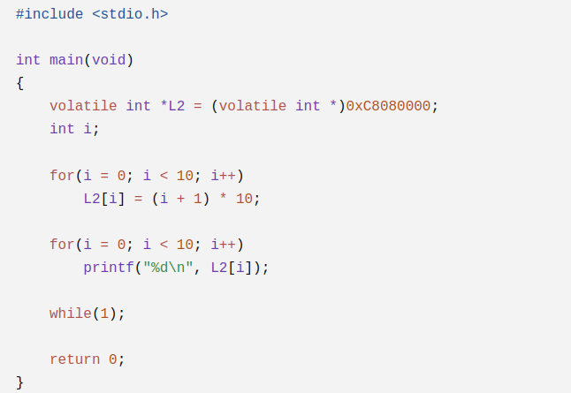
Program for Writing Data into L2 SRAM

4.6 Reading Data from L2 SRAM
After successfully storing data within L2 memory, the next step involved retrieving the stored values.
The same memory addresses were accessed using pointer variables, and the retrieved data was displayed through the debugger or console output. The retrieved values matched the previously stored values, confirming the correctness of both write and read operations.
This experiment demonstrated reliable access to internal SRAM and highlighted the low-latency characteristics of on-chip memory.

Figure 4.5
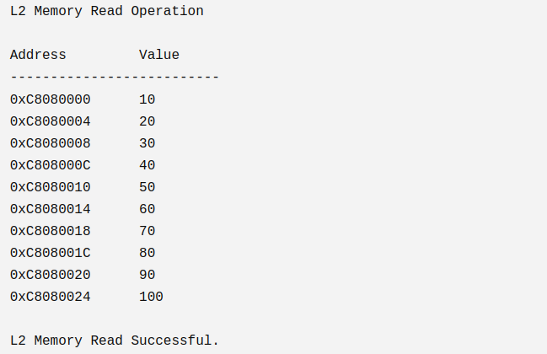
Console Output Showing L2 Read Operation

4.7 Accessing External DDR Memory
Unlike L2 SRAM, DDR SDRAM is located outside the processor and therefore requires communication through the External Memory Interface (EMIF). The Dynamic Memory Controller (DMC) manages the timing and control signals required for DDR operation.
The DDR memory was first initialized by the board support package provided with CCES. Once initialization was complete, memory locations within the DDR address space became accessible using standard pointer operations.
The processor automatically routed all external memory requests through the EMIF and DMC.

4.8 Writing Data into DDR Memory
A pointer was assigned to a valid DDR memory address. Integer values were then written into consecutive memory locations.
The program executed successfully without memory access errors, indicating proper communication between the processor and external DDR memory.
The stored values were verified using the Memory Window.

Figure 4.7
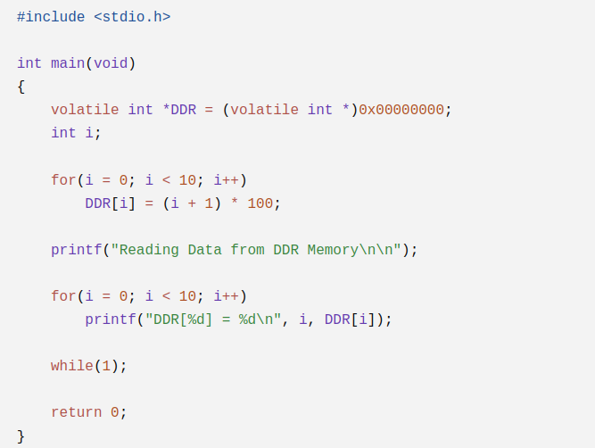
Program for Writing Data into DDR Memory

4.9 Reading Data from DDR Memory
After storing data in DDR memory, the same addresses were accessed to retrieve the stored values.
The processor generated read requests that passed through the EMIF to the DDR memory. The retrieved values were successfully returned to the processor and displayed using the debugger.
The read operation confirmed that external memory communication was functioning correctly.

Figure 4.9
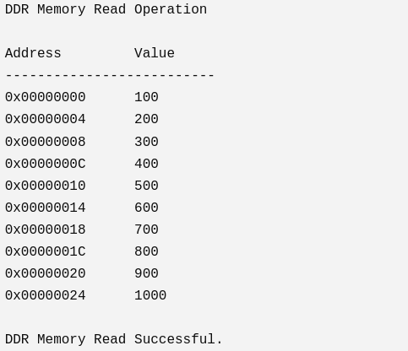
Console Output Showing DDR Read Operation

4.10 Memory Verification Using CCES
CrossCore Embedded Studio provides several debugging tools for monitoring processor execution.
The following tools were extensively used during the internship:
- Memory Window
- Registers Window
- Debug Perspective
- Breakpoints
- Console Window
The Memory Window was particularly useful for observing the contents of both L2 SRAM and DDR memory during execution. By comparing the expected values with the actual memory contents, successful execution of the programs was verified.

4.11 Challenges Faced
Several challenges were encountered during the implementation process.
- Understanding the BF609 memory map.
- Identifying valid DDR memory addresses.
- Differentiating between L1, L2, and DDR memory.
- Learning pointer-based memory access.
- Understanding EMIF and DMC operation.
- Verifying data using debugger tools.
- Configuring the development environment correctly.
Each challenge was addressed through repeated experimentation, consultation of the hardware reference manual, and practical debugging using CrossCore Embedded Studio.

4.12 Learning Outcomes
The implementation work provided practical exposure to several important embedded system concepts.
The major learning outcomes include:
- Understanding the architecture of the ADSP-BF609 processor.
- Working with internal and external memory.
- Programming L2 SRAM.
- Programming DDR SDRAM.
- Understanding the role of EMIF.
- Using pointer-based memory access.
- Working with the CCES debugger.
- Verifying memory contents.
- Understanding processor memory hierarchy.

CHAPTER 5

RESULTS AND CONCLUSION

5.1 Results
The experiments performed during the internship successfully demonstrated memory access on the ADSP-BF609 processor.
The developed programs correctly wrote and retrieved data from both L2 SRAM and external DDR memory. Memory verification using the CCES debugger confirmed that the stored values were preserved accurately.
The implementation also validated the operation of the External Memory Interface and the Dynamic Memory Controller during DDR memory transactions.

Table 5.1 Experimental Results
Experiment | Result
L2 Memory Write | Successful
L2 Memory Read | Successful
DDR Memory Write | Successful
DDR Memory Read | Successful
Memory Verification | Successful
Debugger Verification | Successful

5.2 Skills Acquired
During the internship, the following technical skills were developed:
- Embedded C Programming
- Processor Architecture Analysis
- Memory Programming
- Pointer Manipulation
- CrossCore Embedded Studio
- Debugging Techniques
- Memory Window Analysis
- DDR Memory Access
- L2 SRAM Programming
- Understanding of EMIF and DMC

5.3 Future Scope
The work carried out during this internship provides a strong foundation for more advanced embedded system development. Future enhancements may include:
- DMA-based memory transfer between L2 SRAM and DDR memory.
- Performance comparison of L1, L2, and DDR memory.
- Cache optimization techniques.
- Multi-core programming on the BF609.
- Real-time operating system (RTOS) integration.
- Peripheral communication using SPI, UART, and Ethernet.
- Image and signal processing applications utilizing DDR memory.

5.4 Conclusion
This internship provided valuable practical experience in understanding the architecture and memory organization of the ADSP-BF609 Blackfin processor. Through the use of CrossCore Embedded Studio, embedded C programs were successfully developed to access both internal L2 SRAM and external DDR SDRAM.
The study enhanced understanding of the processor's memory hierarchy, including registers, L1 memory, L2 SRAM, and DDR memory, along with the role of the Dynamic Memory Controller and External Memory Interface in facilitating external memory communication.
Successful implementation and verification of read and write operations demonstrated the practical application of embedded memory programming concepts. The use of debugging tools such as the Memory Window and Registers Window further strengthened knowledge of processor operation and memory management.
Overall, the internship significantly improved practical skills in embedded systems programming, processor architecture, memory interfacing, and debugging techniques, providing a strong foundation for future work involving real-time embedded applications and advanced processor programming.

References
- Analog Devices, ADSP-BF609 Blackfin Processor Hardware Reference Manual.
- Analog Devices, ADSP-BF609 Programming Reference Manual.
- CrossCore Embedded Studio User Guide.
- Blackfin Processor Programming Reference.
- JEDEC Standard for DDR SDRAM.
- Embedded Systems Architecture by Tammy Noergaard.

