**Question 2, 3, 4(a)**

a6 Nominal

cageg Nominal

fidg Ordinal

b10 Numeric

d1 Ordinal

d6 Ordinal

e3 Ordinal

e4 Numeric

stunting Nominal

Code Definition Data Type

0 a6 House floor type Numeric

1 b10 AN Care visit times during pregnancy Numeric

2 cageg Child's age Numeric

3 d1 main source of drinking water Numeric

4 d6 Toilet facility type Numeric

5 e3 Main Food Numeric

6 e4 Minimum dietary diversity at least 4 out of 8 ... Numeric

7 fidg Family monthly income (USD) Numeric

8 stunting Childhood stunting Numeric

The NULL values in dataset are: 0

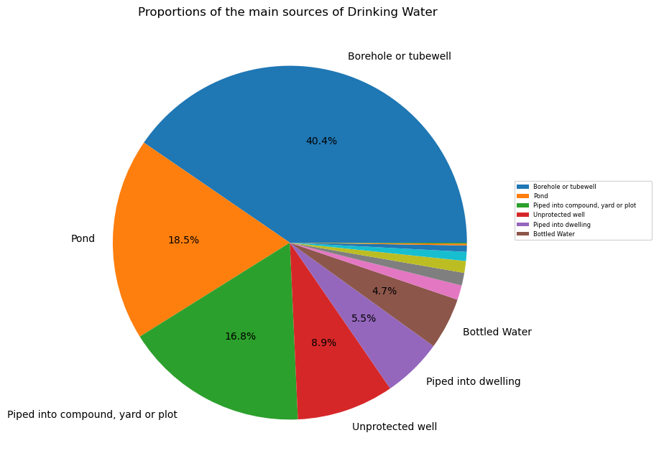

**Question 4(b) –**

**Question 5(a) –**

**Null Hypothesis: There is no association between childhood stunting and family income.**

**Alternate Hypothesis: There is an association between childhood stunting and family income.**

**Chi-square statistic: 17.374152161013605**

**P-value: 3.069723517755396e-05**

**Reject the null hypothesis. There is an association between childhood stunting and family income.**

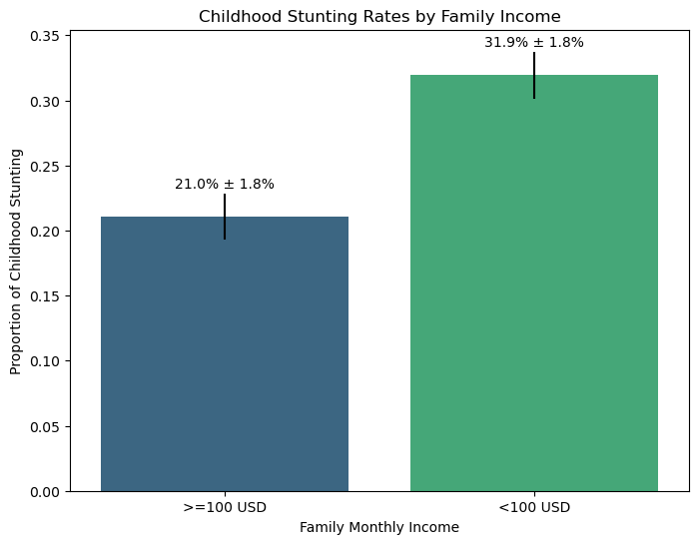

**Question 5(b) –**

**Null Hypothesis: There is no association between fulfilling minimum dietary diversity and stunting.**

**Alternate Hypothesis: There is an association between fulfilling minimum dietary diversity and stunting.**

**Chi-square statistic: 7.070862349908218**

**P-value: 0.007834753774511692**

**Reject the null hypothesis. There is an association between fulfilling minimum dietary diversity and stunting.**

**----------------------------------------------------------**

**The rejection of the null hypothesis, indicating an association between fulfilling minimum dietary diversity and childhood stunting, aligns with the abstract's suggestion that there is an association between these factors. This consistency between the study's findings and the information presented in the abstract supports the abstract's claims regarding the relationship between minimum dietary diversity and childhood stunting.**

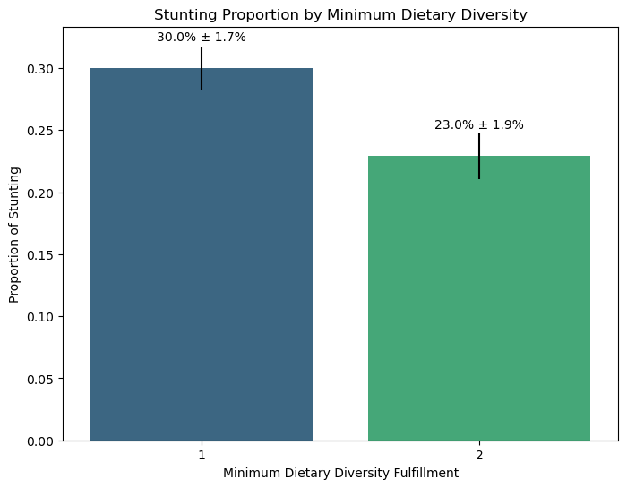

**Question 5 c –**

Null Hypothesis:

There is no association between the type of toilet and stunting. The distribution of stunting is the same across different types of toilets.

Alternative Hypothesis: There is an association between the type of toilet and stunting. The distribution of stunting is different across different types of toilets.

--------

When the dependent variable (in this case, stunting) is binary, and the independent variable is categorical, a chi-square test for independence will be used to assess whether there is an association between the two variables.

---------

Chi-square statistic: 123.22513129003644

P-value: 1.63038069579513e-23

----------------------------------------

Reject the Null Hypothesis. There is an association between the type of toilet and stunting. The distribution of stunting is different across different types of toilets.

--------------------------------------------

1-way ANOVA is typically used when the dependent variable is continuous, and you want to compare means across different levels of a categorical independent variable. Since stunting is binary in your case (0 or 1), a chi-square test for independence is more appropriate for assessing the association between stunting and the type of toilet.