**Q 5A) Explain the concept of aggregation in MongoDB with an Example.**

**Ans)**

Aggregation operations process data records and return computed results. Aggregation operations group values from multiple documents together, and can perform a variety of operations on the grouped data to return a single result.

MongoDB provides three ways to perform aggregation: the [aggregation pipeline](https://docs.mongodb.com/manual/aggregation/#aggregation-framework), the [map-reduce function](https://docs.mongodb.com/manual/aggregation/#aggregation-map-reduce), and [single purpose aggregation methods](https://docs.mongodb.com/manual/aggregation/#single-purpose-agg-operations).

**Syntax of aggregate() method:-**

>db.COLLECTION_NAME.aggregate(AGGREGATE_OPERATION)

**Q 5B) Create an “automobile” database and “Car” table, add columns Model_no, Model_name, catogery, price, mileage and write a PHP script for the same in which create two different database objects, one to insert the details into the table by taking the user input and the other object to display the inserted details using HTML tabular format.**

**Ans)**

<!DOCTYPE html>

<html>

<head>

<title>Automobile Database</title>

</head>

<style>

table, td{

border : 1px solid black;

border-collapse : collapse;

}

td{

padding: 5px;

}

</style>

<body>

<form action="" method="post">

Enter the Model No:

<br><input type="text" name="Modelno"><br>

<br>Enter the Model Name:<br>

<input type="text" name="Modelname"><br>

<br>Enter the Category: <br>

<input type="text" name="category"><br>

<br>Enter the Price:<br>

<input type="text" name="price"><br>

<br>Enter the Mileage:<br>

<input type="text" name="mileage"><br>

<br>&nbsp;<input type="submit" name="submit" value= "Submit">

</form>

</body>

</html>

<?php

$localhost = "localhost";

$username = "root";

$password = "";

$db = "automobile";

// $con = new mysqli($localhost,$username,$password);

$con_insert = new mysqli($localhost,$username,$password,$db);

$con_display = new mysqli($localhost,$username,$password,$db);

if ($con_insert->connect_error && $con_display->connect_error) {

die("Connection failed for Insert: " . $con_insert->connect_error ."Connection failed for Display" .$con_display->connect_error);

}

if(isset($_POST['submit']))

{

$modelname = $_POST['Modelname'];

$modelno = $_POST['Modelno'];

$catogery = $_POST['category'];

$price = $_POST['price'];

$mileage = $_POST['mileage'];

// $db = "create database automobile";

// $tb = "create table cars(Modelno varchar(10), Modelname varchar(10), catogery varchar(10),

// price int,mileage varchar(10))"; // create table

$insert = "insert into cars values('$modelno','$modelname','$catogery',$price,'$mileage')";

if($con_insert->query($insert)==true){

echo "One Data Inserted";

}

else{

die("Connection failed: " . $con_insert->error);

}

}

$display = "select *from cars";

$rslt = $con_display->query($display);

if($rslt->num_rows > 0){

        while ($ob=$rslt->fetch_assoc()) {

// printf("%s \n",$ob['modelno']);

$cardata[] = $ob;

        }

}

?>

<table><br>

    <tr>

        <td>

            Model No.

</td>

        <td>

Modelname

</td>

<td>

            Category

        </td>

        <td>

Price

</td>

<td>

            Mileage

        </td>

</tr>

<?php

foreach ($cardata as $data):

echo "<tr>";

echo "<td>" . $data['Modelno'] . "</td>";

echo "<td>" . $data['Modelname'] . "</td>";

echo "<td>" . $data['catogery'] . "</td>";

echo "<td>" . $data['price'] . "</td>";

echo "<td>" . $data['mileage'] . "</td>";

echo "</tr>";

endforeach;

?>

</table>

**Output: -**

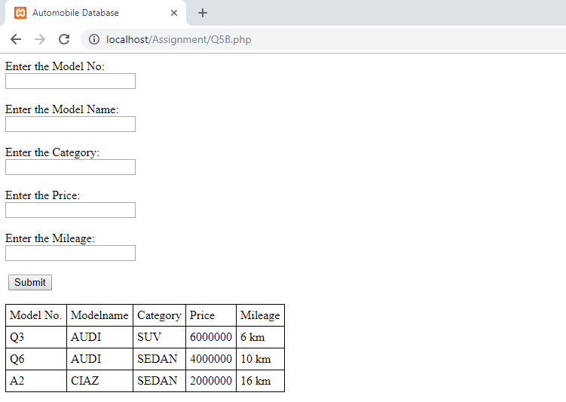

**Q 6A) What is indexing in a database and what are the types of Indexing in MongoDB?**

**Ans)**

Indexing is a way to optimize performance of a database by minimizing the number of disk accesses required when a query is processed.

An index or database index is a data structure which is used to quickly locate and access the data in a database table.

What the DBMS will do when you ask for a specific row, it will go sequentially and check with every row; “Is this the row that I need?”, If yes return it, if no, keep searching till the end.

But we have a better way to do that. An index, as we’ve mentioned, is a data structure, it won’t be obvious for you, but it’s stored inside the DBMS, most commonly as a B- tree.

**The types of Indexing in MongoDB are: -**

**Refer the Link:- https://docs.mongodb.com/manual/indexes/**

**Q 6B) Write a PHP script to generate a Tribonacci series. A Tribonacci series is a one whose first three terms are given and every successive term is the sum of the previous three terms. Example: 0 1 2 3 6 11 etc**

**Ans)**

<?php

$a = 0, $b = 1, $c = 2, $e = 14, $i=3;

$d = array($a,$b,$c);

echo "Values are: " .$a. " " .$b. " " .$c;

echo "<br>Limit: " .$e;

while($i<$e)

{

$d[$i]=$d[$i-1]+$d[$i-2]+$d[$i-3];

$i++;

}

echo "<br><br>Tribonnaci Series are: ";

foreach($d as $x => $value) {

echo " " .$value. "," ;

}

?>

**Output:**

