AGILE DELIVERY PLAYBOOK
AutoPharm
Agile Project and Sprint Plan
A backlog-driven sprint plan for delivering frontend, backend, database, and verification together
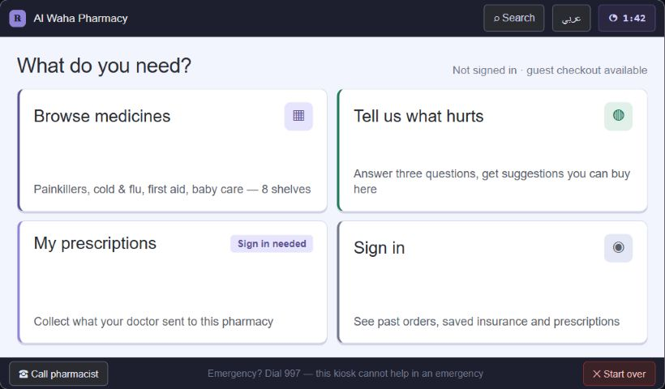
Figure - main kiosk routes and guest-first entry points (screen C in the supplied kiosk design)
Prepared from 01-requirements.md, 02-technology-stack.md, CONTRIBUTING.md, and Pharmacy Kiosk.dc.html

How to use this Agile plan
The project is delivered through a prioritized product backlog and short, time-boxed sprints. Each sprint should produce a complete, demonstrable vertical slice rather than separate frontend-only, backend-only or database-only batches. The proposed cadence is two weeks per sprint, adjusted by the team after the first retrospective.
AGILE WORKING RULE A backlog item is Done only when its UI, API, database migration, automated tests, bilingual/RTL behavior, security rules, documentation and review are complete. Unfinished work returns to the product backlog; it is not counted as completed sprint scope.

Agile roles and ceremonies
- Product ownership: the five-person team jointly prioritizes the academic product backlog; one rotating member facilitates acceptance decisions for each sprint.
- Sprint planning: select only stories that meet the Definition of Ready, estimate them, identify dependencies and agree on a sprint goal.
- Daily stand-up: 15 minutes to expose progress, next work, blockers and cross-layer handoffs.
- Backlog refinement: once per week to split large stories, clarify acceptance criteria and prepare the next sprint.
- Sprint review: demonstrate working software at 1024x600 plus AutoDoc/backend evidence; stakeholders accept or return stories.
- Retrospective: agree on one or two measurable process improvements for the following sprint.

Source interpretation
- The requirements and technology-stack documents control scope and architecture.
- The HTML controls visual intent and interaction examples only; labels and sample data are not requirements.
- CONTRIBUTING.md controls branch, pull-request, review, migration, screenshot, test, and sensitive-data practices.
CORRECTION REQUIRED The HTML still contains Saudi examples (SAR, +966, Mada, Amana and Saudi-style pharmacy data). Replace these with Egyptian examples before implementation: EGP, 010/011/012/015 mobile validation stored as E.164, and fictional Egypt-appropriate payment/insurance content.

Recommended product decisions before Sprint 3
- Choose rule-based symptom guidance for the build, with an optional LLM phrasing layer only after the deterministic flow passes. This keeps red-flag behavior testable and supports offline use.
- Choose a realistic but bounded insurance model: per-category coverage percentage, annual/transaction cap, exclusions and co-pay. It is richer than a flat rate without becoming an insurer platform.

Team structure and ownership
TEAM MODEL Managers are hands-on technical leads. They coordinate architecture, review and integration while still implementing sprint work. Every story has one primary owner and at least one reviewer from the other technical layer when it crosses frontend, backend or data boundaries.

Member | Role | Standing responsibilities
Boda | Frontend & Design Manager | Design system, kiosk UX, frontend architecture, task coordination, UI review and sprint-demo quality.
Negm | Backend & Database Manager | Domain architecture, API contracts, PostgreSQL design, migrations, backend coordination, integrity and security review.
Ahmed Sherif | Backend Member | Django services/endpoints, integrations, state machines, background jobs and backend tests.
Wela | Frontend Member | Primary kiosk/AutoDoc feature implementation, component behavior and frontend integration tests.
Nasser | Frontend Member | Supporting and failure states, Arabic/RTL, accessibility, responsive behavior and end-to-end test support.

Review and handoff rules
- Boda approves visual/design consistency; Wela or Nasser reviews the implementing frontend member's code.
- Negm approves migrations, domain rules and data integrity; Ahmed Sherif reviews or pairs on backend implementation where practical.
- Authentication, prescriptions, inventory, insurance, payment, dispensing, audit and device-agent changes require cross-layer review from both managers.
- No story is handed over with undocumented assumptions. API examples, acceptance criteria and error states travel with the story.

Pre-implementation workspace and project-structure planning
MANDATORY GATE This planning workshop and its written decisions must be completed and accepted before feature implementation begins. Sprint 0 may scaffold only the agreed structure; it must not invent a different architecture during setup.

Planning workshop outputs
- Confirm the monorepo boundaries, naming conventions, package ownership and dependency direction.
- Create a repository map showing which team member leads and reviews every major folder.
- Agree on local, test/CI, staging and offline graduation-demo profiles, including ports and environment-variable names.
- Define OpenAPI generation, shared TypeScript client generation, migration workflow and fictional seed-data workflow.
- Approve branch, pull-request, review, Definition of Ready, Definition of Done and release-label conventions.
- Record the decisions in an architecture decision record and convert the approved structure into Sprint 0 backlog stories.

Approved target workspace
AutoPharm/
apps/
kiosk-web/ React kiosk application (Boda lead; Wela/Nasser)
autodoc-web/ React clinician portal (Boda lead; Wela/Nasser)
device-agent/ Local Python hardware boundary (Negm lead; Ahmed)
backend/ Django/DRF modular monolith (Negm lead; Ahmed)
config/ settings, URLs, ASGI/WSGI, Celery bootstrap
modules/ identity, catalogue, inventory, prescriptions, orders, payments...
packages/
ui/ shared accessible components
design-tokens/ colors, type, spacing and kiosk sizing
api-client/ generated/maintained OpenAPI client
validation/ shared schemas and input rules
i18n/ Arabic/English resources and locale helpers
infrastructure/
docker/ image definitions and entrypoints
nginx/ reverse-proxy configuration
docs/ requirements, ADRs, API notes, sprint evidence
tests/ cross-application integration and E2E suites
compose.yaml local/LAN services
pnpm-workspace.yaml TypeScript workspace boundaries
package.json shared frontend scripts

Folder and dependency rules
- Applications may depend on shared packages; shared packages must never import application code.
- Both frontends call Django through the shared API client. They never access PostgreSQL or Supabase directly.
- Django modules may collaborate through explicit services/events while remaining one deployable modular monolith.
- The device agent owns hardware adapters and loopback endpoints; Django owns central authorization and business truth.
- Tests live beside units when local and under tests/ when they span applications or services.

Planning acceptance checklist
- Directory tree, naming and owners approved by all five members.
- Local setup and environment-variable template documented without secrets.
- OpenAPI/client and database migration workflows demonstrated on a small example.
- CI checks and pull-request protection agreed.
- First two sprints refined with acceptance criteria, estimates, dependencies and reviewers.
- D-4 symptom-engine and D-6 insurance-model decisions recorded or explicitly scheduled before dependent stories.

Agile sprint roadmap at a glance
Sprint | Sprint goal | Primary review demonstration
0 | Foundation and contracts | Repository, CI, shared types, terminal identity
1 | Session, language and shell | Attract, language, RTL, timeout, start over
2 | Catalogue and cart | Search, stock, reservation, product detail
3 | Symptom guidance | Questions, red flags, ranked stocked OTC
4 | Customer authorization | PIN, SMS, lockout, reset, QR boundary
5 | AutoDoc and prescriptions | Clinician auth, draft, sign, revoke
6 | Kiosk prescription fulfilment | Atomic partial dispensing
7 | Insurance | Eligibility, adjudication, claim simulation
8 | Order and payment | Idempotent payment state machine
9 | Dispensing and device agent | Signed commands, journal, recovery
10 | Receipts and history | Print/email/account/ETA simulation
11 | Offline and maintenance | Degradation, sync, technician mode
12 | Operations and release | Back office, audit, monitoring, rehearsal
Suggested milestone progression: 0.1.0 foundation, 0.2.0 session/authentication, 0.3.0 catalogue/cart, 0.4.0 prescriptions, 0.5.0 payment/dispensing, 0.6.0 insurance, 0.7.0 receipts, 0.8.0 hardware, 0.9.0 feature-complete rehearsal, 1.0.0 graduation release.

Sprint 0: Foundation, contracts and engineering controls
DONE MEANS A reproducible monorepo boots locally and in CI; frontend, Django, PostgreSQL and test tooling share versioned contracts and safe configuration.

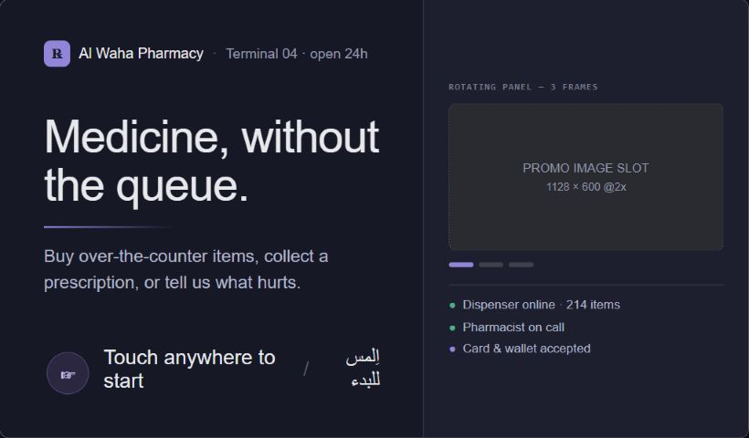
Figure - attract screen and terminal-operational status (screen A in the supplied kiosk design)
Frontend
- Create pnpm workspace, kiosk-web and autodoc-web shells, shared design tokens, UI, i18n, validation and API-client packages.
- Fix the kiosk viewport at 1024x600 while retaining responsive AutoDoc layouts; bundle assets locally with no runtime CDN dependency.
- Add error boundary, loading, offline and unavailable-feature primitives before feature screens.
Backend and integration
- Create Django/DRF project with modular domain apps, OpenAPI generation, health/version endpoints and environment profiles.
- Define terminal authentication, correlation IDs, idempotency conventions, audit-event interface and explicit state-machine base patterns.
- Create Docker Compose for PostgreSQL and Django; add Redis/Celery later, after core domain stability.
Database
- Create PostgreSQL baseline migration for principal, terminal, audit event and idempotency record.
- Add seed tooling for fictional bilingual catalogue and demo identities; prohibit real patient or clinician data.
- Document backup/restore commands and migration ownership.
Verification and exit gate
- CI runs formatting, linting, TypeScript checks, frontend tests, Pytest and OpenAPI validation.
- A clean checkout starts through one documented developer command and reports matching component versions.
- Pull-request template requires issue link, screenshots for UI changes, migrations with model changes and domain review for sensitive areas.
Team assignment
- Boda - frontend/design lead: owns UX decisions, frontend review, visual acceptance and sprint-demo preparation.
- Negm - backend/database lead: owns domain/API/database decisions, migrations, backend review and data integrity.
- Ahmed Sherif - backend: implements services, endpoints, integrations and backend automated tests with Negm.
- Wela - frontend: implements the primary kiosk/AutoDoc flow and frontend component/integration tests.
- Nasser - frontend: implements supporting/error/RTL states, accessibility checks and end-to-end test support.
DESIGN / SCOPE NOTE Keep the modular monolith. Do not introduce microservices, GraphQL, direct frontend-to-Supabase access, or a repository class for every Django model.

Backlog prerequisites: None

Sprint 1: Kiosk session, language, accessibility and shell
DONE MEANS A person can start anonymously, explicitly choose Arabic or English, use a mirrored kiosk shell, receive timeout warning, extend or cancel, and leave no session data behind.

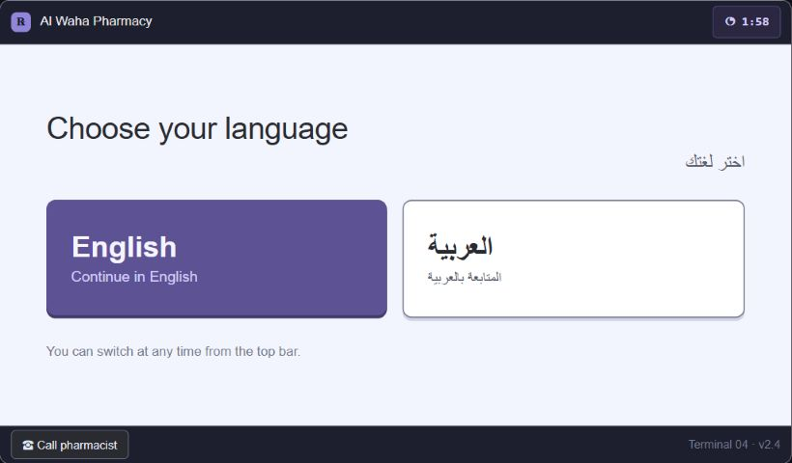
Figure - mandatory first-step language selection (screen B in the supplied kiosk design)
Figure - guest-first main menu (screen C in the supplied kiosk design)
Frontend
- Implement attract, explicit equal language choices, main navigation, Arabic/English messages, RTL mirroring and locale numerals.
- Create global countdown, warning modal, extend-session and Start Over controls; disable termination during protected payment/dispense states.
- Meet touch-target, contrast, keyboard/focus, screen-reader-label and 1024x600 no-scroll requirements.
Backend and integration
- Create kiosk-session API bound to terminal identity with anonymous default and short-lived server record.
- Issue/bind customer tokens to terminal and kiosk session; support server-driven session termination and privacy-safe heartbeat.
- Return capability flags for online/offline availability without exposing sensitive terminal credentials to JavaScript.
Database
- Store terminal, kiosk session lifecycle, selected locale, non-sensitive status and opaque correlation ID.
- Do not persist symptom answers, cart contents or identity in the session table after termination; record only privacy-safe audit facts.
Verification and exit gate
- English and Arabic critical-path screenshots pass at 1024x600; RTL reading order and physical directions are correct.
- Expiry, cancellation and completion erase browser state, tokens and server session attachments.
- Payment/dispense terminal-state guard prevents unsafe timeout termination.
Team assignment
- Boda - frontend/design lead: owns UX decisions, frontend review, visual acceptance and sprint-demo preparation.
- Negm - backend/database lead: owns domain/API/database decisions, migrations, backend review and data integrity.
- Ahmed Sherif - backend: implements services, endpoints, integrations and backend automated tests with Negm.
- Wela - frontend: implements the primary kiosk/AutoDoc flow and frontend component/integration tests.
- Nasser - frontend: implements supporting/error/RTL states, accessibility checks and end-to-end test support.
Backlog prerequisites: Sprint 0

Sprint 2: Catalogue, inventory, search, product detail and cart reservations
DONE MEANS A guest browses or searches only stocked products, sees bilingual detail and live stock, and maintains a cart protected by expiring stock reservations.

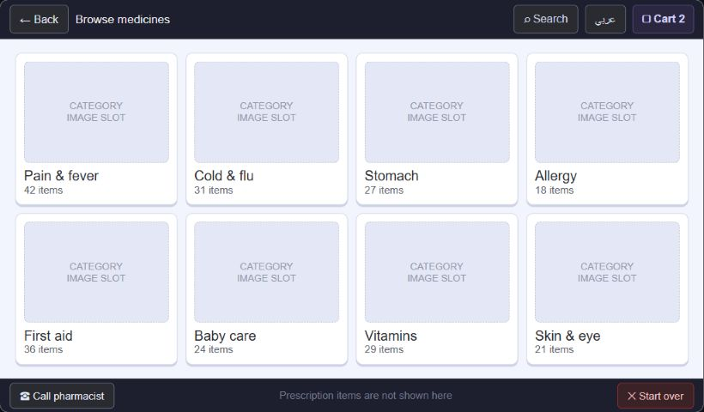
Figure - category-first catalogue navigation (screen D in the supplied kiosk design)
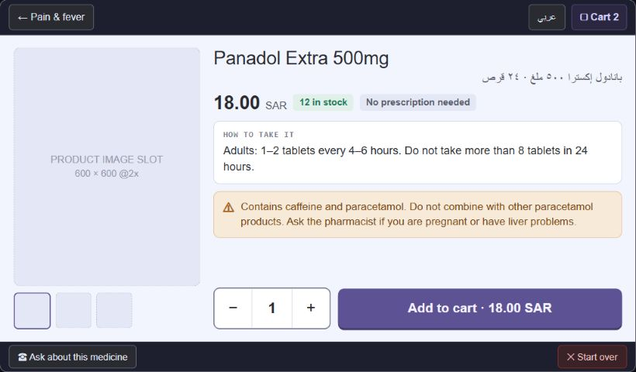
Figure - product detail and add-to-cart action (screen G in the supplied kiosk design)
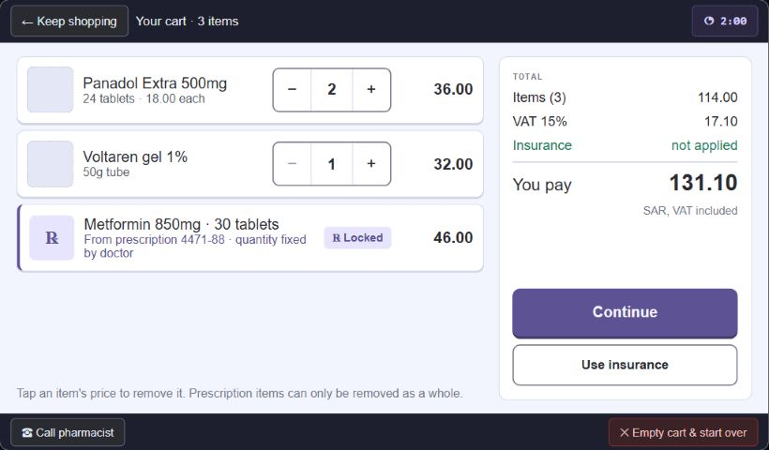
Figure - mixed cart with totals (screen O in the supplied kiosk design)
Frontend
- Implement category browse, bilingual fuzzy search, results, product detail, prescription badge, stock status, quantity controls and running total.
- Show loading, empty, offline-snapshot, newly-out-of-stock and reservation-expired states.
- Keep prescription-only products non-addable until a validated prescription supplies an authorized line.
Backend and integration
- Expose terminal-scoped catalogue/search/detail endpoints and cart/reservation commands.
- Implement PostgreSQL-backed soft reservations with expiry, regulatory quantity caps and transactional conflict handling.
- Publish catalogue/price/planogram versions for safe non-sensitive local snapshots.
Database
- Model product, bilingual content, ingredient, category, dosage form, regulatory class, terminal, slot/planogram, stock batch and reservation.
- Use constraints and indexes for SKU uniqueness, terminal stock lookup, expiry and reservation status.
Verification and exit gate
- Concurrent reservation tests use real PostgreSQL and prove no oversell.
- Search handles Arabic/English, partial brand/generic/ingredient terms and representative misspellings.
- Mid-session stock loss is shown before payment; expired reservation releases stock idempotently.
Team assignment
- Boda - frontend/design lead: owns UX decisions, frontend review, visual acceptance and sprint-demo preparation.
- Negm - backend/database lead: owns domain/API/database decisions, migrations, backend review and data integrity.
- Ahmed Sherif - backend: implements services, endpoints, integrations and backend automated tests with Negm.
- Wela - frontend: implements the primary kiosk/AutoDoc flow and frontend component/integration tests.
- Nasser - frontend: implements supporting/error/RTL states, accessibility checks and end-to-end test support.
DESIGN / SCOPE NOTE The screenshot currency and country examples must be changed to Egypt before frontend acceptance.

Backlog prerequisites: Sprints 0-1

Sprint 3: Rule-based symptom guidance and pharmacist escalation
DONE MEANS A guest completes the minimum three-step assessment, red flags stop recommendations, and safe results contain only stocked OTC products with rationale and disclaimer.

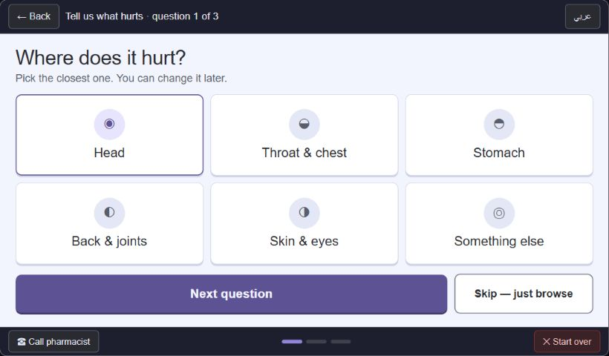
Figure - stepwise symptom question with visible progress (screen H1 in the supplied kiosk design)
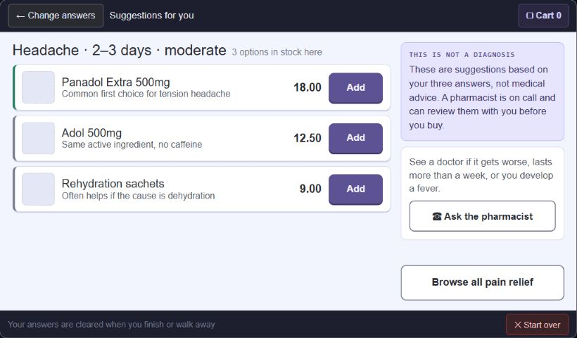
Figure - stocked OTC suggestions with safety language (screen H4 in the supplied kiosk design)
Frontend
- Implement one-question-at-a-time symptom, duration, severity and red-flag screens with persistent emergency/pharmacist escape.
- Render recommendation rationale without diagnosis claims; show disclaimer on every result screen.
- Clear answers on start-over, timeout, completion and navigation away from the flow.
Backend and integration
- Implement a versioned deterministic rules engine, red-flag evaluator and terminal-stock filter behind an interface.
- Return explainable matched rules and safe escalation outcome; never send health answers to analytics logs.
- Optional later LLM may phrase an already-approved explanation but cannot choose products or override red flags.
Database
- Model symptom concept, question, answer option, rule version, condition predicate, red flag, recommendation mapping and content translation.
- Store no identifiable session answer history; analytics, if added, use irreversible aggregation.
Verification and exit gate
- Every red-flag class routes away from recommendations.
- Only OTC, in-stock, non-contraindicated mapped items appear; no response states or implies a diagnosis.
- Versioned rules run offline from a validated snapshot and match online results.
Team assignment
- Boda - frontend/design lead: owns UX decisions, frontend review, visual acceptance and sprint-demo preparation.
- Negm - backend/database lead: owns domain/API/database decisions, migrations, backend review and data integrity.
- Ahmed Sherif - backend: implements services, endpoints, integrations and backend automated tests with Negm.
- Wela - frontend: implements the primary kiosk/AutoDoc flow and frontend component/integration tests.
- Nasser - frontend: implements supporting/error/RTL states, accessibility checks and end-to-end test support.
DESIGN / SCOPE NOTE Recommended decision: rule-based BUILD. Treat any LLM wording layer as optional and strictly downstream of deterministic safety logic.

Backlog prerequisites: Sprints 1-2 plus decision D-4

Sprint 4: Customer authorization, account recovery and identity boundary
DONE MEANS A customer signs up or signs in only when needed using Egyptian mobile + four-digit PIN, with SMS verification/reset, lockout and guest continuation.

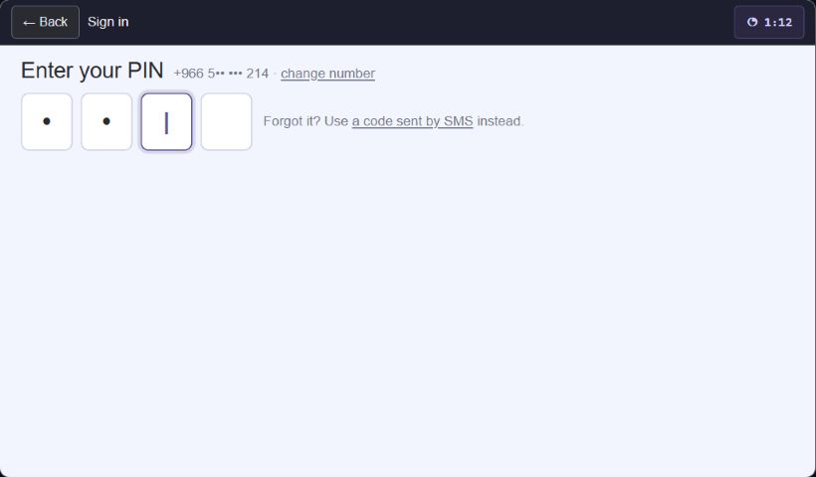
Figure - large numeric PIN entry (screen J in the supplied kiosk design)
Frontend
- Implement prescription/insurance/history sign-in gates, phone entry, masked PIN keypad, signup, six-digit SMS verification, Forgot PIN sequence, resend and guest fallback.
- Validate Egyptian national prefixes and normalize display while the server stores E.164.
- Add QR fast-path UI as an authenticated handoff boundary, not a credential embedded in the QR payload.
Backend and integration
- Separate principal/profile from PIN credential, verification challenge, recovery challenge and kiosk session.
- Hash PIN with the strongest configured Django hasher; rate-limit per phone, terminal and source; enforce temporary exponential lockout and reject common PINs.
- Issue short-lived customer sessions bound to terminal and kiosk session; never expose AutoDoc routes.
Database
- Model principal, customer profile, credential, verification/recovery challenge, failed-attempt counters, lockout and authenticated session.
- Store challenge hashes, expiries, issued-at, used-at and replacement lineage; never store plaintext PIN or code.
Verification and exit gate
- Lockout cannot be bypassed with another kiosk; reset code is six digits, single-use, expiring and invalidated by replacement/use.
- SMS failure offers resend and guest continuation.
- Session end revokes identity and removes personal data from the kiosk.
Team assignment
- Boda - frontend/design lead: owns UX decisions, frontend review, visual acceptance and sprint-demo preparation.
- Negm - backend/database lead: owns domain/API/database decisions, migrations, backend review and data integrity.
- Ahmed Sherif - backend: implements services, endpoints, integrations and backend automated tests with Negm.
- Wela - frontend: implements the primary kiosk/AutoDoc flow and frontend component/integration tests.
- Nasser - frontend: implements supporting/error/RTL states, accessibility checks and end-to-end test support.
DESIGN / SCOPE NOTE Replace the mock +966 number with fictional Egyptian examples. Keep the four-digit PIN / six-digit reset-code asymmetry explicit.

Backlog prerequisites: Sprints 0-1

Sprint 5: AutoDoc clinician authorization and prescription lifecycle
DONE MEANS An invited, MFA-authenticated clinician can create, sign and revoke structured prescriptions; an assistant may draft but cannot issue or revoke.

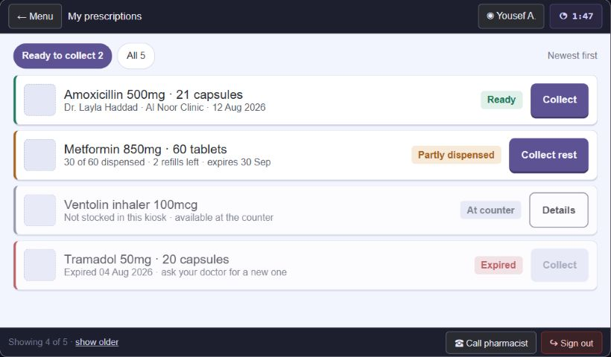
Figure - kiosk view of prescriptions produced by AutoDoc (screen M in the supplied kiosk design)
Frontend
- Build independent AutoDoc routes and shell using shared design tokens but a separate security boundary.
- Implement invitation activation, strong-password login, TOTP MFA, patient match, structured draft editor, signing reauthentication, issue/revoke and audit views.
- Clearly separate assistant draft permissions from prescriber-only actions.
Backend and integration
- Implement invitation-only clinician auth, simulated registry verification, organization membership, role, professional credential, prescribing privilege and delegation.
- Create prescription draft/sign/revoke services; sign an immutable canonical prescription payload and expose patient-scoped retrieval to kiosks.
- Exclude controlled/narcotic medicines from the prototype and reject unauthorized scope server-side.
Database
- Model organization, membership, professional credential, privilege, delegation, invitation, MFA enrollment, prescription, line, signature and status history.
- Preserve immutable signed content and append-only revocation/status events; use optimistic or explicit concurrency control.
Verification and exit gate
- Public clinician registration is impossible; invitation, MFA and verified simulated credential are required.
- Assistant can save a draft but cannot sign, issue or revoke; administrator role alone grants no prescribing authority.
- Signature verification detects any change to signed structured data.
Team assignment
- Boda - frontend/design lead: owns UX decisions, frontend review, visual acceptance and sprint-demo preparation.
- Negm - backend/database lead: owns domain/API/database decisions, migrations, backend review and data integrity.
- Ahmed Sherif - backend: implements services, endpoints, integrations and backend automated tests with Negm.
- Wela - frontend: implements the primary kiosk/AutoDoc flow and frontend component/integration tests.
- Nasser - frontend: implements supporting/error/RTL states, accessibility checks and end-to-end test support.
Backlog prerequisites: Sprints 0 and 4

Sprint 6: Kiosk prescription retrieval and atomic partial fulfilment
DONE MEANS A signed-in customer sees current/previous prescriptions and can atomically collect available quantities without double dispensing across terminals.

Figure - current and previous prescription list (screen M in the supplied kiosk design)
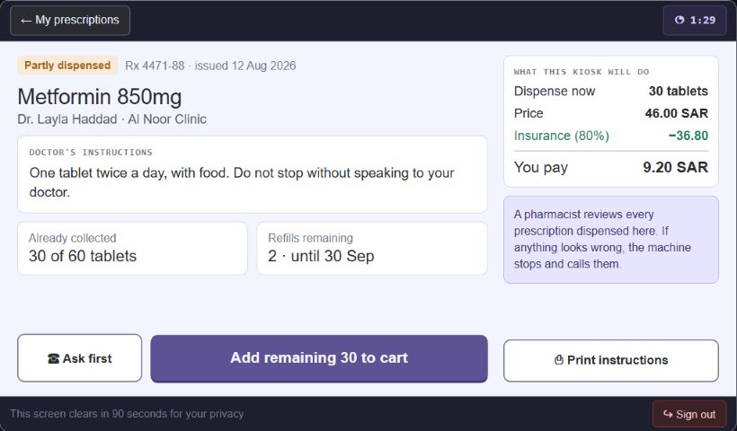
Figure - partial fulfilment and availability detail (screen N in the supplied kiosk design)
Frontend
- Implement current/previous/status views, prescriber/clinic/date metadata, line availability, prior quantity, remaining refills and reason for unfulfillable items.
- Allow only available authorized quantity to enter the cart; make partial fulfilment and privacy timeout explicit.
- Provide pharmacist-review/escalation state where policy requires it.
Backend and integration
- Authorize prescription reads per active customer session; never cache prescription contents beyond the session.
- Use atomic PostgreSQL transactions and row locking for fulfilment allocation, refill decrement and stock reservation.
- Create signed short-lived dispense authorization scoped to terminal, order, lines, quantities, expiry and nonce.
Database
- Add prescription fulfilment, allocation, dispense authorization, nonce and line-level quantity ledger.
- Enforce invariants preventing dispensed quantity from exceeding authorized quantity and preventing nonce reuse.
Verification and exit gate
- Two terminals cannot dispense the same units; concurrent partial fulfilments resolve safely.
- Expired, revoked and fully dispensed prescriptions are non-dispensable with clear UI status.
- Privacy timeout and sign-out remove prescription data from browser caches and memory.
Team assignment
- Boda - frontend/design lead: owns UX decisions, frontend review, visual acceptance and sprint-demo preparation.
- Negm - backend/database lead: owns domain/API/database decisions, migrations, backend review and data integrity.
- Ahmed Sherif - backend: implements services, endpoints, integrations and backend automated tests with Negm.
- Wela - frontend: implements the primary kiosk/AutoDoc flow and frontend component/integration tests.
- Nasser - frontend: implements supporting/error/RTL states, accessibility checks and end-to-end test support.
Backlog prerequisites: Sprints 2, 4 and 5

Sprint 7: Insurance eligibility, adjudication and claim simulation
DONE MEANS A signed-in customer may use or skip a saved/scanned policy; item-level coverage is explainable, failure never traps checkout, and claim transitions are durable.

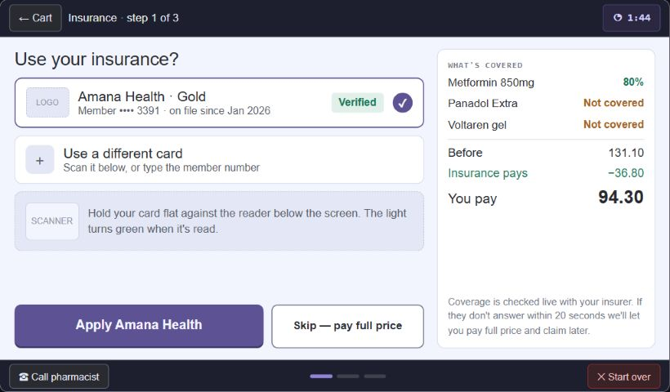
Figure - optional insurance selection and coverage summary (screen P in the supplied kiosk design)
Frontend
- Implement policy selection/card scan, verification, per-item eligibility, co-pay/coverage totals, skip and retry paths.
- Show pending, unavailable, declined, partial coverage and continue-without-insurance states.
- Never reveal full policy identifiers on the kiosk.
Backend and integration
- Create insurer-adapter interface and realistic simulated adjudicator with idempotent eligibility/claim requests.
- Apply bounded rules: product/category coverage, percentage, cap, exclusion and co-pay; record explainable result.
- Use Celery only after request state is durable; retries must not duplicate claims.
Database
- Model insurer, customer policy token/reference, coverage rule, eligibility request/result, claim, claim line and status history.
- Encrypt or minimize sensitive policy data and keep it out of logs.
Verification and exit gate
- Retry and duplicate request reuse the same idempotent result.
- Unverifiable insurance can be skipped without losing cart or prescription allocation.
- Totals reconcile at line and order level for eligible, excluded, capped and mixed carts.
Team assignment
- Boda - frontend/design lead: owns UX decisions, frontend review, visual acceptance and sprint-demo preparation.
- Negm - backend/database lead: owns domain/API/database decisions, migrations, backend review and data integrity.
- Ahmed Sherif - backend: implements services, endpoints, integrations and backend automated tests with Negm.
- Wela - frontend: implements the primary kiosk/AutoDoc flow and frontend component/integration tests.
- Nasser - frontend: implements supporting/error/RTL states, accessibility checks and end-to-end test support.
DESIGN / SCOPE NOTE Recommended D-6 model: per-category coverage with caps, exclusions and co-pay. Keep insurers simulated but generate real request/response structures.

Backlog prerequisites: Sprints 2, 4 and 6 plus decision D-6

Sprint 8: Order orchestration and payment state machine
DONE MEANS An order moves through durable, idempotent payment states; raw card data never enters AutoPharm, and cancellation/failure/timeout are safely explained.

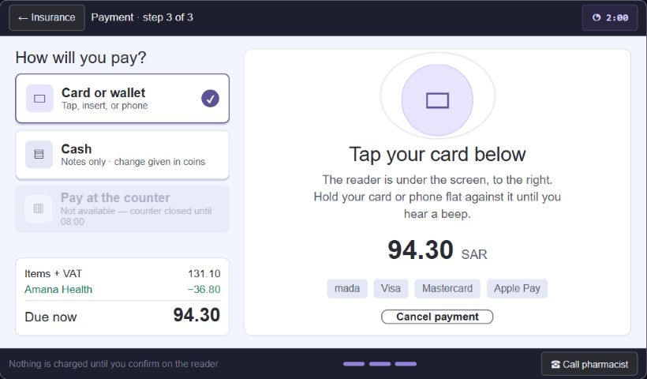
Figure - payment method, reader direction and amount (screen Q in the supplied kiosk design)
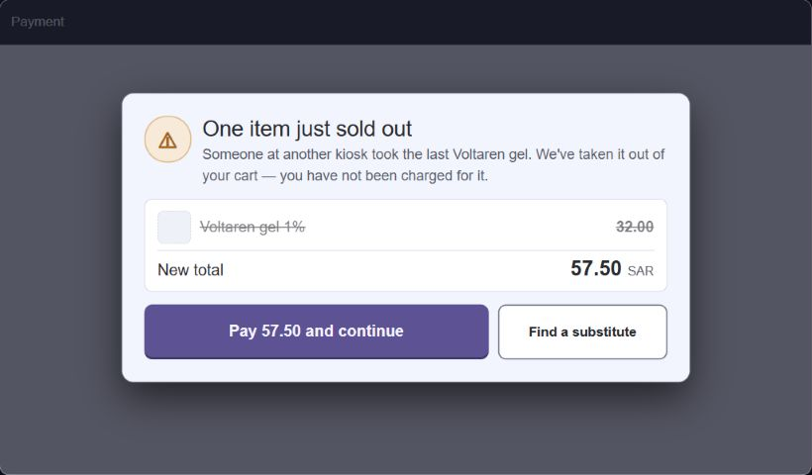
Figure - stock change before charging (screen U2 in the supplied kiosk design)
Frontend
- Implement payment-method selection, reader/cash instructions, amount breakdown, safe cancel and explicit pending/declined/timeout/unknown states.
- Block session expiry while payment is in flight and re-check stock/reservations before authorization.
- Make physical reader directions RTL-aware and locally correct for the installed terminal.
Backend and integration
- Create order/payment orchestration with explicit transitions, idempotency keys, processor adapter and compensation/refund commands.
- Persist state before external calls; reject illegal transitions and duplicate callbacks.
- Never accept/store raw card details; integrate only processor references and sanitized results.
Database
- Model order, order line, totals snapshot, payment attempt, external reference, status transition, idempotency record and compensation/refund.
- Use immutable financial snapshots and uniqueness constraints for processor/idempotency identifiers.
Verification and exit gate
- Payment retry/callback duplication cannot double-charge or duplicate an order.
- Timeout before/after authorization and stock loss produce correct customer message and compensation state.
- All totals reconcile with inventory, insurance, taxes and paid amount.
Team assignment
- Boda - frontend/design lead: owns UX decisions, frontend review, visual acceptance and sprint-demo preparation.
- Negm - backend/database lead: owns domain/API/database decisions, migrations, backend review and data integrity.
- Ahmed Sherif - backend: implements services, endpoints, integrations and backend automated tests with Negm.
- Wela - frontend: implements the primary kiosk/AutoDoc flow and frontend component/integration tests.
- Nasser - frontend: implements supporting/error/RTL states, accessibility checks and end-to-end test support.
DESIGN / SCOPE NOTE Replace SAR/Mada examples with Egyptian demo payment content. The certified terminal remains outside browser, device agent, Django and PostgreSQL card-data scope.

Backlog prerequisites: Sprints 2, 6 and 7

Sprint 9: Dispensing, local device agent and crash recovery
DONE MEANS A paid/authorized order is dispensed through an authenticated loopback-only agent with signed commands, idempotency and a durable recovery journal.

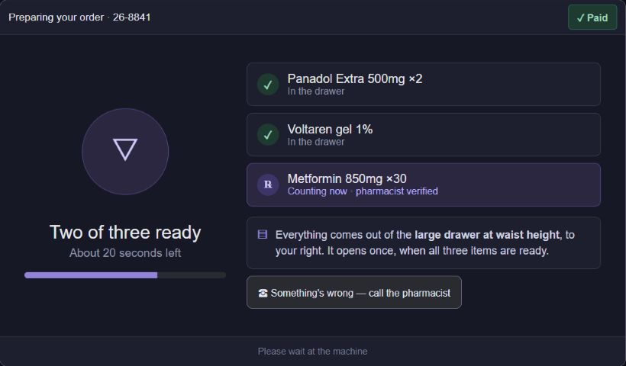
Figure - preparation and drawer instructions (screen S in the supplied kiosk design)
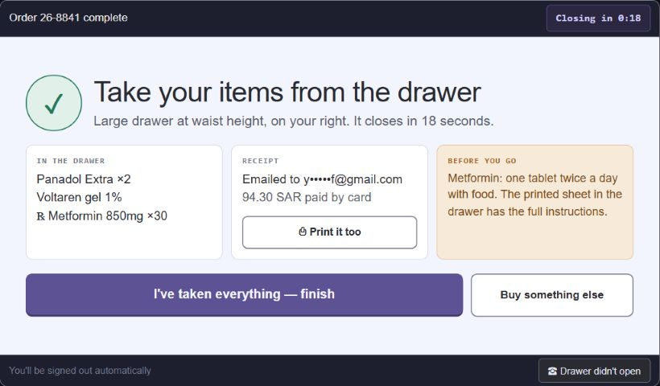
Figure - unmistakable collection completion (screen T in the supplied kiosk design)
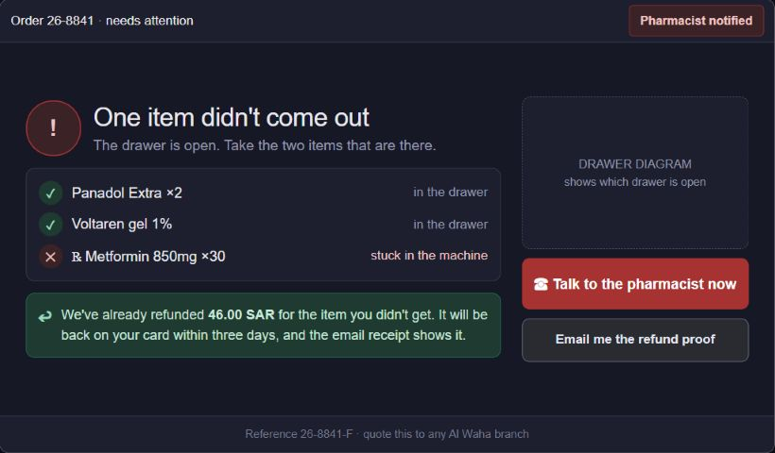
Figure - partial dispense and escalation (screen U4 in the supplied kiosk design)
Frontend
- Implement preparation progress, drawer-specific collection instructions, completion acknowledgement and needs-attention/refund guidance.
- Do not treat a spinner as proof of hardware action; display backend/agent-confirmed states.
Backend and integration
- Build Python device agent with interfaces and real/mock printer, dispenser, drawer, camera and health adapters.
- Listen on loopback, enforce allowed origin and installation authentication, validate signed online authorization or signed offline policy.
- Journal before/after irreversible action, report incomplete commands on restart and reconcile with Django using stable IDs.
Database
- Model device command, signed authorization, dispense event, drawer confirmation, reconciliation case and resolution.
- The local journal stores opaque operational IDs only - no patient, prescription, symptom, phone or card data.
Verification and exit gate
- Duplicate hardware command executes once; invalid/expired/widened authorization is rejected.
- Power loss at every irreversible boundary recovers to known state without silent double dispense.
- Partial/failed dispense opens refund/reconciliation work and preserves audit trail.
Team assignment
- Boda - frontend/design lead: owns UX decisions, frontend review, visual acceptance and sprint-demo preparation.
- Negm - backend/database lead: owns domain/API/database decisions, migrations, backend review and data integrity.
- Ahmed Sherif - backend: implements services, endpoints, integrations and backend automated tests with Negm.
- Wela - frontend: implements the primary kiosk/AutoDoc flow and frontend component/integration tests.
- Nasser - frontend: implements supporting/error/RTL states, accessibility checks and end-to-end test support.
Backlog prerequisites: Sprints 6 and 8

Sprint 10: Receipts, ETA e-receipt simulation and order history
DONE MEANS Every sale produces a real structured receipt and ETA-format signed e-receipt; delivery follows guest/account rules and remains available when the printer fails.

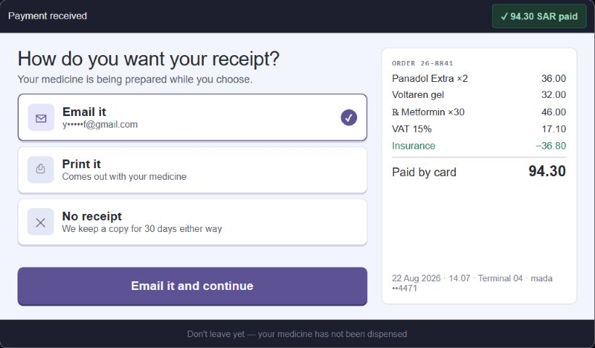
Figure - receipt delivery choices after payment (screen R in the supplied kiosk design)
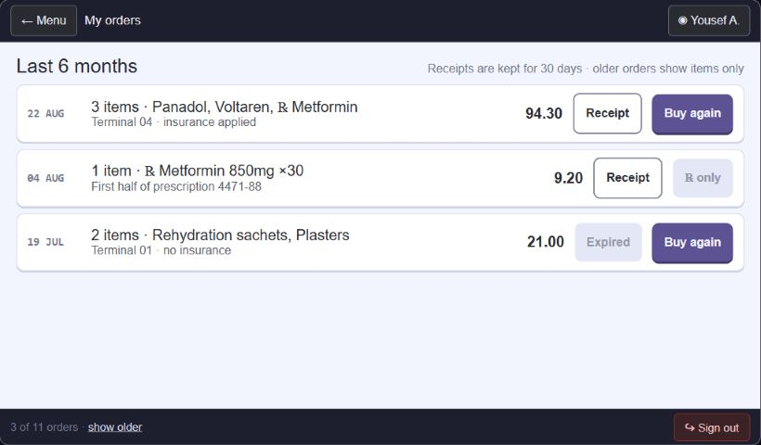
Figure - signed-in order and receipt history (screen T2 in the supplied kiosk design)
Frontend
- Implement printed/email/account delivery choices, guest email opt-in, printer-unavailable fallback, receipt confirmation and signed-in history.
- Guest always has printed or optionally emailed proof; account holders always store receipt and may print/email.
Backend and integration
- Generate immutable receipt snapshot, PDF/ESC-POS payload, UUID, signature and verification QR.
- Submit genuine ETA-format document to a mock endpoint through durable outbox/Celery; implement retry/dead-letter/admin visibility.
- Keep printer behind the device-agent interface and degrade to on-screen/email rather than crash.
Database
- Model receipt, receipt line/tax snapshot, delivery attempt, document signature, ETA submission and transactional outbox event.
- Use unique order/receipt/UUID/idempotency constraints and append-only delivery status.
Verification and exit gate
- Every completed sale has exactly one canonical receipt despite retries.
- Printer offline and email failure preserve recoverable proof and do not reverse a completed dispense.
- ETA payload, signature and QR verify against stored receipt data; only submission endpoint is mocked.
Team assignment
- Boda - frontend/design lead: owns UX decisions, frontend review, visual acceptance and sprint-demo preparation.
- Negm - backend/database lead: owns domain/API/database decisions, migrations, backend review and data integrity.
- Ahmed Sherif - backend: implements services, endpoints, integrations and backend automated tests with Negm.
- Wela - frontend: implements the primary kiosk/AutoDoc flow and frontend component/integration tests.
- Nasser - frontend: implements supporting/error/RTL states, accessibility checks and end-to-end test support.
Backlog prerequisites: Sprints 8-9

Sprint 11: Offline degradation, synchronization and technician mode
DONE MEANS Network loss produces a clearly limited, safe kiosk; supported OTC cash work reconciles once, while account/prescription/insurance/card paths stay blocked.

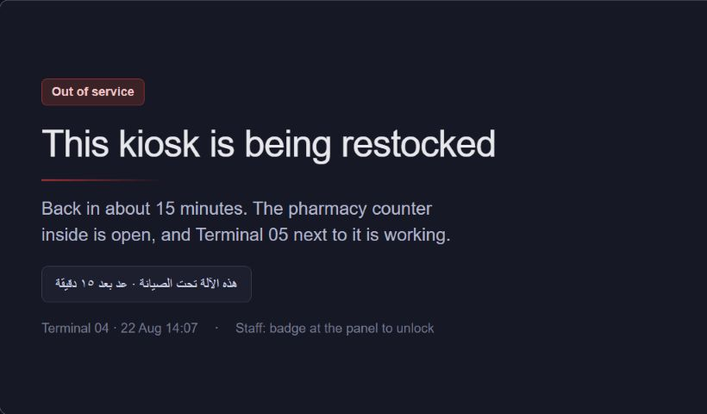
Figure - planned maintenance/out-of-service state (screen U5 in the supplied kiosk design)
Figure - operator-assisted recovery state (screen U4 in the supplied kiosk design)
Frontend
- Cache only shell, translations, catalogue, rules, planogram and stock snapshot; never cache health or identity data.
- Guard unavailable flows before the customer invests effort; implement offline banner, version status, reconnect and maintenance screen.
- Create separate authenticated technician mode for health, restock and diagnostics.
Backend and integration
- Implement versioned snapshot APIs and idempotent offline-event synchronization.
- Accept cash-only OTC offline events under a signed policy excluding prescription/controlled items and card payments.
- Reconcile incomplete dispenses and conflicts into operator-visible cases instead of overwriting silently.
Database
- Model configuration/snapshot version, offline policy, sync event, acknowledgement, conflict, terminal heartbeat, maintenance session and restock event.
- Device journal remains local and minimal; server records received event IDs exactly once.
Verification and exit gate
- Offline account, prescription, insurance and card operations are rejected before data entry.
- Duplicate reconnect uploads are accepted once; snapshot replacement happens only after validation.
- Technician role cannot access customer/prescription data and maintenance state blocks customer use.
Team assignment
- Boda - frontend/design lead: owns UX decisions, frontend review, visual acceptance and sprint-demo preparation.
- Negm - backend/database lead: owns domain/API/database decisions, migrations, backend review and data integrity.
- Ahmed Sherif - backend: implements services, endpoints, integrations and backend automated tests with Negm.
- Wela - frontend: implements the primary kiosk/AutoDoc flow and frontend component/integration tests.
- Nasser - frontend: implements supporting/error/RTL states, accessibility checks and end-to-end test support.
Backlog prerequisites: Sprints 1-3 and 9

Sprint 12: Back office, audit, observability, hardening and release
DONE MEANS Operators can run the demo safely, investigate failures and inventory, restore data, and demonstrate every critical flow in Arabic and English from a versioned release.

Figure - operational incident requiring reconciliation (screen U4 in the supplied kiosk design)
Figure - healthy terminal status on attract screen (screen A in the supplied kiosk design)
Frontend
- Build least-privilege back-office views for catalogue/pricing, planogram, inventory/batches, terminal health, queues, reconciliation and audit search.
- Add kiosk/AutoDoc About/version surfaces and complete accessibility, empty/error/offline states and Egyptian content pass.
Backend and integration
- Add structured JSON logging and correlation across request, order, payment, device command, dispense, job and reconciliation.
- Expose privacy-safe metrics/alerts for health, queue depth, low stock, expiry, failed ETA/EPTTS simulations and anomalies.
- Harden authorization, secrets/configuration, rate limits and data minimization; document §5 regulatory/privacy analysis without pretending commercial readiness.
Database
- Complete audit-event coverage, alert/reconciliation indexes, retention rules and operational reporting views.
- Rehearse backup and restore into an isolated demo environment; seed deterministic fictional demo data.
Verification and exit gate
- Run full end-to-end matrix: Arabic/English, RTL, guest/account, prescription partial fill, insurance, payment, device failure, printer failure, offline cash and reconnect.
- Pass concurrency/idempotency/power-loss tests, security review, accessibility review and local/LAN no-internet rehearsal.
- Tag v1.0.0 only after release checklist, backup restore and examiner demo script succeed.
Team assignment
- Boda - frontend/design lead: owns UX decisions, frontend review, visual acceptance and sprint-demo preparation.
- Negm - backend/database lead: owns domain/API/database decisions, migrations, backend review and data integrity.
- Ahmed Sherif - backend: implements services, endpoints, integrations and backend automated tests with Negm.
- Wela - frontend: implements the primary kiosk/AutoDoc flow and frontend component/integration tests.
- Nasser - frontend: implements supporting/error/RTL states, accessibility checks and end-to-end test support.
DESIGN / SCOPE NOTE Regulatory and privacy requirements in requirements §5 are DOCUMENT scope unless another requirement explicitly promotes the behavior to BUILD.

Backlog prerequisites: All earlier sprints

Definition of Ready for sprint stories
- User or system value is clear and the story is small enough to complete within one sprint.
- Acceptance criteria include happy path, failure states, permissions, privacy and audit behavior.
- Required Arabic/English content, RTL behavior and 1024x600 design evidence are identified.
- API request/response examples and affected database entities are understood.
- Dependencies, external simulations, hardware assumptions and unresolved decisions are visible.
- Primary owner, reviewer, estimate and test approach are assigned.
- No real personal, clinical, payment or credential data is needed for development or demonstration.

Definition of Done for every sprint
- Issue/task and acceptance criteria agreed; unresolved architectural decision documented.
- Schema migration, rollback consideration and fictional seed/fixture data included.
- OpenAPI contract and shared TypeScript client updated together.
- Frontend implements happy, loading, empty, error, timeout and offline states where applicable.
- Arabic and English verified; RTL and physical directions verified on the real 1024x600 target.
- Authorization, privacy, audit, idempotency and concurrency rules tested at the server boundary.
- Relevant unit, integration and end-to-end tests pass with real PostgreSQL for transaction-sensitive cases.
- Visible changes include screenshots; domain-sensitive changes receive additional review.
- Documentation and architecture decisions updated; no secrets or real personal/health data committed.
- Pull request approved, required checks green, squash-merged, and main remains demonstrable.

Named team responsibilities during every sprint
Member | Primary ownership inside each sprint
Boda | Frontend/design management, UX acceptance, frontend integration and sprint demonstration
Negm | Backend/database management, architecture, migrations, security and data-integrity acceptance
Ahmed Sherif | Backend services, endpoints, integrations, jobs and automated backend verification
Wela | Primary kiosk/AutoDoc feature UI and component/integration tests
Nasser | Secondary/error/Arabic/RTL states, accessibility and end-to-end test support
The sprint facilitator and story owner may rotate, but Boda retains frontend/design acceptance and Negm retains backend/database acceptance. Pairing and cross-review should prevent knowledge of authentication, prescriptions, payment, inventory and hardware from concentrating in one person.

Reference basis
- 01-requirements.md - functional, non-functional, regulatory/documentation and simulation scope.
- 02-technology-stack.md - architecture, service boundaries, data, offline, deployment and implementation order.
- CONTRIBUTING.md - branch, pull-request, review, testing and sensitive-data rules.
- Pharmacy Kiosk.dc.html - supplied kiosk interaction and visual design; screenshots reproduced in this document.

