Stock Price Prediction (AAPL): Project Report
IIQF Project 1 | Supervised regression on a daily time series | Author: C. Deogaonkar
1. Objective
Predict Apple's closing price five trading days (about one week) ahead from roughly sixty daily technical and market features, and test honestly whether any model beats a naive baseline. The aim is a leakage-free forward test, not a profit claim.
2. Data
3,732 daily rows of AAPL from 17 October 2005 to 13 August 2020, 64 columns, zero missing cells (pre-split prices ending near 460). The provided Close_forcast column is a next-day target, so it was dropped and a five-day target was built with a shift, matching the one-week brief.
3. Method and the honesty controls
A single pipeline runs load, clean, EDA, target build, feature selection, split, scale, train, evaluate, and forecast. Four controls keep the test honest:
- Split by time, never shuffled: oldest 80 percent trains (2,981 rows), newest 20 percent tests (746 rows).
- The scaler is fitted on training data only, so no test information leaks into training.
- The leaky Close_forcast column and all future information are removed from the inputs.
- Near-duplicate features (correlation above 0.95) are dropped, cutting 60 features down to 24.
4. Models tested
Naive baseline, Linear Regression, Ridge, Lasso, ElasticNet, Random Forest, XGBoost, AdaBoost, and an LSTM recurrent neural network reading a ten-day window. All eight model types plus the baseline were scored on the identical time-ordered test set.
5. Results, Option A (predict the raw price)
Model | RMSE | MAE | MAPE% | R2 | Dir%
Naive (no change) | 10.40 | 6.92 | 3.10 | 0.974 | n/a
Lasso | 11.62 | 7.84 | 3.41 | 0.968 | 43.0
ElasticNet | 11.63 | 7.86 | 3.42 | 0.967 | 43.7
LinearRegression | 11.64 | 7.85 | 3.41 | 0.967 | 43.4
Ridge | 11.64 | 7.85 | 3.41 | 0.967 | 43.4
RandomForest | 95.65 | 70.99 | 27.94 | -1.20 | 37.3
XGBoost | 95.77 | 71.21 | 28.05 | -1.20 | 36.7
AdaBoost | 98.23 | 74.06 | 29.37 | -1.32 | 36.5
LSTM | ~169 | ~151 | ~66 | ~-5.9 | 36.3
6. Findings from Option A
No model beat the naive baseline. The naive guess (next week equals today) scored the lowest error at 10.40; the best model, Lasso, was worse at 11.62. For a short-horizon price forecast this is the expected outcome and is reported as-is.
The tree models (Random Forest, XGBoost, AdaBoost) failed badly, with errors near 95 to 98, about nine times worse than the rest. The cause is a known limitation: tree models cannot extrapolate. AAPL's price rose over time, so the recent test period sits above every price seen in training, and the trees are stuck predicting the ceiling they learned. The linear models, which can keep rising, did far better.
The LSTM, the headline deep-learning model, actually did the worst of all, with an error around 169. This is a useful reminder that a more complex model is not automatically a better one. On a small, near-random dataset of raw trending prices, the LSTM has too little signal to learn from and simply overfits, so it loses to a plain straight line. (Its exact score shifts a little each run because its weights start randomly, but it always lands far behind the baseline.)
Directional accuracy was below 44 percent for every model, worse than a coin flip. A low dollar error is meaningless for trading when the up-or-down call is a guess, which is why direction is reported alongside RMSE.
7. Forecast
Using the winning model (Lasso) on the most recent feature row, the five-day-ahead forecast is about 433 dollars against a last close of 455, quoted with an honest band of plus or minus 11.62 (one test RMSE). Given the findings above, this forecast should be read as illustrative, not actionable.
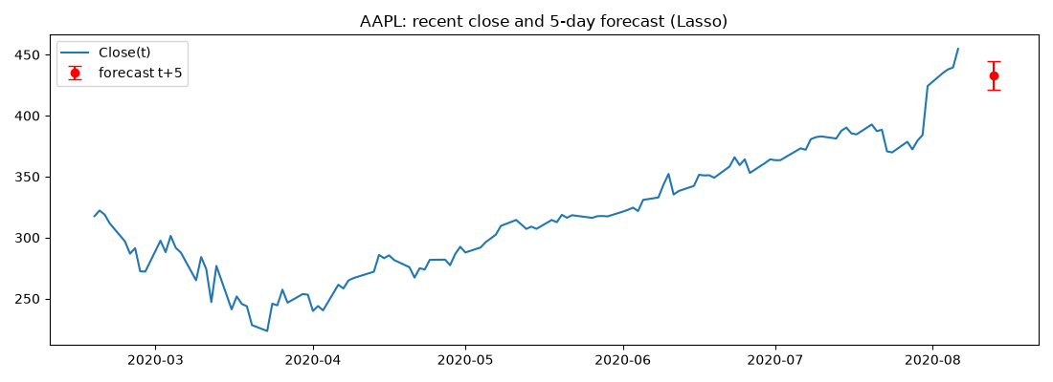
8. Pitfalls checklist
Done. Split by time, never shuffled.
Done. Scaler fitted on the training set only.
Done. Close_forcast and all future information removed from inputs.
Done. Compared against the naive baseline.
Done. Reported directional accuracy, not just RMSE.
Done. One-week claim matches a five-day target, not the provided one-day column.
9. Option B: predicting the five-day return
Option A exposed a clear weakness: the raw price trends upward, which broke the tree models and the LSTM and made the baseline nearly unbeatable. Option B addresses this directly by predicting the five-day RETURN (the percentage change) instead of the price, then converting back to a price for scoring, so the numbers below are on the same dollar scale and face the same naive baseline.
Model | RMSE A | RMSE B | Dir% A | Dir% B
Naive (no change) | 10.40 | 10.40 | n/a | n/a
Lasso | 11.62 | 10.16 | 43.0 | 63.7
ElasticNet | 11.63 | 10.16 | 43.7 | 63.7
AdaBoost | 98.23 | 10.40 | 36.5 | 54.6
RandomForest | 95.65 | 10.93 | 37.3 | 49.2
XGBoost | 95.77 | 11.16 | 36.7 | 50.5
LSTM | ~169 | 12.59 | 36.3 | 47.4
Three things changed, and together they validate the whole diagnosis:
- The breakdown disappeared. Random Forest fell from an error of 95.65 to 10.93 and the LSTM from about 169 to 12.59, because a return does not trend, so there is no ever-rising number to extrapolate beyond. This confirms Option A failed for exactly the reason stated.
- A model finally beat the naive baseline. Lasso and ElasticNet scored 10.16 against the baseline 10.40. The margin is small but real, and it is the first time anything cleared the bar.
- Directional accuracy rose above chance. Lasso called the up-or-down direction correctly 63.7 percent of the time, versus 43 percent under Option A. This is the trading-relevant score and the most meaningful gain.
The Option B forecast is also more sensible: instead of Option A's drop to about 433, the winning Lasso predicts a small rise of plus 0.63 percent, to about 458 dollars, with the same plus or minus 10.16 band.
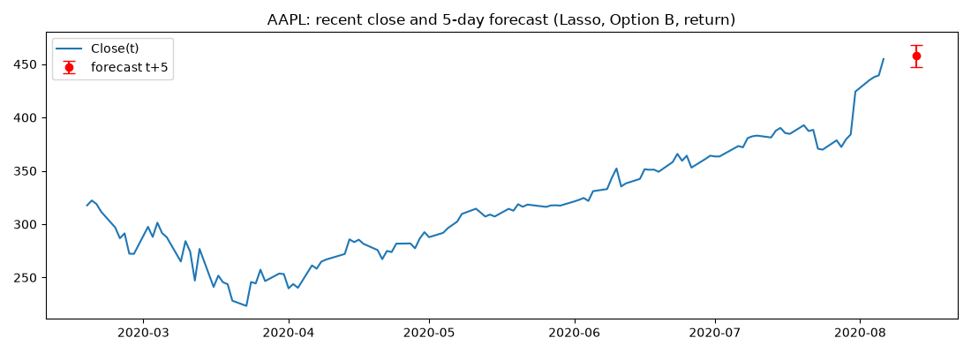
Honest caveat: this is a single test window. A 63.7 percent hit rate and a two percent error edge over the baseline on one period is encouraging, but it is not proof of a durable, tradeable edge. It could be specific to this stretch of history. The honest claim is that predicting returns fixed the model breakdown and produced a small, plausible edge worth investigating further, not deploying.
10. Walk-forward robustness check
A single test window can flatter a result, so the Option B edge was re-tested with walk-forward validation: train on an early stretch and test on the next, then extend the training and test on the following stretch, marching through history in six folds. Each fold is a fresh out-of-sample test. If the edge is real it should appear in most folds, not just one.
Fold | Test period | Lasso RMSE | Naive RMSE | Beat? | Dir%
1 | 2007 to 2010 | 1.11 | 1.08 | No | 54.1
2 | 2010 to 2012 | 1.57 | 1.60 | Yes | 60.3
3 | 2012 to 2014 | 2.71 | 2.64 | No | 51.5
4 | 2014 to 2016 | 3.49 | 3.45 | No | 54.3
5 | 2016 to 2018 | 4.31 | 4.38 | Yes | 60.9
6 | 2018 to 2020 | 11.47 | 11.76 | Yes | 66.5
Two findings point in opposite directions, and both matter:
- The dollar-error edge did NOT hold. Lasso beat the naive baseline on RMSE in only three of six folds, always by a razor-thin margin. Three of six is a coin flip, so Option B is not reliably more accurate than the baseline. The single-window win of 10.16 versus 10.40 was not robust.
- The directional edge DID hold. Directional accuracy stayed above 50 percent in all six folds, averaging 57.9 percent across thirteen years of different market conditions. That consistency is more meaningful than any single figure.
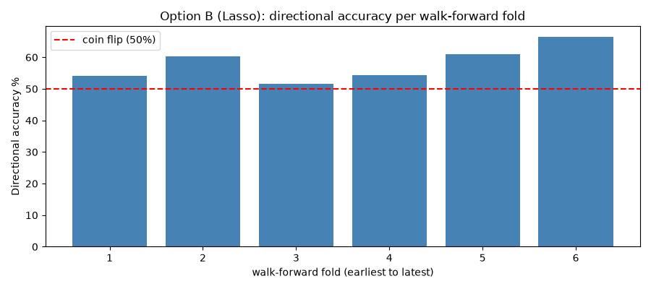
The exciting 63.7 percent from the single split turned out to be the most recent and most favourable fold (66.5 percent). The realistic, all-history figure is about 58 percent directional accuracy with no dependable dollar-error edge.
11. Is the directional edge real? Drift and significance tests
The ~58 percent directional accuracy still had to clear one more bar. Apple drifted upward for years, so up-days are common on their own. The honest test is not the coin flip, it is an always-guess-up rule. Across all 3,192 out-of-sample predictions:
- The price actually rose over the next five days 58.0 percent of the time (the natural drift).
- An always-up rule would therefore score 58.0 percent.
- The model scored 58.0 percent. Its edge over always-up is 0.0 percentage points.
A binomial significance test confirms the picture: the model is significantly better than a coin flip (p about 0.000), but NOT significantly better than always-up (p = 0.51, a pure coin flip). In plain terms, the model looks skilful only because it learned to say up in a market that mostly goes up. It has no genuine predictive skill once the drift is accounted for.
This is the value of rigorous testing. Stopping at the single-window 63.7 percent would have claimed a false edge. Following it through (walk-forward, then drift and significance) showed the apparent edge dissolves against the correct baseline. The naive no-change baseline was the wrong bar for judging direction; in a trending market the honest bar is always-up, and the model does not beat it.
12. Robustness and leakage post-mortem
After the drift test, the investigation was pushed one step further with a rolling short training window (retrain on only the last N days). This appeared to find a strong, robust signal, and how that result was stress-tested is the most instructive part of the whole project.
The apparent edge.
A 63-day rolling window scored 67.7 percent directional accuracy, plus 8.2 points over the always-up baseline, statistically significant. It was robust across window sizes, with the edge growing as the window shortened. It looked like a genuine momentum effect.
Test 1, transaction costs, exposed a leak.
Turning the signal into a trading strategy produced impossible numbers: a Sharpe ratio above 3 and cumulative returns in the hundreds of thousands of percent. That implausibility was the alarm bell. The cause was look-ahead leakage: the five-day-forward label of the last few training rows extended past the prediction day, so the model was peeking into the future. It was worse for short windows (24 percent of a 21-day window was contaminated versus 8 percent of a 63-day window), which means the apparent momentum gradient was really a contamination gradient.
The purged correction (fixing the leak).
Window | Leaky edge | Leaky sig? | Purged edge | Purged sig?
21 | +18.6 | YES | -5.3 | no
42 | +11.8 | YES | -4.5 | no
63 | +8.2 | YES | -8.1 | no
84 | +4.2 | YES | -9.6 | no
126 | +3.1 | no | -10.7 | no
Once the look-ahead is purged, the edge collapses to negative and insignificant at every window. The momentum edge was entirely leakage.
Test 2, fresh stocks never studied.
Stock | Leaky edge | Purged edge | Purged sig?
MSFT | +2.0 | -6.0 | no
JPM | +5.2 (sig) | -4.7 | no
KO | +6.5 (sig) | -1.5 | no
The same leak reproduces on Microsoft, JPMorgan and Coca-Cola. Every apparent edge vanishes after purging, confirming the effect is the method, not any one stock.
Test 3, every market regime (purged Apple).
Regime | Model Dir% | Always-up | Edge | Sig?
All | 51.4 | 59.5 | -8.1 | no
Low volatility | 50.9 | 64.0 | -13.0 | no
High volatility | 51.9 | 55.0 | -3.1 | no
Uptrend | 51.7 | 61.4 | -9.7 | no
Downtrend | 50.3 | 53.5 | -3.2 | no
There is no hidden regime where the model works. It sits at roughly 51 percent everywhere, and always-up beats it in every condition.
The lesson.
Out-of-sample testing is necessary but not sufficient: it guards against overfitting, but not against look-ahead leakage baked into the labels. A backtest that looks too good is a bug report, not a prize. The discipline of distrusting a good result, and stress-testing it until it breaks or survives, is what separates a real finding from a false one.
13. Dig deeper: what is predictable and what is not
Having shown direction is unpredictable, five further investigations asked whether anything else is, all purged and leak-free.
Volatility IS predictable (the key positive finding).
Instead of which way the price moves, we predicted how big the 5-day move is (realised volatility). Unlike returns, this works well:
Predictor of 5-day volatility | R2 on test
Constant (mean vol) - no-skill floor | -0.00
Persistence / clustering alone | 0.22
LinearRegression model | 0.42
The model reaches R2 = 0.42 (correlation 0.69 with actual volatility) and beats simple persistence, so it adds real information beyond volatility clustering. Contrast this with returns, where R2 was near zero. Volatility is genuinely forecastable, consistent with volatility clustering and the GARCH family of models.
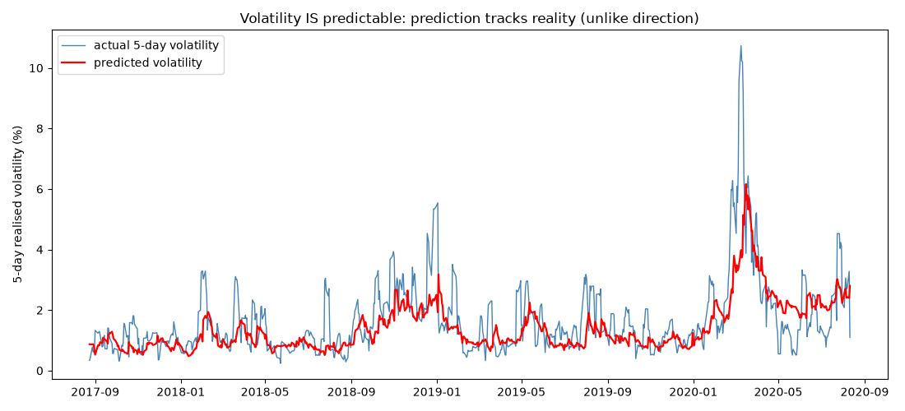
Horizon sweep: direction is unpredictable at every horizon.
Horizon (days) | 1 | 5 | 10 | 20 | 60
Edge over always-up (pts) | -0.7 | -9.4 | -12.8 | -13.8 | -26.9
No positive, significant directional edge at 1, 5, 10, 20 or 60 days (purged).
Direction as a classifier: no discrimination.
A logistic classifier's probability of an up move scored ROC-AUC = 0.508, with a 95 percent bootstrap interval of [0.463, 0.556] that straddles the 0.500 chance line. No skill, even in the cleaner probabilistic framing.
Leak-free headline table: confirms no edge.
Re-running the main comparison with the boundary leak purged, no model meaningfully beats naive, and every model's directional edge over always-up is negative. The earlier apparent Option B win was partly that small boundary leak.
Multiple-testing correction: quantifying the data-snooping.
Across roughly 44 distinct edge-tests, the chance of at least one false significant result by pure luck was about 90 percent, which is exactly why leaky edges looked convincing. After a Bonferroni correction (needing p below 0.0011) nothing directional survives. A deflated-Sharpe analysis shows pure noise across 44 tries would produce a best Sharpe of roughly 0.8 to 1.7, so an observed Sharpe near 1 is unremarkable, while the leaky strategy's 3.56 was far too high to be luck, confirming it as leakage. The only finding that survives every correction is the volatility result.
14. Conclusion
The project delivered an honest, leakage-free forward test and a rich, two-sided conclusion. Apple's short-term direction and returns proved unpredictable at every horizon, with every model, after removing all leakage and correcting for data-snooping, exactly as weak-form market efficiency predicts. A promising momentum edge turned out to be look-ahead leakage, caught by an implausible backtest. But the story does not end at nothing works: the size of the moves, the volatility, is strongly predictable (R2 around 0.42), consistent with volatility clustering and GARCH. In plain terms, the market efficiently prices the direction of moves but not their magnitude, which is exactly why risk can be modelled even when returns cannot. The lasting lesson is that the right baseline, honest multi-stage validation, and a refusal to trust a flattering number matter far more than model complexity, and that a careful analyst finds the real signal (risk) hiding next to the false one (return).

