<!DOCTYPE html>  <html>  <head>  <title>Coffee Shop</title>  <!-- Bootstrap -->  <link href="https://cdn.jsdelivr.net/npm/bootstrap@  5.3.0/dist/css/bootstrap.min.css" rel="stylesheet">  <style>  /* Hide all sections */  .section {  display: none;  padding: 40px;  }  /* Show active section */  .active {  display: block;  }  /* Home section style */  .hero {  background-image: url('https://images.unsplash.com/photo-1495474472287-4d71bcdd2085');  background-size: cover;  background-position: center;  height: 500px;  color: white;  display: flex;  justify-content: center;  align-items: center;  /* Image style */  img {  height: 250px;  object-fit: cover;  }  </style>  </head>  <body>  <!-- Navbar -->  <nav class="navbar navbar-dark bg-dark">  <div class="container">  <span class="navbar-brand">☕ Coffee Shop</span>  <!-- Buttons -->  <div>  <imgsrc="https://images.unsplash.com/photo-1498804103079-a6351b050096" class="card-img-top">  <div class="card-body text-center">  <h5>Latte</h5>  <p>₹180</p>  </div>  </div>  </div>  <!-- Item 3 -->  <div class="col-md-4">  <div class="card">  <img src="https://images.unsplash.com/photo-1509785307050-d4066910ec1e" class="card-img-top">  <div class="card-body text-center">  <h5>Espresso</h5>  <p>₹120</p>  </div>  </div>  </div>  </div>  </div>  </div> | <button class="btn btn-light" onclick="show('home')">Home</button>  <button class="btn btn-light" onclick="show('about')">About</button>  <button class="btn btn-light" onclick="show('menu')">Menu</button>  <button class="btn btn-light" onclick="show('contact')">Contact</button>  </div>  </div>  </nav>  <!-- HOME -->  <div id="home" class="section active">  <div class="hero">  <h1>Welcome to Coffee Shop ☕</h1>  </div>  </div>  <!-- ABOUT -->  <div id="about" class="section text-center">  <h2>About Us</h2>  <!-- Image -->  <img src="https://images.unsplash.com/photo-1509042239860-f550ce710b93" width="300">  <p>We serve fresh and tasty coffee every day.</p>  </div>  <!-- MENU -->  <div id="menu" class="section">  <h2 class="text-center">Menu</h2>  <div class="container">  <div class="row">  <!-- Item 1 -->  <div class="col-md-4">  <div class="card">  <img src="https://images.unsplash.com/photo-1511920170033-f8396924c348" class="card-img-top">  <div class="card-body text-center">  <h5>Cold Brew</h5>  <p>₹150</p>  </div>  </div>  </div>  <!-- Item 2 -->  <div class="col-md-4">  <div class="card">  <!-- CONTACT -->  <div id="contact" class="section text-center">  <h2>Contact</h2>  <!-- Image -->  <img src="https://images.unsplash.com/photo-1521017432531-fbd92d768814" width="300">  <p>Email: coffee@email.com</p>  <p>Phone: 9876543210</p>  </div>  <!-- JavaScript -->  <script>  function show(id) {  let sections = document.getElementsByClassName("section");  // Hide all sections  for (let i = 0; i < sections.length; i++) {  sections[i].classList.remove("active");  }  // Show selected section  document.getElementById(id).classList.add("active");  }  </script>  </body>  </html>

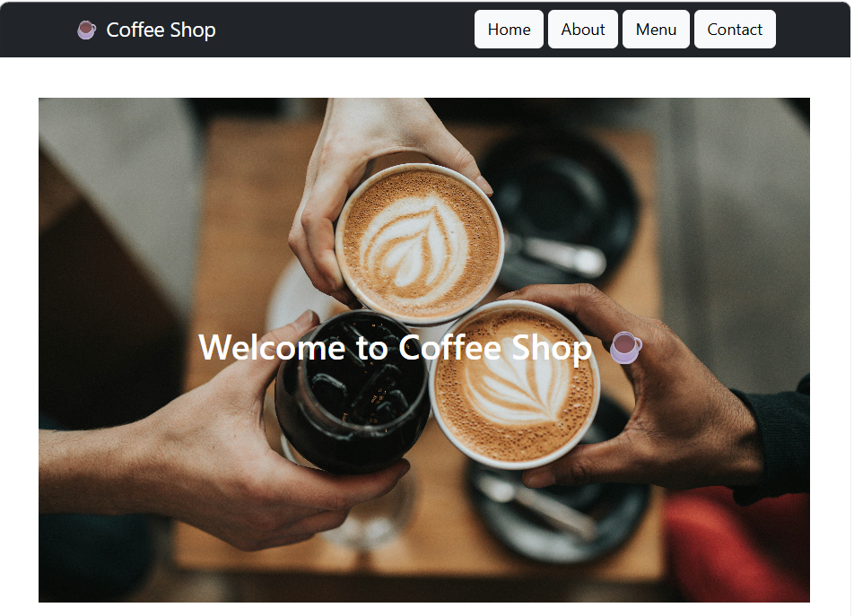
OUTPUT :
