Authors,

Dr. Nalini C. Iyer

Prof. R V. Hangal

Prof. Sujata N

Prof. Shraddha Hiremath

Prof. Shruti M

Prof. Prashant V. Achari

Prof. Sneha Meti

Analog Electronic Circuits

Analog Electronic Circuits Laboratory Manual

**Course code: 15EECP202**

KLE Technological University, Hubballi-31 School of Electronics Engineering Electronics and Communication

3rd Semester

2018-19

**EXPERIMENT NO. : 1**

**1.1Title of the Experiment:** Design and testing of Diode Clipping circuits

**1.2 Aim or Objective:** To design suitable diode clipper circuits for the transfer characteristics shown in Fig 1(a),(b) and (c).Use diode 1N4001.Limit the diode peak current to ≤ 20mA.

Input Signal, vs= VmSinωt = 8.0Sin(2π*103t)Volts

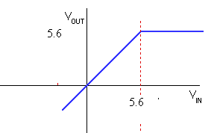

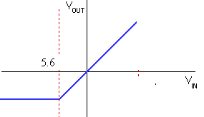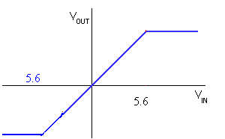

**Fig 1.a Fig 1.b Fig 1.c**

**1.3 List of Component / Equipments:**

|  |  |  |  |
| --- | --- | --- | --- |
| **Sl. No** | **Component / Equipments** | **Specifications** | **Quantity** |
| 1 | Diodes | OA79/1N4001 | 02 |
| 2 | Resistor | 1kΩ | 01 |
| 3 | AFO | 3MHz, 20Vp-p | 01 |
| 4 | CRO | 20MHz, 80Vp-p | 01 |
| 5 | DC Power supply | 0 – 30V, 2A | 01 |
| 6 | BNC’s | ------ | 03 |

**1.4 Theoretical background for the experiment/validation of the experiment:**

The circuit, which removes or clips a portion of the input waveform applied to it is called as the ‘clipping circuit’. In this experiment diode clippers are used. These clippers can remove voltages above or below a specified level. The important diode clippers are:

* Positive clipper
* Negative clipper
* Combinational clipper.

In case of positive clipper the part of the positive half cycle of the input waveform is clipped off. This action is similar to that of a half wave rectifier circuit. In case of negative clipper the part of the negative half cycle is clipped off. This action is similar to that of a half wave rectifier circuit. It is a combination of biased positive & negative clippers. In this case the output voltage of both positive & negative half cycles is restricted to 5V. If Vm is much greater than the clipping levels a square waveform can be obtained.

**Biased clipper:** In this case only a portion of input waveform is clipped. As shown in the above circuit diagram the positive biased clipper clips the output voltage at 5V as long as the input waveform voltage is greater than 5V, when input voltage is lesser than 5V the output is similar to the input. In case of negative clipper input voltage beyond –5V is clipped or removed. The negative half cycle(in case of positive clipper) & positive half cycle(in case of negative clipper) of input voltage maintain diode under reverse bias condition thus almost entire negative or positive half cycle appear across the load respectively.

**1.5 Formula required/Design:**

Positive Clipper:

The transfer characteristics shown in figure 1(a) is for a positive clipper. The circuit for the same is shown in the below figure 2(a)

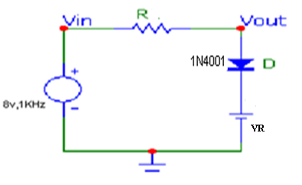

Figure 2(a) Diode Positive Clipper

***Design***

**Given Data:**

* **Diode-**
* **Specifications: Forward resistance of diode** Rf = 0,
* **Reverse resistance of diode** Rr=∞,
* **Cut- in Voltage of diode** Vɣ=0.6V
* **Peak forward current =** 2.5 mA
* **Input voltage** = vs=8.0 Sin(2π×103)tvolts

**Steps:**

**1**: Compute the value of the reference voltage VR

Criterion: From the transfer characteristic curve of fig 1.a the breakpoint occurs at

Vs=5.6v= VR+Vγ ----- (1)

VR=Vs- Vγ =5.6-0.6=5v ------ (2)

VR=5V ------ (3)

**2:** Compute the value of R required for limiting the diode peak current.

Applying KVL to the circuit shown in figure 2(a) we have

Vs(t)=Is(t).R+ Vγ +VR -------(4)

Under maximum conditions

Vm=Im.R+ Vγ +VR ------- (5)

Where

Vm=8v, VR=5v, Vγ =0.6v and peak current to be limited=Im≤2.5mA

Let us consider maximum current

Im = 2.5mA ------- (6)

Hence R can be calculated as

Im.R=Vm- Vγ -VR ------- (7)

R=(Vm- Vγ –VR)/Im=8-0.6-5/2.5×10-3=960Ω

R=960 Ω is not standard resistor and the nearest standard value is 1kΩ

R=1kΩ;VR=5V;Vm=8V;f=1kHz

**3**: To decide the wattage of the resistor let us first determine the power dissipated in resistance.

PD(R) =(Im/√2)2.R=Im2.R/2.

PD(R) = (2.5×10-3)2.1×103/2=3.125×10-3W

PD(R) = 3mW

**4**: Power rating of the resistor=10 times as large as this PD(R)

PD(R) =10×3mW=30mW=0.03W

Hence, a quarter Watt(1/4W=0.25W) resistor can be used

R=1kΩ and 0.25W for the above specifications

**1.6 Step by step procedure to carry out experiment:**

* The circuit connections are made as shown in the fig.
* For each circuit a sine wave of desired amplitude and frequency has to be given & the output waveform has to be noted down on the CRO.
* Also observe the transfer characteristic curve on CRO.

**1.7 Table of observations:**

**(i) Positive Clipping circuit**

**With a series resistor R= 1KΩ**

|  |  |  |  |  |  |
| --- | --- | --- | --- | --- | --- |
| **SI.NO** | **Vref= VR in Volts** | **frequency in Hz** | **Vin pp in Volts** | **Vo pp**  **in Volts** | **Clipped off portion**  **= Vin pp – Vo pp** |
|  |  |  |  |  |  |
|  |  |  |  |  |  |
|  |  |  |  |  |  |

**(ii) Negative Clipping circuit**

**With a series resistor R= 1KΩ**

|  |  |  |  |  |  |
| --- | --- | --- | --- | --- | --- |
| **SI.NO** | **Vref= VR in Volts** | **Frequency in Hz** | **Vin pp in Volts** | **Vo pp**  **in Volts** | **Clipped off portion**  **= Vin pp – Vo pp** |
|  |  |  |  |  |  |
|  |  |  |  |  |  |
|  |  |  |  |  |  |

**(iii) Combinational Clipping circuit**

**With a series resistor R= 1KΩ**

|  |  |  |  |  |  |
| --- | --- | --- | --- | --- | --- |
| **SI.NO** | **Vref= VR in Volts** | **Frequency in Hz** | **Vin pp in Volts** | **Vo pp**  **in Volts** | **Clipped off portion**  **= Vin pp – Vo pp** |
|  |  |  |  |  |  |
|  |  |  |  |  |  |
|  |  |  |  |  |  |

**1.8 Specimen calculation:** Vout = VR + Vγ

Let us consider V0ut = 5.6 V and Vγ = 0.6 V

VR = 5.6 - 0.6= 5.0 V

**1.9 Nature of graph:**

**Clipping circuits**

1. **Positive Clipper:**

**Input and output waveform**

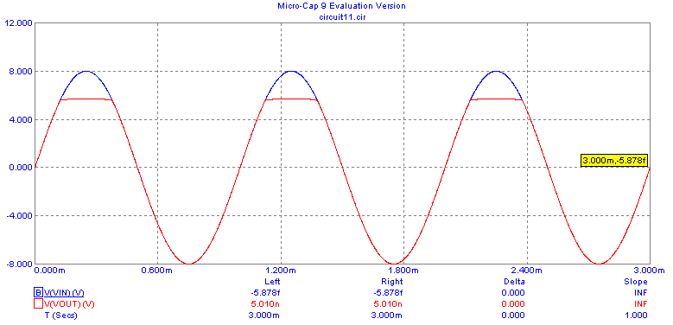

**Transfer characteristics**



1. **Negative Clipper:**

**Input and output waveform**

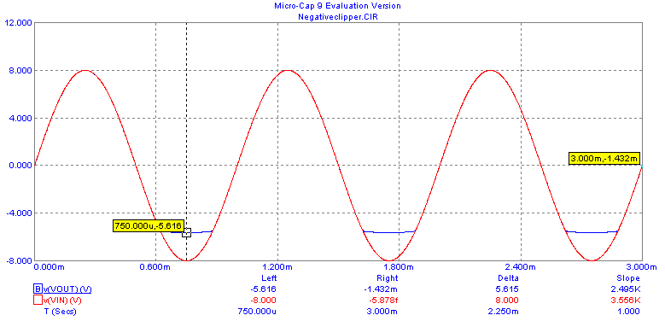

**Transfer characteristics**



1. **Combinational or Positive- Negative Clipper:**

**Input and output waveform**

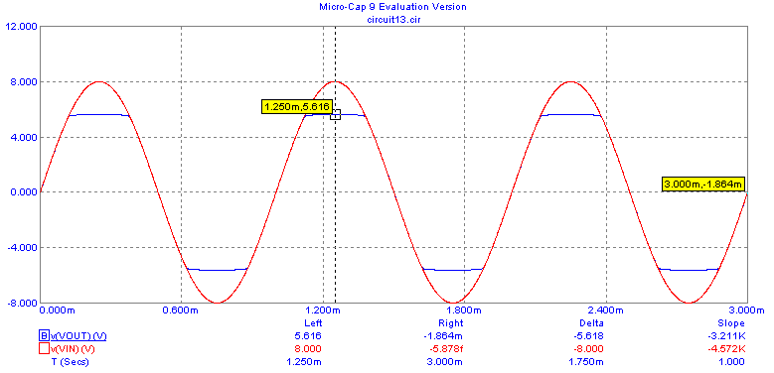

**Transfer characteristics**



**1.10 Conclusion of the experiment:**

**Results and discussion:** Experimental set up for clipping circuit using diode is configured and verified for different input voltage levels and reference voltages to demonstrate the removal or clipping of unwanted portion of the input signal.

**Conclusion**: Clipping can occur only when following conditions are satisfied. 1) Vm>VR, and 2)R= √(Rf. Rr)