# How to Add a FAQ in the Admin Panel

## Step 1: Navigate to the FAQs Section

• Go to the sidebar on the left.  
• Click on the 'FAQs' option.

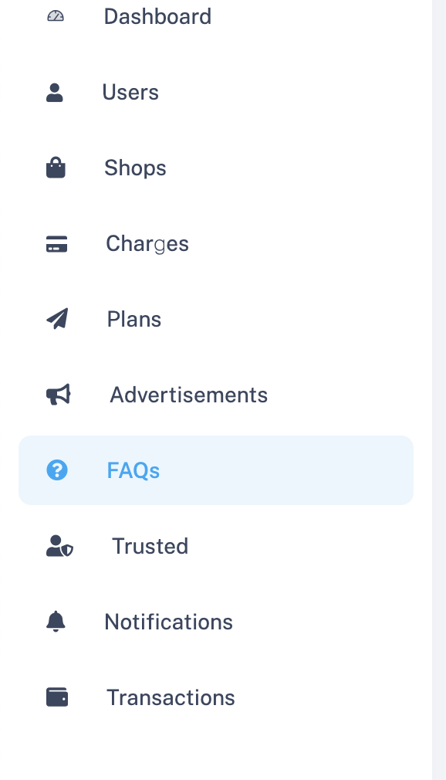

## Step 2: Click on "Create New FAQ"

• In the FAQs dashboard, click the 'Create New Faq' button at the top right.

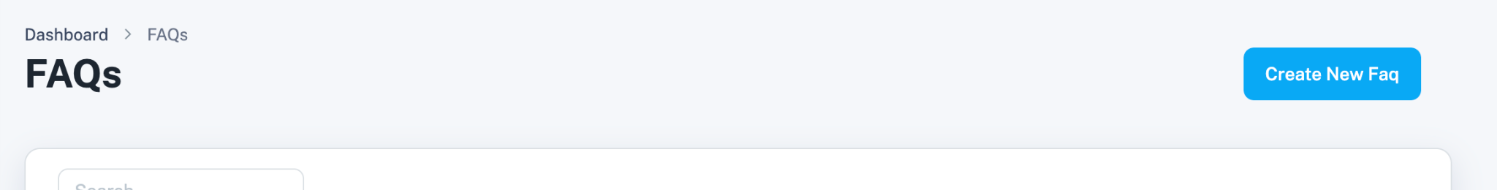

## Step 3: Add Your FAQ Details

• Enter the Question in the first field.  
• Enter the Answer in the second field.  
• Click the 'Submit' button to save.  
• Use 'Back' if you want to return without saving.

