- CREATE BOOKS TABLE

B.NEHA-2520090013

PRACTICAL WEEK-4

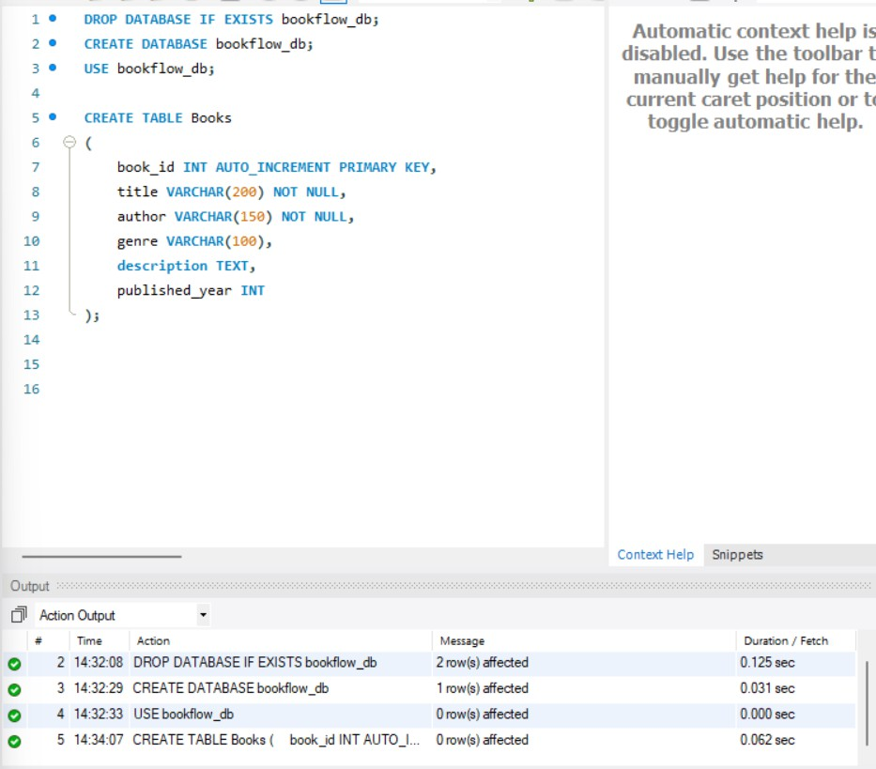
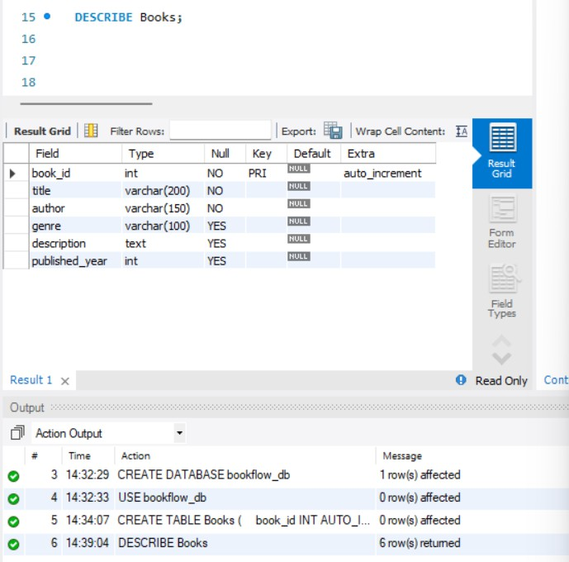

- INSERT BOOK DATA
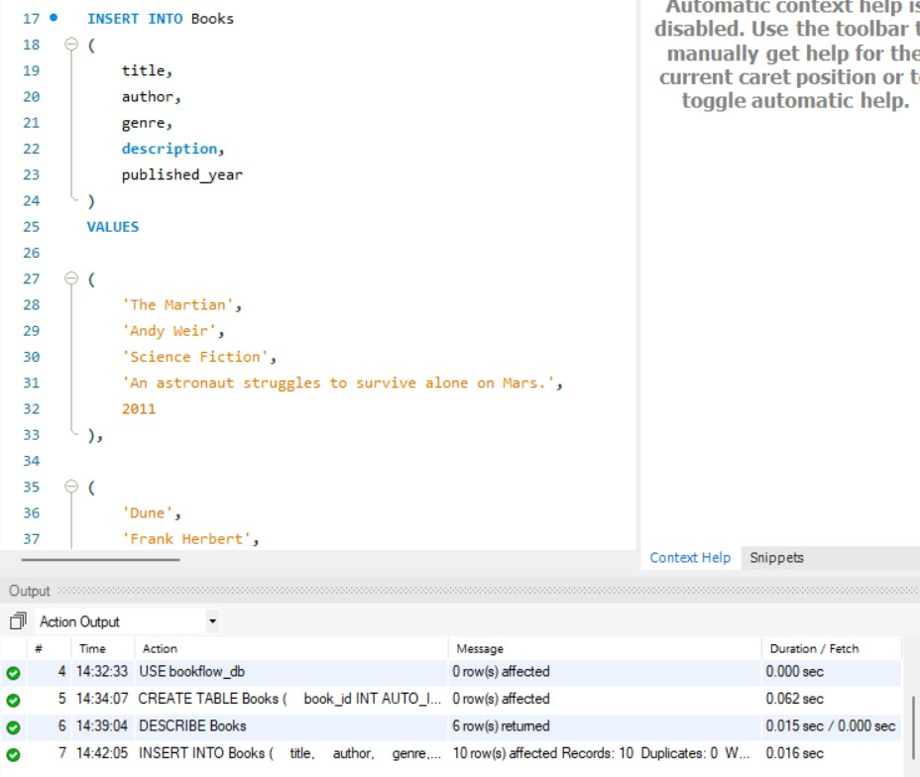
- DISPLAY BOOKS
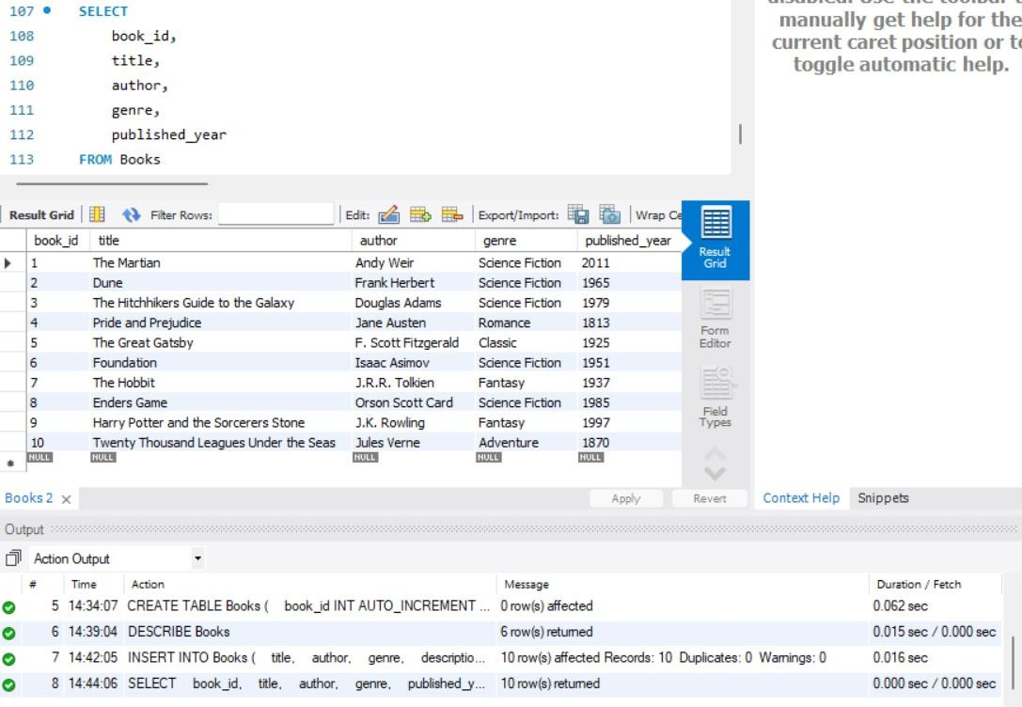

- ADD EMBEDDING COLUMN
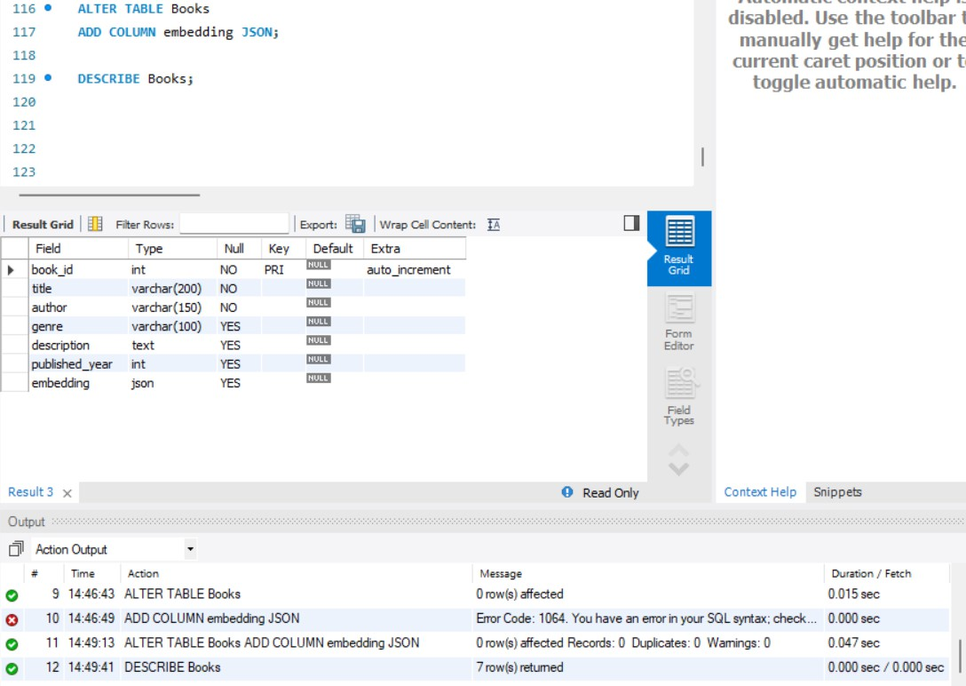
- INSERT MOCK VECTORS
- BOOK 1 - MARTIN
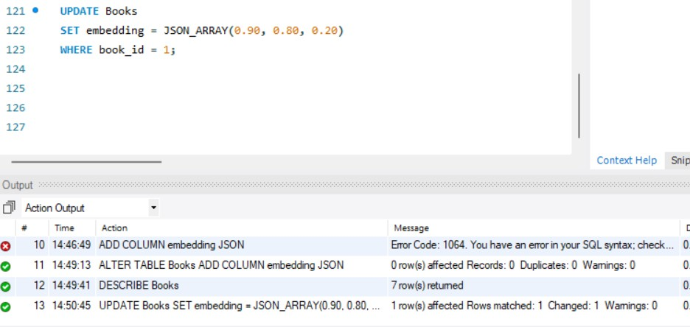

- DUNE
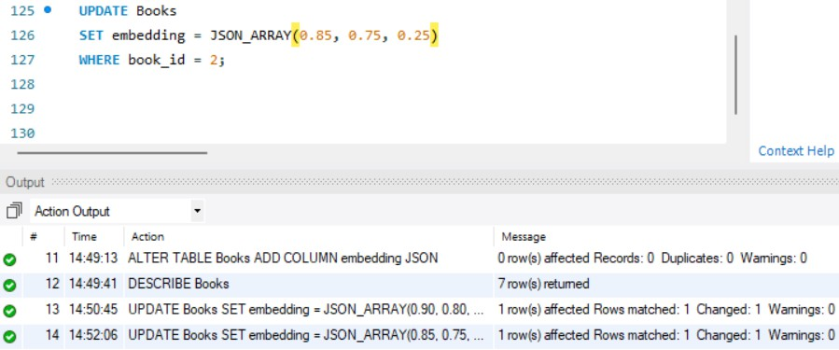
- HITCHHIKERS GUIDE
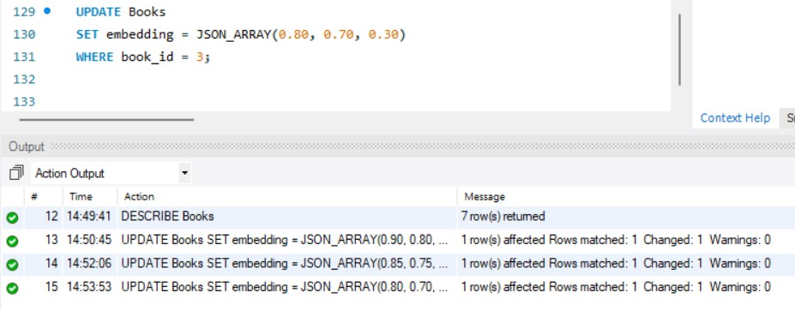
- PRIDE AND PREJUDICE
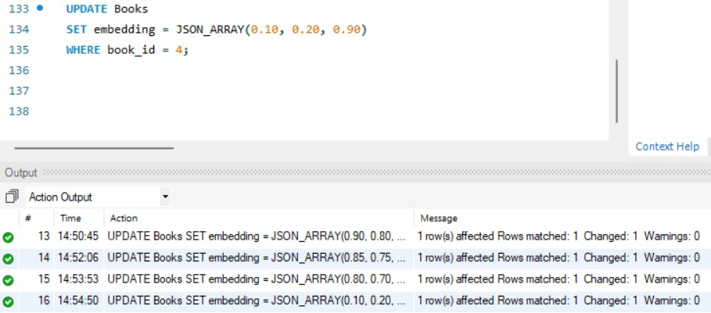

- GREAT GATSBY
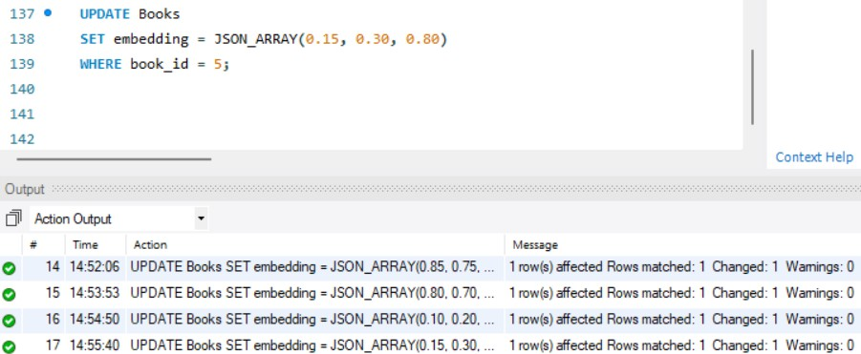

- FOUNDATION
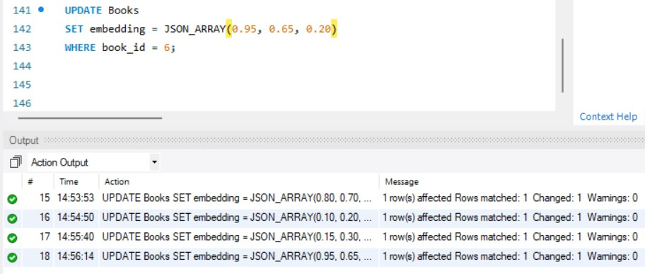
- THE HOBBIT & ENDERS GAME
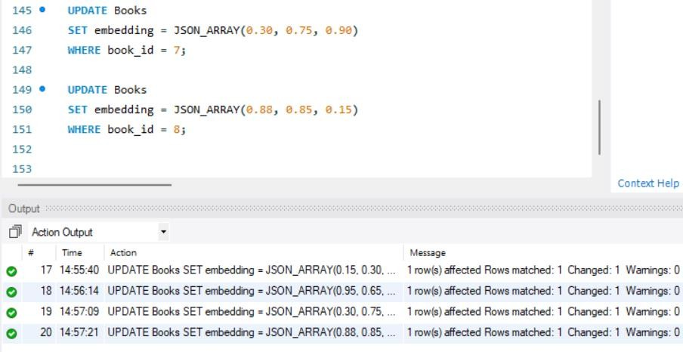
- HARRY POTTER & TWENTY THOUSAND LEAGUES

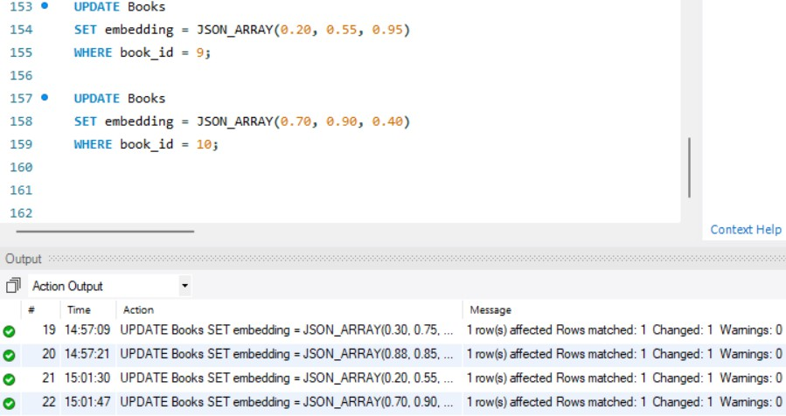
- VERIFY ALL VECTORS
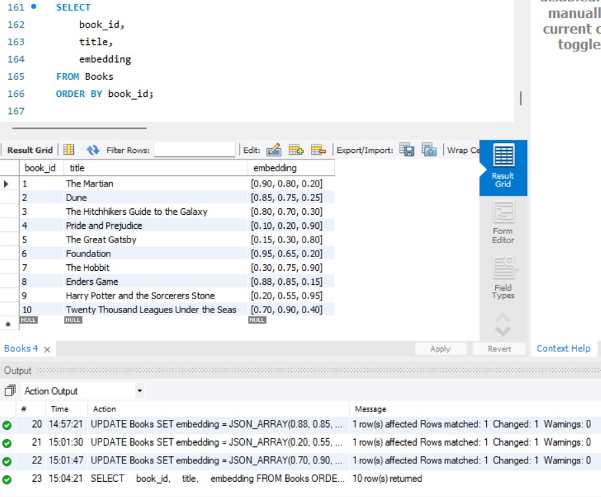
- L2 DISTANCE

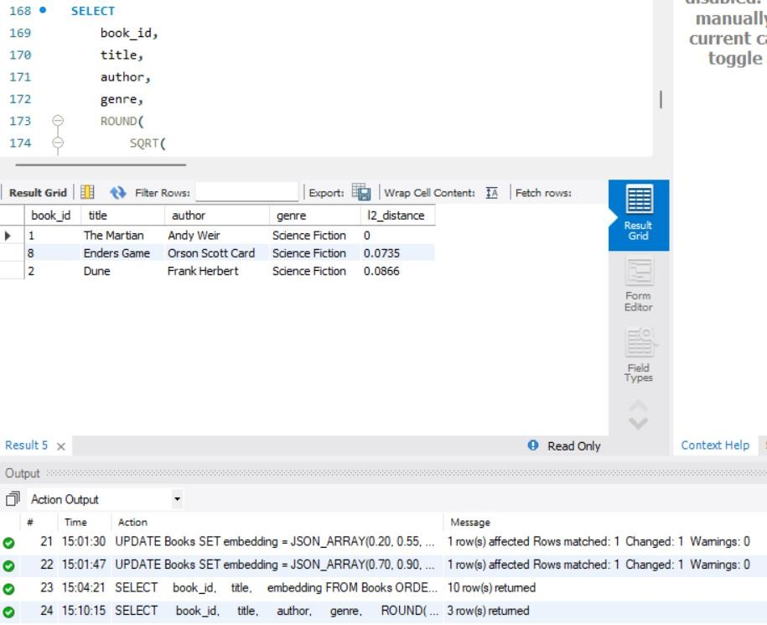
- COSINE SIMILARITY
