CH.MADHULIKA-2520090056
SKILL WEEK-3
- CREATE CUSTOMER TABLE & ACCOUNT TABLE
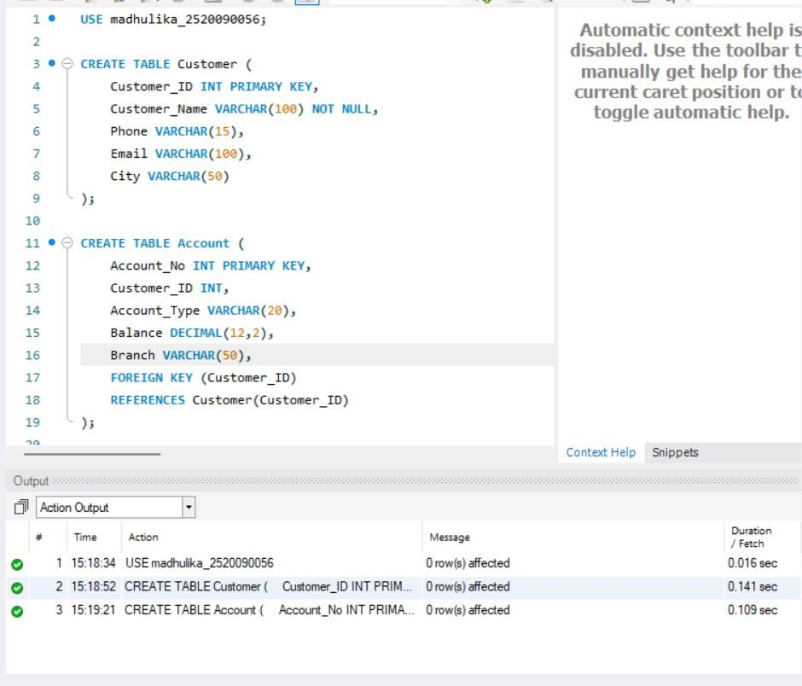
- CREATE BANK TRANSACTION TABLE
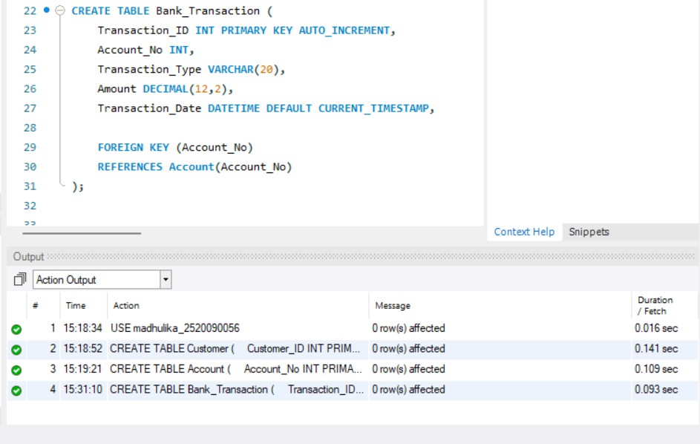

- CREATE LOAN TABLE
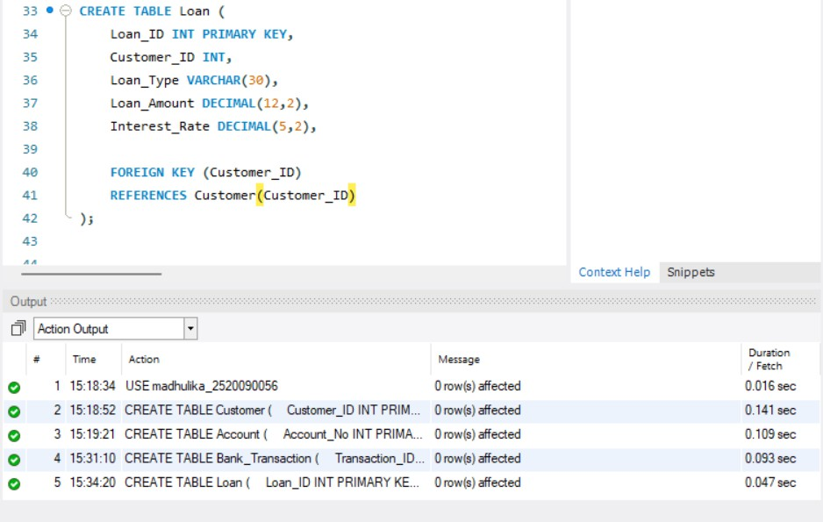
- INSERT CUSTOMER DATA
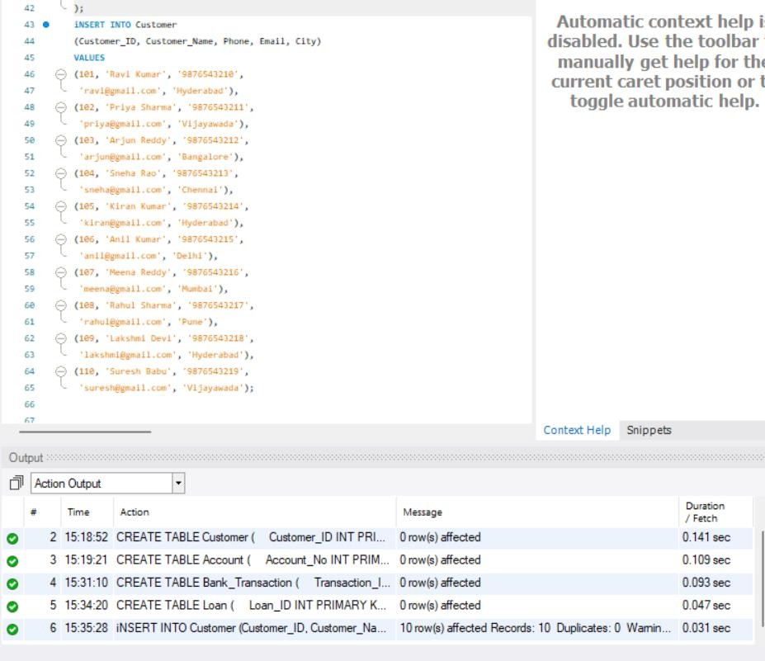

- INSERT ACCOUNT DATA
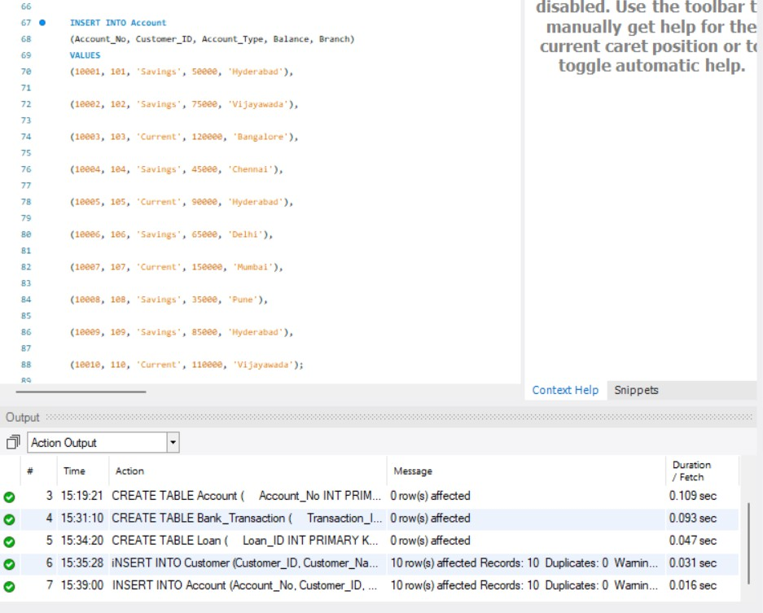
- INSERT TRANSACTION DATA
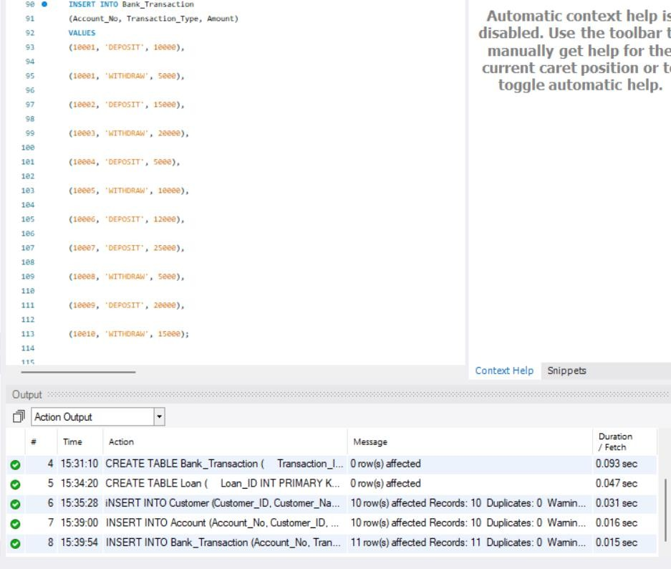

- INSERT LOAN DATA

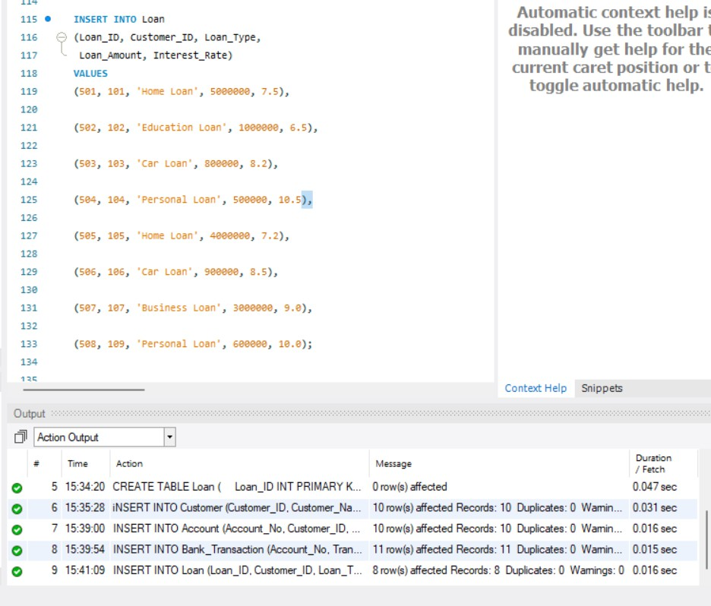
- DISPLAY ORIGINAL TABLES
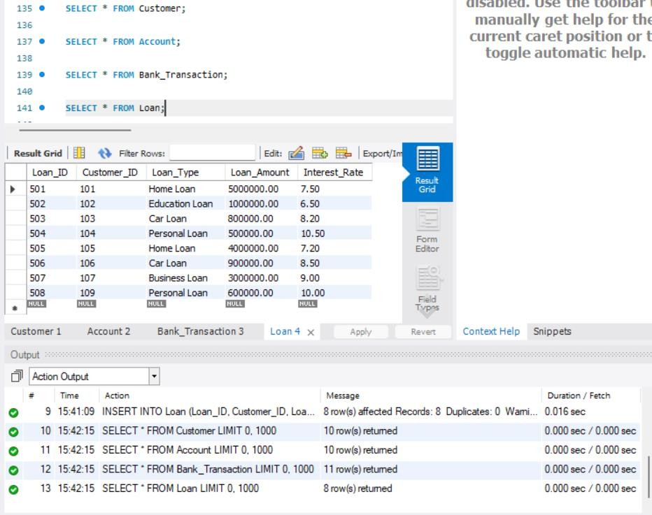

- CREATE A VIEW FOR ALL CUSTOMERS
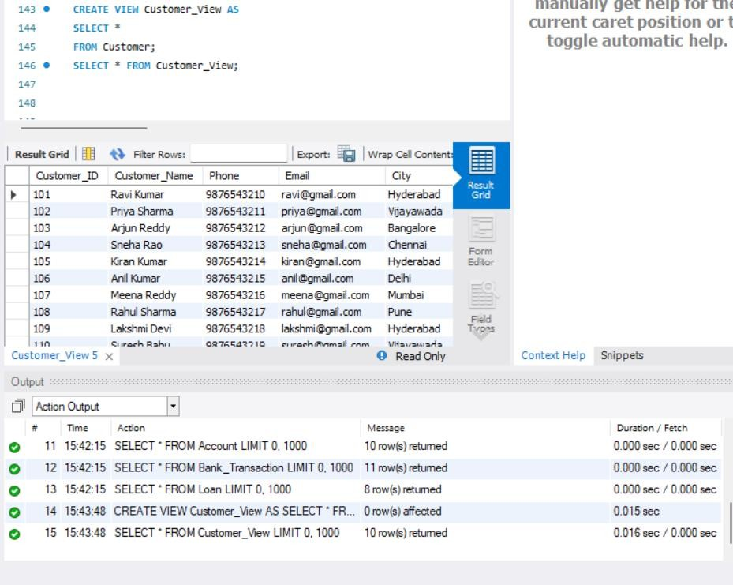
- CREATE A VIEW FOR CUSTOMER BASIC INFORMATION
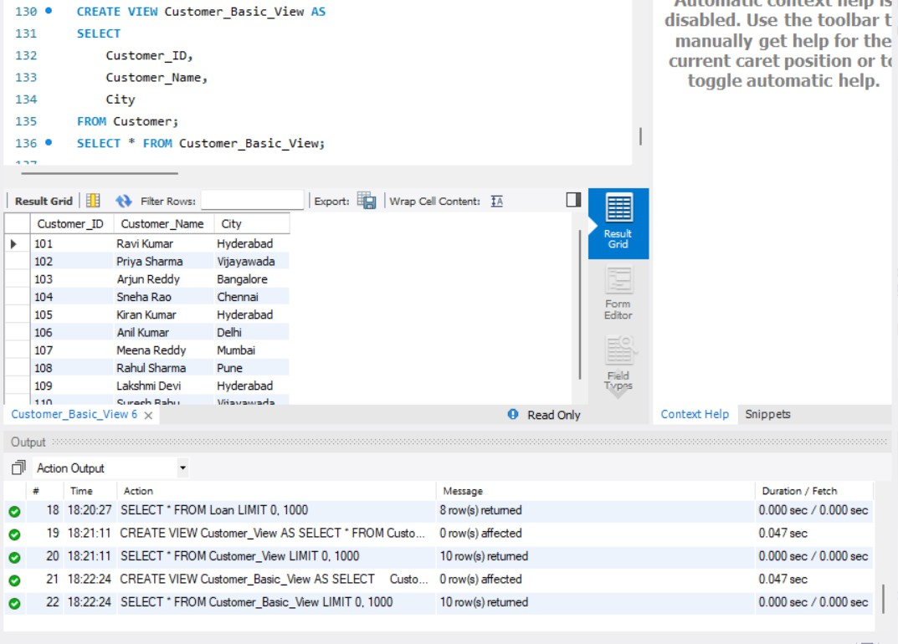

- CREATE A VIEW FOR ACCOUNT INFORMATION

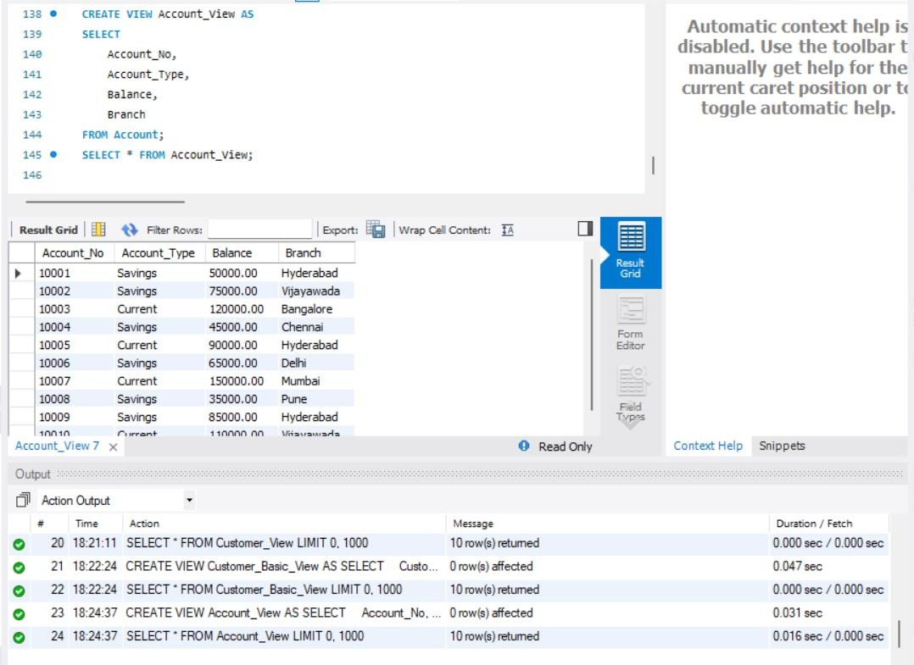
- CREATE A VIEW FOR SAVINGS ACCOUNTS
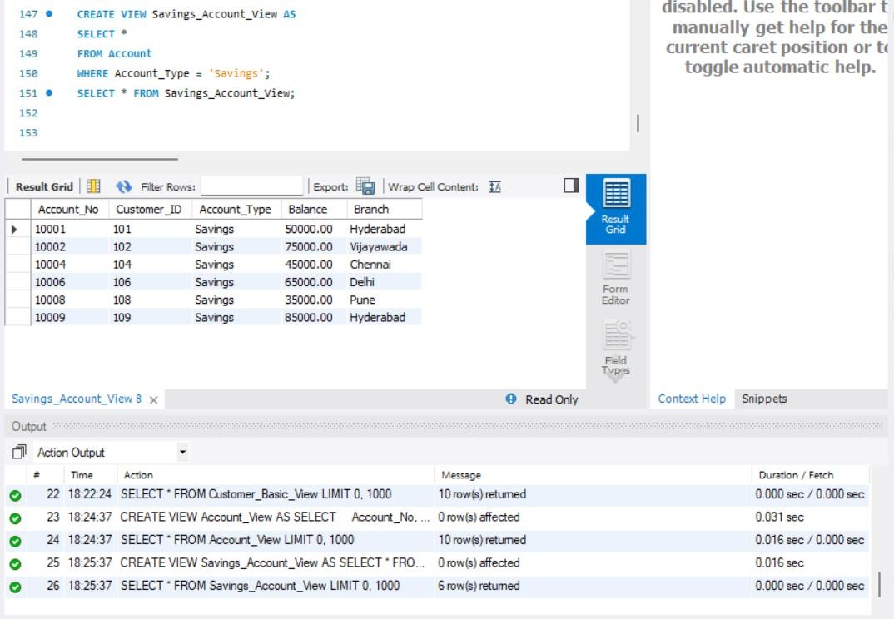

- CREATE A VIEW FOR CURRENT ACCOUNTS
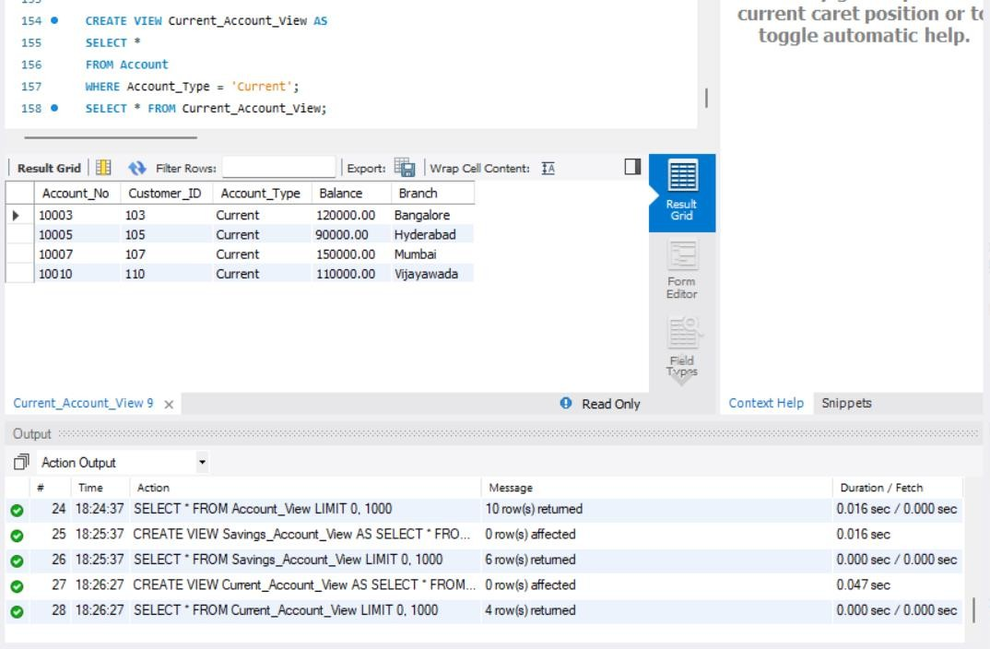
- HIGH BALANCE ACCOUNT VIEW
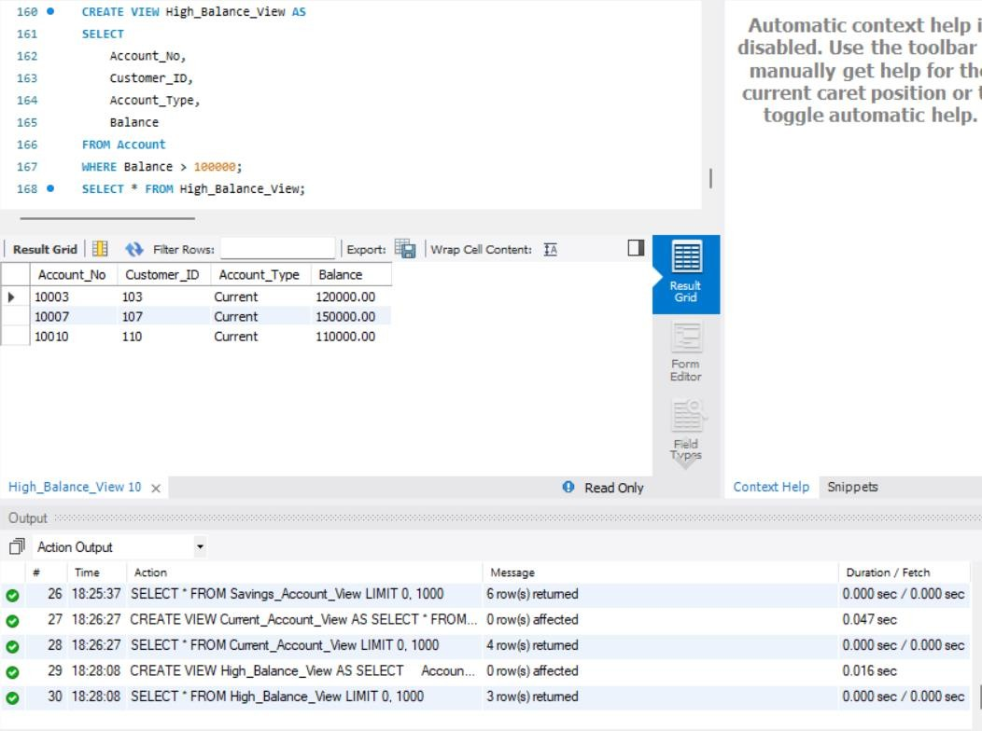

- HYDERABAD ACCOUNT VIEW
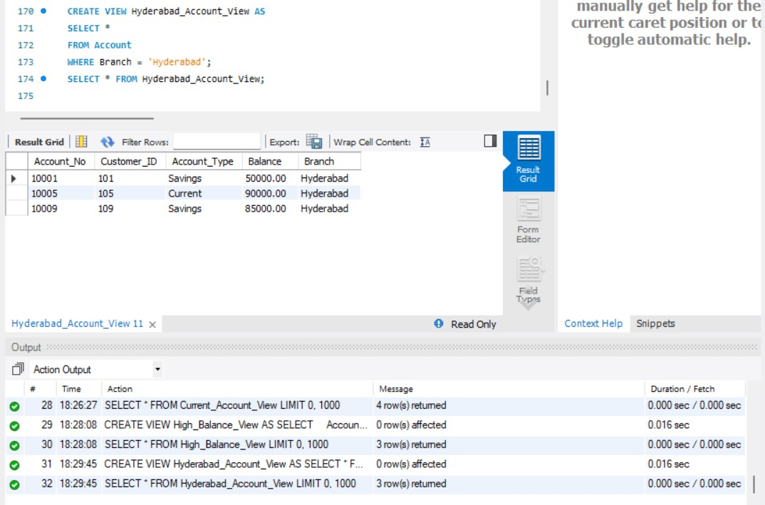
- LOW BALANCE ACCOUNT VIEW
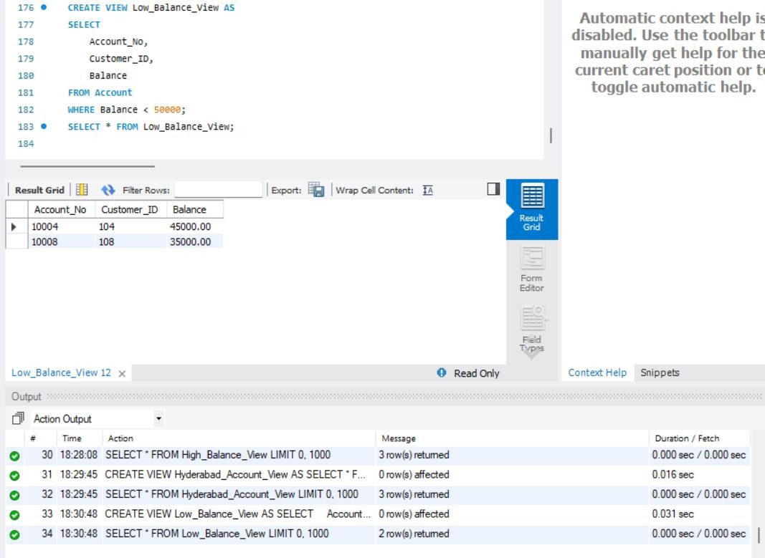

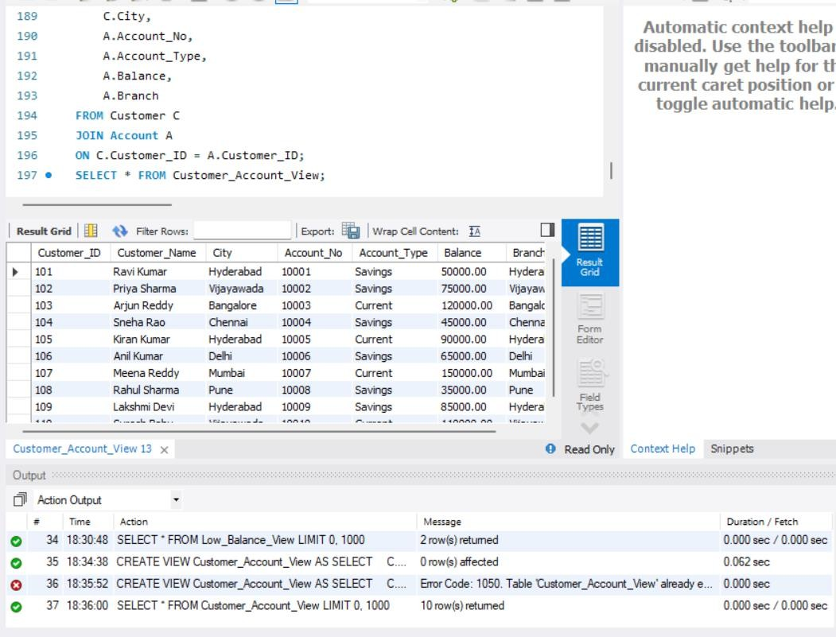
- CUSTOMER + ACCOUNT VIEW
- HYDERABAD CUSTOMER ACCOUNT VIEW
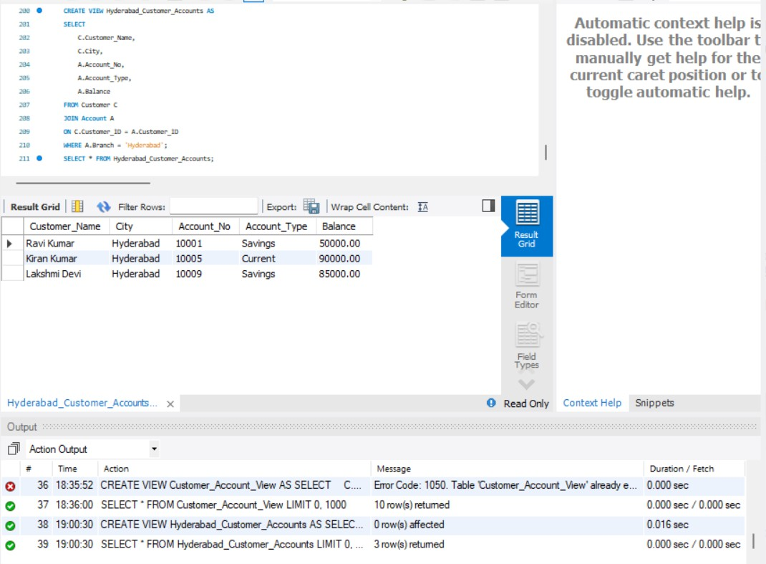

- CUSTOMER LOAN VIEW

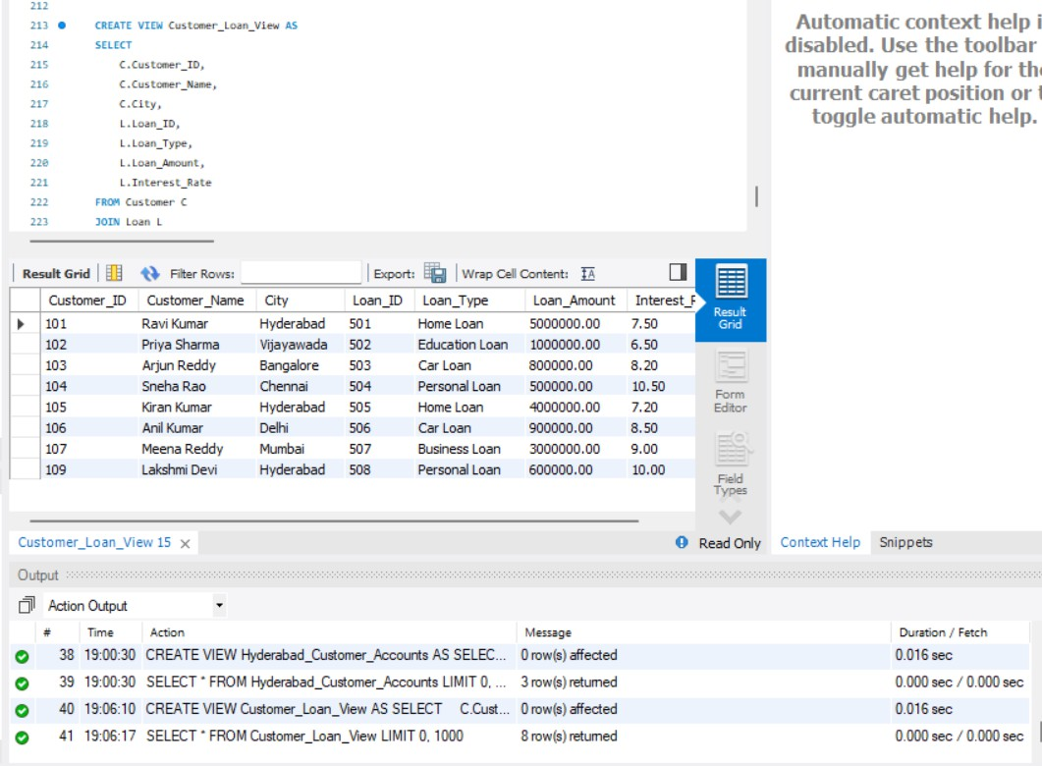
- COMPLETE CUSTOMER BANKING VIEW
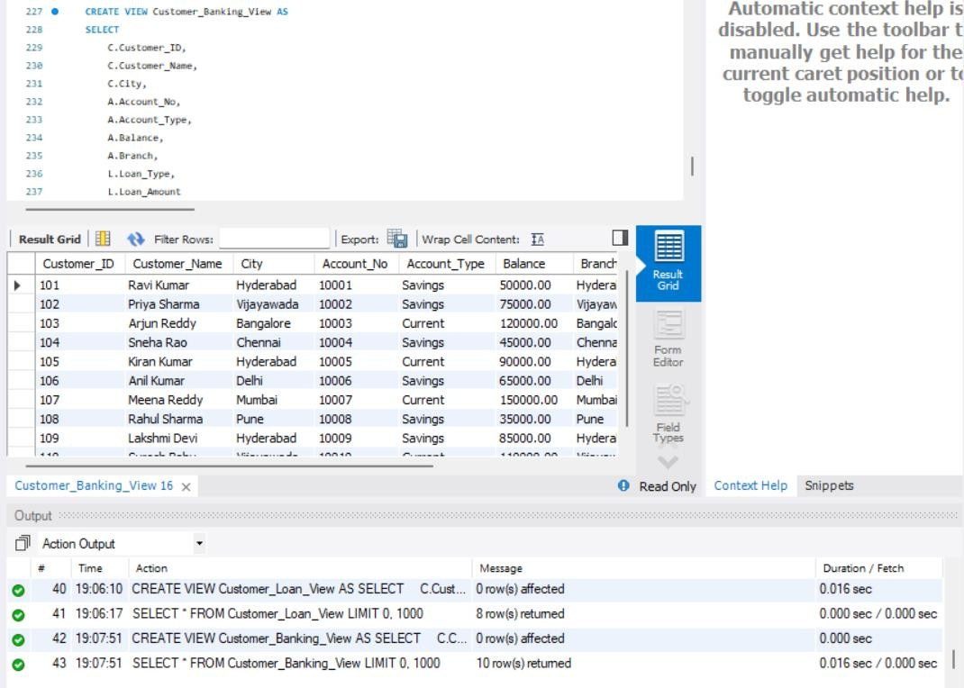

- TOTAL BANK BALANCE
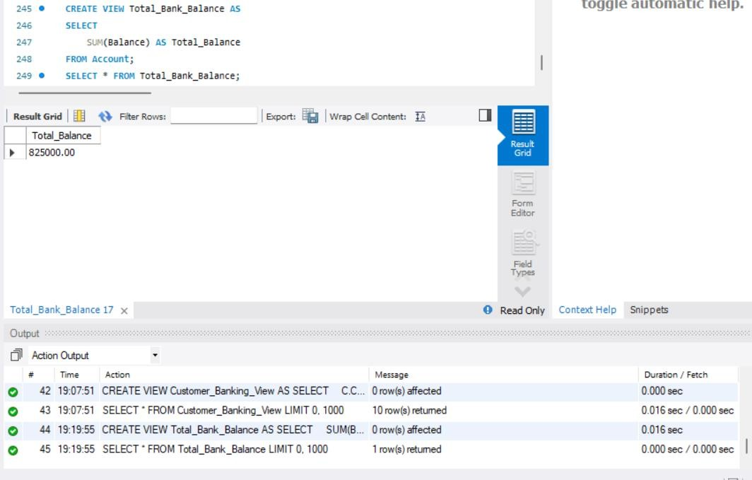
- AVERAGE ACCOUNT BALANCE
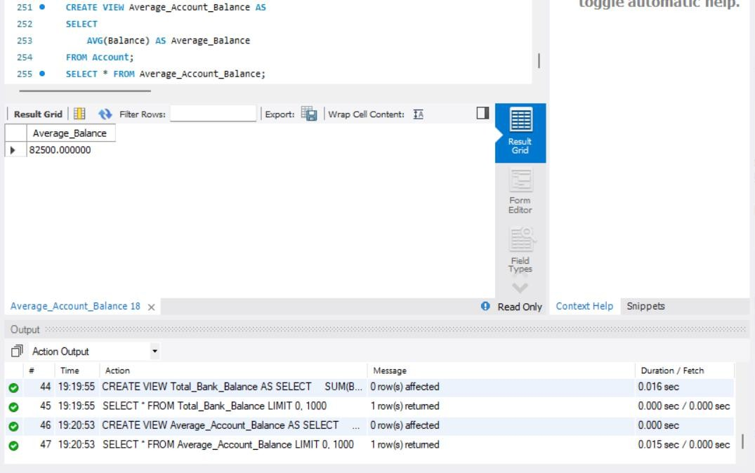

- MAXIMUM ACCOUNT BALANCE

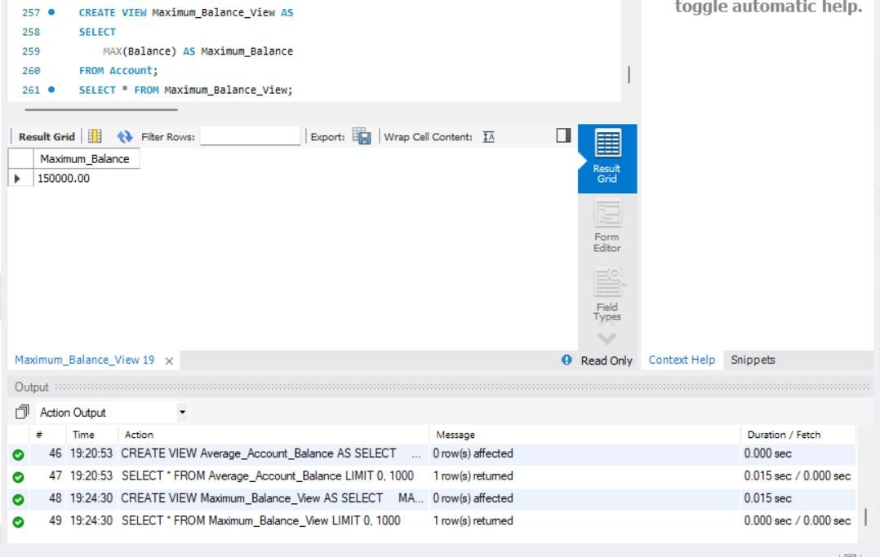
- MINIMUM ACCOUNT BALANCE
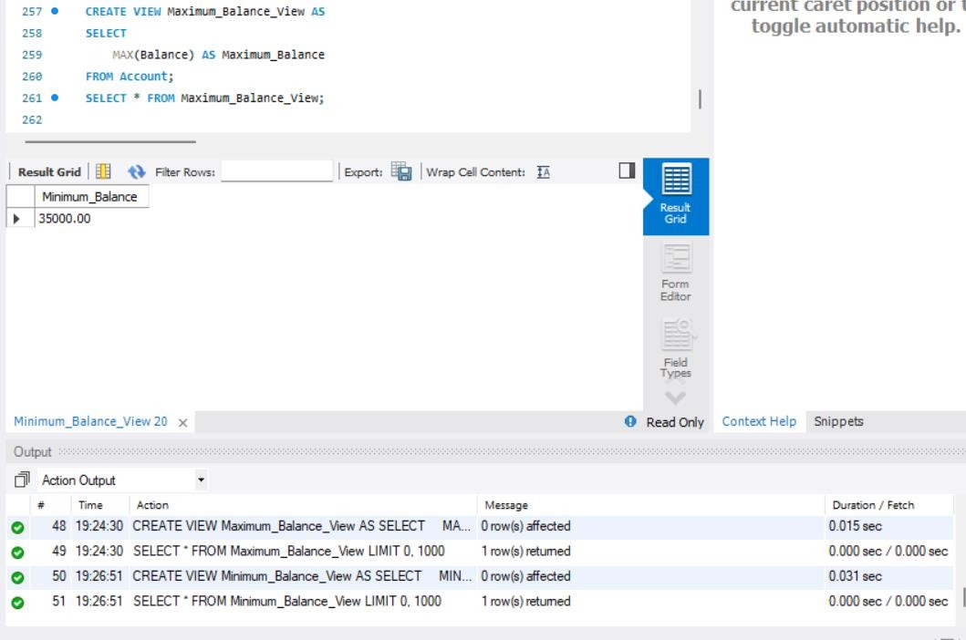

- TOTAL NUMBER OF ACCOUNTS
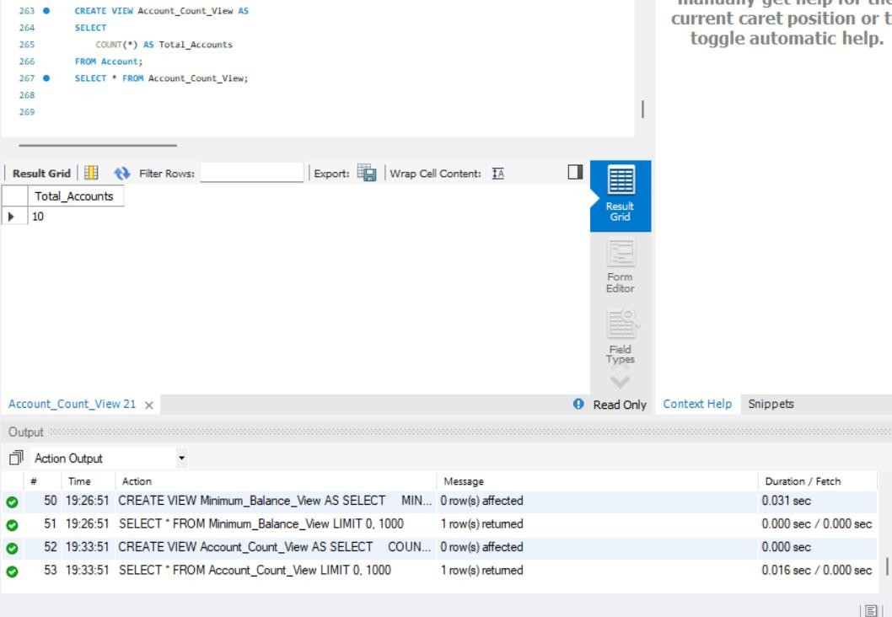
- BRANCH-WISE ACCOUNT COUNT
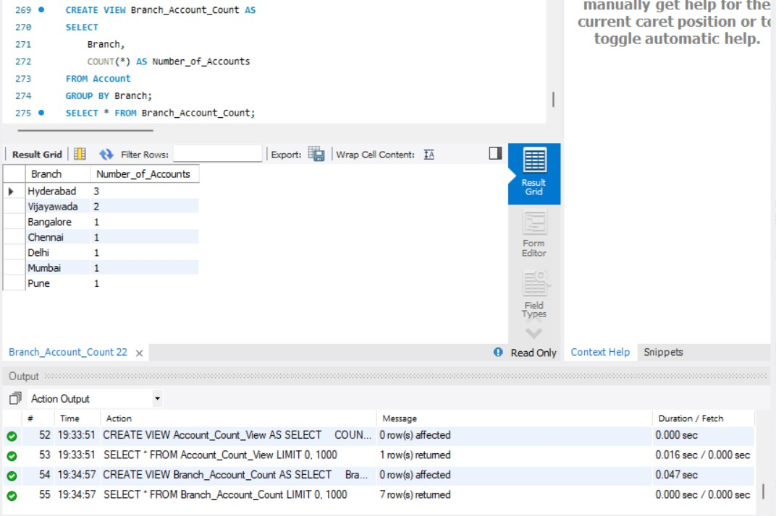

- BRANCH-WISE TOTAL BALANCE
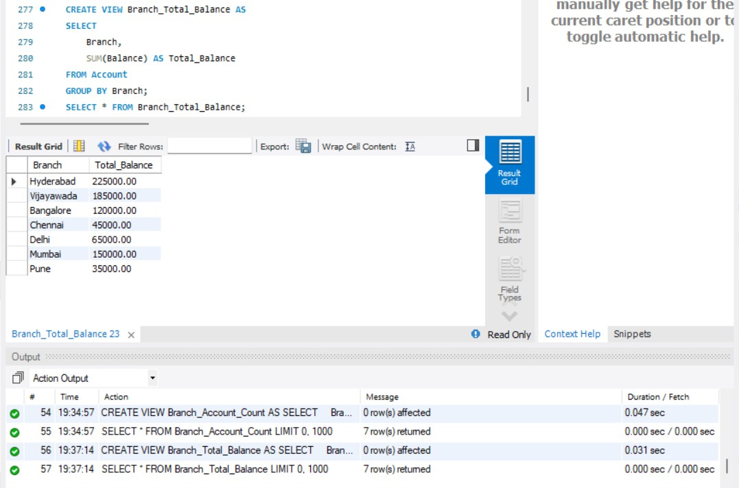
- ACCOUNT TYPE COUNT
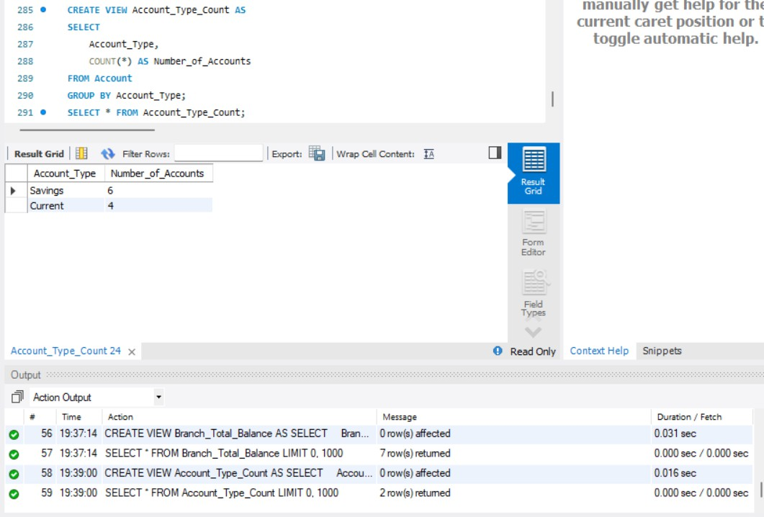

- ACCOUNT TYPE TOTAL BALANCE
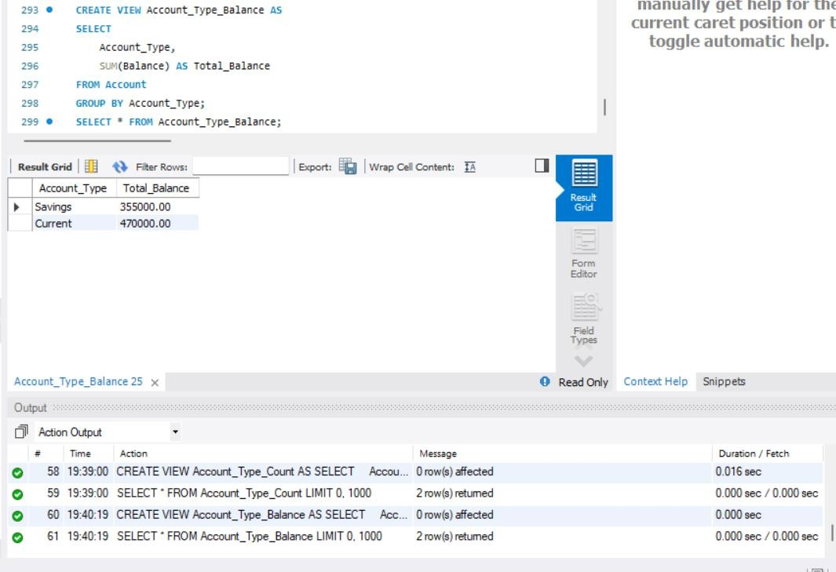
- BRANCHES WITH MORE THAN ONE ACCOUNT
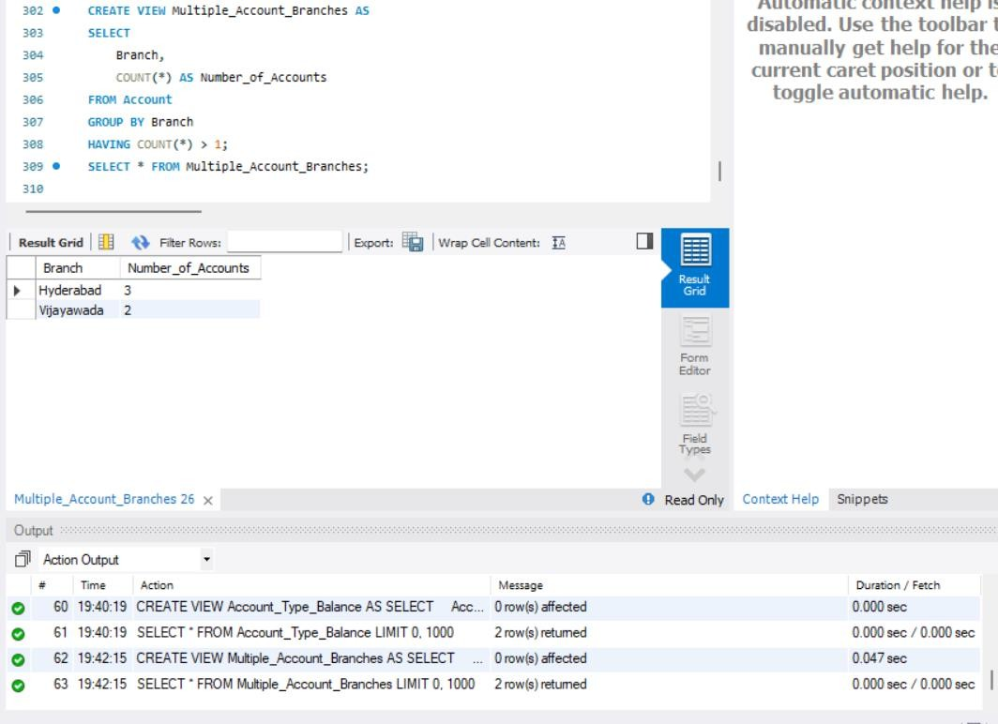

- BRANCHES WITH TOTAL BALANCE ABOVE 100000
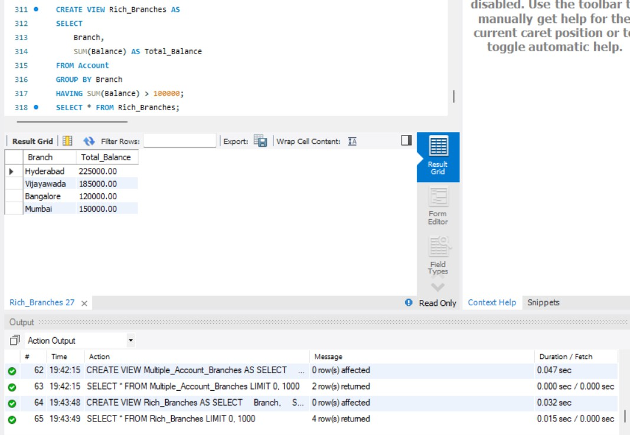
- DEPOSIT TRANSACTION VIEW
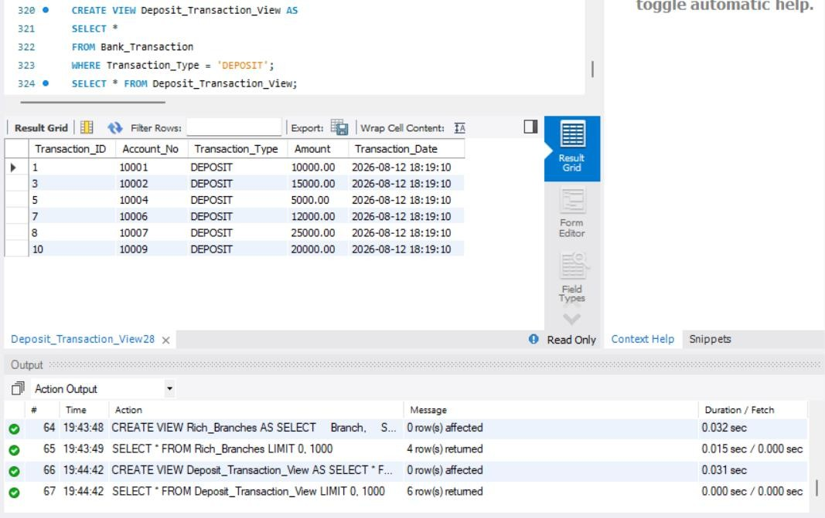

- WITHDRAWAL TRANSACTION VIEW
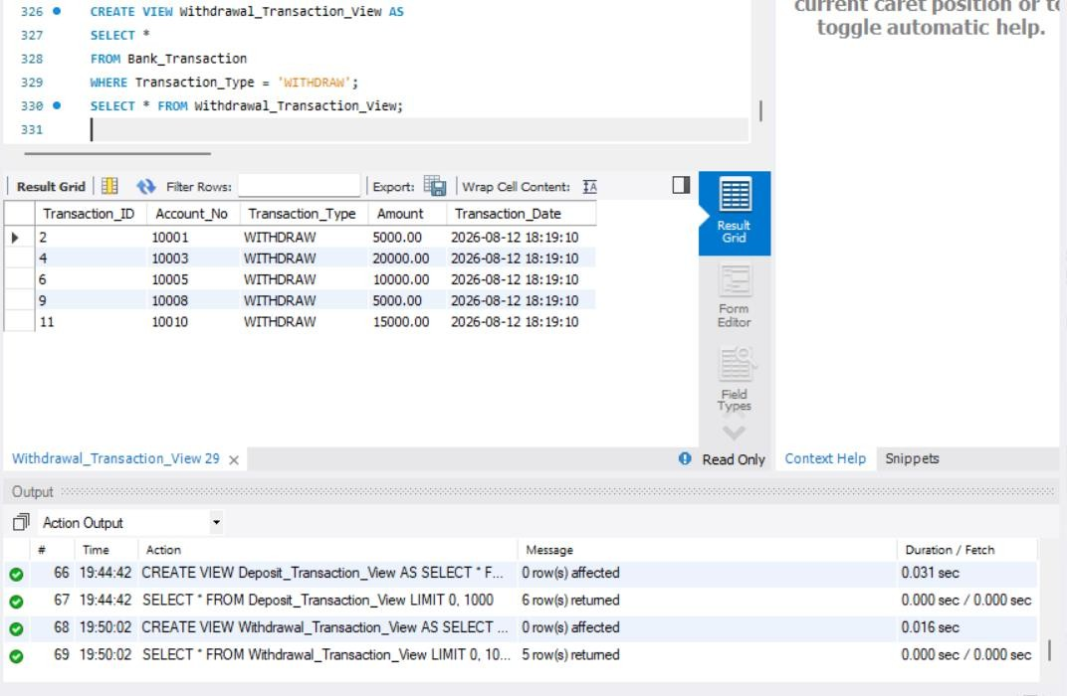
- TRANSACTION DETAILS WITH CUSTOMER
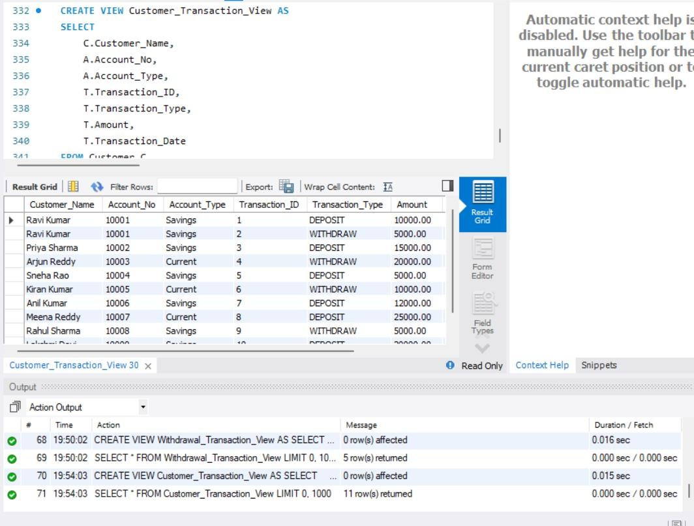

- HIGH VALUE TRANSACTION VIEW
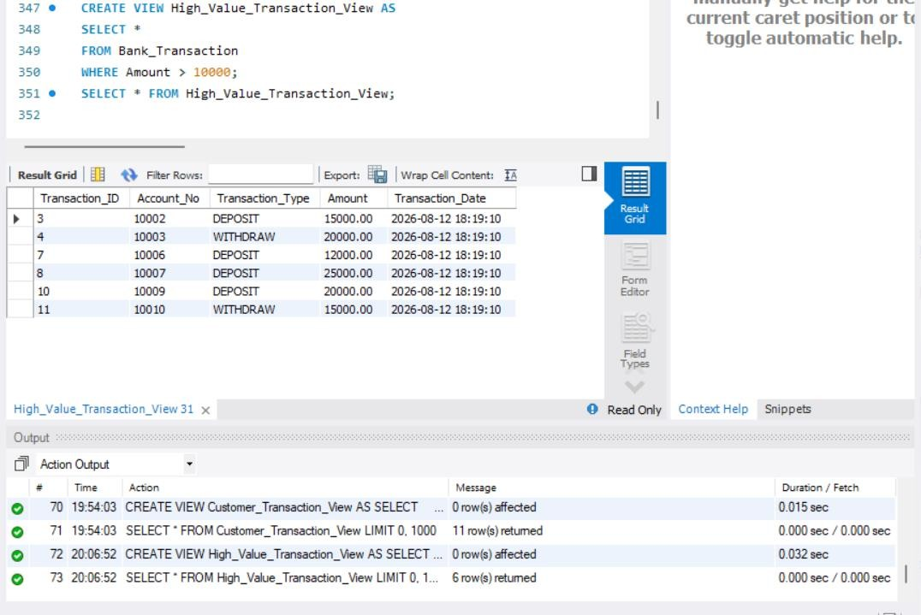
- ACCOUNTS ORDERED BY BALANCE
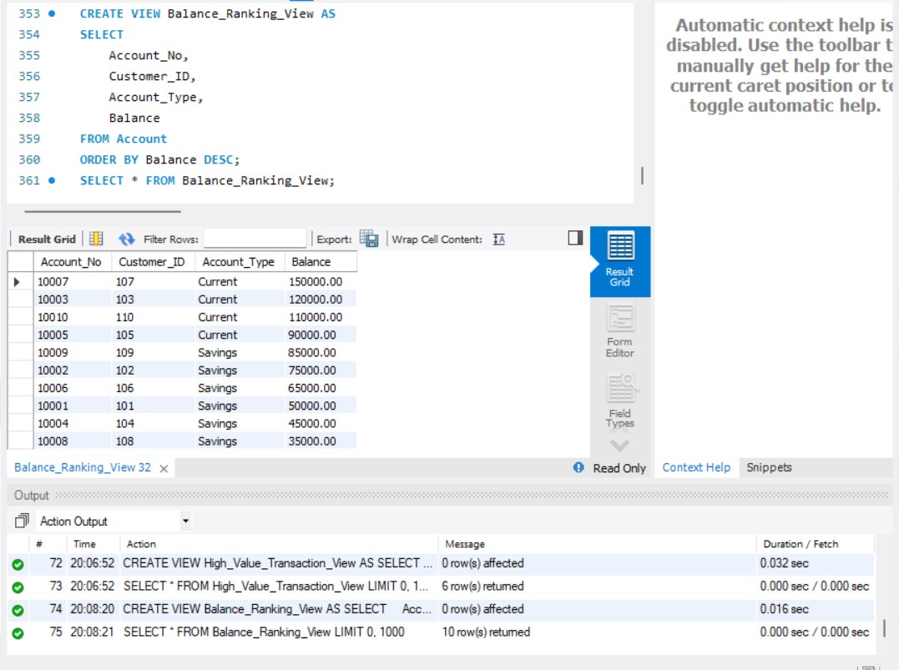

- CUSTOMERS ORDERED BY NAME
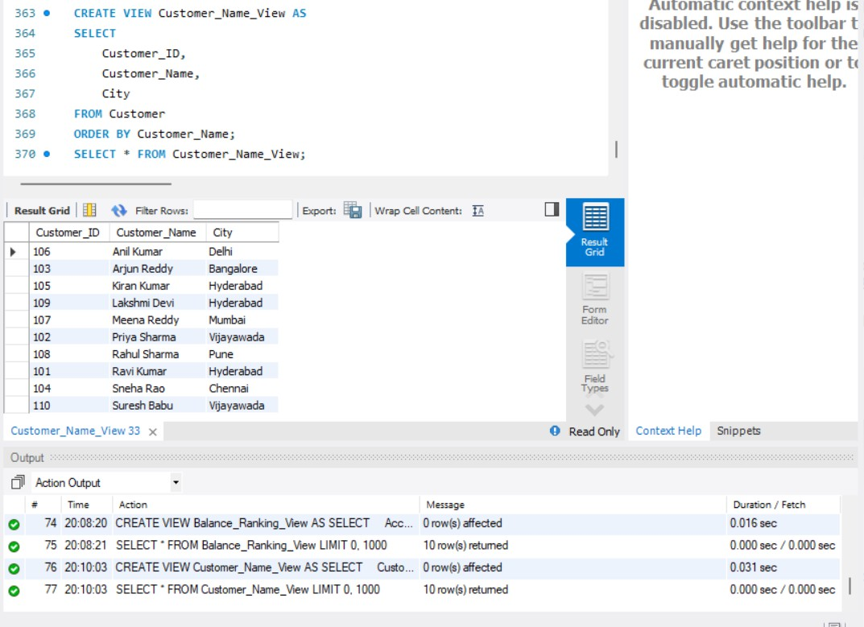
- LOAN INTEREST CALCULATION VIEW
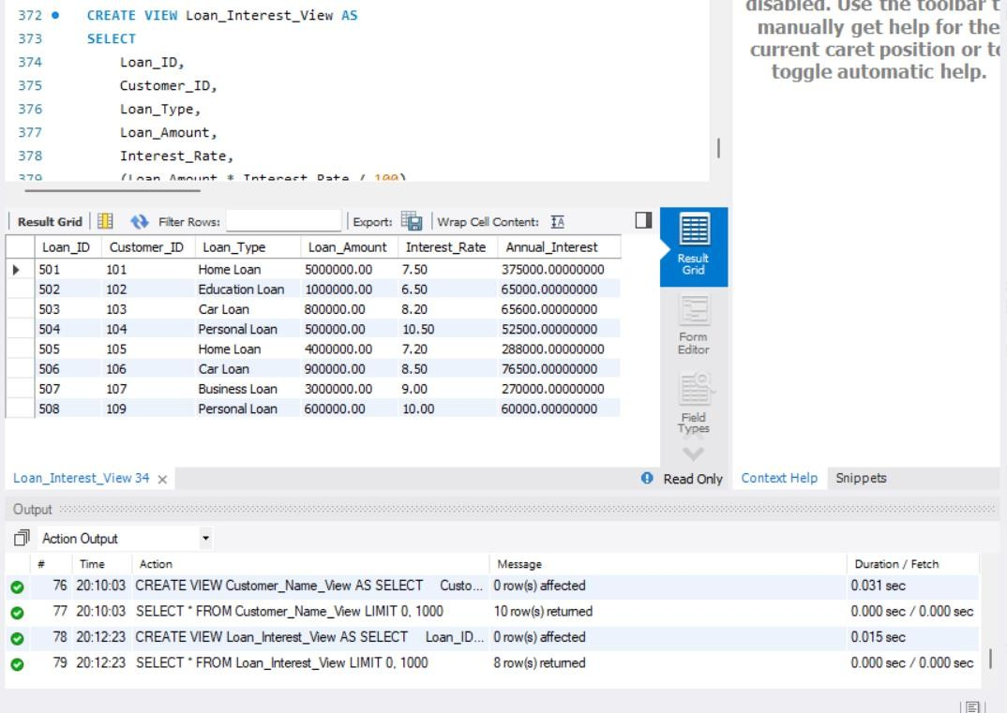

- LOAN TOTAL AMOUNT VIEW
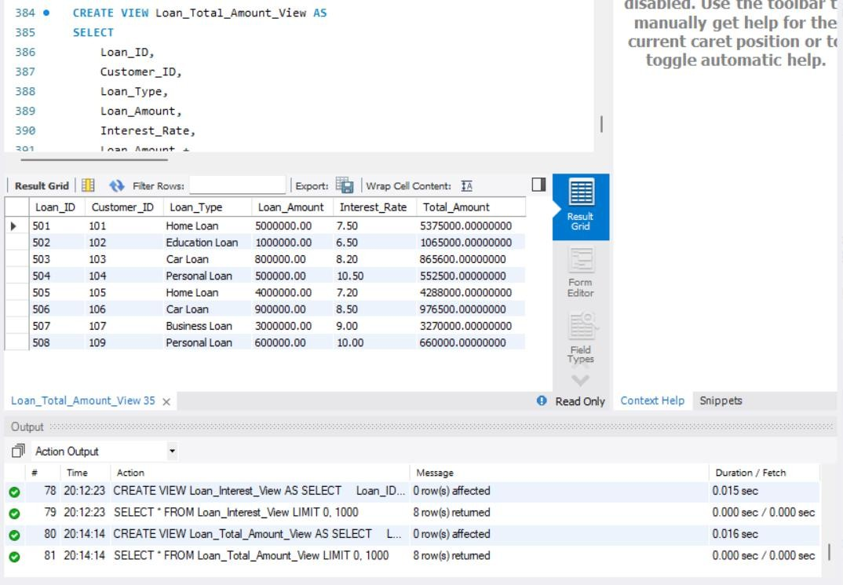
- DISPLAY HIGH BALANCE ACCOUNTS FROM VIEW
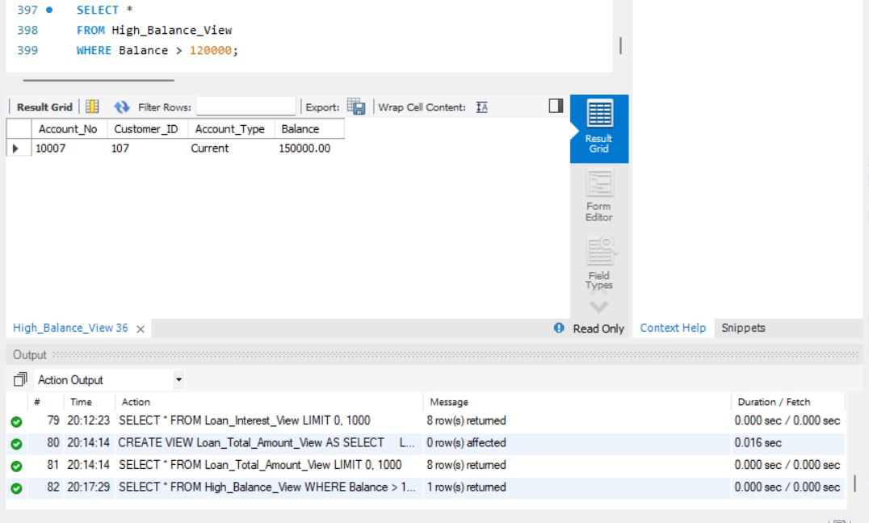

- DISPLAY SAVINGS ACCOUNTS ABOVE 60000
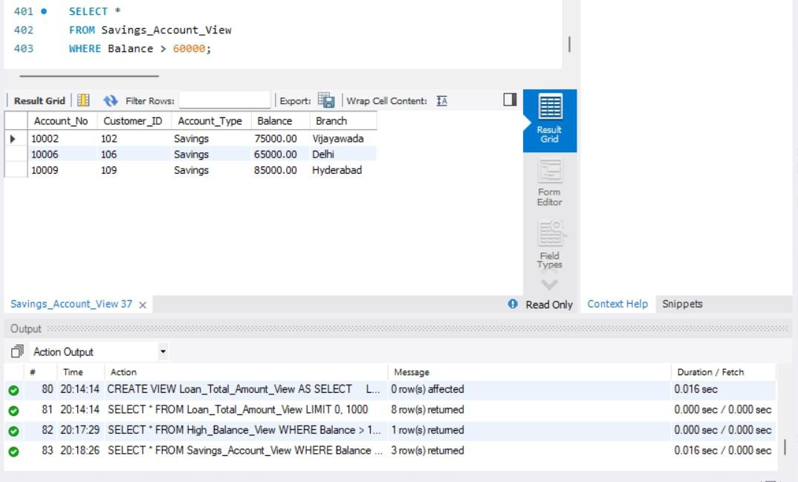
- DISPLAY HYDERABAD ACCOUNTS ABOVE 50000
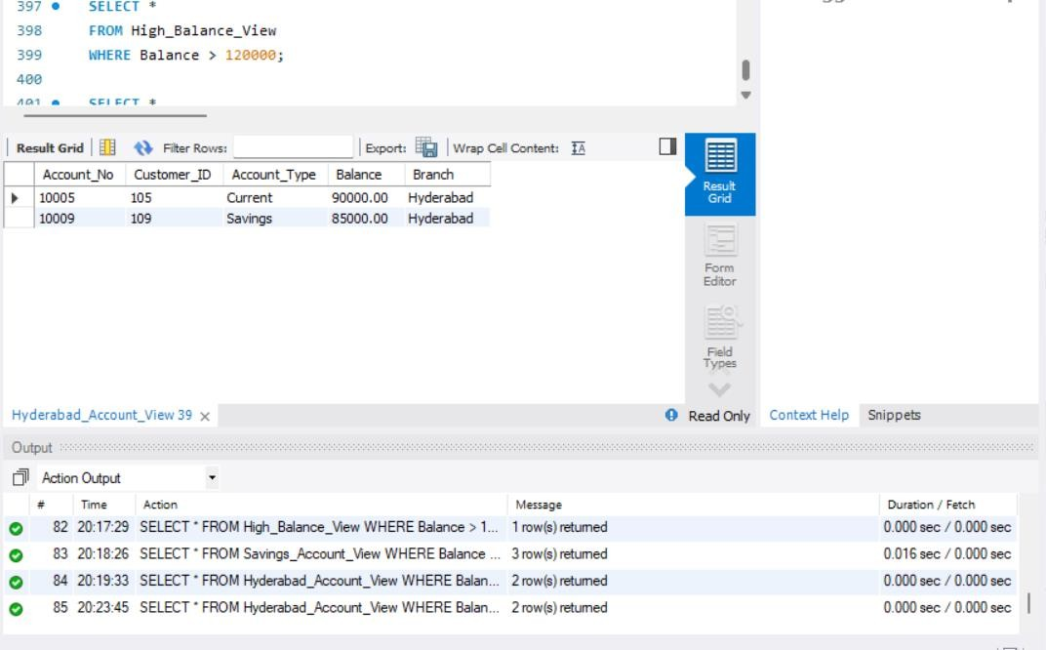

- DISPLAY CUSTOMER ACCOUNTS ORDERED BY BALANCE
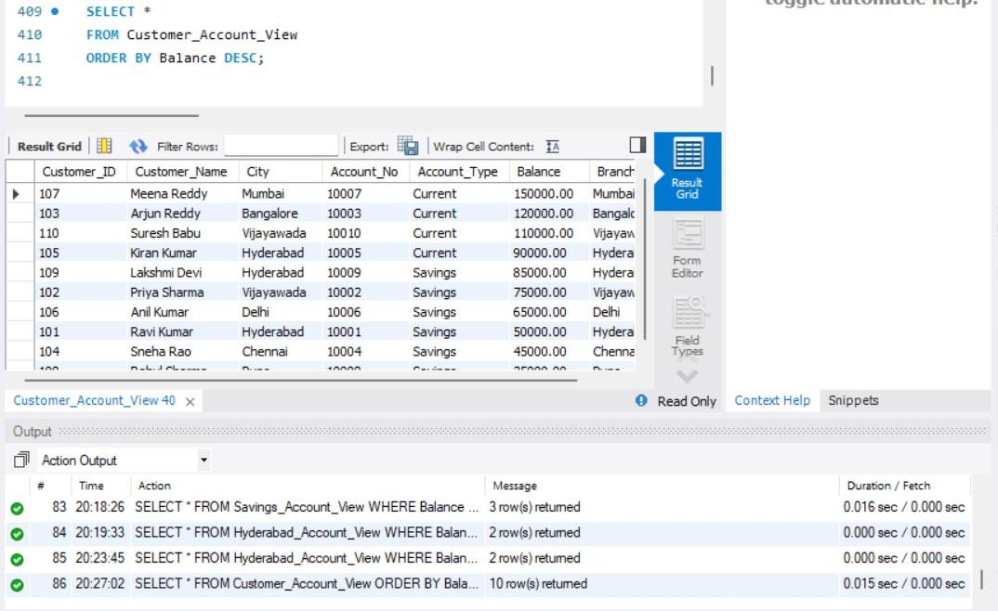
- DISPLAY LOANS ABOVE 1000000
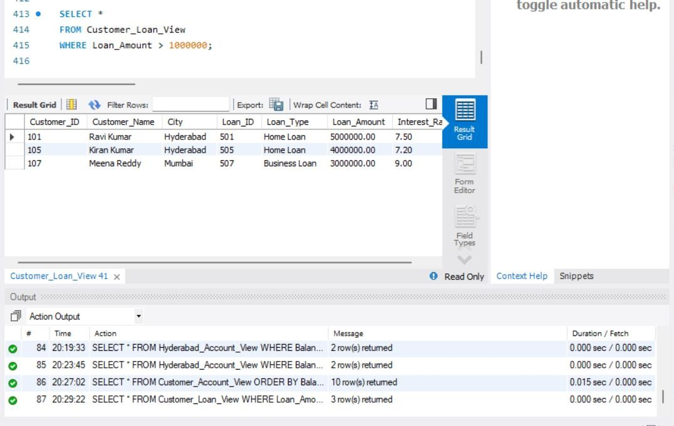

- UPDATE ACCOUNT BALANCE THROUGH VIEW

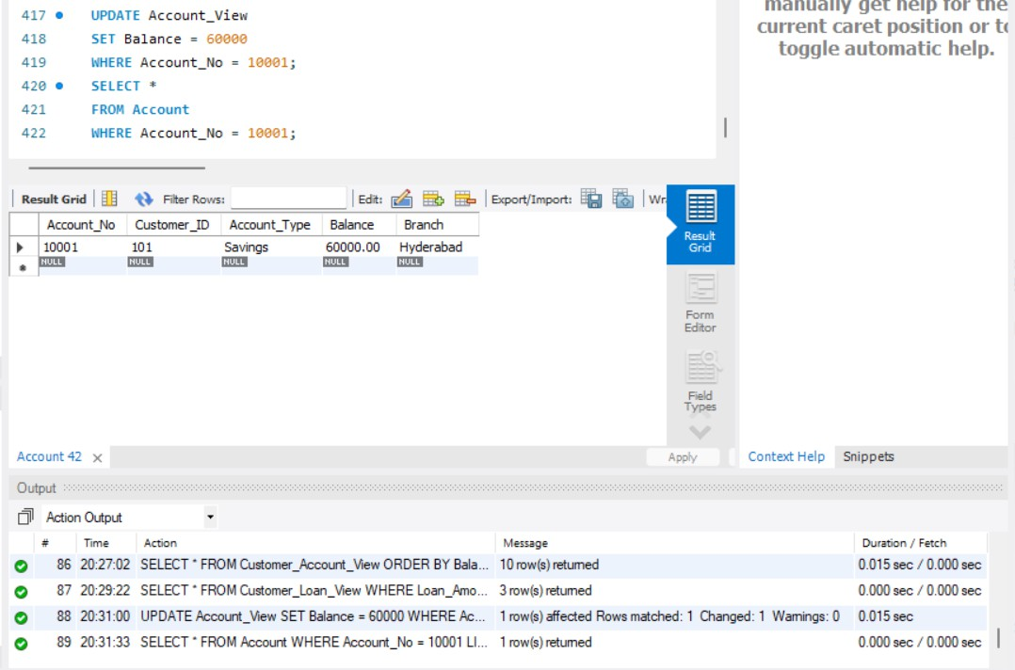
- INSERT USING SIMPLE VIEW
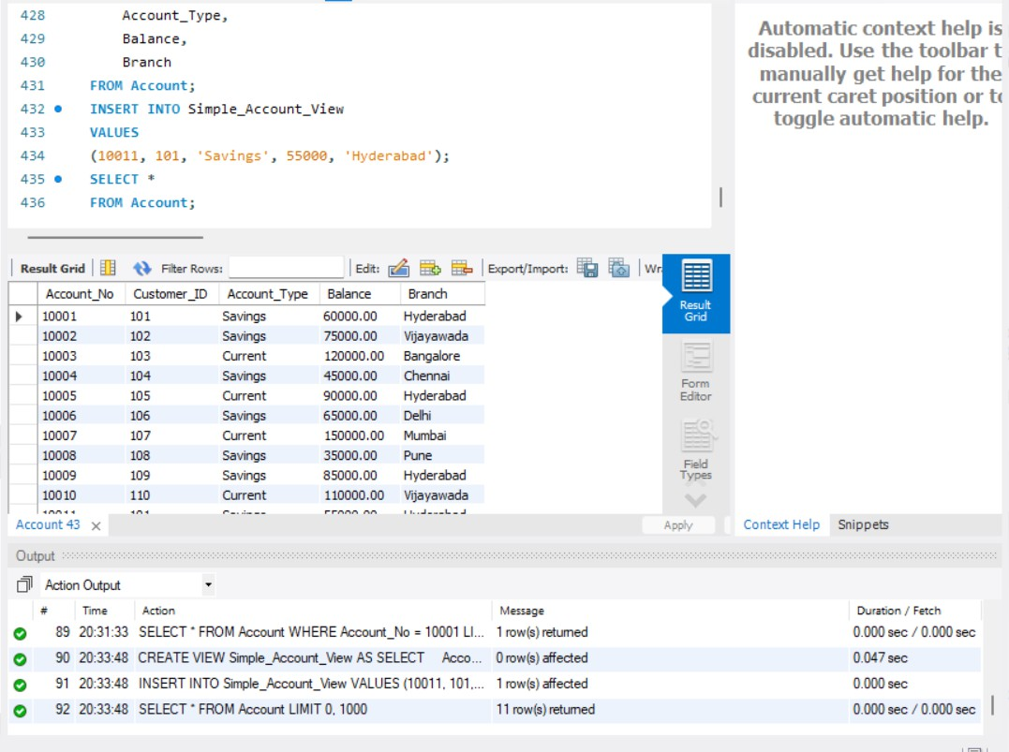

- DELETE USING SIMPLE VIEW
