**Practical No. 1**

**Aim:** Program to change the brightness of an image.

**Program Code:**

!pip install opencv-python matplotlib numpy

import cv2

import numpy as np

from google.colab.patches import cv2_imshow

image=cv2.imread("sample.png")

brightness_value=45

bright_image=cv2.convertScaleAbs(image, alpha=1, beta=brightness_value)

print("Original Image")

cv2_imshow(image)

print("After Brightening")

cv2_imshow(bright_image)

cv2.waitKey(0)

cv2.destroyAllWindows()

**Output:**

1. **For a random coloured image:**

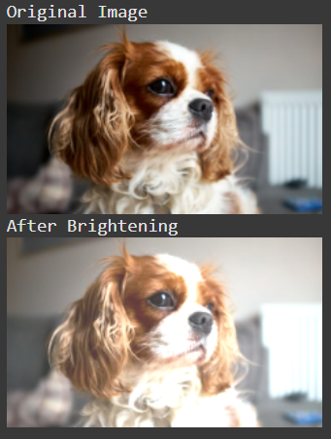

1. **For a grayscale image:**

