**Practical No. 3**

**Aim:** Program to display the color components of the image Red, Green, Blue components of Image.

**Program Code:**

from PIL import Image

import numpy as np

from matplotlib import pyplot as plt

image_path = 'photo.jpg'

try:

    img = Image.open(image_path)

    r, g, b = img.split()

    fig, axes = plt.subplots(1, 3, figsize=(15, 5))

    axes[0].imshow(r, cmap='Reds')

    axes[0].set_title('Red Component')

    axes[0].axis('off')

    axes[1].imshow(g, cmap='Greens')

    axes[1].set_title('Green Component')

    axes[1].axis('off')

    axes[2].imshow(b, cmap='Blues')

    axes[2].set_title('Blue Component')

    axes[2].axis('off')

    plt.show()

except FileNotFoundError:

    print(f"Error: Image file not found at '{image_path}'. Please update the 'image_path' variable with the correct path to your image.")

except Exception as e:

    print(f"An error occurred: {e}")

**Output:**

**Original Image**

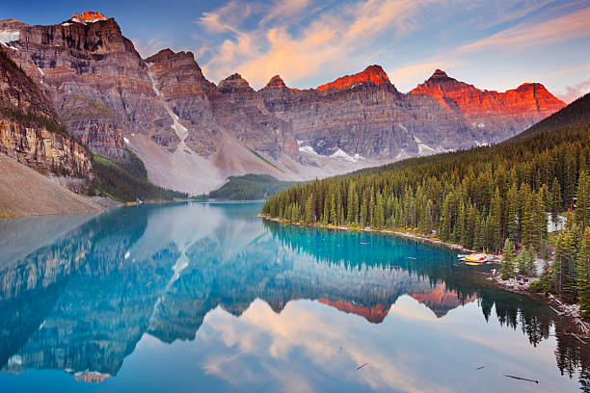

**Red, Green and Blue components extracted:**

