**Practical No. 7**

**Aim:** Program to calculate the histogram of a given image.

**Program Code:**

import cv2

from matplotlib import pyplot as plt

import numpy as np

image_path = 'image.jpg'

image = cv2.imread(image_path, cv2.IMREAD_GRAYSCALE)

if image is None:

    print(f"Error: Could not load image from {image_path}")

else:

    hist, bins = np.histogram(image.flatten(), 256, [0, 256])

    plt.figure()

    plt.title("Grayscale Histogram")

    plt.xlabel("Pixel Value")

    plt.ylabel("Frequency")

    plt.plot(hist)

    plt.xlim([0, 256])

    plt.show()

**Output:**



Original Image

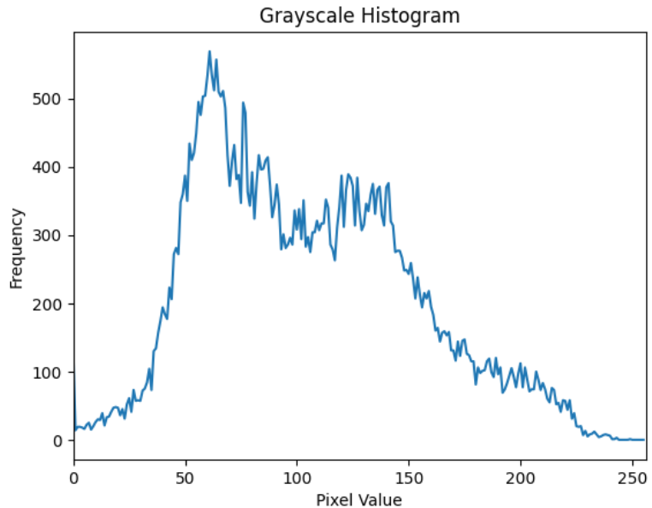

Histogram Plot

**For three channel Histogram**

**Program Code:**

import cv2

from matplotlib import pyplot as plt

import numpy as np

image_path = 'image.jpg'

image = cv2.imread(image_path, cv2.IMREAD_COLOR)

if image is None:

    print(f"Error: Could not load image from {image_path}")

else:

    colors = ('b','g','r')

    for i, color in enumerate(colors):

        hist = cv2.calcHist([image], [i], None, [256], [0, 256])

        plt.plot(hist, color = color)

        plt.xlim([0, 256])

    plt.title("Color Histogram")

    plt.xlabel("Pixel Value")

    plt.ylabel("Frequency")

    plt.show()

**Output (For the same image as above) :**

