**1. INTRODUCTION**

This project is focused on automating Excel reports using Python to reduce manual effort and minimize errors in data management. The objective is to deliver a solution that allows professionals to automate repetitive tasks such as data cleaning, report generation, and analysis. By using Python, the system can create dynamic, accurate reports faster than manual methods.

Excel is widely used in many industries for tasks such as data processing, report creation, and financial analysis. However, managing large datasets in Excel manually can be time-consuming and prone to human error. This project leverages Python’s libraries (like Pandas and OpenPyXL) to automate these tasks, making data management more efficient and error-free.

* 1. **PROBLEM STATEMENT:**

Manually handling data in Excel involves repetitive actions, such as cleaning datasets, applying formulas, and creating reports. This process can be slow and prone to errors, especially when dealing with large datasets. Businesses need a faster, more reliable method to generate reports and manage data, which this project aims to solve by automating Excel-based tasks using Python.

**1.2 OBJECTIVES:**

The objective of this project is to automate tasks in Excel using Python to:

* Minimize the time spent on repetitive tasks.
* Improve the accuracy of reports by reducing manual errors.
* Create dynamic and customizable reports automatically.
* Benefit both technical and non-technical users by making the automation process accessible.

**1.3 SCOPE:**

The system can be implemented in various industries that rely heavily on Excel for data management, such as finance, marketing, and administration. It will automate tasks such as data cleaning, applying formulas, generating graphs, and creating customized reports. The system is flexible enough to handle different types of datasets and can be adapted to a variety of reporting needs. It can be used to perform analysis and visualizations on both Excel and csv files.

**2. RELATED WORK**

**2.1 EXISTING SYSTEM:**

In the current scenario, professionals manually process Excel files, spending significant time on repetitive tasks like formatting data, applying formulas, and generating reports. This manual process often leads to errors and inconsistencies, which can impact decision-making.

There are built-in Excel tools like macros, but these are limited and require the user to have knowledge of VBA programming. Python provides a more robust solution, allowing for greater flexibility and automation in data processing.

**2.1.1 Automation Add-ins**

Automation add-ins are external tools or programs that integrate with Excel to extend its capabilities. These add-ins allow users to automate complex tasks, such as data analysis or report generation, directly within Excel. While they enhance productivity, setting them up often requires some technical knowledge, and they are typically designed for specialized use cases or advanced data processing. It streamlines repetitive tasks, but often require technical expertise for setup.

**2.1.2 VBA (Visual Basic for Applications)**

VBA is a programming language built into Excel that allows users to automate tasks by writing custom scripts. With VBA, users can create complex macros, manipulate data, and even build custom functions. It’s highly flexible and powerful for advanced automation, but it requires a basic understanding of programming concepts, making it harder for beginners to use initially. Powerful for customization, but has a steeper learning curve and potential security risks.

**2.1.3 Macros**

Macros in Excel allow users to automate repetitive tasks by recording a series of actions that can be played back later. Users can create macros without any coding knowledge by using the "Record Macro" feature, making it accessible for beginners. While easy to use, macros can be limited in complexity and flexibility compared to VBA, but they are perfect for simple task automation. Easy to implement, but limited flexibility compared to VBA and lacks advanced functionality.

**3. SYSTEM DESIGN**

System design is critical to ensure the system can efficiently process large datasets, handle various tasks, and generate dynamic reports. The system is built around Python’s capabilities to manage and manipulate Excel files through libraries such as Pandas and OpenPyXL.

## 3.1 PROPOSED SYSTEM:

## The proposed system automates several key tasks in Excel:

## Data Cleaning: Python functions like isnull(), dropna(), fillna() will clean datasets by removing duplicates, filling in missing values, and formatting data.

## Data Analysis: The system will perform calculations, such as summing values, calculating averages, or applying other statistical functions.

## Report Generation: Python will generate formatted reports that include tables and visualizations like charts or graphs. These reports can be customized based on user-defined templates.

## The user only needs to upload the Excel file into the system, specify the tasks, and the Python script will process the data and export the final report.

## 3.2 SYSTEM DESIGN:

**Input**: The system takes in raw Excel data provided by the user. The data can include anything from sales figures to employee records.

**Processing**: The Python script processes the data by performing cleaning, formatting, calculations, and generating visualizations. Key libraries used include:

* **Pandas**: For data manipulation and analysis.
* **OpenPyXL**: For reading and writing Excel files.
* **Matplotlib/Seaborn**: For generating charts and graphs.

**Output**: The processed data is exported back into a new Excel file with the final report, which includes visualizations like bar charts, pie charts, and formatted tables.

## 3.3 SYSTEM FUNCTIONAL REQUIREMENTS:

The system’s key functional requirements include:

* **Data Validation**: Ensure the input data is in the correct format and handle missing or incorrect values.
* **Automated Report Generation**: Create reports that are automatically updated based on the input data.
* **Error Handling**: Handle errors gracefully, such as when encountering corrupt Excel files or incorrect formats.
* **User-Friendly Interface**: Provide an easy-to-use interface for non-technical users to upload data and receive reports.

**3.4 ER DIAGRAM:**

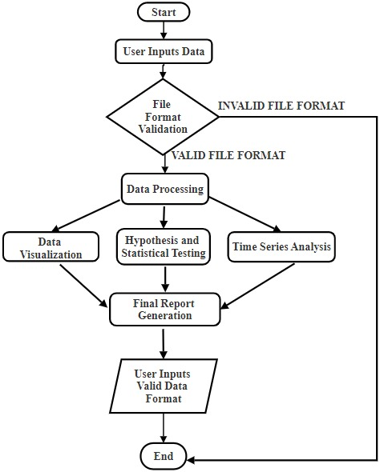

Fig 3.1 Flowchart of The System

**3.5 WORKFLOW:**

* The process starts when a user uploads a file into the Streamlit application.
* The document is verified against the standard formats (Excel or csv) and then the subsequent process begins. If the data is not in the valid format, the system prompts the user to upload the correct file format.
* The input data is processed, including tasks like cleaning, formatting, and structuring the dataset for further analysis.
* The processed data is visualized using appropriate charts or graphs. This could include bar charts, heatmaps, scatter plots, etc.
* The system conducts hypothesis testing or statistical analysis on the processed data, potentially providing insights into relationships or patterns in the data.
* If applicable, the system performs time series analysis to understand trends and patterns over time.
* A final report is generated summarizing the results of the analysis, including visualizations, statistical tests, and any other relevant findings.

**3.6 BLOCK-DIAGRAM:**

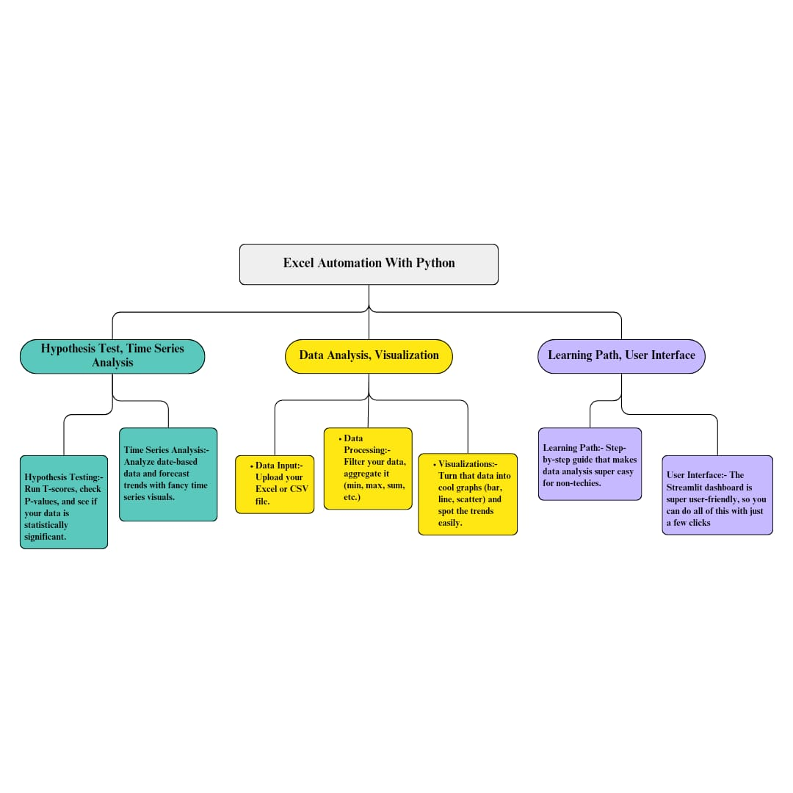

Fig 3.2. Block Diagram

This block diagram illustrates the process of Excel automation using Python, highlighting key components involved in the system. The framework begins with data input, where users upload Excel or CSV files. Following this, the data processing phase occurs, where data is filtered and aggregated (e.g., calculating minimum, maximum, or sum values).

Next comes data visualization, where processed data is turned into visual forms like bar graphs, line charts, or scatter plots, making trend spotting easier. For advanced analysis, the system includes hypothesis testing, allowing users to run statistical tests like T-scores and p-values, while the time series analysis feature helps in forecasting trends in date-based data.

Finally, the learning path and user interface guide non-technical users through a simplified process. The user-friendly Streamlit dashboard ensures smooth navigation, making the system accessible for users at all skill levels. The design aims to deliver an intuitive yet powerful data automation tool for efficient decision-making.

**4. METHODOLOGY**

The methodology for developing the Excel automation system involves the following steps:

1. **Data Collection**: Users upload their raw Excel data to the system.
2. **Data Cleaning:** Python scripts clean the data by handling missing values, duplicates, and formatting inconsistencies.
3. **Data Processing**: The system applies predefined formulas and functions to the cleaned data (e.g., summing values, calculating averages).
4. **Report Generation**: The final report is generated, including charts and tables, and exported back to Excel.
5. **Testing and Debugging**: The system is tested with various datasets to ensure it performs as expected.

This methodology ensures a structured approach to automating tasks while maintaining flexibility to handle different types of Excel files and reports.

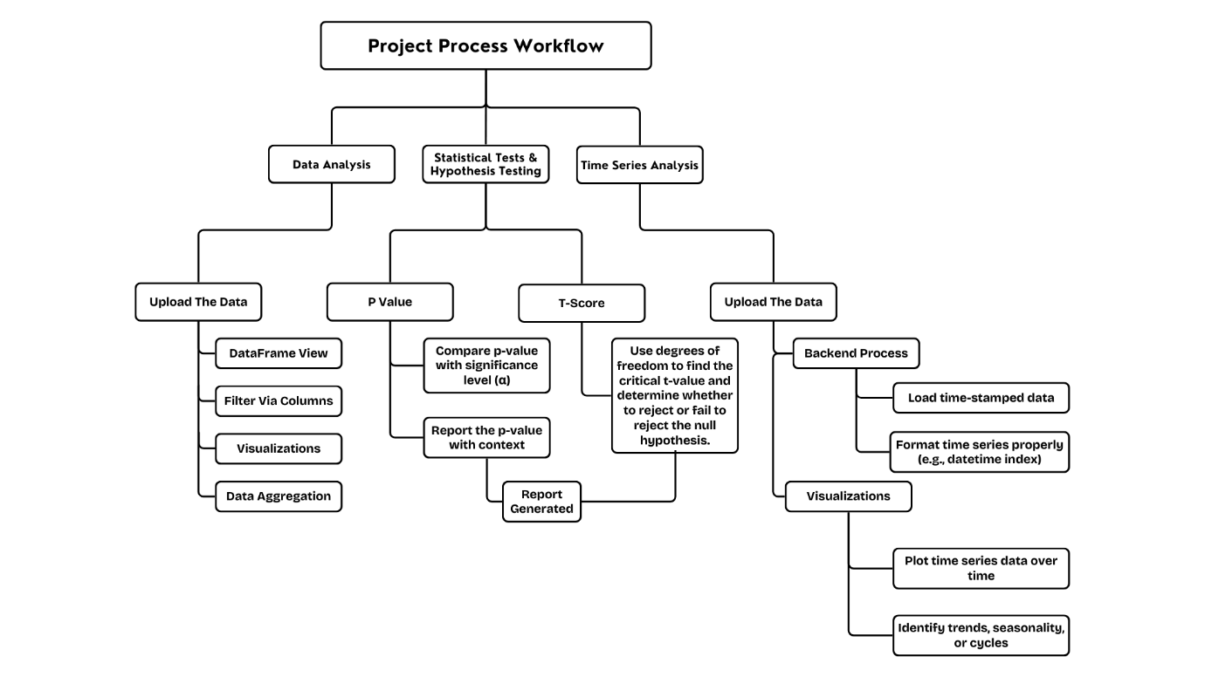

Fig 4.1. Workflow of the System

Fig No. 4.1 Outlines the steps involved in conducting data analysis, statistical tests, hypothesis testing, and time series analysis. Here's a breakdown of the methodology:

**4.1 DATA ANALYSIS:**

Upload the Data: This step involves loading the dataset into a system for analysis.

* DataFrame View: Present the data in a tabular format for inspection.
* Filter Via Columns: Select and filter specific columns to focus on the relevant data.
* Visualizations: Create visual representations like graphs and charts to better
* understand the data.
* Data Aggregation: Summarize and group data to gain insights (e.g., sum, mean, etc.).

**4.2 TIME SERIES ANALYSIS:**

Upload the Data: Time-stamped data is uploaded for analysis.

**1.Backend Process:**

* Load time-stamped data: Import and load data with time-specific information (e.g., dates, times).
* Format time series properly (e.g., datetime index): Ensure the time series data is formatted correctly for analysis (like setting a datetime index).

**2.Visualizations:**

* Plot time series data over time: Create time-based plots to show changes and trends in the data over a period.
* Identify trends, seasonality, or cycles: Analyze the time series data to identify patterns, such as recurring cycles or seasonal effects.

**5. SYSTEM REQUIREMENTS**

## 5.1 HARDWARE REQUIREMENTS:

* **RAM:** At least 4GB to handle small to medium datasets without performance lag.
* **Processor:** A multi-core processor (e.g., Intel i3 or AMD equivalent) is sufficient for basic operations like data manipulation and report generation.
* **Storage:** At least 20GB of free storage to manage temporary files, intermediate datasets, and output reports.
* **Display Resolution:** 1024x768 pixels to ensure that the interface and outputs (such as charts) are displayed clearly.

## 5.2 SOFTWARE REQUIREMENTS:

**5.2.1 Operating System:**

* Windows 10 or higher, macOS 10.13 or higher, or any major Linux distribution (e.g., Ubuntu 18.04 LTS or higher). These operating systems provide necessary drivers and system-level libraries to support Python environments efficiently.

**Python (Version 3.x):**

* Python is the core programming language for the project, offering libraries like Pandas and OpenPyXL to automate Excel tasks.

**5.2.2 Required Libraries:**

* **Pandas:** Essential for data manipulation, cleaning, and analysis. It handles everything from reading Excel files to performing complex data operations.
* **OpenPyXL:** Used for reading and writing Excel files, enabling the script to interact with Excel spreadsheets programmatically.
* **XlsxWriter:** A library to generate Excel files with formatted cells, charts, and other advanced features.
* **Matplotlib/Seaborn:** Visualization libraries used to create bar charts, pie charts, line graphs, etc. that are included in the final report.

**5.2.3 Integrated Development Environment (IDE):**

* **PyCharm** or **VS Code** for writing and debugging Python scripts.
* **Jupyter Notebook** can also be used for prototyping, especially when analyzing and visualizing data interactively.

**5.2.4 Microsoft Excel:**

* The system requires an installed version of Microsoft Excel (2016 or newer) to view and manually interact with the generated reports if needed.

1. **RESULTS**

**6.1 SCREENSHOTS:**

The screenshots demonstrate the system in action:

* Data Before Automation: Shows raw data input into Excel (e.g., unformatted sales figures).
* Data After Processing: Cleaned and processed data with corrected formats and applied formulas.
* Generated Report: A final Excel report that includes tables and visualizations such as bar charts, pie charts, and line graphs, automatically generated by Python.

These results highlight the effectiveness of the system in automating Excel tasks and producing high-quality reports.

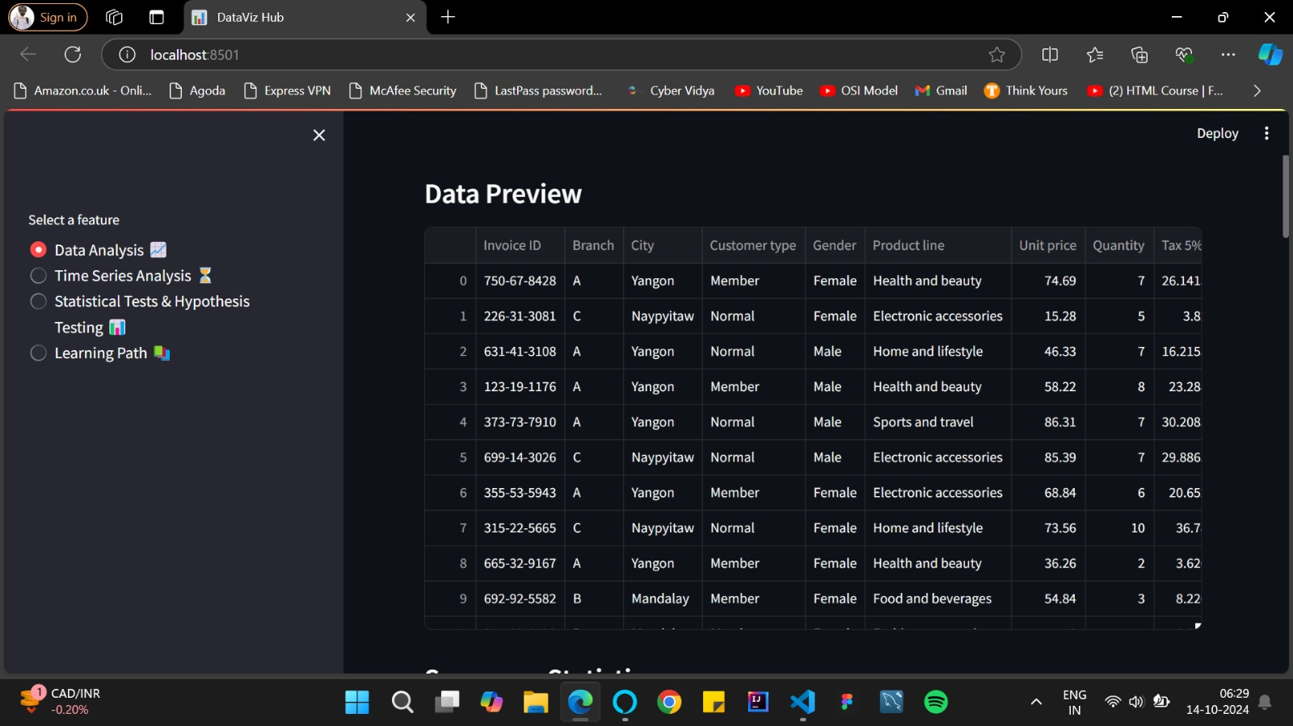

Fig 6.1 Data preview after uploading the dataset. 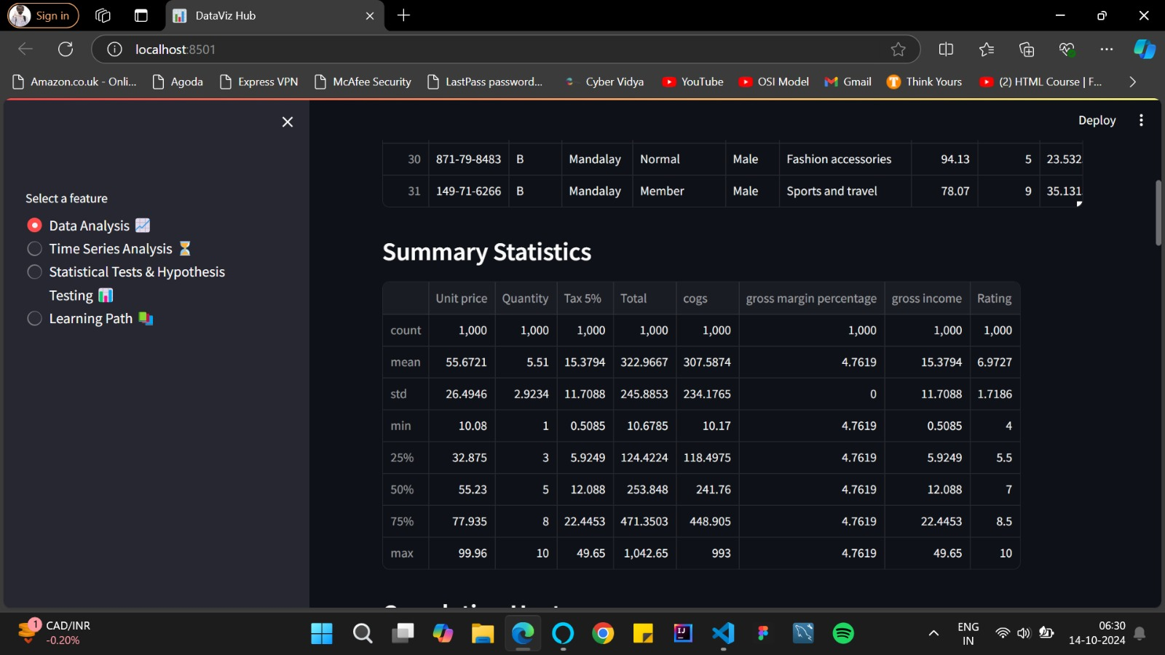

Fig 6.2 Summary statistics of the dataset.

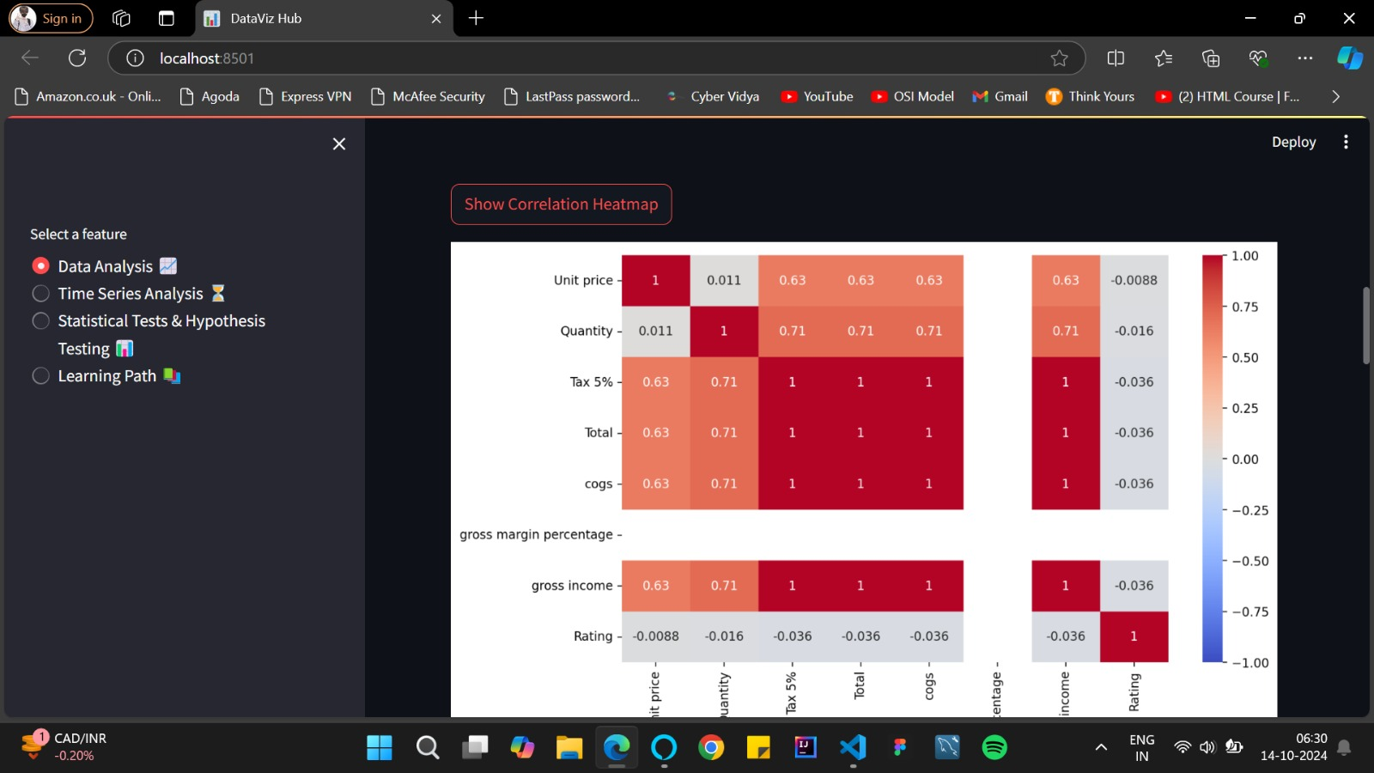

Fig 6.3 Heatmap of the dataset. 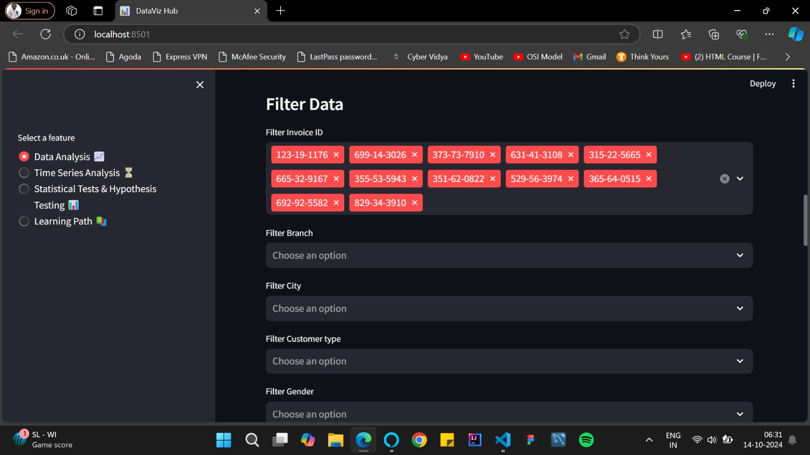

Fig 6.4 Filters the data according to the user choice.

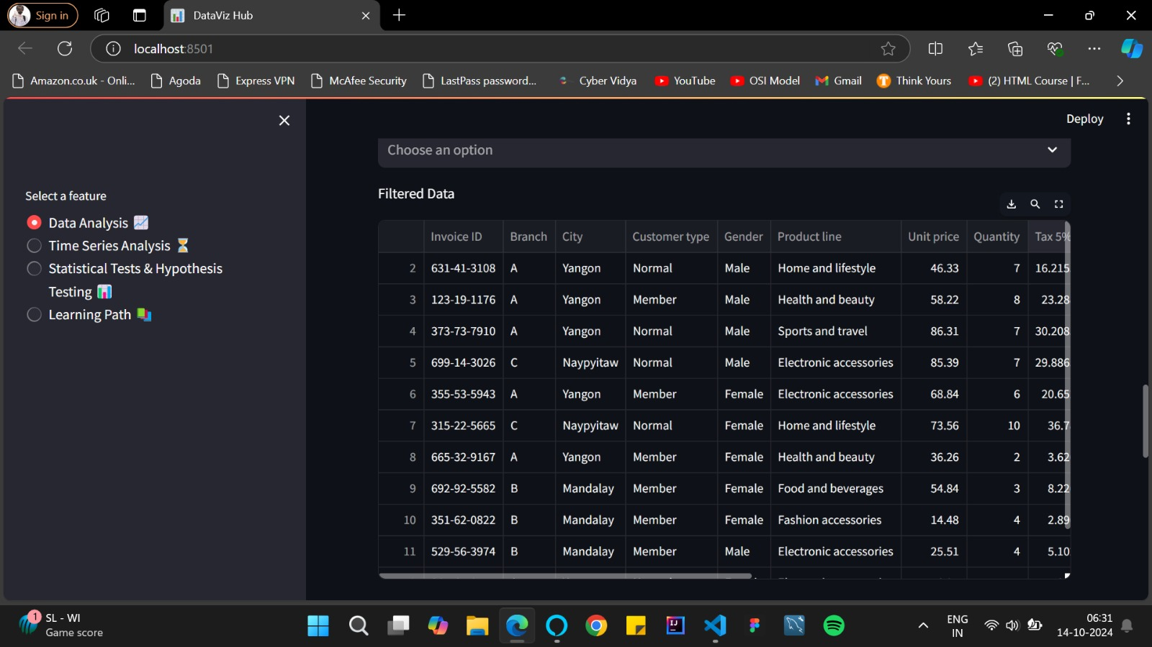

Fig 6.5 Preview of the filtered data 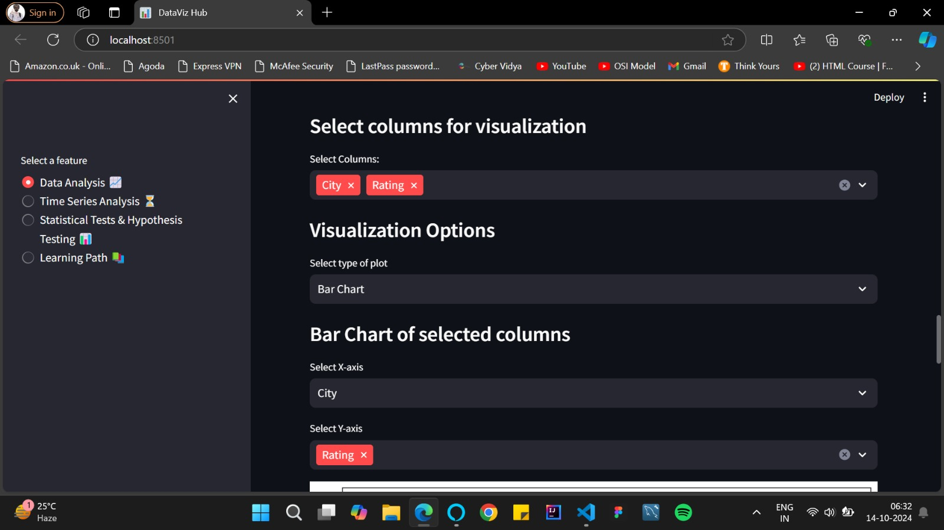

Fig 6.6 Users can choose from different columns to facilitate the visualization process.

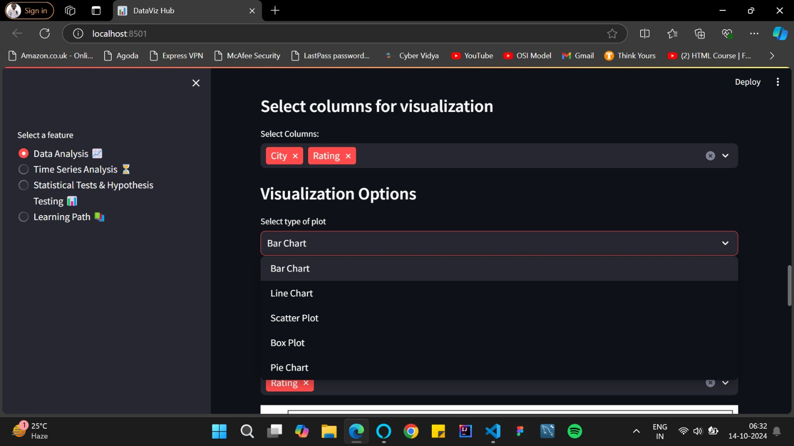

Fig 6.7 Users can choose from different visualization options

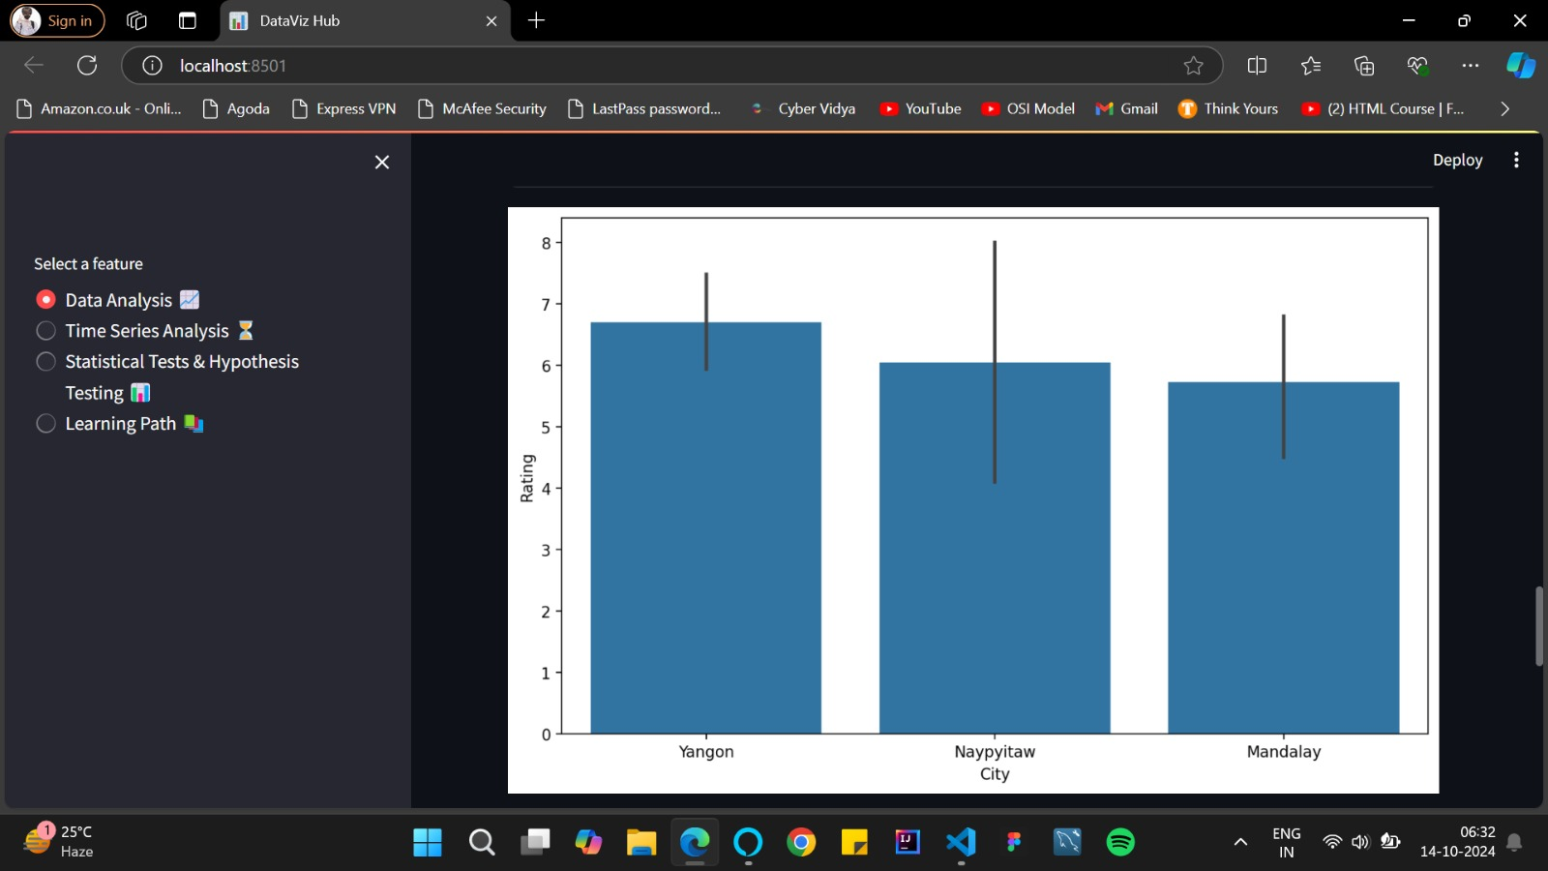

Fig 6.8 Visualization displayed

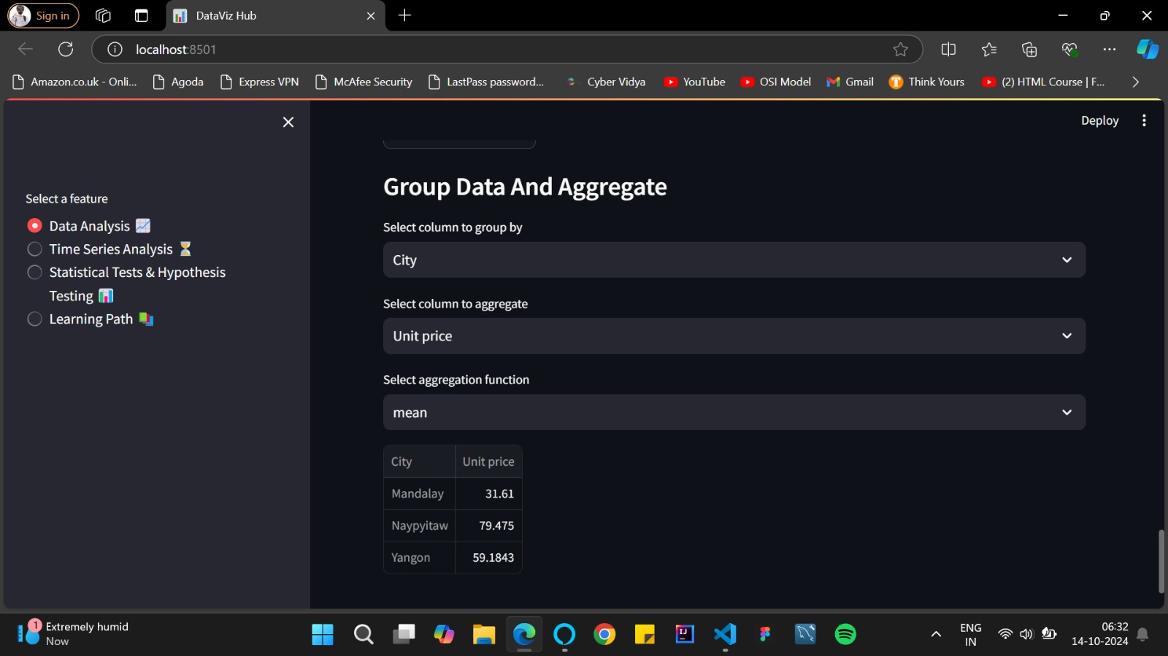

Fig 6.9 Data aggregation option.

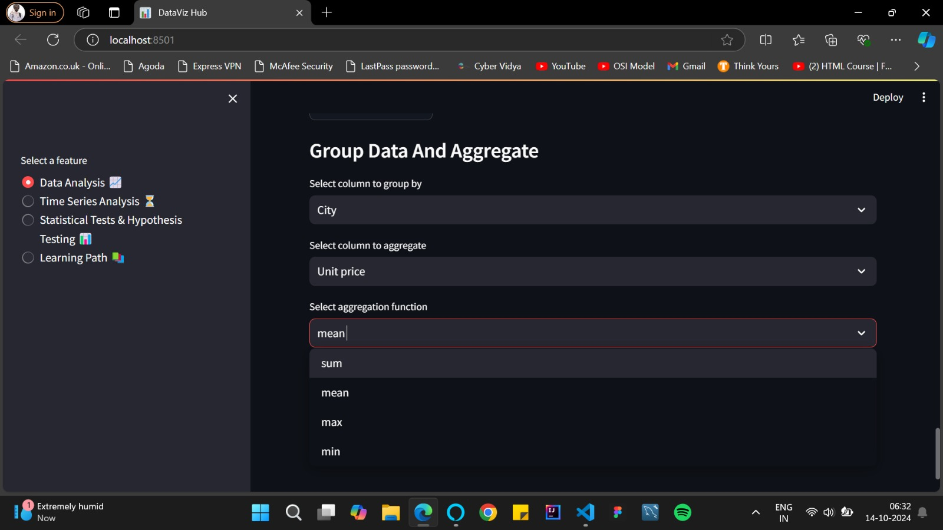

Fig 6.10 Users can choose from different aggregation functions like min, max, sum or mean values.

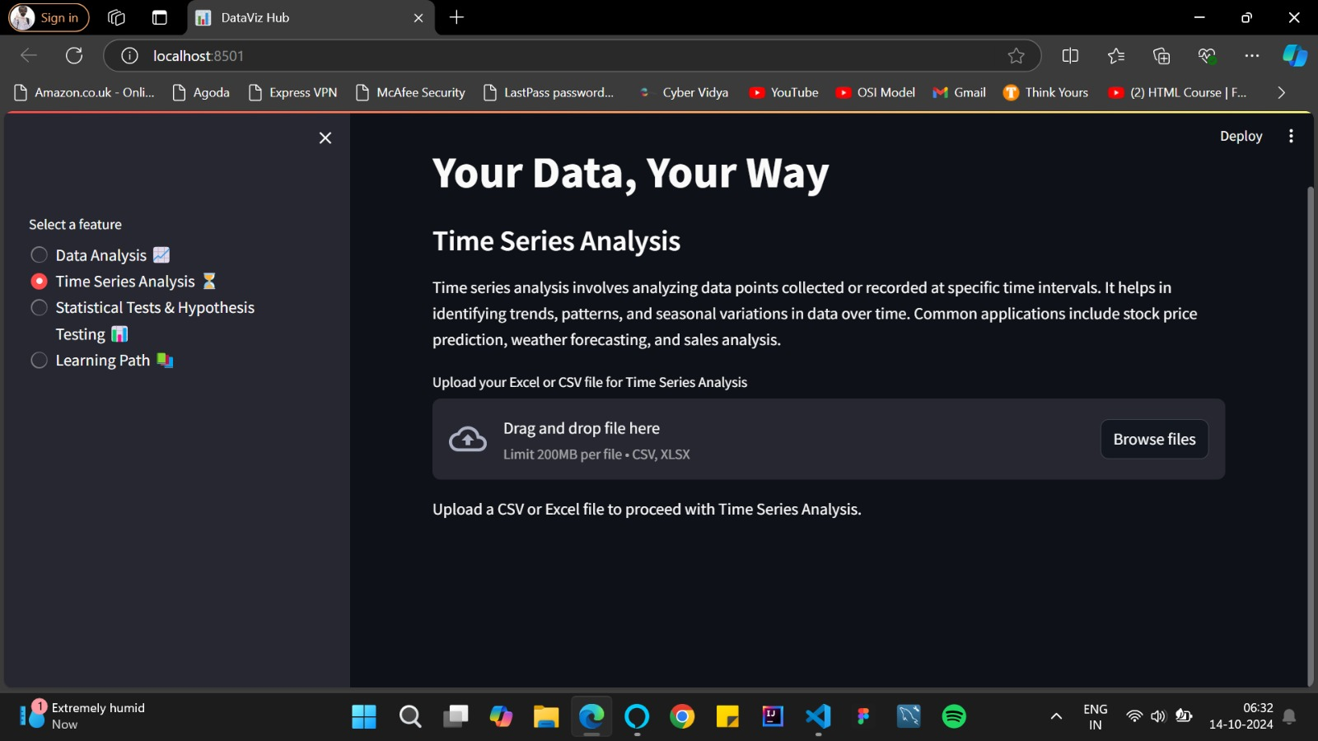

Fig 6.11 Time series analysis feature.

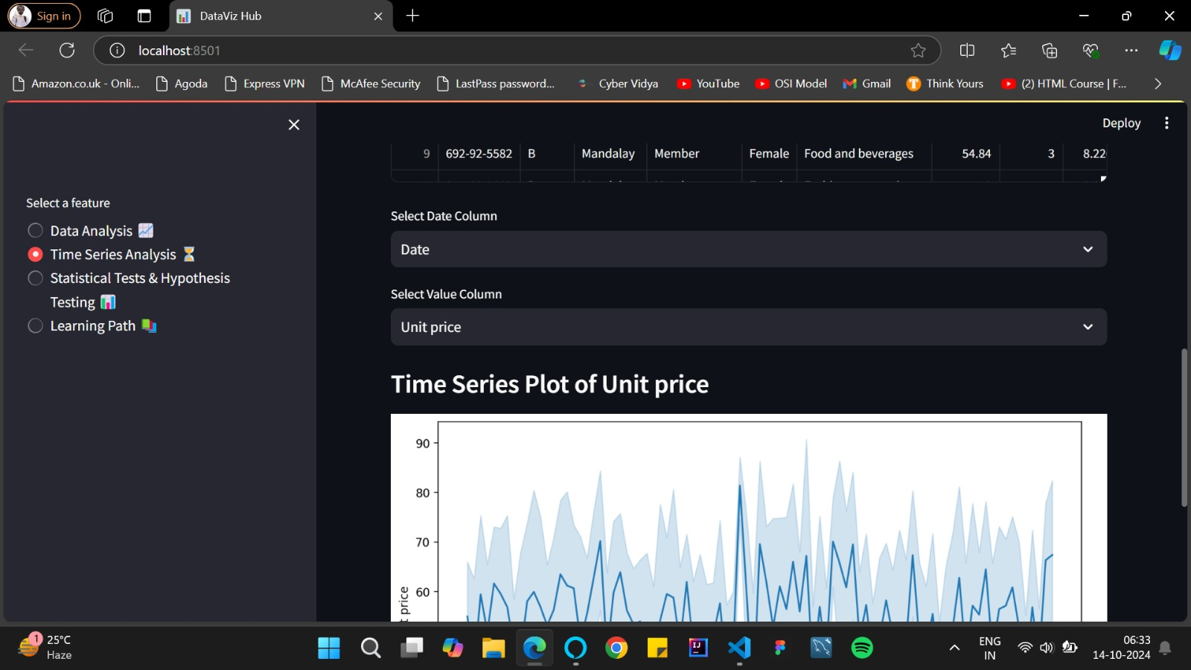

Fig 6.12 Select the required columns for performing time series forecasting.

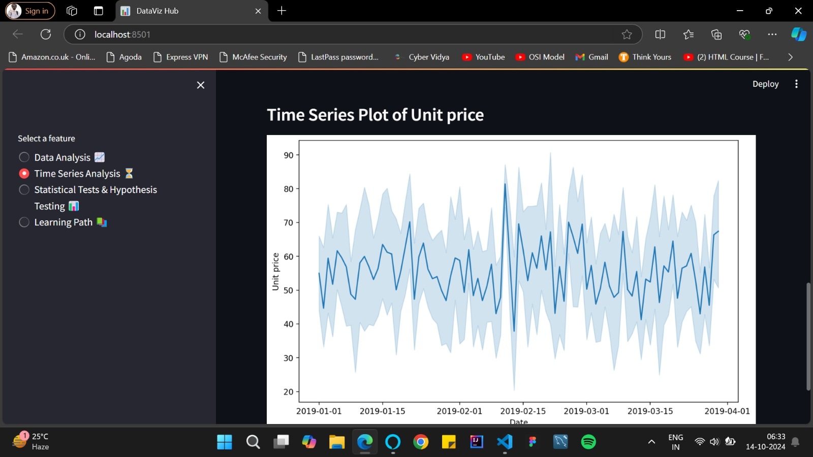

Fig 6.13 Time series analysis based on user inputs.

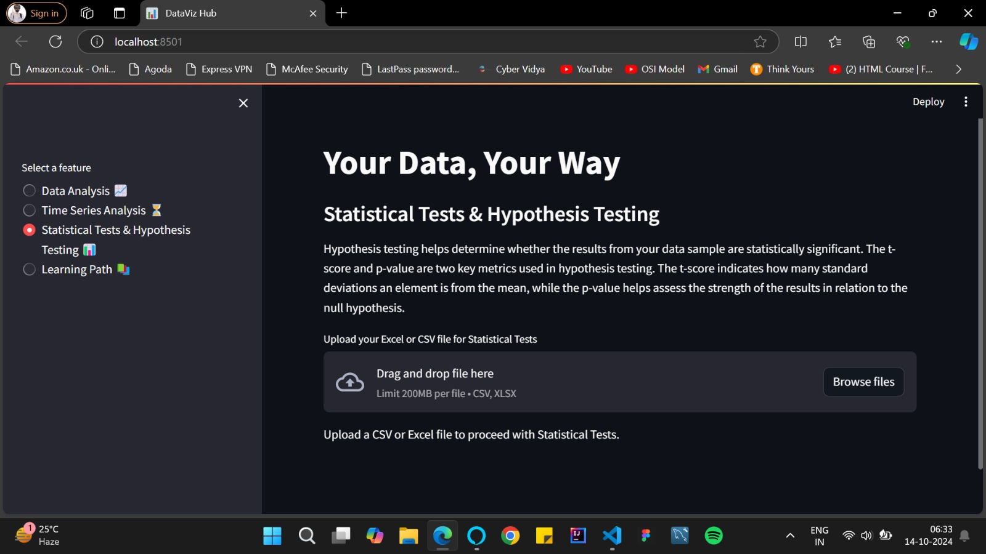

Fig 6.14 Statistical tests and hypothesis testing feature.

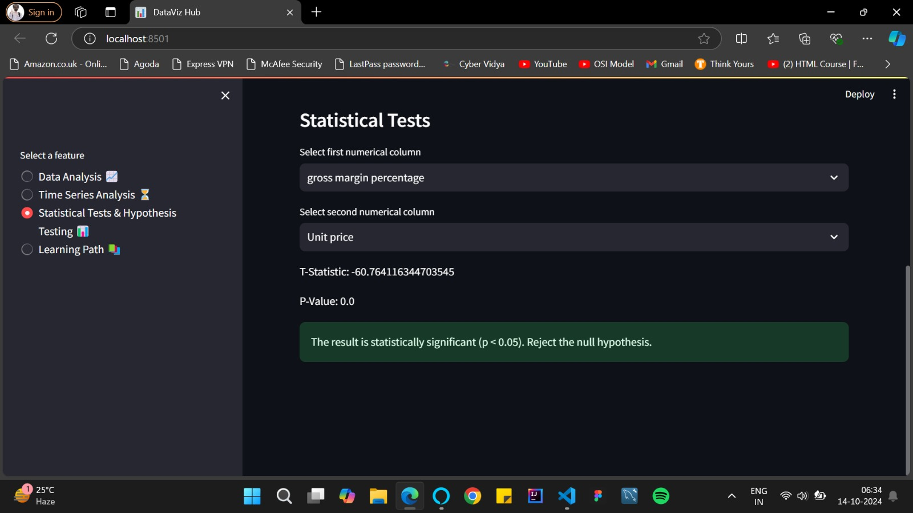

Fig 6.15 Result of the testing.

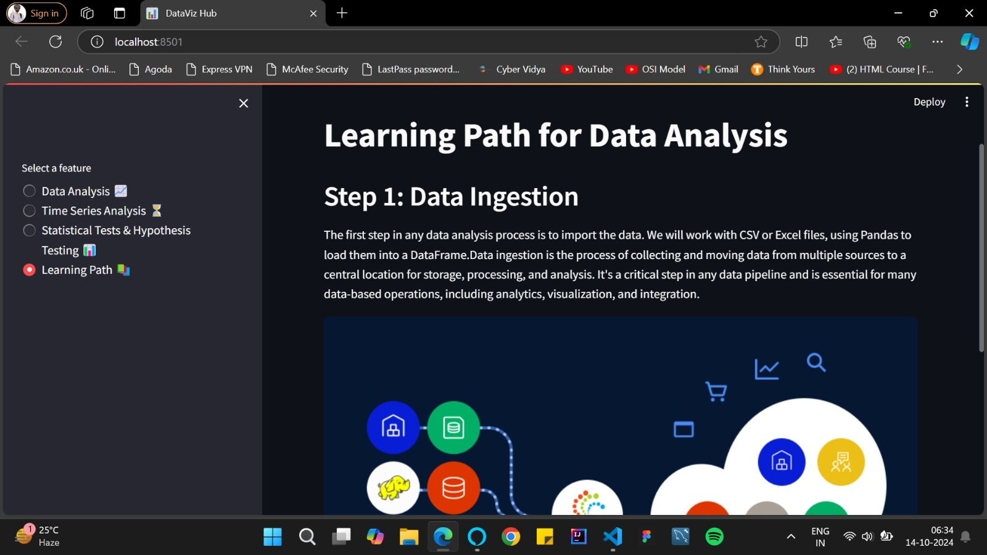

Fig 6.16 Learning path feature.

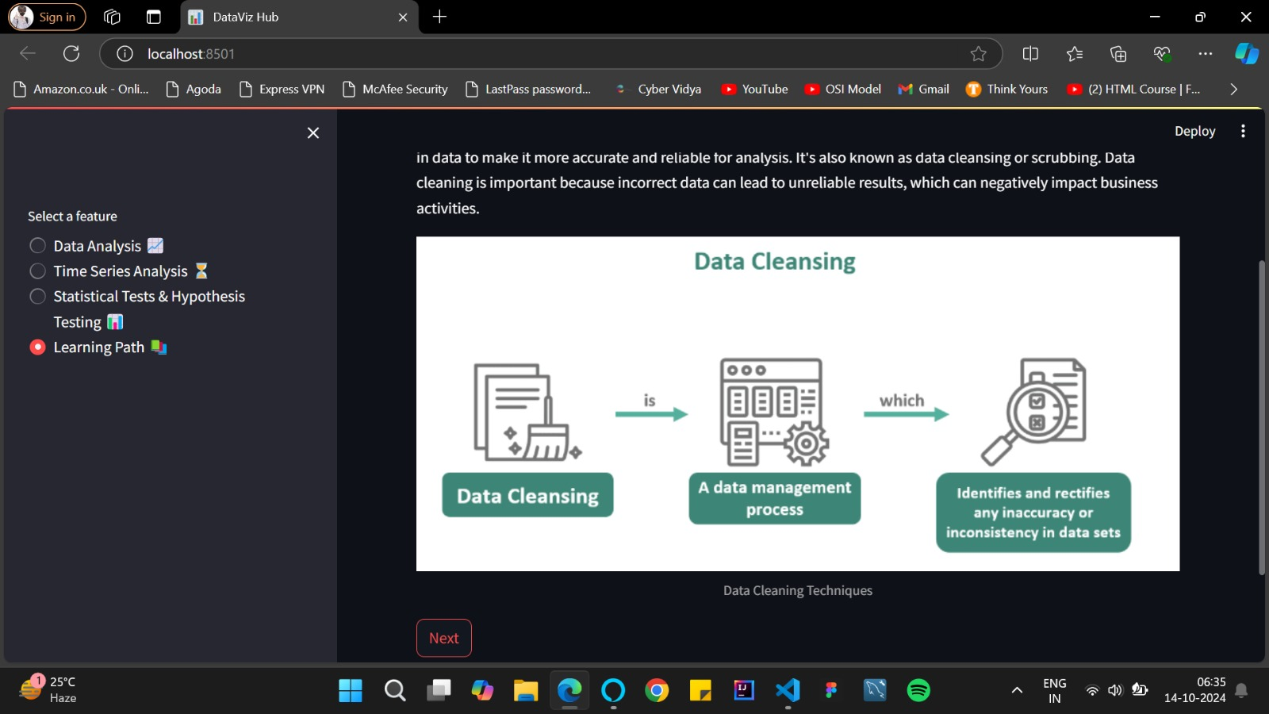

Fig 6.17 Different steps performed in data analysis process.

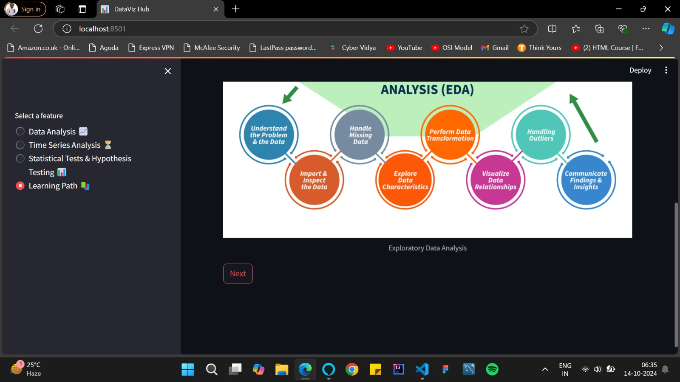

Fig 6.18 Subsequent steps.

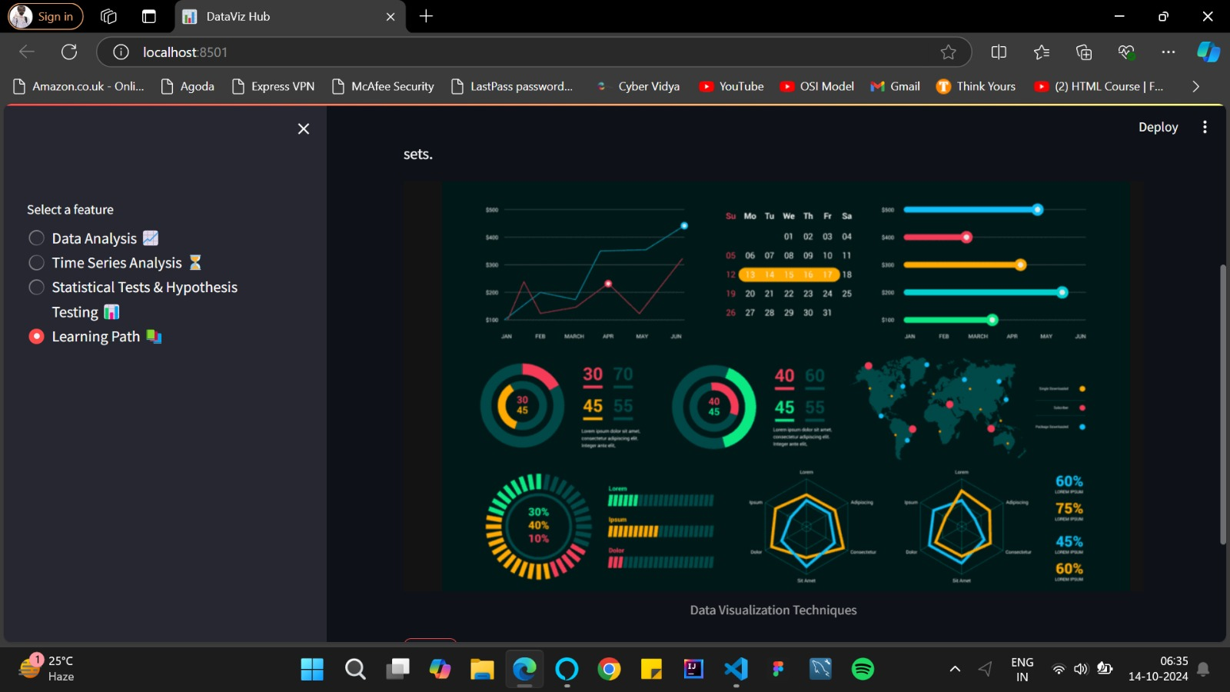

Fig 6.19 Subsequent data analysis steps.

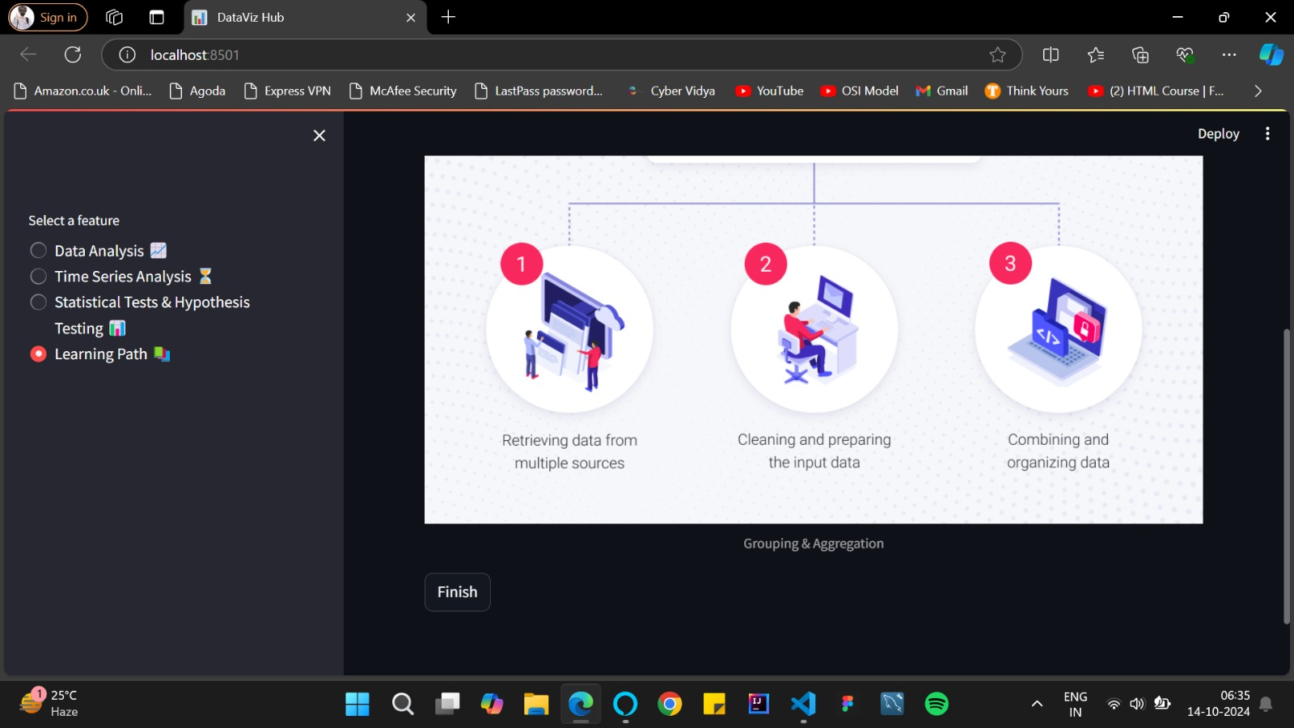

Fig 6.20 Last step of the data analysis process.

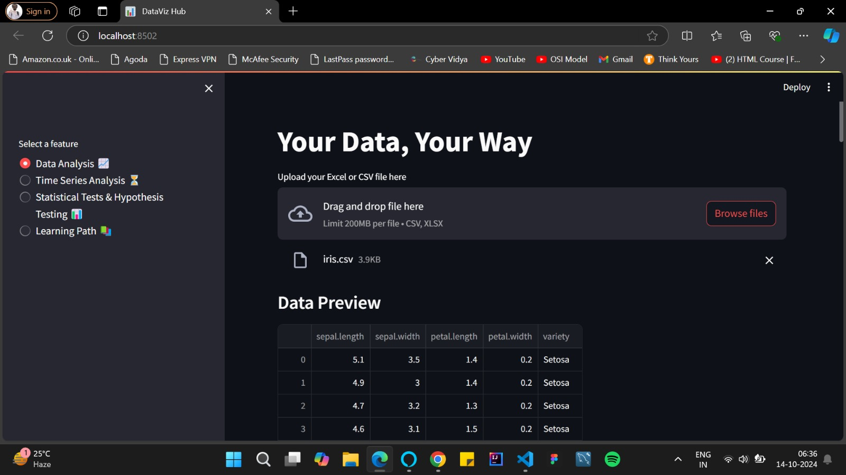

Fig 6.21 Another dataset processing with the project.

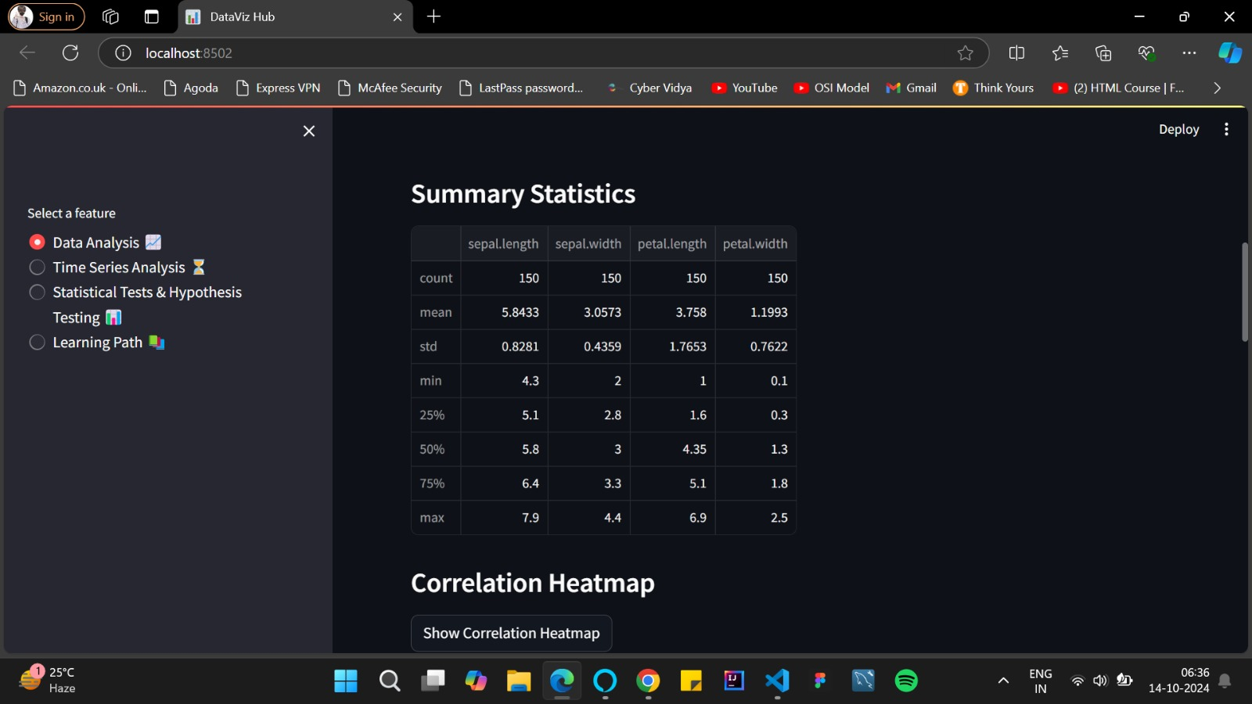

Fig 6.22 Related results for the different dataset.

1. **CONCLUSION AND FUTURE SCOPE**

This project demonstrates how Python can be effectively used to automate repetitive tasks in Excel, significantly reducing manual effort and the likelihood of human error. The system processes large datasets efficiently and generates dynamic, customizable reports tailored to user needs.

The Excel Automation with Python project significantly enhances data analysis and management for non-technical users. By providing a user-friendly interface built on Streamlit, the application allows users to easily upload datasets and perform essential operations like filtering, aggregation, and visualization. The integration of hypothesis testing and time series analysis enables users to derive meaningful insights from their data, fostering informed decision-making. Feedback from users indicates that the application's intuitive design simplifies complex tasks, making data analysis accessible and engaging. This project exemplifies how combining Excel with Python can create efficient, automated solutions, empowering users to navigate their data confidently and effectively.

**SOME OF THE FUTURE SCOPE MAY INCLUDE:**

* **Integration with Databases:** Extend the system to pull data from databases such as MySQL or PostgreSQL.
* **Advanced Analytics:** Incorporate machine learning models to provide predictive analytics based on
* the data.
* **Scheduling Automation:** Allow users to schedule the Python script to run automatically at regular
* intervals (e.g., daily, weekly)
* **Real-time Data Processing:** Enabling real-time data extraction from online sources (APIs, databases) and immediate processing in Excel, reducing manual imports.
* **Customization of Automation:** Allowing users to customize automation flows, such as defining specific filtering or aggregation rules based on their needs.
* **Cloud Integration:** Integrating cloud services (like Google Sheets or Microsoft OneDrive) for seamless cloud-based data handling and automation.

**8.REFERENCES**

[1] Ali, O. M., Breik, M., Aly, T., Raslan, A. T. N. E. D., & Gheith, M. (2024). Enhancing Data Analysis and Automation: Integrating Python with Microsoft Excel for Non-Programmers. *Journal of Software Engineering and Applications, 17*(6), 530-540.

[2] Zumstein, F. (2021). *Python for Excel*. " O'Reilly Media, Inc.".

[3] Martínez González, L. F. (2016). Automated Data Acquisition using Microsoft Excel. *Computer Science;*

[4] Soliev, B. N., Odilov, A., & Sh, A. (2023). Leveraging Python for Enhanced Excel Functionality: A Practical Exploration. *Al-Farg’oniy avlodlari, 1*(4), 267-271.

[5] Richards, T. (2021). *Getting Started with Streamlit for Data Science: Create and deploy Streamlit web applications from scratch in Python.* Packt Publishing Ltd.

[6] Ari, N., & Ustazhanov, M. (2014, September). Matplotlib in python. In *2014 11th International Conference on Electronics, Computer and Computation (ICECCO)* (pp. 1-6). IEEE.

[7] Nelli, F. (2015). *Python data analytics: Data analysis and science using PANDAs, Matplotlib and the Python Programming Language.* Apress.

[8] McKinney, W., Perktold, J., & Seabold, S. (2011, July). Time Series Analysis in Python with statsmodels. In *SciPy* (pp. 107-113).