1. Hive – Complex Commands
Hive complex commands are used when basic SELECT, WHERE, and GROUP BY are not enough to analyze data. They are especially useful for nested data, multiple tables, subqueries, and advanced analysis.
Common Complex Hive Commands
Command / Concept | Purpose
JOIN | Combines data from multiple tables
Subquery | Uses the result of one query inside another query
CTE (WITH) | Creates a temporary result that can be reused
Window Functions | Performs calculations across related rows
CASE WHEN | Applies conditional logic
UNION | Combines results from multiple queries
LATERAL VIEW | Works with complex/nested data such as arrays
Explode | Converts array elements into individual rows
Partitioning | Reduces the amount of data scanned
Bucketing | Organizes data into buckets to improve certain operations
Example: Subquery
SELECT *
FROM employees
WHERE salary > (
SELECT AVG(salary)
FROM employees
);
Meaning:
First find the average salary → then return employees whose salary is greater than that average.
Example: Window Function
SELECT
employee,
department,
salary,
RANK() OVER (
PARTITION BY department
ORDER BY salary DESC
) AS rank
FROM employees;
Meaning:
Rank employees within each department based on salary.
Example: Explode
Suppose a table contains:
student courses
John [SQL, Python, Spark]
Using:
SELECT student, course
FROM students
LATERAL VIEW EXPLODE(courses) t AS course;
Output:
John SQL
John Python
John Spark
Key idea:
EXPLODE turns one row containing multiple values into multiple rows.
Easy way to remember
Hive complex commands help us manipulate, combine, and analyze data beyond simple SQL queries.

2. Spark Architecture
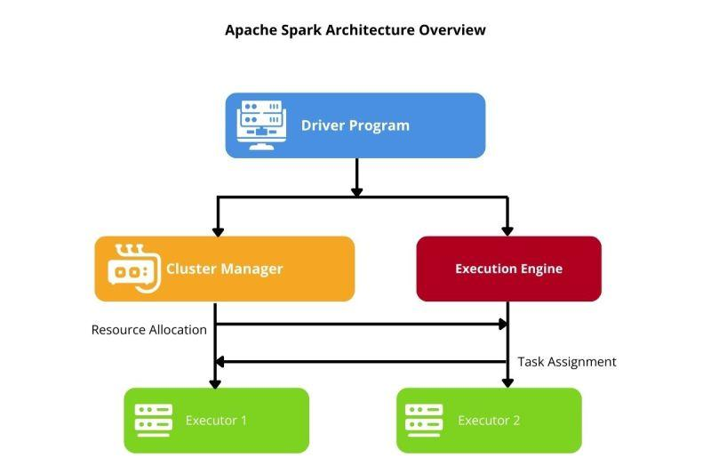
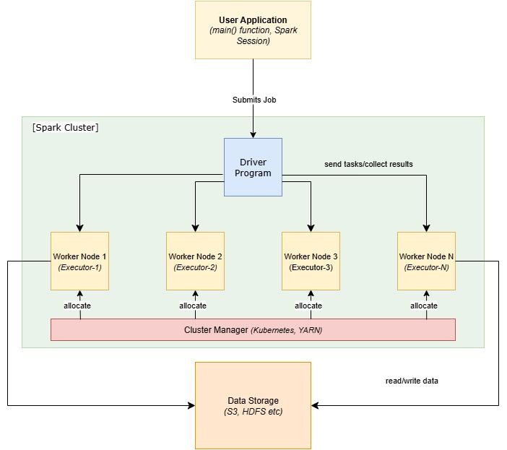
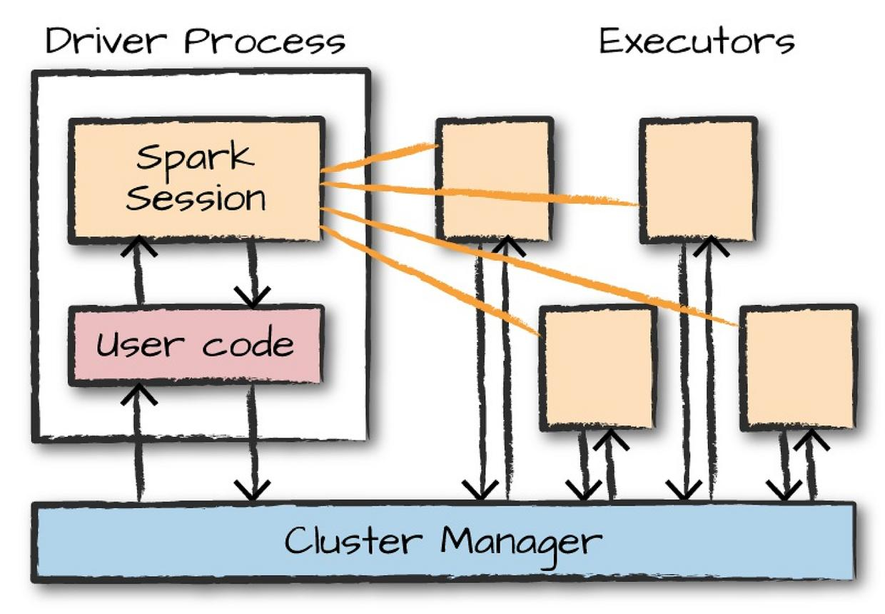
5
Apache Spark is a distributed data-processing engine. It divides a large data-processing job across multiple machines so that the work can happen in parallel.
The main components are:
SPARK APPLICATION
│
▼
┌───────────┐
│ DRIVER │
│ │
│ SparkContext
│ / Session │
└─────┬─────┘
│
Cluster Manager
│
┌────────────┴────────────┐
▼ ▼
┌───────────┐ ┌───────────┐
│ Executor │ │ Executor │
│ │ │ │
│ Tasks │ │ Tasks │
│ Cache │ │ Cache │
└───────────┘ └───────────┘
1. Driver
The Driver is the brain of the Spark application.
It:
- Runs the main program
- Creates the Spark session/context
- Understands what the application wants to do
- Creates the execution plan
- Breaks work into tasks
- Sends tasks to Executors
- Monitors the execution
Easy definition:
Driver = Brain of the Spark application

2. Cluster Manager
The Cluster Manager manages the resources needed by Spark.
It decides:
- Which machines/resources are available
- How many CPU cores are available
- How much memory can be allocated
- Where executors should run
Examples:
- YARN
- Kubernetes
- Standalone
- Mesos
Easy definition:
Cluster Manager = Resource manager

3. Executors
Executors run on worker machines and actually perform the work.
They:
- Execute tasks
- Process data
- Store/calculate cached data
- Return results to the Driver
Easy definition:
Executor = Worker that performs the computation

4. Tasks
A task is the smallest unit of work sent to an executor.
For example, if Spark needs to process a large dataset:
1 TB data
↓
Partitions
↓
Partition 1 → Task 1
Partition 2 → Task 2
Partition 3 → Task 3
Partition 4 → Task 4
Multiple tasks can run in parallel.

Spark Execution Flow
A simple way to understand Spark is:
User submits Spark application
↓
Driver
↓
Creates execution plan
↓
Cluster Manager
↓
Allocates Executors
↓
Executors
↓
Run Tasks
↓
Process Partitions
↓
Result
Example
Imagine we have 1 TB of sales data.
Instead of one computer processing everything:
1 TB
↓
Partition into smaller pieces
↓
100 partitions
↓
100 tasks
↓
Multiple executors process tasks
↓
Result
This is why Spark can process very large datasets efficiently.

Most Important Spark Concepts
Application
The complete Spark program submitted by the user.
Job
Created when an action is called.
Example:
df.count()
Stage
A job is divided into stages based largely on shuffle boundaries.
Task
A unit of work for one partition.
So remember:
Application
↓
Job
↓
Stages
↓
Tasks
↓
Partitions
One-line summary
Driver plans the work → Cluster Manager provides resources → Executors execute tasks → Tasks process data partitions in parallel.
Very important exam/interview point
Driver does not normally process all the data itself.
The Executors perform the distributed data processing, while the Driver coordinates the work.

