Amazon_Redshift
Learning goal---Understand where data lives, how SQL is executed, why data moves between nodes, and how to optimize common analytics queries.

1. What is Amazon Redshift?
Amazon Redshift is an AWS cloud data warehouse designed for analytics (OLAP). It runs SQL over large datasets using parallel processing, column-oriented storage, and compression. It is not designed to replace a transactional database for frequent small updates.
Concept | Plain-English meaning
Data warehouse | Central location for analytical reporting and historical data.
MPP | Massively Parallel Processing: multiple compute resources process parts of a query at once.
Columnar storage | Read only the columns needed for a query rather than entire rows.
OLAP vs OLTP | OLAP = analytics and aggregates, historical data, datawarehouse; OLTP = application transactions, runtime data, relational database

2. Architecture: How a SQL query executes
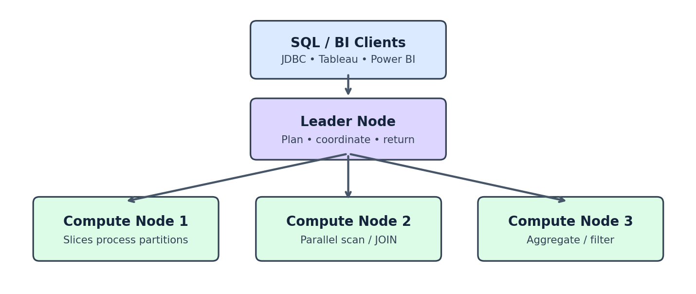
Illustration: a simplified provisioned cluster. In Redshift Serverless, AWS manages the underlying compute resources for you.
Part | Responsibility
Leader node | Accepts queries, plans execution, coordinates work, and returns results.
Compute nodes | Execute scans, joins, filtering, and aggregation in parallel.
Slices | Subdivisions of compute resources that process assigned data partitions.
Storage | Columnar data; RA3 nodes use managed storage separate from local compute caching.

Example: total sales by category
SELECT category, SUM(amount) AS total_sales
FROM sales
GROUP BY category;
1. Redshift receives the SQL. 2. It plans the query. 3. Compute resources scan and aggregate data in parallel. 4. Partial results are combined and returned.

3. Redshift Spectrum: Query S3 without loading
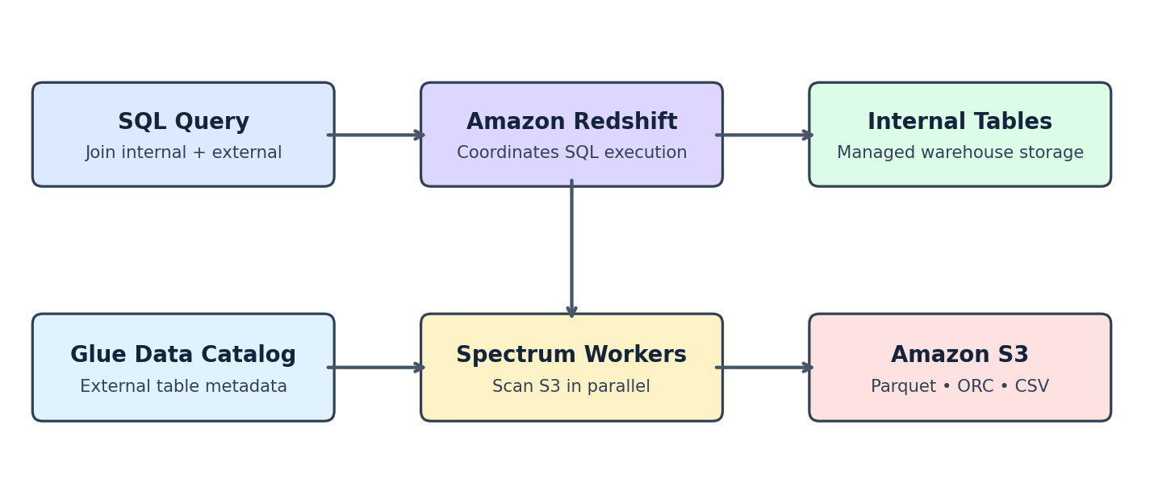
Spectrum lets Redshift query files in Amazon S3 through external tables. AWS Glue Data Catalog (or a supported external catalog) supplies metadata such as columns and partitions. Spectrum scans external files and sends results into the Redshift query plan.

Practical scenario
Keep frequently accessed customer records in Redshift and five years of archived orders in S3 as Parquet. Join them through SQL instead of loading every archived order into internal tables.
CREATE EXTERNAL SCHEMA spectrum_schema
FROM DATA CATALOG
DATABASE 'sales_db'
IAM_ROLE 'arn:aws:iam::123456789012:role/RedshiftSpectrumRole';
Prerequisites: the catalog database and external tables must exist, and the IAM role needs permissions for the catalog and S3 objects. The ARN above is an example placeholder.
SELECT c.customer_name, SUM(o.quantity * o.price) AS sales
FROM public.customers c
JOIN spectrum_schema.orders o
ON c.customer_id = o.customer_id
GROUP BY c.customer_name;
Performance tip: store external data as Parquet or ORC, partition on commonly filtered columns, and filter early to reduce scanned bytes. Spectrum costs can depend on bytes scanned and applicable pricing rules.

4. Distribution: ALL, EVEN, KEY, AUTO
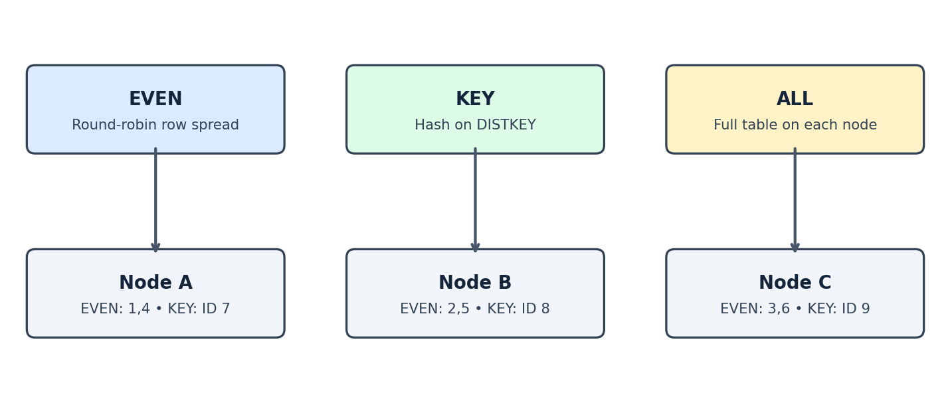
Distribution determines which compute slices hold rows. The diagram is conceptual: ALL replicates a whole table to each node; EVEN spreads rows; KEY hashes values so matching keys can be colocated.
Style | Behavior | When to use
AUTO (default) | Redshift chooses and may adapt distribution. | Best starting point for most tables.
EVEN | Spreads rows evenly across slices. | No useful join key; balanced scan workload.
KEY | Hashes one DISTKEY column. | Large tables repeatedly joined on the same key.
ALL | Replicates table on every node. | Small, slowly changing lookup/dimension tables.
CREATE TABLE orders (
order_id INT, customer_id INT, amount DECIMAL(12,2)
) DISTSTYLE KEY DISTKEY(customer_id);
CREATE TABLE regions (
region_id INT, region_name VARCHAR(50)
) DISTSTYLE ALL;
Warning: KEY can create skew if one key occurs far more often than others. ALL increases storage and maintenance overhead. AUTO is generally the safest default until measurements justify a change.

5. What is data shuffling?
Shuffling is moving rows across nodes during operations such as joins and aggregation. Network movement can slow queries. Colocating rows on matching distribution keys may avoid this movement.

Four practical ways to reduce shuffle
Technique | What it does
1. Colocate JOIN keys | Use compatible KEY distribution on large, frequently joined tables.
2. Replicate small dimensions | Use ALL for appropriately small lookup tables.
3. Filter early | Reduce rows entering a join; the optimizer may already push filters down.
4. Pre-aggregate | Summarize large fact data before joining where semantically valid; aggregation may still redistribute data.
EXPLAIN
SELECT c.customer_name, o.amount
FROM customers c
JOIN orders o ON c.customer_id = o.customer_id;
EXPLAIN marker | Interpretation
DS_DIST_NONE | No redistribution needed for the join.
DS_DIST_ALL_NONE | Join avoids redistribution using replicated ALL table.
DS_BCAST_INNER | Inner-side rows broadcast across nodes.
DS_DIST_INNER / DS_DIST_OUTER | One side redistributed.
DS_DIST_BOTH | Both sides redistributed; often expensive.

6. Sort keys, compression, and query tuning
Sort keys organize stored rows to make certain filters and range scans more efficient. They are not the same as traditional B-tree indexes. Redshift also uses columnar compression to reduce I/O.
Feature | Why it helps
SORTKEY | Can reduce block reads for selective predicates on ordered columns.
Column encoding | Compression reduces disk I/O.
ANALYZE / statistics | Helps the optimizer estimate row counts and choose plans.
EXPLAIN | Shows join methods, scans, and redistribution.
Materialized views | Reuse expensive precomputed results for suitable workloads.
CREATE TABLE sales (
sale_id INT, sale_date DATE, amount DECIMAL(12,2)
) SORTKEY(sale_date);

7. Redshift vs Spectrum vs Serverless
Option | Data location | Best fit
Redshift internal tables | Redshift managed warehouse storage | Frequently queried curated analytics data.
Redshift Spectrum | S3 external files | Historical/lake data that need not be loaded.
Redshift Serverless | Managed Redshift storage + automatic compute | Teams wanting less cluster capacity management.
These are complementary concepts: a Serverless workgroup can also query external S3 data through Spectrum.

8. Data engineering example: S3 to reporting
1. Land source files in S3. 2. Clean and convert to Parquet. 3. Register external table metadata in Glue. 4. Query external data through Spectrum for exploration. 5. Load high-use curated datasets into internal Redshift tables as needed. 6. Build reporting queries and check EXPLAIN for scans and redistribution.

Interview quick review
Question | Short answer
What is MPP? | Parallel query execution across multiple compute resources.
What is Spectrum? | Query S3 files through external tables without loading them into Redshift.
What is DISTKEY? | Column used to hash-distribute rows across slices.
Which style is default? | AUTO.
ALL vs EVEN? | ALL replicates; EVEN spreads rows.
How to spot shuffle? | Use EXPLAIN and inspect DS_DIST / DS_BCAST markers.
Study priority: First understand leader/compute/slices, then distribution styles, then Spectrum and EXPLAIN. These connect architecture directly to real SQL performance.

