1.A Data type of all columns in the "customers" tab

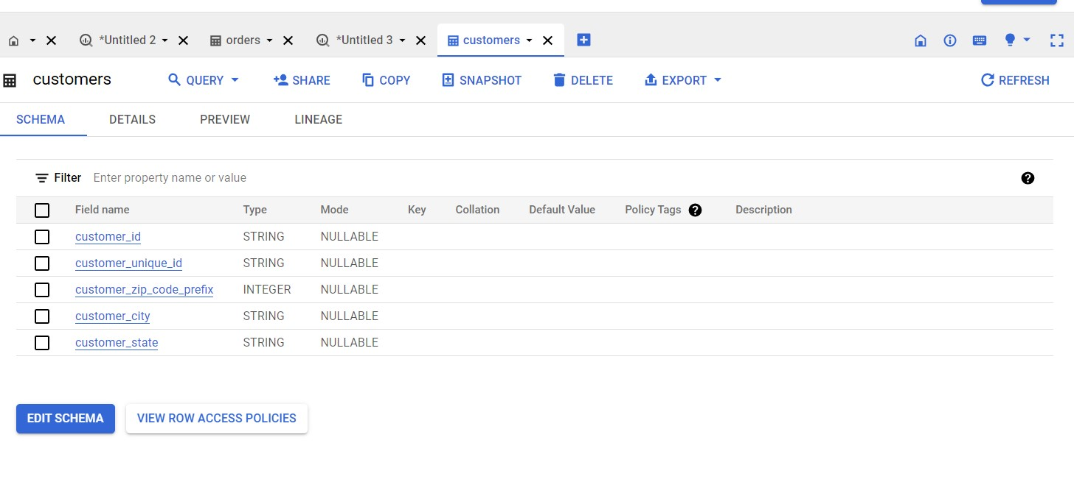

1.B Get the time range between which the orders were placed.

Query :

SELECT MIN(order_purchase_timestamp) AS start_time,

MAX(order_estimated_delivery_date) AS end_time

FROM `case_study.orders`;

Output :

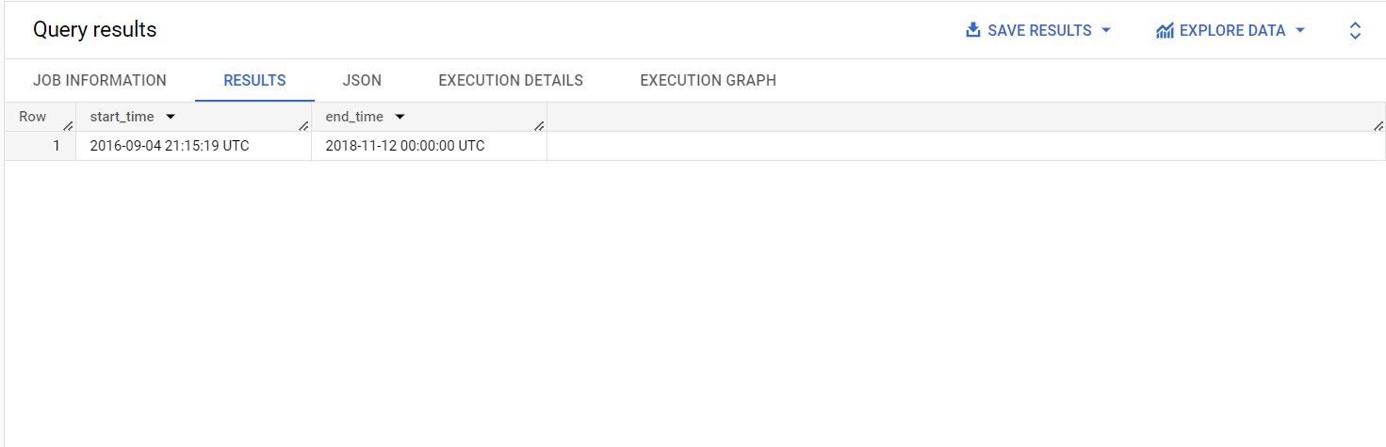

Insight :

* **start_time**: The earliest order was placed on September 4, 2016, at 21:15:19 UTC. This indicates the date and time when the first recorded order in the dataset was placed.
* **end_time**: The latest order was placed on November 12, 2018, at 00:00:00 UTC. This indicates the date and time when the last recorded order in the dataset was placed.
* Time Range: Based on the provided data, the time range between the earliest and latest orders is approximately 2 years, 2 months, and 8 days. This duration spans from the first order on September 4, 2016, to the last order on November 12, 2018.

Recommendations :

1. **Customer Behavior Analysis**: The time range between September 4, 2016, and November 12, 2018, covers a significant period. The company can perform a detailed analysis of customer behavior during this time to identify patterns and trends. This analysis could include factors such as peak ordering times, popular products, and average order values. Understanding customer behavior can help optimize marketing strategies and tailor offerings to customer preferences.
2. **Identify Seasonal Trends**: By analyzing the orders within the given time range, the company can identify any seasonal trends in customer purchasing behavior. For example, if there are spikes in orders during specific months or holidays, the company can plan targeted marketing campaigns or offer seasonal promotions to capitalize on these trends.
3. **Evaluate Growth and Performance**: The time range provides a good window to evaluate the company's growth and performance over the period. By comparing the number and value of orders at the beginning and end of the time range, the company can assess its overall progress. It's an opportunity to celebrate achievements and set goals for further growth.
4. **Assess Inventory Management**: Analyzing the orders placed during this period can help the company assess its inventory management practices. Identifying which products were popular and had consistent demand can help in maintaining optimal stock levels and avoiding stockouts. On the other hand, products with declining demand can be reevaluated for their relevance in the inventory.
5. **Customer Retention Strategies**: The time range covers a considerable duration during which customer retention and loyalty play a crucial role. The company can identify repeat customers and devise strategies to encourage customer loyalty. Personalized offers, loyalty programs, or follow-up communication could be considered to improve customer retention rates.
6. **Competitive Analysis**: The company can use the data to perform a competitive analysis within the market. Understanding how their performance compares to competitors during the same period can provide insights into their strengths and weaknesses. This knowledge can help in positioning their products and services more effectively in the market.
7. **Plan for Future Growth**: Having a clear understanding of historical performance can aid in forecasting and planning for future growth. The company can use this data as a reference point to set realistic growth targets and devise strategies to achieve them.
8. **Improve Order Processing Efficiency**: Analyzing the order time range can also help the company assess its order processing efficiency. If there are significant delays or fluctuations in order processing times, the company can focus on streamlining the order fulfillment process to improve customer satisfaction.

Assumptions :

1. **Continued Growth:** Assuming the company's positive performance, it's likely to continue growing.
2. **Seasonal Opportunities:** Leveraging seasonal trends for targeted marketing can drive increased sales.
3. **Product Innovation:** Analyzing popular products can guide new product development.
4. **Market Expansion:** Successful performance may lead to expansion into new markets.
5. **Customer Experience:** Improving order processing can enhance customer satisfaction.
6. **Competitive Strategies:** Monitoring competitors can inform adaptive strategies.
7. **Data-Driven Decisions:** Prioritizing data-driven decision-making for better outcomes.
8. **Customer-Centric Approach:** Retaining customers by prioritizing their needs.

**1.C** Count the Cities & States of customers who ordered during the given period.

Query :

SELECT

DISTINCT c.customer_city, c.customer_state,

 COUNT(o.customer_id) order_count

FROM `case_study.orders` as o

JOIN `case_study.customers` as c

ON o.customer_id = c.customer_id

GROUP BY 1, 2

ORDER BY 3 DESC;

Output :

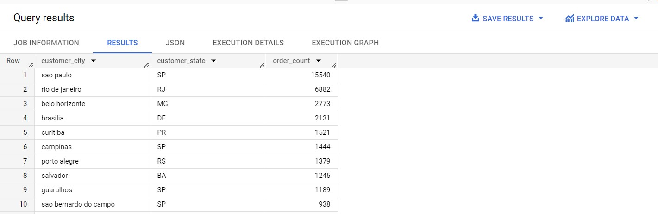

Insights :

1. **Customer Distribution by City and State:** The data shows the top 10 cities and states with the highest order counts. The cities include São Paulo, Rio de Janeiro, Belo Horizonte, Brasilia, Curitiba, Campinas, Porto Alegre, Salvador, Guarulhos, and São Bernardo do Campo.
2. **Most Orders from São Paulo:** São Paulo (SP) has the highest number of orders with 15,540 orders, indicating it's a significant market for the company.
3. **Major Metropolitan Areas:** The top cities like São Paulo, Rio de Janeiro, and Belo Horizonte are major metropolitan areas with dense populations and strong economic activity. Targeting these regions can lead to increased business opportunities.
4. **Diverse Customer Base:** The presence of multiple cities from different states in the top 10 list suggests that the company has a diverse customer base, spread across various regions of the country.
5. **Potential Growth Areas:** While São Paulo dominates in order count, other cities like Rio de Janeiro and Belo Horizonte also show substantial order numbers, indicating potential growth opportunities in these regions.
6. **Regional Focus:** The company can consider focusing on the states and cities with significant order counts for targeted marketing efforts, customer engagement, and potential expansion.
7. **Customer Retention:** For cities with high order counts, the company should prioritize customer retention strategies to ensure long-term loyalty and repeat business.
8. **Market Penetration:** For cities with lower order counts (e.g., São Bernardo do Campo), the company can focus on market penetration strategies to increase its presence and attract more customers.
9. **Sales and Distribution:** Understanding the distribution of orders across different cities can help the company optimize its sales and distribution networks for better efficiency.
10. **Localized Marketing:** Tailoring marketing campaigns to specific cities and states can resonate better with the local customer base and lead to higher engagement.

Recommendations :

1. **Invest in São Paulo Market:** Given that São Paulo (SP) has the highest number of orders, the company should consider investing more resources in this market. Expanding operations, increasing marketing efforts, and offering localized promotions can help further capitalize on this significant customer base.
2. **Target Major Metropolitan Areas:** Major metropolitan areas like Rio de Janeiro (RJ) and Belo Horizonte (MG) also show substantial order counts. The company should focus on targeting these regions with tailored marketing strategies to attract more customers and increase brand visibility.
3. **Customer Retention Strategies:** Since São Paulo, Rio de Janeiro, and Belo Horizonte have high order counts, it's crucial to implement strong customer retention strategies in these regions. Loyalty programs, personalized offers, and excellent customer service can foster long-term customer loyalty.
4. **Explore New Markets:** While the top cities dominate in orders, the company should also explore opportunities in other regions. Cities with lower order counts, such as São Bernardo do Campo (SP), can be targeted for market penetration and expansion.
5. **Regional Marketing Campaigns:** Tailor marketing campaigns to cater to the preferences and cultural aspects of each region. Localized campaigns can resonate better with customers and drive higher engagement.
6. **Optimize Sales and Distribution Networks:** Analyze the data to optimize the company's sales and distribution networks. Ensure efficient delivery and supply chain management to meet customer demands promptly.
7. **Customer Segmentation:** Segment customers based on their location and purchase behavior. This can help in targeted marketing and offering personalized experiences to different customer groups.
8. **Monitor Market Trends:** Continuously monitor market trends in different cities and states. Stay agile and adapt marketing strategies based on changing customer preferences and competitor activities.
9. **Expand Customer Support:** As the customer base grows, the company should invest in expanding its customer support to handle increasing inquiries and provide excellent service.
10. **Analyze Product Demand:** Analyze which products are most popular in different regions. This information can guide inventory management decisions and ensure the availability of in-demand products.
11. **Social Media and Local Influencers:** Leverage social media platforms and collaborate with local influencers to promote products in specific regions. Social media can be a powerful tool to connect with the target audience.
12. **Feedback and Surveys:** Regularly gather customer feedback and conduct surveys to understand customer satisfaction and identify areas for improvement.

Assumptions :

1. **Sustained Growth in Key Markets:** Expect continued growth in São Paulo, Rio de Janeiro, and Belo Horizonte.
2. **Expansion into Emerging Markets:** Explore new opportunities in regions with lower order counts.
3. **Increased Market Penetration:** Focus on strengthening presence in promising markets.
4. **Localized Marketing Strategies:** Tailor marketing efforts to cater to specific city preferences.
5. **E-commerce and Digital Presence:** Invest in online platforms and digital marketing.
6. **Customer-Centric Approach:** Prioritize customer satisfaction and feedback.
7. **Product Diversification:** Consider offering region-specific products or customizations.
8. **Logistics Optimization:** Ensure efficient delivery and supply chain management.
9. **Market Research and Trends:** Stay updated on market changes and customer preferences.
10. **Competition and Differentiation:** Identify unique selling points to stand out in the market.
11. **International Expansion:** Explore opportunities for global market entry.
12. **Sustainable Practices:** Promote sustainability for positive brand image.