2.A Is there a growing trend in the no. of orders placed over the past years?

Query :

  SELECT

  EXTRACT(YEAR FROM o.order_purchase_timestamp) AS year,

  EXTRACT(MONTH FROM o.order_purchase_timestamp) AS month,

  COUNT(DISTINCT o.order_id) AS order_count

FROM `case_study.orders` o

JOIN `case_study.customers` c

ON o.customer_id = c.customer_id

GROUP BY year, month

ORDER BY year, month;

Output :

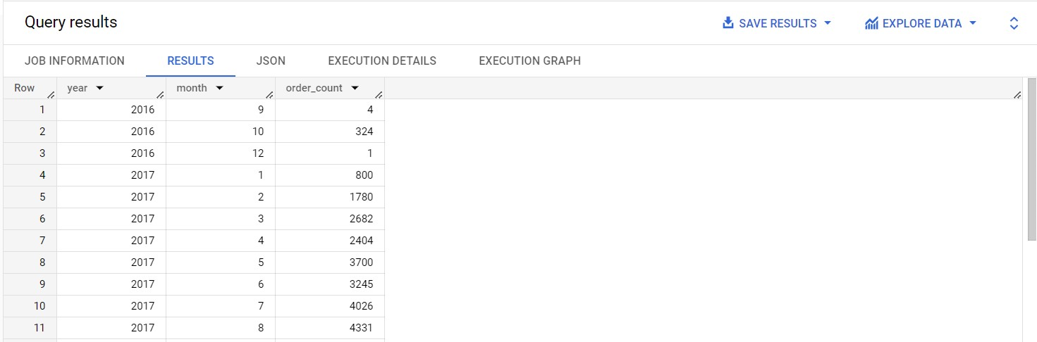

Insights :

1. **Order Count Variation over Time:** The data represents the number of orders placed over several months in different years.
2. **Order Count Fluctuations:** The order count shows fluctuations from as low as 1 order in December 2016 to a peak of 4026 orders in July 2017.
3. **Monthly Patterns:** There are variations in order counts across different months. For example, there is a sharp increase in order count from October 2016 to February 2017, followed by relatively stable order counts from March to June 2017, and another significant increase in July 2017.
4. **Seasonal Trends:** The data indicates possible seasonal trends in customer ordering behavior, with higher order counts observed during certain months. Identifying these seasonal trends can help the company plan targeted marketing and promotions during peak months.
5. **Growth Over Time:** The data shows a general upward trend in order counts from September 2016 to July 2017, suggesting that the company experienced overall growth during this period.
6. **Yearly Comparison:** There is a notable increase in order counts from 2016 to 2017, indicating potential growth and improved performance in the latter year.
7. **Factors Influencing Orders:** The company may investigate external factors, such as marketing campaigns, product launches, or seasonal events, that could have contributed to the fluctuations in order counts.
8. **Insights for Resource Allocation:** Understanding monthly fluctuations can help the company allocate resources efficiently. For example, during peak months, additional staff or inventory may be needed to handle increased demand.
9. **Customer Behavior Analysis:** The company can analyze customer behavior during different months to identify patterns and preferences. This analysis can guide marketing strategies and product offerings.
10. **Demand Forecasting:** Based on the observed patterns, the company can use this data for demand forecasting, aiding in inventory management and production planning.
11. **Performance Evaluation:** Comparing the order counts between different months and years can help the company assess the success of marketing initiatives and business strategies implemented during those periods.
12. **Customer Retention:** Understanding trends in customer ordering behavior can assist the company in developing customer retention strategies to encourage repeat business during slower months.

Recommendations :

1. **Seasonal Marketing:** Plan targeted campaigns during high-demand months.
2. **Demand Forecasting:** Use data to optimize inventory levels.
3. **Resource Allocation:** Adjust staff and stock during peak periods.
4. **Customer Engagement:** Retain customers during slower months with offers.
5. **Analyze Influencing Factors:** Identify strategies affecting order fluctuations.
6. **Yearly Performance Evaluation:** Evaluate growth and successful strategies.
7. **Continuous Customer Analysis:** Monitor changing trends and preferences.
8. **Sustainable Growth:** Plan for long-term and steady expansion.
9. **Data-Driven Decisions:** Utilize historical data for informed choices.
10. **Enhance Digital Presence:** Invest in online platforms and marketing.
11. **Customer Segmentation:** Tailor approaches to different customer groups.
12. **Collaboration with Suppliers:** Share data for efficient coordination.

Assumptions :

1. **Growing Business:** The company's order counts have been increasing over time, suggesting that the business is likely to continue growing in the future.
2. **Seasonal Impact:** Orders tend to fluctuate throughout the year, indicating seasonal trends. In the future, the company may experience busier and slower periods based on these trends.
3. **Customer Engagement:** During slower months, customer engagement efforts will be crucial to retain customers and encourage repeat business.
4. **Digital Presence:** As orders increase, the company may need to strengthen its online presence and invest in digital marketing to reach more customers.
5. **Smart Inventory Management:** With varying order counts, the company should focus on smart inventory management to ensure products are available when demand is high and avoid excess inventory during slower periods.
6. **Adaptive Strategies:** The company should be flexible and adapt its strategies based on historical data to make informed decisions and stay competitive.
7. **Continuous Improvement:** Analyzing past performance can help the company identify successful strategies and areas for improvement to maintain growth.
8. **Market Expansion:** With increasing orders, there might be opportunities to expand to new markets and reach more customers.
9. **Customer-Centric Approach:** Keeping customers satisfied and understanding their preferences will be key to long-term success and loyalty.
10. **Collaboration:** Collaborating with suppliers and partners can enhance efficiency and ensure smooth operations during peak demand periods.

2.B Can we see some kind of monthly seasonality in terms of the no. of orders being placed?

Query :

SELECT

  EXTRACT(MONTH FROM order_purchase_timestamp) AS month,

  COUNT(DISTINCT order_id) AS order_count

FROM `case_study.orders`

GROUP BY month

ORDER BY month;

Output :

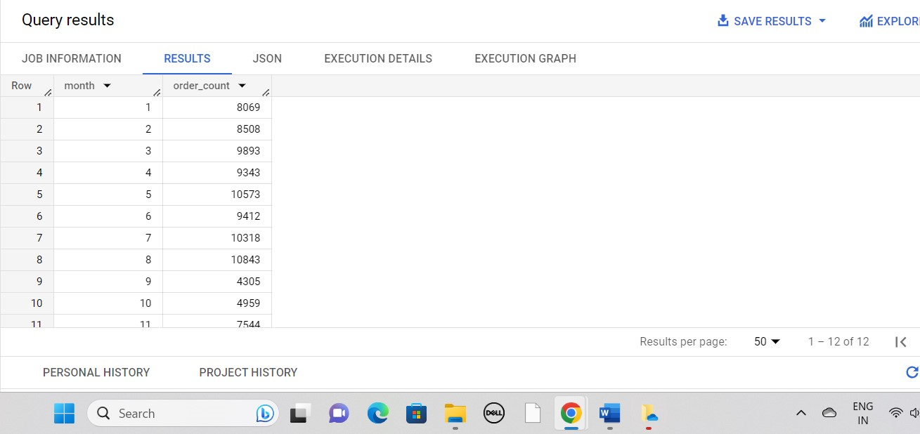

Insights :

1. **Monthly Order Counts:** The data represents the number of orders placed each month over a period of 10 months.
2. **Seasonal Patterns:** There is a noticeable pattern of fluctuations in order counts throughout the months.
3. **Peak Months:** Months 5 (May) and 8 (August) show the highest order counts, with 10,573 and 10,843 orders, respectively.
4. **Low Months:** Months 1 (January) and 9 (September) have comparatively lower order counts, with 8,069 and 4,305 orders, respectively.
5. **Upward Trend:** The data shows a general upward trend in order counts from January to August, with a gradual increase in orders during this period.
6. **Seasonal Demand:** The company experiences increased demand during the months of May and August, which could be due to various factors like holidays, promotions, or seasonal events.
7. **Off-Peak Strategy:** Months with lower order counts (e.g., January and September) may require specific strategies to boost sales and engage customers during slower periods.
8. **Demand Forecasting:** The data can help the company forecast demand for different months, allowing for better inventory management and resource allocation.
9. **Optimize Marketing Efforts:** Tailoring marketing efforts based on seasonal patterns can lead to more effective campaigns and higher customer engagement.
10. **Sales and Promotion Planning:** By understanding the peaks and troughs in order counts, the company can plan sales and promotions to capitalize on high-demand months.
11. **Customer Behavior Analysis:** Analyzing customer behavior during different months can provide insights into their preferences and buying patterns, helping to refine customer retention strategies.
12. **Continuous Monitoring:** Regularly monitoring monthly order counts can help the company stay agile and adjust strategies as market conditions and customer preferences change.

Recommendations :

1. **Seasonal Marketing Strategies:** Implement targeted marketing campaigns and promotions during peak months (May and August) to take advantage of increased customer demand.
2. **Off-Peak Promotions:** During slower months (January and September), offer special promotions or discounts to encourage customer engagement and boost sales.
3. **Demand Forecasting and Inventory Management:** Use historical order data to forecast demand for each month. Optimize inventory levels to meet customer needs during peak periods while minimizing excess inventory during slower months.
4. **Resource Allocation:** Allocate resources, such as staff and inventory, based on monthly order trends. Increase resources during peak months to handle higher demand efficiently.
5. **Customer Engagement Strategies:** Focus on building customer loyalty during high-demand months. Offer loyalty rewards, personalized offers, or exclusive deals to retain customers and encourage repeat business.
6. **Sales and Promotion Planning:** Plan sales and promotions strategically around the peak months to maximize impact and drive sales.
7. **Customer Behavior Analysis:** Analyze customer behavior during different months to identify preferences and trends. Tailor offerings and marketing messages to resonate with customers during each period.
8. **Continuous Monitoring and Adaptation:** Regularly monitor monthly order trends and stay agile in response to changing market conditions. Be prepared to adjust strategies as customer preferences evolve.
9. **Optimize Marketing Budget:** Allocate marketing budgets based on expected customer demand during different months. Invest more in marketing efforts during peak months to capitalize on higher returns.
10. **Customer Feedback and Surveys:** Gather customer feedback during various months to understand their satisfaction and preferences. Use this data to refine products and services.
11. **Social Media Engagement:** Leverage social media platforms to engage with customers during different months. Utilize creative content and promotions to maintain customer interest.
12. **Collaborate with Suppliers:** Share demand forecasts with suppliers to ensure a smooth supply chain and timely delivery of products during high-demand months.

Assumptions :

1. **Continued Growth:** Expecting continued business growth based on the upward trend in order counts.
2. **Seasonal Variations:** Anticipating seasonal fluctuations with peak and slow months.
3. **Seasonal Sales Opportunities:** Capitalizing on increased customer demand during peak months.
4. **Off-Peak Strategies:** Employing specific strategies to boost sales during slower months.
5. **Demand Forecasting Benefits:** Using historical data to forecast demand and optimize inventory.
6. **Marketing Adjustments:** Adapting marketing efforts to align with seasonal patterns and customer preferences.
7. **Customer Retention Focus:** Focusing on retaining customers during peak months for long-term loyalty.
8. **Competitive Landscape:** Being aware of competitors' activities during peak months.
9. **Digital Presence Importance:** Emphasizing a strong online presence to attract customers year-round.
10. **Data-Driven Decision Making:** Relying on data insights for informed decision-making.
11. **Market Adaptation:** Being prepared to adapt strategies to changing customer behavior and market dynamics.
12. **Collaboration for Efficiency:** Collaborating with suppliers and partners for smooth operations during peak periods.

2.C During what time of the day, do the Brazilian customers mostly place their orders? (Dawn, Morning, Afternoon or Night)

* + 0-6 hrs : Dawn
  + 7-12 hrs : Mornings
  + 13-18 hrs : Afternoon
  + 19-23 hrs : Night

Query :

SELECT

CASE

WHEN EXTRACT(HOUR FROM o.order_purchase_timestamp) BETWEEN 0 AND 5 THEN 'Dawn'

WHEN EXTRACT(HOUR FROM o.order_purchase_timestamp) BETWEEN 6 AND 11 THEN 'Morning'

WHEN EXTRACT(HOUR FROM o.order_purchase_timestamp) BETWEEN 12 AND17THEN'Afternoon'

WHEN EXTRACT(HOUR FROM o.order_purchase_timestamp) BETWEEN 18 AND 23 THEN 'Night'

END AS hour,

COUNT(o.order_id) AS order_count

FROM `case_study.orders` as o

JOIN `case_study.customers` as c

ON o.customer_id = c.customer_id

GROUP BY hour

ORDER BY order_count DESC;

Output :

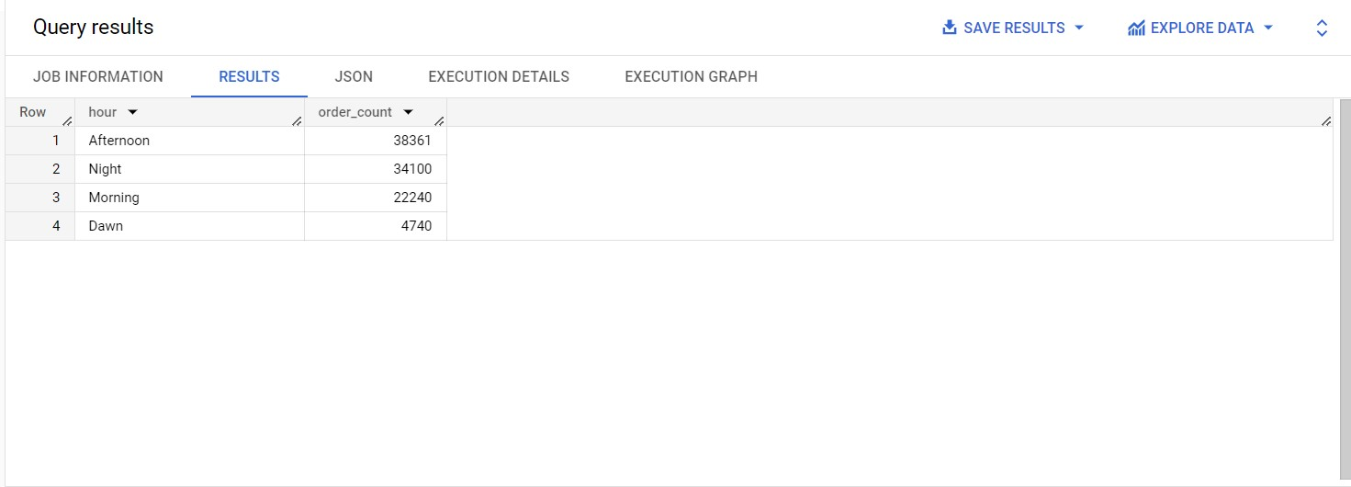

Insight :

1. **Order Count by Hour:** The data represents the number of orders placed during different hours of the day.
2. **Peak Hours:** Afternoon and Night are the peak hours with the highest order counts of 38,361 and 34,100, respectively.
3. **Morning and Dawn Orders:** Morning and Dawn have lower order counts of 22,240 and 4,740, respectively, compared to the peak hours.
4. **Customer Behavior:** Customers tend to place the highest number of orders during the Afternoon and Night hours, suggesting that these are the busiest and most popular times for purchases.
5. **Business Opportunities:** During peak hours, the company should ensure it has sufficient resources, staff, and inventory to handle the higher demand efficiently.
6. **Off-Peak Strategies:** During Morning and Dawn hours, the company may need to employ specific strategies to boost sales and encourage customer engagement during slower periods.
7. **Marketing and Promotions:** The company can plan targeted marketing campaigns and promotions during peak hours to maximize sales and reach a larger audience.
8. **Customer Support:** Providing excellent customer support during busy hours is essential to handle inquiries and ensure a positive shopping experience.
9. **Online Order Management:** As orders are likely to be higher during the peak hours, the company should ensure its online ordering system is robust and can handle increased traffic.
10. **Data-Driven Insights:** Analyzing order patterns by hour can provide data-driven insights into customer behavior, which can guide decision-making and improve overall operations.
11. **Local Time Considerations:** If the company operates in multiple time zones, it should adjust its strategies accordingly based on regional peak hours.
12. **Continuous Monitoring:** Regularly monitoring order counts by hour can help the company make timely adjustments to its operations and marketing efforts.

Recommendations :

1. **Peak Hour Preparedness:** During Afternoon and Night, the company should ensure it is well-prepared to handle higher order volumes. Have adequate staff, inventory, and resources in place to meet customer demand efficiently.
2. **Off-Peak Promotions:** To boost sales during Morning and Dawn hours, the company can offer special promotions, discounts, or exclusive deals to encourage customer orders during these slower periods.
3. **Targeted Marketing:** Plan targeted marketing campaigns during peak hours to maximize the impact and reach a larger audience. Tailor marketing messages to resonate with customers during specific hours.
4. **Customer Support:** Provide excellent customer support during busy hours to handle inquiries and ensure a smooth shopping experience. Fast response times and helpful assistance can enhance customer satisfaction.
5. **Optimize Online Ordering:** Ensure that the online ordering system can handle increased traffic during peak hours. A user-friendly and efficient online platform can improve customer experience and prevent technical issues.
6. **Data-Driven Decisions:** Use the insights from order patterns by hour to make data-driven decisions. Analyze customer behavior and preferences to guide marketing strategies and resource allocation.
7. **Local Time Considerations:** If the company operates in multiple time zones, tailor promotions and marketing efforts based on regional peak hours to engage customers effectively.
8. **Continuous Monitoring and Adaptation:** Regularly monitor order counts by hour and be prepared to adapt strategies based on changing customer behavior and market trends.
9. **Personalization:** Utilize customer data to personalize offers and promotions based on individual preferences and ordering habits during different hours.
10. **Collaboration with Staff:** Collaborate with staff to ensure smooth operations during peak hours. Effective communication and teamwork are vital to handle increased demand efficiently.
11. **Upselling Opportunities:** During peak hours, identify upselling opportunities to offer complementary products or services to customers, increasing the overall order value.
12. **Evaluate Peak Hour Performance:** Regularly evaluate performance during peak hours to identify bottlenecks and areas for improvement. Use this data to streamline operations and enhance customer experience.

Assumptions :

1. **Continuous Growth:** Expecting ongoing business growth with increased order counts.
2. **Steady Demand during Peak Hours:** Consistent demand during busy Afternoon and Night hours.
3. **Potential Off-Peak Growth:** Off-peak strategies may lead to growth during Morning and Dawn hours.
4. **Customer Behavior Adaptation:** Adapting strategies based on changing customer preferences.
5. **Enhanced Customer Experience:** Improved satisfaction through excellent support during peak hours.
6. **Increased Online Orders:** More customers may prefer online shopping during peak hours.
7. **Localized Time Zone Impact:** Variations in peak hours in different regions.
8. **Data-Driven Decisions:** Relying on data insights for informed choices.
9. **Competitive Adaptation:** Responding to competitors during peak hours.
10. **Personalized Customer Engagement:** Tailoring offers to boost engagement.
11. **Collaboration and Efficiency:** Smooth operations during peak hours with effective collaboration.
12. **Agility and Adaptability:** Being prepared for uncertainties and market changes.