3.A Get the month on month no. of orders placed in each state.

Query :

SELECT c.customer_state,

EXTRACT(month FROM o.order_purchase_timestamp) AS month,

COUNT(o.order_purchase_timestamp) AS order_count

FROM `case_study.orders` as o

JOIN `case_study.customers` as c

ON o.customer_id = c.customer_id

GROUP BY c.customer_state, month

ORDER BY c.customer_state, month;

Output :

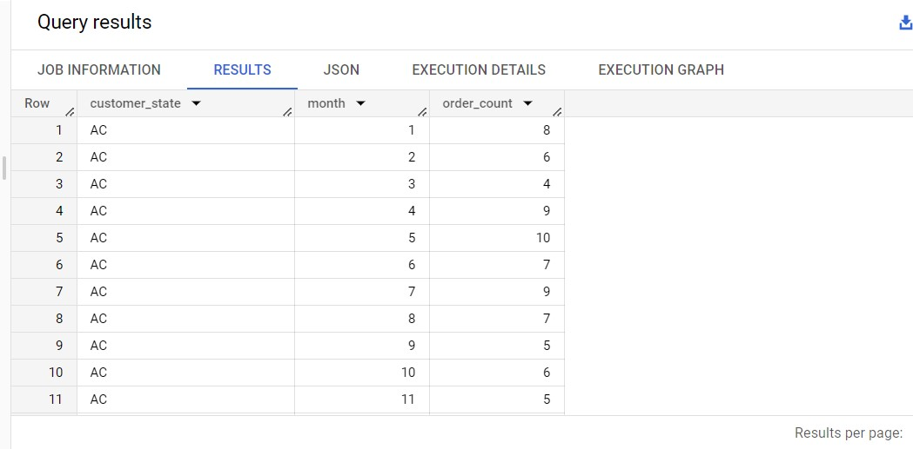

Insights :

1. Variations in monthly order counts indicate possible seasonal or monthly demand fluctuations.
2. May had the highest order count (10), while March had the lowest (4).
3. Consistent order counts (ranging from 4 to 10) suggest stable demand in this customer state (AC).
4. Analyze demand trends for resource planning and customer retention strategies.
5. Consider exploring factors contributing to higher orders in May for growth opportunities.
6. Plan promotions during high-order months to maximize impact.
7. Use data to understand regional market preferences for targeted marketing.
8. Continuously monitor order counts for customer behavior insights.

Recommendations :

1. Analyze seasonal demand to optimize inventory and resources.
2. Plan promotions during high-order months for increased sales.
3. Implement customer retention strategies during low-order months.
4. Identify factors contributing to higher orders in peak months for growth opportunities.
5. Tailor products and marketing to meet local customer preferences.
6. Optimize resource allocation based on demand trends.
7. Continuously monitor customer behavior for adaptive strategies.
8. Stay informed about competitors' activities in the customer state (AC).
9. Introduce seasonal offerings and limited-time promotions.
10. Collaborate with local partners for market insights.
11. Focus on long-term customer relationships with excellent service.
12. Remain agile and responsive to changes in the market.

Assumptions :

1. **Seasonal Demand:** Expecting consistent seasonal fluctuations in orders.
2. **Growth Opportunities:** Potential for growth through targeted promotions and customer retention efforts.
3. **Increased Sales:** Anticipating higher sales during planned promotions.
4. **Customer Engagement:** Tailoring offerings for better customer engagement.
5. **Resource Optimization:** Optimizing resources for cost-efficiency.
6. **Market Competitiveness:** Staying competitive with market awareness.
7. **Adaptive Strategies:** Responding to market changes with flexibility.
8. **Collaboration Benefits:** Gaining insights through local partnerships.
9. **Customer Loyalty:** Focusing on long-term customer loyalty.
10. **Feedback for Improvement:** Using feedback to improve products and services.
11. **Responsive Approach:** Being agile and responsive to market shifts.
12. **Strategic Planning:** Using data insights for future planning.

3.B How are the customers distributed across all the states?

Query :

SELECT c.customer_state,

  COUNT(c.customer_id) AS no_of_customers

FROM `case_study.customers` as c

GROUP BY c.customer_state

ORDER BY no_of_customers DESC;

Output :

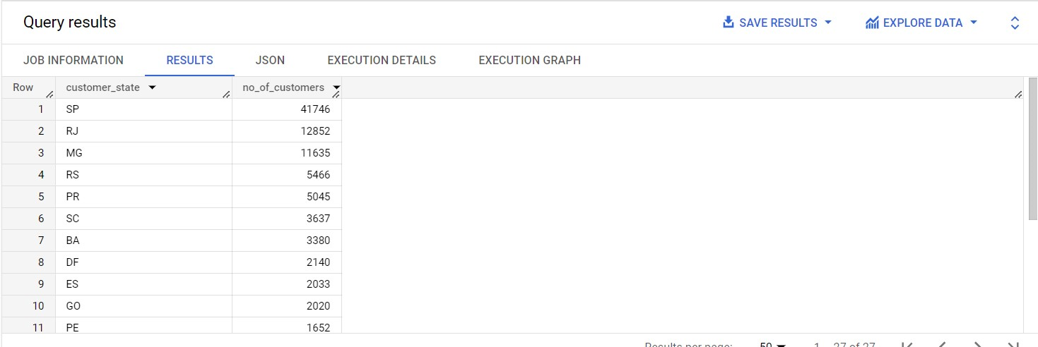

Insights :

1. São Paulo (SP) has the largest customer base, followed by Rio de Janeiro (RJ) and Minas Gerais (MG).
2. Other key markets include Rio Grande do Sul (RS), Paraná (PR), Santa Catarina (SC), Bahia (BA), and the Federal District (DF).
3. Espírito Santo (ES) and Goiás (GO) have smaller but still significant customer bases.
4. Regional insights can guide targeted marketing and personalized experiences.
5. Market penetration is strong in SP and RJ, while other states offer growth opportunities.
6. Analyzing market share can identify competitive advantages and areas needing attention.
7. Consider localized campaigns to attract and retain customers in specific states.
8. Assess expansion opportunities based on customer distribution.
9. Customer segmentation can support targeted marketing strategies.
10. Conduct market research to understand demands in states with smaller customer bases.

Recommendations :

1. **Focus on Strong Markets:** Concentrate efforts on São Paulo (SP) and explore growth opportunities in Rio de Janeiro (RJ) and Minas Gerais (MG).
2. **Expand Presence:** Invest in marketing to strengthen presence in Rio Grande do Sul (RS), Paraná (PR), Santa Catarina (SC), Bahia (BA), and the Federal District (DF).
3. **Tap into Growth Markets:** Explore potential growth in Espírito Santo (ES) and Goiás (GO).
4. **Personalized Marketing:** Customize marketing for each state to engage customers and cater to regional preferences.
5. **Targeted Customer Approach:** Analyze customer preferences and segment for targeted marketing and personalized experiences.
6. **Competitive Strategy:** Identify advantages to capture more market share in different states.
7. **Encourage Referrals:** Foster word-of-mouth referrals and incentivize customers to refer new customers from various states.
8. **Adapt Offerings:** Tailor products or services to suit specific regional demands.
9. **Prioritize Customer Service:** Provide excellent customer service across all states to build loyalty and positive reputation.
10. **Feedback for Improvement:** Continuously collect and analyze customer feedback to make product and service improvements.
11. **Flexibility:** Stay flexible and adapt to changing market conditions and customer preferences.
12. **Data-Driven Decisions:** Utilize data insights and market research to guide decision-making for growth and optimization.

Assumptions :

1. **Strong Presence:** Expecting continued market dominance in São Paulo (SP).
2. **Growth in Key Markets:** Anticipating growth in Rio de Janeiro (RJ) and Minas Gerais (MG) markets.
3. **Expansion Opportunities:** Potential for expanding customer base in Rio Grande do Sul (RS), Paraná (PR), Santa Catarina (SC), Bahia (BA), and the Federal District (DF).
4. **Exploring New Markets:** Considering potential growth in Espírito Santo (ES) and Goiás (GO).
5. **Increased Customer Engagement:** Expecting higher customer engagement and loyalty through personalized marketing and targeted approaches.
6. **Competitive Advantage:** Leveraging competitive advantages to gain a stronger foothold in different states.
7. **Word-of-Mouth Impact:** Word-of-mouth referrals contributing to organic growth in customer base.
8. **Customization for Regional Preferences:** Adapting products and services to suit regional demands for better customer acceptance.
9. **Customer Satisfaction and Loyalty:** Prioritizing excellent customer service to enhance customer satisfaction and loyalty.
10. **Continuous Improvement:** Making ongoing improvements based on customer feedback for better products and services.
11. **Adaptive Strategy:** Being flexible and responsive to market changes and customer preferences.
12. **Data-Driven Growth:** Using data insights for informed decision-making to drive future growth and optimization.