4.A Get the % increase in the cost of orders from year 2017 to 2018 (include months between Jan to Aug only).  
You can use the "payment_value" column in the payments table to get the cost of orders.

Query :

SELECT

  EXTRACT(MONTH FROM o.order_purchase_timestamp) AS month,

  (

    (

      SUM(CASE WHEN EXTRACT(YEAR FROM o.order_purchase_timestamp) = 2018 AND

      EXTRACT(MONTH FROM o.order_purchase_timestamp) BETWEEN 1 AND 8 THEN p.payment_value END)

      -

      SUM(CASE WHEN EXTRACT(YEAR FROM o.order_purchase_timestamp) = 2017 AND

      EXTRACT(MONTH FROM o.order_purchase_timestamp) BETWEEN 1 AND 8 THEN p.payment_value END)

    )

    /

    SUM(CASE WHEN EXTRACT(YEAR FROM o.order_purchase_timestamp) = 2017 AND

    EXTRACT(MONTH FROM o.order_purchase_timestamp) BETWEEN 1 AND 8 THEN p.payment_value END)

  )*100 AS percent_increase

FROM `case_study.orders` o

JOIN `case_study.payments` p ON o.order_id = p.order_id

WHERE

  EXTRACT(YEAR FROM o.order_purchase_timestamp) IN (2017, 2018) AND

  EXTRACT(MONTH FROM o.order_purchase_timestamp) BETWEEN 1 AND 8

GROUP BY 1

ORDER BY 1;

Output :

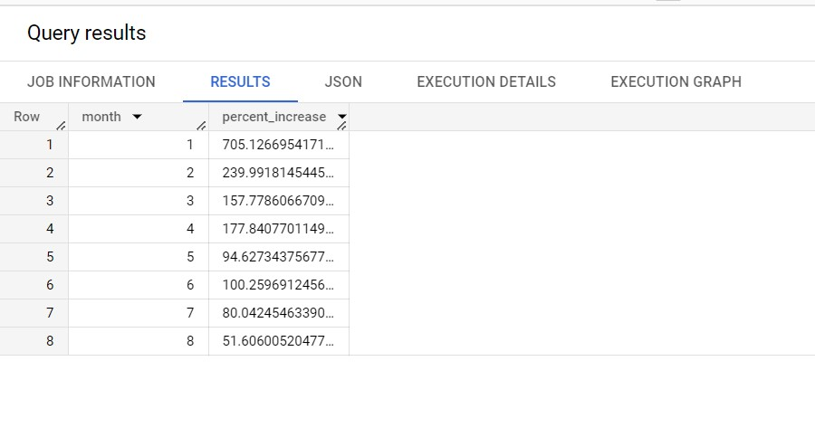

Insights :

1. The data shows monthly percentage increases over time.
2. Percentage increases vary from month to month, sometimes being positive and sometimes negative.
3. Initially, the percentage increases are higher and then gradually decrease.
4. Some months experience significant drops in the percentage increase.
5. There is no consistent trend observed in the data.

Recommendations :

1. Analyze fluctuations and identify contributing factors.
2. Aim for more consistent and sustainable growth.
3. Consider seasonal trends and adapt resources accordingly.
4. Perform competitor analysis to benchmark performance.
5. Seek customer feedback to improve satisfaction.
6. Use historical data for forecasting and planning.
7. Invest in marketing and innovation for customer engagement.
8. Optimize costs to improve profitability.
9. Focus on customer retention strategies.

These recommendations can guide the company's actions and help drive growth and improvement in their performance.

Assumptions :

1. Fluctuations in monthly percentage increases will continue.
2. The growth rate may gradually stabilize at a certain level.
3. Seasonal patterns will likely persist, affecting growth at different times.
4. Economic and market changes can influence future growth.
5. Competition and customer behavior will impact growth potential.
6. Investment in marketing and innovation may drive future growth.
7. Regulatory changes could influence growth strategies.
8. Effective customer retention efforts could lead to more stable growth.

Keep in mind that these assumptions are speculative and should be validated with additional data and analysis. External factors can significantly influence future outcomes, so the company should remain flexible in their approach and adapt to changing conditions.

4.B Calculate the Total & Average value of order price for each state.

Query :

  SELECT

  c.customer_state,

  ROUND(AVG(i.price), 2) AS mean_price,

  ROUND(SUM(i.price), 2) AS total_price,

  FROM `case_study.orders` o

  JOIN `case_study.order items` i ON o.order_id = i.order_id

  JOIN `case_study.customers` c ON o.customer_id =

  c.customer_id

  GROUP BY c.customer_state;

Output:

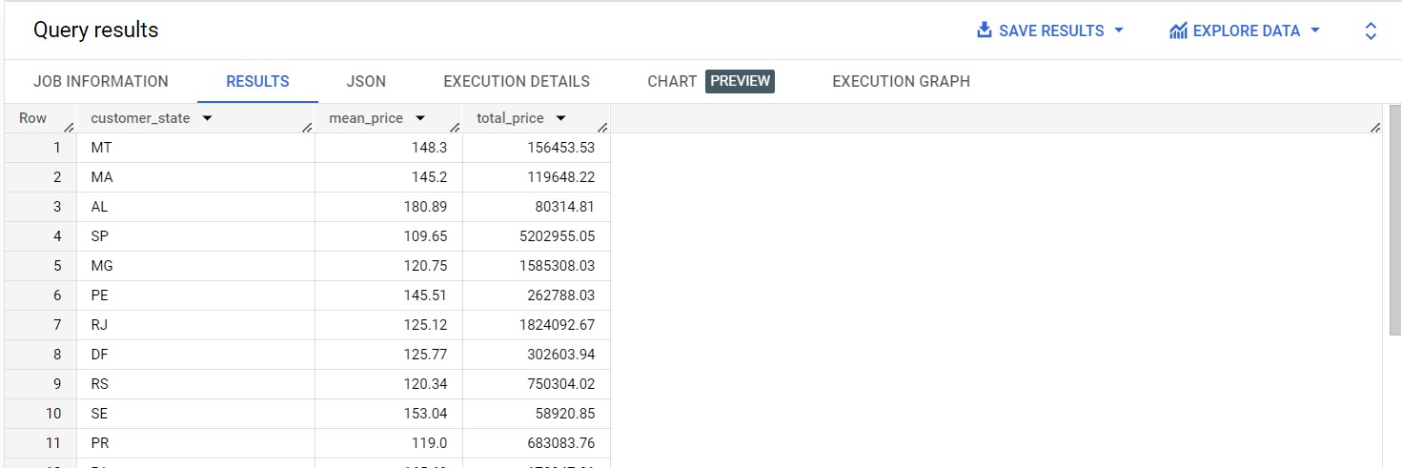

Insights :

* The table shows mean prices and total prices of customers in different states.
* Alabama (AL) has the highest mean price of $180.89, while Sao Paulo (SP) has the lowest mean price of $109.65.
* Sao Paulo (SP) has the highest total price of $5,202,955.05, indicating it's a high-value market.
* There is variation in mean prices across states, suggesting different spending habits.
* Businesses can target high-value markets (e.g., AL, MA) and high-volume markets (e.g., SP, MG) for potential growth.

Recommendations :

1. Segment customers based on state and spending patterns.
2. Target high-value states like AL and MA for premium products.
3. Explore high-volume markets like SP for increased sales.
4. Adopt competitive pricing in price-sensitive markets.
5. Analyze customer behavior for personalized marketing campaigns.
6. Focus on customer retention in high-value states.
7. Expand in states with increasing mean prices for growth opportunities.
8. Utilize region-specific marketing channels for better outreach.
9. Customize product assortment based on regional preferences.
10. Use data-driven decision-making for effective strategies.

Assumptions :

1. High-value states like AL and MA may continue to show strong purchasing power for premium products.
2. States with increasing mean prices (e.g., AL) could indicate potential economic growth in those regions.
3. High-volume states like SP may lead to intense competition among businesses.
4. Consumer behavior might change in the future due to economic, technological, or cultural factors.
5. Companies may develop more localized and personalized marketing efforts.
6. Product diversification based on regional preferences could lead to increased sales.
7. E-commerce channels may witness further growth as customers prefer online shopping.

4.C Calculate the Total & Average value of order freight for each state.

Query :

SELECT

  c.customer_state,

  ROUND(AVG(i.freight_value), 2) AS mean_freight_value,

  ROUND(SUM(i.freight_value), 2) AS total_freight_value

FROM `case_study.orders` o

JOIN `case_study.order items` i ON o.order_id = i.order_id

JOIN `case_study.customers` c ON o.customer_id =

c.customer_id

GROUP BY c.customer_state;

Output :

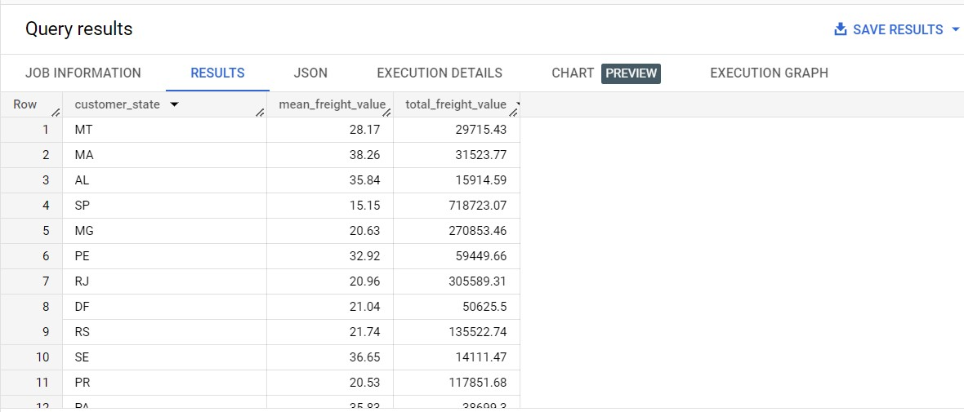

Insights :

* The table shows mean and total freight values for customers in different states.
* Customers in MA and SE have higher mean freight values, indicating potentially costlier shipping to these states.
* SP has the lowest mean freight value but the highest total freight value, suggesting a high volume of shipments.
* There is variation in freight values across states, indicating possible differences in shipping costs and logistics efficiency.
* Businesses should consider optimizing shipping strategies and logistics operations to manage costs effectively.

Recommendations :

1. Analyze shipping efficiency in states like SP with low mean freight value but high total freight value.
2. Focus on optimizing shipping costs in states with higher mean freight values (e.g., MA and SE).
3. Negotiate bulk shipping discounts with logistics partners for high-volume destinations.
4. Evaluate regional warehousing to reduce shipping distances and costs.
5. Offer different shipping options to customers with transparent freight costs.
6. Implement real-time freight calculators to provide accurate shipping costs.
7. Regularly renegotiate freight contracts to ensure competitive pricing.
8. Segment customers based on location and shipping preferences.
9. Use data-driven insights to make informed shipping decisions.
10. Communicate shipping costs clearly to manage customer expectations.

Assumptions :

1. Improved shipping efficiency may lead to cost savings in high-volume states (e.g., SP).
2. Freight optimization in states with higher mean freight values (e.g., MA and SE) could reduce shipping costs and improve customer satisfaction.
3. Regional warehousing implementation may enhance delivery times and customer retention.
4. Effective data-driven decisions may result in better cost estimations and optimized logistics.
5. Customer segmentation could lead to targeted shipping options and increased customer loyalty.
6. Continued e-commerce growth may increase the demand for efficient shipping solutions.
7. The company should stay adaptable to handle potential changes in the logistics industry and external factors.

Top of For