6.A Find the month on month no. of orders placed using different payment types.

Query:

SELECT p.payment_type,

EXTRACT(MONTH FROM o.order_purchase_timestamp) AS month,

  COUNT(DISTINCT o.order_id) AS order_count

FROM `case_study.orders` o

JOIN `case_study.payments` p

ON o.order_id = p.order_id

GROUP BY 1, 2

ORDER BY 1, 2;

Output :

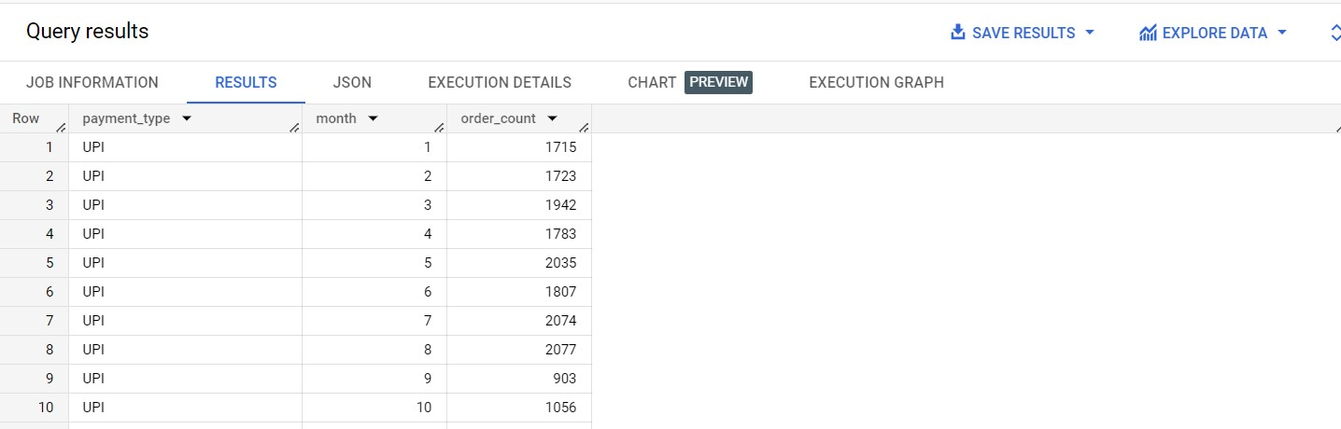

Insights :

* The data shows UPI (Unified Payments Interface) as the payment type for all entries.
* UPI transactions were recorded for 10 months.
* Monthly order counts varied from 903 (in month 9) to 2077 (in month 8).
* There was a noticeable increase in orders from month 4 (1783 orders) to month 5 (2035 orders).
* Analyzing monthly trends can help identify growth and seasonal variations in UPI transactions.
* Understanding user behavior and preferences can optimize UPI payment methods.
* Marketing and promotions during certain months could impact UPI transaction numbers.

Recommendations :

1. Promote UPI Usage: Encourage customers to use UPI through incentives and discounts.
2. Analyze Month 4 to 5 Surge: Identify successful strategies and replicate them.
3. Target Seasonal Opportunities: Utilize peak months for targeted marketing campaigns.
4. User Education and Support: Provide clear instructions for using UPI.
5. Monitor Month 9 Dip: Investigate reasons for the dip in UPI transactions.
6. Improve App and Checkout Experience: Ensure a seamless payment process.
7. Partnerships with UPI-enabled Services: Collaborate with other businesses accepting UPI.
8. Analyze Customer Segments: Tailor marketing efforts to UPI users' preferences.
9. Data-Driven Decision Making: Continuously analyze UPI transaction data.
10. Security and Privacy: Assure customers about UPI transaction security.

Assumptions :

1. Continued UPI Growth: UPI transactions are expected to grow steadily in the future.
2. Seasonal Fluctuations: UPI usage may vary based on seasonal trends and events.
3. Increasing User Adoption: More users are likely to adopt UPI as it becomes user-friendly.
4. Competitive Landscape: Businesses will compete to capture a share of the growing UPI market.
5. Diversification of Payment Methods: Multiple digital payment options will remain popular alongside UPI.
6. Security and Trust: Maintaining high security standards will be crucial for UPI's success.
7. Regulatory and Policy Changes: Government policies may impact UPI transactions.
8. Integration with E-commerce and Services: UPI will be integrated into more platforms.
9. Innovations in UPI Technology: Technological advancements may enhance UPI's features.
10. Global Adoption: UPI might see increased international acceptance.

6.B Find the no. of orders placed on the basis of the payment installments that have been paid.

Query :

SELECT p.payment_installments,

COUNT(o.order_id) AS order_count

FROM `case_study.orders` o

JOIN `case_study.payments` p

ON o.order_id = p.order_id

WHERE o.order_status != 'canceled'

GROUP BY 1

ORDER BY 2 DESC;

Output :

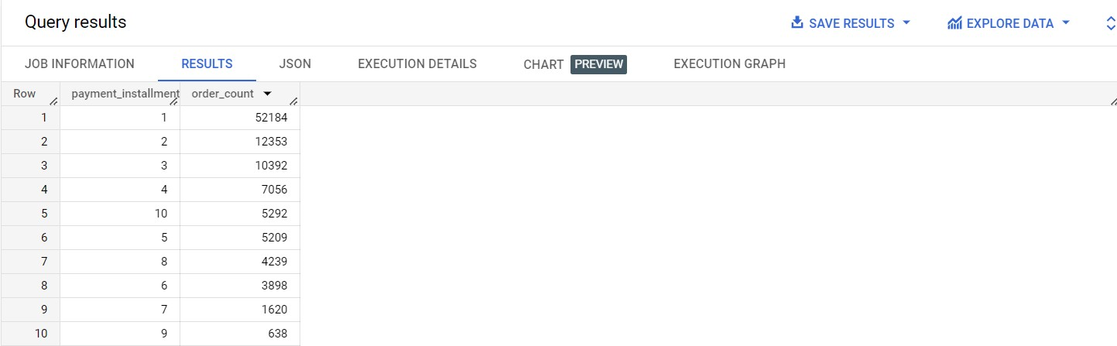

Insights :

* Most orders (52,184) were made with a single installment, indicating its popularity.
* As the number of installments increases, the order count generally decreases.
* The company should analyze and optimize installment plans based on customer preferences.
* Promoting flexible payment options could attract more customers to installment plans.
* Segmenting customers based on installment choices can guide targeted marketing efforts.
* Risk management strategies should be implemented for installment plans.
* Promotional campaigns and incentives can encourage customers to choose specific installments.
* Gathering customer feedback can provide valuable insights for improvement.
* Competitor comparison can help identify unique selling points.

Recommendations :

1. Optimize popular installment plans to meet customer preferences.
2. Promote flexible payment options to attract more customers to installment plans.
3. Segment marketing efforts based on installment choices for targeted campaigns.
4. Implement risk management strategies for installment plans to mitigate defaults.
5. Offer incentives and promotions to encourage customers to choose specific installments.
6. Gather customer feedback to improve the installment experience and satisfaction.
7. Monitor competitor offerings to stay competitive and highlight unique advantages.
8. Simplify the installment process for a user-friendly experience.
9. Educate customers about the benefits of installment plans through transparent communication.
10. Consider loyalty programs to reward customers for using installment options.
11. Encourage customers to choose slightly higher installment plans for increased revenue.
12. Implement dynamic pricing strategies for installment plans based on demand and behavior.

Assumptions :

1. Increased Adoption of Installment Plans: Optimized plans and promotions may lead to more customers choosing installment options.
2. Improved Customer Satisfaction: Gathering feedback and improvements can enhance customer satisfaction and loyalty.
3. Competitive Edge: Monitoring competitors and highlighting advantages can help maintain a competitive position.
4. Revenue Growth: Dynamic pricing and promotions might lead to higher average order value and increased revenue.
5. Customer Loyalty: Loyalty programs and incentives could foster customer loyalty and repeat business.
6. Risk Mitigation: Effective risk management can reduce potential financial losses.
7. Adaptation to Market Changes: Monitoring trends and preferences allows the company to adapt to market shifts.
8. Business Expansion: Enhanced customer experience might open opportunities for market expansion.
9. Digital Transformation: Promoting digital payment options contributes to a modern brand image.
10. Innovation in Payment Solutions: Investing in innovative payment methods can drive future growth.