Question 1
Write an SQL query to display the names and salaries of employees whose salary is greater than the average salary in the company.

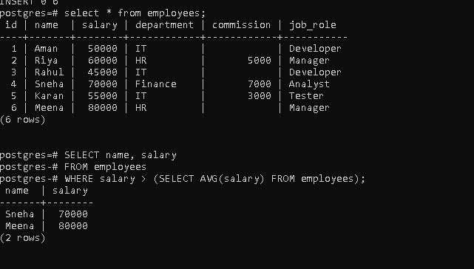
Question 2
2. Write a query to retrieve the top 5 highest-paid employees from an employees table.
Explain how sorting affects the output.

3. Write a query to calculate:
- Total number of employees
- Average salary
- Minimum and maximum salary
Explain the difference between aggregate and scalar functions.
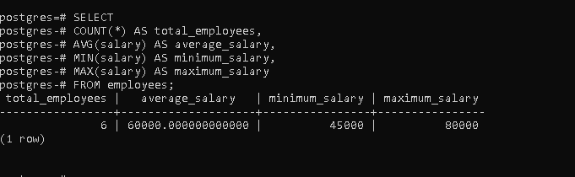
4. Given a sales table with columns (region, amount), write a query to find total sales per region.
Filter only those regions where total sales exceed 50,000.
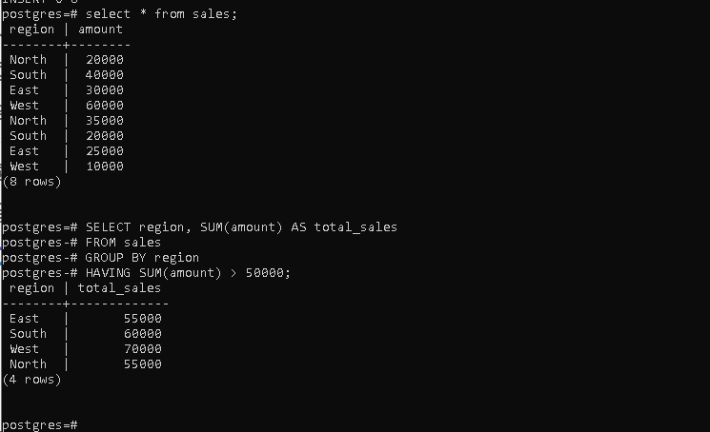

5. Write a query to find the number of unique job roles in an employees table. Explain why DISTINCT is necessary here.
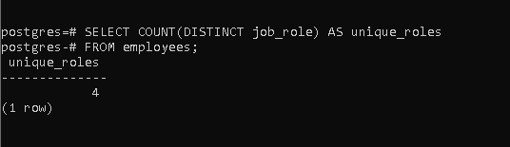
6. Write a query to retrieve students who scored between 60 and 80 marks.
Rewrite the same query using BETWEEN.
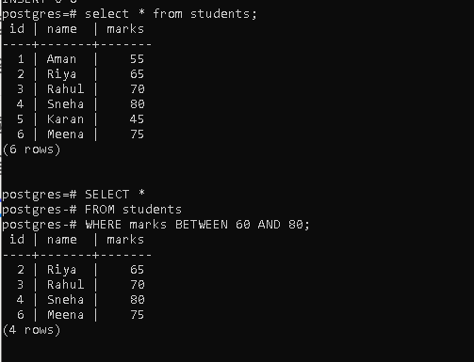

7. Write a query to display employees whose commission is NULL. Explain the correct way to check NULL values in SQL.
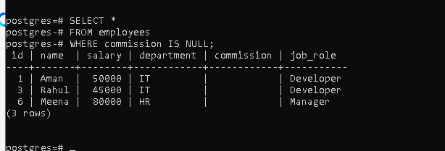

8. Write a query to increase the salary of employees in the "IT" department by 10%.
Explain how arithmetic operations are handled in SQL.



9. Write a query to delete records of students who scored less than 40 marks.
What precaution should be taken before executing DELETE?



10.Write a query to find employees who earn more than the average salary of their department (without using joins).
Explain the logic of the subquery.
