

TOPIC: MINI PROJECT SYNOPSIS ON
“BookNook – Library Management System”

Submitted By | Submitted To:
Name: Neha Varshney  ID: 2415001025  Name: Aryansh Sikarwar  ID: 2415000362  Name: Ayush Bhardwaj  ID: 2415000397 | Faculty Name: Mr. Akash Kumar Choudhary  Technical Trainer

ACKNOWLEDGEMENT

We would like to express our sincere gratitude to Mr. Akash Kumar Choudhary (Technical Trainer) for his valuable guidance, encouragement, and support throughout the development of this project. We also thank the JOVAC program and GLA University for providing us with the opportunity and resources to work on this real-world application of the MERN stack. Finally, we thank our peers and family for their continuous support.

INDEX
This Index is a reference for synopsis only

S.No | Topic
1 | Introduction / About the Project
2 | Primary Reason to Choose This Project
3 | The Main Objective of the Project
4 | Scope of the Project
5 | Working Methodology of the Project
6 | System Requirements
7 | Hardware Requirements
8 | Frontend and Backend
9 | Module Description
10 | Data Flow Diagrams (0, 1, 2 Level)
11 | References

1. Introduction
About the Project
Libraries traditionally rely on manual registers or outdated desktop software to manage books, members, and borrowing records. This process is slow, error-prone, and difficult to scale as the number of books and members grows. BookNook is a full-stack MERN web application designed to digitize and simplify library operations for both students/members and librarians/admins. It allows members to browse the catalog, reserve (borrow) books, and track due dates, while librarians manage inventory, approve/reject borrow requests, and monitor overdue returns — all through a centralized, role-based system.

2. Primary Reason to Choose This Project
Libraries are a part of everyday academic life, yet many small and academic libraries still depend on manual or semi-digital record-keeping, which is inefficient and error-prone. This project was chosen because it addresses a genuine, relatable problem while giving us hands-on experience in building a complete full-stack application — covering frontend development, backend API design, database modeling, authentication, and deployment, all of which are core, in-demand skills in modern web development.

3. The Main Objective of the Project
- To design and develop a full-stack MERN web application for library management.
- To allow members to browse the catalog, search/filter books, and reserve (borrow) books online.
- To allow members to track due dates and view their borrowing history.
- To provide librarians/admins with tools to manage inventory (add, update, delete books).
- To implement secure authentication and role-based authorization (Member vs. Admin).
- To build the system using REST API design principles for clean frontend-backend communication.
- To follow clean coding practices and Git/GitHub version control throughout development.

4. Scope of the Project
The scope of BookNook covers the complete digital workflow of a small-to-medium library:
- Member-side features: registration, login, catalog browsing, search/filter, book reservation, due-date tracking, and borrowing history.
- Admin-side features: book inventory management, member management, borrow-request approval/rejection, and overdue tracking.
- The system is limited to core library operations (catalog and borrowing) and does not currently cover fine/payment processing, multi-branch library support, or physical barcode scanning — these are noted as future scope.

5. Working Methodology of the Project
The project follows an incremental, phase-wise development methodology:
- Requirement analysis and planning – identifying user roles, features, and database structure.
- Backend development – building models, REST APIs, authentication, and authorization using Node.js, Express.js, and MongoDB.
- Frontend development – building the React.js user interface for members and admins.
- Integration – connecting the React frontend to the Express backend via Axios and REST APIs.
- Testing – verifying each feature (auth, book CRUD, borrow workflow) using Postman and manual UI testing.
- Deployment – hosting the frontend, backend, and database on suitable free/low-cost cloud platforms.

6. System Requirements
Supported Operating System
Windows 10/11, macOS, or Linux (any OS capable of running Node.js and a modern web browser).
Software Required
- Node.js (v18 or above) and npm
- Visual Studio Code (Code Editor)
- MongoDB Compass / MongoDB Atlas (Database)
- Postman (API Testing)
- Git and a GitHub account (Version Control)
- Modern web browser (Chrome/Edge/Firefox)

7. Hardware Requirements
Component | Minimum Requirement
Processor | Dual-core 2.0 GHz or above
RAM | 4 GB minimum (8 GB recommended)
Storage | At least 2 GB free disk space
Internet | Stable connection (for MongoDB Atlas & deployment)

8. Frontend and Backend
Frontend
Built using React.js along with HTML5, CSS3, and JavaScript (ES6+). React handles the single-page application UI, routing (via React Router), and communicates with the backend using Axios for REST API calls.
Backend
Built using Node.js and Express.js. The backend exposes REST APIs for authentication, book management, and borrowing operations, and uses MongoDB (via Mongoose) as the database. JWT is used for authentication and bcrypt for password hashing.

9. Module Description
1. Authentication Module
Handles user registration, login, logout, password hashing (bcrypt), and JWT-based session management. Also enforces role-based access control (Member vs. Admin).
2. Book Management Module
Allows admins to add, update, and delete books, and allows members to browse, search, and filter the catalog by category or author. Tracks total and available copies of each book.
3. Borrowing Module
Manages the full borrow lifecycle: request → admin approval/rejection → borrowed → due date tracking → return → overdue detection. Automatically updates available-copy counts in the Book module.
4. User/Admin Dashboard Module
Displays relevant statistics — members see their borrowed books, history, and pending requests; admins see total books, total members, pending requests, and overdue books.

10. Data Flow Diagrams
A Data Flow Diagram (DFD) illustrates how data is processed by a system in terms of inputs and outputs. Its focus is on the flow of information — where data comes from, where it goes, and how it gets stored.
0-Level DFD (Context Diagram)
Shows BookNook as a single process interacting with two external entities: Member and Admin.
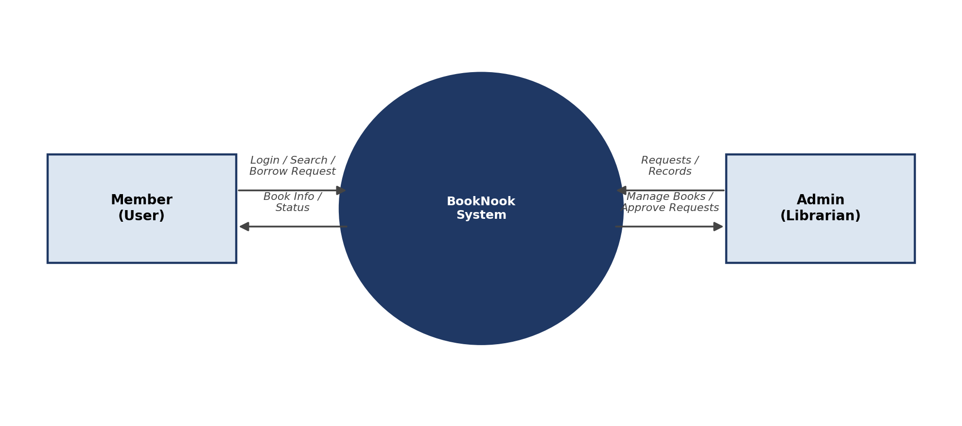
1-Level DFD
Breaks the system into three major processes — Authentication, Book Management, and Borrow Management — each interacting with its own data store.
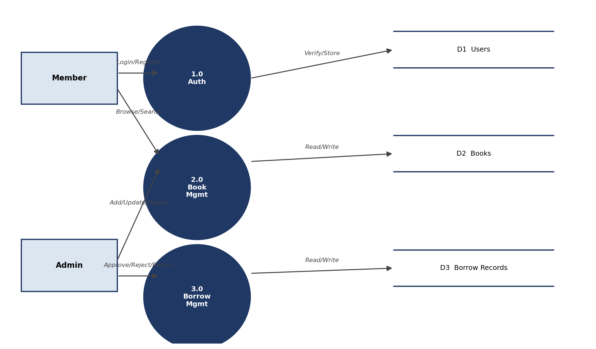
2-Level DFD (Borrow Management expanded)
Expands the Borrow Management process into sub-processes: Request Borrow, Check Availability, Approve/Reject, Update Status, and Process Return.
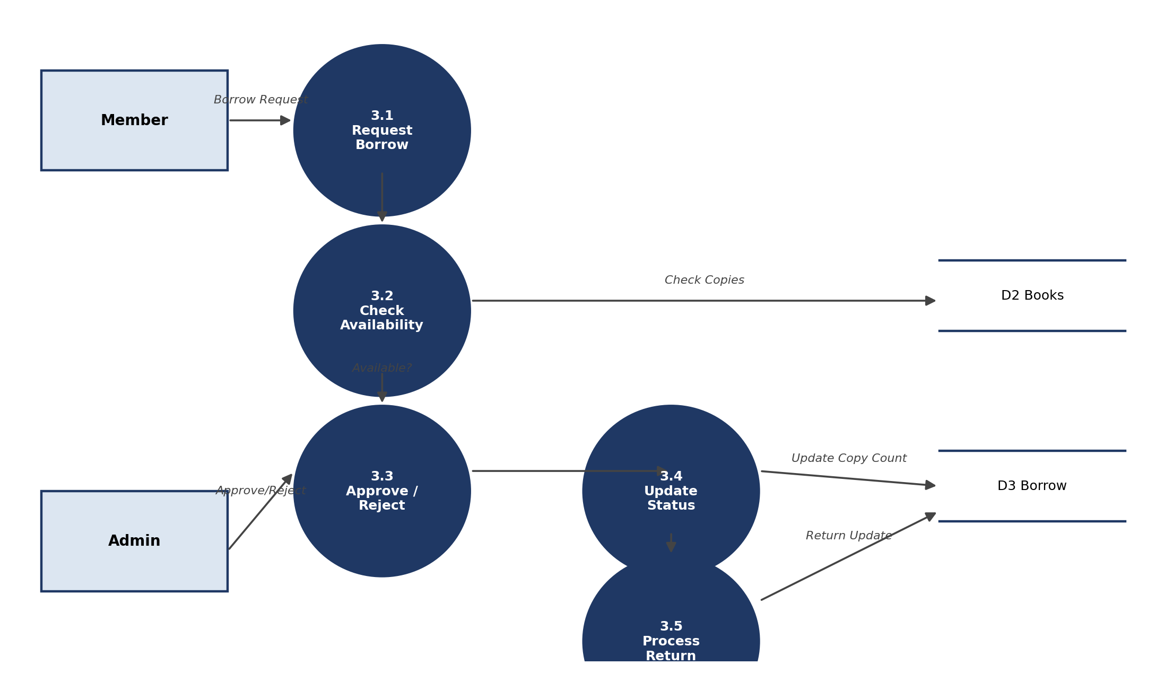

11. References
- MongoDB Official Documentation – https://www.mongodb.com/docs/
- Express.js Official Documentation – https://expressjs.com/
- React.js Official Documentation – https://react.dev/
- Node.js Official Documentation – https://nodejs.org/docs/
- JWT.io – https://jwt.io/introduction
- Postman Learning Center – https://learning.postman.com/

