**FINAL OERATING SYSTEM WORKSHEET- 4**

**Student Name:-** Neha Sharma  **UID:-**20BCS4576

**Branch: -** (CSE_IOT)**Section/Group: -** 20BIT (A)

**Semester:** 3rd **Date of Performance: -** 7/12/2021

# **Subject Name:-**Operating System Lab

1. **Implement system calls – fork, exec, getpid, exit.**

**1. Aim/Overview of the practical:-** . Implement system calls – fork, exec, getpid, exit.

**2. Task to be done:-** We have to implement the program using system calls: fork, exec, getpid, exit.

**3. Apparatus**:- PC , online Compiler

**4. Program Code-**

#include <stdio.h>

#include <unistd.h>

int main()

{

int id;

printf("Hello, This is Neha Sharma\n");

id = fork();

if (id > 0) {

printf("--> PARENT SECTION [PROCESS ID: %d].\n", getpid());

}

else if (id == 0) {

printf("fork created [PROCESS ID: %d].\n", getpid());

printf("THE fork PARENT PROCESS ID: %d.\n", getppid());

}

else {

printf("ERROR fork CREATION FAILED\n");

}

return 0;

}

**5. OUTPUT**

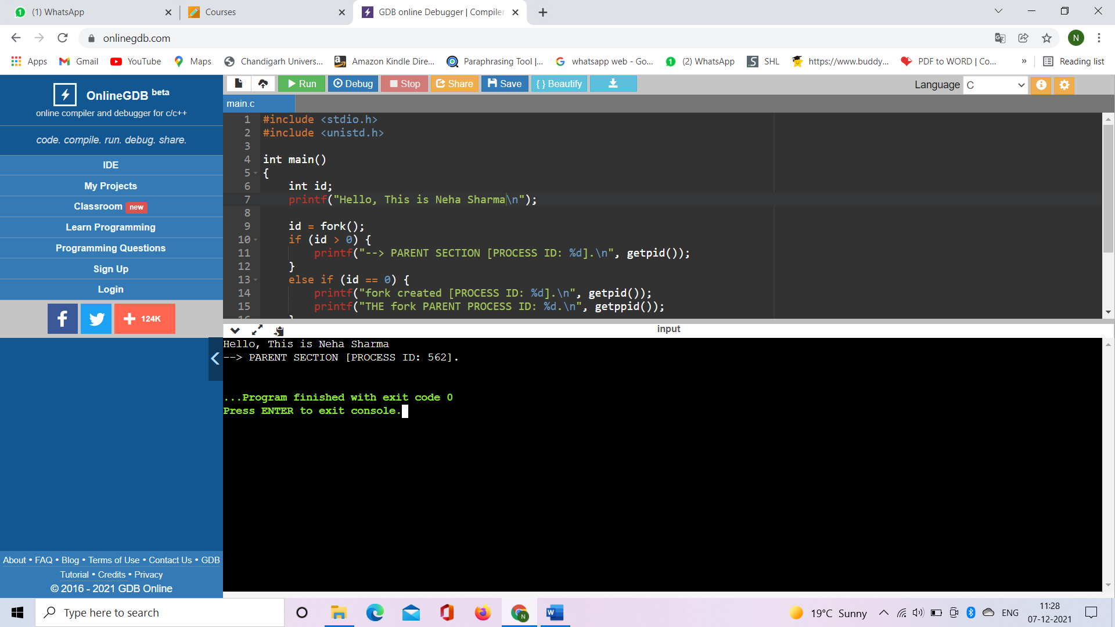

**B.** **Write a program to implement the SJF with 5 processes out of which 2 process having same burst time.**

**1. Aim/Overview of the practical:-** Simulation of shortest job first scheduling algorithm

**2. Task to be done:-** We have to implement the program shortest job first scheduling algorithm.

**3. Algorithm/Flowchart (For programming based labs):**

1. Sort all the process according to the arrival time.

2. Then select that process which has minimum arrival time and minimum Burst time.

3. After completion of process make a pool of process which after till the completion of previous pro-cess and select that process among the pool which is having minimum Burst time.

**4. Steps for experiment/practical:**

#include <iostream>

using namespace std;

int mat[10][6];

void swap(int* a, int* b)

{

int temp = *a;

*a = *b;

*b = temp;

}

void arrangeArrival(int num, int mat[][6])

{

for (int i = 0; i < num; i++) {

for (int j = 0; j < num - i - 1; j++) {

if (mat[j][1] > mat[j + 1][1]) {

for (int k = 0; k < 5; k++) {

swap(mat[j][k], mat[j + 1][k]);

}

}

}

}

}

void completionTime(int num, int mat[][6])

{

int temp, val;

mat[0][3] = mat[0][1] + mat[0][2];

mat[0][5] = mat[0][3] - mat[0][1];

mat[0][4] = mat[0][5] - mat[0][2];

for (int i = 1; i < num; i++) {

temp = mat[i - 1][3];

int low = mat[i][2];

for (int j = i; j < num; j++) {

if (temp >= mat[j][1] && low >= mat[j][2]) {

low = mat[j][2];

val = j;

}

}

mat[val][3] = temp + mat[val][2];

mat[val][5] = mat[val][3] - mat[val][1];

mat[val][4] = mat[val][5] - mat[val][2];

for (int k = 0; k < 6; k++) {

swap(mat[val][k], mat[i][k]);

}

}

}

int main()

{

int num, temp;

cout << "Enter number of Process: ";

cin >> num;

cout << "...Enter the process ID...\n";

for (int i = 0; i < num; i++) {

cout << "...Process " << i + 1 << "...\n";

cout << "Enter Process Id: ";

cin >> mat[i][0];

cout << "Enter Arrival Time: ";

cin >> mat[i][1];

cout << "Enter Burst Time: ";

cin >> mat[i][2];

}

cout << "Before Arrange...\n";

cout << "Process ID\tArrival Time\tBurst Time\n";

for (int i = 0; i < num; i++) {

cout << mat[i][0] << "\t\t" << mat[i][1] << "\t\t"

<< mat[i][2] << "\n";

}

arrangeArrival(num, mat);

completionTime(num, mat);

cout << "Final Result...\n";

cout << "Process ID\tArrival Time\tBurst Time\tWaiting "

"Time\tTurnaround Time\n";

for (int i = 0; i < num; i++) {

cout << mat[i][0] << "\t\t" << mat[i][1] << "\t\t"

<< mat[i][2] << "\t\t" << mat[i][4] << "\t\t"

<< mat[i][5] << "\n";

}

}

**5. Observations/ Discussions (For applied/experimental sciences/materials based labs):**

1. Find **waiting time** for all other processes i.e. for Process i -> wt[i] = bt[i-1] + wt[i-1] .
2. Find **turnaround time** = waiting time + burst time for all processes.
3. Find **average waiting time** = total waiting time / no of processes.
4. Similarly, find **average turnaround time** = total turnaround time / no of processes.

**6. Output**

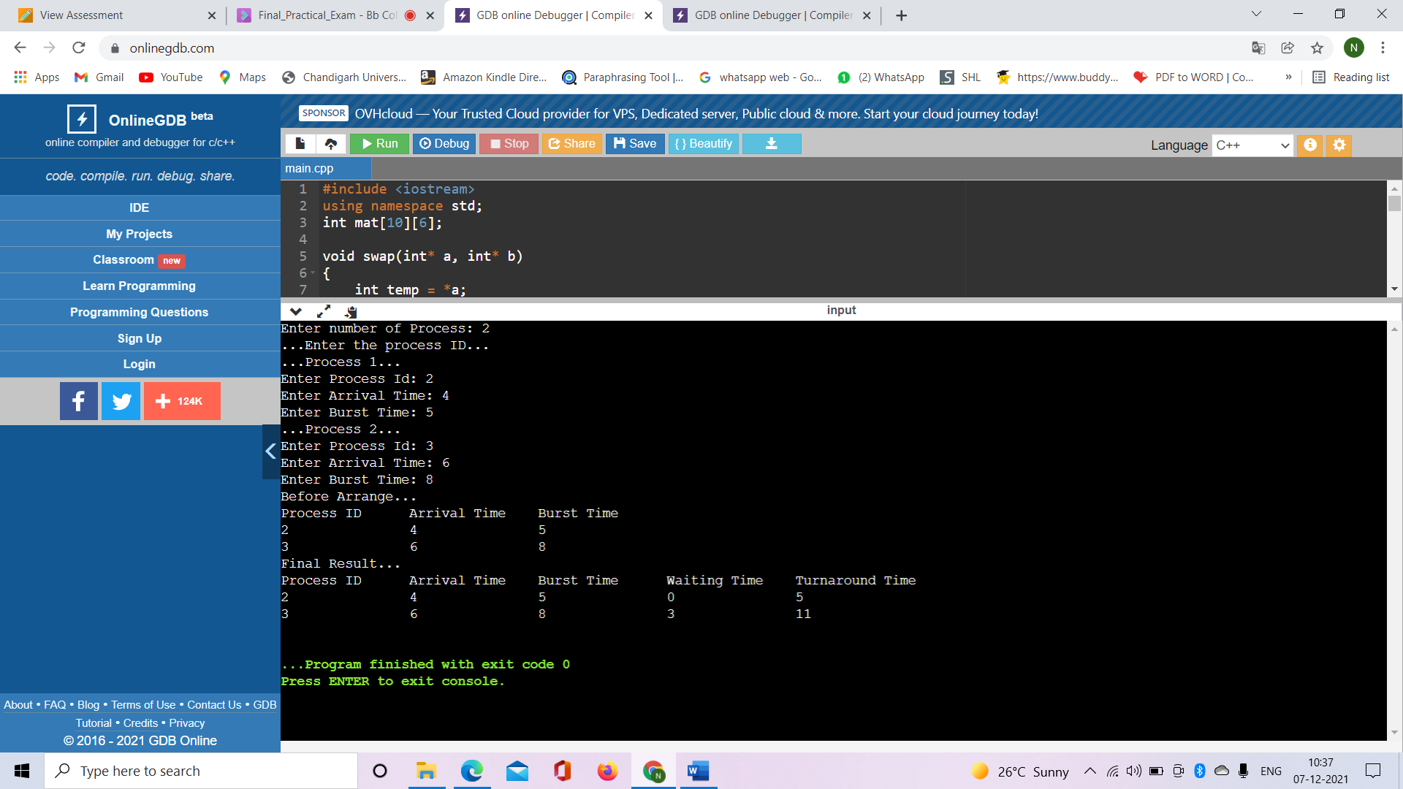

**Learning outcomes (What I have learnt):**

1. Learned about shortest job first algorithm.

2. Learned about how to calculate Waiting time, turnaround time, average waiting time, and average turnaround time.

**Evaluation Grid (To be created as per the SOP and Assessment guidelines by the faculty):**

|  |  |  |  |
| --- | --- | --- | --- |
| Sr. No. | Parameters | Marks Obtained | Maximum Marks |
| 1. |  |  |  |
| 2. |  |  |  |
| 3. |  |  |  |
|  |  |  |  |