**EXPERIMENT:-2**

**Student Name: Neha Sharma UID:- 20BCS4576**

**Branch: CSE-IOT Section/Group:-A**

**Semester: 3RD Date of Performance:- 28/08/2021**

**Subject Name:- Programming in Java lab Subject Code: 21O-20CSP-235_20BIT-1_A**

**1. Aim/Overview of the practical:-** The Fibonacci sequence is defined by the following rule. The first 2 values in the sequence are 1, 1. Every subsequent value is the sum of the 2 values preceding it. Write a Java program that uses both recursive and non-recursive functions to print the nth value of the Fibonacci sequence.

**2. Task to be done:-**

* The Fibonacci series of element where, the previous two elements are added to get the next elements, starting with 0 and 1. Here previous terms of Fibonacci is 1 and current is 1, so that next term = previous(1) + current(1) etc so on.
* Fibonacci series is calculated using recursion, with seed as 0 and 1. Recursion means a function calling itself, in the below code Fibonacci function calls itself with a lesser value several time.

**3. Apparatus(For applied/experimental sciences/materials based labs):-**

* Notepad++
* Command Prompt

**4. Algorithm/Flowchart (For programming based labs):-**

**Non-Recursive**

Step 1:- Start

Step 2:- Declare Variable prev, curr, next, i.

Step 3:- Initialize variable prev=1, curr=1, i=10

Step 4:- Read value of length from user.

Step 5:- print enter the length of Fibonacci.

Step 6:- Repeat until i<=length

Step 6.1:- next=prev+curr

Step 6.2:- print next

Step 6.3:- prev=curr, curr=next

Step 6.4:- i=i+1

Step 7:- Stop

**Recusive**

Step 1:- Start

Step 2:- Declare a variable for the total numbers of terms.

Step 3:- Ask the user to initialize the number of terms.

Step 4:- Print the first and second numbers of the series.

Step 5:- Call a recursive function to print the Fibonacci series up to

That number of terms.

Step 6:- Update the series terms recursively.

Step 7:- Print the Fibonacci series.

Step 8:- Stop

**5. Code( For creative domains):-**

**Non-Recursive**

**import java.util.Scanner;**

**class Fibonacci{**

**public static void main(String[] args)**

**{**

**int prev=1;**

**int curr=1;**

**System.out.println("Enter the length of fibonacci : ");**

**Scanner input=new Scanner(System.in);**

**int length=input.nextInt();**

**System.out.println("Fibonacci of first "+length+" numbers : ");**

**System.out.println(prev);**

**System.out.println(curr);**

**for(int i=3; i<=length; i++)**

**{**

**int next=prev+curr;**

**System.out.println(next);**

**prev=curr;**

**curr=next;**

**}**

**}**

**}**

**With Recursive**

**class FibonacciRec{**

**static int n1=0,n2=1,n3=0;**

**static void printFibonacci(int count){**

**if(count>0){**

**n3 = n1 + n2;**

**n1 = n2;**

**n2 = n3;**

**System.out.print(" "+n3);**

**printFibonacci(count-1);**

**}**

**}**

**public static void main(String args[]){**

**int count=10;**

**System.out.print(n1+" "+n2);**

**printFibonacci(count-2);**

**}**

**}**

**6. Percentage error (if any or applicable):-NA**

**7. Result/Output/Writing Summary:-**

**Non-Recursive Output**

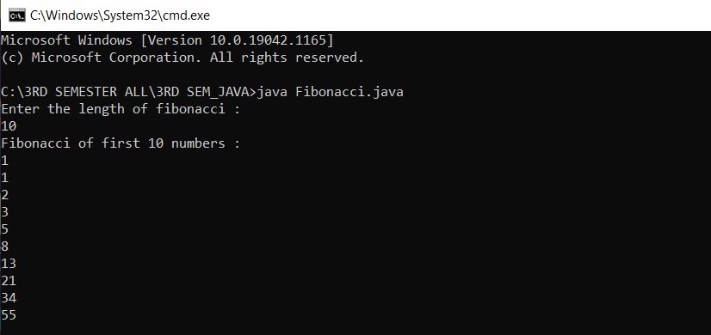

**Recursive Output**

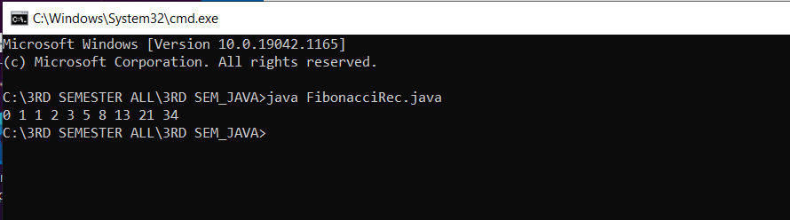

**8. Graphs (If Any): Image /Soft copy of graph paper to be attached here**

**NA**

**Learning outcomes (What I have learnt):**

**1. Learn How to create the Fibonacci series and Fibonacci Using Recursion.**

**2. Learn how to write types of loops.**

**3. To learn Select the correct type of loop based on a given problem.**

**4. To learn Fibonacci Series.**

**5. To learn Fibonacci Series using Recursion.**

**Evaluation Grid (To be created as per the SOP and Assessment guidelines by the faculty):**

|  |  |  |  |
| --- | --- | --- | --- |
| Sr. No. | Parameters | Marks Obtained | Maximum Marks |
| 1. |  |  |  |
| 2. |  |  |  |
| 3. |  |  |  |
|  |  |  |  |