🔹 Accuracy Comparison
Figure: Accuracy Comparison of Machine Learning Models
Description:
The above graph represents the comparison of accuracy among different machine learning models. It can be observed that the Random Forest model achieves the highest accuracy, followed by Support Vector Machine, while Logistic Regression performs comparatively lower. This indicates that ensemble methods provide better performance for the given dataset.

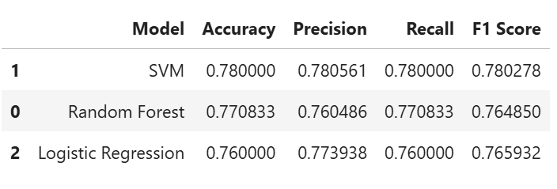
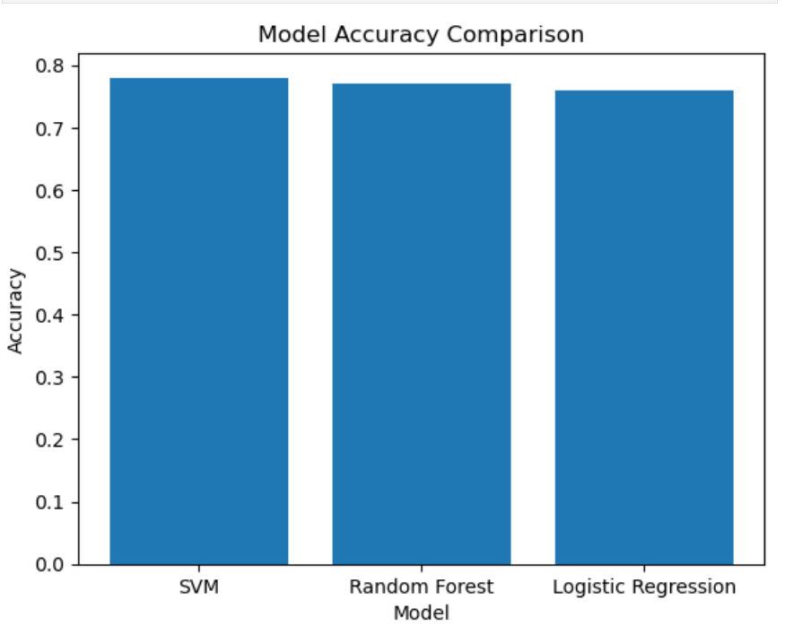

🔹 Model Performance
Figure: Model Performance Comparison
Description:
The above figure represents the overall performance comparison of different machine learning models based on evaluation metrics such as accuracy, precision, recall, and F1-score. It can be observed that the Random Forest model performs better than the other models across most of the metrics. Support Vector Machine also shows good performance, while Logistic Regression provides baseline results. This comparison helps in identifying the most efficient model for the given dataset.

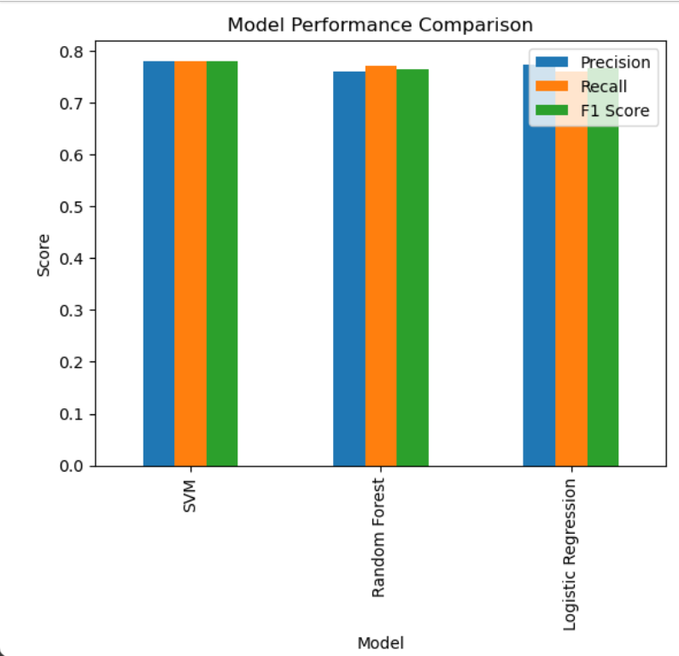

🔹 CONFUSION MATRIX
Figure: Confusion Matrix of Model
Description:
The above figure represents the confusion matrix of the model. It shows the number of correct and incorrect predictions made by the model. The diagonal elements indicate correctly classified instances, while the off-diagonal elements represent misclassifications. The higher values along the diagonal suggest that the model performs well with minimal classification errors.

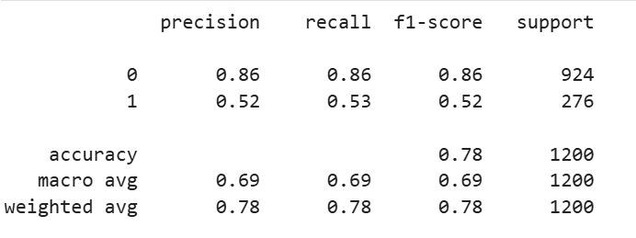
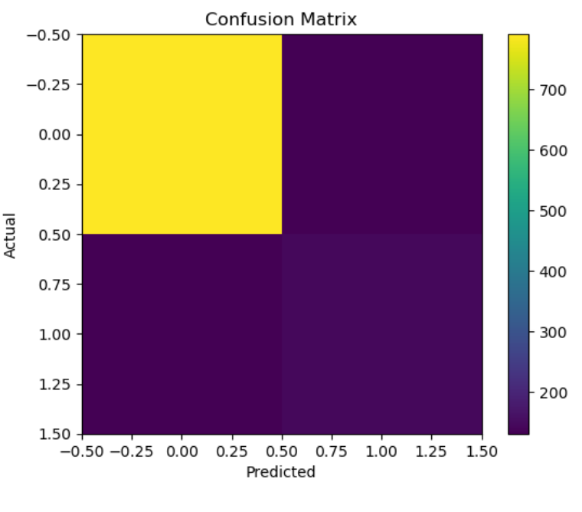

🔹 LEADERBOARD
Figure: Model Leaderboard
Description:
The above figure shows the leaderboard of different machine learning models ranked based on their performance metrics such as accuracy and F1-score. It can be observed that the Random Forest model ranks highest, followed by Support Vector Machine and Logistic Regression. The leaderboard helps in identifying the best-performing model for the given dataset.

