1) what is the diffrence between Source Qualifire and joiner transformation?
1. Source Qualifier Operates only with relational sources within the same schema.
Joiner can have either heterogenous sources or relation sources in different schema
2. Source qualifier requires atleats one matching column to perform a join.
Joiner joins based on matching port.
3. Additionally, Joiner requires two separate input pipelines and should not have an update strategy or Sequence generator (this is no longer true from Infa 7.2).

1)Joiner can join relational sources which come from different sources whereas in source qualifier the relational sources should come from the same data source.
2)We need matching keys to join two relational sources in source qualifier transformation.
Where as we doesn?t need matching keys to join two sources.

2)Difference between Filter and Router transformation?
1.A Filter transformation tests data for one condition and drops the rows of data that do not meet the condition.

Router transformation provides us the facility to capture the rows of data that do not meet any of the conditions to a default output group.

2.Filter transformation works as WHERE clause of SQL .

Router transformation acts like IIF condition in informatica or CASE.. WHEN in database .

3.Router transformation is more efficient than the Filter transformation.

For example :-We have 3 departments in source HR, ADMIN and TECHNICAL, now we want to send these records into 3 tables call HR_TABLE, ADMIN_TABLE and TECHNICAL_TABLE based on it's department id.

To achieve this we require only one Router transformation.

In case we want to get same result with Filter transformation then we require at least 3 Filter transformations.

What are the differences between Connected and Unconnected Lookup?
Connected Lookup | Unconnected Lookup
Connected lookup participates in dataflow and receives input directly from the pipeline | Unconnected lookup receives input values from the result of a LKP: expression in another transformation
Connected lookup can use both dynamic and static cache | Unconnected Lookup cache can NOT be dynamic
Connected lookup can return more than one column value ( output port ) | Unconnected Lookup can return only one column value i.e. output port
Connected lookup caches all lookup columns | Unconnected lookup caches only the lookup output ports in the lookup conditions and the return port
Supports user-defined default values (i.e. value to return when lookup conditions are not satisfied) | Does not support user defined default values

What is meant by active and passive transformation?
An active transformation is the one that performs any of the following actions:
1) Change the number of rows between transformation input and output. Example: Filter transformation.
2) Change the transaction boundary by defining commit or rollback points., example transaction control transformation.
3) Change the row type, example Update strategy is active because it flags the rows for insert, delete, update or reject.
On the other hand a passive transformation is the one which does not change the number of rows that pass through it. Example: Expression transformation.

What is the difference between Router and Filter?
Router | Filter
Router transformation divides the incoming records into multiple groups based on some condition. Such groups can be mutually inclusive (Different groups may contain same record) | Filter transformation restricts or blocks the incoming record set based on one given condition.
Router transformation itself does not block any record. If a certain record does not match any of the routing conditions, the record is routed to default group | Filter transformation does not have a default group. If one record does not match filter condition, the record is blocked
Router acts like CASE.. WHEN statement in SQL (Or Switch().. Case statement in C) | Filter acts like WHERE condition is SQL.

What can we do to improve the performance of Informatica Aggregator Transformation?
Aggregator performance improves dramatically if records are sorted before passing to the aggregator and "sorted input" option under aggregator properties is checked. The record set should be sorted on those columns that are used in Group By operation.
It is often a good idea to sort the record set in database level (click here to see why?) e.g. inside a source qualifier transformation, unless there is a chance that already sorted records from source qualifier can again become unsorted before reaching aggregator
You may also read this article to know how to tune the performance of aggregator transformation

What are the different lookup cache(s)?
Informatica Lookups can be cached or un-cached (No cache). And Cached lookup can be either static or dynamic. A static cache is one which does not modify the cache once it is built and it remains same during the session run. On the other hand, A dynamic cache is refreshed during the session run by inserting or updating the records in cache based on the incoming source data. By default, Informatica cache is static cache.
A lookup cache can also be divided as persistent or non-persistent based on whether Informatica retains the cache even after the completion of session run or deletes it

How can we update a record in target table without using Update strategy?
A target table can be updated without using 'Update Strategy'. For this, we need to define the key in the target table in Informatica level and then we need to connect the key and the field we want to update in the mapping Target. In the session level, we should set the target property as "Update as Update" and check the "Update" check-box.
Let's assume we have a target table "Customer" with fields as "Customer ID", "Customer Name" and "Customer Address". Suppose we want to update "Customer Address" without an Update Strategy. Then we have to define "Customer ID" as primary key in Informatica level and we will have to connect Customer ID and Customer Address fields in the mapping. If the session properties are set correctly as described above, then the mapping will only update the customer address field for all matching customer IDs.

Under what condition selecting Sorted Input in aggregator may fail the session?
- If the input data is not sorted correctly, the session will fail.
- Also if the input data is properly sorted, the session may fail if the sort order by ports and the group by ports of the aggregator are not in the same order.

Why is Sorter an Active Transformation?
This is because we can select the "distinct" option in the sorter property.
When the Sorter transformation is configured to treat output rows as distinct, it assigns all ports as part of the sort key. The Integration Service discards duplicate rows compared during the sort operation. The number of Input Rows will vary as compared with the Output rows and hence it is an Active transformation.

Is lookup an active or passive transformation?
From Informatica 9x, Lookup transformation can be configured as as "Active" transformation.
Find out How to configure lookup as active transformation
However, in the older versions of Informatica, lookup is a passive transformation

What is the difference between Static and Dynamic Lookup Cache?
We can configure a Lookup transformation to cache the underlying lookup table. In case of static or read-only lookup cache the Integration Service caches the lookup table at the beginning of the session and does not update the lookup cache while it processes the Lookup transformation.
In case of dynamic lookup cache the Integration Service dynamically inserts or updates data in the lookup cache and passes the data to the target. The dynamic cache is synchronized with the target.
In case you are wondering why do we need to make lookup cache dynamic, read this article on dynamic lookup

What is the difference between STOP and ABORT options in Workflow Monitor?
When we issue the STOP command on the executing session task, the Integration Service stops reading data from source. It continues processing, writing and committing the data to targets. If the Integration Service cannot finish processing and committing data, we can issue the abort command.
In contrast ABORT command has a timeout period of 60 seconds. If the Integration Service cannot finish processing and committing data within the timeout period, it kills the DTM process and terminates the session.

What are the new features of Informatica 9.x in developer level?
From a developer's perspective, some of the new features in Informatica 9.x are as follows:
- Now Lookup can be configured as an active transformation - it can return multiple rows on successful match
- Now you can write SQL override on un-cached lookup also. Previously you could do it only on cached lookup
- You can control the size of your session log. In a real-time environment you can control the session log file size or time
- Database deadlock resilience feature - this will ensure that your session does not immediately fail if it encounters any database deadlock, it will now retry the operation again. You can configure number of retry attempts.

How to Delete duplicate row using Informatica

Scenario 1: Duplicate rows are present in relational database
Suppose we have Duplicate records in Source System and we want to load only the unique records in the Target System eliminating the duplicate rows. What will be the approach?
Assuming that the source system is a Relational Database, to eliminate duplicate records, we can check the Distinctoption of the Source Qualifier of the source table and load the target accordingly.
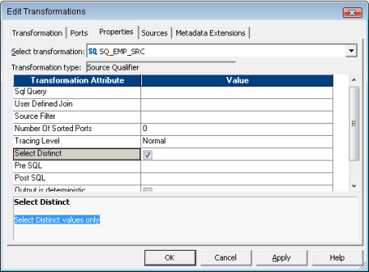

Deleting duplicate rows / selecting distinct rows for FLAT FILE sources
In the previous page we saw how to choose distinct records from Relational sources. Next we asked the question, how may we select the distinct records for Flat File sources?
Here since the source system is a Flat File you will not be able to select the distinct option in the source qualifier as it will be disabled due to flat file source table. Hence the next approach may be we use a Sorter Transformation and check theDistinct option. When we select the distinct option all the columns will the selected as keys, in ascending order by default.
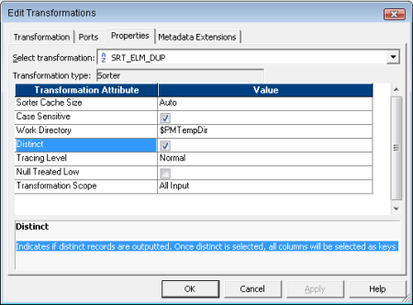

Deleting Duplicate Record Using Informatica Aggregator
Other ways to handle duplicate records in source batch run is to use an Aggregator Transformation and using the Group By checkbox on the ports having duplicate occurring data. Here you can have the flexibility to select the last or the first of the duplicate column value records.
There is yet another option to ensure duplicate records are not inserted in the target. That is through Dynamic lookup cache. Using Dynamic Lookup Cache of the target table and associating the input ports with the lookup port and checking the Insert Else Update option will help to eliminate the duplicate records in source and hence loading unique records in the target.
For more details check, Dynamic Lookup Cache

Loading Multiple Target Tables Based on Conditions

Scenario
Suppose we have some serial numbers in a flat file source. We want to load the serial numbers in two target files one containing the EVEN serial numbers and the other file having the ODD ones.

Answer
After the Source Qualifier place a Router Transformation. Create two Groups namely EVEN and ODD, with filter conditions as:
MOD(SERIAL_NO,2)=0 and MOD(SERIAL_NO,2)=1
... respectively. Then output the two groups into two flat file targets.
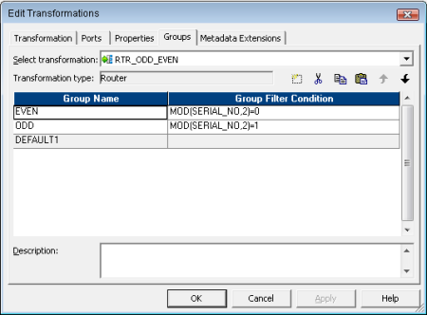

Normalizer Related Questions

Scenario 1
Suppose in our Source Table we have data as given below:
Student Name | Maths | Life Science | Physical Science
Sam | 100 | 70 | 80
John | 75 | 100 | 85
Tom | 80 | 100 | 85
We want to load our Target Table as:
Student Name | Subject Name | Marks
Sam | Maths | 100
Sam | Life Science | 70
Sam | Physical Science | 80
John | Maths | 75
John | Life Science | 100
John | Physical Science | 85
Tom | Maths | 80
Tom | Life Science | 100
Tom | Physical Science | 85
Describe your approach.

Answer
Here to convert the Rows to Columns we have to use the Normalizer Transformation followed by an Expression Transformation to Decode the column taken into consideration. For more details on how the mapping is performed please visit Working with Normalizer

Question
Name the transformations which converts one to many rows i.e increases the i/p:o/p row count. Also what is the name of its reverse transformation.

Answer
Normalizer as well as Router Transformations are the Active transformation which can increase the number of input rows to output rows.
Aggregator Transformation performs the reverse action of Normalizer transformation.

Scenario 2
Suppose we have a source table and we want to load three target tables based on source rows such that first row moves to first target table, secord row in second target table, third row in third target table, fourth row again in first target table so on and so forth. Describe your approach.

Answer
We can clearly understand that we need a Router transformation to route or filter source data to the three target tables. Now the question is what will be the filter conditions. First of all we need an Expression Transformation where we have all the source table columns and along with that we have another i/o port say seq_num, which is gets sequence numbers for each source row from the port NextVal of a Sequence Generator start value 0 and increment by 1. Now the filter condition for the three router groups will be:
- MOD(SEQ_NUM,3)=1 connected to 1st target table
- MOD(SEQ_NUM,3)=2 connected to 2nd target table
- MOD(SEQ_NUM,3)=0 connected to 3rd target table
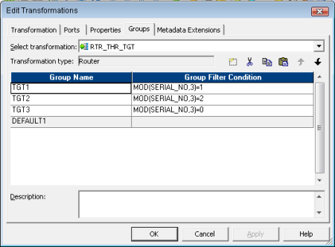

Loading Multiple Flat Files using one mapping

Scenario
Suppose we have ten source flat files of same structure. How can we load all the files in target database in a single batch run using a single mapping.

Answer
After we create a mapping to load data in target database from flat files, next we move on to the session property of the Source Qualifier. To load a set of source files we need to create a file say final.txt containing the source falt file names, ten files in our case and set the Source filetype option as Indirect. Next point this flat file final.txt fully qualified throughSource file directory and Source filename.
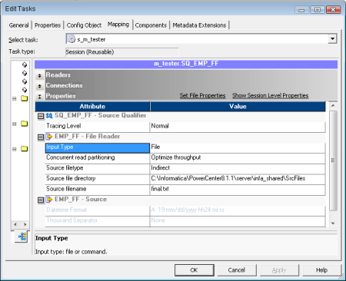

Aggregator Transformation Related Questions

How can we implement Aggregation operation without using an Aggregator Transformation in Informatica?

Answer
We will use the very basic concept of the Expression Transformation that at a time we can access the previous row data as well as the currently processed data in an expression transformation. What we need is simple Sorter, Expression and Filter transformation to achieve aggregation at Informatica level.
For detailed understanding visit Aggregation without Aggregator

Scenario
Suppose in our Source Table we have data as given below:
Student Name | Subject Name | Marks
Sam | Maths | 100
Tom | Maths | 80
Sam | Physical Science | 80
John | Maths | 75
Sam | Life Science | 70
John | Life Science | 100
John | Physical Science | 85
Tom | Life Science | 100
Tom | Physical Science | 85
We want to load our Target Table as:
Student Name | Maths | Life Science | Physical Science
Sam | 100 | 70 | 80
John | 75 | 100 | 85
Tom | 80 | 100 | 85
Describe your approach.

Answer
Here our scenario is to convert many rows to one rows, and the transformation which will help us to achieve this isAggregator.
Our Mapping will look like this:
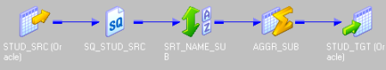
We will sort the source data based on STUDENT_NAME ascending followed by SUBJECT ascending.
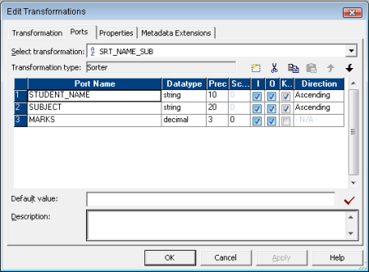
Now based on STUDENT_NAME in GROUP BY clause the following output subject columns are populated as
- MATHS: MAX(MARKS, SUBJECT=Maths)
- LIFE_SC: MAX(MARKS, SUBJECT=Life Science)
- PHY_SC: MAX(MARKS, SUBJECT=Physical Science)
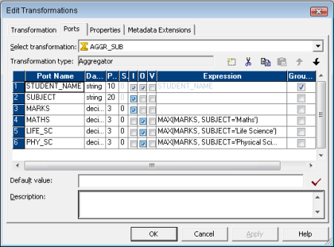

Revisiting Source Qualifier Transformation

What is a Source Qualifier? What are the tasks we can perform using a SQ and why it is an ACTIVE transformation?
Ans. A Source Qualifier is an Active and Connected Informatica transformation that reads the rows from a relational database or flat file source.
- We can configure the SQ to join [Both INNER as well as OUTER JOIN] data originating from the same source database.
- We can use a source filter to reduce the number of rows the Integration Service queries.
- We can specify a number for sorted ports and the Integration Service adds an ORDER BY clause to the default SQL query.
- We can choose Select Distinctoption for relational databases and the Integration Service adds a SELECT DISTINCT clause to the default SQL query.
- Also we can write Custom/Used Defined SQL query which will override the default query in the SQ by changing the default settings of the transformation properties.
- Also we have the option to write Pre as well as Post SQL statements to be executed before and after the SQ query in the source database.
Since the transformation provides us with the property Select Distinct, when the Integration Service adds a SELECT DISTINCT clause to the default SQL query, which in turn affects the number of rows returned by the Database to the Integration Service and hence it is an Active transformation.

What happens to a mapping if we alter the datatypes between Source and its corresponding Source Qualifier?
Ans. The Source Qualifier transformation displays the transformation datatypes. The transformation datatypes determine how the source database binds data when the Integration Service reads it.
Now if we alter the datatypes in the Source Qualifier transformation or the datatypes in the source definition and Source Qualifier transformation do not match, the Designer marks the mapping as invalid when we save it.

Suppose we have used the Select Distinct and the Number Of Sorted Ports property in the SQ and then we add Custom SQL Query. Explain what will happen.
Ans. Whenever we add Custom SQL or SQL override query it overrides the User-Defined Join, Source Filter, Number of Sorted Ports, and Select Distinct settings in the Source Qualifier transformation. Hence only the user defined SQL Query will be fired in the database and all the other options will be ignored .

Describe the situations where we will use the Source Filter, Select Distinct and Number Of Sorted Ports properties of Source Qualifier transformation.
Ans. Source Filter option is used basically to reduce the number of rows the Integration Service queries so as to improve performance.
Select Distinct option is used when we want the Integration Service to select unique values from a source, filtering out unnecessary data earlier in the data flow, which might improve performance.
Number Of Sorted Ports option is used when we want the source data to be in a sorted fashion so as to use the same in some following transformations like Aggregator or Joiner, those when configured for sorted input will improve the performance.

What will happen if the SELECT list COLUMNS in the Custom override SQL Query and the OUTPUT PORTS order in SQ transformation do not match?
Ans. Mismatch or Changing the order of the list of selected columns to that of the connected transformation output ports may result is session failure.

What happens if in the Source Filter property of SQ transformation we include keyword WHERE say, WHERE CUSTOMERS.CUSTOMER_ID > 1000.
Ans. We use source filter to reduce the number of source records. If we include the string WHERE in the source filter, the Integration Service fails the session.

Describe the scenarios where we go for Joiner transformation instead of Source Qualifier transformation.
Ans. While joining Source Data of heterogeneous sources as well as to join flat files we will use the Joiner transformation. Use the Joiner transformation when we need to join the following types of sources:
- Join data from different Relational Databases.
- Join data from different Flat Files.
- Join relational sources and flat files.

What is the maximum number we can use in Number Of Sorted Ports for Sybase source system.
Ans. Sybase supports a maximum of 16 columns in an ORDER BY clause. So if the source is Sybase, do not sort more than 16 columns.

Suppose we have two Source Qualifier transformations SQ1 and SQ2 connected to Target tables TGT1 and TGT2 respectively. How do you ensure TGT2 is loaded after TGT1?
Ans. If we have multiple Source Qualifier transformations connected to multiple targets, we can designate the order in which the Integration Service loads data into the targets.
In the Mapping Designer, We need to configure the Target Load Plan based on the Source Qualifier transformations in a mapping to specify the required loading order.
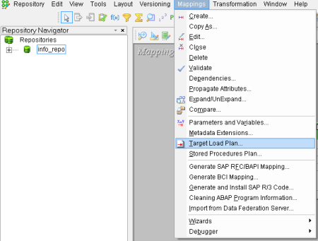
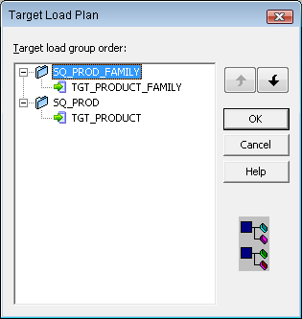

Suppose we have a Source Qualifier transformation that populates two target tables. How do you ensure TGT2 is loaded after TGT1?
Ans. In the Workflow Manager, we can Configure Constraint based load ordering for a session. The Integration Service orders the target load on a row-by-row basis. For every row generated by an active source, the Integration Service loads the corresponding transformed row first to the primary key table, then to the foreign key table.
Hence if we have one Source Qualifier transformation that provides data for multiple target tables having primary and foreign key relationships, we will go for Constraint based load ordering.
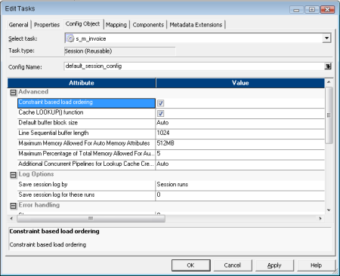

Revisiting Filter Transformation
Q19. What is a Filter Transformation and why it is an Active one?
Ans. A Filter transformation is an Active and Connected transformation that can filter rows in a mapping.
Only the rows that meet the Filter Condition pass through the Filter transformation to the next transformation in the pipeline. TRUE and FALSE are the implicit return values from any filter condition we set. If the filter condition evaluates to NULL, the row is assumed to be FALSE.
The numeric equivalent of FALSE is zero (0) and any non-zero value is the equivalent of TRUE.
As an ACTIVE transformation, the Filter transformation may change the number of rows passed through it. A filter condition returns TRUE or FALSE for each row that passes through the transformation, depending on whether a row meets the specified condition. Only rows that return TRUE pass through this transformation. Discarded rows do not appear in the session log or reject files.
Q20. What is the difference between Source Qualifier transformations Source Filter to Filter transformation?
Ans.
SQ Source Filter | Filter Transformation
Source Qualifier transformation filters rows when read from a source. | Filter transformation filters rows from within a mapping
Source Qualifier transformation can only filter rows from Relational Sources. | Filter transformation filters rows coming from any type of source system in the mapping level.
Source Qualifier limits the row set extracted from a source. | Filter transformation limits the row set sent to a target.
Source Qualifier reduces the number of rows used throughout the mapping and hence it provides better performance. | To maximize session performance, include the Filter transformation as close to the sources in the mapping as possible to filter out unwanted data early in the flow of data from sources to targets.
The filter condition in the Source Qualifier transformation only uses standard SQL as it runs in the database. | Filter Transformation can define a condition using any statement or transformation function that returns either a TRUE or FALSE value.

Revisiting Joiner Transformation
Q21. What is a Joiner Transformation and why it is an Active one?
Ans. A Joiner is an Active and Connected transformation used to join source data from the same source system or from two related heterogeneous sources residing in different locations or file systems.
The Joiner transformation joins sources with at least one matching column. The Joiner transformation uses a condition that matches one or more pairs of columns between the two sources.
The two input pipelines include a master pipeline and a detail pipeline or a master and a detail branch. The master pipeline ends at the Joiner transformation, while the detail pipeline continues to the target.
In the Joiner transformation, we must configure the transformation properties namely Join Condition, Join Type and Sorted Input option to improve Integration Service performance.
The join condition contains ports from both input sources that must match for the Integration Service to join two rows. Depending on the type of join selected, the Integration Service either adds the row to the result set or discards the row.
The Joiner transformation produces result sets based on the join type, condition, and input data sources. Hence it is an Active transformation.
Q22. State the limitations where we cannot use Joiner in the mapping pipeline.
Ans. The Joiner transformation accepts input from most transformations. However, following are the limitations:
- Joiner transformation cannot be used when either of the input pipeline contains an Update Strategytransformation.
- Joiner transformation cannot be used if we connect a Sequence Generator transformation directly before the Joiner transformation.
Q23. Out of the two input pipelines of a joiner, which one will you set as the master pipeline?
Ans. During a session run, the Integration Service compares each row of the master source against the detail source. The master and detail sources need to be configured for optimal performance.
To improve performance for an Unsorted Joiner transformation, use the source with fewer rows as the master source. The fewer unique rows in the master, the fewer iterations of the join comparison occur, which speeds the join process.
When the Integration Service processes an unsorted Joiner transformation, it reads all master rows before it reads the detail rows. The Integration Service blocks the detail source while it caches rows from the master source. Once the Integration Service reads and caches all master rows, it unblocks the detail source and reads the detail rows.
To improve performance for a Sorted Joiner transformation, use the source with fewer duplicate key values as the master source.
When the Integration Service processes a sorted Joiner transformation, it blocks data based on the mapping configuration and it stores fewer rows in the cache, increasing performance.
Blocking logic is possible if master and detail input to the Joiner transformation originate from different sources. Otherwise, it does not use blocking logic. Instead, it stores more rows in the cache.
Q24. What are the different types of Joins available in Joiner Transformation?
Ans. In SQL, a join is a relational operator that combines data from multiple tables into a single result set. The Joiner transformation is similar to an SQL join except that data can originate from different types of sources.
The Joiner transformation supports the following types of joins :
- Normal
- Master Outer
- Detail Outer
- Full Outer
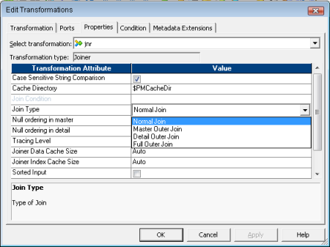
Note: A normal or master outer join performs faster than a full outer or detail outer join.
Q25. Define the various Join Types of Joiner Transformation.
Ans.
- In a normal join , the Integration Service discards all rows of data from the master and detail source that do not match, based on the join condition.
- A master outer join keeps all rows of data from the detail source and the matching rows from the master source. It discards the unmatched rows from the master source.
- A detail outer join keeps all rows of data from the master source and the matching rows from the detail source. It discards the unmatched rows from the detail source.
- A full outer join keeps all rows of data from both the master and detail sources.
Q26. Describe the impact of number of join conditions and join order in a Joiner Transformation.
Ans. We can define one or more conditions based on equality between the specified master and detail sources. Both ports in a condition must have the same datatype.
If we need to use two ports in the join condition with non-matching datatypes we must convert the datatypes so that they match. The Designer validates datatypes in a join condition.
Additional ports in the join condition increases the time necessary to join two sources.
The order of the ports in the join condition can impact the performance of the Joiner transformation. If we use multiple ports in the join condition, the Integration Service compares the ports in the order we specified.
NOTE: Only equality operator is available in joiner join condition.
Q27. How does Joiner transformation treat NULL value matching.
Ans. The Joiner transformation does not match null values.
For example, if both EMP_ID1 and EMP_ID2 contain a row with a null value, the Integration Service does not consider them a match and does not join the two rows.
To join rows with null values, replace null input with default values in the Ports tab of the joiner, and then join on the default values.
Note: If a result set includes fields that do not contain data in either of the sources, the Joiner transformation populates the empty fields with null values. If we know that a field will return a NULL and we do not want to insert NULLs in the target, set a default value on the Ports tab for the corresponding port.
Q28. Suppose we configure Sorter transformations in the master and detail pipelines with the following sorted ports in order: ITEM_NO, ITEM_NAME, PRICE.
When we configure the join condition, what are the guidelines we need to follow to maintain the sort order?
Ans. If we have sorted both the master and detail pipelines in order of the ports say ITEM_NO, ITEM_NAME and PRICE we must ensure that:
- Use ITEM_NO in the First Join Condition.
- If we add a Second Join Condition, we must use ITEM_NAME.
- If we want to use PRICE as a Join Condition apart from ITEM_NO, we must also use ITEM_NAME in the Second Join Condition.
- If we skip ITEM_NAME and join on ITEM_NO and PRICE, we will lose the input sort order and the Integration Service fails the session.
Q29. What are the transformations that cannot be placed between the sort origin and the Joiner transformation so that we do not lose the input sort order.
Ans. The best option is to place the Joiner transformation directly after the sort origin to maintain sorted data. However do not place any of the following transformations between the sort origin and the Joiner transformation:
- Custom
- UnsortedAggregator
- Normalizer
- Rank
- Union transformation
- XML Parser transformation
- XML Generator transformation
- Mapplet [if it contains any one of the above mentioned transformations]
Q30. Suppose we have the EMP table as our source. In the target we want to view those employees whose salary is greater than or equal to the average salary for their departments. Describe your mapping approach.
Ans. Our Mapping will look like this:
ahref="http://png.dwbiconcepts.com/images/tutorial/info_interview/info_interview10.png" 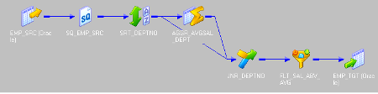
To start with the mapping we need the following transformations:
After the Source qualifier of the EMP table place a Sorter Transformation . Sort based on DEPTNOport.
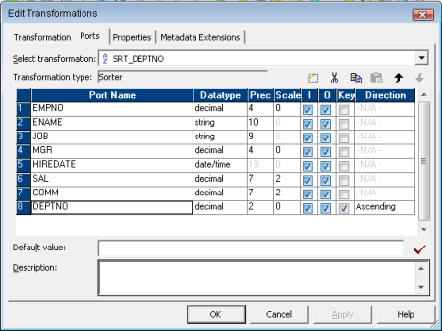
Next we place a Sorted Aggregator Transformation. Here we will find out the AVERAGE SALARY for each (GROUP BY)DEPTNO.
When we perform this aggregation, we lose the data for individual employees.
To maintain employee data, we must pass a branch of the pipeline to the Aggregator Transformation and pass a branch with the same sorted source data to the Joiner transformation to maintain the original data.
When we join both branches of the pipeline, we join the aggregated data with the original data.
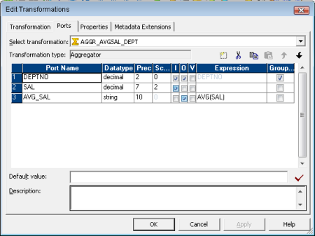
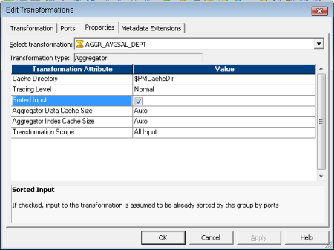
So next we need Sorted Joiner Transformation to join the sorted aggregated data with the original data, based onDEPTNO. Here we will be taking the aggregated pipeline as the Master and original dataflow as Detail Pipeline.
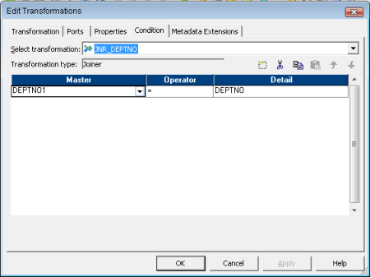
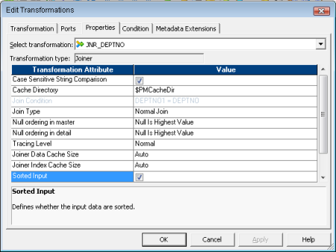
After that we need a Filter Transformation to filter out the employees having salary less than average salary for their department.
Filter Condition: SAL>=AVG_SAL
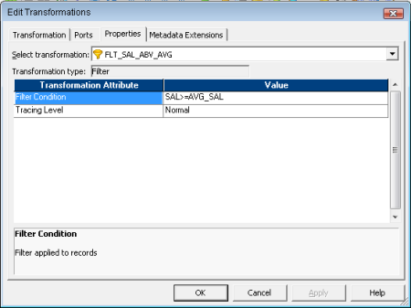
Lastly we have the Target table instance.

Revisiting Sequence Generator Transformation
Q31. What is a Sequence Generator Transformation?
Ans. A Sequence Generator transformation is a Passive and Connected transformation that generates numeric values. It is used to create unique primary key values, replace missing primary keys, or cycle through a sequential range of numbers. This transformation by default contains ONLY Two OUTPUT ports namely CURRVAL and NEXTVAL. We cannot edit or delete these ports neither we cannot add ports to this unique transformation. We can create approximately two billion unique numeric values with the widest range from 1 to 2147483647.
Q32. Define the Properties available in Sequence Generator transformation in brief.
Ans.
Sequence Generator Properties | Description
Start Value | Start value of the generated sequence that we want the Integration Service to use if we use the Cycle option. If we select Cycle, the Integration Service cycles back to this value when it reaches the end value. Default is 0.
Increment By | Difference between two consecutive values from the NEXTVAL port.Default is 1.
End Value | Maximum value generated by SeqGen. After reaching this value the session will fail if the sequence generator is not configured to cycle.Default is 2147483647.
Current Value | Current value of the sequence. Enter the value we want the Integration Service to use as the first value in the sequence. Default is 1.
Cycle | If selected, when the Integration Service reaches the configured end value for the sequence, it wraps around and starts the cycle again, beginning with the configured Start Value.
Number of Cached Values | Number of sequential values the Integration Service caches at a time. Default value for a standard Sequence Generator is 0. Default value for a reusable Sequence Generator is 1,000.
Reset | Restarts the sequence at the current value each time a session runs.This option is disabled for reusable Sequence Generator transformations.
Q33. Suppose we have a source table populating two target tables. We connect the NEXTVAL port of the Sequence Generator to the surrogate keys of both the target tables.
Will the Surrogate keys in both the target tables be same? If not how can we flow the same sequence values in both of them.
Ans. When we connect the NEXTVAL output port of the Sequence Generator directly to the surrogate key columns of the target tables, the Sequence number will not be the same.
A block of sequence numbers is sent to one target tables surrogate key column. The second targets receives a block of sequence numbers from the Sequence Generator transformation only after the first target table receives the block of sequence numbers.
Suppose we have 5 rows coming from the source, so the targets will have the sequence values as TGT1 (1,2,3,4,5) and TGT2 (6,7,8,9,10). [Taken into consideration Start Value 0, Current value 1 and Increment by 1.
Now suppose the requirement is like that we need to have the same surrogate keys in both the targets.
Then the easiest way to handle the situation is to put an Expression Transformation in between the Sequence Generator and the Target tables. The SeqGen will pass unique values to the expression transformation, and then the rows are routed from the expression transformation to the targets.
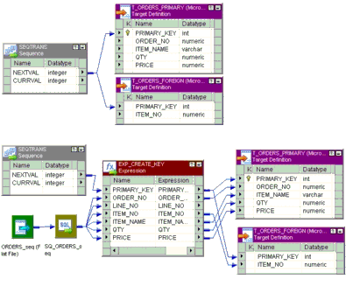
Q34. Suppose we have 100 records coming from the source. Now for a target column population we used a Sequence generator.
Suppose the Current Value is 0 and End Value of Sequence generator is set to 80. What will happen?
Ans. End Value is the maximum value the Sequence Generator will generate. After it reaches the End value the session fails with the following error message:
TT_11009 Sequence Generator Transformation: Overflow error.
Failing of session can be handled if the Sequence Generator is configured to Cycle through the sequence, i.e. whenever the Integration Service reaches the configured end value for the sequence, it wraps around and starts the cycle again, beginning with the configured Start Value.
Q35. What are the changes we observe when we promote a non resuable Sequence Generator to a resuable one? And what happens if we set the Number of Cached Values to 0 for a reusable transformation?
Ans. When we convert a non reusable sequence generator to resuable one we observe that the Number of Cached Valuesis set to 1000 by default; And the Reset property is disabled.
When we try to set the Number of Cached Values property of a Reusable Sequence Generator to 0 in the Transformation Developer we encounter the following error message:
The number of cached values must be greater than zero for reusable sequence transformation.

Revisiting Aggregator Transformation
Q36. What is an Aggregator Transformation?
Ans. An aggregator is an Active, Connected transformation which performs aggregate calculations like AVG, COUNT, FIRST,LAST, MAX, MEDIAN, MIN, PERCENTILE, STDDEV, SUM and VARIANCE.
Q37. How an Expression Transformation differs from Aggregator Transformation?
Ans. An Expression Transformation performs calculation on a row-by-row basis. An Aggregator Transformation performs calculations on groups.
Q38. Does an Informatica Transformation support only Aggregate expressions?
Ans. Apart from aggregate expressions Informatica Aggregator also supports non-aggregate expressions and conditional clauses.
Q39. How does Aggregator Transformation handle NULL values?
Ans. By default, the aggregator transformation treats null values as NULL in aggregate functions. But we can specify to treat null values in aggregate functions as NULL or zero.
Q40. What is Incremental Aggregation?
Ans. We can enable the session option, Incremental Aggregation for a session that includes an Aggregator Transformation. When the Integration Service performs incremental aggregation, it actually passes changed source data through the mapping and uses the historical cache data to perform aggregate calculations incrementally.
For reference check Implementing Informatica Incremental Aggregation
Q41. What are the performance considerations when working with Aggregator Transformation?
Ans.
- Filter the unnecessary data before aggregating it. Place a Filter transformation in the mapping before the Aggregator transformation to reduce unnecessary aggregation.
- Improve performance by connecting only the necessary input/output ports to subsequent transformations, thereby reducing the size of the data cache.
- Use Sorted input which reduces the amount of data cached and improves session performance.
Q42. What differs when we choose Sorted Input for Aggregator Transformation?
Ans. Integration Service creates the index and data caches files in memory to process the Aggregator transformation. If the Integration Service requires more space as allocated for the index and data cache sizes in the transformation properties, it stores overflow values in cache files i.e. paging to disk. One way to increase session performance is to increase the index and data cache sizes in the transformation properties. But when we check Sorted Input the Integration Service uses memory to process an Aggregator transformation it does not use cache files.
Q43. Under what conditions selecting Sorted Input in aggregator will still not boost session performance?
Ans.
- Incremental Aggregation, session option is enabled.
- The aggregate expression contains nested aggregate functions.
- Source data is data driven.
Q44. Under what condition selecting Sorted Input in aggregator may fail the session?
Ans.
- If the input data is not sorted correctly, the session will fail.
- Also if the input data is properly sorted, the session may fail if the sort order by ports and the group by ports of the aggregator are not in the same order.
Q45. Suppose we do not group by on any ports of the aggregator what will be the output.
Ans. If we do not group values, the Integration Service will return only the last row for the input rows.
Q46. What is the expected value if the column in an aggregator transform is neither a group by nor an aggregate expression?
Ans. Integration Service produces one row for each group based on the group by ports. The columns which are neither part of the key nor aggregate expression will return the corresponding value of last record of the group received. However, if we specify particularly the FIRST function, the Integration Service then returns the value of the specified first row of the group. So default is the LAST function.
Q47. Give one example for each of Conditional Aggregation, Non-Aggregate expression and Nested Aggregation.
Ans.
Use conditional clauses in the aggregate expression to reduce the number of rows used in the aggregation. The conditional clause can be any clause that evaluates to TRUE or FALSE.
SUM( SALARY, JOB = CLERK )
Use non-aggregate expressions in group by ports to modify or replace groups.
IIF( PRODUCT = Brown Bread, Bread, PRODUCT )
The expression can also include one aggregate function within another aggregate function, such as:
MAX( COUNT( PRODUCT ))

Revisiting Rank Transformation
Q48. What is a Rank Transform?
Ans. Rank is an Active Connected Informatica transformation used to select a set of top or bottom values of data.
Q49. How does a Rank Transform differ from Aggregator Transform functions MAX and MIN?
Ans. Like the Aggregator transformation, the Rank transformation lets us group information. The Rank Transform allows us to select a group of top or bottom values, not just one value as in case of Aggregator MAX, MIN functions.
Q50. What is a RANK port and RANKINDEX?
Ans. Rank port is an input/output port use to specify the column for which we want to rank the source values. By default Informatica creates an output port RANKINDEX for each Rank transformation. It stores the ranking position for each row in a group.
Q51. How can you get ranks based on different groups?
Ans. Rank transformation lets us group information. We can configure one of its input/output ports as a group by port. For each unique value in the group port, the transformation creates a group of rows falling within the rank definition (top or bottom, and a particular number in each rank).
Q52. What happens if two rank values match?
Ans. If two rank values match, they receive the same value in the rank index and the transformation skips the next value.
Q53. What are the restrictions of Rank Transformation?
Ans.
- We can connect ports from only one transformation to the Rank transformation.
- We can select the top or bottom rank.
- We need to select the Number of records in each rank.
- We can designate only one Rank port in a Rank transformation.
Q54. How does a Rank Cache works?
Ans. During a session, the Integration Service compares an input row with rows in the data cache. If the input row out-ranks a cached row, the Integration Service replaces the cached row with the input row. If we configure the Rank transformation to rank based on different groups, the Integration Service ranks incrementally for each group it finds. The Integration Service creates an index cache to stores the group information and data cache for the row data.
Q55. How does Rank transformation handle string values?
Ans. Rank transformation can return the strings at the top or the bottom of a session sort order. When the Integration Service runs in Unicode mode, it sorts character data in the session using the selected sort order associated with the Code Page of IS which may be French, German, etc. When the Integration Service runs in ASCII mode, it ignores this setting and uses a binary sort order to sort character data.

Revisiting Sorter Transformation
Q56. What is a Sorter Transformation?
Ans. Sorter Transformation is an Active, Connected Informatica transformation used to sort data in ascending or descending order according to specified sort keys. The Sorter transformation contains only input/output ports.
Q57. Why is Sorter an Active Transformation?
Ans. When the Sorter transformation is configured to treat output rows as distinct, it assigns all ports as part of the sort key. The Integration Service discards duplicate rows compared during the sort operation. The number of Input Rows will vary as compared with the Output rows and hence it is an Active transformation.
Q58. How does Sorter handle Case Sensitive sorting?
Ans. The Case Sensitive property determines whether the Integration Service considers case when sorting data. When we enable the Case Sensitive property, the Integration Service sorts uppercase characters higher than lowercase characters.
Q59. How does Sorter handle NULL values?
Ans. We can configure the way the Sorter transformation treats null values. Enable the property Null Treated Low if we want to treat null values as lower than any other value when it performs the sort operation. Disable this option if we want the Integration Service to treat null values as higher than any other value.
Q60. How does a Sorter Cache works?
Ans. The Integration Service passes all incoming data into the Sorter Cache before Sorter transformation performs the sort operation.
The Integration Service uses the Sorter Cache Size property to determine the maximum amount of memory it can allocate to perform the sort operation. If it cannot allocate enough memory, the Integration Service fails the session. For best performance, configure Sorter cache size with a value less than or equal to the amount of available physical RAM on the Integration Service machine.
If the amount of incoming data is greater than the amount of Sorter cache size, the Integration Service temporarily stores data in the Sorter transformation work directory. The Integration Service requires disk space of at least twice the amount of incoming data when storing data in the work directory.

Revisiting Union Transformation
Q61. What is a Union Transformation?
Ans. The Union transformation is an Active, Connected non-blocking multiple input group transformation use to merge data from multiple pipelines or sources into one pipeline branch. Similar to the UNION ALL SQL statement, the Union transformation does not remove duplicate rows.
Q62. What are the restrictions of Union Transformation?
Ans.
- All input groups and the output group must have matching ports. The precision, datatype, and scale must be identical across all groups.
- We can create multiple input groups, but only one default output group.
- The Union transformation does not remove duplicate rows.
- We cannot use a Sequence Generator or Update Strategy transformation upstream from a Union transformation.
- The Union transformation does not generate transactions.

General questions
Q63. What is the difference between Static and Dynamic Lookup Cache?
Ans. We can configure a Lookup transformation to cache the corresponding lookup table. In case of static or read-only lookup cache the Integration Service caches the lookup table at the beginning of the session and does not update the lookup cache while it processes the Lookup transformation.
In case of dynamic lookup cache the Integration Service dynamically inserts or updates data in the lookup cache and passes the data to the target. The dynamic cache is synchronized with the target.
Q64. What is Persistent Lookup Cache?
Ans. Lookups are cached by default in Informatica. Lookup cache can be either non-persistent or persistent. The Integration Service saves or deletes lookup cache files after a successful session run based on whether the Lookup cache is checked as persistent or not.
Q65. What is the difference between Reusable transformation and Mapplet?
Ans. Any Informatica Transformation created in the in the Transformation Developer or a non-reusable promoted to reusable transformation from the mapping designer which can be used in multiple mappings is known as Reusable Transformation. When we add a reusable transformation to a mapping, we actually add an instance of the transformation. Since the instance of a reusable transformation is a pointer to that transformation, when we change the transformation in the Transformation Developer, its instances reflect these changes.
A Mapplet is a reusable object created in the Mapplet Designer which contains a set of transformations and lets us reuse the transformation logic in multiple mappings. A Mapplet can contain as many transformations as we need. Like a reusable transformation when we use a mapplet in a mapping, we use an instance of the mapplet and any change made to the mapplet is inherited by all instances of the mapplet.
Q66. What are the transformations that are not supported in Mapplet?
Ans. Normalizer, Cobol sources, XML sources, XML Source Qualifier transformations, Target definitions, Pre- and post- session Stored Procedures, Other Mapplets.
Q67. What are the ERROR tables present in Informatica?
Ans.
- PMERR_DATA- Stores data and metadata about a transformation row error and its corresponding source row.
- PMERR_MSG- Stores metadata about an error and the error message.
- PMERR_SESS- Stores metadata about the session.
- PMERR_TRANS- Stores metadata about the source and transformation ports, such as name and datatype, when a transformation error occurs.
Q68. What is the difference between STOP and ABORT?
Ans. When we issue the STOP command on the executing session task, the Integration Service stops reading data from source. It continues processing, writing and committing the data to targets. If the Integration Service cannot finish processing and committing data, we can issue the abort command.
In contrast ABORT command has a timeout period of 60 seconds. If the Integration Service cannot finish processing and committing data within the timeout period, it kills the DTM process and terminates the session.
Q69. Can we copy a session to new folder or new repository?
Ans. Yes we can copy session to new folder or repository provided the corresponding Mapping is already in there.
Q70. What type of join does Lookup support?
Ans. Lookup is just similar like SQL LEFT OUTER JOIN.

Tuning Aggregator Transformation
If you have to do the aggregation using Informatica aggregator, then ensure that all the columns used in the group by are sorted in the same order of group by and “Sorted Input” option is checked in the aggregator properties. Ensuring the input data is sorted is absolutely must in order to achieve better performance and we will soon know why.

Tuning JOINER Transformation
However, if you have to use the joiner transformation, following are the additional points/actions that you must consider:
- When joining between two data sources, treat the data source containing less number of records as Master. This is because the Cache size of the Joiner transformation depends on master data (unless sorted input with the same source is used).
- Ensure that both the master and detail input sources are sorted and both “Sorted Input” and “Master Sort Order” ports are checked and set
- Consider using cache partitioning for Joiner transformation if you have partition option available under your Informatica license. More details on this topic later
- Check if the Data and Index cache sizes can be configured. More details on this next

