JAVA

- Java SE 21 Developer Professional (1Z0-830)

NA

2. Exam 1Z0-829: Java SE 17 Developer

Handling date, time, text, numeric and boolean values
- Use primitives and wrapper classes including Math API, parentheses, type promotion, and casting to evaluate arithmetic and boolean expressions
- Manipulate text, including text blocks, using String and StringBuilder classes
- Manipulate date, time, duration, period, instant and time-zone objects using Date-Time API
Controlling Program Flow
- Create program flow control constructs including if/else, switch statements and expressions, loops, and break and continue statements
Utilizing Java Object-Oriented Approach
- Declare and instantiate Java objects including nested class objects, and explain the object life-cycle including creation, reassigning references, and garbage collection
- Create classes and records, and define and use instance and static fields and methods, constructors, and instance and static initializers
- Implement overloading, including var-arg methods
- Understand variable scopes, use local variable type inference, apply encapsulation, and make objects immutable
- Implement inheritance, including abstract and sealed classes. Override methods, including that of Object class. Implement polymorphism and differentiate object type versus reference type. Perform type casting, identify object types using instanceof operator and pattern matching
- Create and use interfaces, identify functional interfaces, and utilize private, static, and default interface methods
- Create and use enumerations with fields, methods and constructors
Handling Exceptions
- Handle exceptions using try/catch/finally, try-with-resources, and multi-catch blocks, including custom exceptions
Working with Arrays and Collections
- Create Java arrays, List, Set, Map, and Deque collections, and add, remove, update, retrieve and sort their elements
Working with Streams and Lambda expressions
- Use Java object and primitive Streams, including lambda expressions implementing functional interfaces, to supply, filter, map, consume, and sort data
- Perform decomposition, concatenation and reduction, and grouping and partitioning on sequential and parallel streams
Packaging and deploying Java code and use the Java Platform Module System
- Define modules and their dependencies, expose module content including for reflection. Define services, producers, and consumers
- Compile Java code, produce modular and non-modular jars, runtime images, and implement migration using unnamed and automatic modules
Managing concurrent code execution
- Create worker threads using Runnable and Callable, manage the thread lifecycle, including automations provided by different Executor services and concurrent API
- Develop thread-safe code, using different locking mechanisms and concurrent API
- Process Java collections concurrently including the use of parallel streams
Using Java I/O API
- Read and write console and file data using I/O Streams
- Serialize and de-serialize Java objects
- Create, traverse, read, and write Path objects and their properties using java.nio.file API
Accessing databases using JDBC
- Create connections, create and execute basic, prepared and callable statements, process query results and control transactions using JDBC API
Implementing Localization
- Implement localization using locales, resource bundles, parse and format messages, dates, times, and numbers including currency and percentage values
Assume the following:
- Missing package and import statements: If sample code do not include package or import statements, and the question does not explicitly refer to these missing statements, then assume that all sample code is in the same package, or import statements exist to support them.
- No file or directory path names for classes: If a question does not state the file names or directory locations of classes, then assume one of the following, whichever will enable the code to compile and run:
  - All classes are in one file
  - Each class is contained in a separate file, and all files are in one directory
- Unintended line breaks: Sample code might have unintended line breaks. If you see a line of code that looks like it has wrapped, and this creates a situation where the wrapping is significant (for example, a quoted String literal has wrapped), assume that the wrapping is an extension of the same line, and the line does not contain a hard carriage return that would cause a compilation failure.
- Code fragments: A code fragment is a small section of source code presented without its context. Assume that all necessary supporting code exists and that the supporting environment fully supports the correct compilation and execution of the code shown and its omitted environment.
- Descriptive comments: Take descriptive comments, such as "setter and getters go here," at face value. Assume that correct code exists, compiles, and runs successfully to create the described effect.
Candidates are also expected to:
- Understand the basics of Java Logging API.
- Use Annotations such as Override, Functionallnterface, Deprecated, SuppressWarnings, and SafeVarargs.
- Use generics, including wildcards.

Exam 1Z0-819: Java SE 11 Developer

Java Basics
- Define the scope of variables
- Define the structure of a Java class
- Create executable Java applications with a main method; run a Java program from the command line; produce console output
- Import other Java packages to make them accessible in your code
- Compare and contrast the features and components of Java such as: platform independence, object orientation, encapsulation, etc.
Working With Java Data Types
- Declare and initialize variables (including casting of primitive data types)
- Differentiate between object reference variables and primitive variables
- Know how to read or write to object fields
- Explain an Object's Lifecycle (creation, "dereference by reassignment" and garbage collection)
- Develop code that uses wrapper classes such as Boolean, Double, and Integer
Using Operators and Decision Constructs
- Use Java operators; use parentheses to override operator precedence
- Test equality between Strings and other objects using == and equals ()
- Create if and if/else and ternary constructs
- Use a switch statement
Creating and Using Arrays
- Declare, instantiate, initialize and use a one-dimensional array
- Declare, instantiate, initialize and use multi-dimensional arrays
Using Loop Constructs
- Create and use while loops
- Create and use for loops including the enhanced for loop
- Create and use do/while loops
- Compare loop constructs
- Use break and continue
Working with Methods and Encapsulation
- Create methods with arguments and return values; including overloaded methods
- Apply the static keyword to methods and fields
- Create and overload constructors; differentiate between default and user defined constructors
- Apply access modifiers
- Apply encapsulation principles to a class
- Determine the effect upon object references and primitive values when they are passed into methods that change the values
Working with Inheritance
- Describe inheritance and its benefits
- Develop code that makes use of polymorphism; develop code that overrides methods; differentiate between the type of a reference and the type of an object
- Determine when casting is necessary
- Use super and this to access objects and constructors
- Use abstract classes and interfaces
Handling Exceptions
- Differentiate among checked exceptions, unchecked exceptions, and Errors
- Create a try-catch block and determine how exceptions alter normal program flow
- Describe the advantages of Exception handling
- Create and invoke a method that throws an exception
- Recognize common exception classes (such as NullPointerException, ArithmeticException, ArrayIndexOutOfBoundsException, ClassCastException)
Working with Selected classes from the Java API
- Manipulate data using the StringBuilder class and its methods
- Create and manipulate Strings
- Create and manipulate calendar data using classes from java.time.LocalDateTime, java.time.LocalDate, java.time.LocalTime, java.time.format.DateTimeFormatter, java.time.Period
- Declare and use an ArrayList of a given type
- Write a simple Lambda expression that consumes a Lambda Predicate expression
Assume the following:
- Missing package and import statements: If sample code do not include package or import statements, and the question does not explicitly refer to these missing statements, then assume that all sample code is in the same package, or import statements exist to support them.
- No file or directory path names for classes: If a question does not state the file names or directory locations of classes, then assume one of the following, whichever will enable the code to compile and run:
  - All classes are in one file
  - Each class is contained in a separate file, and all files are in one directory
- Unintended line breaks: Sample code might have unintended line breaks. If you see a line of code that looks like it has wrapped, and this creates a situation where the wrapping is significant (for example, a quoted String literal has wrapped), assume that the wrapping is an extension of the same line, and the line does not contain a hard carriage return that would cause a compilation failure.
- Code fragments: A code fragment is a small section of source code that is presented without its context. Assume that all necessary supporting code exists and that the supporting environment fully supports the correct compilation and execution of the code shown and its omitted environment.
- Descriptive comments: Take descriptive comments, such as "setter and getters go here," at face value. Assume that correct code exists, compiles, and runs successfully to create the described effect.

Exam 1Z0-808: Java SE 8 Programmer I

Java Basics
- Define the scope of variables
- Define the structure of a Java class
- Create executable Java applications with a main method; run a Java program from the command line; produce console output
- Import other Java packages to make them accessible in your code
- Compare and contrast the features and components of Java such as: platform independence, object orientation, encapsulation, etc.
Working With Java Data Types
- Declare and initialize variables (including casting of primitive data types)
- Differentiate between object reference variables and primitive variables
- Know how to read or write to object fields
- Explain an Object's Lifecycle (creation, "dereference by reassignment" and garbage collection)
- Develop code that uses wrapper classes such as Boolean, Double, and Integer
Using Operators and Decision Constructs
- Use Java operators; use parentheses to override operator precedence
- Test equality between Strings and other objects using == and equals ()
- Create if and if/else and ternary constructs
- Use a switch statement
Creating and Using Arrays
- Declare, instantiate, initialize and use a one-dimensional array
- Declare, instantiate, initialize and use multi-dimensional arrays
Using Loop Constructs
- Create and use while loops
- Create and use for loops including the enhanced for loop
- Create and use do/while loops
- Compare loop constructs
- Use break and continue
Working with Methods and Encapsulation
- Create methods with arguments and return values; including overloaded methods
- Apply the static keyword to methods and fields
- Create and overload constructors; differentiate between default and user defined constructors
- Apply access modifiers
- Apply encapsulation principles to a class
- Determine the effect upon object references and primitive values when they are passed into methods that change the values
Working with Inheritance
- Describe inheritance and its benefits
- Develop code that makes use of polymorphism; develop code that overrides methods; differentiate between the type of a reference and the type of an object
- Determine when casting is necessary
- Use super and this to access objects and constructors
- Use abstract classes and interfaces
Handling Exceptions
- Differentiate among checked exceptions, unchecked exceptions, and Errors
- Create a try-catch block and determine how exceptions alter normal program flow
- Describe the advantages of Exception handling
- Create and invoke a method that throws an exception
- Recognize common exception classes (such as NullPointerException, ArithmeticException, ArrayIndexOutOfBoundsException, ClassCastException)
Working with Selected classes from the Java API
- Manipulate data using the StringBuilder class and its methods
- Create and manipulate Strings
- Create and manipulate calendar data using classes from java.time.LocalDateTime, java.time.LocalDate, java.time.LocalTime, java.time.format.DateTimeFormatter, java.time.Period
- Declare and use an ArrayList of a given type
- Write a simple Lambda expression that consumes a Lambda Predicate expression
Assume the following:
- Missing package and import statements: If sample code do not include package or import statements, and the question does not explicitly refer to these missing statements, then assume that all sample code is in the same package, or import statements exist to support them.
- No file or directory path names for classes: If a question does not state the file names or directory locations of classes, then assume one of the following, whichever will enable the code to compile and run:
  - All classes are in one file
  - Each class is contained in a separate file, and all files are in one directory
- Unintended line breaks: Sample code might have unintended line breaks. If you see a line of code that looks like it has wrapped, and this creates a situation where the wrapping is significant (for example, a quoted String literal has wrapped), assume that the wrapping is an extension of the same line, and the line does not contain a hard carriage return that would cause a compilation failure.
- Code fragments: A code fragment is a small section of source code that is presented without its context. Assume that all necessary supporting code exists and that the supporting environment fully supports the correct compilation and execution of the code shown and its omitted environment.
- Descriptive comments: Take descriptive comments, such as "setter and getters go here," at face value. Assume that correct code exists, compiles, and runs successfully to create the described effect.

  - Exam 1Z0-809: Java SE 8 Programmer II
Java Class Design
- Implement encapsulation
- Implement inheritance including visibility modifiers and composition
- Implement polymorphism
- Override hashCode, equals, and toString methods from Object class
- Create and use singleton classes and immutable classes
- Develop code that uses static keyword on initialize blocks, variables, methods, and classes
Advanced Java Class Design
- Develop code that uses abstract classes and methods
- Develop code that uses the final keyword
- Create inner classes including static inner class, local class, nested class, and anonymous inner class
- Use enumerated types including methods, and constructors in an enum type
- Develop code that declares, implements and/or extends interfaces and use the @Override annotation.
- Create and use Lambda expressions
Generics and Collections
- Create and use a generic class
- Create and use ArrayList, TreeSet, TreeMap, and ArrayDeque objects
- Use java.util.Comparator and java.lang.Comparable interfaces
- Collections Streams and Filters
- Iterate using forEach methods of Streams and List
- Describe Stream interface and Stream pipeline
- Filter a collection by using lambda expressions
- Use method references with Streams
Lambda Built-in Functional Interfaces
- Use the built-in interfaces included in the java.util.function package such as Predicate, Consumer, Function, and Supplier
- Develop code that uses primitive versions of functional interfaces
- Develop code that uses binary versions of functional interfaces
- Develop code that uses the UnaryOperator interface
Java Stream API
- Develop code to extract data from an object using peek() and map() methods including primitive versions of the map() method
- Search for data by using search methods of the Stream classes including findFirst, findAny, anyMatch, allMatch, noneMatch
- Develop code that uses the Optional class
- Develop code that uses Stream data methods and calculation methods
- Sort a collection using Stream API
- Save results to a collection using the collect method and group/partition data using the Collectors class
- Use flatMap() methods in the Stream API
Exceptions and Assertions
- Use try-catch and throw statements
- Use catch, multi-catch, and finally clauses
- Use Autoclose resources with a try-with-resources statement
- Create custom exceptions and Auto-closeable resources
- Test invariants by using assertions
Use Java SE 8 Date/Time API
- Create and manage date-based and time-based events including a combination of date and time into a single object using LocalDate, LocalTime, LocalDateTime, Instant, Period, and Duration
- Work with dates and times across timezones and manage changes resulting from daylight savings including Format date and times values
- Define and create and manage date-based and time-based events using Instant, Period, Duration, and TemporalUnit
Java I/O Fundamentals
- Read and write data from the console
- Use BufferedReader, BufferedWriter, File, FileReader, FileWriter, FileInputStream, FileOutputStream, ObjectOutputStream, ObjectInputStream, and PrintWriter in the java.io package.
Java File I/O (NIO.2)
- Use Path interface to operate on file and directory paths
- Use Files class to check, read, delete, copy, move, manage metadata of a file or directory
- Use Stream API with NIO.2
Java Concurrency
- Create worker threads using Runnable, Callable and use an ExecutorService to concurrently execute tasks
- Identify potential threading problems among deadlock, starvation, livelock, and race conditions
- Use synchronized keyword and java.util.concurrent.atomic package to control the order of thread execution
- Use java.util.concurrent collections and classes including CyclicBarrier and CopyOnWriteArrayList
- Use parallel Fork/Join Framework
- Use parallel Streams including reduction, decomposition, merging processes, pipelines and performance.
Building Database Applications with JDBC
- Describe the interfaces that make up the core of the JDBC API including the Driver, Connection, Statement, and ResultSet interfaces and their relationship to provider implementations
- Identify the components required to connect to a database using the DriverManager class including the JDBC URL
- Submit queries and read results from the database including creating statements, returning result sets, iterating through the results, and properly closing result sets, statements, and connections
Localization
- Read and set the locale by using the Locale object
- Create and read a Properties file
- Build a resource bundle for each locale and load a resource bundle in an application
Assume the following:
- Missing package and import statements: If sample code do not include package or import statements, and the question does not explicitly refer to these missing statements, then assume that all sample code is in the same package, or import statements exist to support them.
- No file or directory path names for classes: If a question does not state the file names or directory locations of classes, then assume one of the following, whichever will enable the code to compile and run:
  - All classes are in one file
  - Each class is contained in a separate file, and all files are in one directory
- Unintended line breaks: Sample code might have unintended line breaks. If you see a line of code that looks like it has wrapped, and this creates a situation where the wrapping is significant (for example, a quoted String literal has wrapped), assume that the wrapping is an extension of the same line, and the line does not contain a hard carriage return that would cause a compilation failure.
- Code fragments: A code fragment is a small section of source code that is presented without its context. Assume that all necessary supporting code exists and that the supporting environment fully supports the correct compilation and execution of the code shown and its omitted environment.
- Descriptive comments: Take descriptive comments, such as "setter and getters go here," at face value. Assume that correct code exists, compiles, and runs successfully to create the described effect.

Exam 1Z0-900: Java EE 7 Application Developer

Understand Java EE Architecture
- Describe Java EE 7 standards, containers, APIs, and services
- Differentiate between application component functionalities as they apply to different tiers and containers, including Java EE Web Container, Business Logic implementation and WebServices
- Create, package and deploy Java EE application
- Demonstrate understanding of Enterprise JavaBeans and CDI beans, their lifecycle and memory scopes
- Demonstrate understanding of the relationship between bean components, annotations, injections, and JNDI
Manage Persistence using JPA Entities and BeanValidation
- Create JPA Entity and Relationship Object-Relational Mappings (ORM)
- Use Entity Manager to perform database operations, transactions and locking with JPA entities
- Handle entity data with conversions, validations, and key generation
- Create and execute JPQL statements
Implement Business Logic by Using EJBs
- Create session EJB components containing synchronous and asynchronous business methods, manage the life cycle container callbacks and use interceptors
- Demonstrate understanding of how to control EJB transactions, distinguish Container Managed (CMT) and Bean Managed (BMT) transactions
- Create EJB timers
Use Java Message Service API
- Describe the Java Message Service (JMS) messaging models and implement Java SE and Java EE message producers and consumers, including Message-Driven beans
- Use transactions with JMS API
Implement SOAP Services by Using JAX-WS and JAXB APIs
- Create SOAP Web Services and Clients using JAX-WS API
- Define Java to XML Schema mappings to marshall and unmarshall Java Objects by using JAXB API

Create Java Web Applications using Servlets
- Create Java Servlets, describe how they are mapped to urls and use HTTP methods
- Handle HTTP headers, parameters, cookies
- Manage servlet life cycle with container callback methods and WebFilters
Create Java Web Applications using JSPs
- Describe JSP life cycle
- Describe JSP syntax, use tag libraries and Expression Language (EL)
- Handle errors using Servlets and Java Server Pages
Implement REST Services using JAX-RS API
- Understand and Apply REST service conventions
- Create REST Services and clients using JAX-RS API
Create Java Applications using WebSockets
- Understand and utilise WebSockets communication style and lifecycle
- Create WebSocket Server and Client Endpoint Handlers using JSR 356 API and JavaScript
- Produce and consume, encode and decode WebSocket messages
Develop Web Applications using JSFs
- Describe JSF arcitecture, lifecycle and navigation
- Understand JSF syntax and use JSF Tag Libraries
- Handle localisation and produce messages
- Use Expression Language (EL) and interact with CDI beans
Secure Java EE 7 Applications
- Describe Java EE declarative and programmatic security and configure authentication using application roles and security constraints and Login Modules
- Describe WebServices security standards
Use CDI Beans
- Create CDI Bean Qualifiers, Producers, Disposers, Interceptors, Events and Stereotypes
Use Concurrency API in Java EE 7 Applications
- Demonstrate understanding of Java Concurrency Utilities and use Managed Executors
Use Batch API in Java EE 7 Applications
- Describe batch jobs using JSL XML documents and JSR 352 API

JAVA Servlet:-

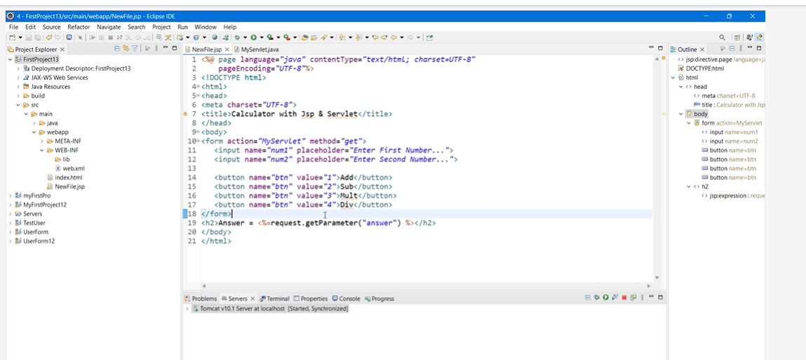

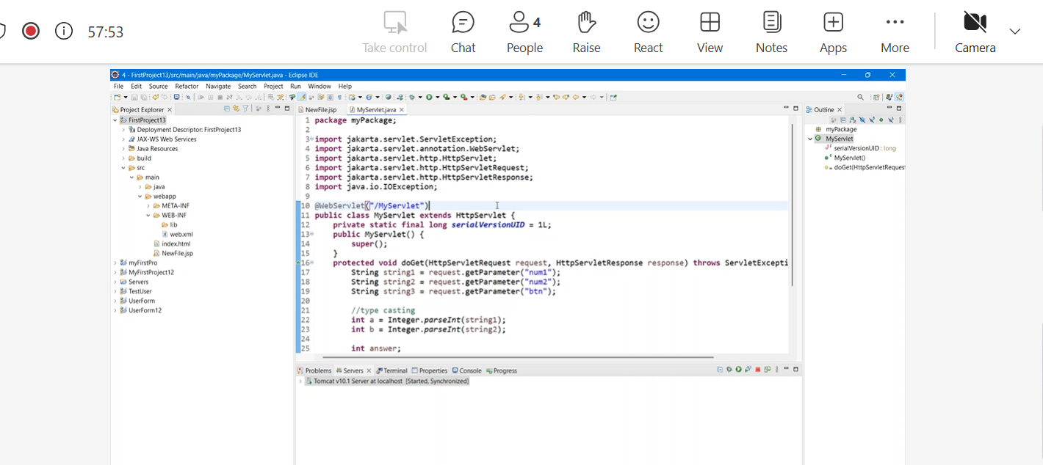

priority-queue-class-in-java - go through few examples

You have the following API:
void push(std::string s);
std::string pop();
bool isEmpty();
Requirements:
- Return the strings by length, shorter strings first.
- If the strings have the same length, return in First In First Out (FIFO) order.

Analysis
- Relatively simple here, the idea is that the candidate should identify that this is a priority queue question.
- The candidate should identify possible ways of implementing a priority queue. One option is to just have a list that we continually choose to resort upon every insertion (kind of expensive, though). The other is with a heap.
- The candidate should be able to identify the time complexity of the various options.
  - For the sorted array we have:
    - Peek: O(1)
    - Enqueue: O(n) <- worse case must move all elements
    - Dequeue: O(n) <- worst case must move all elements
  - For the heap we have:
    - Peek: O(1)
    - Enqueue: O(log(n))
    - Dequeue: O(log(n))

Followup
- If the candidate identified a sorted array as an option, can they also identify heap as an option?
- If the candidate identified heap as an option, can they suggest any optimizations?
  - Heapify is the big one if the elements are available ahead of time, what is the time complexity of heapify? O(n)
- Can the candidate implement change in prioritization after creation?
  - The structure will require allowing ordering function to be passed in.
  - This should use heapify to rapidly resort.
- Are there other implementations of a heap besides the binary heap? Can the candidate walk through the various advantages and disadvantages?

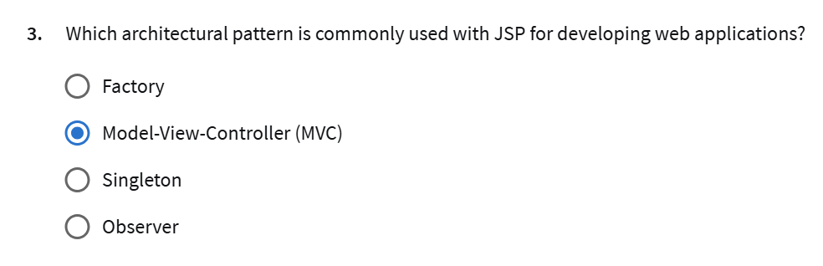

01Week 1:

Session 1: Java Architecture and Basics of OOP
- Introduction to Java architecture: JDK, JRE, and JVM.
- Basics of Object-Oriented Programming (OOP): Objects, Classes, Inheritance.
- Understanding Polymorphism, Abstraction, and Encapsulation in OOP.
- Practical examples illustrating Object-Oriented Programming concepts.
Session 2: Abstract Classes vs. Interfaces, Exception Handling, and Singleton Design Pattern
- Comparison between Abstract Classes and Interfaces with examples and use cases.
- Exception Hierarchy in Java: understanding types and relationships.
- Overview of Finally Block for cleanup operations.
- Throwing Exceptions explicitly using the throw keyword.
- Exception Propagation: how exceptions propagate up the call stack.
- Introduction to Singleton Design Pattern.

02Week 2:
Session 3: Lambda Expressions, Functional Interfaces, and Collections
- Exploring Lambda Expressions and Functional Interfaces in Java 8.
- Practical usage of built-in functional interfaces: Predicate, Consumer, Function.
- Overview of Java Collections framework: Lists, Sets, Maps.
- Introduction to Queues in Java Collections.
- Using Lambdas for concise and functional programming.
Session 4: Generics, Streams and HashMap
- Understanding Generics in Java: generic classes and methods.
- Working with Streams API for functional-style operations on collections.
- Delving into the workings of HashMap and its usage.
- Exploring different hashing algorithms used by HashMap.
- Leveraging Streams for efficient data processing and manipulation.
- Differences between Sequential and Parallel Streams.

03Week 3:
Session 5: Multithreading Basics and Advanced Concepts
- Introduction to Multithreading: Creating and managing threads in Java
- Exploring thread pool and join operations.
- Synchronization Mechanisms
- Exploring thread pools for efficient thread management.
- Executor Service: Overview and Benefits
Session 6: Maven Project Management
- Understanding the Need for Maven
- Working with POM.xml and Maven Repositories
- Maven Lifecycle Management
- Introduction to Maven plugins
- Creating a new Maven project using archetypes

04Week 4:
Session 7: Introduction to Spring Framework
- Overview of the Spring Framework and its Need.
- Dependency Injection (DI) and Inversion of Control (IoC) principles.
- Types of Dependency Injection (constructor and setter)
- Configuring Beans using XML and annotations.
- Differentiates between ApplicationContext and BeanFactory in Spring.
- Bean Lifecycle and Scopes.
Session 8: Spring Boot Basics
- Advantages of Spring Boot over Traditional Spring Framework and its Purpose
- Setting up a Spring Boot project using Spring Initializr.
- Understanding Spring Boot auto-configuration.
- Creating and running a Spring Boot application.
- Spring Boot Annotations.
- Packaging and deploying Spring Boot applications.

05Week 5:
Session 9: Spring MVC Basics & REST API Implementation
- Overview of Spring MVC architecture and its role in web development.
- Understanding the Model, View, and Controller components.
- Setting up a Spring MVC project.
- Handling requests and responses using Spring MVC.
- Principles and benefits of RESTful architecture.
- Overview of HTTP methods: GET, POST, DELETE, PUT, PATCH.
- Designing and implementing RESTful APIs.
Session 10: Spring AOP, Lombok API , and Spring Logger
- Introduction to Aspect-Oriented Programming (AOP).
- Implementing cross-cutting concerns using Spring AOP.
- Using Lombok for Simplified Java Code.
- Integrating Lombok in a Spring Boot Project.
- Overview of logging in Spring Boot applications.

06Week 6:
Session 11: Java Database Connectivity (JDBC)
- Overview of JDBC and its role in database connectivity.
- Learn DDL and DML commands.
- Setting up Database Configuration
- Introduction to Spring JDBC Template for database operations.
- Implementing some operations using the JDBC Template.
- Mapping database rows to Java objects using RowMapper.
- Understand how connection pooling works.
Session 12: Hibernate and Spring Data JPA
- Understanding the Need for Abstraction
- Introduction to JPA (Java Persistence API)
- Introduction to Hibernate
- Entity Classes and Annotations
- JPA Repository and Performing CRUD Operations
- Implementing transactional behavior in Spring Boot applications.
- Learn about relationships in JPA (One-to-One, One-to-Many, Many-to-One, Many-to-Many)

07Week 7:
Session 13: Minor Project - Digital Library
- Work on a Digital Library [Minor Project]
- Setting Up the Project Environment
- Design the technical architecture of an application
- Design a project flowchart to visualize the overall architecture and workflow.
Session 14: Digital Library [Minor Project] (Continued)
- Continue working on the Digital Library [Minor Project]
- Add Features to the Project
- Understand project HLSD
- Data Modeling concepts
08Week 8:
Session 15: Unit Testing with JUnit & Mockito
- Describe JUnit5 testing
- Implement repository layer testing
- Explore the Mockito framework
- Implement service layer testing
- Explore Mockmvc
- Implement controller layer testing
Session 16: Redis & Caching
- Learn the differences between Cache and Cookie.
- Understand Server Cache vs. Browser Cache.
- Get introduced to Redis.
- Work with Local Redis Server.
- Online Centralized Redis Server for efficient caching.
09Week 9:
Session 17: Spring Security & Authentication
- Learn about Spring Security and its terminologies.
- Setting Up Spring Security
- Authentication and Authorization
- Understand Authorization with In-Memory.
- Database user Authentication.
Session 18: Digital Library [Minor Project] (Continued)
- Integration of J-unit and Redis caching in a Minor project.
- Add Spring Security in a Minor project.
- Improvement and feature addition for Digital Library [Minor Project].
- Gain insights into project overview, project HLSD, and project Data Modeling.
10Week 10:
Session 19: OAuth 2 & Github Integration
- Introduction to OAuth2.
- OAuth 2 Providers
- Learn the workflow of OAuth 2.0.
- Explore Scopes and Consent.
- Implement Github OAuth2 integration with Spring Boot.
- Implementation Steps.
Session 20: Microservices
- Difference between Monolith Architecture and Microservices Architecture.
- Develop microservices using Spring Boot.
- Intercommunication between Microservices using Feign client.
- Load Balancing Algorithms and Introduction to Eureka Server
- Learn about the Consumers and Producers Model.
11Week 11:
Session 21: Kafka Integration with Microservices and Spring Cloud
- Learn about Message Queues and their types.
- Integrate Kafka with Spring Boot.
- Introduced to Kafka Message Queue for efficient messaging systems.
- Introduction to Spring Cloud and its configuration & Hystrix circuit breaker.
Session 22: E-Wallet App like Paytm Pay [Major Project Part 1]
- Start working on an E-Wallet App like Paytm Pay.
- Project Overview.
- Project HLSD.
- Project Data Modeling.
- Building Microservice Architecture.
12Week 12:
Session 23: E-Wallet App like Paytm Pay [Major Project Part 2]
- Major Project Continued.
- Design the technical architecture of an application
- Set up Spring Cloud Gateway to route requests to the appropriate microservices.
- Project Queries.
Session 24: Deployment Java Application
- Introduction to the deployment process and its workflow.
- CI/CD: Setting up CI/CD pipelines using Jenkins or GitHub Actions.
- Building and packaging Java applications.
- Deploying our projects to the cloud.
- Monitoring and logging using tools like Prometheus, Grafana, and the ELK stack (Elasticsearch, Logstash, Kibana).

JAVA DI - IOC -
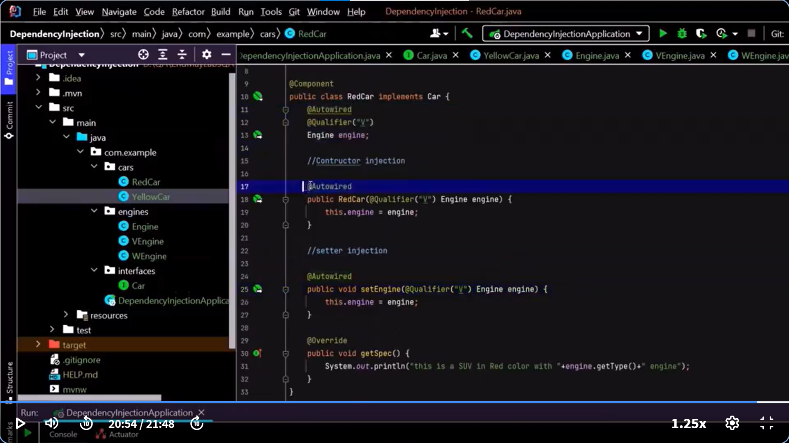

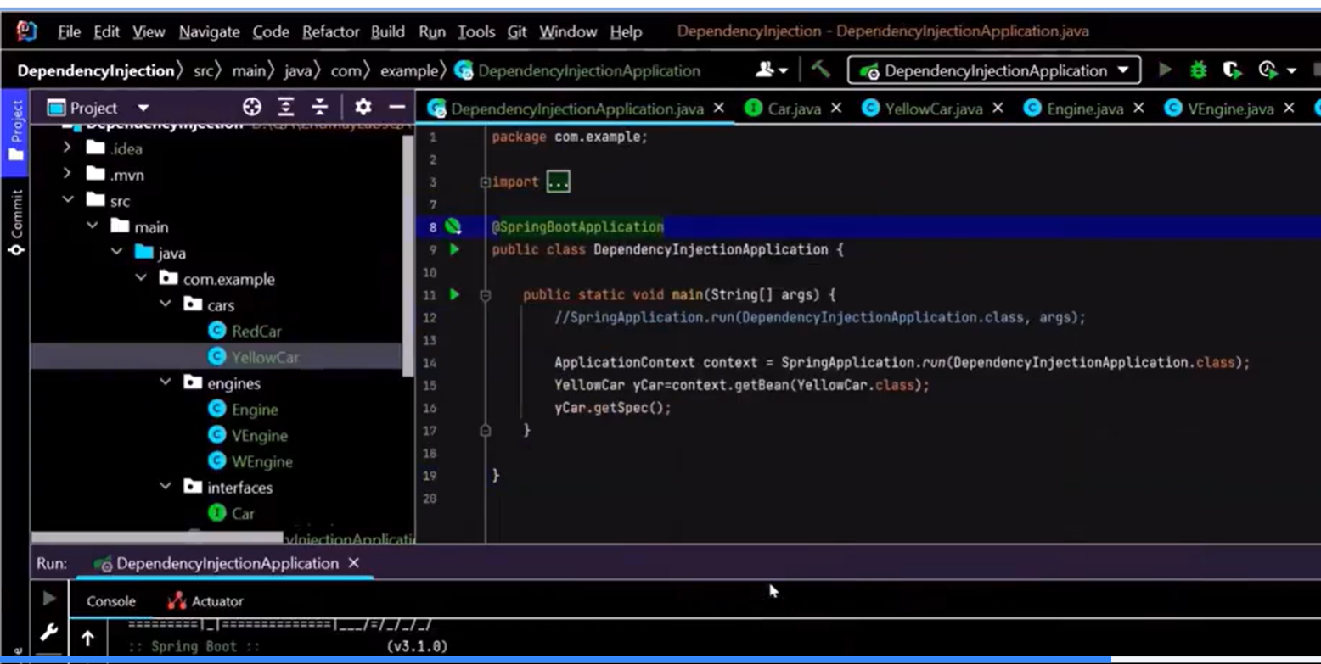

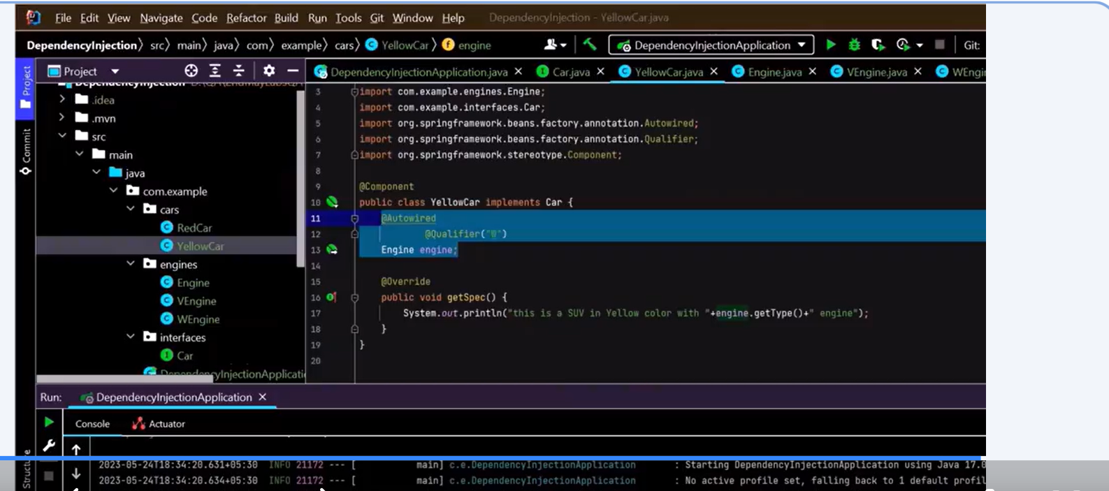

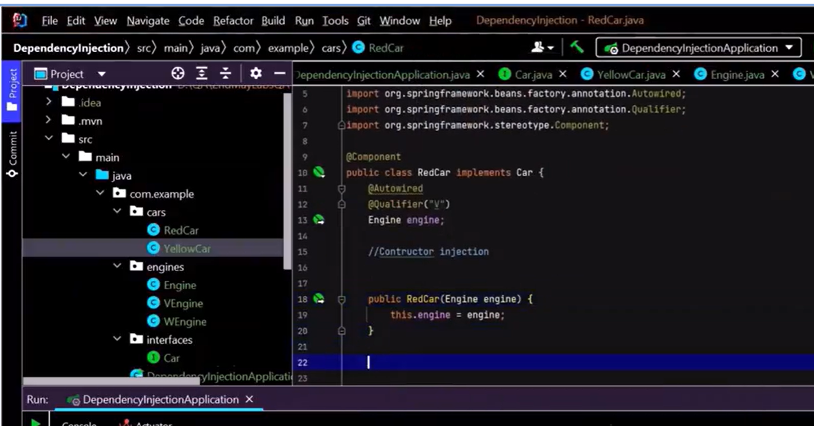

//////////Example in Java (without DI):////////////
class Engine {
public void start() {
System.out.println("Engine started");
}
}

class Car {
Engine engine = new Engine(); // tightly coupled

public void startCar() {
engine.start();
}
}
////Example with DI://////////////////
class Car {
private Engine engine;

// Engine is injected through constructor
public Car(Engine engine) {
this.engine = engine;
}

public void startCar() {
engine.start();
}
}

//////Java (especially using frameworks like Spring), Dependency Injection (DI) can be done in three common ways:////
///1. Constructor-based DI
///Dependencies are passed through the constructor.
@Component
public class Car {
private Engine engine;

// Constructor injection
@Autowired
public Car(Engine engine) {
this.engine = engine;
}

public void start() {
engine.start();
}
}
//2. Setter-based DI
/////Dependencies are set via public setter methods.
@Component
public class Car {
private Engine engine;

public Car() {
// default constructor
}

@Autowired
public void setEngine(Engine engine) {
this.engine = engine;
}

public void start() {
engine.start();
}
}
////3. Field-based DI
///Dependencies are injected directly into the class fields.
@Component
public class Car {

@Autowired
private Engine engine;

public void start() {
engine.start();
}
}

//////Hibernate//////

@Data
@Entity
@Table(name = "employee")
public class EmployeeEntity {

@Id
private Long id;

@Column(name=name)
private String name;

@Column(name=phone)
private String phone;

@Column(name=email)
private String email;
}

Spring:-
Spring Initializer and folder structure/ Starting point:-
Right click run Java
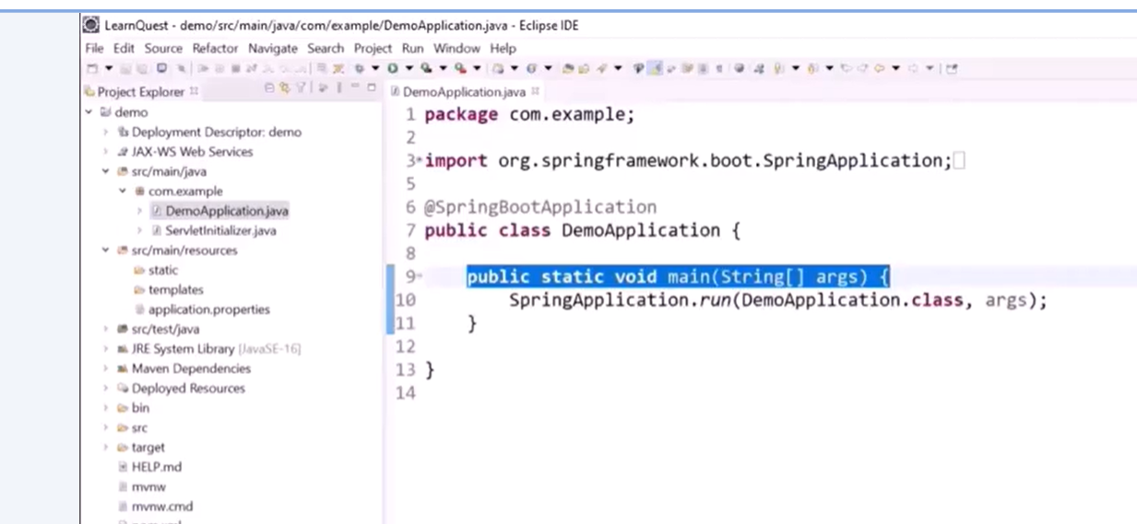

//Example
public class Main {
public static void main(String[] args) {
int myNum = 5; // integer (whole number)
float myFloatNum = 5.99f; // floating point number
char myLetter = 'D'; // character
boolean myBool = true; // boolean
String myText = "Hello"; // String
System.out.println(myNum);
System.out.println(myFloatNum);
System.out.println(myLetter);
System.out.println(myBool);
System.out.println(myText);
}
}

// Create a Main class(Constructor)
public class Main {
int x;

// Create a class constructor for the Main class
public Main() {
x = 5;
}

public static void main(String[] args) {
Main myObj = new Main();
System.out.println(myObj.x);
}
}

// Static and public Methods
public class Main {
// Static method
static void myStaticMethod() {
System.out.println("Static methods can be called without creating objects");
}

// Public method
public void myPublicMethod() {
System.out.println("Public methods must be called by creating objects");
}

// Main method
public static void main(String[] args) {
myStaticMethod(); // Call the static method

Main myObj = new Main(); // Create an object of MyClass
myObj.myPublicMethod(); // Call the public method
}
}

// Abstraction in Java
// abstract class Main.java
abstract class Main {
public String fname = "John";
public int age = 24;
public abstract void study(); // abstract method
}

// Subclass (inherit from Main)
class Student extends Main {
public int graduationYear = 2018;
public void study() { // the body of the abstract method is provided here
System.out.println("Studying all day long");
}
}

//Second Java
class Second {
public static void main(String[] args) {
// create an object of the Student class (which inherits attributes and methods from Main)
Student myObj = new Student();

System.out.println("Name: " + myObj.fname);
System.out.println("Age: " + myObj.age);
System.out.println("Graduation Year: " + myObj.graduationYear);
myObj.study(); // call abstract method
}
}

// MyClass.java //Encapsulation
public class Main {
public static void main(String[] args) {
Person myObj = new Person();
myObj.setName("John");
System.out.println(myObj.getName());
}
}

//Person.java //Encapsulation
public class Person {
private String name; // private variable

// Getter // No void instead string as it's returning name
public String getName() {
return name;
}

// Setter //Void as it isn't returning anything
public void setName(String newName) {
this.name = newName;
}
}

//Java Packages & API // Taking input
import java.util.Scanner; // import the Scanner class

class Main {
public static void main(String[] args) {
Scanner myObj = new Scanner(System.in);
String userName;

// Enter username and press Enter
System.out.println("Enter username");
userName = myObj.nextLine();

System.out.println("Username is: " + userName);
}
}

//Java Interface
interface Animal {
public void animalSound(); // interface method (does not have a body)
public void sleep(); // interface method (does not have a body)
}

class Pig implements Animal {
public void animalSound() {
System.out.println("The pig says: wee wee");
}
public void sleep() {
System.out.println("Zzz");
}
}

class Main {
public static void main(String[] args) {
Pig myPig = new Pig();
myPig.animalSound();
myPig.sleep();
}
}

//Java Interfaces
An interface is a completely "abstract class" that is used to group related methods with empty bodies:
To access the interface methods, the interface must be "implemented" (kinda like inherited) by another class with the implements keyword (instead of extends).
The body of the interface method

interface FirstInterface {
public void myMethod(); // interface method
}
​
interface SecondInterface {
public void myOtherMethod(); // interface method
}
​
// DemoClass "implements" FirstInterface and SecondInterface
class DemoClass implements FirstInterface, SecondInterface {
public void myMethod() {
System.out.println("Some text..");
}
public void myOtherMethod() {
System.out.println("Some other text...");
}
}
​
class Main {
public static void main(String[] args) {
DemoClass myObj = new DemoClass();
myObj.myMethod();
myObj.myOtherMethod();
}
}
​
Some text...
Some other text...

//ArrayList Example
import java.util.ArrayList;

public class Main {
public static void main(String[] args) {
ArrayList<String> cars = new ArrayList<String>();
cars.add("Volvo");
cars.add("BMW");
cars.add("Ford");
cars.add("Mazda");
System.out.println(cars);
}
}

//Arraylist Example
import java.util.ArrayList;

public class Main {
public static void main(String[] args) {
ArrayList<String> cars = new ArrayList<String>();
cars.add("Volvo");
cars.add("BMW");
cars.add("Ford");
cars.add("Mazda");
System.out.println(cars.get(0));
}
}

1. public, private, protected
//These are access modifiers that control the visibility of the method, variable, or class.
//
//Modifier -- Visibility
//public -- Accessible from anywhere (other classes, other packages).
//private -- Only accessible within the same class.
//protected -- Accessible within the same class, subclasses, and the same package.
//(default) -- Accessible within the same package (no keyword //is used for default).

public class Example {
public int a = 10; // Accessible from anywhere
private int b = 20; // Only accessible within this class
protected int c = 30; // Accessible within subclasses or same package
int d = 40; // Default, accessible within the same package

public void showPublic() {
System.out.println("Public Method");
}

private void showPrivate() {
System.out.println("Private Method");
}
}

2. Static

2. static
The static keyword means the member belongs to the class rather than to a specific object.
You can access static methods/variables without creating an instance of the class.

Static Variables: Shared among all objects.
Static Methods: Can only access other static members (variables, methods) of the class. Cannot directly access instance variables or methods.

public class StaticExample {
static int staticVariable = 100; // Shared by all objects
int instanceVariable = 200; // Specific to each object

public static void staticMethod() {
System.out.println("Static Method");
System.out.println("Static Variable: " + staticVariable);
// System.out.println(instanceVariable); // Error! Cannot access non-static
}

public void instanceMethod() {
System.out.println("Instance Method");
System.out.println("Static Variable: " + staticVariable);
System.out.println("Instance Variable: " + instanceVariable);
}
}

public class Main {
public static void main(String[] args) {
StaticExample.staticMethod(); // No object required
StaticExample obj = new StaticExample();
obj.instanceMethod(); // Requires an object
}
}

//Example of HashMap
import java.util.HashMap;

public class Main {
public static void main(String[] args) {
HashMap<String, String> capitalCities = new HashMap<String, String>();
capitalCities.put("England", "London");
capitalCities.put("Germany", "Berlin");
capitalCities.put("Norway", "Oslo");
capitalCities.put("USA", "Washington DC");
System.out.println(capitalCities.get("England"));
}
}

// Import the HashSet class
import java.util.HashSet;

public class Main {
public static void main(String[] args) {

// Create a HashSet object called numbers
HashSet<Integer> numbers = new HashSet<Integer>();

// Add values to the set
numbers.add(4);
numbers.add(7);
numbers.add(8);

// Show which numbers between 1 and 10 are in the set
for(int i = 1; i <= 10; i++) {
if(numbers.contains(i)) {
System.out.println(i + " was found in the set.");
} else {
System.out.println(i + " was not found in the set.");
}
}
}
}

//Reverse a string
public class Main {
public static void main(String[] args) {
String originalStr = "Hello";
String reversedStr = "";
System.out.println("Original string: " + originalStr);

for (int i = 0; i < originalStr.length(); i++) {
reversedStr = originalStr.charAt(i) + reversedStr;
}

System.out.println("Reversed string: "+ reversedStr);
}
}

//Original string: Hello
//Reversed string: olleH

//Sum of the elements
public class Main {
public static void main(String[] args) {
int[] myArray = {1, 5, 10, 25};
int sum = 0;
int i;

// Loop through array elements and get the sum
for (i = 0; i < myArray.length; i++) {
sum += myArray[i];
}
System.out.println("The sum is: " + sum);
}
}

/////////////////////////////////////////////////

-- What I lost all sorting related problems from coursera and their practical applications and some snippets related to
-- Go through this again and paste your code snippet again

///////////////////////////////////////////////////////////////////////////////////////////////////////////////////////

-- Convert ArrayList in hashmap
-- JAVA 8 features
-- parallelStream
-- LazyEvaluations
-- Stream and types of stream operations(Intermediate/Terminal(Lazy Streams)/Short-CircuitOperations)
-- Java Thread Pool -- Multithreading (https://w.amazon.com/bin/view/DevicePlatform/Threading_Cheat_Sheet/) ????? Runnable interface vs Thread class extend
-- JAVA Synchronization Bank account example. Problem with sync is resolved by creating two different syncsynchronized counter methods to increment two different counter
variables further problem related to lock at class level needs to be taken care

---- Topics
// DP Approach

//Approach 1:

//////////////////////////////////////////

//// Runnable interface in JAVA

-- Collection/Data Structures (hashmap, hashSet,linkedset, linkedhashset, array, anrraylist(listas, iterator), linkedmap, linkedhash)
-- Regular methods fill, remove, delete, contains, sorting, add, Arrow function
-- Inheritance/Abstraction/interfaces
-- comparable/comparator interface
-- Threads, multithreading, race, runnable interfaces and Synchronization
-- Diamond problem(multiple inheritance not allowed problem is solved by interfaces)
-- Stream operations on JAVA collections

////////////////////HashMap/////////////////////////
//Stores key-value pairs. Keys are unique, and values can be duplicated. Unordered.

import java.util.*;

public class HashMapExample {
public static void main(String[] args) {
HashMap<Integer, String> map = new HashMap<>();
map.put(1, "Apple");
map.put(2, "Banana");
map.put(3, "Cherry");

System.out.println(map);
}
}
//////////////////////////HashSet////////////////////////
////Stores unique elements, unordered and no duplicates.

import java.util.*;

public class HashSetExample {
public static void main(String[] args) {
HashSet<String> set = new HashSet<>();
set.add("Red");
set.add("Green");
set.add("Blue");
set.add("Red"); // duplicate

System.out.println(set);
}
}
///////////////////////LinkedHashset////////////////////////////
///Like HashSet, but maintains insertion order.

import java.util.*;

public class LinkedHashSetExample {
public static void main(String[] args) {
LinkedHashSet<String> set = new LinkedHashSet<>();
set.add("One");
set.add("Two");
set.add("Three");

System.out.println(set);
}
}
//////////////TreeSet//////////////////
///Sorted set (ascending by default), no duplicates.
import java.util.*;

public class TreeSetExample {
public static void main(String[] args) {
TreeSet<Integer> set = new TreeSet<>();
set.add(50);
set.add(10);
set.add(30);

System.out.println(set); // Sorted output
}
}

/////////////////Array///////////////////
////Fixed-size container for same data type.

public class ArrayExample {
public static void main(String[] args) {
int[] numbers = {10, 20, 30, 40};
for (int n : numbers) {
System.out.println(n);
}
}
}

//////////////////////ArrayList (List + Iterator)
/////Dynamic array. Maintains insertion order. Allows duplicates.

import java.util.*;

public class ArrayListExample {
public static void main(String[] args) {
ArrayList<String> list = new ArrayList<>();
list.add("Dog");
list.add("Cat");
list.add("Parrot");

// Using Iterator
Iterator<String> itr = list.iterator();
while (itr.hasNext()) {
System.out.println(itr.next());
}
}
}

//////////////////////// LinkedList (as List)
//Implements List, maintains insertion order, efficient at insertions/deletions.

import java.util.*;

public class LinkedListExample {
public static void main(String[] args) {
LinkedList<String> list = new LinkedList<>();
list.add("Java");
list.add("Python");
list.add("C++");

for (String lang : list) {
System.out.println(lang);
}
}
}
////////////////////// LinkedHashMap
//Maintains insertion order of keys. Key-value pairs.
import java.util.*;

public class LinkedHashMapExample {
public static void main(String[] args) {
LinkedHashMap<Integer, String> map = new LinkedHashMap<>();
map.put(1, "One");
map.put(2, "Two");
map.put(3, "Three");

System.out.println(map);
}
}
//////////////////////////////TreeMap
///Sorted by keys.

import java.util.*;

public class TreeMapExample {
public static void main(String[] args) {
TreeMap<Integer, String> map = new TreeMap<>();
map.put(5, "Five");
map.put(2, "Two");
map.put(9, "Nine");

System.out.println(map); // Sorted by keys
}
}
///////////////////Common JAVA Method///////////////////

import java.util.*;
import java.util.stream.Collectors;

public class CommonMethodsDemo {
public static void main(String[] args) {
// 1. add()
List<String> names = new ArrayList<>();
names.add("Alice");
names.add("Bob");
names.add("Charlie");

// 2. contains()
if (names.contains("Bob")) {
System.out.println("Bob is in the list.");
}

// 3. remove()
names.remove("Charlie");

// 4. sort() - alphabetical
Collections.sort(names);

// 5. Arrow function (lambda) - print each name
names.forEach(name -> System.out.println("Name: " + name));

// 6. Arrow function with filter and collect
List<String> filtered = names.stream()
.filter(name -> name.startsWith("A"))
.collect(Collectors.toList());
System.out.println("Filtered names: " + filtered);

// 7. fill() - works with arrays
int[] numbers = new int[5];
Arrays.fill(numbers, 7);
System.out.println("Filled array: " + Arrays.toString(numbers));

// 8. clear() - delete all
names.clear();
System.out.println("List after clear: " + names);
}
}

////////////////single Java code snippet that demonstrates Inheritance, Abstraction, and Interfaces all together in a clear and simple way:

// Interface
interface Vehicle {
void start(); // Abstract method
void stop();
}

// Abstract class
abstract class Machine {
abstract void fuel(); // Abstract method

void maintenance() { // Concrete method
System.out.println("Performing maintenance...");
}
}

// Concrete class that extends abstract class and implements interface
class Car extends Machine implements Vehicle {
@Override
public void start() {
System.out.println("Car is starting...");
}

@Override
public void stop() {
System.out.println("Car is stopping...");
}

@Override
void fuel() {
System.out.println("Filling petrol in the car...");
}
}

// Main class
public class InheritanceAbstractionInterfaceDemo {
public static void main(String[] args) {
Car myCar = new Car();

// Interface methods
myCar.start();
myCar.stop();

// Abstract class method
myCar.fuel();
myCar.maintenance(); // Concrete method from abstract class
}
}

Concept Implementation Example
Interface Vehicle with start() and stop()
Abstraction Machine with fuel() abstract method
Inheritance Car extends Machine, implements Vehicle
Polymorphism start(), stop(), and fuel() are overridden

/////////////////////single Java code snippet that demonstrates both the Comparable and Comparator interfaces together://///////////////

import java.util.*;

// Class implements Comparable for natural ordering (by id)
class Student implements Comparable<Student> {
int id;
String name;
int age;

Student(int id, String name, int age) {
this.id = id;
this.name = name;
this.age = age;
}

// Comparable: sort by id (natural order)
@Override
public int compareTo(Student other) {
return this.id - other.id;
}

@Override
public String toString() {
return id + " " + name + " " + age;
}
}

// Comparator to sort by age
class AgeComparator implements Comparator<Student> {
public int compare(Student a, Student b) {
return a.age - b.age;
}
}
// https://www.baeldung.com/java-comparator-comparable
// Comparator to sort by name
class NameComparator implements Comparator<Student> {
public int compare(Student a, Student b) {
return a.name.compareTo(b.name);
}
}

public class ComparableComparatorDemo {
public static void main(String[] args) {
List<Student> list = new ArrayList<>();
list.add(new Student(103, "Charlie", 22));
list.add(new Student(101, "Alice", 20));
list.add(new Student(102, "Bob", 21));

// Sort using Comparable (by id)
Collections.sort(list);
System.out.println("Sorted by ID (Comparable):");
list.forEach(System.out::println);

// Sort using Comparator (by age)
Collections.sort(list, new AgeComparator());
System.out.println("\nSorted by Age (Comparator):");
list.forEach(System.out::println);

// Sort using Comparator (by name)
Collections.sort(list, new NameComparator());
System.out.println("\nSorted by Name (Comparator):");
list.forEach(System.out::println);
}
}

Comparable: for natural ordering (by id)

Comparator: for custom ordering (by age, name)

Collections.sort() used with both interfaces

/////////single Java snippet that demonstrates the Diamond Problem and how Java solves it using interfaces.///////////////////////
////Diamond Problem Example Solved Using Interfaces
interface A {
default void show() {
System.out.println("Interface A");
}
}

interface B extends A {
default void show() {
System.out.println("Interface B");
}
}

interface C extends A {
default void show() {
System.out.println("Interface C");
}
}

// Class D implements both B and C
class D implements B, C {
// Must override show() to resolve ambiguity
public void show() {
B.super.show(); // Or C.super.show()
}

public static void main(String[] args) {
D obj = new D();
obj.show(); // Output: Interface B
}
}

// Key Points

//Java does not allow multiple inheritance with classes to avoid the Diamond Problem.

//With interfaces, Java requires the implementing class to override the default method if there's a conflict.

//You can specify which interface's method to use with InterfaceName.super.method().

//Let me know if you want an example with abstract classes or classes-only to show the original problem scenario.

////////////////////////////////////////////////////////////////////////////////////////////
//////single Java code snippet that demonstrates:

/////Thread creation

////Runnable interface

////Multithreading

///A race condition

////How to fix it using synchronization

// Shared counter without synchronization (will cause race condition)
class Counter {
int count = 0;

// Uncomment this synchronized version to fix the race condition
// synchronized void increment() {
// count++;
// }

void increment() {
count++; // Race condition if not synchronized
}
}

// Runnable task that increments the counter
class CounterTask implements Runnable {
Counter counter;

CounterTask(Counter counter) {
this.counter = counter;
}

@Override
public void run() {
for (int i = 0; i < 1000; i++) {
counter.increment();
}
}
}

public class ThreadRaceSyncDemo {
public static void main(String[] args) throws InterruptedException {
Counter counter = new Counter();

// Create two threads sharing the same counter
Thread t1 = new Thread(new CounterTask(counter));
Thread t2 = new Thread(new CounterTask(counter));

// Start both threads
t1.start();
t2.start();

// Wait for threads to finish
t1.join();
t2.join();

// Output will vary due to race condition unless synchronized
System.out.println("Final count: " + counter.count);
}
}

// output without sync method
Final count: 1673 // Not 2000 due to race condition
//OUtput with sync method
Final count: 2000 // Correct
////////////////////////////////////////////////////
//////single Java code snippet that demonstrates:

////Stream operations (filter, map, sorted, collect)

Parallel stream

Lazy evaluation (with peek)

Terminal operation triggering the stream

import java.util.*;
import java.util.stream.*;

public class StreamDemo {
public static void main(String[] args) {
List<String> names = Arrays.asList("Alice", "Bob", "Charlie", "David", "Angela");

System.out.println("=== Sequential Stream ===");
List<String> filteredList = names.stream()
.filter(name -> {
System.out.println("Filtering: " + name); // Lazy evaluation
return name.startsWith("A");
})
.map(name -> {
System.out.println("Mapping: " + name);
return name.toUpperCase();
})
.sorted()
.collect(Collectors.toList()); // Terminal operation triggers processing

System.out.println("Filtered Result: " + filteredList);

System.out.println("\n=== Parallel Stream ===");
List<String> parallelResult = names.parallelStream()
.peek(name -> System.out.println("Processing (parallel): " + name + " - " + Thread.currentThread().getName()))
.filter(name -> name.length() > 3)
.map(String::toLowerCase)
.collect(Collectors.toList());

System.out.println("Parallel Result: " + parallelResult);
}
}

Feature Demonstrated By
Stream API names.stream()
Lazy Evaluation Logging in filter() and map() (runs only on collect())
Terminal Operation collect(Collectors.toList())
Parallel Stream names.parallelStream() with .peek()
Mapping and Sorting map(), sorted()
peek() usage Debugging / intermediate inspection

/////////////Output Sample (Order may vary for parallel stream):////////////////////////////////////////////

=== Sequential Stream ===
Filtering: Alice
Mapping: Alice
Filtering: Bob
Filtering: Charlie
Filtering: David
Filtering: Angela
Mapping: Angela
Filtered Result: [ALICE, ANGELA]

=== Parallel Stream ===
Processing (parallel): Alice - ForkJoinPool.commonPool-worker-1
Processing (parallel): Bob - main
Processing (parallel): Charlie - ForkJoinPool.commonPool-worker-2
...
Parallel Result: [alice, charlie, david, angela]

//////////////////////////////////////////
///////////////////Example: Setting a Cookie in Servlet/////////////////////////
//////////////////// Http session management in servlet
////////////////////// Http cookies management and saving user specific data on server site

import javax.persistence.*;
import java.util.Date;

@Entity
public class Event {

@Id
@GeneratedValue
private Long id;

@Temporal(TemporalType.DATE)
private Date eventDate;

@Temporal(TemporalType.TIMESTAMP)
private Date createdDate;

// Getters and setters
}

3-tier-architecture VS MVC
https://medium.com/@shrestha.matina.20/what-is-the-3-tier-architecture-4520522e0720

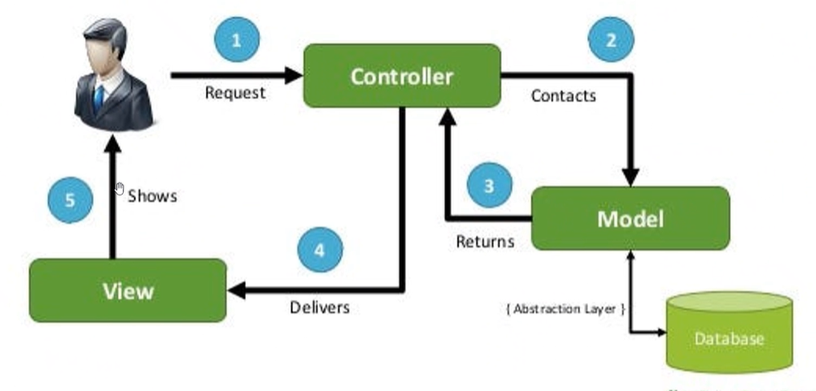

JAVA Servlet project:-
https://github.com/ayushman1024/Hospital-Management-UsingServlets/blob/master/WebProject/src/RetrieveMedicine.java

JAVA:-

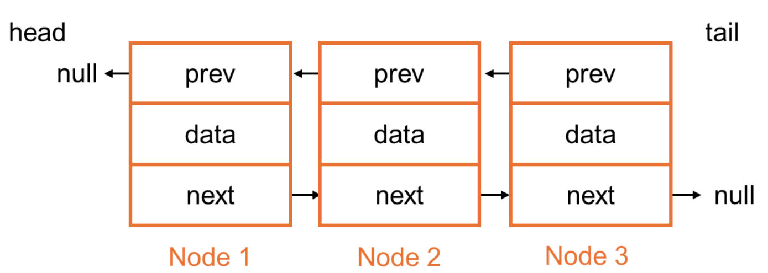

JAVA MCQ:-

Easy Level (1-30)
- What is the default value of a boolean variable in Java?
  - A) true
  - B) false
  - C) null
  - D) undefined
Answer: B) false
Explanation: In Java, the default value of a boolean variable is false when declared as an instance variable.
- What does the main() method in Java look like?
- A) public static void main(String args[])
- B) public static main(String[] args)
- C) public void main(String[] args)
- D) static void main(String[] args)
Answer: A) public static void main(String args[])
Explanation: This is the standard entry point for any Java application. The public keyword allows access from anywhere, static means it can be called without creating an instance, and void means it doesn't return a value.
- Which of the following is used to find the length of a string in Java?
- A) string.size()
- B) string.length()
- C) string.length()
- D) string.getLength()
Answer: B) string.length()
Explanation: The .length() method in Java returns the number of characters in a string.
4. Which data type is used to store decimal numbers in Java?
A) int
B) float
C) double
D) char
Answer: C) double
Explanation: double is a data type used to store decimal numbers with a higher precision, while float is a lower-precision decimal type.
- Which method is used to compare two strings in Java?
- A) compareTo()
- B) equals()
- C) isEqual()
- D) equalsIgnoreCase()
Answer: B) equals()
Explanation: The .equals() method is used to compare the contents of two strings in Java.
- What will be the result of the expression "Hello".length()?
A) 4
B) 5
C) 6
D) 1
7. Which of these keywords is used for inheritance in Java?
- A) super
- B) this
- C) extends
- D) implements
Answer: C) extends
Explanation: The extends keyword is used to inherit from a superclass in Java.

Insertion order
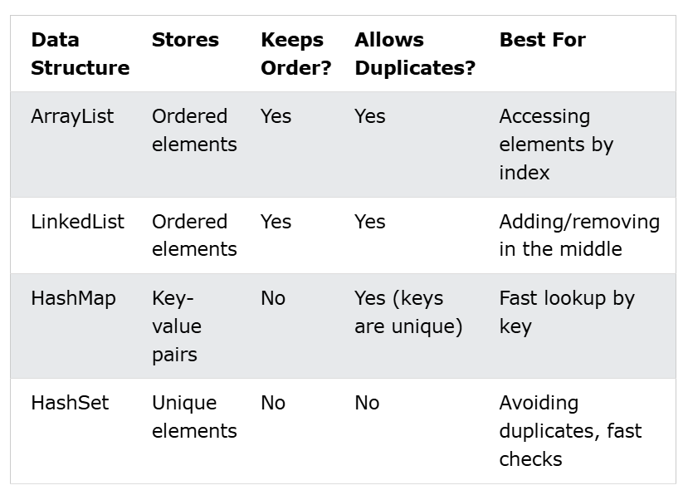

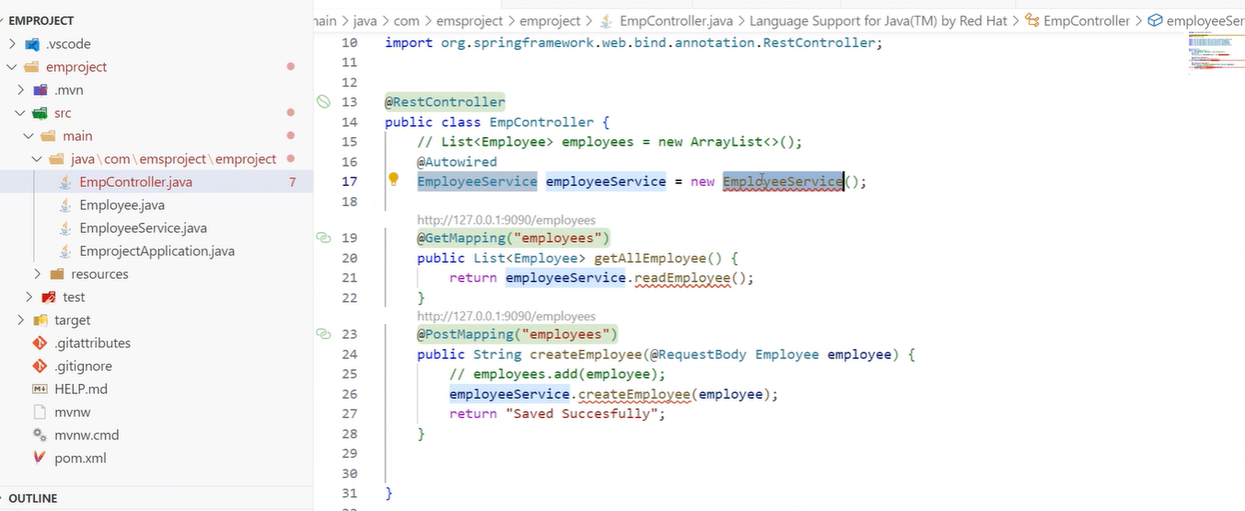

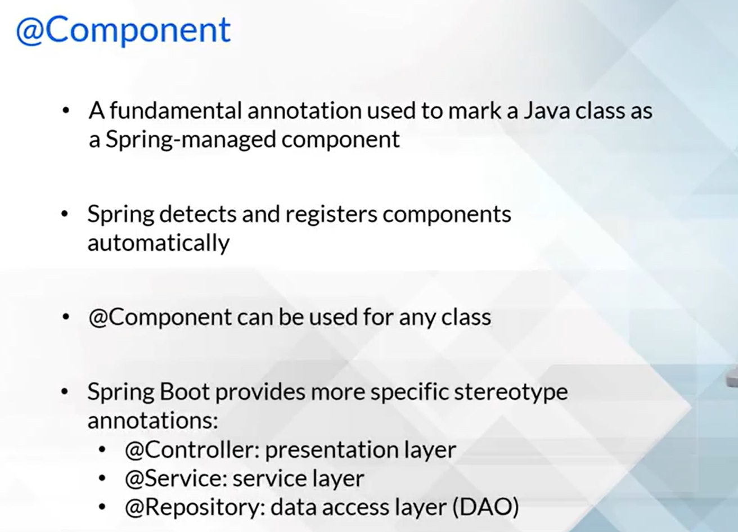

Annotation:-
-- @Data
-- @NoArgConstructor
-- @AllArgConstructor
-- @Autowired -- Injecting dependency in class
-- @GetMapping
-- @PostMapping
-- @DeleteMapping
-- @Restcontroller

  - Employee.java

package com.example.demo.model;

import lombok.AllArgsConstructor;
import lombok.Data;
import lombok.NoArgsConstructor;

@Data // Generates getters, setters, toString, equals, hashCode
@NoArgsConstructor // Generates no-argument constructor
@AllArgsConstructor // Generates constructor with all fields
public class Employee {
private Long id;
private String name;
private String role;
}

  - EmployeeService.java
package com.example.demo.service;

import com.example.demo.model.Employee;
import org.springframework.stereotype.Service;

import java.util.*;

@Service
public class EmployeeService {
private final Map<Long, Employee> employeeMap = new HashMap<>();

public List<Employee> getAll() {
return new ArrayList<>(employeeMap.values());
}

public Employee save(Employee employee) {
employeeMap.put(employee.getId(), employee);
return employee;
}

public void delete(Long id) {
employeeMap.remove(id);
}
}

3. EmployeeController.java

package com.example.demo.controller;

import com.example.demo.model.Employee;
import com.example.demo.service.EmployeeService;
import org.springframework.beans.factory.annotation.Autowired;
import org.springframework.web.bind.annotation.*;

import java.util.List;

@RestController // Marks this as a REST API controller
@RequestMapping("/employees")
public class EmployeeController {

private final EmployeeService employeeService;

@Autowired // Injects EmployeeService bean
public EmployeeController(EmployeeService employeeService) {
this.employeeService = employeeService;
}

@GetMapping // Handles GET /employees
public List<Employee> getAllEmployees() {
return employeeService.getAll();
}

@PostMapping // Handles POST /employees
public Employee addEmployee(@RequestBody Employee employee) {
return employeeService.save(employee);
}

@DeleteMapping("/{id}") // Handles DELETE /employees/{id}
public String deleteEmployee(@PathVariable Long id) {
employeeService.delete(id);
return "Deleted employee with ID: " + id;
}
}

4. DemoApplication.java
package com.example.demo;

import org.springframework.boot.SpringApplication;
import org.springframework.boot.autoconfigure.SpringBootApplication;

@SpringBootApplication // Bootstraps Spring Boot
public class DemoApplication {
public static void main(String[] args) {
SpringApplication.run(DemoApplication.class, args);
}
}

Link to Lambda Integration with Tickety:- https://builderhub.corp.amazon.com/blog/tickety-api-integration-with-lambda/

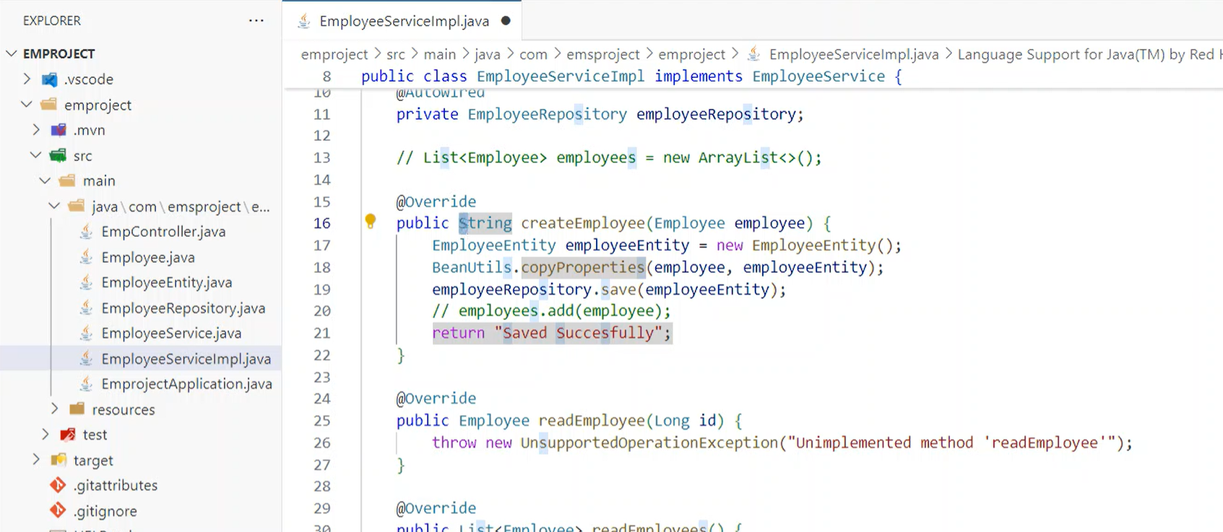

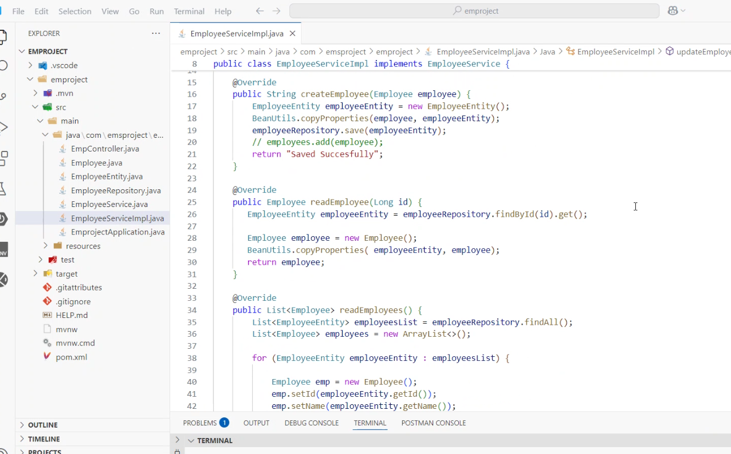

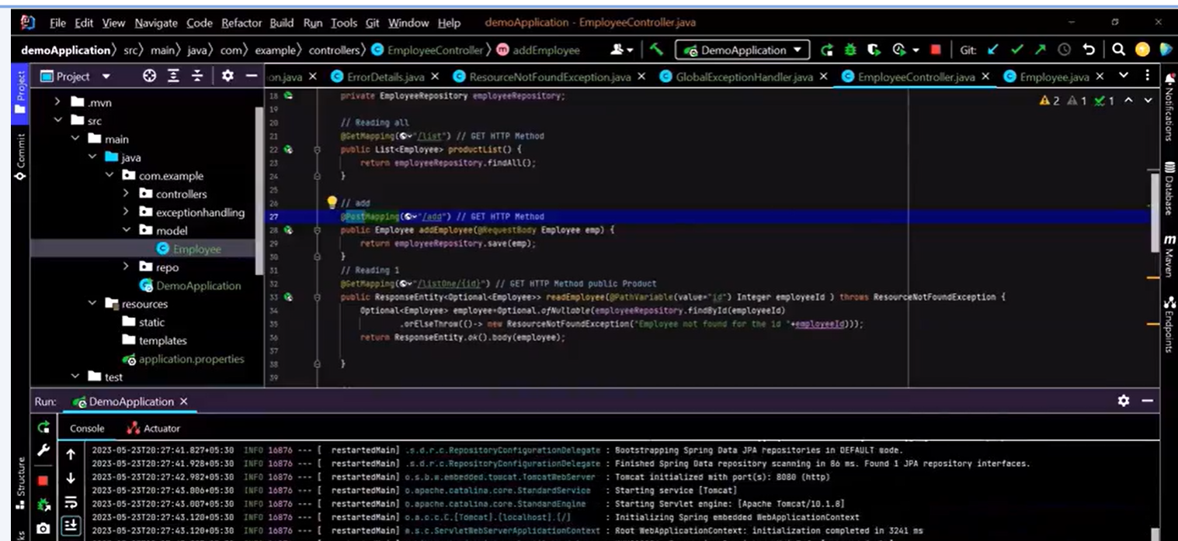

    - JAVA DSA/HLD/LLD by Learnby/TutorAcademy
    - Go through JAVA syllabus above one is official exam and another is GeekForGeeks
    - Refer project based on Spring security

