Outputs:

1. On Running the Application: Welcome Page

The top left space consists of a media player that will be played on visiting the welcome page.

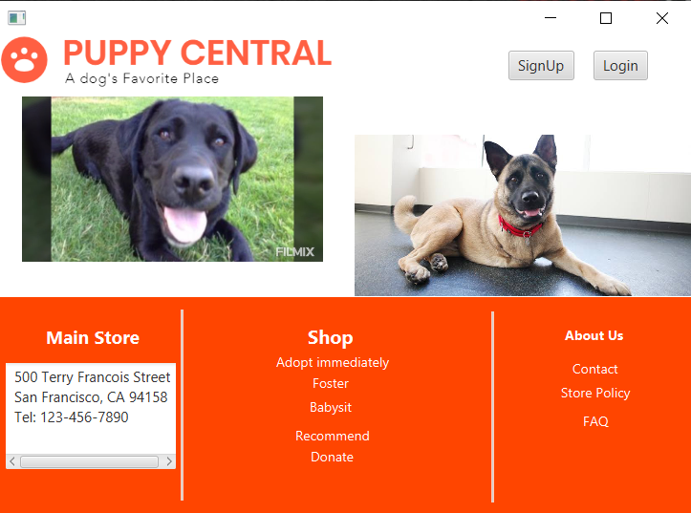

1. SignUp page: We get an Auto generated Captcha As soon as we press the sign up button on welcome page.

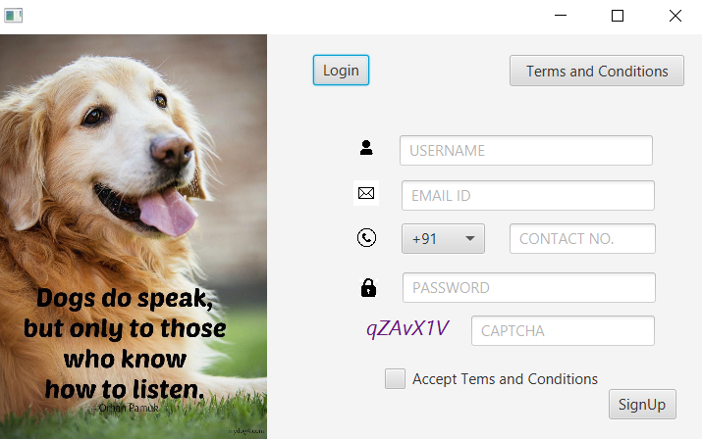

1. On filling the Complete Details And Signing Up : The date is stored in MySql database and we are ready to log in:

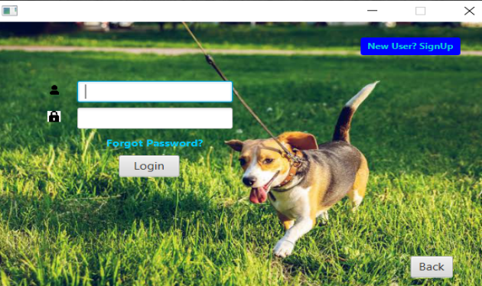

1. On Entering Wrong Id Or Password:

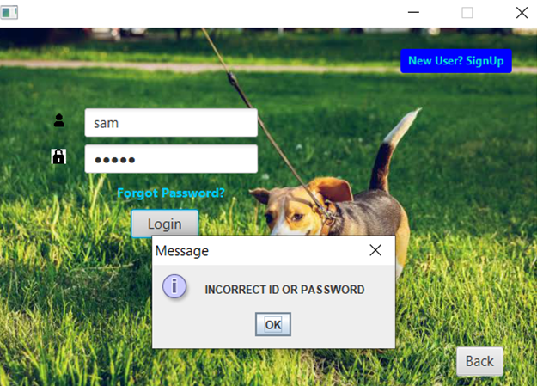

1. So As the User forgot the Password he Clicks on the Forgot Password Button and Forgot password Scenes Pop Up:

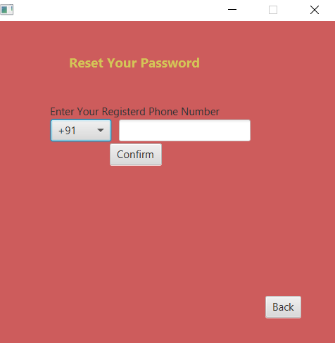

1. On Confirming The Phone Number as Mentioned In Database he get the Option To Reset The Password:

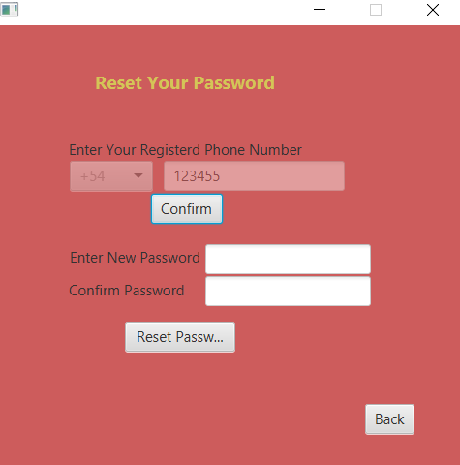

1. Now On Entering New Password and Confirming It the details has been changed in the Database:

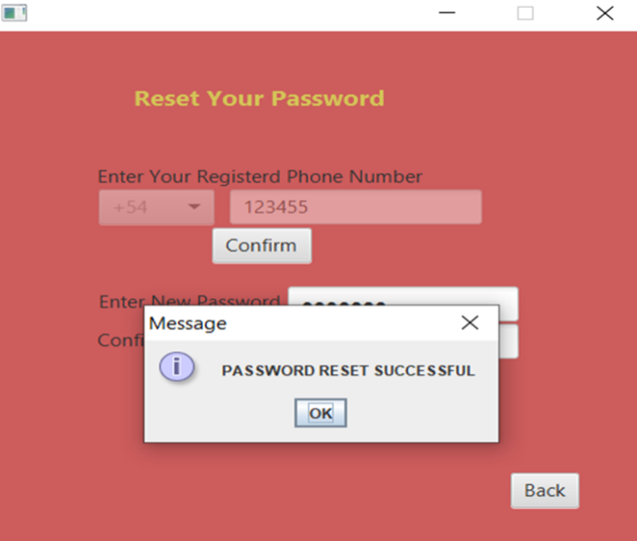

1. After Logging In with Correct Id and Password they are directed to the welcome Page Again With their Login credentials:

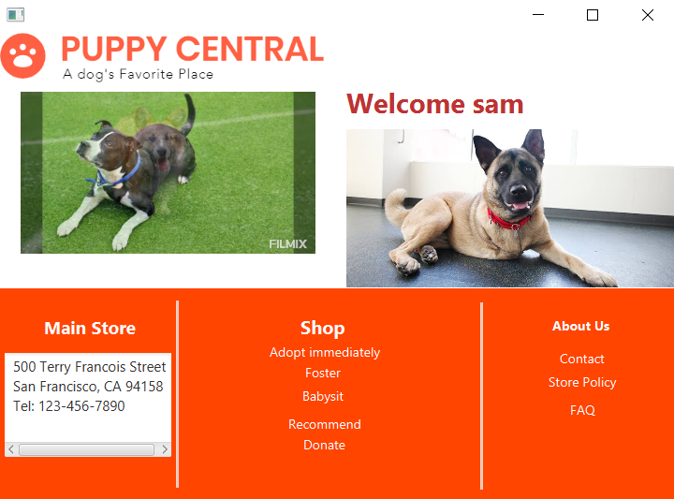

1. Clicking the “ADOPT IMMEDIATELY”:

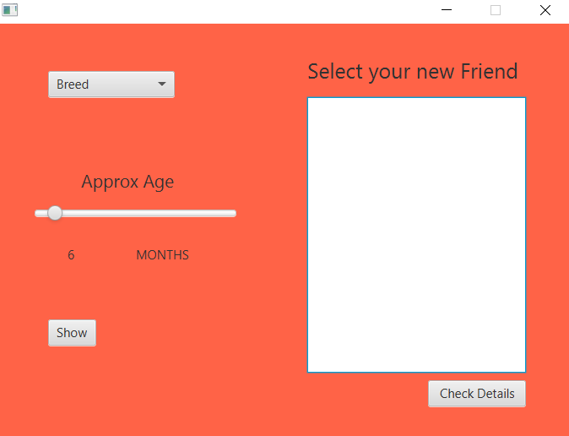

1. On selecting the breed and age and Clicking the how button: the list of puppies available appears on the list view from the database:

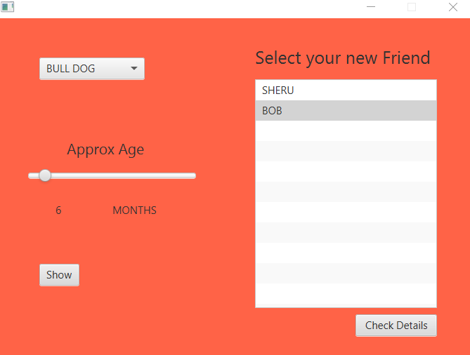

1. On Selecting the Name From the list box and pressing on check details: the details of the puppy arrives which the user can view and based on his choice can adopt:

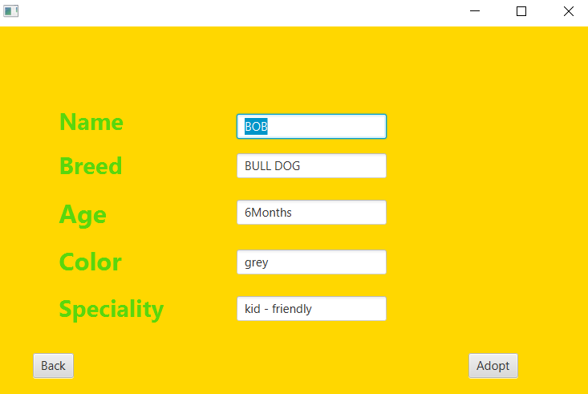

1. For adopting when the ADOPT button is pressed: the verification of password is important from:

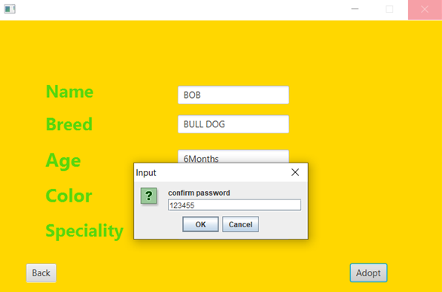

1. After Confirming the password : the Update is fed to the database and then clicking on the ok button they are back to the welcome page:

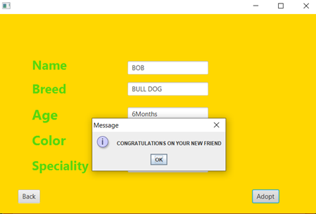

1. Now if the customer wants to give this NGO a dog found somewhere: So clicking on the foster button:



1. Foster Page is displayed and the details are required to give the dog.

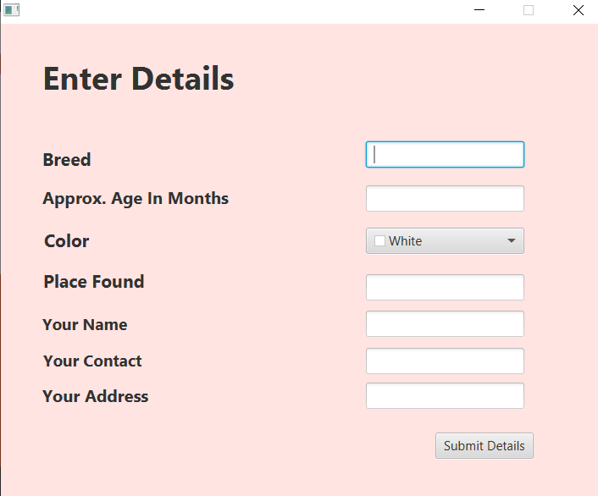

1. After entering the details and submitting it:

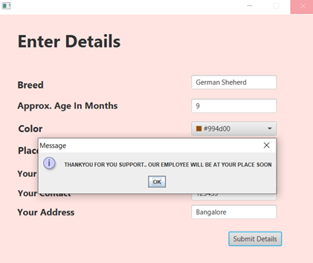

1. Now if a customer wants to baby sit a puppy he clicks on the babysit button:



1. The babysit page is popped up and he/ she is asked for select the breed they want to babysit:

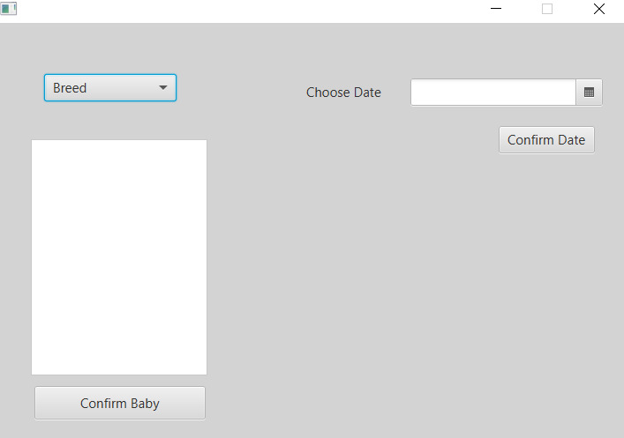

1. On selecting the Breed the name of available dogs are displayed in the list from the database and on confirming on their name their image is displayed:

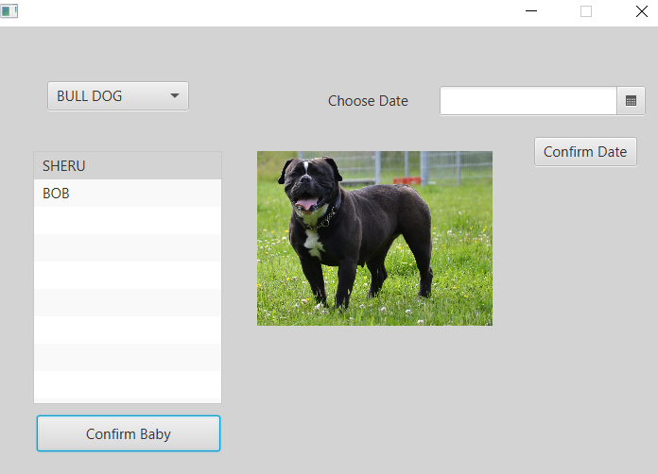

1. According to the user choice once selecting the dog they have to confirm the date from the date picker when they want to babysit the dogs and then they are asked to confirm their password as in database:

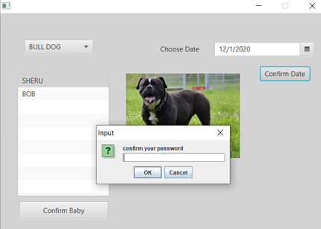

1. And once confirming the password the babysit date and dog is booked for them:

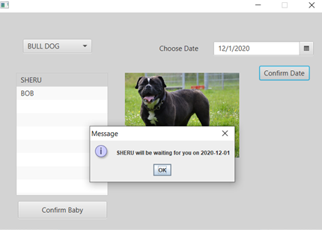

1. Now if the user wants to recommend something for NGO or give feedback they click on the recommend button:



1. On entering their details and recommendation the submit it and those are added to and existing file named as recommendation:

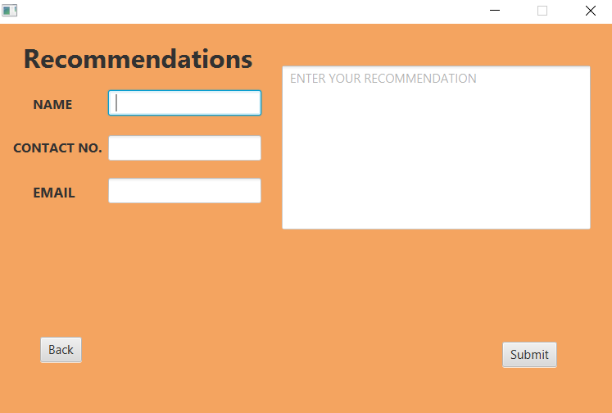

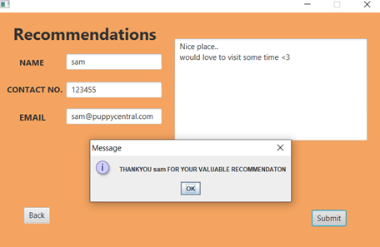

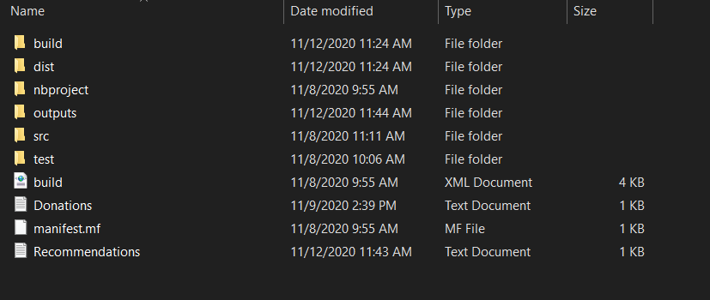

1. Now the admin on the other side can view this recommendation by opeaning the text document:

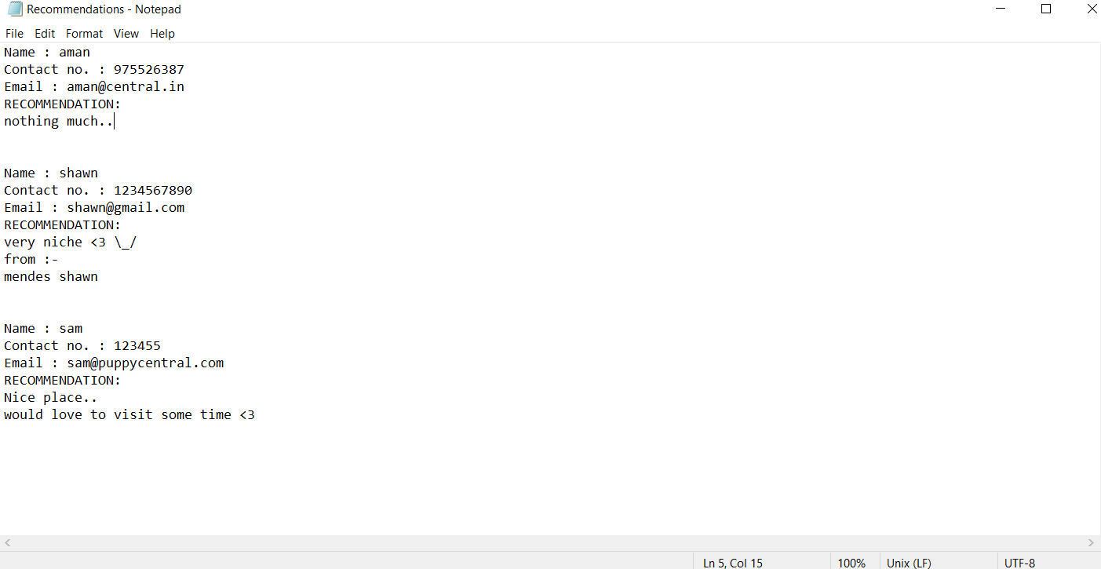

1. If the user want to donate something to the NGO the click on the donate button :



1. On selecting the amount or entering when they proceed to pay they need to enter their card no. and other related details:

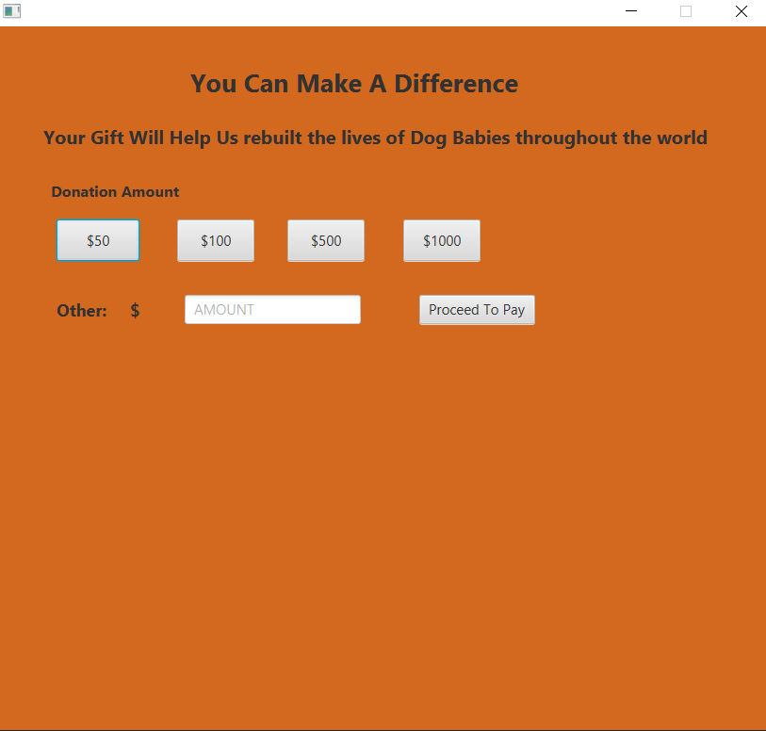

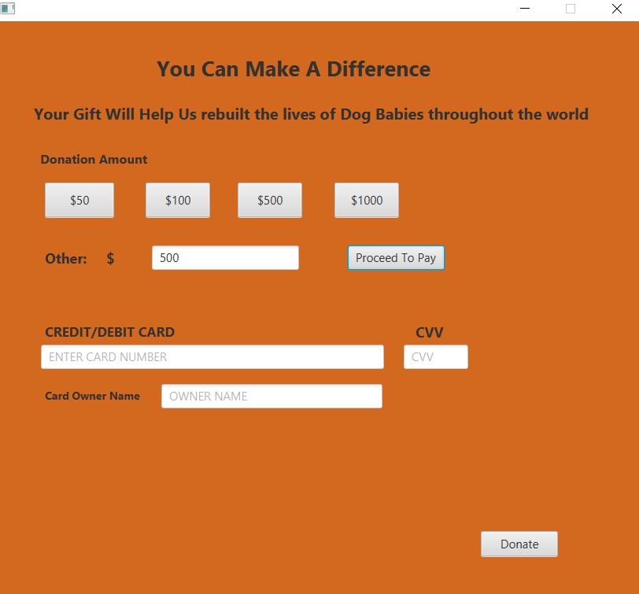

1. After Entering the Card Details the need to confirm there phone no. linked to the card to make payment and the donation history is again stored in the file created named donations:

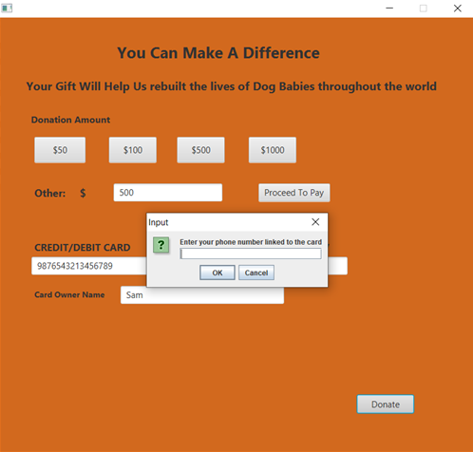

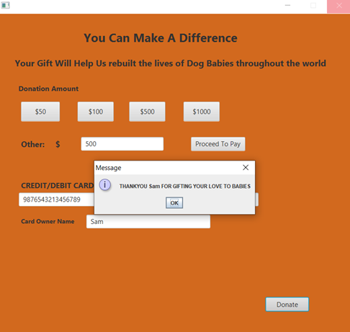



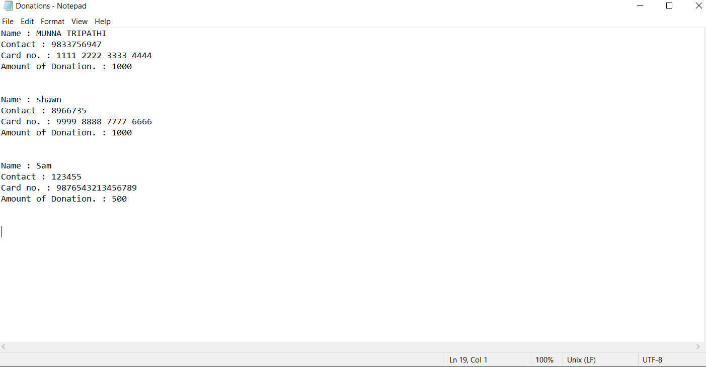

1. If the user press the contact button :

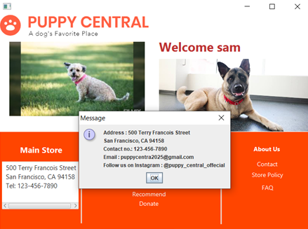

1. On pressing the Store policy button:

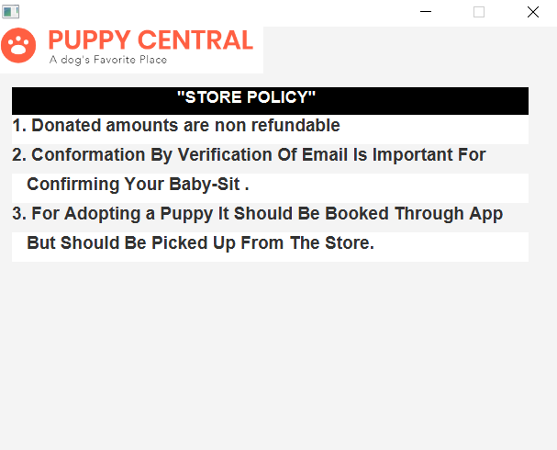

1. On clicking the faqs.

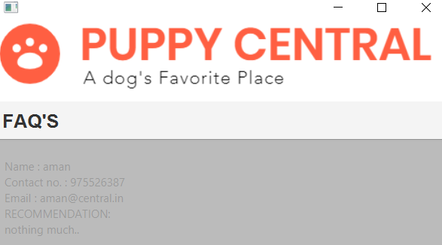

1. Tables in database:

