**B.M.S. COLLEGE OF ENGINEERING BENGALURU**

Autonomous Institute, Affiliated to VTU



An Internship Report

**Automation of Lightweight Ingress Contoller deployment**

*Submitted in partial fulfillment for the award of degree of*

Bachelor of Engineering

in

Computer Science and Engineering

*Submitted by:*

**Neha Bhaskar Kamath**

1BM21CS113

Internship Carried Out

*at*

|  |  |  |
| --- | --- | --- |
| Visa Inc |  | Aquamarine Building, L4 & 5, Bagmane WTC, Marathalli, Mahadevapura, KR Puram, Banglore- 560048, Karnataka |

**Internal Guide** **External Guide**

Dr. Seema Patil, Pavan Kumar Kuri

Assistant Professor, Visa

BMSCE, Bengaluru

Department of Computer Science and Engineering

BMS College of Engineering

Bull Temple Road, Basavanagudi, Bangalore 560 019

2023-2024

**B.M.S. College of EngineerinG**

**DEPARTMENT OF COMPUTER SCIENCE AND ENGINEERING**

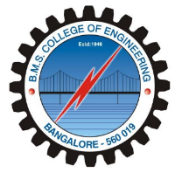

***DECLARATION***

I, Neha Bhaskar Kamath (1BM21CS113) student of 6thSemester, B.E, Department of Computer Science and Engineering, BMS College of Engineering, Bangalore, hereby declare that, this Internship entitled "Automation of Lightweight Ingress controller deployment", has been carried out under the guidance of **Pavan Kumar Kuri, Visa and Dr. Seema Patil, Assitant Professor,** Department of CSE, BMS College of Engineering, Bangalore during the academic semester March - June 2024. I also declare that to the best of my knowledge and belief, the Internship report is not a part of any other report by any other student.

**Signature of the Candidate**

Neha Bhaskar Kamath (1BM21CS113)

**B.M.S. College of EngineerinG**

**DEPARTMENT OF COMPUTER SCIENCE AND ENGINEERING**



***CERTIFICATE***

This is to certify that the Internship titled “**Automation of Lightweight Ingress controller deployment”** has been carried out by Neha Bhaskar Kamath during the academic year 2023-2024.

Signature of the Guide Signature of the Head of the Department

Signature of Examiners with date

1. Internal Examiner _____________________________
2. External Examiner _____________________________

**Offer letter screenshot**

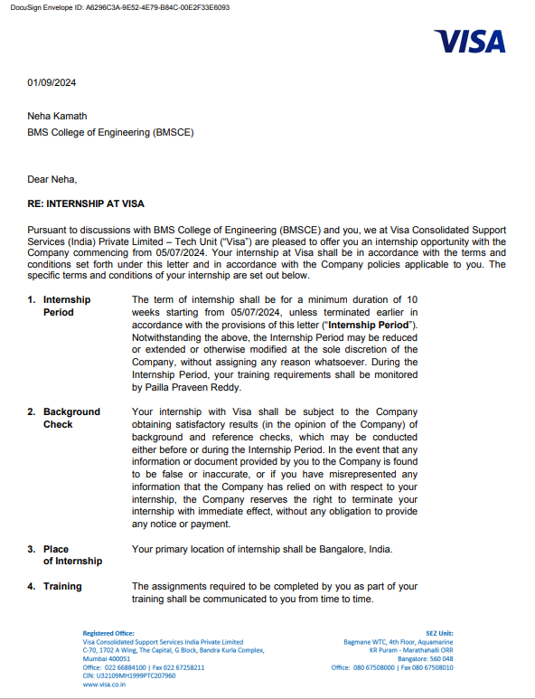

**Abstract**

In Kubernetes environments, efficiently managing ingress controllers is essential for routing external traffic to internal services. However, manual deployment can be tedious and error-prone. To tackle this, the process is automated using Go and client-go. This approach involves creating a streamlined pipeline that handles deployment tasks like configuration generation and resource provisioning. Go's concurrency is used to speed up deployment. The deployment pipeline is modular and interacts with Kubernetes resources using client-go. Focus is on error handling and logging for reliability. Tests show that this solution significantly improves deployment speed and reduces operational overhead compared to manual methods. It also ensures consistent and reliable deployments. Automating ingress controller deployment using Go and client-go offers a reliable, efficient solution for Kubernetes infrastructure management. This approach can streamline cloud-native deployments and improve overall efficiency.

**Table of contents**

|  |  |  |
| --- | --- | --- |
| **Sl. No** | **Title** | **Page. No** |
| 1 | About Visa | 7-8 |
| 2 | About the team- Container Infra Engineering | 9 |
| 3 | Tasks performed | 10 |
| 4 | Reflection notes | 11 |
| 5 | References | 12 |

**Chapter 1**

**About Visa Inc.**

Visa Inc. is a global payments technology company headquartered in Foster City, California, USA. It was founded in 1958 by Dee Hock and a group of bankers as BankAmericard, which later became Visa. Visa is one of the world's leading electronic payment networks, facilitating secure, convenient, and reliable transactions for consumers, businesses, financial institutions, and governments worldwide.

**Brief History and Major Milestones:**

In 1958, Bank of America launched the BankAmericard program in Fresno, California, marking the birth of Visa.

In 1976, the company was renamed Visa.

In 2008, Visa became a publicly traded company, listed on the New York Stock Exchange (NYSE).

In 2016, Visa completed its acquisition of Visa Europe, unifying the global Visa brand.

Over the years, Visa has continuously innovated its payment technologies, introducing chip cards, contactless payments, and mobile payment solutions.

**Organizational Structure:**

Visa operates through a decentralized structure with regional offices around the world. The company is led by a Board of Directors and executive leadership team, including the CEO and various executive vice presidents overseeing key functions such as product development, finance, technology, and global operations.

**Products and Services**:

Visa offers a wide range of payment products and services, including:

Visa-branded credit cards, debit cards, and prepaid cards

Payment processing solutions for merchants and financial institutions

Secure payment technologies, including EMV chip cards and tokenization

Digital payment solutions, such as Visa Checkout and Visa Direct

Data analytics and fraud prevention services

**Number of Employees:**

As of the latest available data, Visa employs over 30,000 people globally.

**Financial Details:**

Visa's financial details include:

Annual revenue: In the billions of dollars (specific figures vary from year to year)

Market capitalization: One of the largest in the financial services industry

Operating expenses: Comprising various costs associated with technology infrastructure, marketing, personnel, and regulatory compliance

**Company Operations and Departments:**

Visa operates through various departments and functions, including:

Product development and innovation: Responsible for creating and enhancing Visa's payment products and services.

Technology and engineering: Oversees the development and maintenance of Visa's global technology infrastructure.

Sales and business development: Works with merchants, financial institutions, and partners to expand Visa's network and grow its business.

Finance and accounting: Manages Visa's financial operations, including budgeting, forecasting, and financial reporting.

Legal and compliance: Ensures Visa's operations comply with regulatory requirements and oversees legal matters.

Marketing and communications: Develops marketing strategies to promote Visa's brand and products globally.

Operations and customer support: Manages day-to-day operations and provides support to Visa's clients and customers.

Overall, Visa plays a critical role in the global payments ecosystem, facilitating billions of transactions annually and driving economic growth and financial inclusion worldwide.

**Chapter 2**

**About the team- Container Infra Engineering**

The Container Engineering Team within a company specializes in managing and optimizing containerized applications and infrastructure, primarily leveraging Kubernetes, Ansible, and other related technologies.

**Container Orchestration with Kubernetes:**

The team orchestrates containerized applications efficiently using Kubernetes, an open-source container orchestration platform. They deploy, scale, and manage containers across distributed environments, ensuring high availability and resource efficiency.

**Infrastructure Management with Ansible:**

Leveraging Ansible, an automation tool, the team manages the infrastructure required to support containerized workloads. They automate provisioning, configuration, and maintenance tasks for container hosts, networking, storage, and other underlying resources.

**CI/CD Integration with Kubernetes:**

Integrating containerized applications into CI/CD pipelines is essential for automated testing, deployment, and rollback. The team configures Kubernetes to work seamlessly with CI/CD tools, enabling automated build, test, and deployment workflows for container images.

**Monitoring and Logging:**

Implementing robust monitoring and logging solutions is crucial for tracking container health, performance metrics, and application logs. The team configures Kubernetes monitoring tools and integrates logging solutions to facilitate proactive troubleshooting and performance analysis.

**Training and Knowledge Sharing:**

The team provides training and knowledge sharing sessions to internal teams on Kubernetes, Ansible, and other container-related technologies. They offer guidance on best practices, tooling, and automation, enabling broader adoption and proficiency across the organization.

**Chapter 3**

**Tasks Performed**

During my internship, I maintain a detailed record of both technical and non-technical activities I undertake. I work in the office every day from 8 AM to 5 PM, primarily focusing on automating the deployment of a lightweight ingress controller using Go and the client-go library within Kubernetes environments. This project involves leveraging Go's concurrency features and the client-go library's capabilities to streamline and optimize the deployment process, ensuring high availability and efficient resource utilization.

Beyond my primary project, I also complete various courses, attend seminars, participate in team meetings, and join sync-up calls. These activities are essential for gaining deeper insights into container engineering, staying updated with the latest industry practices, and fostering collaboration within the team. As a sixth-semester student, I balance these professional responsibilities with my academic commitments, demonstrating strong time management skills. After returning home, I dedicate time to college work, effectively managing dual responsibilities.

To enhance my knowledge in the assigned field, I refer to multiple resources, including YouTube tutorials, Google searches, the official client-go library documentation, and ChatGPT for additional guidance and clarification. These resources prove invaluable in understanding complex concepts and implementing best practices.

Throughout my internship, I actively participate in meetings, coordinate with colleagues within and outside the organization, and hone my verbal and written communication skills. This involves regular updates on project progress, seeking feedback, and contributing to team discussions. Effective time management and resource utilization are critical in meeting deadlines and achieving project milestones.

I also demonstrate strong interpersonal skills and take initiative in various tasks, contributing to a collaborative and productive work environment. This comprehensive engagement in both technical and non-technical activities ensures a well-rounded and enriching internship experience.

**Chapter 4**

**Reflection Notes**

During my ongoing internship, I have gained invaluable experience and developed a range of skills that are crucial for my professional growth. Working in the Container Engineering Team has provided me with the opportunity to delve into the intricacies of automating the deployment of lightweight ingress controllers using Go and the client-go library within Kubernetes environments. This hands-on experience has allowed me to apply theoretical knowledge to practical scenarios, enhancing my technical proficiency and problem-solving abilities.

**Technical Outcomes:**

* **Automation Development:** I have successfully contributed to the development of an automated pipeline for deploying ingress controllers, significantly reducing manual intervention and deployment time.
* **Tool Integration:** By leveraging Go's concurrency features and the client-go library, I have created efficient scripts that streamline the deployment process and ensure high availability and scalability of containerized applications.
* **Kubernetes Management:** My work involves managing and optimizing Kubernetes clusters, which has deepened my understanding of container orchestration and resource management.
* **Security Implementation:** I have implemented security measures such as image scanning and vulnerability management, contributing to the overall security and compliance of our deployments.

**Non-Technical Outcomes:**

* **Communication Skills:** My participation in team meetings, sync-up calls, and seminars has significantly improved my verbal and written communication skills. I am now more confident in presenting my ideas and providing updates on project progress.
* **Personality Development:** Engaging with colleagues and contributing to team discussions have helped me develop a collaborative and proactive approach to work. I have also gained a better understanding of professional etiquette and workplace dynamics.
* **Time Management:** Balancing my internship responsibilities with my academic commitments has honed my time management skills. I have learned to prioritize tasks effectively and manage my time efficiently to meet deadlines.
* **Resource Utilization:** I have become adept at utilizing various resources for learning and problem-solving, including YouTube tutorials, Google searches, the official client-go library documentation, and ChatGPT. This has enabled me to quickly acquire new knowledge and apply it to my work.

Overall, my internship experience has been immensely enriching. The technical skills I am acquiring and the non-technical competencies I am developing will undoubtedly contribute to my future career success. I look forward to continuing my internship and further expanding my skill set while making meaningful contributions to the organization.

**References**

<https://go.dev/doc/>

<https://pkg.go.dev/k8s.io/client-go>