

**DEPARTMENT OF ELECTRICAL AND ELECTRONICS ENGINEERING**

**BMS COLLEGE OF ENGINEERING**

**(AUTONOMOUS COLLEGE UNDER VTU, BELGAUM)**

**BANGLORE- 560019**

AAT REPORT ON:

WIRELESS POWER TRANSMISSION

COURSE: BASIC ELECTRICAL ENGINEERING

COURSE CODE:21EE2ESBEE

ASSIGNMENT SUBMITTED ON THE PARTIAL FULFILLMENT OF THE AAT FOR SEMESTER 2

SUBMITTED BY:

**HARSH GHIYA- 1BM21CS073**

**KANJIKA SINGH- 1BM21CS086**

**LIKHITH GS- 1BM21CS096**

**NEHA BHASKAR KAMATH- 1BM21CS113**

SUBMITTED TO:

**DR. CHANDRASREE DAS**

ASSOCIATE PROFESSOR

DEPARTMENT OF ELECTRICAL AND ELECTRONICS ENGINEERING

DATE OF SUBMISSION:

06-09-2022

INTRODUCTION

WHAT IS WIRELESS ELECTRICITY?

As the name suggests wireless electricity is the transmission of electrical energy without the usage of wires.

As far as the current technology goes wireless electricity mostly refers to devices that rest in a cradle or on a pad for charging

Transmitting electricity from a power grid without wires over long distance is an emerging technology.

Wireless power transfer (WPT), wireless power transmission, wireless energy transmission (WET), or electromagnetic power transfer is the transmission of electrical energy without wires as a physical link.

HISTORY

In late 1980’s, the vision of Nicola Tesla, the pioneer of induction techniques, was “World Wireless System”. He therefore made possible a 187 feet tall tower to broadcast energy so that all people can have access to free energy. But due to lack of funds, the tower did not operate.

But Tesla was able to transfer energy from one coil to another. He managed to light 200 lamps from a distance of 40kms.

The idea of Tesla is taken to research after 100 years by a team led by Marin Soljacic from MIT. The project is named “WiTricity”.

WHY WIRELESS OVER WIRED?

Wireless systems are preferred nowadays because

wires limit our ability to move around, undergo corrosion and on an average, around 30% of the energy is lost during transmission, and in India, the energy loss exceeds 40%.

On the other hand, wireless systems are reliable and efficient, fast and require less maintenance.

SCOPE OF WIRELESS ELECTRICITY IN REAL WORLD

* Powercast and w Zealand's second-largest power distributor has set up a wireless transmission test between relays on poles approximately a hundred feet apart.
* VoltServer, Ossia, WiTricity, Powercast and Energous are some of the famous companies which are leading the way in the research and development of wireless electricity.
* WiTricity was born in the MIT Department of Physics a decade ago when Professors Marin Soljačić ’96, John Joannopoulos, and Peter H. Fisher first envisioned a wireless charging system that would send current to a specified device.

In a 2007 experiment, Soljačić successfully transmitted current wirelessly from an AC source to a 60-watt lightbulb more than eight feet away.

NEEDS OF WIRELESS TECHNOLOGY

For one, wireless power allows you to completely seal your device. Whether you’re looking to get rid of a power port, remove something you don’t want in the system, or advance your product from water-resistant to waterproof, wireless power could be your perfect solution.

For another, wireless power means less cord clutter. Since each mobile device typically requires its own charging cord, many of us are constantly tripping over (or searching for) chargers in our homes. Wireless power eliminates those problems by providing one universal, cordless power solution for all those devices.

BASIC PRINCIPLE OF WIRELESS ELECTRICITY

The basic working principle of wireless power transfer is, two objects having similar resonant frequency and in magnetic resonance at powerfully coupled rule tend to exchange the energy, while dissipating relatively little energy to the extraneous off resonant objects.

WORKING OF WIRELESS TRANSMISSION BY DIFFERENT METHODS

Inductive Coupling:

In this method, the principle of mutual inductance between the two coils is used to transfer electrical energy without wires.

In inductive power transfer (IPT), the energy from power outlet is transferred to the onboard battery magnetically. The working principle of IPT is based on the [magnetic coupling](https://www.sciencedirect.com/topics/engineering/magnetic-couplings) between two coils of a very-high-frequency transformer. The first coil of the transformer is mounted on the charger side, and the second coil is installed on the receiver. Single-phase or three-phase ac supply of frequency 50–60 Hz is first rectified to dc, and then, this rectified dc is inverted to very-high-frequency ac within the charging station. This high-frequency power is transferred to the onboard battery through magnetically coupled primary and secondary coil. This high-frequency ac power received through receiver side coil is converted to dc to charge the battery on board. The clear advantages of IPT are elimination of charger connectors, user convenience, and galvanic isolation.

In inductive power transfer, longitudinally arranged dipole fields are produced. These fields decrease with the cube of distance between the transmitter and receiver. Hence one of the factors affecting the efficiency of power transfer is the distance between the two coils. Hence, closer the receiver and the transmitter, the better is the efficiency.

Laser power transmission:

The laser source transmits the laser beam through an efficient lens. The lens is used to converge the beam of the laser to the specific place where the receiver is present. The laser receiver consists of a series of highly efficient photovoltaic cells which receives the laser beam and then convert them into electrical energy. The load is attached with the photovoltaic cells which after being energized through laser beam convert light energy of laser beam into electrical energy. This method is challenging to implement and manage.

WIRELESS CHARGING

How does it work?

A magnetic loop antenna (copper coil) is used to create an oscillating magnetic field, which can create a current in one or more receiver antennas.

If the appropriate capacitance is added so that the loops resonate at the same frequency, the amount of induced current in the receivers increases.

This is resonant inductive charging or magnetic resonance; it enables power transmission at greater distances between transmitter and receiver and increases efficiency.

Coil size also affects the distance of power transfer. The bigger the coil, or the more coils there are, the greater the distance a charge can travel.

In the case of smartphone wireless charging pads, for example, the copper coils are only a few inches in diameter, severely limiting the distance over which power can travel efficiently.

But when the coils are larger, more energy can be transferred wirelessly. That's the tactic WiTricity, has helped pioneer. It licenses loosely-coupled resonant technology for everything from automobiles and wind turbines to robotics.

In WiTricity's car charging system, large copper coils – over 25 centimetres in diameter for the receivers – allow for efficient power transfer over distances up to 25 centimetres. The use of resonance enables high levels of power to be transmitted (up to 11kW) and high efficiency (greater than 92% end-to-end), according to WiTricity CTO Morris Kesler. WiTricity also adds capacitors to the conducting loop, which boosts the amount of energy that can be captured and used to charge a battery.

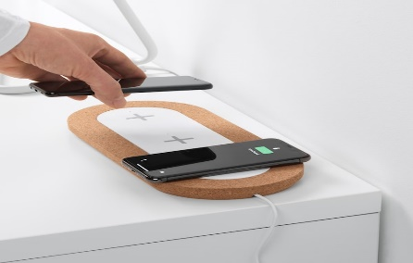The system isn't just for cars: Last year, Japan-based robotics manufacturer [Daihen Corp.](http://www.daihen.co.jp/en/) began shipping a [wireless power transfer system](http://witricity.com/daihen-shipping-industrial-robotics-solutions-powered-witricitys-wireless-charging-technology/) based on WiTricity's technology for automatic guided vehicles (AGVs). AGVs equipped with Daihen's [D-Broad wireless charging system](http://www.daihen.co.jp/products/wireless/agv/) can simply pull up to a charging area to power up and then go about their warehouse duties.

Wireless charging in smartphones:

Wireless charging offers us a safe, convenient and efficient way for powering up as well as charging our electrical equipment/gadgets at a small scale (like home) and at a bigger scale, too (like workshops and industrial level). Many of our house-hold gadgets are based on it and we are using this technology from decades.

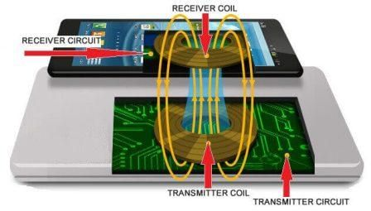

Working:

Step 1: Applied power (voltage) is first converted into HFAC (High-frequency alternating current).

Step 2: The HFAC is then supplied to the Transmitter coil through Transmitter circuitry.  The HFAC flowing through the coil generates a magnetic field in the transmitter coil.

Step 3: The Transmitter coil’s magnetic field passes through the Receiver coil of the device to be charged.

Step 4: This varying magnetic field in the Receiver coil produces a flow of current through it.

Step 5: This current flowing through the Receiver coil is then converted into Direct current (DC) by the Receiver circuitry which is further used for charging the battery of the device be charged.

Wireless charging in a car:

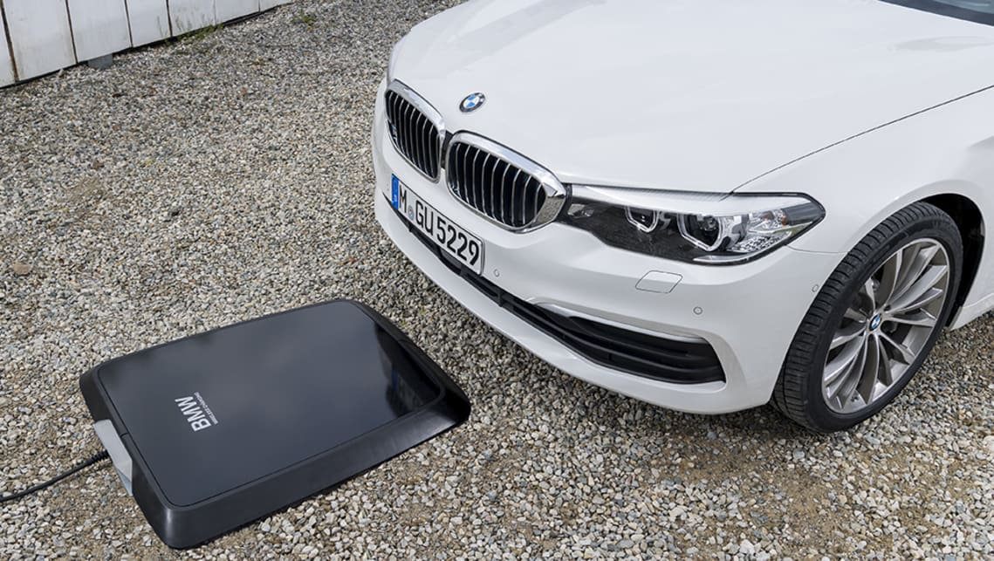Charging electric cars is typically done using a cable that can receive either alternating current (AC) or direct current (DC) electricity.

Level 1 charging is typically done via a domestic AC power socket that offers between 2.4-3.7kW of power, which equates to taking between five and 16 hours to fully charge a battery (per hour of charging, you’ll be getting 10-20km of driving range).

Level 2 charging is done via either a domestic or public AC wall box charger that offers 7kW of power, which equates to 2-5 hours to fully charge a battery (per hour of charging, you’ll be getting 30-45km of driving range).

Level 3 charging is done via a DC fast charger at a public [EV battery](https://www.carsguide.com.au/ev) charging station. This offers around 11-22kW of power, which equates to taking 20-60 minutes to fully charge a battery (per hour of charging, you’ll be getting 250-300km of driving range).

Level 4 is super-fast charging done at a public DC charging station for electric cars. This offers around 120kW of power, which equates to taking 20-40 minutes to fully charge a battery (per hour of charging, you’ll be getting 400-500km of driving range).

There’s also ultra-fast charging public charging available, where 350kW of power can get a battery charged in 10-15 minutes, and deliver a staggering 1000km of driving range per hour.

Disadvantages of Wireless Charging:

* Slow Charging than wired setup:

Usually, in wireless charging the time taken to charge is greater than that of wired charging as it is not completely in contact

* Too much of Heat:

It is mainly because the energy is lost in the form of radiation that interacts with surrounding while transferring the charge.

* In smartphones, we have to use wireless charging pad to charge, which is not convenient and we expect to have a wireless charging system where we can use our phone normally and it gets charged.

DIFFERENCE BETWEEN WIRED AND WIRELESS ELECTRICITY:

Wired system:

* There is use of wires.
* Charge transfer is through flow of electrons inside the wire.
* Performance is not affected by atmospheric properties.
* Interference is low.
* Requires installation of cables, implying high investment costs.
* Can charge only few devices at once.
* Requires physical access to the cables.
* Specific arrangement / setup is required.

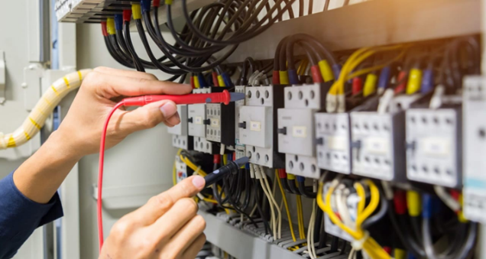

Wireless system:

* Free from wires.
* Charge transfer occurs through electromagnetic waves.
* Interference is significant because all signals share the medium, that is, air.
* Almost no installations required. Can use a mesh network to increase robustness.
* Can charge multiple devices at once.
* Performance may be affected by atmospheric conditions.
* Connections can be made anywhere along the path where electromagnetic waves propagate.
* 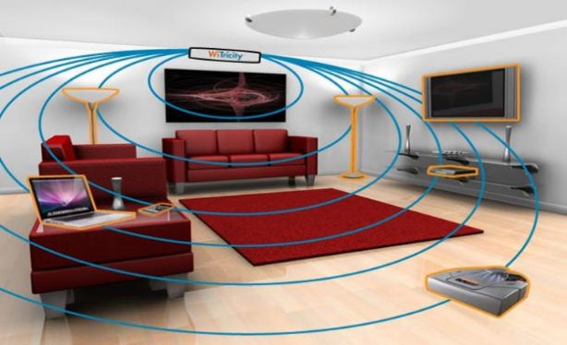No specific arrangement / setup is required here.

ADVANTAGES AND DISADVANTAGES OF WIRELESS POWER TRANSMISSION:

Advantages:

* Eliminates the need for an inefficient, costly, and capital-intensive grid of cables, towers, and substations.
* The electrical energy can be economically transmitted without wires to even the remote places, so there will be no transmission and distribution loss.
* The power failure due to short circuit and fault on cables would never exist in the transmission.
* System would reduce the cost of electrical energy used by the consumer.
* Need for battery is eliminated.
* Wireless energy transfer can potentially recharge laptops, cell phones without chords.
* Reduces the risk of electric shocks.
* Electric vehicles can be charged from anywhere.
* Risks of power theft is reduced.

Disadvantages:

* Capital cost for practical implementation of wireless system is high.
* When lasers are used, conversion is inefficient and absorption loss is high.
* Transmissions are possible only in few meters. Efficiency decreases as distance increases.
* The resonance condition should be satisfied. If there is any error, there is almost no possibility of power transfer.
* Field strengths must be under safety levels.
* Can cause drastic effects to the human body, because of the radiations.
* The transmitter and the receiver should be very powerful as the distance increases.

CONCLUSION

Transmission without wires is a reality and we are moving towards it. There are many cons in the systems and efforts are being made to overcome them. Efforts are being made to develop wireless power technology to the point of large-scale production. The future work in this field is to increase the distance between receiver and transmitter. There are means and designs, it is only a matter of obligation to create wireless power on mass scales for the betterment of the society.

In the near future, the world will be almost completely wireless.