## B.M.S. COLLEGE OF ENGINEERING BENGALURU

Autonomous Institute, Affiliated to VTU



# Internet Of Things Project Report on

**Obstacle Detection for Blind people**

*Submitted in partial fulfillment for the award of degree of*

Bachelor of Technology in

Computer Science and Engineering

*Submitted by:*

**M ANANTA NAGA RAJESH (1BM21CS098)**

**MANAV TAKE (1BM21CS102)**

**NEHA BHASKAR KAMATH (1BM21CS113)**

# Work carried out at



## Subject Guide

## Dr. Gauri Kalnoor Assistant Professor

Department of Computer Science and Engineering

B.M.S. College of Engineering

Bull Temple Road, Basavanagudi, Bangalore 560 019 2023-2024

## B.M.S. COLLEGE OF ENGINEERING DEPARTMENT OF COMPUTER SCIENCE AND ENGINEERING



***DECLARATION***

We, M Ananta Naga Rajesh (1BM21CS098), Manav Take (1BM21CS102) and Neha Bhaskar Kamath (1BM21CS113) students of 5thSemester, B.E, Department of Computer Science and Engineering, B.M.S. College of Engineering, Bangalore, hereby declare that, this alternative assessment technical seminar entitled "Obstacle detection for blind people" has been carried out under the guidance of Dr. Gauri Kalnoor**,** Assistant Professor, Department of CSE, B.M.S. College of Engineering, Bangalore during the academic semester Nov, 2023 -Feb 2024. We also declare that to the best of our knowledge and belief, the alternative assessment technical seminar report is not from part of any other report by any other students.

## Signature of the Candidate

M Ananta Naga Rajesh (1BM21CS098)

Manav Take (1BM21CS102)

Neha Bhaskar Kamath (1BM21CS113)

# **Abstract**

In today's world, the integration of technology into assisting people with disabilities has become imperative. Visual impairment poses significant challenges to mobility and safety, especially in unfamiliar environments. This paper proposes an Internet of Things (IoT)-based obstacle detection system tailored to aid visually impaired individuals in navigating their surroundings safely. The system utilizes ultrasonic sensors mounted on a wearable device to detect obstacles in real-time. Data from the sensors are processed using machine learning algorithms to classify obstacles and provide auditory feedback to the user through bone conduction headphones or a smartphone application. The system's design emphasizes portability, affordability, and user-friendliness, ensuring its practicality for everyday use. Through extensive testing and validation, our prototype demonstrates promising results in accurately detecting obstacles and assisting visually impaired individuals in navigating indoor and outdoor environments effectively. This research contributes to the ongoing efforts to leverage technology for improving the quality of life and independence of individuals with visual impairments.

**Chapter 1: INTRODUCTION**

* 1. **Overview**

The IoT-based obstacle detection system for blind people is designed to provide real-time  
assistance to visually impaired individuals in navigating their surroundings safely and independently. The project integrates ultrasonic sensors with a wearable device, leveraging IoT technology to detect obstacles in the environment. These sensors continuously scan the surroundings and send data to a processing unit, where machine learning algorithms classify obstacles based on their characteristics.

The system's architecture emphasizes simplicity, portability, and affordability, ensuring its practicality for everyday use. The wearable device is lightweight and ergonomic, equipped with bone conduction headphones or a smartphone application to deliver auditory feedback to the user. This feedback informs the user about the presence and location of obstacles, enabling them to make informed navigation decisions.

The project aims to address the challenges faced by visually impaired individuals when navigating unfamiliar environments, both indoors and outdoors. By providing real-time obstacle detection and feedback, the system enhances the user's mobility, safety, and independence. Extensive testing and validation are conducted to ensure the accuracy and reliability of the system in various real-world scenarios.

Ultimately, this project contributes to the broader effort of leveraging technology to improve the quality of life and autonomy of individuals with visual impairments. It highlights the potential of IoT solutions in addressing specific challenges faced by people with disabilities, paving the way for more inclusive and accessible technologies in the future.

**1.2 Motivation**

The motivation behind the IoT-based obstacle detection system for blind people project stems from the pressing need to enhance the independence, safety, and mobility of visually impaired individuals. Visual impairment significantly impacts an individual's ability to navigate their surroundings, leading to challenges and potential hazards, particularly in unfamiliar environments. Traditional aids like canes and guide dogs offer assistance, but they may have limitations or require significant training.

This project seeks to address these challenges by leveraging the capabilities of IoT technology to create a portable and affordable obstacle detection system. The motivation lies in empowering visually impaired individuals to navigate with greater confidence and autonomy, regardless of their surroundings. By providing real-time feedback about obstacles, the system aims to reduce the risk of accidents and improve the user's overall quality of life.

Furthermore, the project is motivated by the potential of technology to bridge accessibility gaps and promote inclusivity. By developing innovative solutions tailored to the needs of visually impaired individuals, the project contributes to a more equitable society where everyone can participate fully and independently in daily activities.

Overall, the motivation behind the project is rooted in the desire to harness technology for positive social impact, enabling greater independence and empowerment for individuals with visual impairments.

**1.3Objective**

The primary objective of leveraging radar technology, such as that demonstrated in the Arduino project, is to create an advanced obstacle detection system for the visually impaired. This system aims to significantly enhance the mobility and safety of blind individuals by providing real-time, accurate information about their surroundings. By integrating compact, efficient radar modules with wearable or handheld devices, the project seeks to detect obstacles in the path of a user and communicate this information through auditory or haptic feedback mechanisms.

Such technology promises to offer a more intuitive and comprehensive understanding of the environment than traditional aids like the white cane or basic electronic travel aids (ETAs). The radar system can detect objects at various distances and heights, alerting users to overhead obstacles, which are typically challenging to detect with a cane. Furthermore, by leveraging advancements in signal processing and machine learning, the system could potentially identify the nature of obstacles, providing a richer context to the user.

Implementing this technology requires a multidisciplinary approach, combining expertise in electronics, software development, and user-centered design to ensure the device is practical, comfortable, and effective for daily use. Collaboration with visually impaired individuals during the development process is crucial to tailor the device to their needs and preferences.

The ultimate goal is to improve the independence and quality of life for blind people, allowing them to navigate more safely and confidently in various environments, from familiar indoor spaces to complex urban landscapes.

**Chapter 2: LITERATURE SURVEY**

[1]The research paper titled "Smart Obstacle Detector for Blind Person" presents a system designed to assist blind individuals by detecting obstacles through video processing and ultrasonic sensors, providing feedback via sound and vibrations. The device integrates MATLAB software for object detection, using a camera, and an ultrasonic sensor to measure distances to objects, with the results conveyed to the user through auditory and tactile signals. This approach aims to enhance mobility and independence for visually impaired persons by offering detailed information about their surroundings beyond what traditional canes can provide. The paper discusses the technical aspects of the system, including the design and functionality of the video processing and ultrasonic components, as well as the potential benefits of such technology in improving the quality of life for blind individuals.

[2] The research paper titled "Obstacle detection and avoidance module for the blind" outlines a novel wearable system called the Blavigator project aimed at aiding visually impaired individuals in navigating both indoor and outdoor environments. This study emphasizes the development of a computer vision (CV) module that utilizes an object collision detection algorithm based on stereo vision. The proposed algorithm employs Peano-Hilbert Ensemble Empirical Mode Decomposition (PH-EEMD) for disparity image processing and a dual-layer image segmentation strategy for detecting nearby objects. This research contributes to the field by presenting an innovative approach to enhance the mobility and safety of visually impaired people through advanced image analysis and real-time processing capabilities.

**Chapter 3: DESCRIPTION OF TOOL SELECTED**

Arduino Uno: A compact microcontroller board based on the ATmega328P, offering a versatile platform for programming and integrating with various sensors and components in electronic projects. It's the brain of the obstacle detection device, processing input from sensors to trigger outputs like audio alerts.

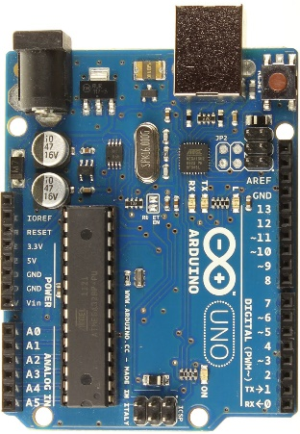

Servo Motor: A rotary actuator that allows for precise control of angular position, used here to rotate the sonar sensor for a wider detection range, enabling the device to scan multiple directions for obstacles.

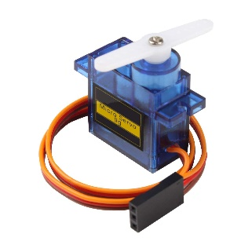

Breadboard: A solderless device for prototyping electronic circuits, allowing for easy insertion and wiring of components. In this project, it's used to connect the Arduino, servo motor, sonar, buzzer, and other components without soldering, facilitating testing and adjustments.

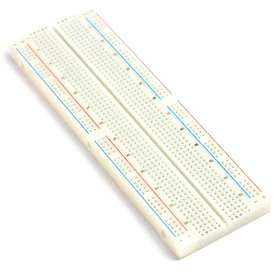

Sonar (Ultrasonic Sensor): Utilizes sound waves to detect objects and measure distances by emitting ultrasonic pulses and calculating the time it takes for the echoes to return. Critical for detecting obstacles in the path of a visually impaired person.

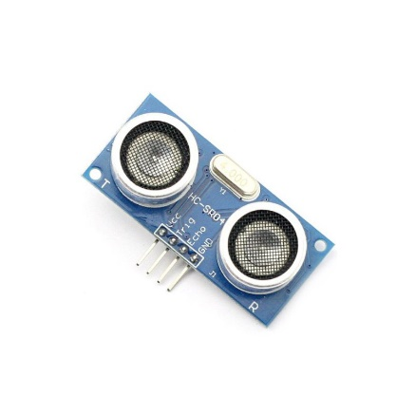

Buzzer: An audio signaling device that emits sound when activated. In this system, it alerts the user through auditory signals when an obstacle is detected within a certain range.

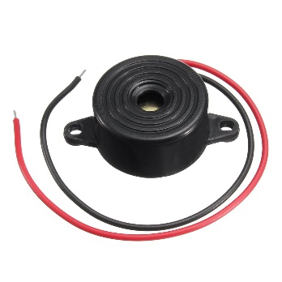

Wires: Electrical wires connect the components on the breadboard and ensure communication between the Arduino, sensors, and output devices.

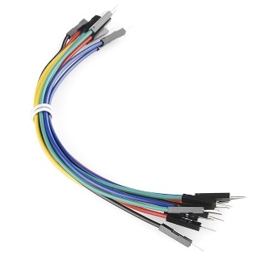

**Chapter 4: DETAILED DESCRIPTION OF MODULES IMPLEMENTED**

**Connections**

**Servo motor-> Ardunino Board**

* Ground->Ground
* Power supply->Vcc
* Control signal-> Pin 12

**Sonar sensor-> Arduino board**

* VCC🡪5V
* GND->Ground
* Trig->Pin 10
* Echo->Pin 11

**Code**

// Includes the Servo library

#include <Servo.h>.

// Defines Tirg and Echo pins of the Ultrasonic Sensor

const int trigPin = 10;

const int echoPin = 11;

const int buzzerPin = 9;

// Variables for the duration and the distance

long duration;

int distance;

Servo myServo; // Creates a servo object for controlling the servo motor

void setup() {

pinMode(trigPin, OUTPUT); // Sets the trigPin as an Output

pinMode(echoPin, INPUT); // Sets the echoPin as an Input

Serial.begin(9600);

myServo.attach(12); // Defines on which pin is the servo motor attached

}

void beepBuzzer() {

// Beep the buzzer for a short duration (adjust as needed)

tone(buzzerPin, 10000, 300); // 1000 Hz tone for 200 milliseconds

delay(10); // Delay to separate beeps (adjust as needed)

noTone(buzzerPin); // Turn off the buzzer

}

// Function for calculating the distance measured by the Ultrasonic sensor

int calculateDistance(){

digitalWrite(trigPin, LOW);

delayMicroseconds(0.2);

// Sets the trigPin on HIGH state for 10 micro seconds

digitalWrite(trigPin, HIGH);

delayMicroseconds(0.10);

digitalWrite(trigPin, LOW);

duration = pulseIn(echoPin, HIGH); // Reads the echoPin, returns the sound wave travel time in microseconds

distance= duration*0.034/2;

return distance;

}

void loop() {

// rotates the servo motor from 15 to 165 degrees

for(int i=15;i<=165;i++){

myServo.write(i);

delay(0.005);

distance = calculateDistance();// Calls a function for calculating the distance measured by the Ultrasonic sensor for each degree

Serial.print(i); // Sends the current degree into the Serial Port

Serial.print(","); // Sends addition character right next to the previous value needed later in the Processing IDE for indexing

Serial.print(distance); // Sends the distance value into the Serial Port

Serial.print(".\n"); // Sends addition character right next to the previous value needed later in the Processing IDE for indexing

if (distance < 20){ // If the object is closer than 20 cm, beep the buzzer

beepBuzzer();

}

}

// Repeats the previous lines from 165 to 15 degrees

for(int i=175;i>5;i--){

myServo.write(i);

delay(0.005);

distance = calculateDistance();

Serial.print(i);

Serial.print(",");

Serial.print(distance);

Serial.print("\n");

if (distance < 20) { // If the object is closer than 20 cm, beep the buzzer

beepBuzzer();

}

}

}

**Output**

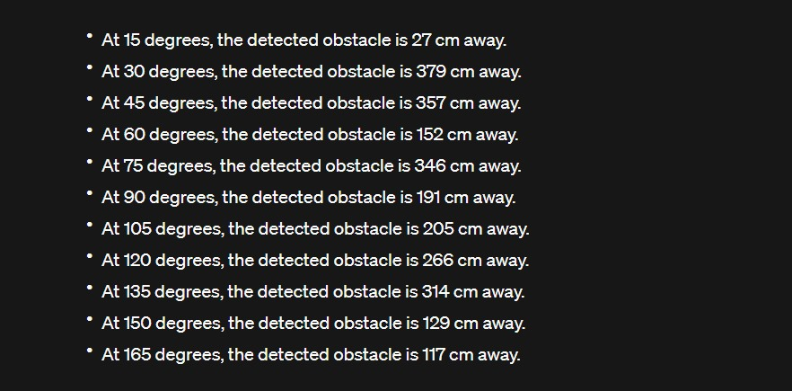

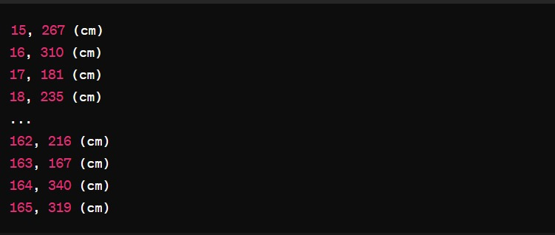

**Chapter 6: NEW LEARNINGS FROM THE TOPIC**

* Understanding the pin configurations and wiring of Arduino boards and peripheral components.
* Learning to interface the Arduino with the breadboard for temporary circuit connections and prototyping.
* Gaining practical insights into the application of IoT technology in object detection scenarios, such as obstacle avoidance systems in robotics.
* Understanding the potential implications and limitations of deploying IoT solutions in real-world environments, including considerations for power consumption, reliability, and scalability.
* Fostering teamwork and effective communication among group members to distribute tasks and coordinate project development.
* Leveraging individual strengths and expertise to troubleshoot challenges and optimize project performance.
* Embracing a collaborative problem-solving approach to overcome obstacles and achieve project objectives.

**REFERENCES AND ANNEXURES**

1. Paulo Costa School of Technology and Management Computer Graphics and Sound Research/CCIC Polytechnic Institute of Leiria Leiria, Portugal paulo.costa@ipleiria.pt Hugo Fernandes, João Barroso, Hugo Paredes-“Obstacle detection and avoidance module for the blind”
2. Daniyal Rajput, Faheem Ahmed, Habib Ahmed, Engr Zakir Ahmed Shaikh, Aamir Shamshad Institute Of Biomedical Technology, Liaquat University Of Medical & Health Sciences Jamshoro, and Mehran University of Engineering and Technology,Jamshoro,Pakistan-“Smart Obstacle Detector for Blind Person”
3. https://www.youtube.com/watch?v=JvmIutmQd9U