VISVESVARAYA TECHNOLOGICAL UNIVERSITY

“JnanaSangama”, Belgaum -590014, Karnataka.



VERILOG LABORATORY REPORT

Submitted by

**HARSHITHA R(1BM21CS075)**

**KANJIKA SINGH(1BM21CS086)**

**NEHA BHASKAR KAMATH(1BM21CS113)**

in partial fulfilment for the award of the degree of

**BACHELOR OF ENGINEERING**

in

**COMPUTER SCIENCE AND ENGINEERING**



**B.M.S. COLLEGE OF ENGINEERING**

**(Autonomous Institution under VTU)**

**BENGALURU-560019**

**Oct 2022-Feb 2023**

**B. M. S. College of Engineering,**

**Bull Temple Road, Bangalore 560019**

**(Affiliated To Visvesvaraya Technological University, Belgaum)**

**Department of Computer Science and Engineering**



**CERTIFICATE**

This is to certify that the Lab work entitled “**LOGIC DESIGN**” carried out by, **HARSHITHA R(1BM21CS075), KANJIKA SINGH(1BM21CS086)** and **NEHA BHASKAR KAMATH(1BM21CS113)** , who are bonafide students of B. M. S. College of Engineering. It is in partial fulfilment for the award of Bachelor of Engineering in Computer Science and Engineering of the Visvesvaraya Technological University, Belgaum during the year 2022-23.

The Lab report has been approved as it satisfies the academic requirements in respect of **LOGIC DESIGN- (22CS3PCLOD)** work prescribed for the said degree.

|  |  |
| --- | --- |
| Marks | |
| Max. Marks | Obtained |
| **10** |  |
| Marks in Words | |
|  | |

**Signature of the staff in-charge                      Head of the Department**

**Date:**

**TABLE OF CONTENTS**

|  |  |  |
| --- | --- | --- |
| **Sl.No** | **Experiment title** | **Pg.No** |
|  | CYCLE 1:  STRUCTURAL MODELLING |  |
| 1 | Write HDL implementation for the following Logic AND/OR/NOT  Simulate the same using structural model and depict the timing diagram for valid inputs. | 5-6 |
| 2 | Write HDL implementation for the following Logic NAND/NOR  Simulate the same using structural model and depict the timing diagram for valid inputs. | 7 |
| 3 | Write HDL implementation for the following Boolean expression: A'C' + A'C + AB'  Simulate the same using structural model and depict the timing diagram for valid inputs. | 8 |
| 4 | Write HDL implementation for a 8:1 Multiplexer. Simulate the same using structural model and dipict the timing diagram for valid inputs. | 9-10 |
| 5 | Write HDL implementation for a 2-to-4 decoder. Simulate the same using structural model and depict the timing diagram for valid inputs. | 11-12 |
| 6 | Write HDL implementation for a 4-to-2 encoder. Simulate the same using structural model and depict the timing diagram for valid inputs. | 13-14 |
|  | CYCLE 2:  BEHAVIOR MODELLING |  |
| 7 | Write HDL implementation for a RS flip-flop using behavioral model. Simulate the same using Behavior model and depict the timing diagram for valid inputs. | 15-16 |
| 8 | Write HDL implementation for a JK flip-flop using behavioral model. Simulate the same using Behavior model and depict the timing diagram for valid inputs. | 17-18 |
| 9 | Write HDL implementation for a 4-bit right shift register using behavioral model. Simulate the same using Behavior model and depict the timing diagram for valid inputs. | 19 |
| 10 | Write HDL implementation for a 3-bit down-counter using behavioral model. Simulate the same using Behavior model and depict the timing diagram for valid inputs. | 20 |
|  | CYCLE 3:  DATAFLOW MODELLING |  |
| 11 | Write HDL implementation for NAND/NOR/EXOR gates using data flow model. Simulate the same using Dataflow model and depict the timing diagram for valid inputs. | 21-22 |
| 12 | Write HDL implementation for a 3-bit full adder using data flow model. Simulate the same using Dataflow model and depict the timing diagram for valid inputs. | 23-24 |

**CYCLE 1: STRUCTURAL MODELLING**

**EXPERIMENT 1**

Write HDL implementation for the following Logic AND/OR/NOT.

Simulate the same using structural model and depict the timing diagram for valid inputs.

**PROGRAM**

module AND_OR_NOT( output and1,or1,not1,input A, B);

and(and1, A, B);

or(or1,A,B);

not(not1,B);

endmodule

module testbench;

reg A,B;

wire and1,or1,not1;

AND_OR_NOT g(and1,or1,not1,A,B);

initial

begin

$dumpfile("gates.vcd");

$dumpvars(0,testbench);

A= 1'b0; B=1'b0;

#20

A= 1'b0; B=1'b1;

#20

A= 1'b1; B=1'b0;

#20

A= 1'b1; B=1'b1;

#20

$finish;

end

endmodule

**COMPILATION, EXECUTION AND RESULT OF SIMULATION**

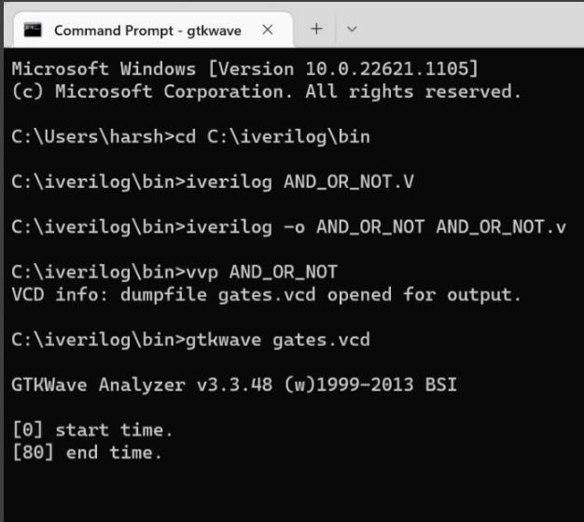

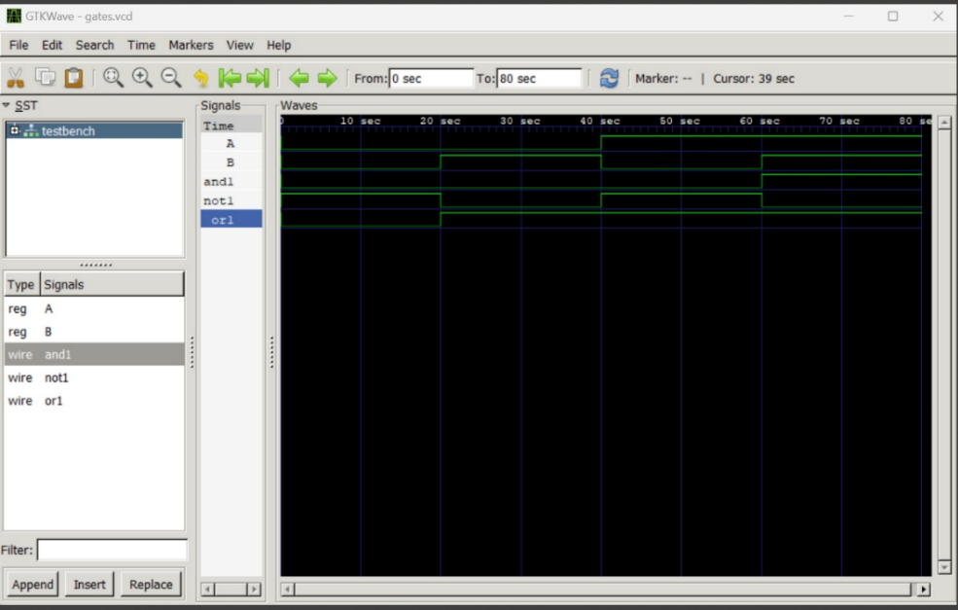

**EXPERIMENT 2**

Write HDL implementation for the following Logic NAND/NOR.

Simulate the same using structural model and depict the timing diagram for valid inputs.

**PROGRAM**

module NAND_NOR(output Y1,Y2, input A, B); wire Yd1,Yd2;

and(Yd1, A, B);

not(Y1, Yd1);

or(Yd2,A,B);

not(Y2,Yd2); endmodule

module NAND_NOR_tb; reg A, B;

wire Y;

NAND_NOR Indtance0 (Y1,Y2, A, B);

initial begin

A = 1'b0; B = 1'b0;

#1 A = 1'b0; B = 1'b1; #1 A = 1'b1; B = 1'b0; #1 A = 1'b1; B = 1'b1;

#1 $finish; end

initial begin

$dumpfile("dump.vcd");

$dumpvars(); end endmodule

**COMPILATION, EXECUTION AND RESULT OF SIMULATION**

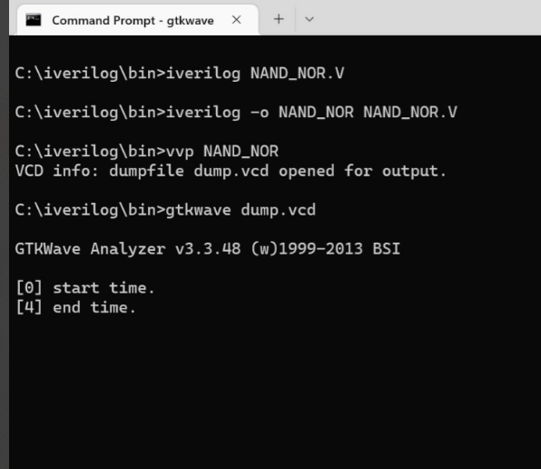

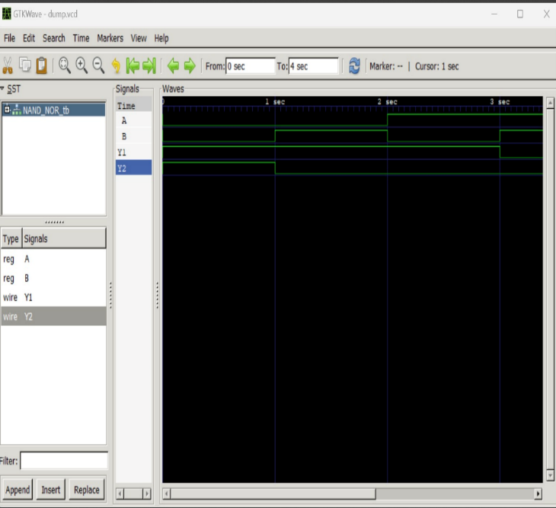

**EXPERIMENT 3**

Write HDL implementation for the following Boolean expression:

A'C' + A'C + AB'

Simulate the same using structural model and depict the timing diagram for valid inputs.

**PROGRAM**

module bool_exp(a,b,c,y); input a,b,c;

output y;

wire and_op1, and_op2, and_op3, and_op4, and_op5; and g1(and_op1,~a,~c);

and g2(and_op2,~a,c); and g3(and_op3,a,~b);

or g4(and_op4, and_op1, and_op2); or g5(and_op5, and_op3, and_op4); or g6(y, and_op5, and_op4);

endmodule

module testbench; reg a,b,c,d; wire y;

bool_exp ao(a,b,c,y); initial begin

$dumpfile("dump.vcd");

$dumpvars(0,testbench);

a=0;b=0;c=0; #5 a=0;b=0;c=1; #5 a=0;b=1;c=0; #5 a=0;b=1;c=1; #5 a=1;b=0;c=0; #5 a=1;b=0;c=1; #5 a=1;b=1;c=0; #5 a=1;b=1;c=1;

$finish;

end endmodule

**COMPILATION, EXECUTION AND RESULT OF SIMULATION**

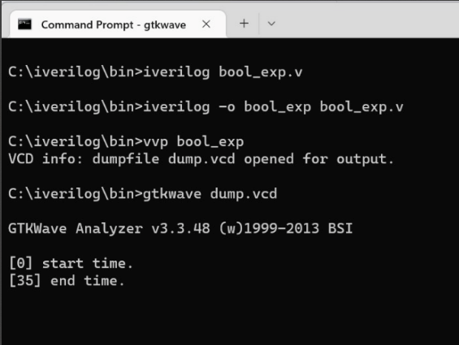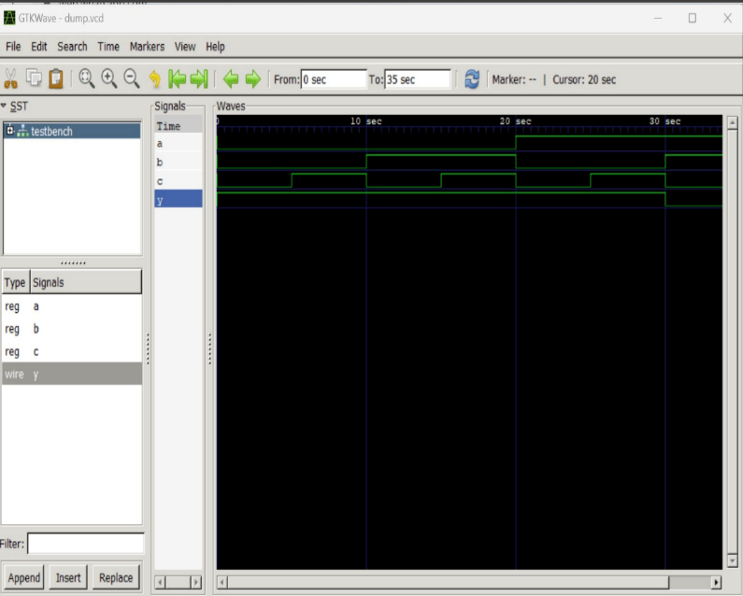

**EXPERIMENT 4**

Write HDL implementation for a 8:1 Multiplexer.

Simulate the same using structural model and depict the timing diagram for valid inputs.

**PROGRAM**

module and_gate(output a, input b, c, d, e); assign a = b & c & d & e;

endmodule

module not_gate(output f, input g); assign f = ~ g;

endmodule

module or_gate(output l, input m, n, o, p, q, r, s, t); assign l = m | n | o | p | q | r | s | t;

endmodule

module m81(out, D0, D1, D2, D3, D4, D5, D6, D7, S0, S1, S2);

output out;

input D0, D1, D2, D3, D4, D5, D6, D7, S0, S1, S2; wire s0bar, s1bar, T1, T2, T3, T4, T5, T6, T7, T8;

not_gate u1(s1bar, S1); not_gate u2(s0bar, S0); not_gate u3(s2bar, S2);

and_gate u4(T1, D0, s0bar, s1bar, s2bar); and_gate u5(T2, D1, S0, s1bar, s2bar); and_gate u6(T3, D2, s0bar, S1, s2bar); and_gate u7(T4, D3, S0, S1, s2bar); and_gate u8(T5, D4, s0bar, s1bar, S2); and_gate u9(T6, D5, S0, s1bar, S2); and_gate u10(T7, D6, s0bar, S1, S2); and_gate u11(T8, D7, S0, S1, S2);

or_gate u12(out, T1, T2, T3, T4, T5, T6, T7, T8);

endmodule

//`timescale 1ns/1ps

module top;

wire out;

reg D0, D1, D2, D3, D4, D5, D6, D7, D8, S0, S1, S2;

m81 name(.D0(D0), .D1(D1), .D2(D2), .D3(D3), .D4(D4), .D5(D5), .D6(D6), .D7(D7), .S0(S0), .S1(S1), .S2(S2), .out(out));

initial begin

$dumpfile("dump.vcd");

$dumpvars(0,top);

D0=1'b0; D1=1'b0; D2=1'b0; D3=1'b0; D4=1'b0; D5=1'b0; D6=1'b0; D7=1'b0;S0=1'b0; S1=1'b0; S2=1'b0;

#500 $finish; end

always #1 D0=~D0;

always #2 D1=~D1;

always #3 D2=~D2;

always #4 D3=~D3;

always #5 D4=~D4;

always #6 D5=~D5;

always #7 D6=~D6;

always #8 D7=~D7;

always #9 S0=~S0;

always #10 S1=~S1;

always #11 S2=~S2;

always@(D0 or D1 or D2 or D3 or D4 or D5 or D6 or D7 or S0 or S1 or S2);

endmodule

**COMPILATION, EXECUTION AND RESULT OF SIMULATION**

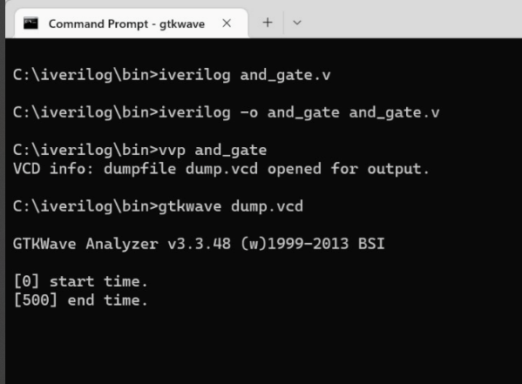

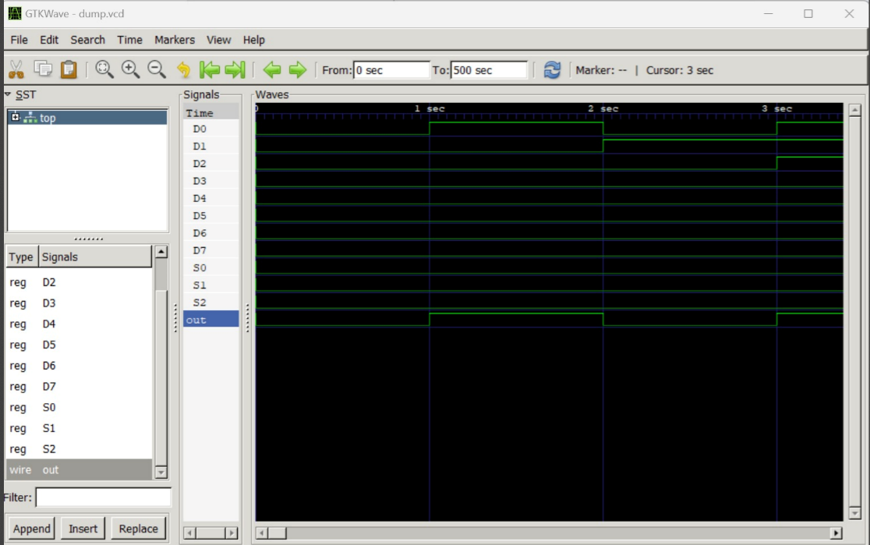

**EXPERIMENT 5**

Write HDL implementation for a 2-to-4 decoder. Simulate the same using structural model and depict the timing diagram for valid inputs.

**PROGRAM**

module bcddecoder2to4(b0, b1, d0, d1, d2, d3); input b0, b1;

output d0, d1, d2, d3; wire t0, t1;

not n1(t0, b0);

not n2(t1, b1);

and a0(d0, t0, t1);

and a1(d1, t0, b1);

and a2(d2, b0, t1);

and a3(d3, b0, b1);

endmodule

module test;

reg b0, b1; wire d0, d1, d2, d3;

bcddecoder2to4 bcdg(b0, b1, d0, d1, d2, d3); initial

begin

$dumpfile("bcd.vcd");

$dumpvars(0, test); b0 = 0; b1 = 0;

#40

b0 = 0; b1 = 1;

#40

b0 = 1; b1 = 0;

#40

b0 = 1; b1 = 1;

#40

$finish;

end endmodule

**COMPILATION, EXECUTION AND RESULT OF SIMULATION**

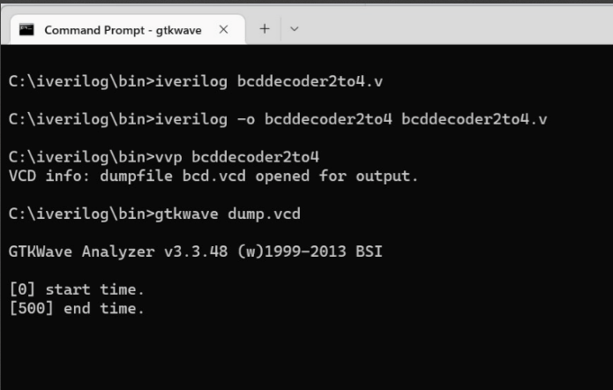

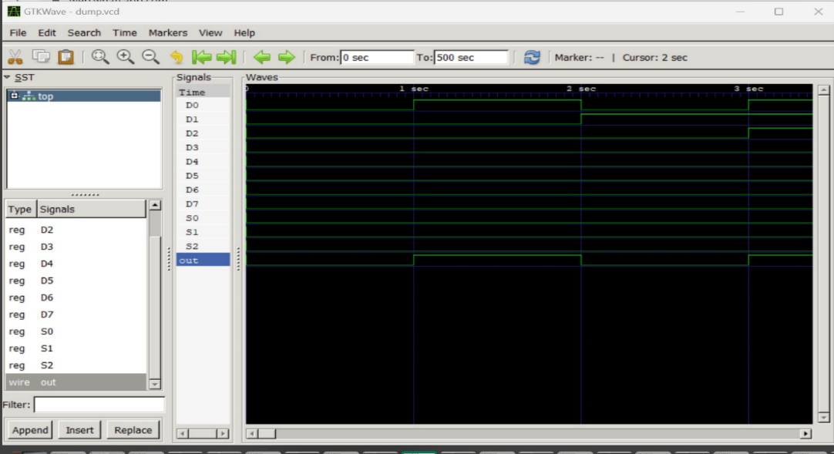

**EXPERIMENT 6**

Write HDL implementation for a 4-to-2 encoder.

Simulate the same using structural model and depict the timing diagram for valid inputs.

**PROGRAM**

module encoder4to2(b0, b1, d0, d1, d2, d3); output b0,b1;

input d0, d1, d2, d3;

wire t0, t1, t2, t3, t4, t5, t6, t7; not n0(t0, d0);

not n1(t1, d1);

not n2(t2, d2);

not n3(t3, d3);

and a0(t4, t0, t1, d2, t3);

and a1(t5, t0, t1, t2, d3);

and a2(t6, t0, d1, t2, t3);

and a3(t7, t0, t1, t2, d3);

or o0(b0, t4, t5);

or o1(b1, t6, t7);

endmodule

module test; wire b0, b1;

reg d0, d1, d2, d3;

encoder4to2 encg(b0, b1, d0, d1, d2, d3); initial

begin

$dumpfile("enc4to2.vcd");

$dumpvars(0, test);

d0 = 1; d1 = 0; d2 = 0; d3 = 0;

#40

d0 = 0; d1 = 1; d2 = 0; d3 = 0;

#40

d0 = 0; d1 = 0; d2 = 1; d3 = 0;

#40

d0 = 0; d1 = 0; d2 = 0; d3 = 1;

#40

$finish; end

Endmodule

**COMPILATION, EXECUTION AND RESULT OF SIMULATION**

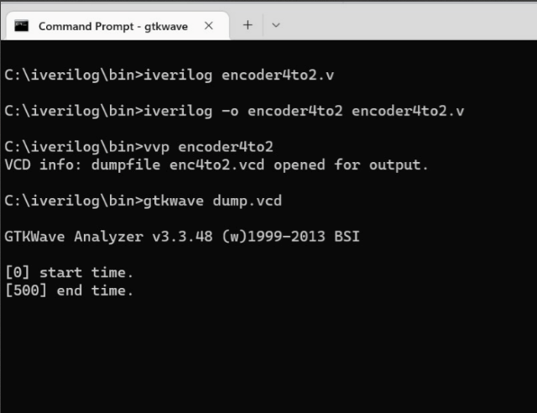

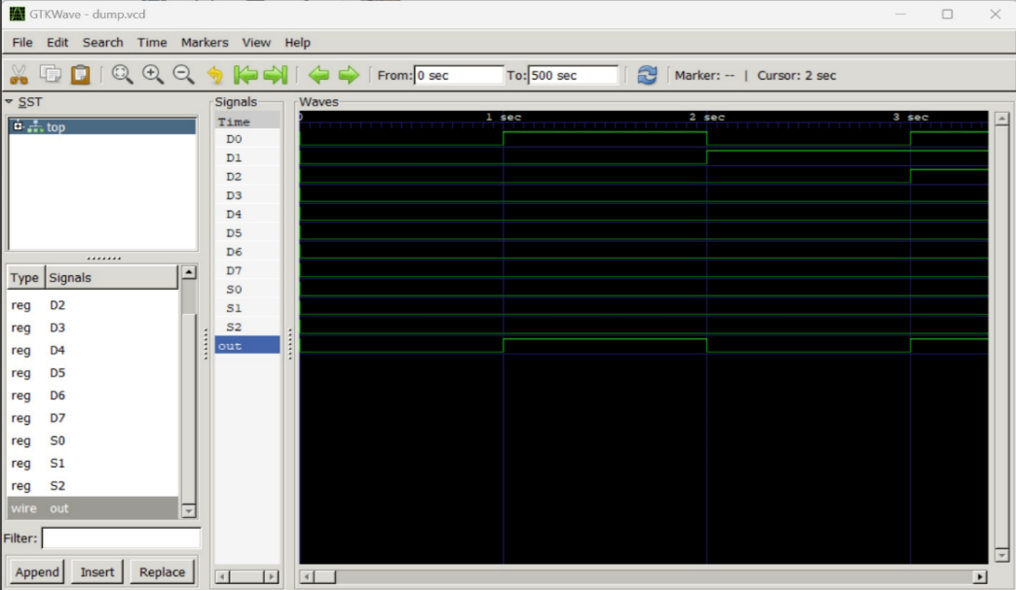

**CYCLE 2: BEHAVIOR MODELLING**

**EXPERIMENT 7**

Write HDL implementation for a RS flip-flop using behavioral model. Simulate the same using Behavior model and depict the timing diagram for valid inputs

**PROGRAM**

module SRFF(sr, clk, q, qb);

input[1:0]sr; input clk;

output reg q=1'b0;

output reg qb;

always@(posedge clk)

begin

case(sr)

2'b00:q=q; 2'b01:q=1'b0;

2'b10:q=1'b1;

2'b11:q=1'bz; endcase

qb=~q;

end

 endmodule

module test_srflipf;

reg[1:0]A; reg c; wire x, xb;

SRFF srff(A, c, x, xb);

initial c=1'b0; always #5 c=~c; initial

begin

$dumpfile("sr.vcd");

$dumpvars(0, test_srflipf);

A=2'b00;#10;

A=2'b01;#10;

A=2'b10;#10;

A=2'b11;

#20 $finish;

end endmodule

**COMPILATION, EXECUTION AND RESULT OF SIMULATION**

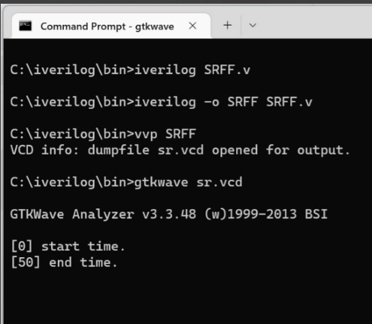

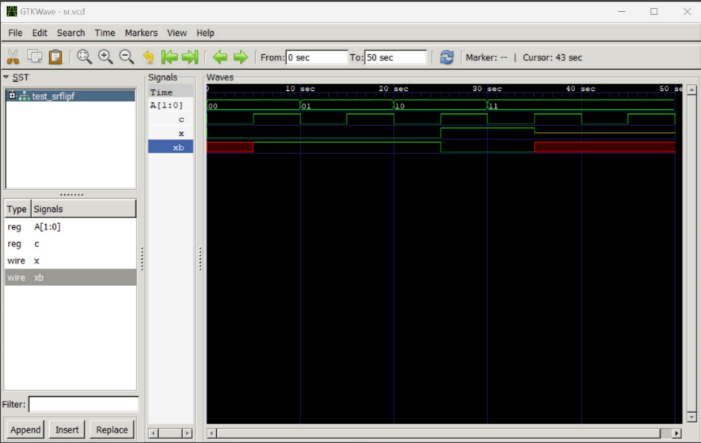

**EXPERIMENT 8**

Write HDL implementation for a JK flip-flop using behavioral model.

Simulate the same using Behavior model and depict the timing diagram for valid inputs.

**PROGRAM**

module JKFF(jk, clk, q, qb);

input[1:0]jk; input clk;

output reg q=1'b0; output reg qb; always@(posedge clk) begin

 case(jk)

2'b00:q=q; 2'b01:q=1'b0;

2'b10:q=1'b1;

2'b11:q=~q; endcase qb=~q;

end

 endmodule

module test_jkflipf; reg[1:0]A;

reg c; wire x, xb;

JKFF jkff(A, c, x, xb); initial  c=1'b0; always #5 c=~c; initial

begin

 $dumpfile("jk.vcd");

$dumpvars(0,test_jkflipf);

A=2'b00;#10;

A=2'b01;#10;

A=2'b10;#10;

A=2'b11;

#20 $finish;

end endmodule

**COMPILATION, EXECUTION AND RESULT OF SIMULATION**

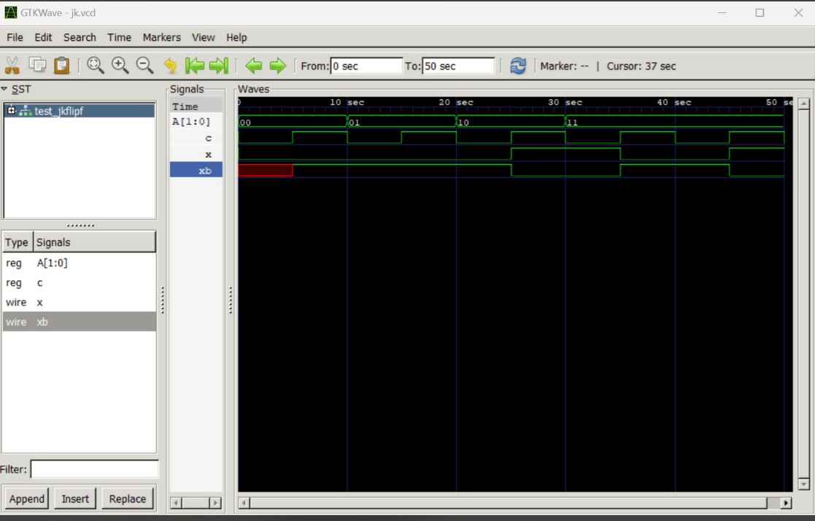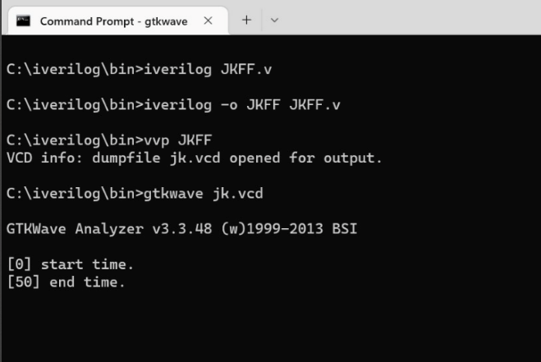

**EXPERIMENT 9**

Write HDL implementation for a 4-bit right shift register using behavioral model.

Simulate the same using Behavior model and depict the timing diagram for valid inputs.

**PROGRAM**

module Rshiftregister(input clk, input clrb, input SDR, output reg[3:0]Q); always@(posedge(clk), negedge(clrb))

if(~clrb) Q<=4'b0000;

else

Q<={SDR, Q[3:1]};

endmodule

module test_Rshiftregister; reg clk, clrb, SDR; wire[3:0]Q;

Rshiftregister RS(clk, clrb, SDR, Q); initial clk = 0;

always #50 clk= ~clk; initial

begin

$dumpfile("test_ShReg.vcd");

$dumpvars(0,test_Rshiftregister); clk=1;

clrb=0; SDR=1; #100;

clrb=1; SDR=1; #150; SDR=0;

#200 $finish;

end endmodule

**COMPILATION, EXECUTION AND RESULT OF SIMULATION**

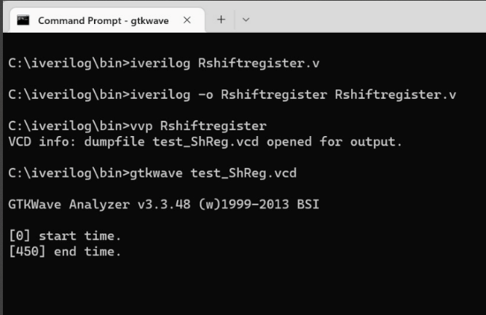

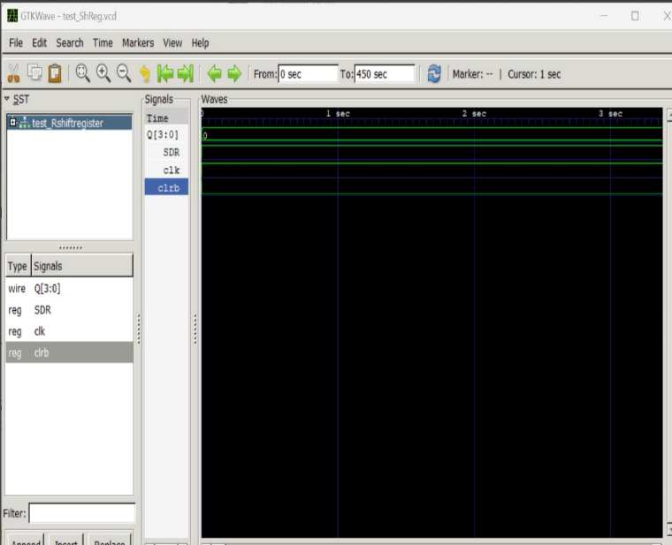

**EXPERIMENT 10**

Write HDL implementation for a 3-bit down-counter using behavioral model.

Simulate the same using Behavior model and depict the timing diagram for valid inputs.

**PROGRAM**

module counter_down(count,rst,clk);

input rst,clk;

output reg[2:0] count; always@(posedge clk) if(rst)

count<=3'b000;

else

count<=count-1;

 endmodule

module testbench; reg r, c;

wire [2:0] ct;

counter_down countd(ct,r,c);

initial begin

$dumpfile("counter.vcd");

$dumpvars(0,testbench); r=1;

c=8; #100; r=0; #200

$finish;

end

always #5 c=~c;

endmodule

**COMPILATION, EXECUTION AND RESULT OF SIMULATION**

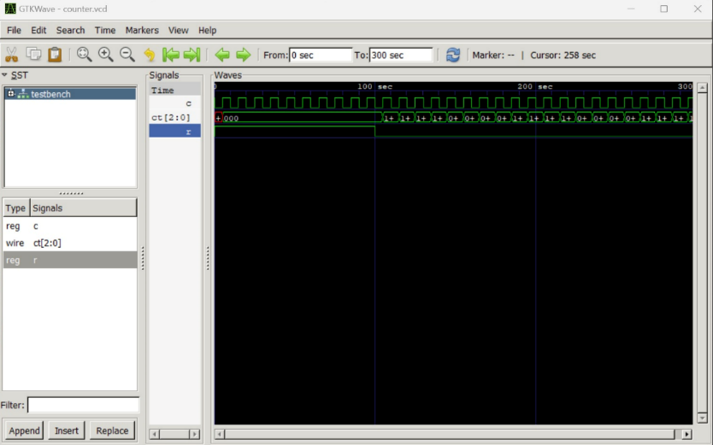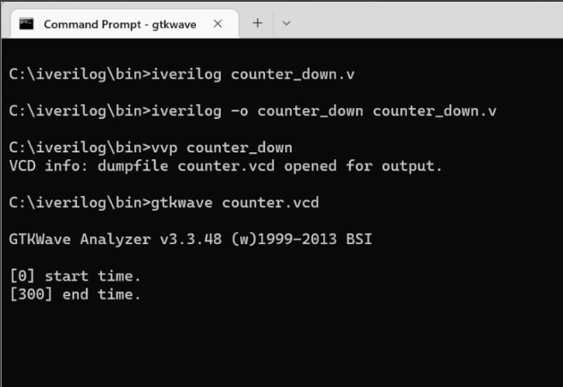

**CYCLE 3: DATAFLOW MODELLING**

**EXPERIMENT 11**

Write HDL implementation for NAND/NOR/EXOR gates using data flow model.

Simulate the same using Dataflow model and depict the timing diagram for valid inputs.

**PROGRAM**

module NAND_NOR_EXOR (output nand1,nor1,exor1, input A, B);

assign nand1= ~(A & B);

assign nor1=~(A+B);

assign exor1 = A ^ B;

endmodule

module NAND_NOR_EXOR_tb;

reg A, B;

wire nand1,nor1,exor1;

NAND_NOR_EXOR Indtance (nand1,nor1,exor1, A, B);

initial begin

A = 1'b0; B = 1'b0; #1 A = 1'b0; B = 1'b1; #1 A = 1'b1; B = 1'b0; #1 A = 1'b1; B = 1'b1;

#1 $finish; end

initial begin

$dumpfile("dump.vcd");

$dumpvars();

end

endmodule

**COMPILATION, EXECUTION AND RESULT OF SIMULATION**

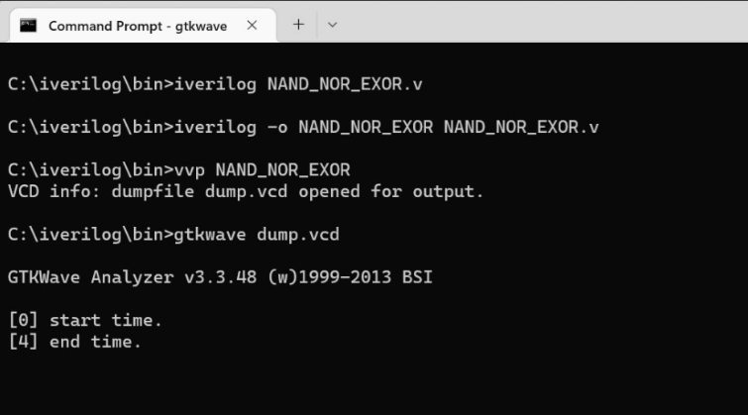

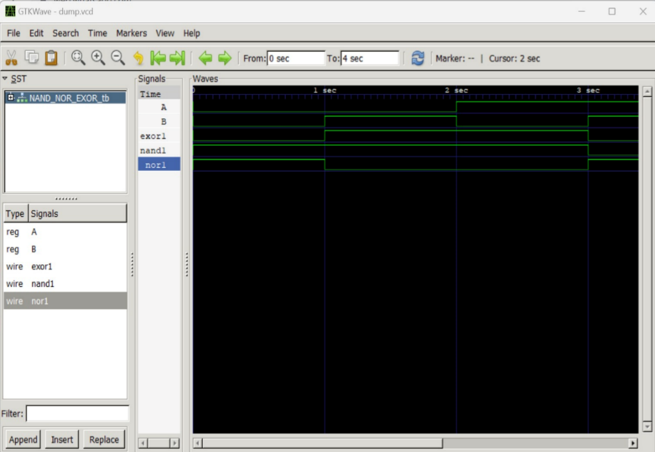

**EXPERIMENT 12**

Write HDL implementation for a 3-bit full adder using data flow model.

Simulate the same using Dataflow model and depict the timing diagram for valid inputs.

**PROGRAM**

module adder3bit(input a, input b, input cin, output s, output cout);

assign s = a^b^cin;

assign cout = (a & b) | (a & cin) | (b & cin);

 endmodule

module test;

reg a, b, cin; wire s, cout;

adder3bit Full(a,b,cin,s,cout);

initial

begin

$dumpfile("Fulladder.vcd");

$dumpvars(0,test); a=1;

b=1;

cin =0; #5 a=1;

b=1;

cin = 1; #5 a=0;

b=1;

cin = 0;#5

#10 $finish;

end

 endmodule

**COMPILATION, EXECUTION AND RESULT OF SIMULATION**

