VISVESVARAYA TECHNOLOGICAL UNIVERSITY

“JnanaSangama”, Belgaum -590014, Karnataka.



LAB REPORT

on

**OBJECT ORIENTED JAVA**

Submitted by

**NAME: NEHA BHASKAR KAMATH**

**USN: 1BM21CS113**

in partial fulfilment for the award of the degree of

**BACHELOR OF ENGINEERING**

in

**COMPUTER SCIENCE AND ENGINEERING**



**B.M.S. COLLEGE OF ENGINEERING**

**(Autonomous Institution under VTU)**

**BENGALURU-560019**

**Oct 2022-Feb 2023**

**B. M. S. College of Engineering,**

**Bull Temple Road, Bangalore 560019**

**(Affiliated To Visvesvaraya Technological University, Belgaum)**

**Department of Computer Science and Engineering**



**CERTIFICATE**

This is to certify that the Lab work entitled “**OBJECT ORIENTED JAVA**” carried out by **NEHA BHASKAR KAMATH(1BM21CS113)** , who is bonafide student of B. M. S. College of Engineering. It is in partial fulfilment for the award of Bachelor of Engineering in Computer Science and Engineering of the Visvesvaraya Technological University, Belgaum during the year 2022-23.

The Lab report has been approved as it satisfies the academic requirements in respect of **Object Oriented Java Lab - (22CS3PCOOJ)** work prescribed for the said degree.

Sunayana S         Dr. Jyothi S Nayak

Assistant professor Professor and Head

Department of CSE Department of CSE

BMSCE, Bengaluru BMSCE, Bengaluru

**TABLE OF CONTENTS**

|  |  |  |
| --- | --- | --- |
| **Sl.No** | **Experiment Title** | **Page No** |
| 1 | Develop a Java program to compute the roots of a quadratic equation and the nature of roots. | 4-6 |
| 2 | Develop a Java program to accept and display the details of a student(name, usn), student’s marks and include methods to calculate his/her SGPA. | 7-10 |
| 3 | Develop a Java program to create n book objects, accept the details of each book(name, author,price, number of pages) and display the details using toString() method. | 11-13 |
| 4 | Develop a Java program to create an abstract class named Shape and provide three classes named Rectangle, Triangle and Circle such that each one of the classes extends the class Shape and prints the area of respective shape. | 14-17 |
| 5 | Develop a Java program to create a class Bank and implement the functionality of two kinds of accounts: savings_account and current_account. | 18-26 |
| 6 | Develop a Java program to demostrate exception handling in an inheritance tree. | 27-30 |
| 7 | Develop a Java program which creates two threads, one thread displaying “BMS College of Engineering” once every ten seconds and another displaying “CSE” once every two seconds. | 31-32 |

**COURSE OUTCOME**

|  |  |
| --- | --- |
| CO1 | Apply the knowledge of Java concepts to find the solution for a given problem |
| CO2 | Analyse the given Java application for correctness/functionalities. |
| CO3 | Develop Java programs / applications for a given requirement. |
| CO4 | Conduct practical experiments for demonstrating features of Java |

**LAB PROGRAM 1**

Develop a Java program that prints all real solutions to the quadratic equation ax2+bx+c = 0. Read in a, b, c and use the quadratic formula. If the discriminate b2 -4ac is negative, display a message stating that there are no real solutions.

**JAVA CODE**

import java.util.*;

class Quadratic

{

int a,b,c;

double d,r1,r2;

void check(int x,int y,int z)

{

a=x;

b=y;

z=c;

d=((b*b)-(4*a*c));

if(a==0)

System.out.println("Invalid quadratic expression!\n");

else

{

if(d>0)

{

System.out.println("The roots are real and distinct!\n");

r1=(-b+Math.sqrt(d))/(2*a);

r2=(-b-Math.sqrt(d))/(2*a);

System.out.println("The roots are: "+r1+" and "+r2+".");

}

else if(d<0)

{

System.out.println("The roots are imaginary!");

r1=(-b+Math.sqrt(Math.abs(d)))/(2*a);

r2=(-b-Math.sqrt(Math.abs(d)))/(2*a);

System.out.println("The roots are: "+r1+" and "+r2+".");

}

else if(d==0)

{

System.out.println("The roots are real and equal!");

r1=(-b)/(2*a);

r2=(-b)/(2*a);

System.out.println("The roots are: "+r1+" and "+r2+".");

}

}

}

}

public class oojLabProg1

{

public static void main(String args[])

{

Quadratic ob= new Quadratic();

Scanner sc=new Scanner(System.in);

System.out.println("Enter the values of quadratic coefficients a, b and c:");

ob.a=sc.nextInt();

ob.b=sc.nextInt();

ob.c=sc.nextInt();

ob.check(ob.a, ob.b, ob.c);

sc.close();

}

**}**

**OUTPUT**

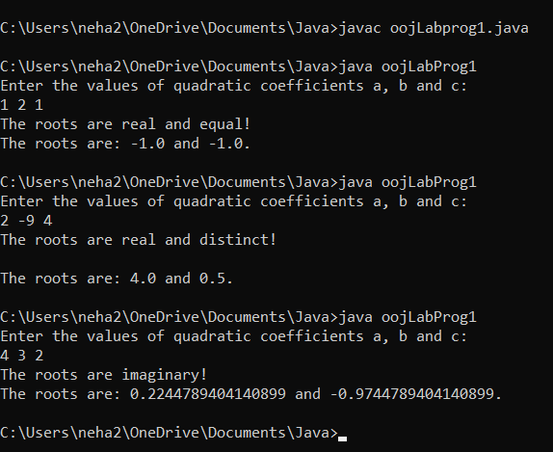

**LAB PROGRAM 2**

Develop a Java program to create a class Student with members usn, name, an array credits and an array marks. Include methods to accept and display details and a method to calculate SGPA of a student.

**JAVA CODE**

import java.util.*;

class Student

{

String usn,name;

int credits[]=new int[10];

int see[]=new int[10];

int cie[]=new int[10];

void initialise(String usn,String name)

{

this.usn=usn;

this.name=name;

}

void display()

{

System.out.println("Name: "+this.name);

System.out.println("USN: "+this.usn);

}

void calculate(int cred[],int s[],int c[])

{

double sgpa;

double sum=0.0;

credits=cred;

see=s;

cie=c;

int t_cred=0;

for(int i=0;i<7;i++)

{

t_cred=t_cred+cred[i];

if(c[i]<20)

sum=sum+0.0;

else

{

if(s[i]>=90 && s[i]<=100)

sum=sum+credits[i]*10;

if(s[i]>=80 && s[i]<=89)

sum=sum+credits[i]*9;

if(s[i]>=70 && s[i]<=79)

sum=sum+credits[i]*8;

if(s[i]>=60 && s[i]<=69)

sum=sum+credits[i]*7;

if(s[i]>=55 && s[i]<=59)

sum=sum+credits[i]*6;

if(s[i]>=50 && s[i]<=54)

sum=sum+credits[i]*5;

if(s[i]>=40 && s[i]<=49)

sum=sum+credits[i]*4;

if(s[i]>=0 && s[i]<=39)

sum=sum+credits[i]*0;

}

}

System.out.println("Total credits: "+t_cred);

sgpa=sum/t_cred;

System.out.println("SGPA: "+sgpa);

}

}

public class oojLabProg2

{

public static void main(String args[])

{

int cred[]=new int[7];

int s[]=new int[7];

int c[]=new int[7];

Scanner sc=new Scanner(System.in);

System.out.println("Enter your name:");

String n=sc.nextLine();

System.out.println("Enter your usn:");

String u=sc.nextLine();

System.out.println("Maths "+"Physics "+"BEE "+"ECM " +"IDT "+"EVI "+"English");

System.out.println("Enter the credits:");

for(int i=0;i<7;i++)

{

cred[i]=sc.nextInt();

}

System.out.println("Enter cie marks:");

for(int i=0;i<7;i++)

{

c[i]=sc.nextInt();

}

System.out.println("Enter see marks:");

for(int i=0;i<7;i++)

{

s[i]=sc.nextInt();

}

Student st=new Student();

st.initialise(u,n);

st.display();

st.calculate(cred,s,c);

}

}

**OUTPUT**

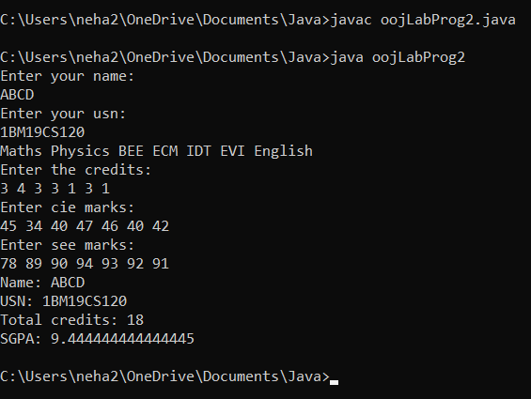

**LAB PROGRAM 3**

Create a class Book which contains four members: name, author, price, num_pages. Include a constructor to set the values for the members. Include methods to set and get the details of the objects. Include a toString( ) method that could display the complete details of the book. Develop a Java program to create n book objects.

**JAVA CODE**

import java.util.*;

class Book{

String name,author;

double price;

int num_pages;

Book(){

name="\0";

author="\0";

price=0.0;

num_pages=0;

}

void get()

{

Scanner sc=new Scanner(System.in);

System.out.println("Enter the name of the book:");

this.name=sc.nextLine();

System.out.println("Enter the author's name:");

this.author=sc.nextLine();

System.out.println("Enter the price of the book:");

this.price=sc.nextDouble();

System.out.println("Enter the number of pages:");

this.num_pages=sc.nextInt();

}

public String toString()

{

String s="Name of the book: "+this.name+"\nAuthor of the book: "+this.author+"\nPrice: "+this.price+"\nNumber of pages: "+this.num_pages;

return s;

}

}

class oojLabProg3

{

public static void main(String args[])

{

int n;

Scanner sc=new Scanner(System.in);

System.out.println("Enter the number of books:");

n=sc.nextInt();

Book b1[]=new Book[n];

for(int i=0;i<n;i++)

{

b1[i]=new Book();

System.out.println("Enter book "+(i+1)+" details");

b1[i].get();

}

for(int i=0;i<n;i++)

{

System.out.println("Book "+(i+1)+" details");

System.out.println(b1[i]);

}

}

}

**OUTPUT**

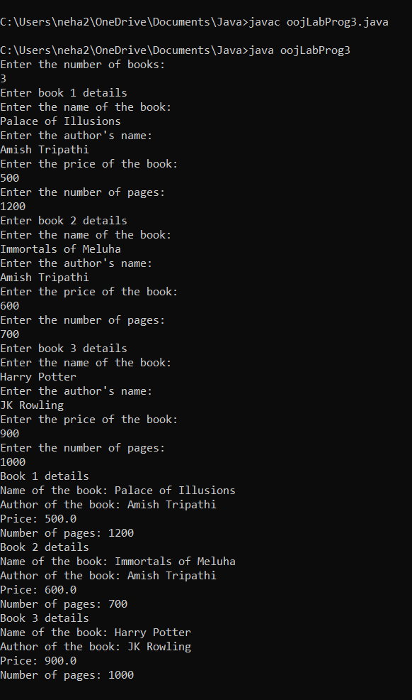

**LAB PROGRAM 4**

Develop a Java program to create an abstract class named Shape that contains two integers and an empty method named printArea( ). Provide three classes named Rectangle, Triangle and Circle such that each one of the classes extends the class Shape. Each one of the classes contain only the method printArea( ) that prints the area of the given shape.

**JAVA CODE**

import java.util.*;

abstract class Shape

{

int a,b;

abstract public void printArea();

void assign_twovar(int x,int y)

{

a=x;

b=y;

}

void assign_onevar(int x)

{

a=x;

}

}

class Rectangle extends Shape

{

public void printArea()

{

System.out.println("The area of rectangle is "+(a*b)+"cm sq");

}

}

class Triangle extends Shape

{

public void printArea()

{

System.out.println("The area of triangle is "+(0.5*a*b)+"cm sq");

}

}

class Circle extends Shape

{

public void printArea()

{

System.out.println("The area of circle is "+(3.14*a*a)+"cm sq");

}

}

public class Main

{

public static void main(String args[])

{

Scanner sc=new Scanner(System.in);

int c,dim1,dim2;

while(true)

{

System.out.println("Enter 1 to find area of rectangle.\nEnter 2 to find area of triangle.\nEnter 3 to find area of circle.\nEnter 4 to exit!");

c=sc.nextInt();

switch(c)

{

case 1:

Rectangle rec=new Rectangle();

System.out.println("Enter the length and breadth of rectangle in cm:");

dim1=sc.nextInt();

dim2=sc.nextInt();

rec.assign_twovar(dim1,dim2);

rec.printArea();

break;

case 2:

Triangle tri=new Triangle();

System.out.println("Enter the length and height of triangle in cm:");

dim1=sc.nextInt();

dim2=sc.nextInt();

tri.assign_twovar(dim1,dim2);

tri.printArea();

break;

case 3:

Circle cir=new Circle();

System.out.println("Enter the radius of circle in cm:");

dim1=sc.nextInt();

cir.assign_onevar(dim1);

cir.printArea();

break;

case 4:

System.exit(0);

default:

System.out.println("You have entered a wrong choice!");

sc.close();

}}}}

**OUTPUT:**

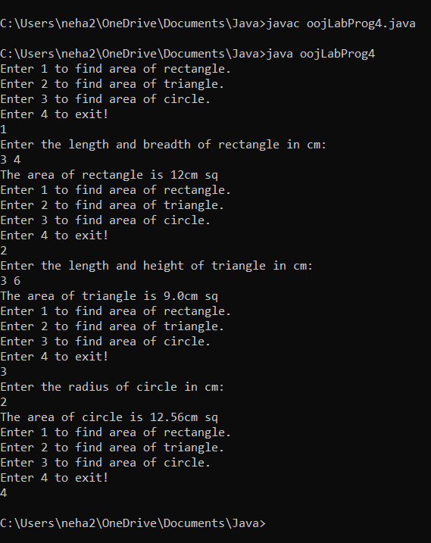

**LAB PROGRAM 5**

Develop a Java program to create a class Bank that maintains two kinds of account for its customers, one called savings account and the other current account. The savings account provides compound interest and withdrawal facilities but no cheque book facility. The current account provides cheque book facility but no interest. Current account holders should also maintain a minimum balance and if the balance falls below this level, a service charge is imposed. Create a class Account that stores customer name, account number and type of account. From this derive the classes Cur-acct and Sav-acct to make them more specific to their requirements. Include the necessary methods in order to achieve the following tasks:

a) Accept deposit from customer and update the balance.

b) Display the balance.

c) Compute and deposit interest

d) Permit withdrawal and update the balance

Check for the minimum balance, impose penalty if necessary and update the balance.

**JAVA CODE**

import java.util.*;

class Account

{

Scanner sc=new Scanner(System.in);

int type_acc;

double withdraw,deposit,balance;

void checkbal(double bal)

{

balance=bal;

}

}

class Current_Account extends Account

{

Scanner sc=new Scanner(System.in);

double min_bal=2000.0;

double penalty=0.15*min_bal;

int n;

void penalty()

{

System.out.println("Bal: "+balance);

if(balance<min_bal)

{

System.out.println("Balance amount is less than the minimum balance amount. You have to pay penalty to withdraw!");

System.out.println("Enter 1 to proceed.\nEnter 0 to cancel the withdraw.");

n=sc.nextInt();

if(n==1)

{

System.out.println("Penalty: "+penalty);

balance=balance-penalty;

System.out.println("Penalty deducted!");

System.out.println("The balance amount is: "+balance);

}

else

System.out.println("Withdraw cancelled!");

}

else

{

System.out.println("Enter the amount to be withdrawn:");

withdraw=sc.nextDouble();

if(withdraw<balance)

{

balance=balance-withdraw;

System.out.println("Amount in your bank account: "+balance);

}

else

System.out.println("Insufficient balance!");

}

}

void deposit()

{

System.out.println("Enter the amount to be deposited:");

deposit=sc.nextDouble();

balance=balance+deposit;

System.out.println("Amount in your bank account: "+balance);

}

}

class Savings_Account extends Account

{

double inter;

Scanner sc=new Scanner(System.in);

void interest()

{

double time,rate;

System.out.println("Enter the time in years:");

time=sc.nextDouble();

System.out.println("Enter the rate of interest:");

rate=sc.nextDouble();

System.out.println("Interest will be compounded 5 times a year!");

inter=balance*(Math.pow((1+rate/5),(5*time)));

balance=balance+inter;

System.out.println("Interest: "+inter);

System.out.println("Amount in your bank account: "+balance);

}

void withdraw()

{

System.out.println("Enter the amount to be withdrawn:");

withdraw=sc.nextDouble();

if(withdraw<balance)

{

balance=balance-withdraw;

System.out.println("Amount in your bank account: "+balance);

}

else

System.out.println("Insufficient balance!");

}

void deposit()

{

System.out.println("Enter the amount to be deposited:");

deposit=sc.nextDouble();

balance=balance+deposit;

System.out.println("Amount in your bank account: "+balance);

}

}

public class oojLabProg5

{

public static void main(String args[])

{

int type_acc;

double balance;

Scanner sc=new Scanner(System.in);

int choice;

Current_Account curr= new Current_Account();

Savings_Account save=new Savings_Account();

System.out.println("Enter your name:");

String cust_name=sc.nextLine();

System.out.println("Enter the account number:\n");

int acc_no=sc.nextInt();

System.out.println("Enter 1 if it's a Current account.\nEnter 2 if it's a Savings account.");

type_acc=sc.nextInt();

System.out.println("Name: "+cust_name);

System.out.println("Account number: "+acc_no);

switch(type_acc)

{

case 1:

System.out.println("This is current account!");

System.out.println("Enter the balance amount in your account:");

balance=sc.nextDouble();

curr.checkbal(balance);

while(true)

{

System.out.println("Enter 1 to withdraw\nEnter 2 to deposit\nEnter 3 to exit");

choice=sc.nextInt();

switch(choice)

{

case 1:

curr.penalty();

break;

case 2:

curr.deposit();

break;

case 3:

System.exit(0);

default:

System.out.println("Invalid choice!");

break;

}

}

//break;

case 2:

System.out.println("This is Savings account!");

System.out.println("Enter the balance amount in your account:");

balance=sc.nextDouble();

save.checkbal(balance);

while(true)

{

System.out.println("Enter 1 to withdraw\nEnter 2 to deposit\nEnter 3 to check your balance after interest\nEnter 4 to exit");

choice=sc.nextInt();

switch(choice)

{

case 1:

save.withdraw();

break;

case 2:

save.deposit();

break;

case 3:

save.interest();

break;

case 4:

System.exit(0);

default:

System.out.println("Invalid choice!");

break;

}

}

//break;

case 3:

System.exit(0);

default:

System.out.println("Invalid Choice!\n");

sc.close();

}

}

}

**OUTPUT**

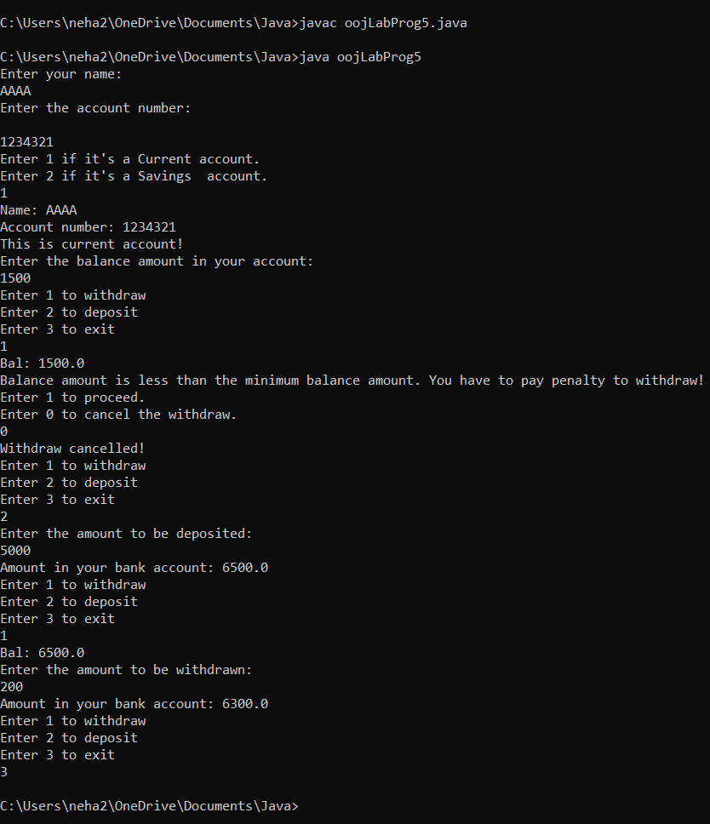

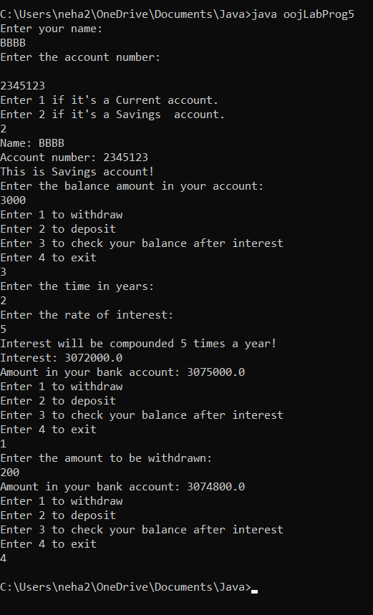

**LAB PROGRAM 6**

Write a program that demonstrates handling of exceptions in inheritance tree. Create a base class called “Father” and derived class called “Son” which extends the base class. In Father class, implement a constructor which takes the age and throws the exception WrongAge( ) when the input age=father’s age.

**JAVA CODE**

import java.util.*;

class WrongAge extends Exception

{

int a;

String s;

WrongAge(int x)

{

a=x;

}

public String toString()

{

if(a<=0)

s="Invalid Age!";

return s;

}

}

class WrongSonAge extends Exception

{

int s_a,f_a;

String str;

WrongSonAge(int x, int y)

{

s_a=x;

f_a=y;

}

public String toString()

{

if(s_a>=f_a)

str= "Son's age cannot be more than or equal to father's age!";

return str;

}

}

class Father

{

Scanner sc=new Scanner(System.in);

int f_age;

Father() throws WrongAge

{

System.out.println("Enter father's age:");

f_age=sc.nextInt();

if(f_age<=0)

throw new WrongAge(f_age);

}

}

class Son extends Father

{

Scanner sc=new Scanner(System.in);

int son_age;

Son() throws WrongAge

{

System.out.println("Enter son's age:");

son_age=sc.nextInt();

}

void check()throws WrongAge{

if(son_age<=0)

throw new WrongAge(son_age);

}

void compare() throws WrongSonAge

{

if(son_age>=f_age)

throw new WrongSonAge(son_age,f_age);

else

{

System.out.println("Father's age: "+f_age);

System.out.println("Son's age: "+son_age);

}

}

}

public class oojLabProg6

{

public static void main(String[] args)

{

Scanner sc=new Scanner(System.in);

try

{

Son obj2=new Son();

obj2.check();

obj2.compare();

}

catch(WrongAge e)

{

System.out.println(e);

}

catch(WrongSonAge e)

{

System.out.println(e);

}

sc.close();

}

}

**OUTPUT**

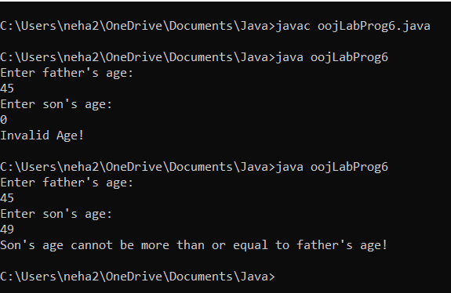

**LAB PROGRAM 7**

Write a program which creates two threads, one thread displaying “BMS College of Engineering” once every ten seconds and another displaying “CSE” once every two seconds.

**JAVA CODE**

class Thread1 extends Thread

{

public void run()

{

try

{

for(int i=1;i<=5;i++)

{

System.out.println("BMS College of Engineering");

Thread.sleep(10000);

}

}

catch(InterruptedException e)

{

System.out.println(e);

}

}

}

class Thread2 extends Thread

{

public void run()

{

try

{

for(int i=1;i<=5;i++)

{

System.out.println("CSE");

Thread.sleep(2000);

}

}

catch(InterruptedException e)

{

System.out.println(e);

}

}

}

public class oojLabProg8

{

public static void main(String args[])

{

Thread1 t1=new Thread1();

t1.start();

Thread2 t2=new Thread2();

t2.start();

}

}

**OUTPUT**

