**VISVESVARAYA TECHNOLOGICAL UNIVERSITY**

**“JnanaSangama”, Belgaum -590014, Karnataka.**



## SEO&OOMD AAT REPORT

### on

Automated Vehicle parking system

***Submitted by***

**Neha Bhaskar Kamath(1BM21CS113)**

***Under the Guidance of***

### Prof. Seema Patil

### Assistant Professor, BMSCE

***in partial fulfillment for the award of the degree of***

**BACHELOR OF ENGINEERING**

***in***

## COMPUTER SCIENCE AND ENGINEERING



**B.M.S. COLLEGE OF ENGINEERING**

**(Autonomous Institution under VTU)**

## BENGALURU-560019

### March 2024 to June 2024

**B. M. S. College of Engineering,**

**Bull Temple Road, Bangalore 560019**

(Affiliated To Visvesvaraya Technological University, Belgaum)

**Department of Computer Science and Engineering**



#### CERTIFICATE

This is to certify that the AAT work entitled “Automated Vehicle parking system”

is carried out by **Neha Bhaskar Kamath (1BM21CS113)** who is bonafide students of **B.M.S. College of Engineering.** It is in partial fulfillment for the award of **Bachelor of Engineering in Computer Science and Engineering** of the Visveswaraya Technological University, Belgaum during the year 2023-2024. The AAT report has been approved as it satisfies the academic requirements in respect of **SE&OOMD(22CS6PCSEO)** work prescribed for the said degree.

Signature of the Guide Signature of the HOD

Prof. Seema Patil Dr. Jyothi S Nayak

Assistant Professor Prof.& Head, Dept. of CSE

BMSCE, Bengaluru BMSCE, Bengaluru

## B.M.S. COLLEGE of ENGINEERING

**DEPARTMENT OF COMPUTER SCIENCE AND ENGINEERING**



#### DECLARATION

I, **Neha Bhaskar Kamath,** the student of 6th Semester, B.E, Department of Computer Science and Engineering, B. M. S. College of Engineering, Bangalore, hereby declare that, this AAT entitled "Automated vehicle parking system" has been carried out by us under the guidance of Prof. Seema Patil, Assistant Professor, Department of CSE, B. M. S. College of Engineering, Bangalore during the academic semester March 2024 to June 2024.

I also declare that to the best of my knowledge and belief, the development reported here is not from part of any other report by any other students.

**Table of contents**

|  |  |  |
| --- | --- | --- |
| **Sl. No** | **Title** | **Page. No** |
| 1 | Problem statement | 5 |
| 2 | Software Requirement Specification | 6-10 |
| 3 | Class diagram | 11-12 |
| 4 | State diagram | 13 |
| 5 | Sequence diagram | 14 |
| 6 | Activity diagram | 15-16 |
| 7 | Use case diagram | 17 |
| 8 | Conclusion | 18 |

**Chapter 1: Problem statement**

In urban environments, finding a parking space is often a time-consuming and frustrating task. With increasing vehicle ownership and limited parking spaces, the need for an efficient parking management system has become paramount. The Automated Vehicle Parking System (AVPS) aims to alleviate this problem by providing a seamless, user-friendly, and efficient solution for parking management. This system automates the entire process of parking from reservation to payment, ensuring a hassle-free experience for users.

The Automated Vehicle Parking System is designed to minimize the time and effort required for users to find and reserve parking spaces. By automating the processes of space allocation, navigation, and payment, the system reduces human intervention and enhances operational efficiency. Additionally, the system focuses on delivering an intuitive and user-friendly interface, ensuring that users can easily interact with the various features. The system also aims to facilitate seamless payment transactions, maintaining accurate records of parking fees and contributing to effective revenue management for parking facility operators.

The scope of the Automated Vehicle Parking System encompasses several critical functionalities. First, it includes a secure login mechanism to authenticate users, ensuring that only authorized individuals can access the system. Once logged in, users are provided with a reservation interface where they can check the availability of parking spaces and make reservations. The system automatically notifies users if no spaces are available, saving them time and effort. If a space is available, users can select their desired parking spot and proceed to pay the reservation charges through an integrated payment gateway.

Upon successful payment, the system provides detailed navigation instructions to guide users to their reserved parking space. Once the user reaches the destination, they can park their vehicle as directed by the system. After parking, the system directs the user to the payment gateway to complete any remaining payment transactions. If the payment is successful, the system displays a confirmation message, signaling the completion of the process. The integration of these functionalities into a cohesive system ensures that the entire parking experience, from reservation to payment, is streamlined and efficient, ultimately enhancing user satisfaction and operational effectiveness.

**Chapter 2: Software Requirement Specification**

**2.1 General Description**

**2.1.1 Purpose**

The purpose of this Software Requirements Specification (SRS) document is to provide a comprehensive description of the Automated Vehicle Parking System (AVPS). This document outlines the system's functionalities, features, and constraints, serving as a guide for developers, stakeholders, and users. The AVPS aims to streamline the parking process in urban environments by automating space reservation, navigation, and payment, thereby enhancing efficiency and user experience.

**2.1.2 Scope**

The AVPS is designed to manage parking spaces in a controlled environment, such as urban parking lots, shopping malls, airports, and office complexes. The system will handle user authentication, parking space reservation, navigation to the reserved space, and payment processing. It will notify users of space availability, provide detailed navigation instructions, and process payments through an integrated gateway. The AVPS is intended to be used by vehicle owners, parking lot administrators, and facility managers.

**2.1.3 System Overview**

The AVPS is composed of several interconnected modules that work together to automate the parking process. These modules include:

User Authentication Module: Manages user login and authentication to ensure secure access.

Reservation Interface Module: Allows users to check parking space availability, make reservations, and pay reservation charges.

Navigation System Module: Provides users with navigation instructions to their reserved parking space.

Payment Gateway Module: Handles the processing of payments for reservations and parking charges.

Notification System Module: Alerts users about space availability, reservation confirmations, payment status, and other important updates.

The system architecture is designed to support scalability and integration with various third-party services such as navigation tools and payment processors. It aims to deliver a seamless user experience while maintaining high standards of security and reliability.

**2.1.4 Product Perspective**

The AVPS is an independent system that interfaces with external components such as navigation tools and payment gateways. It is designed to be deployed in environments with existing parking infrastructure, requiring minimal modifications to integrate with current systems. The system leverages modern web and mobile technologies to provide an intuitive user interface accessible from various devices, including smartphones, tablets, and computers.

**2.1.5 User Classes and Characteristics**

The primary users of the AVPS include:

Vehicle Owners/Drivers: Individuals who use the system to find, reserve, and pay for parking spaces.

Parking Lot Administrators: Personnel responsible for managing parking spaces, monitoring usage, and overseeing the system's operation.

Facility Managers: Individuals who oversee the overall operation and maintenance of the parking facilities.

Each user class has distinct needs and interacts with the system differently. The system provides customized interfaces and functionalities tailored to the requirements of each user group.

2.1.6 Assumptions and Dependencies

The successful operation of the AVPS assumes:

Availability of a reliable internet connection for real-time updates and communication.

Compatibility with various devices and operating systems for accessing the user interface.

Integration with third-party navigation tools and payment gateways.

Adequate infrastructure within the parking facility to support the system's components.

The system's performance and reliability are dependent on the quality and availability of these external factors. Additionally, it is assumed that users possess basic digital literacy to interact with the system effectively.

**2.2 Functional Requirements**

**User Authentication**

Login: The system shall provide a login interface where users can enter their credentials (username and password).

Registration: The system shall allow new users to create an account by providing necessary details (name, email, phone number, vehicle details).

Password Management: The system shall allow users to reset their password through email verification.

**Reservation Interface**

Check Availability: The system shall allow users to check the availability of parking spaces in real-time.

Space Selection: The system shall allow users to select an available parking space from the list of available spaces.

Reservation Confirmation: The system shall confirm the reservation by providing a reservation ID and details.

Notification of No Availability: The system shall notify the user if no parking spaces are available.

**Payment Processing**

Payment Gateway Integration: The system shall integrate with multiple payment gateways to process payments.

Reservation Charges Payment: The system shall allow users to pay reservation charges through the integrated payment gateway.

Payment Confirmation: The system shall provide a payment confirmation receipt to the user upon successful payment.

Failed Payment Handling: The system shall notify the user if the payment fails and provide options to retry or cancel the reservation.

**Navigation Assistance**

Provide Navigation Instructions: The system shall provide step-by-step navigation instructions to guide the user to their reserved parking space.

Real-Time Updates: The system shall provide real-time updates on the navigation path if any changes occur.

**Parking Management**

Parking Space Allocation: The system shall mark the selected parking space as reserved once a user completes a reservation.

Parking Confirmation: The system shall allow users to confirm that they have parked in the reserved space upon arrival.

**Payment Post-Parking**

Payment for Parking Charges: The system shall allow users to pay any additional parking charges after parking their vehicle.

Exit Confirmation: The system shall confirm the completion of payment and provide an exit confirmation to the user.

**Notification System**

Reservation Notifications: The system shall notify users of reservation confirmations, reminders, and cancellations.

Payment Notifications: The system shall notify users of successful and failed payments.

General Notifications: The system shall notify users of any updates, changes, or important information related to their reservation and parking.

**2.3 Non-functional requirements**

**Performance Requirements**

Response Time: The system shall respond to user actions within 2 seconds under normal operating conditions.

Scalability: The system shall be able to handle up to 10,000 concurrent users without degradation in performance.

**Reliability**

Uptime: The system shall have an uptime of 99.9%, ensuring high availability.

Error Handling: The system shall provide meaningful error messages and handle exceptions gracefully without crashing.

**Usability**

User Interface: The system shall provide an intuitive and user-friendly interface accessible from web and mobile devices.

Accessibility: The system shall comply with accessibility standards to ensure it can be used by individuals with disabilities.

**Security**

Data Encryption: The system shall use SSL/TLS encryption for all data transmissions to and from the system.

Authentication: The system shall implement strong authentication mechanisms, including multi-factor authentication (MFA) for users.

Data Protection: The system shall ensure that all personal and payment data is securely stored and complies with relevant data protection regulations.

**Maintainability**

Modularity: The system shall be designed with a modular architecture to facilitate easy maintenance and updates.

Documentation: The system shall include comprehensive documentation for developers, administrators, and users.

**Portability**

Platform Independence: The system shall be compatible with various operating systems, including Windows, macOS, Linux, iOS, and Android.

Browser Compatibility: The system shall support all major web browsers, including Chrome, Firefox, Safari, and Edge.

**2.4 Interface requirements**

**User Authentication Interface:**

Login screen for username and password entry.

Registration screen for user details (name, email, phone, vehicle details).

Password reset screen for email-based password reset.

**Reservation Interface:**

Screen to display available parking spaces.

Screen to select a parking space.

Reservation confirmation screen with details and reservation ID.

**Payment Interface:**

Payment screen integrated with payment gateway.

Payment confirmation screen with receipt.

Error screen for failed payments with retry/cancel options.

**Navigation Interface:**

Screen providing step-by-step navigation instructions.

Real-time update notifications for navigation changes.

**Notification Interface:**

Display notifications for reservations, payments, and general updates.

**2.5 Performance requirements’**

**Response Time:**

System responses within 2 seconds under normal conditions.

**Scalability:**

Support for up to 10,000 concurrent users without performance degradation.

**Uptime:**

System uptime of 99.9%, ensuring high availability.

**Error Handling:**

Meaningful error messages and graceful handling of exceptions.

**2.6 Design constraints**

The Automated Vehicle Parking System must be compatible with major operating systems, including Windows, macOS, Linux, iOS, and Android, as well as major web browsers like Chrome, Firefox, Safari, and Edge. Security measures are crucial and must include SSL/TLS encryption for data transmission and multi-factor authentication for user access. The system should be designed to handle up to 10,000 concurrent users, ensuring scalability for large deployments. Additionally, the system must comply with relevant data protection regulations, such as the General Data Protection Regulation (GDPR), to ensure the privacy and security of user data.

**2.7 Preliminary Schedule and Budget**

The preliminary schedule for the Automated Vehicle Parking System includes six key phases: one month for requirements gathering and analysis, two months for design and prototyping, four months for development, and two months for testing, followed by one month for deployment and training, with ongoing maintenance thereafter. The total estimated budget for the project is $300,000. This includes $200,000 for salaries of developers, designers, and testers, $50,000 for hardware and infrastructure, $20,000 for software licenses and development tools, and $30,000 for training, documentation, and other miscellaneous expenses.

**Chapter 3: Class Diagram**

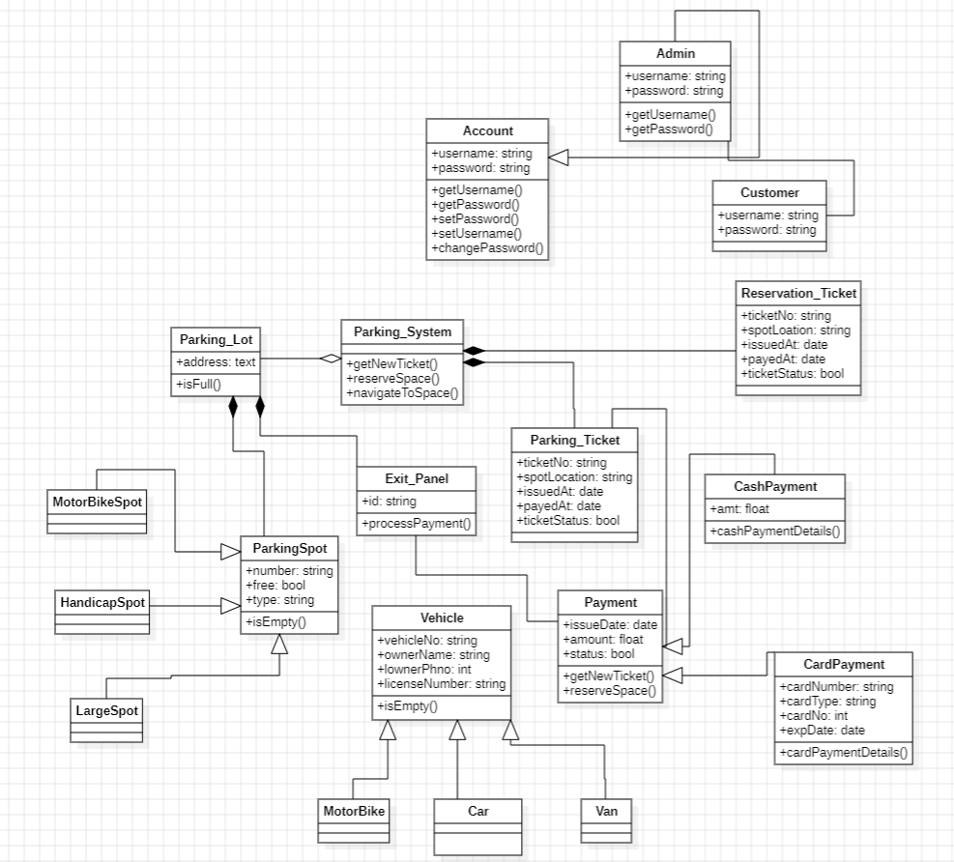

**Admin**

Manages the overall operations of the parking system, including monitoring and maintaining the system's functionality.

**Account**

Handles user account details, including login credentials, personal information, and account management functions.

**Customer**

Represents the users of the parking system. Customers can create reservations, make payments, and access parking services.

**ParkingSystem**

The central class that oversees the entire parking operation. It manages parking lots, processes reservations, and handles overall system logic.

**ParkingLot**

Contains multiple parking spots and exit panels. It oversees the availability and assignment of parking spots.

**ParkingSpot**

Represents individual parking spots within a parking lot. Specific types include:

MotorbikeSpot

HandicapSpot

LargeSpot

**ReservationTicket**

Provides details about a customer's reservation, including the reserved spot and time duration. It has a composition relationship with ParkingSystem, indicating that ReservationTickets are an integral part of the ParkingSystem.

**ParkingTicket**

Issued when a vehicle enters the parking lot, tracking the vehicle's entry time and assigned spot.

**ExitPanel**

Facilitates the exit process, validating parking tickets and processing payments. It has a composition relationship with ParkingLot, indicating that ExitPanels are an integral part of the ParkingLot.

**Vehicle**

Represents different types of vehicles that can use the parking system. Specific types include:

Motorbike

Car

Van

Payment

Abstract class handling payment processing. Specific types include:

CardPayment

CashPayment

**Inheritance Relationships**

Vehicle is a superclass for Motorbike, Car, and Van.

ParkingSpot is a superclass for MotorbikeSpot, HandicapSpot, and LargeSpot.

Payment is a superclass for CardPayment and CashPayment.

**Composition Relationships**

ParkingSpot and ExitPanel have composition relationships with ParkingLot, indicating that these components are integral parts of the ParkingLot.

ReservationTicket has a composition relationship with ParkingSystem, indicating that reservation tickets are an essential part of the parking system's functionality.

**Chapter 4: State diagram**

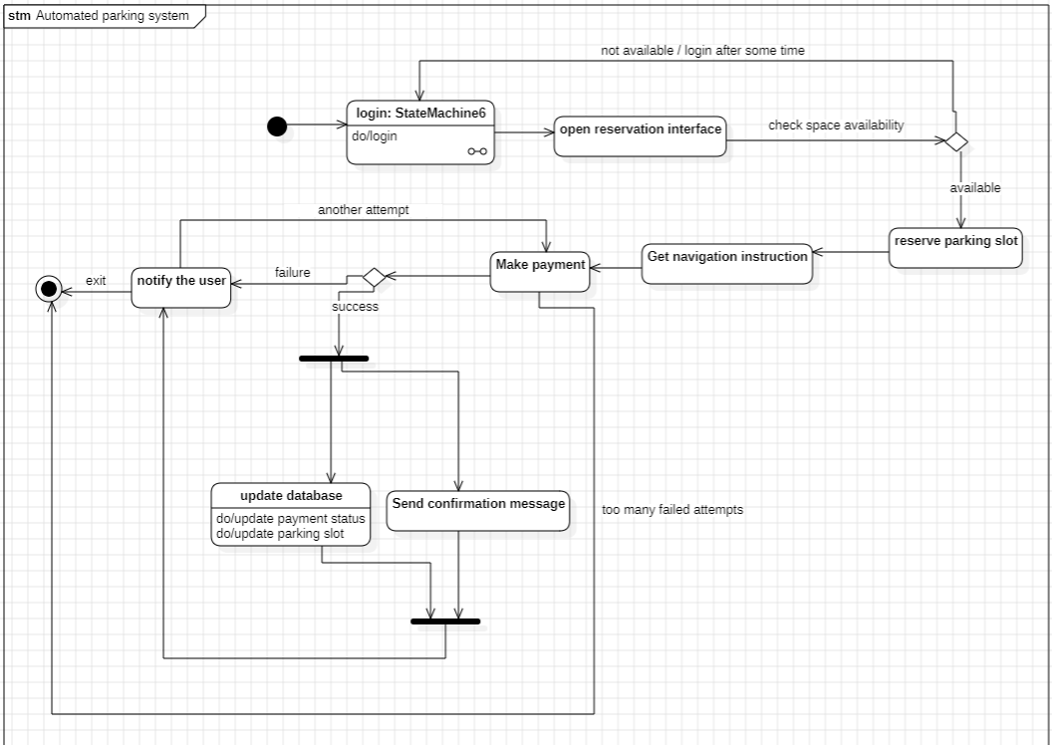

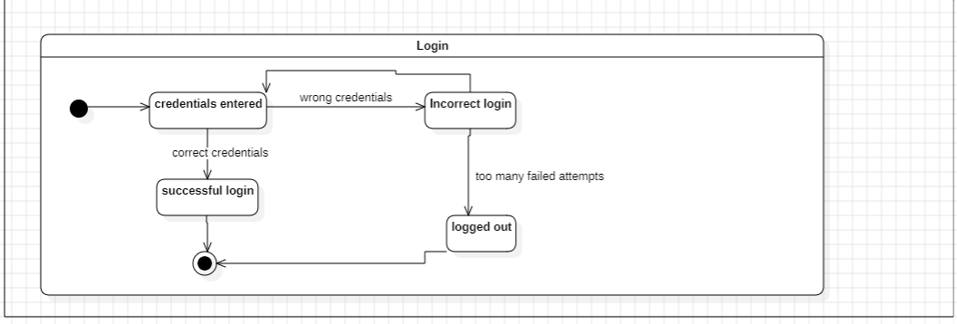

The state diagram for the automated parking system illustrates the flow of customer interactions from entering the system to exiting the parking lot. The process begins with the system in an idle state, awaiting user input. Upon interaction, the customer enters a submachine state for login, involving credential entry and validation. After successful login, the customer selects a parking lot and a specific parking spot. Once a spot is chosen, the system transitions to the state where the customer parks the vehicle. Throughout the stay, the system remains in a parked state until the customer initiates the exit process.

**Chapter 5: Sequence diagram**

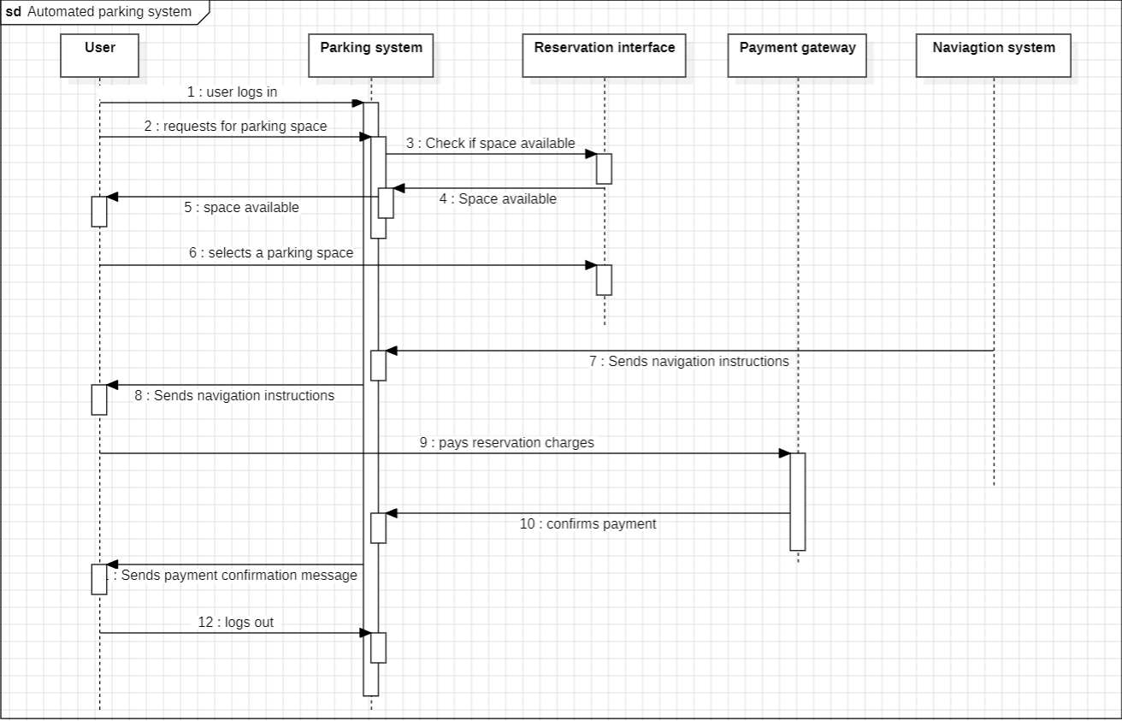

The sequence diagram provides a chronological depiction of interactions between various components of the automated parking system. It showcases the sequential flow of actions initiated by the user, such as logging in, selecting a parking lot, making a reservation, entering the parking lot, processing payment, and confirming exit. Each step triggers interactions between relevant system entities, including the customer, parking system, parking lot, reservation ticket, payment processor, and exit panel. This diagram succinctly illustrates the dynamic behavior and communication pathways within the automated parking system.

**Chapter 6: Activity diagram**

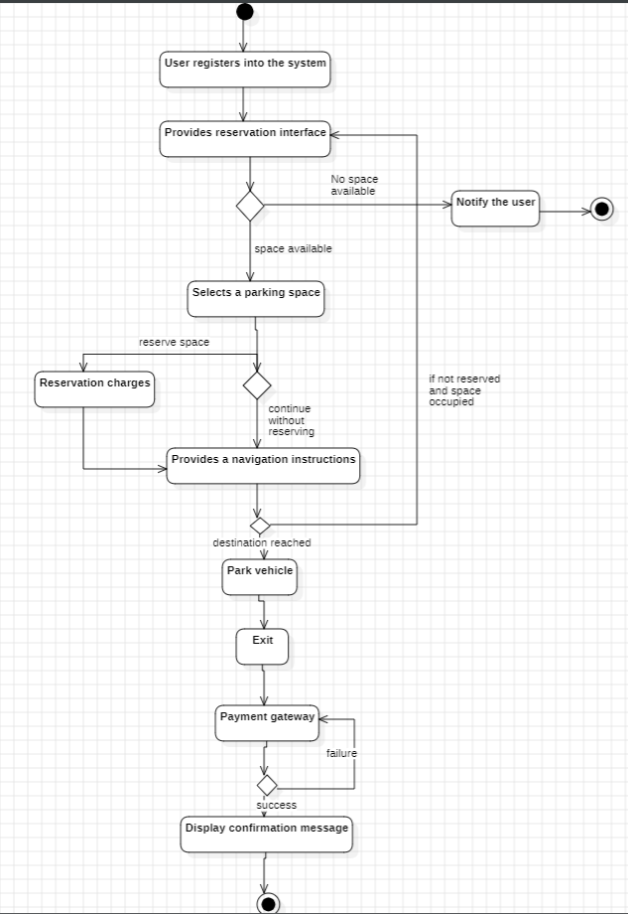

The activity diagram outlines the procedural flow within the automated parking system, illustrating the sequence of actions and decision points. It encapsulates user interactions, system responses, and administrative processes. From the initial activity of user login, the diagram branches into activities such as selecting a parking lot, making a reservation, entering the parking lot, processing payment, and confirming exit. It also includes activities related to administrative tasks, such as system maintenance and configuration. This diagram provides a comprehensive view of the system's workflow and operational logic.

**Chapter 7: Use case diagram**

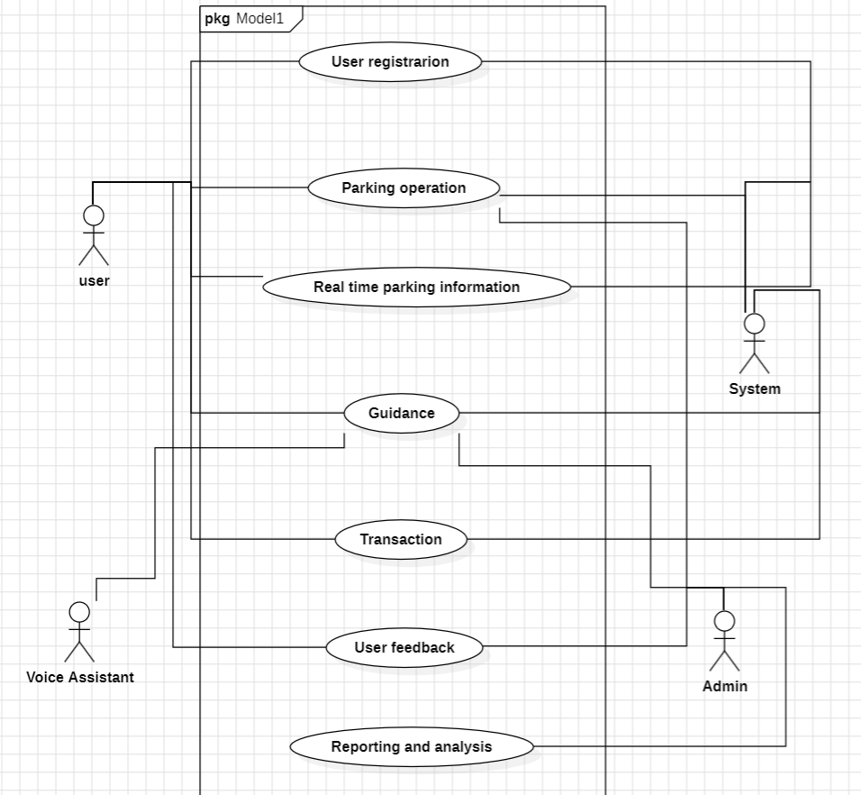

The use case diagram identifies the various actors and their interactions with the automated parking system. It features four primary actors: user, voice assistant, system, and admin. Each actor contributes to specific use cases within the system. The user engages in actions like making reservations, entering/exiting the parking lot, and processing payments. The voice assistant facilitates user interactions through voice commands, enhancing accessibility. The system orchestrates core functionalities such as managing parking lots, processing reservations, and handling payments. The admin actor oversees system configuration, user management, and maintenance tasks. This diagram delineates the roles and responsibilities of each actor within the automated parking system ecosystem.

**Chapter 8: Conclusion**

In conclusion, the Automated Vehicle Parking System represents a beacon of innovation poised to revolutionize urban parking dynamics. By amalgamating seamless functionality with stringent security protocols, it endeavors to mitigate the perennial challenges associated with parking space scarcity. Its compatibility across major operating systems and web browsers ensures inclusivity, catering to diverse user preferences and technological ecosystems. The system's robust scalability not only promises reliability under varying user loads but also anticipates future expansion and adaptation to evolving urban landscapes. The outlined preliminary schedule and budget not only delineate a meticulous roadmap for development but also reflect a commitment to fiscal prudence and operational excellence. In essence, the Automated Vehicle Parking System symbolizes a concerted effort towards enhancing urban mobility, fostering user convenience, and safeguarding privacy and data integrity in the digital age.